
University of Engineering and Technology,
Lahore
Department of Computer Science
Project Report
Team Members
Name | Roll Number | Email
Noor-Ul-Ain | 2025-CS-122 | noorulain.cs25@gmail.com
Azbah Naveed | 2025-CS-170 | azbah.78@gmail.com

Session: Fall’25 Morning | Section: C | Semester: 1st

Course: CSC101 - Discrete Mathematics | Teacher: Mr. Waqas Ali
January 1, 2026

Table of Contents
Table of Contents 3
Project Report 4
1. Project Title 4
2. Chosen Track 4
3. Overview 4
4. Summary 4
5. Technology Stack & Libraries Utilized 4
6. List of Features 4
7. Mathematical Foundations 5
8. Examination of Key Functions/Methods 5
9. Limitations 5
10. User Interface 6
10.1 Interface Overview 6
10.2 Screen-by-Screen Documentation 6
10.3 Sample Test Cases 6
11. Future Improvements 7
12. Conclusion 7
13. References & Learning Sources 7

Project Report
Submission Deadline: January 6, 2026

Project Title
Card Outcome Probability Calculator

Chosen Track
- Track 6: Counting & Combinatorics

Overview
The purpose of this project is to calculate card probabilities using discrete mathematics. A 52-card deck is used to find chances of drawing specific cards. The program uses formulas and simulations and helps students understand probability, combinations, and their practical use in programming.

Summary
This project focuses on calculating probabilities related to drawing cards from a standard deck of 52 cards. The main problem addressed by this project is understanding how certain card outcomes are, such as drawing an Ace, a face card, or combinations of two cards. Probability is an important concept in many real-life applications, including games, stats, and decision-making, so learning it in a practical way is very important.
To solve this problem, a menu-based C++ program was developed. The program uses basic probability formulas and counting methods to calculate exact (theoretical) probabilities. It also applies combinations to handle cases where two cards are drawn without considering order. In addition, the project includes simulation techniques where random card draws are performed many times to estimate experimental probabilities. This helps compare theoretical results with practical outcomes. The key functionalities of this project include implementing multiple probability calculations for both one-card and two-card scenarios, creating a user-friendly command-line interface, and validating results through simulation. The program provides clear numerical outputs that help users easily understand probability values.
This project is important in the context of discrete mathematics because it directly applies core concepts such as counting, combinations, and probability. It shows how mathematical theory can be transformed into a working computer program. By connecting theoretical formulas with real examples, the project helps increase understanding of discrete mathematics and its practical value in computer science.

Technology Stack & Libraries Utilized
- Programming Languages:
(C++ 11)
C++ was selected because it is fast, efficient, and commonly used for mathematical and logic-based programs.
- Libraries
(iostream) for input and output.
(ctime) for random number output.
(iomanip) for formatting decimal values.
- Development Environment:
IDE: Vscode
Compiler: MingW

List of Features
Main Menu:
Menu-Based program: Provides a clear main menu and sub-menus to help users easily choose different probability calculations.
One-Card Probability Module
Face Card Probability: Calculates the probability of drawing any face card (Jack, Queen, or King) from the deck.
Specific Face Card Probability: Calculates the probability of drawing a specific face card such as Jack, Queen, Joker. or King.
Number Card Probability: Calculates the probability of drawing a number card (2–10) from the deck.
Specific Number Card Probability: Calculates the probability of drawing a specific number card chosen by the user.
Ace Probability: Calculates the probability of drawing an Ace from the deck.
Specific Card Probability: Calculates the probability of drawing one exact card from the deck.
Specific Suit Probability: Calculates the probability of drawing a card from a specific suit (Hearts, Diamonds, Clubs, or Spades).
No-Ace Probability: Calculates the probability of not drawing an Ace.
Two-Card Probability Module
Same Rank Probability: Calculates the probability that two drawn cards have the same rank.
One Ace and One Non-Ace Probability: Calculates the probability of drawing one Ace and one non-Ace card.
Same Color Probability: Calculates the probability that both drawn cards are of the same color (red or black).
Simulation Module
Ace Probability Simulation: Uses random card draws to estimate the probability of drawing an Ace.
Face Card Probability Simulation: Uses simulation to estimate the probability of drawing a face card.
Same Rank Simulation: Simulates two card draws to estimate the probability of drawing cards with the same rank.

Mathematical Foundations
This project is based on the fundamental concepts of discrete mathematics, particularly counting techniques and probability theory, as presented in Chapter 6 of Discrete Mathematics and Its Applications by Kenneth H. Rosen (8th Edition). These concepts are used to analyze and calculate probabilities related to drawing cards from a standard deck.
- Relevant Concepts:
- Probability
Probability is a numerical measure of what is the possibility of an event to occur. In this project, probability is used to determine the possibility of specific card outcomes, such as drawing an Ace, a face card, or two cards of the same rank.
- Counting Principles
Counting techniques are applied to determine the total number of possible outcomes and the number of favorable outcomes. These values are essential for computing probabilities accurately.
- Combinations
Combination are used when selecting cards where the order does not matter. For example, when two cards are drawn from the deck without replacement, combinations are used as described in the textbook.
- Sample Space
The sample space is the set of all possible outcomes of an experiment. In this project, the sample space for drawing one card from a standard deck consists of 52 possible outcomes.
- Monte-Carlo Simulation
A Monte Carlo simulation is a computational technique that estimates the probability of an event by . performing a large number of random experiments and analyzing the outcomes.
- Formal Definitions:
- Permutation:
If n and r are integers with 0 ≤ r ≤ n, then P(n, r) $\frac{n!}{\left(n-r\right)!}$$\frac{n!}{\left(n-r\right)!}$
- Combinations:
The number of r-combinations of a set with n elements, where n is a nonnegative integer and r is an integer with 0 ≤ r ≤ n, equals C(n, r) $\frac{n!}{r!\left(-r\right)!}$
- Probability:
The probability of an event $E$is defined as: $P(E)=\frac{∣E∣}{∣S∣}$ where $E$represents the event and $S$ represents the sample space.
- Proofs & Correctness:
The program calculates probabilities using the standard probability formula:
$$P(E)=\frac{\text{Number of Favorable Outcomes}}{\text{Total Number of Outcomes}}$$

For events involving multiple cards, the program uses combinations to count arrangements where order does not matter. The number of ways to choose r elements from n elements is given by:
$$C\left(n,r\right)=\frac{n!}{r!(n-r)!}$$
Let there be x favorable cards in the deck (e.g., 4 Aces). The number of ways to choose r cards is:
$$∣E∣=C(x,r)=\frac{x!}{r!(x-r)!}$$
- Illustrative Examples:
- Two-Card Probability (Drawing Two Aces)
Total cards: 52
Total ways to choose 2 cards:$=\frac{52*52}{2}=1326$
Favorable ways (two Aces): $=\frac{4*3}{2}=6$
Probability: $P\left(\text{two Aces}\right)=\frac{6}{1326}=0.0045$
- Single Card Probability (Drawing One King)
Total cards: 52
Total ways to choose 1 card: $=52$
Favorable ways (one King): $=4$
Probability: $P(\text{King})=\frac{4}{52}=\frac{1}{13}$
- Time and space complexity:
Time Complexity: The program most simple calculations, so it runs in O(n) time for n cards considered. For simulations, complexity depends on the number of trials, O(runs).
Space Complexity: The program stores card and temporary counts, so it uses O(1) extra space from input storage.

Examination of Key Functions/Methods
1. Function Name & Signature:
long long factorial(int number);
Purpose:
- Calculates the factorial of a number (multiply all numbers from 1 to number).
Algorithm Description:
1. Start with result = 1
2. For i = 1 to number:
result = result * i
3. Return result
Time/Space Complexity:
- Time: O(n) – loops from 1 to number
- Space: O(1) – uses only one variable
Implementation Details:.
- Returns long long to handle large numbers.
Code Snippet:
long long factorial(int number
long long result = 1;
for (int i = 1; i <= number; i++)
result = result * i;
return result;
}
2. Function Name & Signature:
void Probability(double favorable, double total);
Purpose:
- Calculates and displays the probability of an event in fraction and decimal form.
- Important because all card probability functions use it to show results clearly.
Algorithm Description:
1. Print favorable outcomes
2. Print total outcomes
3. Calculate probability = favorable / total
4. Print probability as fraction and decimal
Time/Space Complexity:
- Time: O(1) – simple division and printing
- Space: O(1) – uses only local variables
Implementation Details:
- Uses setprecision(6) to show probability in six decimal places.
- Standardizes probability output across all functions.
Code Snippet:

3. Function Name & Signature:
long long nC2(int n);
Purpose:
- Calculates how many ways to pick 2 items from n.
- Important for two-card probability calculations like drawing two cards of the same rank.
Algorithm Description:
1. Use formula: nC2 = n * (n-1) / 2
2. Return the result
Time/Space Complexity:
- Time: O(1) – only one calculation
- Space: O(1) – stores result in one variable
Implementation Details:
- Uses long long to avoid overflow (like n=52).
Code Snippet:
long long nC2(int n)
{
return (long long)n * (n - 1) / 2;
}
4. Function Name & Signature:
void probabilityTwoSameRank();
Purpose:
- Calculates the probability of drawing two cards of the same rank (like two Kings).
Algorithm Description:
1. Total ways to pick 2 cards from 52 = ^{n}C₂(52)
2. Favorable ways to pick 2 cards of the same rank = 13 * ^{n}C₂(4)
3. Probability = favorable / total
4. Display probability using Probability() function
Time/Space Complexity:
- Time: O(1) – only a few calculations
- Space: O(1) – uses local variables
Implementation Details:
- Uses ^{n}C₂() for modular programming.
- Uses Probability() to print results clearly.
Code Snippet:
void probabilityTwoSameRank()
{
cout << "\n**** Probability of Drawing Two Cards of Same Rank ****\n";
long long favorable = 13 * nC2(4);
long long total = nC2(52);

Probability(favorable, total);
}
Function Name & Signature
void simulateTwoSameRank();
Purpose:
- Uses Monte Carlo simulation to experimentally estimate the probability of drawing two cards of the same rank.
- Important because it verifies the mathematical probability with random trials.
Algorithm Description:
1. Set number of runs (e.g., 100000)
2. Initialize count = 0
3. Repeat for each run:
a. Pick random card1 and card2 (0-51)
b. If card1 == card2, skip
c. If card1 % 13 == card2 % 13, count++
4. Probability ≈ count / runs
5. Display probability
Time/Space Complexity:
- Time: O(runs) – depends on number of simulations
- Space: O(1) – uses few variables
Implementation Details:
- Uses srand(time(0)) to draw random numbers.
- Uses modulus 13 to check if two cards have the same rank.
Code Snippet:
void simulateTwoSameRank()
{
srand(time(0));

int runs = 100000;
int count = 0;

for(int i = 0; i < runs; i++)
{
int card1 = rand() % 52;
int card2 = rand() % 52;
if(card1 == card2)
{
i--;
continue;
}
if(card1 % 13 == card2 % 13)
count++;
}

cout << "\n****Simulation Result (Two Cards Same Rank)****\n";
cout << "Experimental Probability = "<< (double)count / runs << endl;
}

9. Limitations
1. Scope Limitations
- Works only with a 52-card deck
- Does not include jokers
- Does not fully cover complex card games like Poker.
2. Performance Constraints
- Simulation becomes slow for very large numbers
- Uses rand() which is not very fast or accurate
3. Algorithmic Limitations
- Some values are fixed (like number of face cards)
- Factorial may fail for very large numbers
- Simulation results can change slightly each time
4. Design Trade-offs
- Code is written to be easy to understand, not very fast
- Uses console menu, no graphics menu.
5. Known Issues
- No full check for wrong input
- Division by zero is possible
- Small simulations may give less accurate results

10. User Interface

10.1 Interface Overview
The Card Probability System uses a console-based Command Line Interface (CLI) with a hierarchical menu structure. The design philosophy emphasizes simplicity and ease of navigation through numbered menu options. The user experience is organized into logical categories: single card probabilities, two-card probabilities, and Monte Carlo simulations, allowing users to efficiently access different probability calculations without overwhelming them with options on a single screen.

10.2 Screen-by-Screen Documentation
Screen 1: Welcome & Main Menu
- Screen Name/Title: Main Menu - Card Probability System

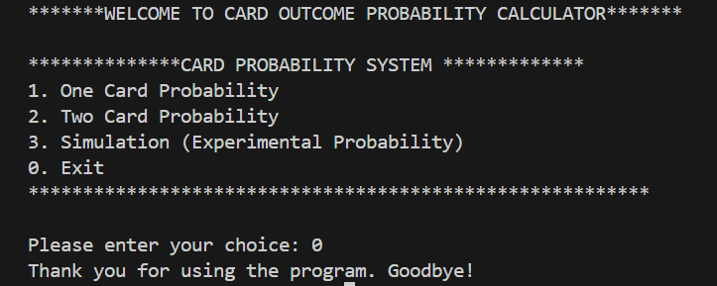
- Screenshot:

- Purpose: This is the entry point where users select the broad category of probability calculation they want to perform or exit the program
- User Actions:
- Input 1: Navigate to One Card Probability submenu
- Input 2: Navigate to Two Card Probability submenu
- Input 3: Navigate to Simulation submenu
- Input 0: Exit the program
- Input Description: User enters a single digit (0-3) to select their desired option
- Output Description: Based on selection, the system either displays the corresponding submenu or displays "Thank you for using the program. Goodbye!" and terminates
- Navigation: Selecting options 1-3 takes user to respective submenus; selecting 0 exits the program

Screen 2: One Card Probability Menu
- Screen Name/Title: One Card Probability Submenu
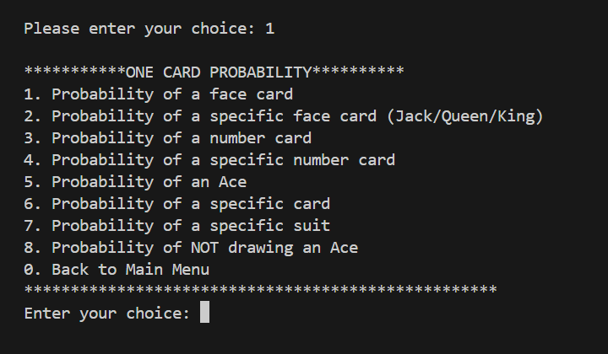
- Screenshot:
- Propose: Users select specific single-card probability calculations
- User Actions:
- Options 1, 3, 5, 6, 7, 8: Direct calculation (no additional input required)
- Option 2: Prompts for face card name (Jack/Queen/King)
- Option 4: Prompts for number (2-10)
- Option 0: Return to Main Menu
- Input Description:
- Primary input: Menu choice (0-8)
- Secondary input (if applicable): Face card name as string or number as integer
- Output Description: Displays favorable outcomes, total outcomes, and calculated probability with 6 decimal precisions
- Navigation: Option 0 returns to Main Menu; other options display results and return to this submenu
Screen 3: Two Card Probability Menu
- Screen Name/Title: Two Card Probability Submenu
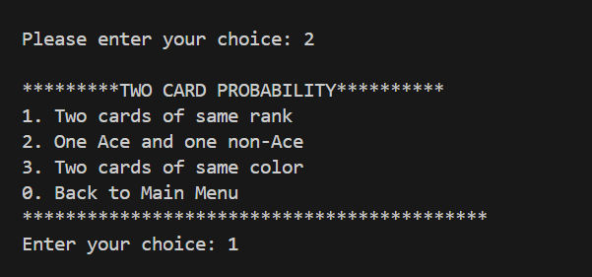
- Screenshot:

- Purpose: Users calculate probabilities involving drawing two cards from a deck
- User Actions:
- Options 1-3: Calculate respective two-card probability scenarios
- Option 0: Return to Main Menu
- Input Description: Single digit menu choice (0-3)
- Output Description: Displays favorable outcomes, total outcomes, and probability formatted to 6 decimal places
- Navigation: Returns to Main Menu on option 0; otherwise displays results and stays in submenu
Screen 4: Simulation Menu
- Screen Name/Title: Simulation Submenu
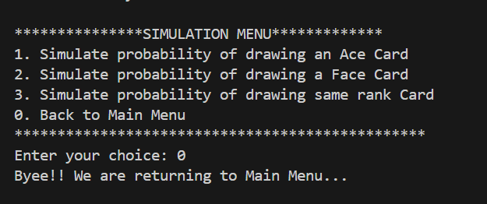
- Screenshot:
- Purpose: Users run Monte Carlo simulations to verify theoretical probabilities experimentally
- User Actions:
- Options 1-3: Run 100,000 random trials for respective scenarios
- Option 0: Return to Main Menu
- Input Description: Single digit menu choice (0-3)
- Output Description: Displays experimental probability based on 100,000 simulation runs
- Navigation: Returns to Main Menu on option 0; displays simulation results and remains in submenu for other options

10.3 Sample Test Cases
Test Case 1: Calculate Probability of Drawing a Face Card
- Test Case Name: Single Face Card Probability Calculation
- Input:
- From Main Menu: Enter 1 (One Card Probability)
- From One Card Menu: Enter 1 (Probability of a face card)
- Expected Output: Face Card Probability that is (12 / 52 = 0.230769)
- Actual Output: 0.230769
- Status: Pass - The program correctly calculates that there are 12 face cards (4 Jacks + 4 Queens + 4 Kings) out of 52 total cards.
Test Case 2: Calculate Probability of Drawing a Specific Face Card (Queen)
- Test Case Name: Specific Face Card Probability
- Input:
- From Main Menu: Enter 1 (One Card Probability)
- From One Card Menu: Enter 1 (Probability of specific face card)
- Expected Output: If user enter any of the face card no matter if it is capitalized or not the output should be (4 / 52 = 0.076923)
- Actual Output: 0.076923
- Status: Pass - The program correctly identifies 4 Queens in a standard deck and calculates the probability as 4/52 = 1/13.
Test Case 3: Calculate Probability of Drawing an Ace
- Test Case Name: Ace Card Probability Calculation
- Input:
- From Main Menu: Enter 1 (One Card Probability)
- From One Card Menu: Enter 1 (Probability of an ace)
- Expected Output: The expected outcome is (4 / 52 = 0.076923)
- Actual Output: 0.076923
- Status: Pass - The program correctly identifies 4 Aces from 52 cards
Test Case 4: Calculate Probability of NOT Drawing an Ace
- Test Case Name: Complement Probability (No Ace)
- Input:
- From Main Menu: Enter 1 (One Card Probability)
- From One Card Menu: Enter 1 (Probability of NOT drawing an Ace)
- Expected Output: The expected output is (48 / 52 = 0.923077)
- Actual Output: 0.923077
- Status: Pass - Correctly calculates the complement probability (52 - 4 = 48 non-Ace cards).

11. Future Improvements
Propose enhancements and extensions to your project. Discuss:
- Performance Optimizations: Ways to make your project faster or more memory-efficient
- Feature Extensions: New capabilities or modes you could add
- Scalability Improvements: How to handle larger or more complex inputs
- User Experience Enhancements: Improvements to the interface or interaction model
- Algorithm Alternatives: Different algorithmic approaches worth exploring
- Real-World Applications: How your project could be extended for practical use
For each proposed improvement, briefly explain the rationale and any anticipated challenges. This demonstrates forward thinking and professional development mindset.

12. Conclusion
This project helped us understand how math works in computer programs. we made a Card Probability Calculator that finds chances of drawing cards.
Key Achievements
We successfully:
- Calculated card probabilities
- Used combinations
- Added simulation functions
- Created a simple menu system
Learning Outcomes
We learned:
- Basic probability
- How combinations work
- How to use math in code
- How simulations check answers
This made learning easier.
Challenges Overcome
Some parts were difficult:
- Writing correct formulas
- Using random numbers
- Getting correct results
We solved these problems with practice.
Reflection
This project was useful and interesting. It showed us that math is not only theory, but also practical.
Final Remarks
This project improved our logical and coding skills. It helped us understand how theory becomes a real program.

13. References & Learning Sources

