User manual

user interface
The user interface of the project consists of a amin menu and several sub menus.
The main menu consists of four options:
- Single draw probability.
- Double draw probability.
- Simulation mode.

Main menu:
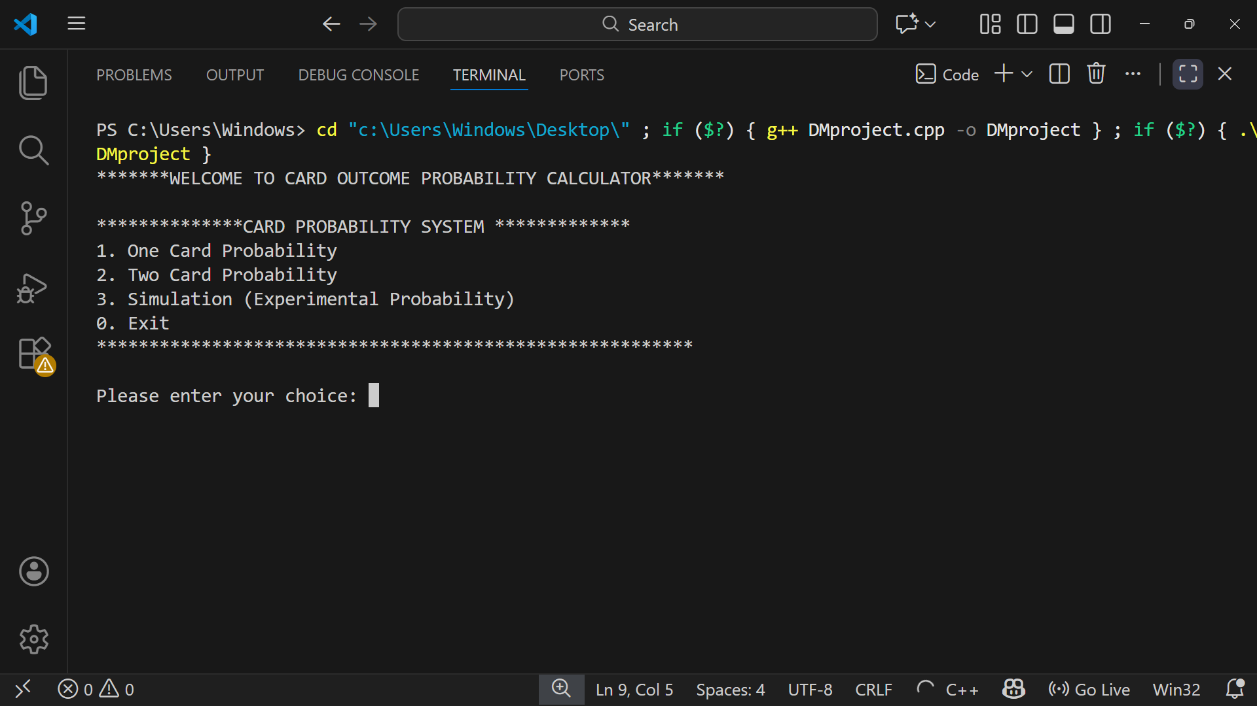
Screen shot:

The main menu appears when the code runs. The main menu asks the user to select one of the following modes.
Single draw
Double draw
Simulation mode
Exit

Single card probability:
The single card probability menu appears when the user presses the first option.

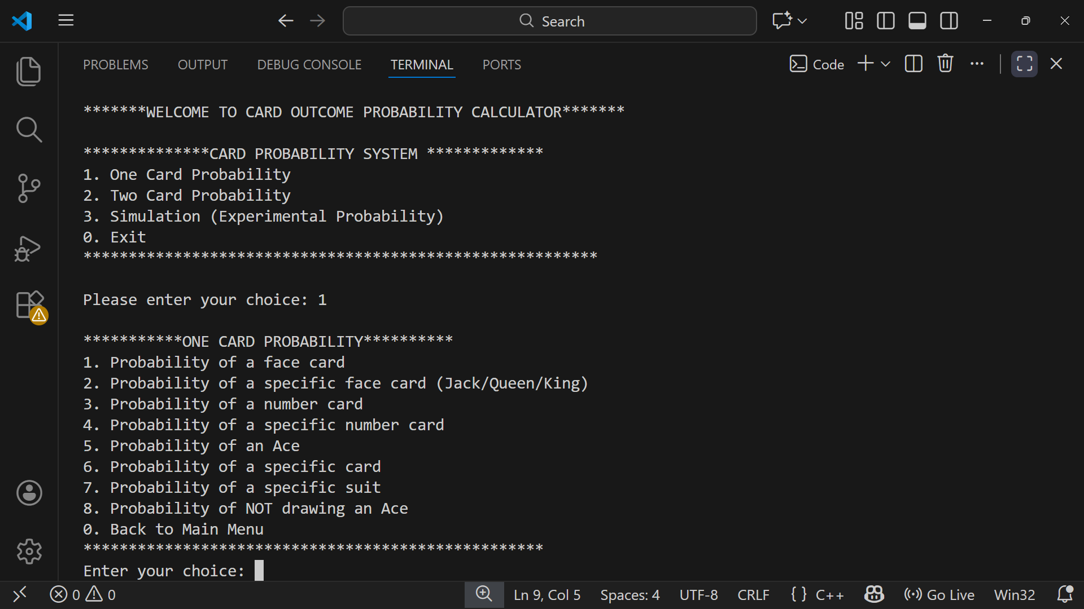
The single card outcome calculator has a sub menu that display following options:
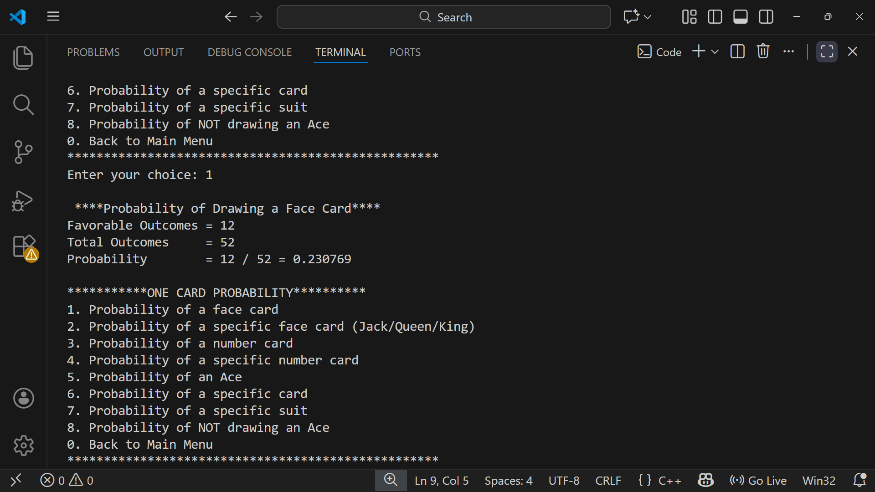
Face Card Probability:

Calculates the probability of drawing any face card (Jack, Queen, or King) from the deck.
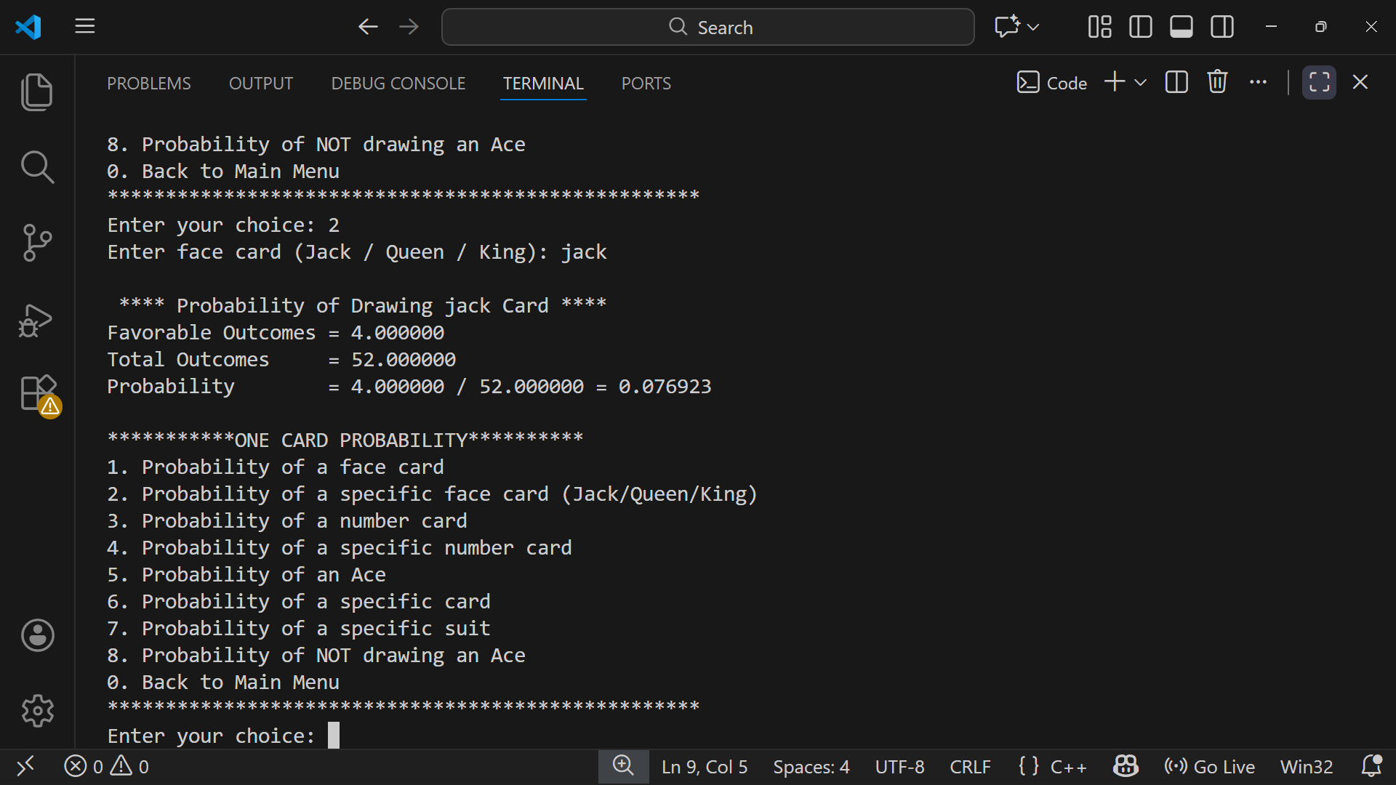
Specific Face Card Probability:

Calculates the probability of drawing a specific face card such as Jack, Queen, Joker. or King.
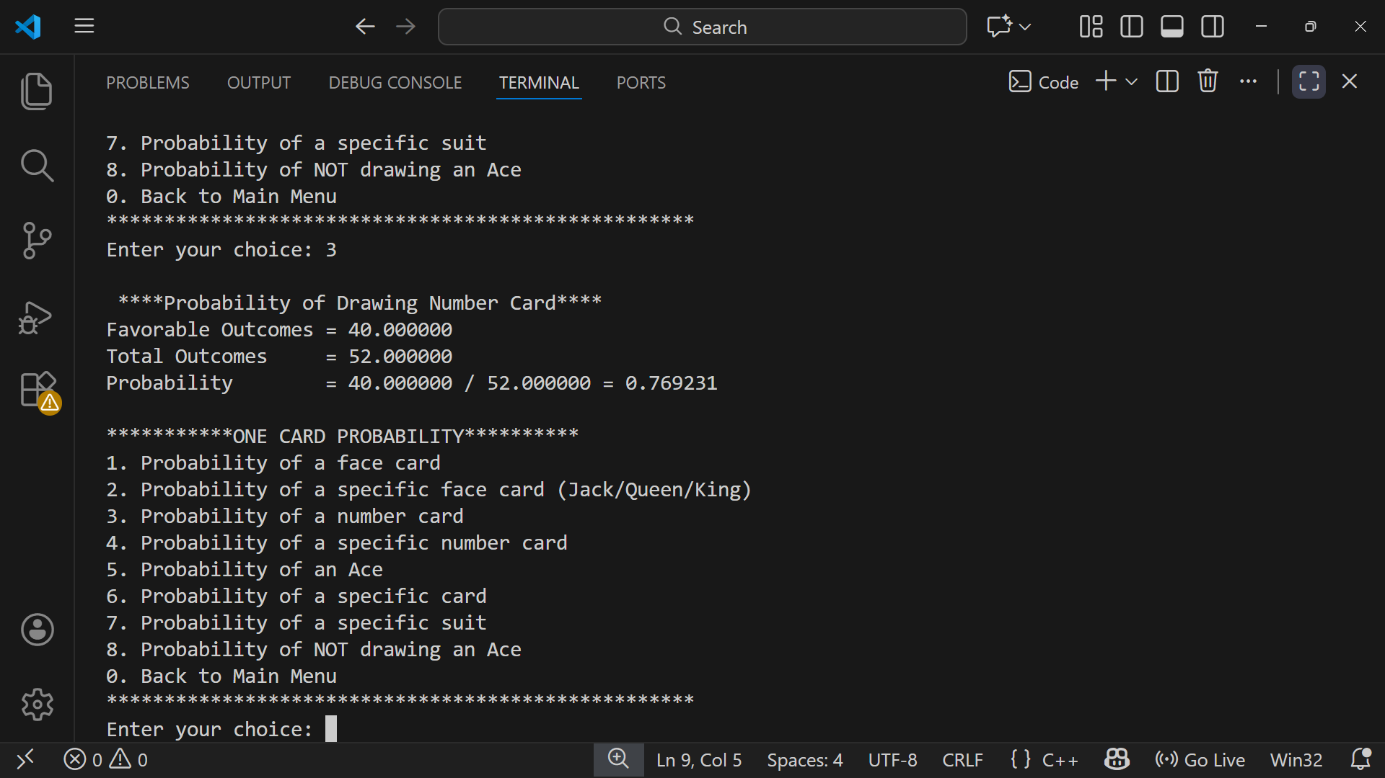
Number Card Probability:
Calculates the probability of drawing a number card (2–10) from the deck.
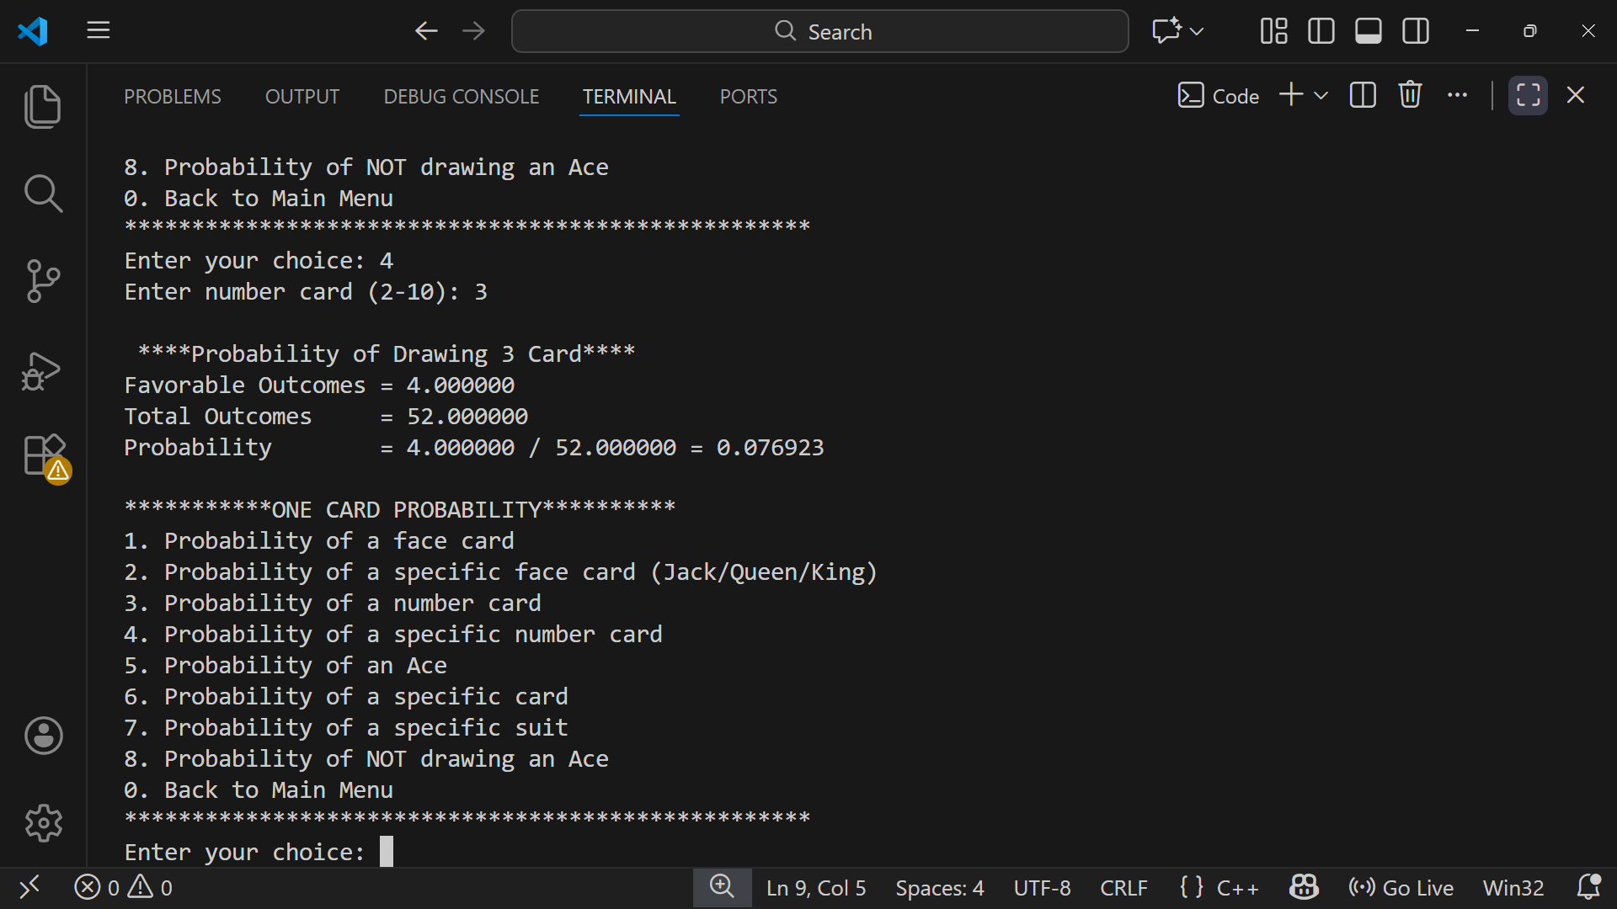
Specific Number Card Probability:
Calculates the probability of drawing a specific number card chosen by the user.
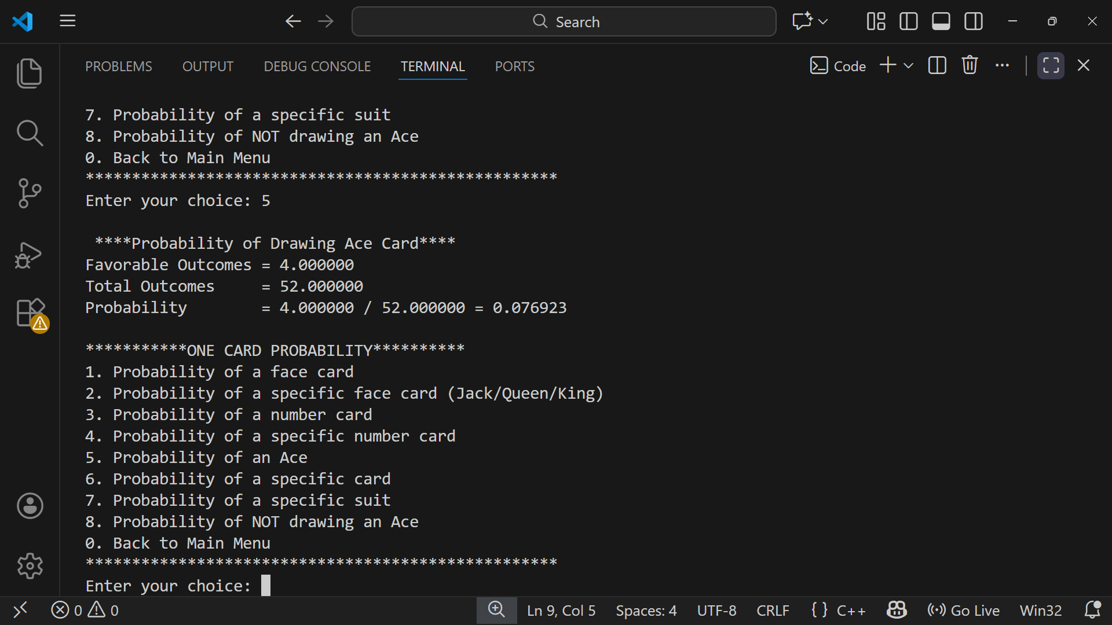
Ace Probability:
Calculates the probability of drawing an Ace from the deck.
Specific Card Probability:
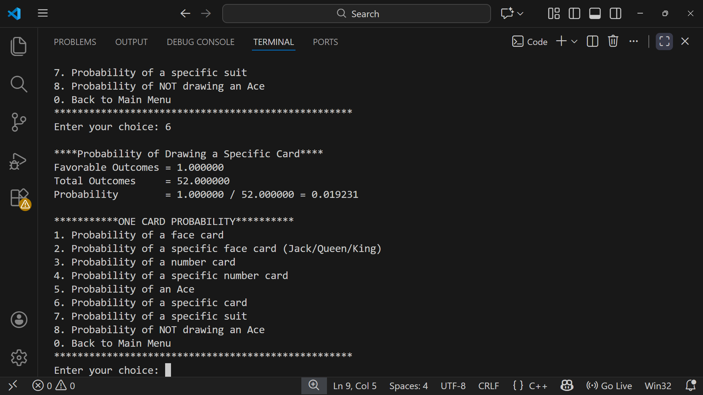
Calculates the probability of drawing one exact card from the deck.
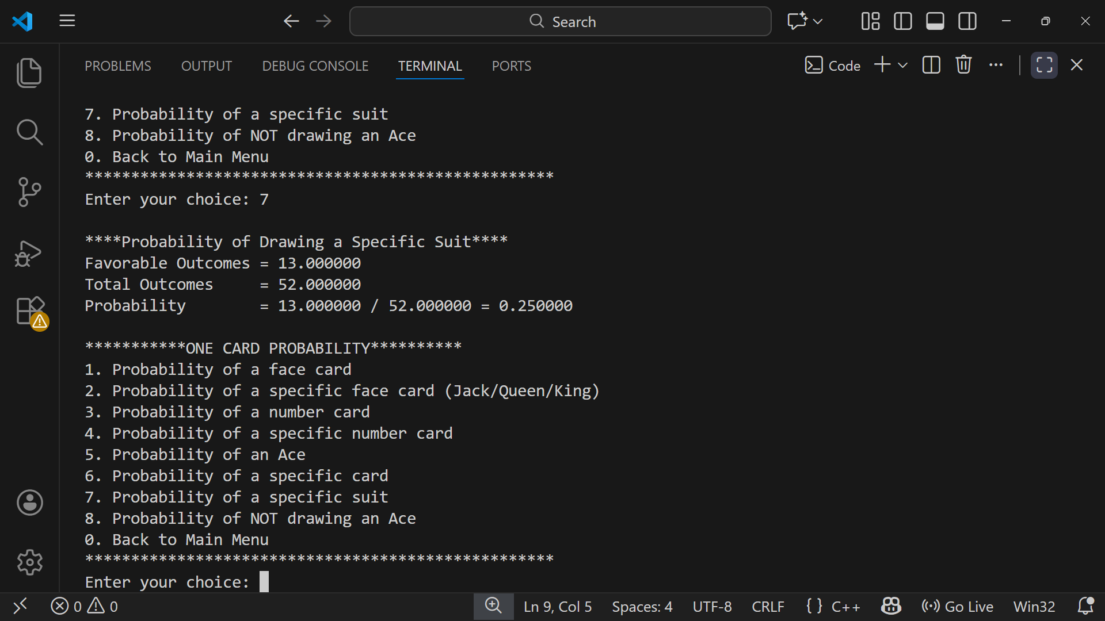
Specific Suit Probability:
Calculates the probability of drawing a card from a specific suit (Hearts, Diamonds, Clubs, or Spades).
No-Ace Probability:
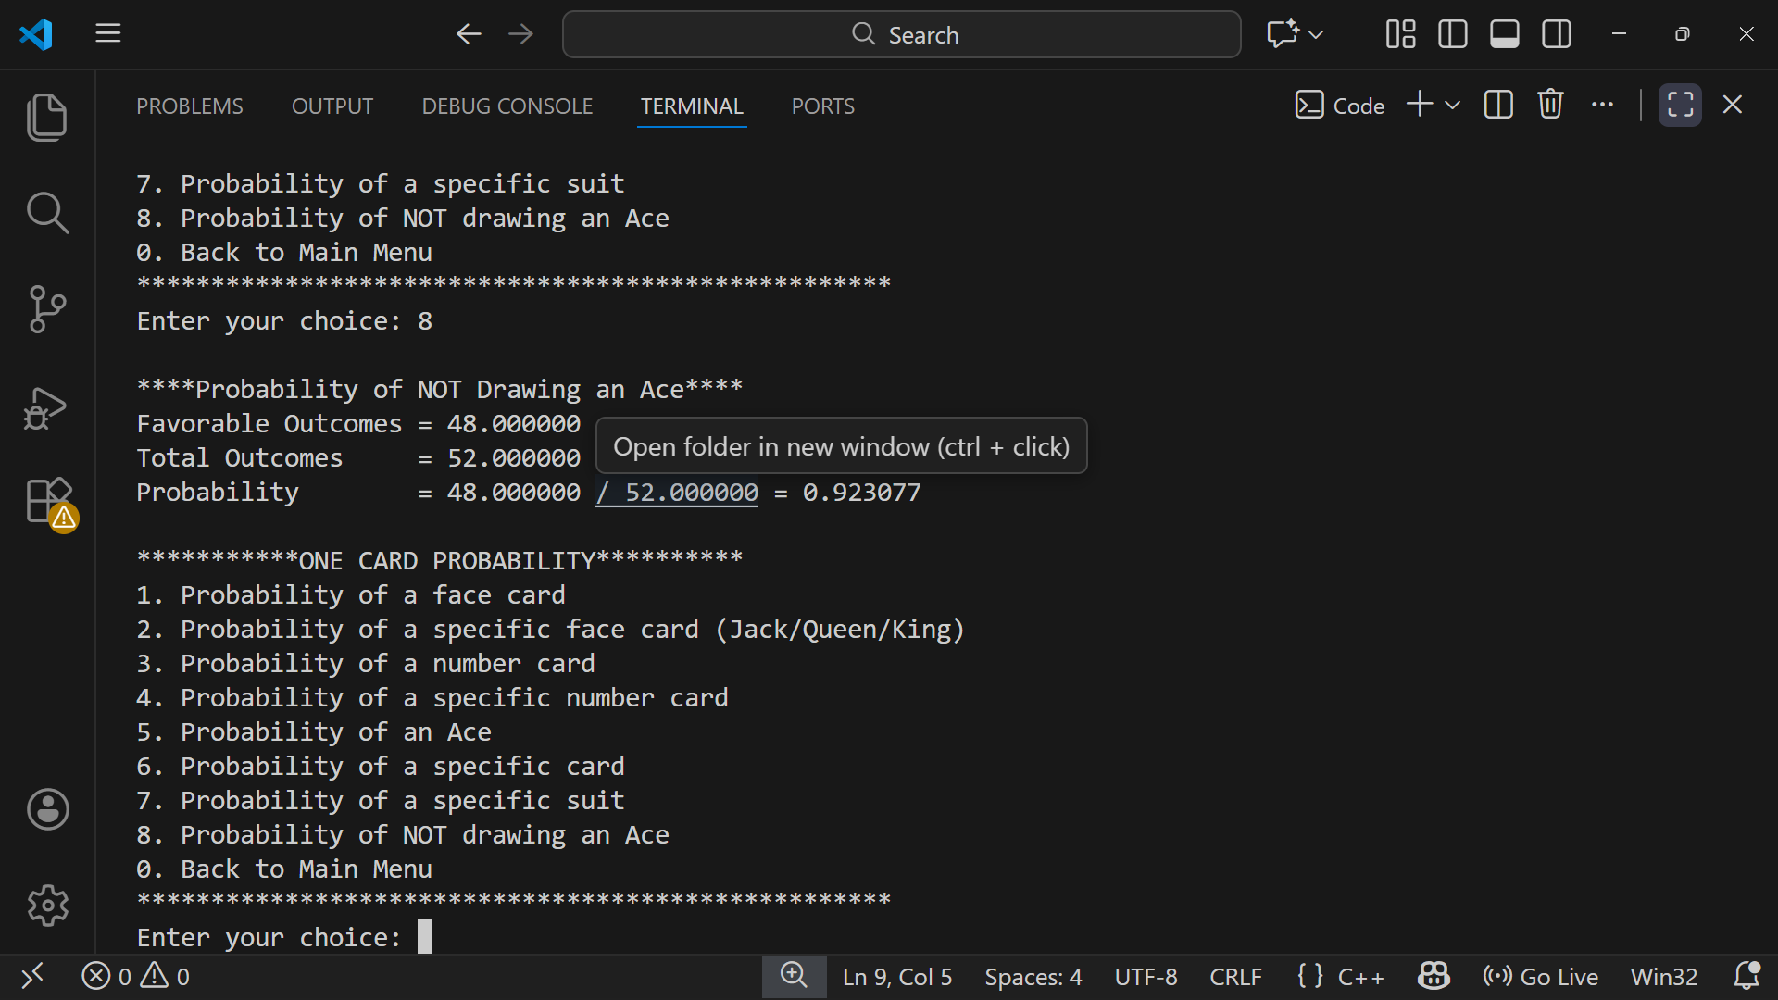
Calculates the probability of not drawing an Ace.

Double draw probability:
The double draw menu contains a menu which display the possible favourable double draw outcomes.
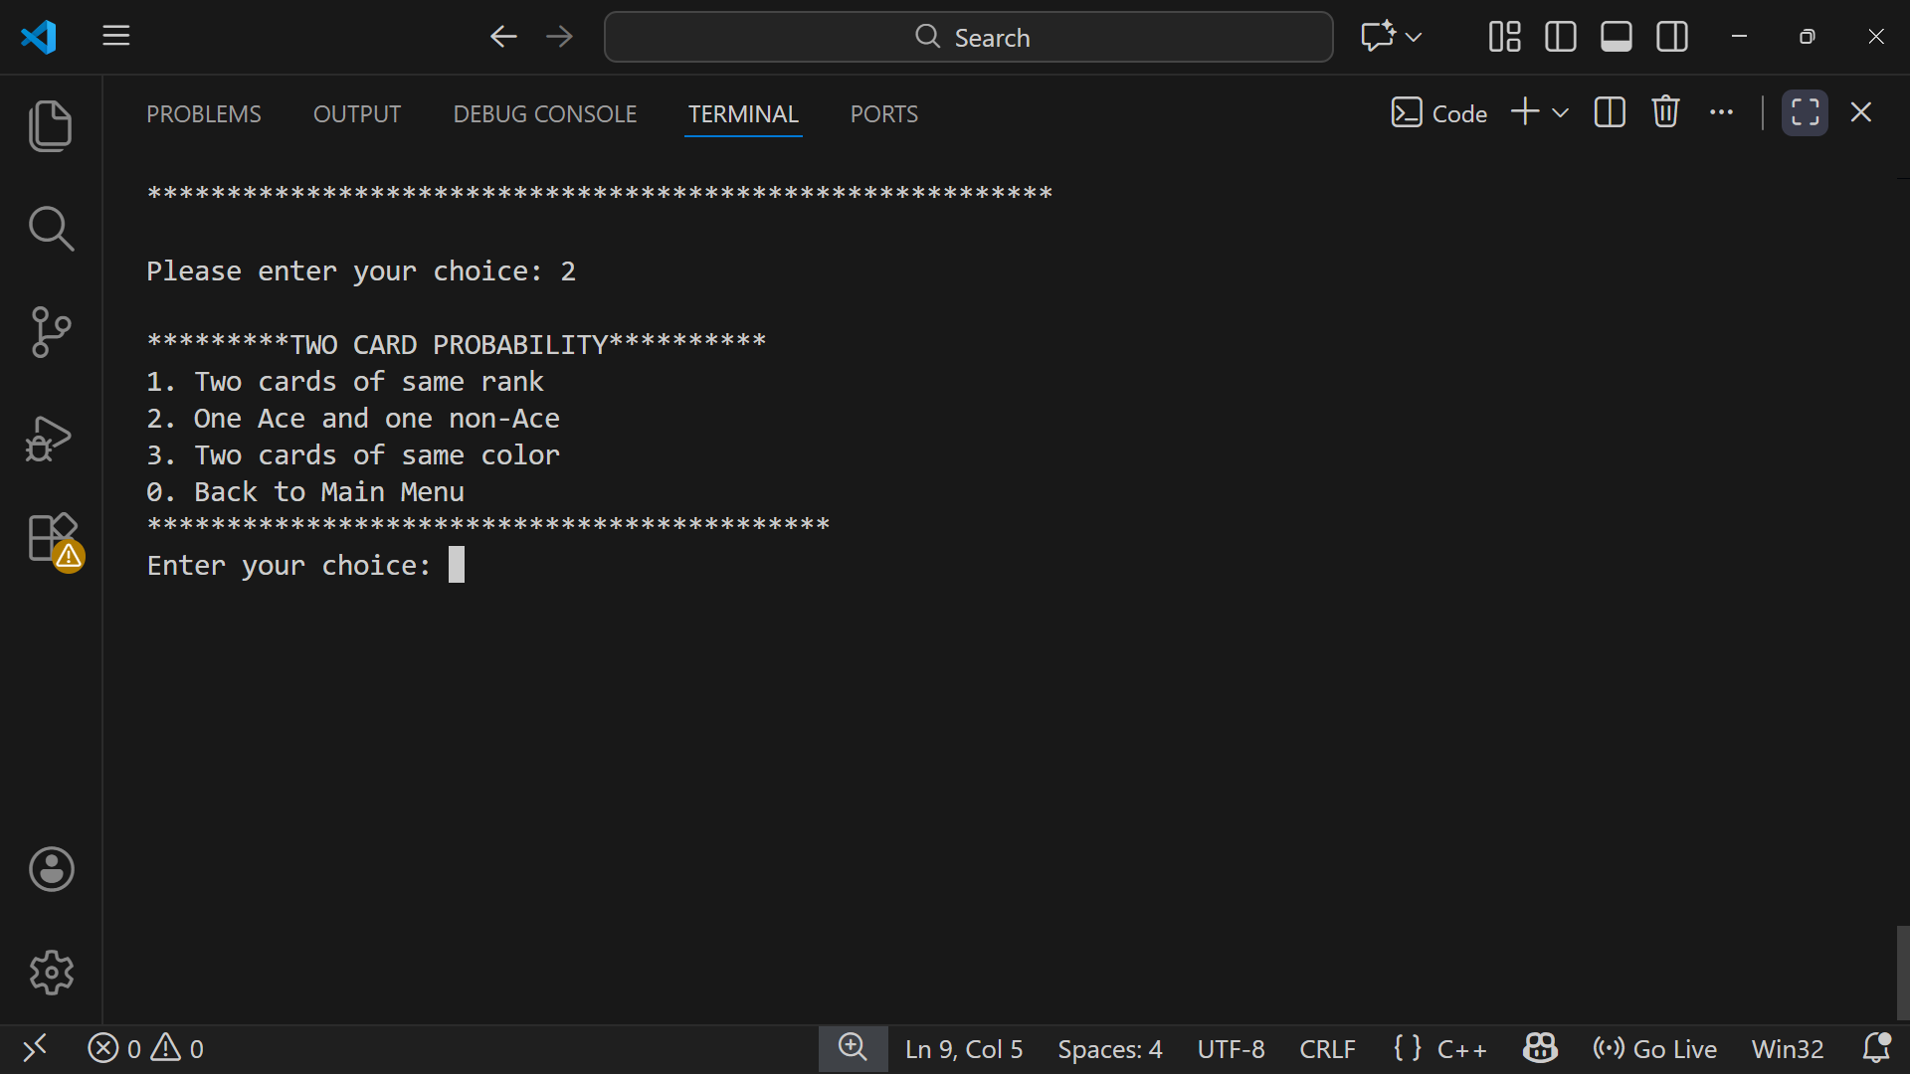
Screen shot:

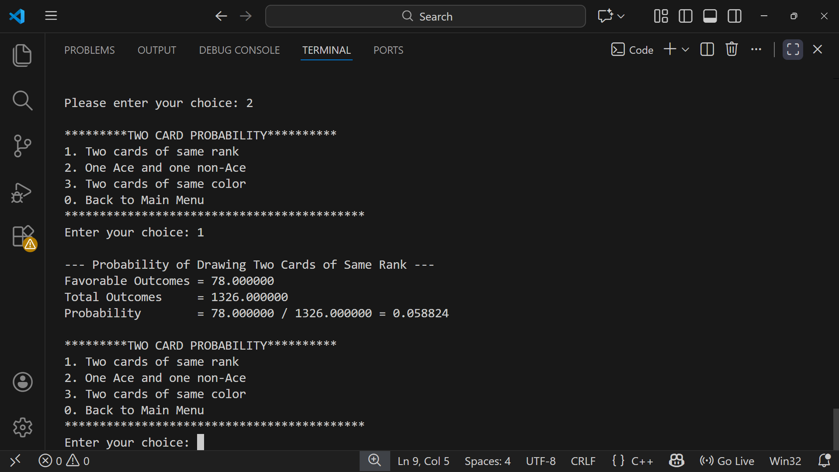
Same Rank Probability:

Calculates the probability that two drawn cards have the same rank.
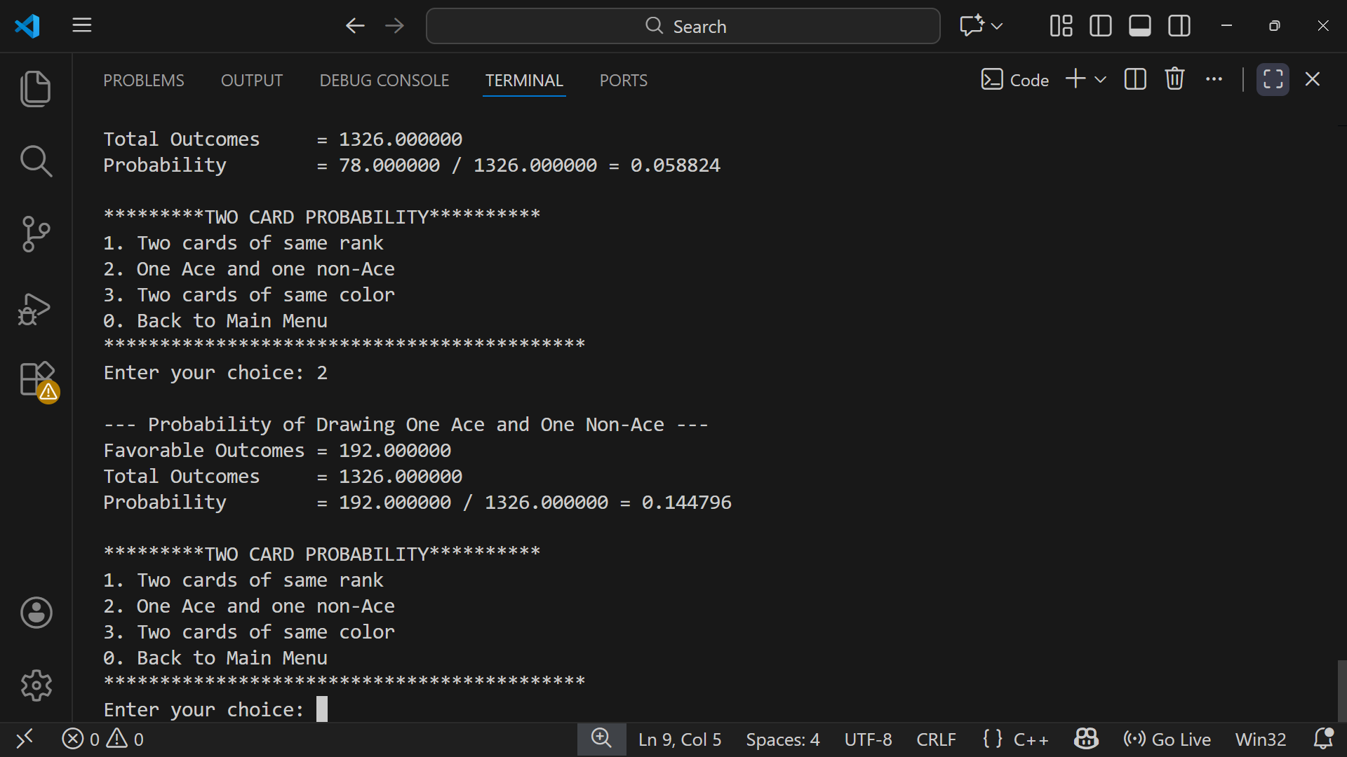
One Ace and One Non-Ace Probability:

Calculates the probability of drawing one Ace and one non-Ace card.
Same Color Probability:
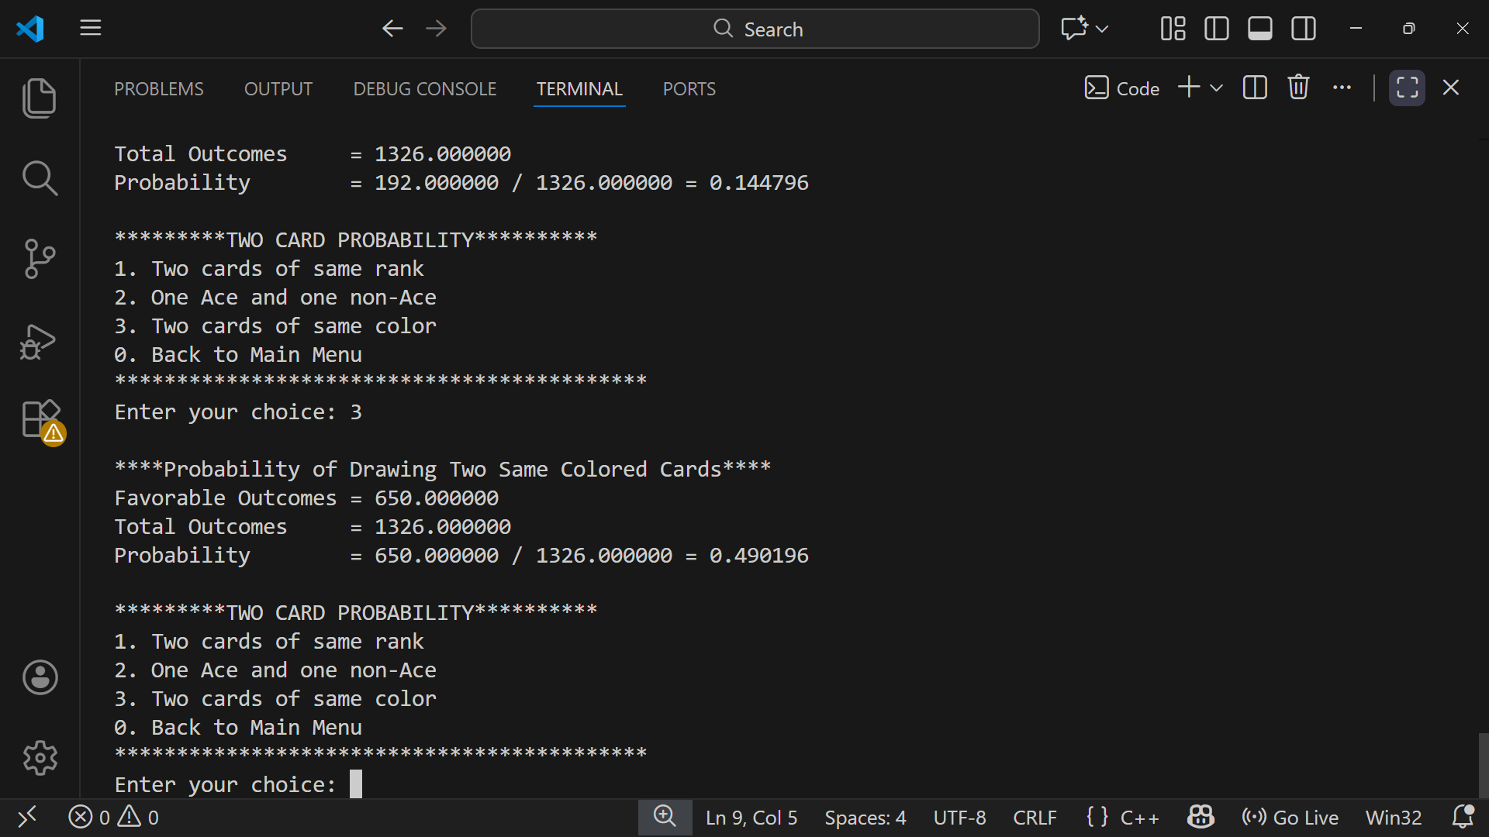
Calculates the probability that both drawn cards are of the same color (red or black).

Simulation Mode
The simulation mode simulates the actual results after drawing a hundred times. Meaning that it is not the theoretical results but the actual results
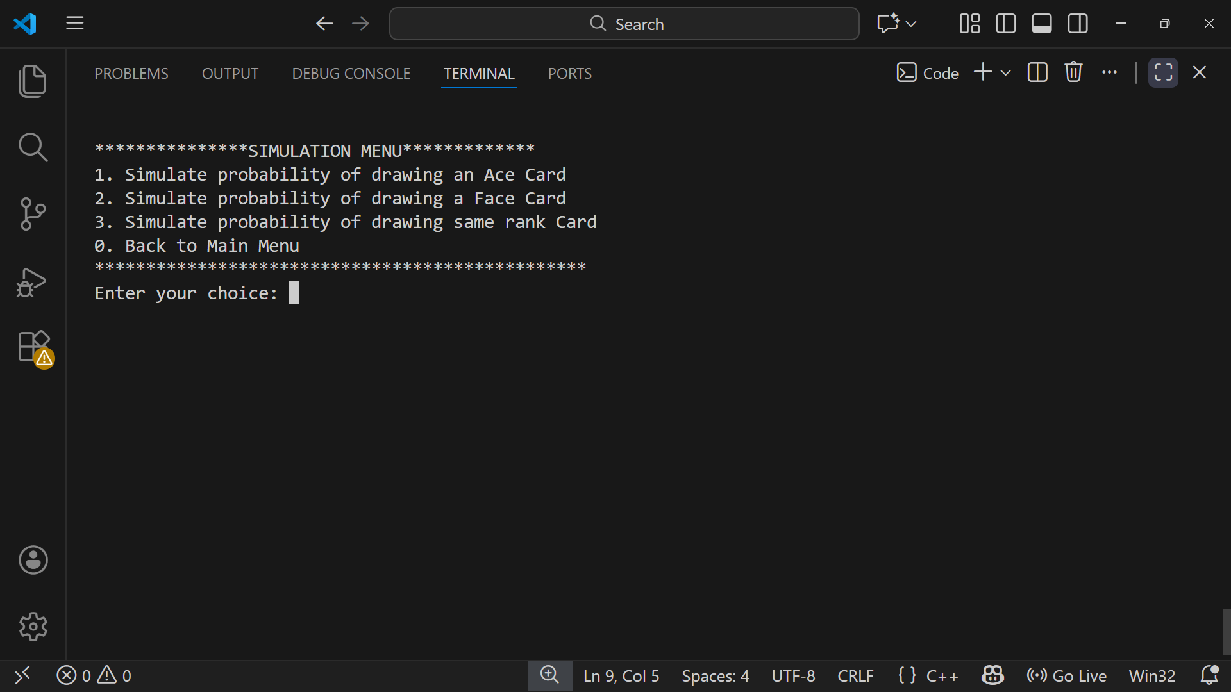
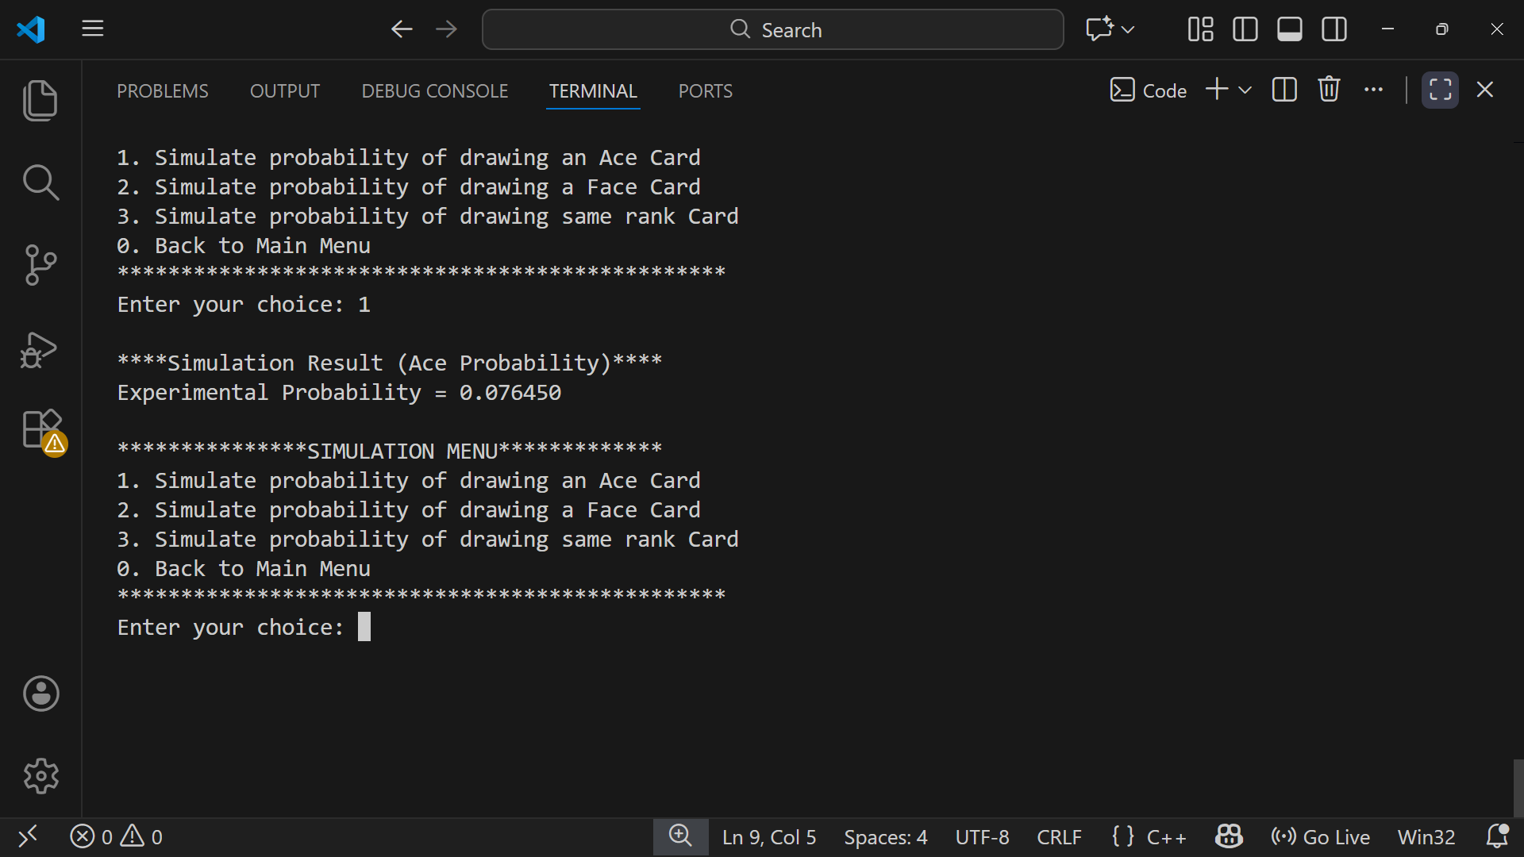
Ace Probability Simulation:

Uses random card draws to estimate the probability of drawing an Ace.
Face Card Probability Simulation:
Uses simulation to estimate the probability of drawing a face card.
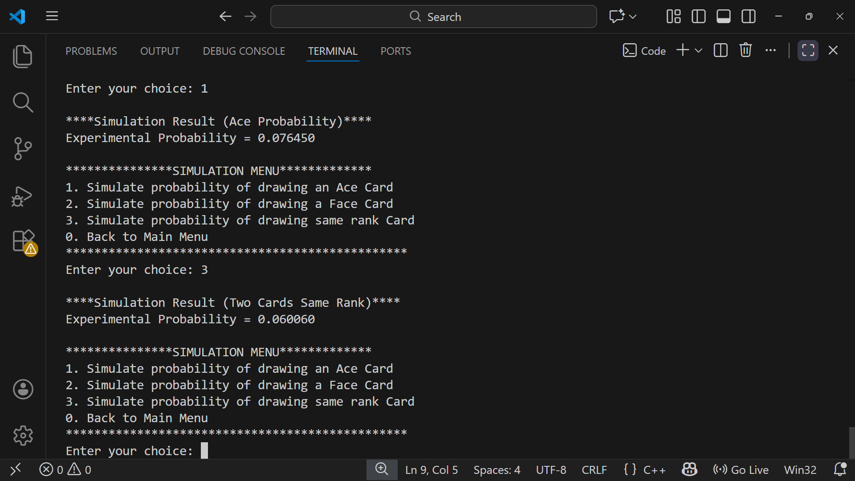
Same Rank Simulation:

Simulates two card draws to estimate the probability of drawing cards with the same rank.

Exit
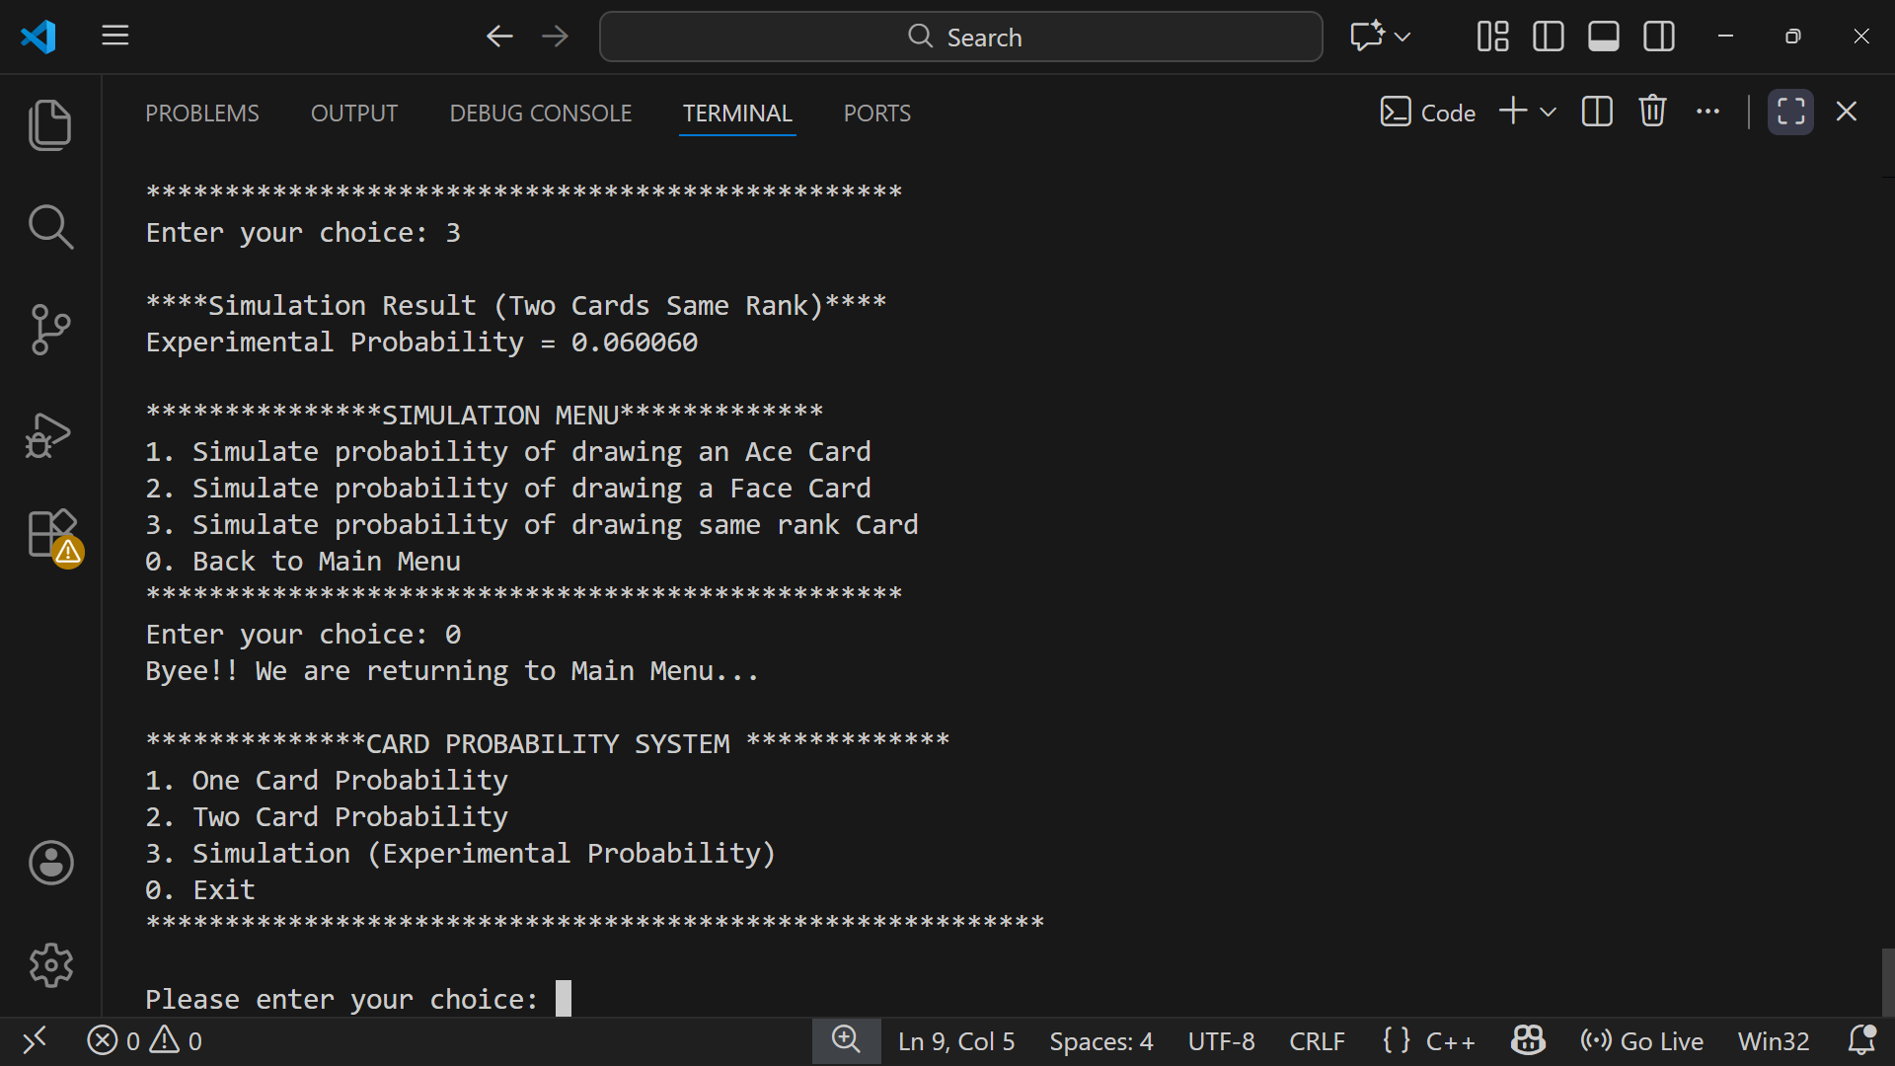
Pressing zero takes the user back to main menu.

Exit
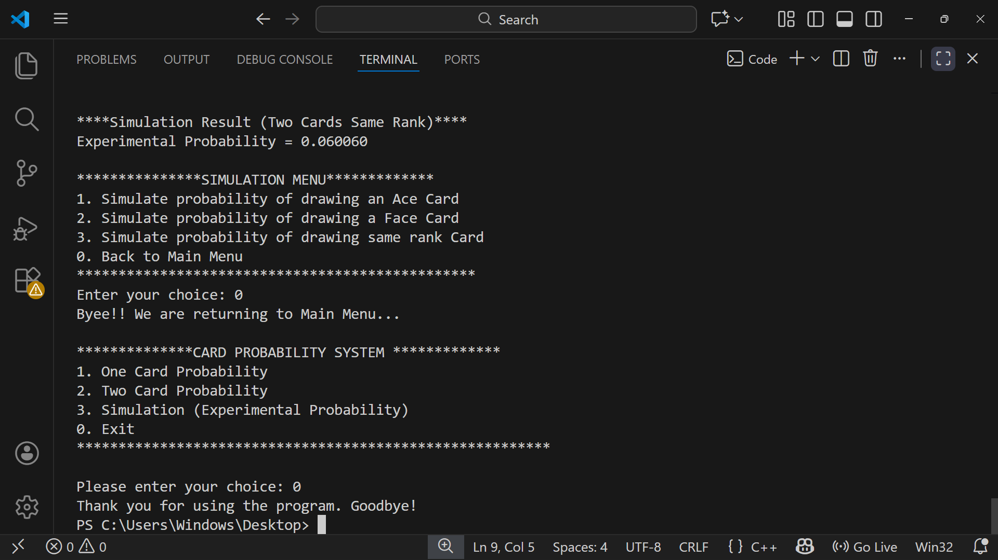
Pressing 0 of the main menu takes the user back to main menu.

