CLOUD COMPUTING

ASSIGNMENT 01
Git Repository Management, Git LFS & GitHub Pages Portfolio
STUDENT INFORMATION
Details | Information
Student Name | Noor Ul Ain
Registration Number | FA24B1-SE-027
GitHub Username | noorulAin027
Course Code | BSE-410
Subject | Cloud Computing
Assignment | Assignment 01

1. INTRODUCTION
This assignment demonstrates practical cloud computing and version control skills using Gitea, GitHub, Git Large File Storage (LFS), and GitHub Pages. It covers repository hosting, managing multiple Git remotes, handling large files, and deploying a personal portfolio website.

2. TASK 1 — GITEA SETUP AND REPOSITORY PUSH

Objective
To configure Gitea on an Ubuntu server and push a local Git repository to the Gitea remote repository.

Description
Gitea was used as a self-hosted Git repository management platform. A repository named Assignment01 was created, and the local project was pushed to the Gitea server.

Screenshot Evidence

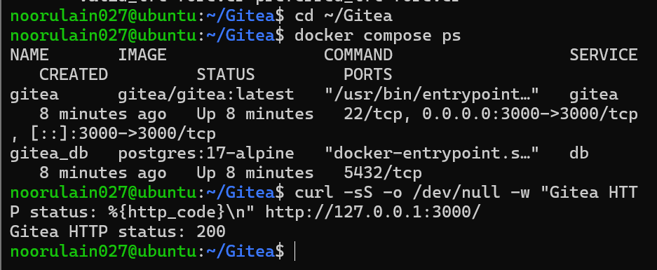
- task1_gitea_running.png

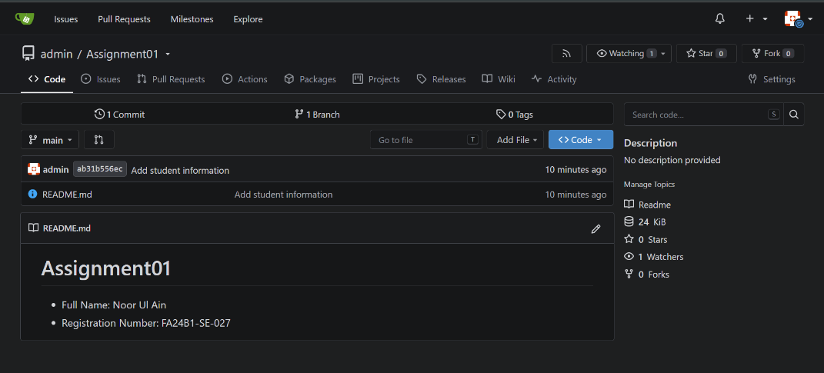
- task1_gitea_push.png

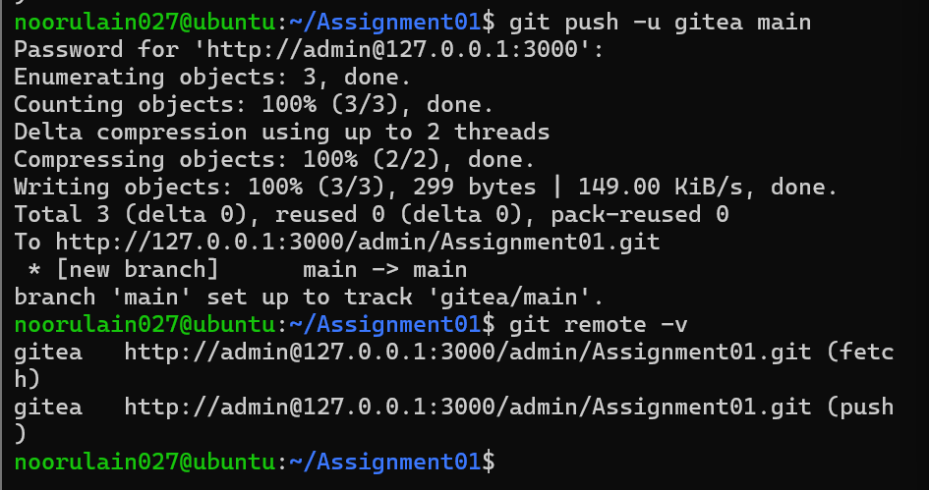
- task1_gitea_repository.png

3. TASK 2 — GITHUB AS A SECOND REMOTE

Objective
To configure GitHub as an additional remote repository and push the project to GitHub.

Description
A second remote was configured so the project could be managed through both Gitea and GitHub. The configured remotes were checked, and the project was pushed to GitHub.

Screenshot Evidence
- task2_remotes.png
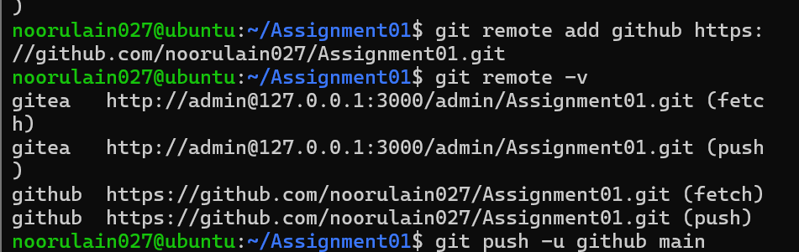
- task2_github_push.png
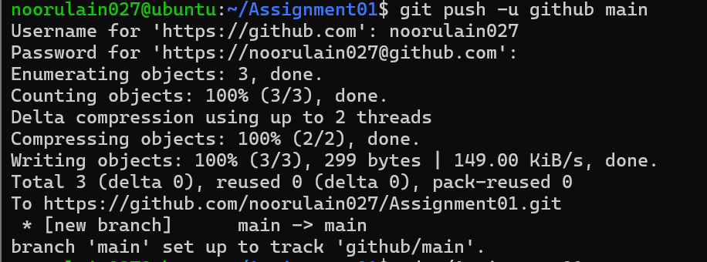
- task2_github_repository.png
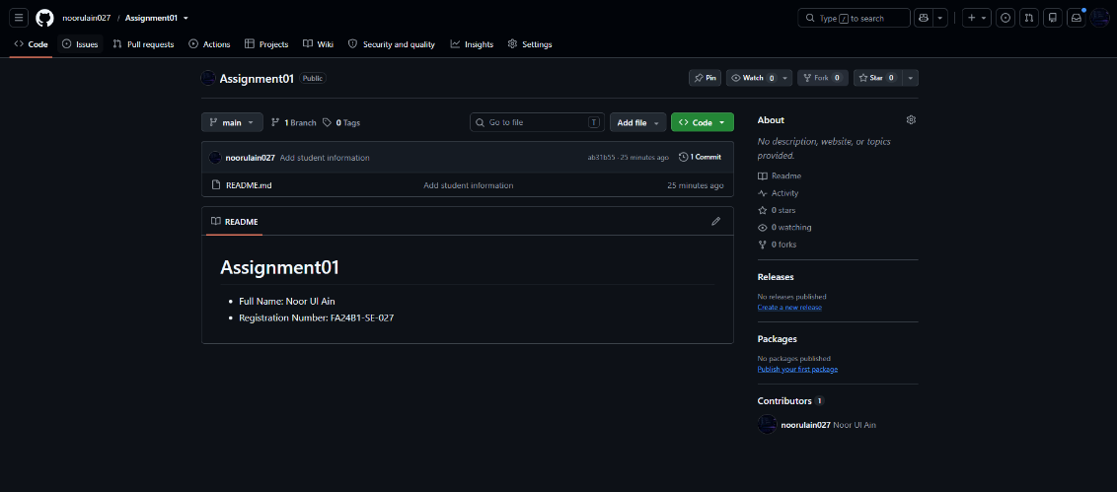
GitHub Repository:
https://github.com/noorulain027/Assignment01

4. TASK 3 — GIT LARGE FILE STORAGE (LFS)

Objective
To configure Git LFS for managing large binary files in a Git repository.

Description
Git Large File Storage (LFS) was configured to track .bin files. Three large binary files were created, added to the repository, committed, and prepared for pushing to GitHub using Git LFS.

Screenshot Evidence
- task3_lfs_setup.png
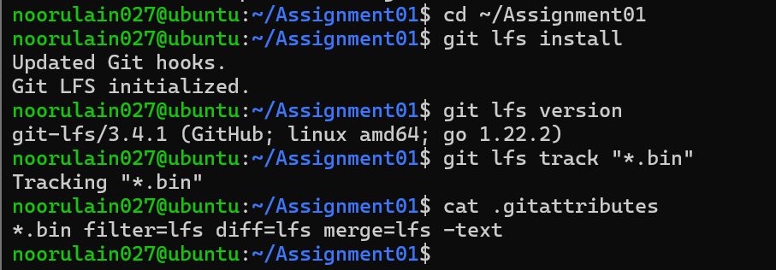
- task3_lfs_files.png
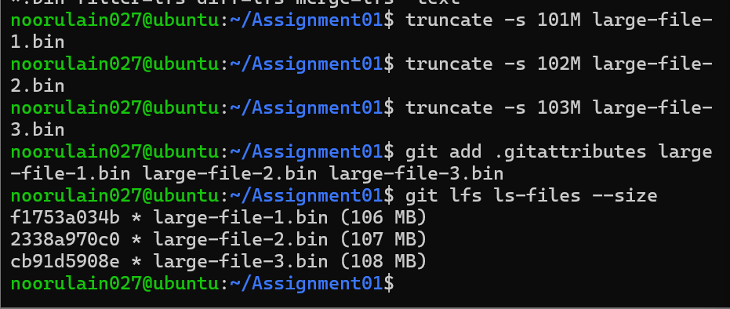
- task3_lfs_push.png
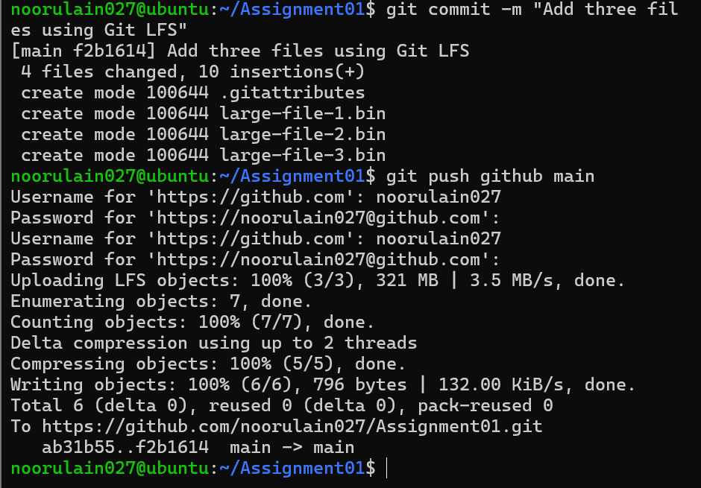

5. TASK 4 — GITHUB PAGES PORTFOLIO

Objective
To create and publish a personal portfolio website using GitHub Pages.

Description
A personal portfolio website was developed using HTML and CSS. The website presents personal information, education, skills, and projects. GitHub Pages was used to publish the website online.
Live Portfolio:
https://noorulain027.github.io/

Screenshot Evidence
- task4_pages_repository.png
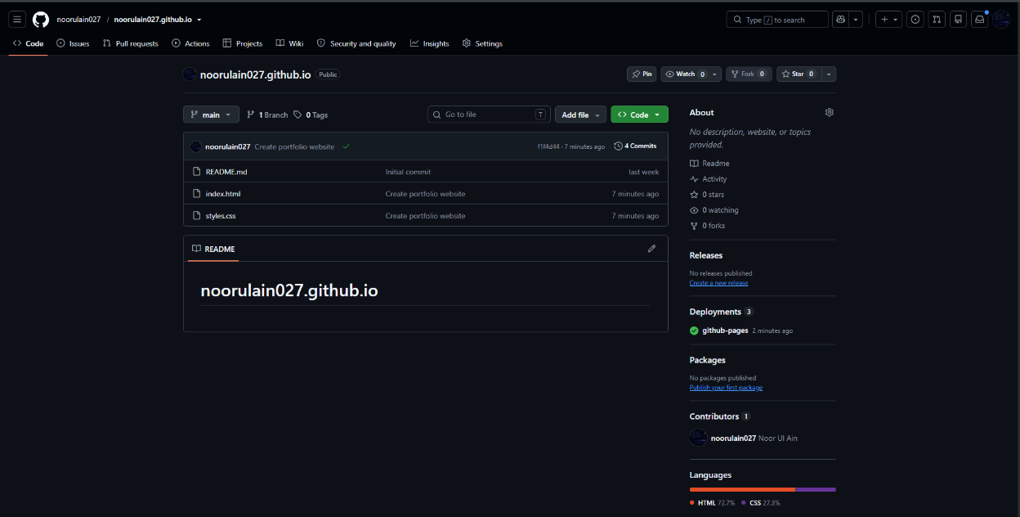
- task4_pages_deployment.png
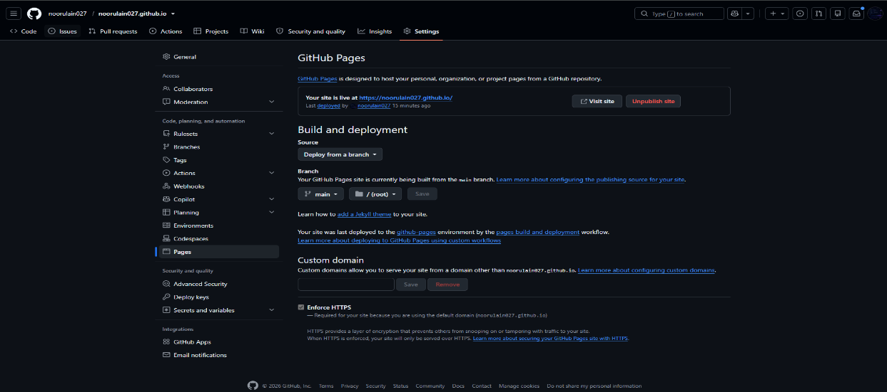
- task4_portfolio_live.png
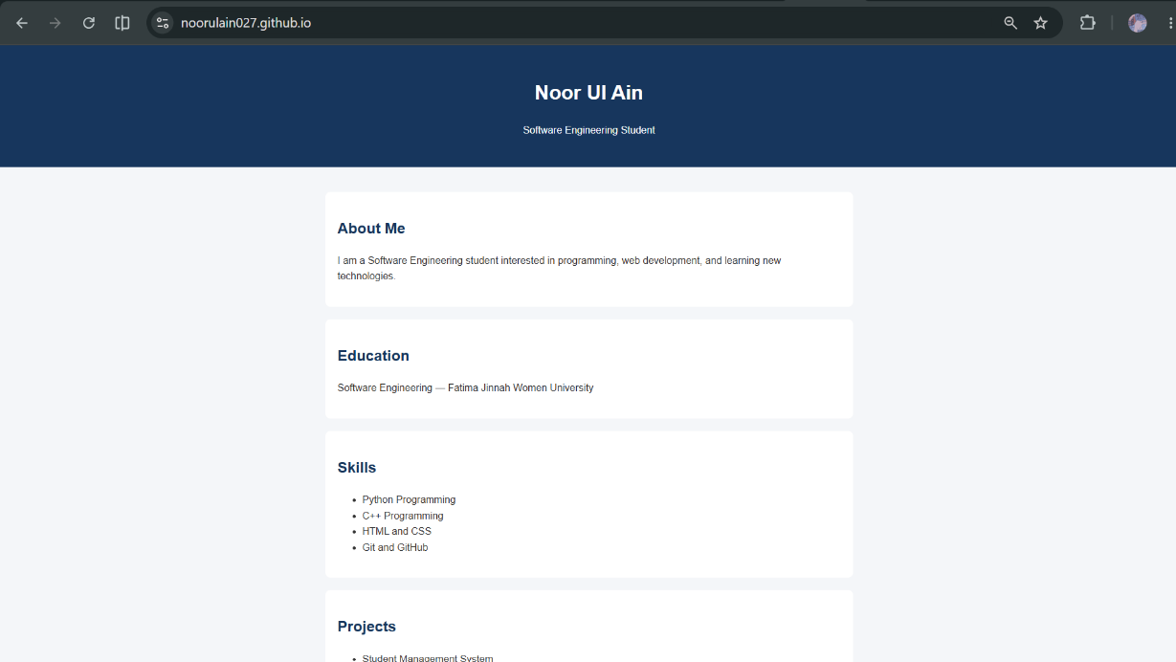

6. CONCLUSION
This assignment provided practical experience with Git repository hosting, multiple remote repositories, Git Large File Storage, and website deployment through GitHub Pages. It demonstrated how development files can be managed using Git and hosted online using cloud-based services.
The included screenshots serve as evidence of the practical tasks performed.
END OF ASSIGNMENT
Course: BSE-410 — Cloud Computing
Student: Noor Ul Ain
GitHub: NoorUlAin027

