Lab Task 1 The index of the maximum of a sequence: A sequence consists of integer numbers and ends with the number 0. Determine the index of the largest element of the sequence. If the highest element is not unique, print the index of the first of them.
public class LabTask1 {
public static void main(String[] args) {
Scanner sc = new Scanner(System.in);

System.out.println("Enter integers one by one (end with 0):");

if (!sc.hasNextInt()) {
System.out.println("No input.");
sc.close();
return;
}

int first = sc.nextInt();
if (first == 0) {
System.out.println("No numbers were entered.");
sc.close();
return;
}

int index = 1; // position of the current number
int maxNumber = first; // initialize max from the first entered number
int maxIndex = 1; // index of the first maximum (so far)

while (sc.hasNextInt()) {
int num = sc.nextInt();
if (num == 0) break;

index++;

if (num > maxNumber) {
maxNumber = num;
maxIndex = index;
}
}

System.out.println("Index of the maximum number: " + maxIndex);
sc.close();
}
}
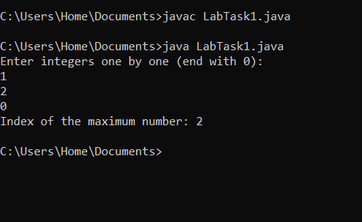

Lab Task 2 The number of even elements of the sequence: Determine the number of even elements in the sequence ending with the number 0.
import java.util.Scanner;

public class LabTask2 {
public static void main(String[] args) {
Scanner sc = new Scanner(System.in);

int countEven = 0; // to count even numbers

System.out.println("Enter numbers (end the sequence with 0):");

int num = sc.nextInt(); // take first number

while (num != 0) { // loop continues until 0 is entered
if (num % 2 == 0) { // check if even
countEven++; // increment count
}
num = sc.nextInt(); // take next number
}

System.out.println("Number of even elements: " + countEven);
}
}

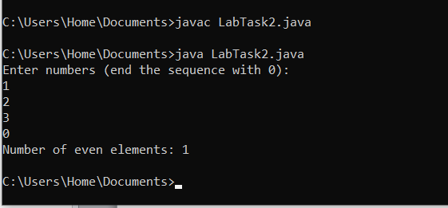
Lab Task 3 The number of elements that are greater than the previous one: A sequence consists of integer numbers and ends with the number 0. Determine how many elements of this sequence are greater than their neighbours above. Input: 1 5 2 4 3
import java.util.Scanner;

public class LabTask3 {
public static void main(String[] args) {
Scanner sc = new Scanner(System.in);

System.out.println("Enter numbers (end the sequence with 0):");

int prev = sc.nextInt(); // first number
int count = 0; // counts numbers greater than previous

while (true) {
int current = sc.nextInt(); // next number

if (current == 0) { // sequence ends
break;
}

if (current > prev) { // compare with previous number
count++;
}

prev = current; // update previous number
}

System.out.println("Number of elements greater than the previous one: " + count);
}
}
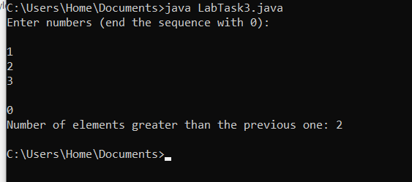

Lab Task 4 Write a program to print following : The program asks the user to enter the number which pattern he/she wants to print. The loop should ask the user whether he or she wishes to perform the operation again. If so, the loop should repeat; otherwise it should terminate.
import java.util.Scanner;

public class LabTask4A {
public static void main(String[] args) {
Scanner sc = new Scanner(System.in);
char choice;

do {
System.out.print("Enter the number of rows for the pattern: ");
int rows = sc.nextInt();

// Example Pattern: Right-Angled Triangle
for (int i = 1; i <= rows; i++) {
for (int j = 1; j <= i; j++) {
System.out.print("* ");
}
System.out.println();
}

System.out.print("Do you want to print another pattern? (y/n): ");
choice = sc.next().charAt(0);

} while (choice == 'y' || choice == 'Y');

System.out.println("Program terminated. Goodbye!");
}
}
import java.util.Scanner;

public class LabTask4 {
public static void main(String[] args) {
Scanner sc = new Scanner(System.in);
char choice;

do {
System.out.println("\nChoose a pattern to print:");
System.out.println("1. Right-Angled Triangle");
System.out.println("2. Square");
System.out.println("3. Inverted Triangle");
System.out.println("4. Pyramid");
System.out.print("Enter your choice (1-4): ");
int patternChoice = sc.nextInt();

System.out.print("Enter the number of rows: ");
int rows = sc.nextInt();

System.out.println(); // blank line before pattern

switch (patternChoice) {
case 1:
// ✅ Right-Angled Triangle
for (int i = 1; i <= rows; i++) {
for (int j = 1; j <= i; j++) {
System.out.print("* ");
}
System.out.println();
}
break;

case 2:
// ✅ Square Pattern
for (int i = 1; i <= rows; i++) {
for (int j = 1; j <= rows; j++) {
System.out.print("* ");
}
System.out.println();
}
break;

case 3:
// ✅ Inverted Triangle
for (int i = rows; i >= 1; i--) {
for (int j = 1; j <= i; j++) {
System.out.print("* ");
}
System.out.println();
}
break;

case 4:
// ✅ Pyramid Pattern
for (int i = 1; i <= rows; i++) {
// spaces
for (int j = i; j < rows; j++) {
System.out.print(" ");
}
// stars
for (int k = 1; k <= (2 * i - 1); k++) {
System.out.print("*");
}
System.out.println();
}
break;

default:
System.out.println("Invalid choice! Please enter a number between 1 and 4.");
}

System.out.print("\nDo you want to print another pattern? (y/n): ");
choice = sc.next().charAt(0);

} while (choice == 'y' || choice == 'Y');

System.out.println("Program terminated. Goodbye!");
sc.close();
}
}
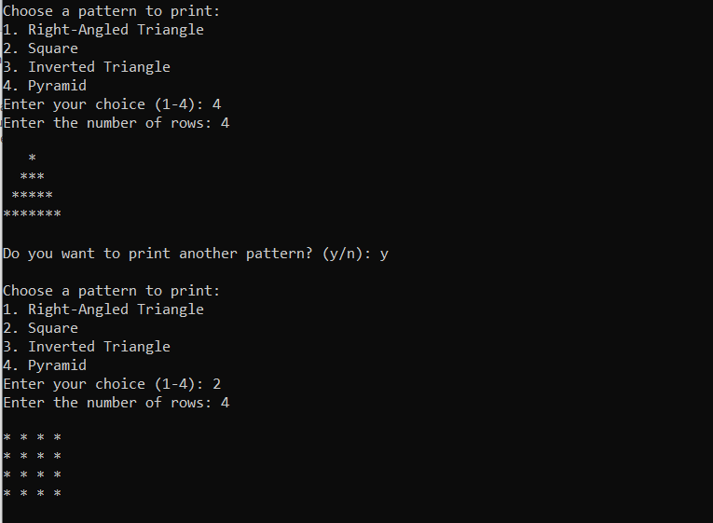
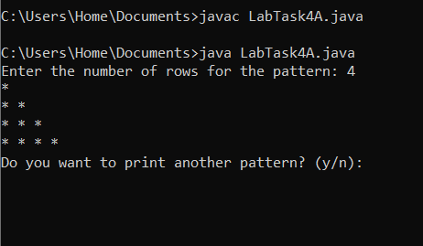

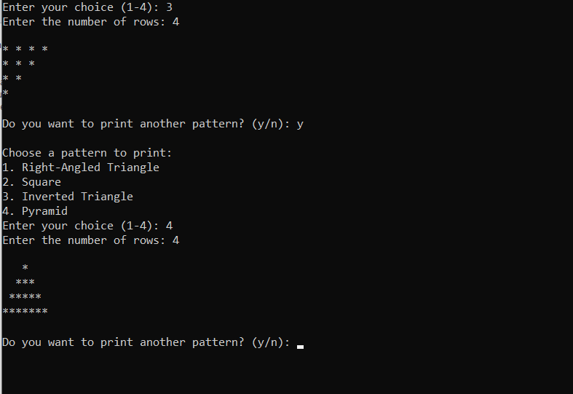

public class LabTask4b {
public static void main(String[] args) {
int rows = 5; // number of rows in the pyramid

for (int i = 1; i <= rows; i++) {
// print spaces
for (int j = i; j < rows; j++) {
System.out.print(" ");
}

// print numbers
for (int k = 1; k <= (2 * i - 1); k++) {
System.out.print(i); // prints the row number (1,2,3,...)
}

System.out.println(); // move to next line
}
}
}
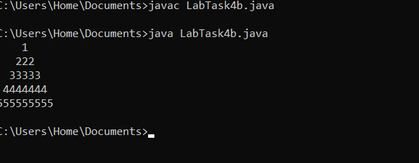
Lab Task 5 Write a program that prompts the user to enter the year and first day of the year and displays the calendar table for the year on the console. For example, if the user entered the year 2013, and 2 for Tuesday, January 1, 2013, your program should display the calendar for each month in the year, as follows:
import java.util.Scanner;

public class LabTask5 {
public static void main(String[] args) {
Scanner sc = new Scanner(System.in);

// Get input from user
System.out.print("Enter the year: ");
int year = sc.nextInt();

System.out.print("Enter the first day of the year (0=Sunday, 1=Monday, ..., 6=Saturday): ");
int firstDayOfYear = sc.nextInt();

// Array for month names
String[] months = {
"January", "February", "March", "April", "May", "June",
"July", "August", "September", "October", "November", "December"
};

// Array for number of days in each month
int[] daysInMonth = {
31, // January
28, // February (will adjust for leap year)
31, 30, 31, 30, 31, 31, 30, 31, 30, 31
};

// Check for leap year (February = 29)
if (isLeapYear(year)) {
daysInMonth[1] = 29;
}

int startDay = firstDayOfYear;

// Loop through all months
for (int month = 0; month < 12; month++) {
printMonthHeader(months[month], year);
printMonthBody(daysInMonth[month], startDay);

// Calculate the starting day for the next month
startDay = (startDay + daysInMonth[month]) % 7;
}

sc.close();
}

// Check leap year
public static boolean isLeapYear(int year) {
return (year % 400 == 0) || (year % 4 == 0 && year % 100 != 0);
}

// Print month header
public static void printMonthHeader(String monthName, int year) {
System.out.println();
System.out.println(" " + monthName + " " + year);
System.out.println("--------------------------------------");
System.out.println("Sun Mon Tue Wed Thu Fri Sat");
}

// Print month body
public static void printMonthBody(int numberOfDays, int startDay) {
for (int i = 0; i < startDay; i++) {
System.out.print(" "); // spaces for empty days
}

for (int day = 1; day <= numberOfDays; day++) {
System.out.printf("%3d ", day);

// Move to next line after Saturday
if ((day + startDay) % 7 == 0) {
System.out.println();
}
}
System.out.println("\n");
}
}
