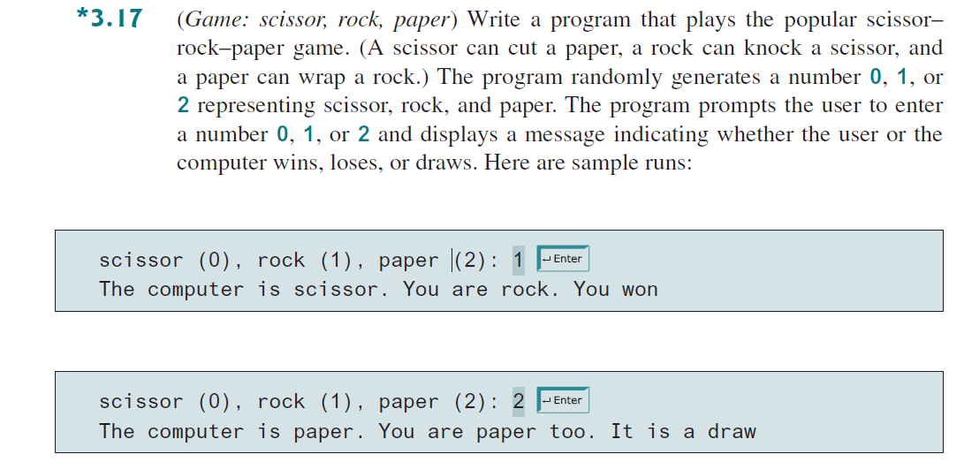Pseudocode on next page
BEGIN
//Declare Variables & Input
GENERATE a random number between 0 and 2 (inclusive)
STORE it in variable computerChoice
DISPLAY "Enter your choice (0 for Scissor, 1 for Rock, 2 for Paper): "
READ userChoice
DISPLAY "Computer chose: " + computerChoice
DISPLAY "You chose: " + userChoice
//Processing & Output :Multiway If Else Structure
IF userChoice == computerChoice THEN
DISPLAY "It's a draw!"
ELSE IF (userChoice == 0 AND computerChoice == 2) OR
(userChoice == 1 AND computerChoice == 0) OR
(userChoice == 2 AND computerChoice == 1) THEN
DISPLAY "You win!"
ELSE
DISPLAY "Computer wins!"
END IF
END
import java.util.Scanner;
public class Game{
public static void main(String[] args){
javac Scanner sc = new Scanner(System.in);
int computerChoice = (int)(Math.random()*3);

System.out.println("Enter userChoice. Scissor 0, Rock 1, Paper 2");
int userChoice = sc.nextInt();
System.out.println("User chose" + userChoice);

if(userChoice == computerChoice){
System.out.println("It's a draw!");
}

else if((userChoice == 0 && computerChoice == 2)||
(userChoice == 1 && computerChoice == 0) ||(userChoice == 2 && computerChoice == 1)){
System.out.println("You win!");

}

else
System.out.println("Computer wins!");

}
}

