Basket Application

Installation :
1.Please download zip file
2.extract zip
3.Apitest folder inside have two folder (database,basket)
4.database folder have mysql schema and data (databasename:basket)
5. basket is our application
6.open basket/app.js file. Then mysql database config enter

Run
1.go to basket directory. Given below command copy past you terminal
2.npm install
3.npm start
4. application runing port :3000

Admin panal Url:http://localhost:3000/users/login

Client Url: http://localhost:3000/#/

Api:
1.An item listing Api to display all the items in the db.
http://localhost:3000/data
method:GET
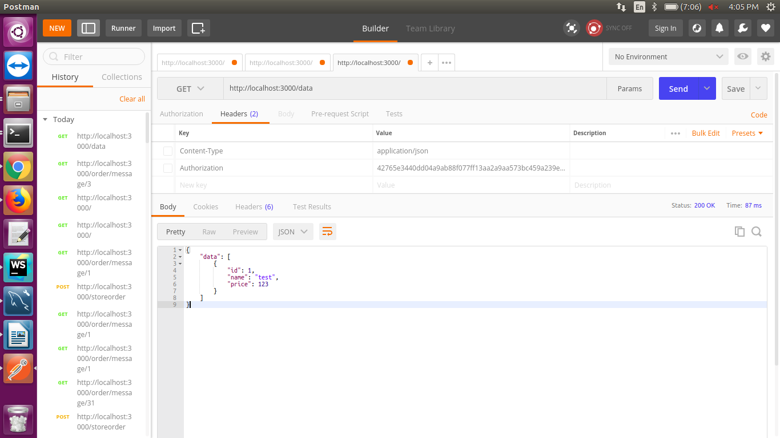

2. Second Api

http://localhost:3000/storeorder
Methos:post

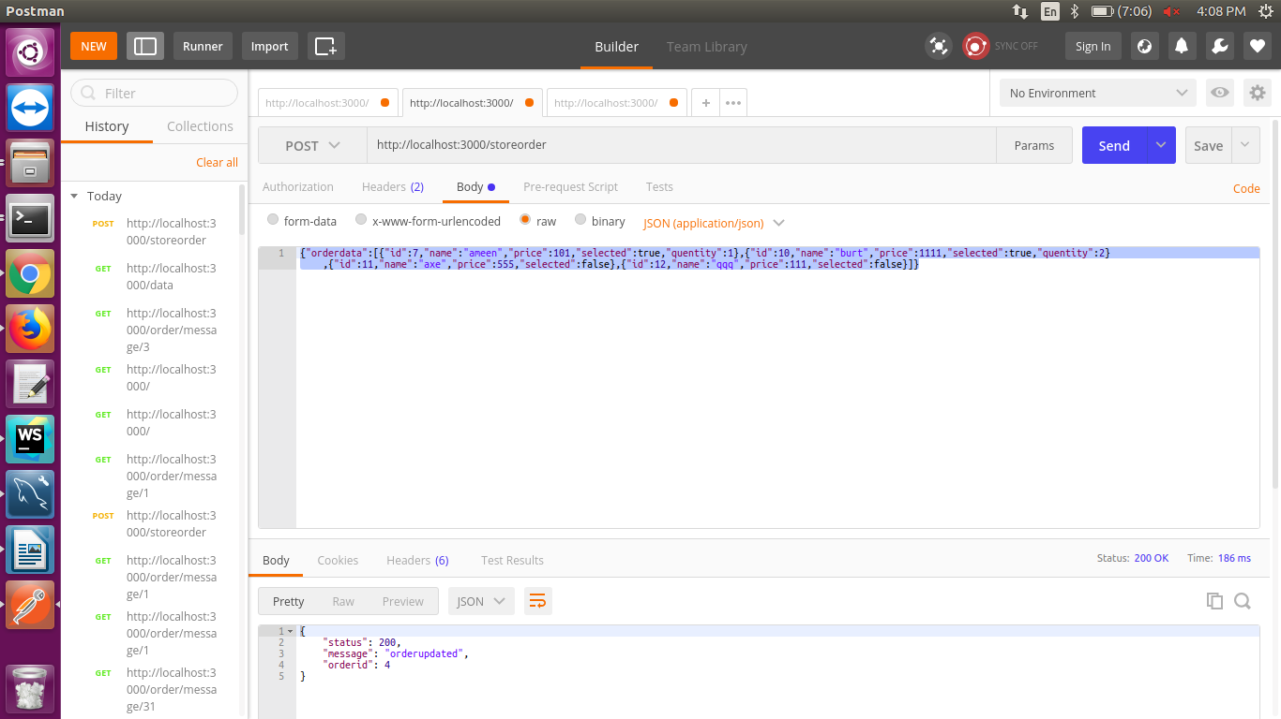

http://localhost:3000/order/message/<orderid>

method:GET

