
University of Central Punjab, Lahore
Software Construction & Development
DOCUMENTATION REPORT
Online Mock Interview Simulator
Student Name | Noor-Ul-Eman
Roll Number | L1F23BSSE0180
Course | Software Construction & Development
Section | SEF6
Semester | 6th Semester
Submitted To | Sir Abdul Rehman Hashmi

Table of Contents

1. Introduction
The Online Mock Interview Simulator is a desktop application built with Java Swing that gives students a realistic, timed platform to practice for Technical, HR, and Behavioral job interviews. Rather than passively reading sample questions or watching tutorials, students log in, choose an interview category, and answer randomly generated questions under a per-question countdown timer.
Once a session ends, the system automatically calculates a score, assigns a performance grade, and generates tailored feedback on a dashboard — giving students immediate, actionable insight into their interview readiness. The application is implemented entirely in Core Java, storing all data in-memory (no external database), and is structured around clear object-oriented design principles across dedicated model, session, report, gui, and util packages.

2. Objectives
- Design and implement a timed, simulated interview environment that mimics real interview pressure.
- Allow students to choose between Technical, HR, and Behavioral interview categories.
- Automatically evaluate submitted answers and calculate an accurate final score.
- Generate personalized, score-based feedback that helps students identify strengths and weaknesses.
- Apply core object-oriented programming concepts — abstraction, inheritance, encapsulation, and polymorphism — in a practical context.
- Deliver an engaging, interactive alternative to conventional CRUD-based academic projects.
- Build a fully self-contained desktop application that requires no external database or internet connection.

3. Problem Statement
In educational institutions, students typically prepare for job interviews by reading sample questions online or watching tutorial videos. While useful for building theoretical knowledge, these methods do not place students under timed, simulated pressure, nor do they offer any feedback on performance. Specifically:
- Students lack a structured, timed environment in which to rehearse real interview conditions.
- No automated mechanism exists to evaluate answers and generate meaningful performance feedback.
- Students have limited insight into their specific strengths and weaknesses before an actual interview.
- Most existing academic projects are simple CRUD applications, offering limited engagement or practical value.
- Poor time management during interviews is common, largely due to a lack of timed practice sessions.
The Online Mock Interview Simulator addresses these problems directly by providing a structured, category-driven, timer-based practice platform — built in Java Swing — that automatically scores responses and generates tailored feedback.

4. Screenshots
The following screenshots walk through a complete user session, from authentication to the final results dashboard.
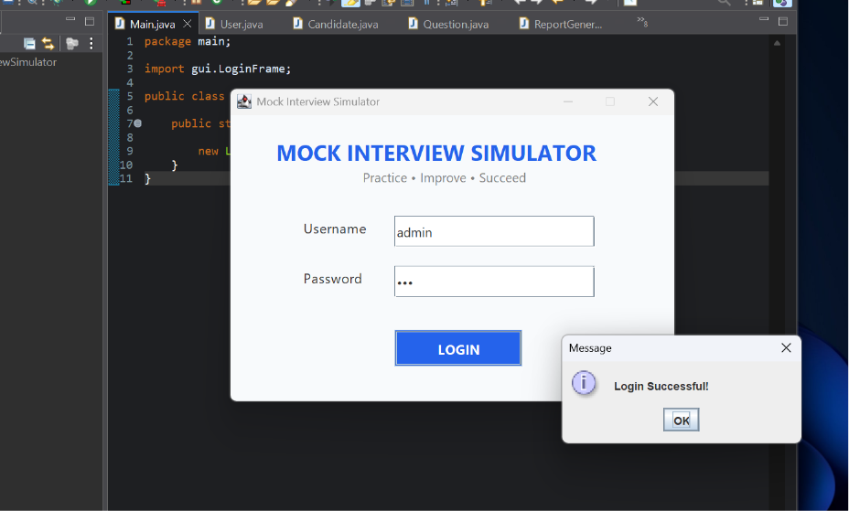
Figure 1: Login Screen
Users authenticate with a username and password before accessing the application.
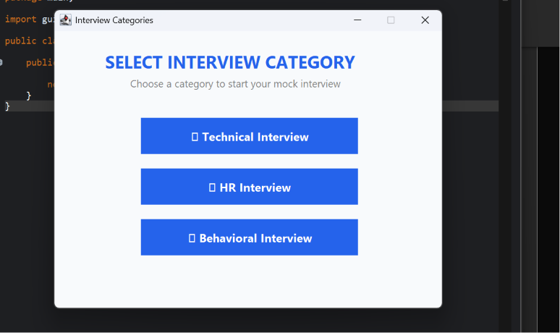
Figure 2: Interview Category Selection
After login, the user selects a Technical, HR, or Behavioral interview category.
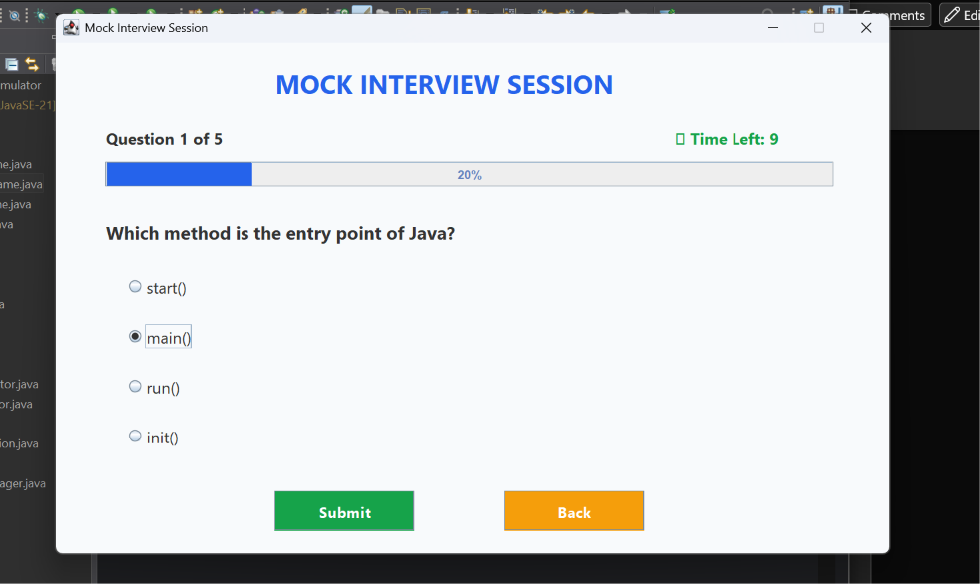
Figure 3: Mock Interview Session (Technical Category)
Each question is shown with a live progress bar and a countdown timer; the system auto-advances when time runs out.
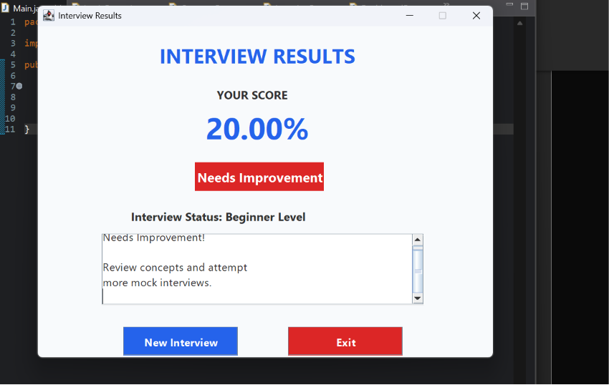
Figure 4: Interview Results Dashboard
After completing all questions, the dashboard displays the final score, performance grade, and tailored feedback.

5. Testing
Manual functional testing was carried out across all core modules — authentication, category selection, the question engine, the timer, and the score/feedback pipeline — to confirm the application behaves correctly under both normal and edge-case conditions.
Test ID | Test Case | Input | Expected Output | Status
TC01 | Valid login | Correct username & password | User authenticated; category screen opens | Pass
TC02 | Invalid login | Incorrect username/password | Error dialog shown; access denied | Pass
TC03 | Category selection | Click “Technical Interview” | Technical question set loads correctly | Pass
TC04 | Random question loading | Start a new session | 5 random, non-repeating questions queued in order | Pass
TC05 | Per-question countdown timer | Question displayed on screen | Timer counts down; auto-advances to next question at 0 | Pass
TC06 | Answer submission | Select an option, click Submit | Response recorded; next question loads | Pass
TC07 | Score calculation | Complete all 5 questions | Correct percentage score computed and displayed | Pass
TC08 | Feedback — low score range | Final score = 20% | “Needs Improvement” feedback displayed | Pass
TC09 | Feedback — high score range | Final score ≥ 90% | “Excellent” feedback displayed | Pass
TC10 | Reset / restart session | Click “New Interview” | Session clears; returns to category screen | Pass
TC11 | Application exit | Click “Exit” | Application closes safely without errors | Pass
All test cases listed above passed during execution, confirming that the core login, session, timer, and scoring workflows behave as expected.

6. Conclusion
The Online Mock Interview Simulator is a practical and engaging Java desktop application that goes beyond standard CRUD-based projects. It demonstrates core OOP principles — including inheritance, encapsulation, polymorphism, and abstraction — while delivering real value to students preparing for technical and HR interviews.
The project proved fully feasible within the semester timeline, required no external database, and was implemented in Eclipse using Java Swing. Functional testing confirmed that the login, timer, scoring, and feedback modules all work reliably together, resulting in a stable, self-contained application that meets its original objectives.

7. Future Enhancements
- AI-based answer evaluation and feedback generation for more nuanced scoring.
- Voice input support to simulate spoken interview responses.
- Advanced performance analytics and progress tracking across multiple sessions.
- Migration from in-memory storage to a persistent database for long-term history.
- A web-based version of the platform for cross-platform accessibility.
- Multi-language question support and peer-to-peer mock interview mode.

