Introduction/background:
Cancer develops through accumulation of mutations; tumors contain multiple genetically distinct clones.
We know that traditionally, pathology relies on study of tissue appearance but only understanding this isn’t enough for understanding progression. Here comes spatial transcriptomics, which allows researchers to study gene expression while preserving the tissue location.
Researchers wanted to determine whether genetic alterations could be detected before tissue appears malignant.
Objective of the study:
Traditional cancer studies focus only on what mutations exist, they ignore where those mutations are taking place inside the tissues, this paper is trying to solve that basically.
Main aspects covered in this are:
- Infer CNVS from spatial transcriptomics data
- Identify clone populations
compare benign and malignant tissues
- Study spatial cancer evolution
Datasets used:
dataset | Tissue type | purpose
prostate | Prostate cancer | Main analysis
Skin scc | Squamous cell carcinoma | Validation
Lymph node | Benign control | Negative control
Medulloblastoma | Brain tumor | Tumor analysis
Breast cancer | Cancer | Heterogeneity analysis
glioblastoma | Brain cancer | Heterogeneity analysis

Methodology:
Tissue samples
↓
Spatial transcriptomics
↓
Gene expression data
↓
Spatial InferCNV (siCNV)
↓
CNV detection
↓
Clone identification
↓
Clone identification
↓
Spatial mapping
↓
Validation (FISH/WGS)
Explanation:
- Tissue samples were collected from prostate, brain, breast etc, then these tissues were divided into “spots” or small regions.
- For each of this “spot”, its gene expression was measured, then from those expressions CNVs were inferred, those CNVs were used to identify clone populations (clones are actually the group of cells which share mutations).
- Those clones were then mapped back to their spatial positions in tissues.
- To verify the inferred CNVS, techniques like DNA FISH and WGS were used.
Results:

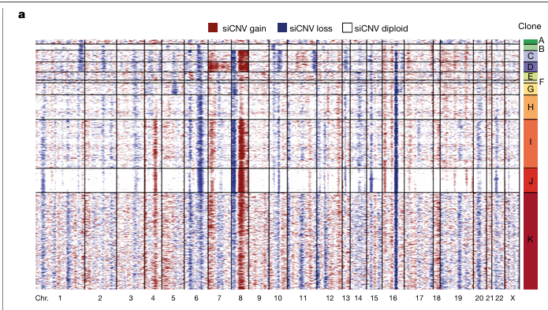
Figure 1 This figure shows the clone structure identified in prostate cancer patient 1, the tissue was divided into smaller “spots” each containing around 10-15 cells
The siCNV method was used to estimate the copy number alterations for each spot, the hierarchical clustering was the applied to group all the spots sharing same mutations, these groups represent different clones that may have originated from the common ancestral cells.
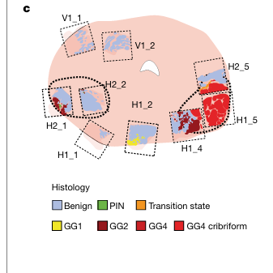
Figure 2 This is the representation of all tissue sections from the patient.
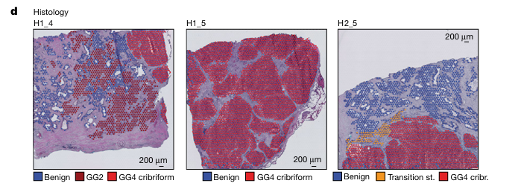
Figure 3 These are just histological annotations for those sections of tissues
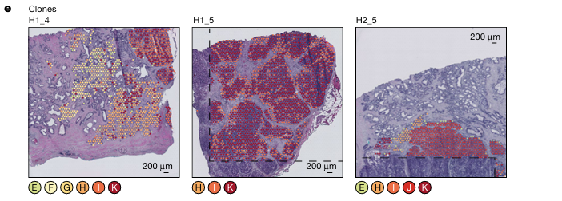
Figure 4 This is spatial visualization of tumor clones
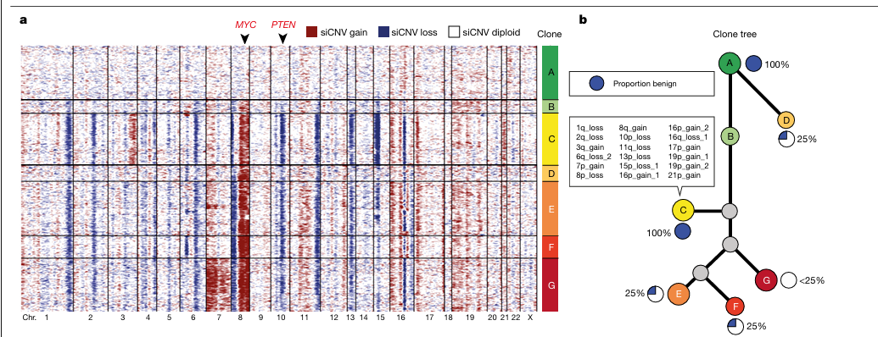
Figure 5 explanation of analysis
Many clones show alterations around chromosome 8 and 10, locations marked MYC and PTEN correspond to important cancer related genes. Some clones share same CNVs suggesting they originated from common ancestor.
The right tree compares the CNV profiles of seven clones (A-G) and shows their evolutionary relationships, clones with similar genetic changes are appear really close in this tree.
The presence of genetically altered clones in benign tissue suggests that some cancer related mutations arise before the tissue develops obvious cancer characteristics.
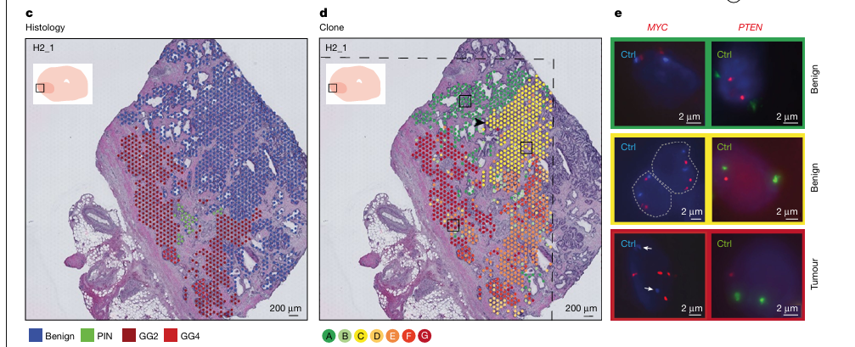
Figure 6 histological and spatial annotation comparison and validation
This is the comparison of the histological appearance of the tissue with its underlying genetic cone structure. First, 2 pathologists examined each spatial spot and classified it as either benign or tumor.
When clone map was compared with pathology map, several clones were found to extend across both benign and tumor regions rather than being restricted to only one tissue type.
This suggests that genetically related cell populations can exist in areas that appear different under microscope.
The right most figure shows FISH validation of MYC and PTEN copy number alterations, confirming that CNVs predicted by the siCNV analysis correspond to real genetic changes in the tissue.
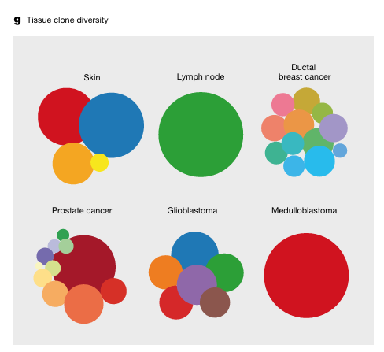
tissue | observation
Lymph node | No CNVs
SCC skin | Malignant and benign clones share events
Medulloblastoma | Homogenous clone
Breast cancer | Multiple clones
glioblastoma | Multiple clones

Major findings:
- Spatial transcriptomics can infer CNVs
- sciCNVs successfully identifies clones
- some benign tissue already contains cancer related CNVs
- some clones exist both in benign and cancerous areas which means cancer evolves gradually not suddenly
- clones can cross histological boundaries
- In conclusion, cancer evolution is spatial and gradual
Strengths:
- Multi organ analysis
- Large dataset
- Spatial information retained
- Experimental validation
Limitations:
- CNVs inferred from RNAs not directly measured everywhere
- Limited number of patients
- Requires high quality spatial transcriptomics data
Conclusion:
Overall, this study shows that cancer evolution follows spatial and gradual process, mutations accumulate and expand as clonal populations across tissue. Even the normal looking regions can have early genetic alterations, this highlights the importance of spatial analysis in understanding the disease progression.

