A CASE-STUDY BASED REPORT
ON
PHISHGUARD AI: INTELLIGENT MACHINE LEARNING BASED PHISHING URL DETECTION AND ANALYSIS
submitted in partial fulfilment of the requirements for the Course
MACHINE LEARNING
BACHELOR OF TECHNOLOGY
in COMPUTER SCIENCE AND ENGINEERING
A.Y.: 2026-27
by
Noor Ul Huda 2520030240
K. Bhavana 2520030253
Under the Esteemed guidance of
Ms. D. Jyosthna
Asst.Professor, Dept. of CSE




INDEX
Abstract 3
Introduction 3
Background 3
Motivation for the Project 3
Overview of the Work Carried Out 4
Scope and Responsible-Use Statement 5
Problem Statement 5
Case-Study Scenario 5
Central Case-Study Question 5
Formal Problem Definition 5
Objectives that Guide the Study 5
Assumptions and Limitations 6
Dataset and Exploratory Data Analysis 6
About the Dataset 6
Purpose of EDA 7
Preparation Steps Actually Performed 7
EDA Exploration - Implementation 7
Summary of EDA Findings 9
Algorithm Selection and Implementation 10

Conclusion 15
Abstract
Phishing websites imitate trusted services to trick users into revealing passwords, personal data and banking details. Blacklist-based defences are slow to react and miss newly registered sites. This case study builds a phishing website detector that classifies a web address as legitimate or phishing using only the text of the URL. Each URL is converted into 10,239 numerical features: ten lexical measurements (length, dots, HTTPS, IP address, path depth, parameters, suspicious words, special characters, digits and entropy), a one-hot encoded top-level domain, and 10,000 character-level TF-IDF features. A Random Forest classifier with 300 trees was trained and compared with a Logistic Regression baseline.
The source dataset of 160,064 URLs was extremely imbalanced (159,244 phishing and 820 legitimate), so a balanced set of 1,640 URLs was built for the final models. Both models reached perfect scores on their held-out test splits. However, a separate 15-URL real-world check showed that the Random Forest wrongly flagged legitimate websites (33% accuracy), while Logistic Regression classified all 15 correctly. We report this honestly as the main limitation. The system was deployed as a Gradio web application on Render, with a risk meter, URL breakdown, plain-language findings, a brand-impersonation check and a typosquat finder.
The developed system provides an interactive web interface in which a user enters a URL and receives a classification, a phishing-risk score and supporting information such as the real domain, URL characteristics and security indicators. The case study demonstrates how machine learning can be applied to a cybersecurity problem, covering data preparation, exploratory analysis, feature engineering, model development, evaluation and application deployment.
1. Introduction
1.1 Background
The growth of the Internet has made people depend on websites and online services for communication, education, shopping and banking. Along with these benefits, cybersecurity threats have increased as well.
Phishing is a form of social engineering in which an attacker sends a link that leads to a fake website. The victim enters credentials or payment details, which the attacker then steals. Traditional defences such as blacklists only block sites that have already been reported. Attackers register new domains constantly, so a blacklist is always behind. Machine learning offers a different approach: learn the patterns that phishing URLs tend to share and apply them to addresses never seen before.
1.2 Motivation for the Project
A URL-only detector is attractive for three reasons. It is fast, because no page has to be downloaded. It is safe, because the user never visits the suspicious site. It is easy to place in browsers, email filters and messaging apps. The project also reflects a practical concern: a model that scores well on a benchmark must still be tested on links it has never seen before anyone trusts it.
A phishing URL may show characteristics such as:
• Unusual URL length or several subdirectories
• Excessive dots or many special characters
• Suspicious words such as login or verify
• An IP address instead of a domain name
• An unusual top-level domain
• No HTTPS
• Random-looking character patterns
A machine-learning model can analyse several of these characteristics at the same time and give an automated prediction. The project was developed to study how machine learning can support automated phishing URL detection.
1.3 Overview of the Work Carried Out
• Loaded and checked a dataset of 160,064 labelled URLs with 13 columns.
• Extracted ten lexical features, encoded the TLD, and built 10,000 character-level TF-IDF features.
• Trained Logistic Regression (baseline) and Random Forest on a stratified 80/20 split.
• Found that 99.49% of the data was phishing, so accuracy alone was misleading; built a balanced dataset of 820 + 820 URLs and retrained.
• Evaluated the balanced models on a held-out split and on 15 external real-world URLs.
• Deployed the final pipeline as a public Gradio web application on Render.
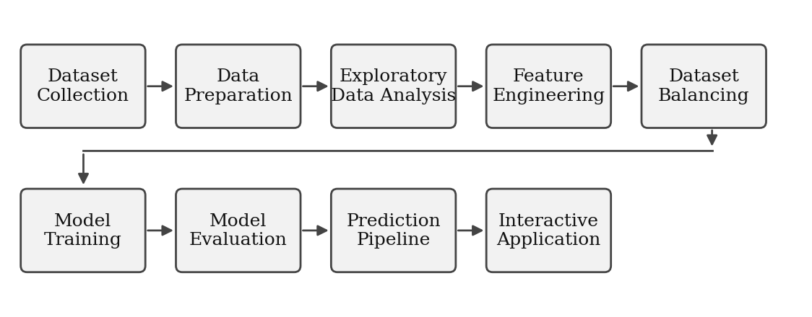
Figure 1: Stages of the project
The dataset contains the original URL together with engineered characteristics such as URL length, number of dots, HTTPS availability, IP presence, suspicious words, TLD, special characters, digit count and entropy. The project combines these structured features with text-based TF-IDF features to give a richer representation of each URL.
1.4 Scope and Responsible-Use Statement
The system analyses only the text of a URL. It does not open the page, inspect its content, check certificates or look up domain age. It produces a risk estimate, not a guarantee, and it can produce both false alarms and missed attacks. It should be used as one signal alongside other safeguards and must not be the sole basis for a security decision. The typosquat finder generates possible look-alike domains; it does not verify that any of them exist or are malicious. The dataset contains public URLs only and no personal data. The application is intended for education and demonstration.
The prediction depends on the patterns present in the training data, so new or highly sophisticated phishing techniques may not always be detected. Users should not rely only on the system when making security-sensitive decisions.
2. Problem Statement
2.1 Case-Study Scenario
A user receives a message containing the link http://secure-paypal-login.account-verify.tk/signin?id=8831. It looks plausible at a glance, but the real domain is account-verify.tk, not paypal.com. The user, or an email filter acting for them, needs a quick, automatic judgement about whether the link is safe, without visiting it.
Manual inspection is not always enough, because phishing URLs are designed to look like genuine ones. The case study therefore considers a machine-learning system that analyses a URL, classifies it as legitimate or phishing, and gives extra information that helps the user understand the prediction.
2.2 Central Case-Study Question
How can machine-learning techniques and URL-based feature engineering be used to classify URLs automatically as legitimate or phishing, and does that performance hold on real URLs that were not part of the benchmark data?
2.3 Formal Problem Definition
Let a URL be represented by a feature vector X = {x1, x2, ..., xn}, where each element describes one characteristic of the URL (n = 10,239 in this project). The objective is to learn a classification function f that maps X to a label Y, where Y = 0 means legitimate and Y = 1 means phishing. The model learns the relationship between URL characteristics and labels from the training data and also estimates the phishing probability P(Y = 1 | X). Performance is measured with accuracy, precision, recall, F1-score, ROC-AUC and the confusion matrix.
2.4 Objectives that Guide the Study
• Study the characteristics of phishing and legitimate URLs.
• Perform exploratory data analysis on the URL dataset.
• Identify useful URL-based features for classification.
• Handle the class imbalance present in the original dataset.
• Create a balanced dataset for model development.
• Apply feature engineering using numerical features, TLD encoding and TF-IDF.
• Implement Logistic Regression and Random Forest classifiers.
• Evaluate the models with classification metrics and an independent real-world check.
• Develop an integrated prediction pipeline.
• Provide an interactive web interface for testing URLs.
2.5 Assumptions and Limitations
Assumptions. The labels in the dataset are correct; the URL text carries enough signal to separate the classes; and the features computed at prediction time are identical to those used in training.
Limitations. The dataset is 99.49% phishing, leaving only 820 legitimate URLs. The final models were trained on 1,640 URLs. The external check contains only 15 URLs, so its results are indicative, not conclusive. The Random Forest performed poorly on that check. No page-content, domain-age or certificate features are used. The brand-impersonation check and typosquat generator are rule-based, not learned. The application runs on a free hosting tier that sleeps when idle. Balanced test performance may not represent real-world performance, and a URL classifier should not replace other cybersecurity measures.
3. Dataset and Exploratory Data Analysis
3.1 About the Dataset
The dataset is a CSV file (phishing_features.csv) of 160,064 URLs with 13 columns. The target column label is 0 for legitimate and 1 for phishing. The remaining columns hold the raw URL, the TLD and ten engineered numerical features.
Column | Type | Description
url | Text | Raw URL string (used for TF-IDF)
label | Target | 0 = legitimate, 1 = phishing
url_length | Numeric | Number of characters in the URL
num_dots | Numeric | Number of dots
has_https | Binary | 1 if the scheme is HTTPS
has_ip | Binary | 1 if the host is an IP address
num_subdirs | Numeric | Number of path segments
num_params | Numeric | Number of query parameters
suspicious_words | Numeric | Count of sensitive keywords (login, verify, bank...)
tld | Categorical | Top-level domain, such as com or tk
special_char_count | Numeric | Non-alphanumeric characters
digits_count | Numeric | Number of digits
entropy | Numeric | Shannon entropy of the URL text

Table 1: Dataset columns
The imbalance was quantified as follows, which means the original dataset has about 194 phishing URLs for every legitimate one.
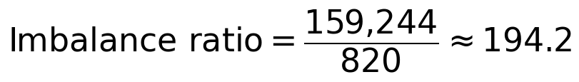
3.2 Purpose of EDA
Exploratory data analysis was used to understand the dataset before training. Its main purposes were:
• To understand the dataset size and feature types.
• To identify the class distribution and any imbalance.
• To understand the numerical URL characteristics.
• To decide which features can be used for machine learning.
• To support decisions on data preparation and feature engineering.
As it turned out, the class distribution analysis changed how the final models were trained.
3.3 Preparation Steps Actually Performed
• Checked the shape (160,064 rows, 13 columns), the column names and the unique labels (0 and 1).
• Checked for duplicate rows and duplicate URLs: none were found.
• Checked for missing values in url and label: none. A URL with no extractable TLD is given the category "unknown".
• Extracted ten numerical features, giving a (160,064 × 10) matrix.
• Built 10,000 character-level TF-IDF features from the URL text.
• One-hot encoded the TLD (536 categories on the full data, 229 on the balanced data).
• Combined the blocks into one sparse matrix (10,546 features on the full data, 10,239 on the balanced data).
• Split the data 80/20 with stratification (128,051 training and 32,013 testing URLs on the full data).
• Built a balanced dataset of 820 legitimate and 820 phishing URLs and split it into 1,312 training and 328 testing URLs.
3.4 EDA Exploration - Implementation
The class distribution and the imbalance ratio were computed as follows. The notebook output is shown below the code.
counts = df['label'].value_counts()
ratio = counts[1] / counts[0]
baseline_acc = counts.max() / counts.sum()

Label Class Count Percentage
0 Legitimate 820 0.51%
1 Phishing 159244 99.49%

Imbalance ratio : 194.20:1
Always predicting 'Phishing' gives ~99.49% accuracy

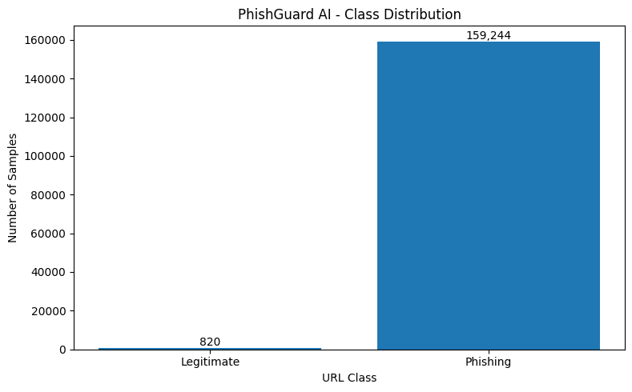
Figure 2: Class distribution and balance analysis from the notebook
Dataset / split | Legitimate | Phishing | Total
Full dataset | 820 | 159,244 | 160,064
Full training split | 656 | 127,395 | 128,051
Full testing split | 164 | 31,849 | 32,013
Balanced dataset | 820 | 820 | 1,640
Balanced testing split | 164 | 164 | 328

Table 2: Class counts for each dataset and split
The URL characteristics used in the study are described below, followed by the three feature groups that were combined.
Feature | What it measures | Example
url_length | Total characters in the URL | 59
num_dots | Dots, hinting at subdomain structure | login.example.com
has_https | Whether HTTPS is used | https:// = 1
has_ip | IP address used instead of a domain | http://192.168.1.5/
num_subdirs | Number of path levels | /account/login/security = 3
num_params | Query parameters after ? | ?id=123&user=test = 2
suspicious_words | Sensitive keywords such as login, verify, bank | secure-paypal-login = 3
tld | Final part of the domain | .com, .org, .tk
special_char_count | Non-alphanumeric characters | @ ? = & % - _
digits_count | Number of digits | b45042.com = 5
entropy | Randomness of the character distribution | 4.63

Table 3: URL features and what they measure
Feature group | Features | Description
Numerical features | 10 | Lexical measurements listed above
TLD encoding | 229 | One-hot columns for the top-level domain (balanced data)
Character TF-IDF | 10,000 | Weights for short character patterns in the URL text
Total | 10,239 | Final feature matrix used by the models

Table 4: Feature groups
3.5 Summary of EDA Findings
• The data had no duplicates and no missing values in url or label.
• The dataset is extremely imbalanced: 194.2 phishing URLs for every legitimate one.
• Because a model that always says "phishing" would score 99.49%, accuracy alone cannot show whether the model has learned anything.
• This is why the first models, which scored 100% on the full test split, could not be trusted, and why a balanced dataset was built.
• The number of TLD categories fell from 536 to 229 once the data was balanced.
• URL structural characteristics provide useful information, and both numerical and text-based features were used.
• The final combined representation contained 10 + 229 + 10,000 = 10,239 features.
4. Algorithm Selection and Implementation
4.1 Algorithms Considered
Two supervised classification algorithms were implemented and trained on the balanced dataset.
Logistic Regression predicts the probability of a class. For binary classification it uses the sigmoid function, shown below, where z is a weighted sum of the features. It was used as a simple, fast baseline for comparison with Random Forest.
Random Forest is an ensemble of decision trees. Each tree is trained on a random sample of the data and features and learns different patterns. Each tree makes its own prediction and the trees vote, so the forest's result is the combined vote and its probability. It was chosen as the main model because it handles many features, copes with mixed numeric and text-derived inputs, can model nonlinear relationships, resists overfitting and gives the probability estimate used as the application's risk score.
Parameter | Random Forest | Logistic Regression
Trees / iterations | 300 trees | max_iter = 2000
Feature sampling | max_features = sqrt | -
Class weighting | balanced | balanced
Solver | - | liblinear
Random seed | 42 | -

Table 5: Model configuration
4.2 Feature Extraction
def extract_url_features(url):
parsed = urlparse(url)
host = parsed.netloc.split('@')[-1].split(':')[0]
return {
'url_length': len(url),
'num_dots': url.count('.'),
'has_https': int(parsed.scheme.lower() == 'https'),
'has_ip': int(bool(re.match(r'^\d{1,3}(\.\d{1,3}){3}$', host))),
'num_subdirs': len([x for x in parsed.path.split('/') if x]),
'num_params': len(parse_qs(parsed.query)),
'suspicious_words': sum(w in url.lower() for w in SUSPICIOUS_TERMS),
'special_char_count': sum(not c.isalnum() for c in url),
'digits_count': sum(c.isdigit() for c in url),
'entropy': shannon_entropy(url),
'tld': host.split('.')[-1].lower() if '.' in host else 'unknown'
}

For the example link in Section 2.1, this produces url_length 59, num_dots 2, has_https 0, has_ip 0, num_subdirs 1, num_params 1, suspicious_words 6, digits_count 4, entropy 4.63 and tld "tk".
4.3 Training
X = hstack([X_num, X_tld, X_tfidf]).tocsr() # 10,239 features
X_train, X_test, y_train, y_test = train_test_split(
X, y, test_size=0.2, stratify=y)

rf_model = RandomForestClassifier(n_estimators=300, max_features='sqrt',
class_weight='balanced', random_state=42)
rf_model.fit(X_train, y_train)

lr_model = LogisticRegression(class_weight='balanced', max_iter=2000, solver='liblinear')
lr_model.fit(X_train, y_train)

joblib.dump(rf_model, 'balanced_rf_model.pkl') # plus TF-IDF and TLD encoder

4.4 Results
Both models were evaluated twice: first on the original imbalanced split, then on the balanced split. Both reached perfect scores on both held-out splits.
Test set | Model | Accuracy | Precision | Recall | F1 | ROC-AUC
Full split (164 / 31,849) | Logistic Regression | 1.00 | 1.00 | 1.00 | 1.00 | 1.00
Full split (164 / 31,849) | Random Forest | 1.00 | 1.00 | 1.00 | 1.00 | 1.00
Balanced split (164 / 164) | Logistic Regression | 1.00 | 1.00 | 1.00 | 1.00 | 1.00
Balanced split (164 / 164) | Random Forest | 1.00 | 1.00 | 1.00 | 1.00 | 1.00

Table 6: Performance on held-out splits
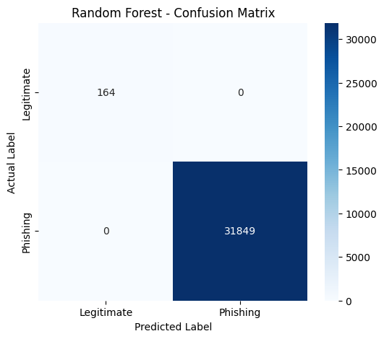
Figure 3: Random Forest confusion matrix on the full test split
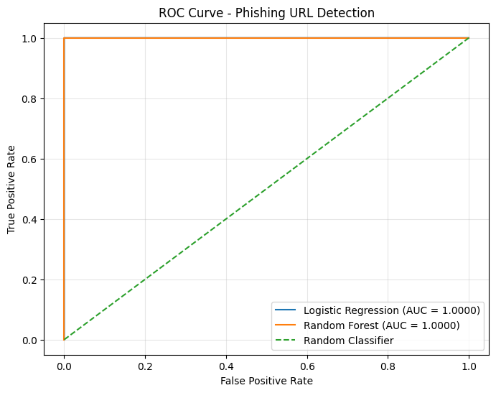
Figure 4: ROC curves for Logistic Regression and Random Forest
4.5 Real-World Validation
Perfect scores on a held-out split, especially on a small dataset, can hide a model that has learned quirks of the dataset. To test this, both balanced models were run on 15 external URLs that were not part of the data: 10 legitimate and 5 phishing.
Metric | Random Forest | Logistic Regression
Accuracy | 0.33 | 1.00
Precision | 0.33 | 1.00
Recall | 1.00 | 1.00
F1-score | 0.50 | 1.00
ROC-AUC | 0.86 | 1.00

Table 7: External validation on 15 real-world URLs
The Random Forest caught all five phishing URLs but classified the legitimate URLs as phishing, including well-known sites such as google.com and github.com. Logistic Regression classified all 15 correctly. With only 15 URLs this is not conclusive, but it is a clear warning. The most likely cause is the very small number of legitimate training examples (820), which gave the model little exposure to normal websites. The perfect held-out scores should therefore be read as evidence of a clean split on a small dataset, not as proof of real-world accuracy.
4.6 Production Pipeline
The same feature-processing steps are applied during training and prediction. A URL is converted into a 10,239-feature vector, passed to the Random Forest and classified as legitimate or phishing. The trained artefacts were saved with joblib: the Random Forest model, the Logistic Regression model, the TF-IDF vectorizer, the TLD encoder, the numerical feature list and the model metadata.
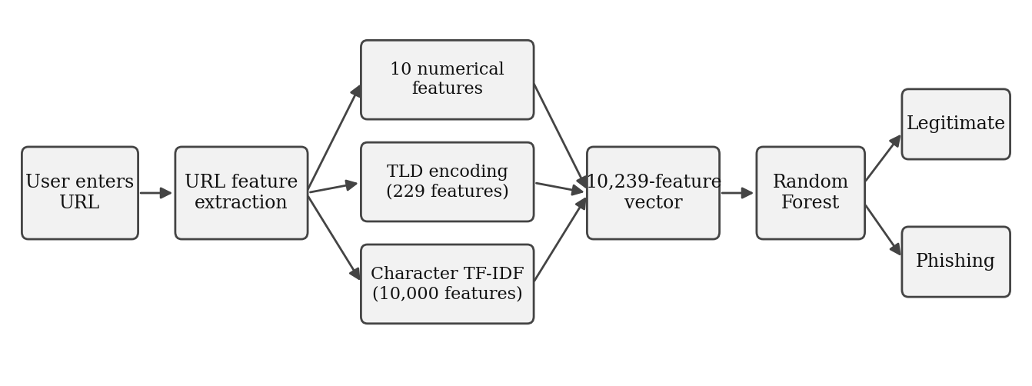
Figure 5: Prediction pipeline
4.7 Deployment and Application
The trained model, TF-IDF vectorizer, TLD encoder and feature list were saved with joblib. A Gradio web application loads them, applies the same feature pipeline to a pasted URL and returns the phishing probability. The code was committed to GitHub and deployed on Render's free tier (Python 3.12, start command python app.py). The live application is at https://two520030240-ml-s4.onrender.com.
def predict_url_app(url):
url = normalize_url(url)
f = extract_url_features(url)
X_num = np.array([[float(f[k]) for k in numeric_features]])
X_tld = tld_encoder.transform(pd.DataFrame({'tld': [f['tld']]}))
X_tfidf = tfidf.transform([url])
X = hstack([X_num, X_tld, X_tfidf]).tocsr() # 10,239 features
proba = best_model.predict_proba(X)[0]
return {'url': url, 'phishing_probability': float(proba[1]), 'features': f}

The application offers a four-level verdict with a risk meter, a breakdown that highlights the real domain, plain-language findings, a rule-based brand-impersonation check, session statistics and a typosquat finder that generates 24 look-alike domains and rates each with the model.
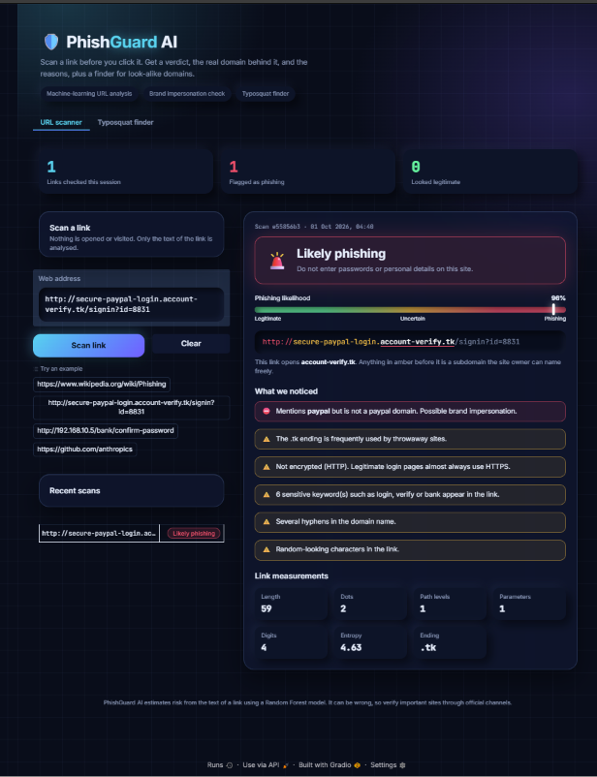 | 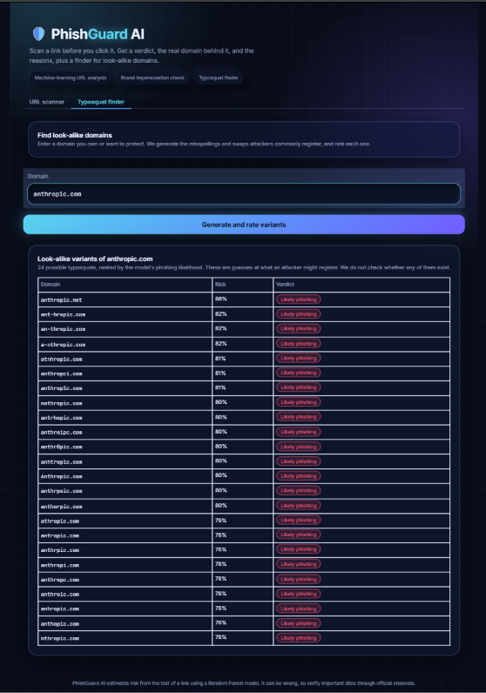
Figure 6: URL scanner | Figure 7: Typosquat finder

4.8 Technology Used
Technology | Purpose
Python | Programming language
Pandas, NumPy, SciPy | Dataset processing and numerical operations
Scikit-learn | Machine learning and feature engineering
TF-IDF | Character-level URL text representation
Random Forest | Final classification model
Logistic Regression | Baseline for comparison
Joblib | Saving models and pipeline steps
Gradio | Interactive web interface
Google Colab | Development and experimentation
GitHub and Render | Code hosting and public deployment

Table 8: Technologies used
5. Conclusion
This case study built a phishing URL detector that combines ten lexical features, an encoded top-level domain and 10,000 character-level TF-IDF features, and classifies them with a 300-tree Random Forest compared against Logistic Regression. The pipeline was saved, deployed as a public web application and extended with a brand-impersonation check and a typosquat finder.
The most important finding is about evaluation. The original dataset was 99.49% phishing, so early perfect scores were misleading. After balancing, both models were again perfect on held-out data, but an external check of 15 real URLs showed that the Random Forest produced false alarms on legitimate sites, while Logistic Regression did not. The project therefore demonstrates a working end-to-end system, and also shows why independent testing matters.
Overall, the project covers the full machine-learning workflow: data collection, preparation, exploratory analysis, feature engineering, balancing, model training, evaluation, a prediction pipeline and an interactive application. It also highlights an important point for security systems: high performance on a particular test set does not guarantee the same performance on unseen real-world data, so independent testing with larger and more varied data is essential.
Future work. The priority is to collect many more legitimate URLs, including deeper paths and login pages, and to evaluate on a larger fresh test set using time-based or domain-based splits. After that, the work should compare further models, report false-positive rates and test which feature groups contribute most. Only then should the Random Forest be considered for real-world use.

Signature of the Team members
S. No. | Name of the Team Member | Roll No. | Signature
1 | Noor Ul Huda | 2520030240
2 | K. Bhavana | 2520030253

