Department of Computer Science and Engineering
2025-2026
Odd Semester

DATA STRUCTURES AND ALGORITHMS-3
(25CS2103E)

LONGEST COMMON PREFIX (LCP) ARRAY FROM A SUFFIX ARRAY
Suffix Array, Kasai’s Algorithm, Substring Queries and Performance Comparison

Parvathaneni Jaahnavi 2520030441
Bhavani Tanya Sri 2520030112
Noor UL Huda 2520030240
Team Number: 12 Section: 5
Under the guidance of D. Swathi
COURSE INSTRUCTOR

Dr. J Sirisha Devi
Professor
Department of Computer Science and Engineering
LONGEST COMMON PREFIX (LCP) ARRAY FROM A SUFFIX ARRAY
1. Abstract
This project implements an efficient method to compute the Longest Common Prefix (LCP) array from a given suffix array. The LCP array stores the length of the longest common prefix between every pair of adjacent suffixes arranged in lexicographical order. The system generates the suffix array, calculates the corresponding LCP array and presents both for visualization and analysis. It also supports substring-related queries, helping users identify repeated patterns and common prefixes within a text. To evaluate efficiency, the execution time of the optimized linear-time method (Kasai’s algorithm) is compared with a naïve approach that compares adjacent suffixes character by character. The application is useful in text processing, data compression, pattern matching, information retrieval and text analytics.
2. Problem Statement
Implement a system to compute the LCP array from a suffix array. The application should determine the longest shared prefixes between adjacent suffixes, support substring-related queries, display both the suffix array and the LCP array for visualization, and compare execution time with naïve approaches.
3. Introduction and Background
A string of length n has exactly n suffixes: the substrings that start at each position and run to the end. For the string "banana" the suffixes are banana, anana, nana, ana, na and a. A suffix array (SA) is an integer array that lists the starting positions of all suffixes after they have been sorted in lexicographical (dictionary) order. It is a compact, cache-friendly alternative to a suffix tree and needs only n integers of memory.
The LCP array is the companion structure of the suffix array. For i ≥ 1, LCP[i] is the length of the longest common prefix of the suffixes SA[i-1] and SA[i]; LCP[0] is defined as 0. Because suffixes that share a long prefix are neighbours in sorted order, the LCP array exposes every repeated substring of the text in a single linear scan. Together, the suffix array and the LCP array can replace a suffix tree for most practical problems while using much less memory.
4. Worked Example
Consider the text T = "banana" (n = 6). Sorting the suffixes lexicographically gives the following suffix array and LCP array.
i | SA[i] | Suffix | LCP[i]
0 | 5 | a | 0
1 | 3 | ana | 1
2 | 1 | anana | 3
3 | 0 | banana | 0
4 | 4 | na | 0
5 | 2 | nana | 2

Table 1: Suffix array and LCP array of "banana"
LCP[1] = 1 because "a" and "ana" share the prefix "a". LCP[2] = 3 because "ana" and "anana" share "ana". LCP[5] = 2 because "na" and "nana" share "na". The largest LCP value is 3, which tells us that the longest repeated substring of "banana" is "ana" (it occurs at positions 1 and 3).
5. Approaches Implemented
5.1 Naïve approach
For every pair of adjacent suffixes in the suffix array, compare the characters one by one until a mismatch or the end of a suffix is reached. Each comparison can cost up to O(n) and there are n−1 pairs, so the worst-case time is O(n²). The worst case occurs on highly repetitive strings, for example "aaaa…a", where almost every comparison runs to the end of the suffix.
5.2 Kasai’s linear-time algorithm
Kasai’s algorithm uses the rank array (the inverse of the suffix array, rank[SA[i]] = i) and processes suffixes in text order instead of sorted order. Its key observation is that if suffix i has an LCP of h with its predecessor in sorted order, then suffix i+1 has an LCP of at least h−1 with its own predecessor. Therefore the running match length h never has to restart from zero; it only decreases by at most one per step. The total number of character comparisons is bounded by 2n and the overall running time is O(n), after the suffix array is available.
6. Substring-Related Queries Supported
• Pattern search / occurrence listing: all starting positions of a pattern P are located by binary search over the suffix array in O(m log n) time (m = |P|), because all suffixes beginning with P form one contiguous block.
• Longest repeated substring: the largest value in the LCP array gives the length of the longest substring that occurs at least twice; the substring is read from the corresponding suffix.
• Count of distinct substrings: the total number of distinct substrings equals n(n+1)/2 − ΣLCP[i]. For "banana" this is 21 − 6 = 15.
• LCP of two arbitrary suffixes: the LCP of any two suffixes is the minimum LCP value in the range between their ranks (a range-minimum query).
7. Applications
• Data compression: repeated substrings found through the LCP array are the basis of dictionary-based and Burrows–Wheeler (BWT) compression.
• Information retrieval: fast substring search and pattern matching in large documents and logs.
• Text analytics: detecting repeated phrases, duplicated content (plagiarism) and frequent patterns in corpora.
• Bioinformatics: finding repeats and motifs in DNA/protein sequences.
8. Complexity Summary
Operation | Time complexity | Extra space
Suffix array (sorting suffixes, as implemented) | O(n² log n) worst case | O(n)
LCP – naïve method | O(n²) | O(n)
LCP – Kasai’s algorithm | O(n) | O(n) (rank array)
Pattern search | O(m log n) | O(1)
Longest repeated substring | O(n) | O(1)
Distinct substring count | O(n) | O(1)

Note: the suffix array in this project is built by directly sorting suffixes for clarity; production systems use O(n log n) prefix doubling or O(n) algorithms such as SA-IS. This does not affect the LCP comparison, since both LCP methods receive the same suffix array.

ALGORITHM / PSEUDO CODE
Algorithm 1: Build Suffix Array
Input : text T of length n
Output: array SA containing start indices of suffixes in sorted order
1. Create list SA = [0, 1, 2, ..., n-1]
2. Sort SA using the key T[i : n] (the suffix starting at i)
3. Return SA

Algorithm 2: Naïve LCP Computation
Input : text T, suffix array SA
Output: array LCP of length n
1. n ← length(T); LCP[0] ← 0
2. for i ← 1 to n-1 do
3. a ← SA[i-1]; b ← SA[i]; k ← 0
4. while a+k < n and b+k < n and T[a+k] = T[b+k] do
5. k ← k + 1
6. LCP[i] ← k
7. return LCP

Algorithm 3: Kasai’s LCP Computation
Input : text T, suffix array SA
Output: array LCP of length n
1. n ← length(T)
2. for i ← 0 to n-1 do rank[SA[i]] ← i // inverse suffix array
3. h ← 0; LCP[0] ← 0
4. for i ← 0 to n-1 do // suffixes in text order
5. if rank[i] > 0 then
6. j ← SA[rank[i] - 1] // predecessor suffix
7. while i+h < n and j+h < n and T[i+h] = T[j+h] do
8. h ← h + 1
9. LCP[rank[i]] ← h
10. if h > 0 then h ← h - 1 // key step
11. else
12. h ← 0
13. return LCP

Algorithm 4: Substring Queries
SEARCH(T, SA, P): // all occurrences of P
lo ← first index in SA whose suffix prefix (length |P|) ≥ P // binary search
hi ← first index in SA whose suffix prefix (length |P|) > P // binary search
return sorted( SA[lo .. hi-1] )

LONGEST_REPEATED_SUBSTRING(T, SA, LCP):
i ← index of the maximum value in LCP
return T[ SA[i] : SA[i] + LCP[i] ]

DISTINCT_SUBSTRINGS(n, LCP):
return n(n+1)/2 − sum(LCP)

LCP_OF_SUFFIXES(i, j): // i ≠ j
(a, b) ← sorted(rank[i], rank[j])
return min( LCP[a+1 .. b] )

Step-by-step trace of Kasai’s algorithm on "banana"
SA = [5, 3, 1, 0, 4, 2]; rank = [3, 2, 5, 1, 4, 0] (rank[i] is the position of suffix i in SA). Initially h = 0.
i | Suffix | rank[i] | Predecessor j | Comparison | h after | LCP[rank[i]]
0 | banana | 3 | SA[2]=1 (anana) | b ≠ a | 0 | LCP[3]=0
1 | anana | 2 | SA[1]=3 (ana) | a,n,a match; then end of "ana" | 3 → 2 | LCP[2]=3
2 | nana | 5 | SA[4]=4 (na) | n,a match; then end of "na" | 2 → 1 | LCP[5]=2
3 | ana | 1 | SA[0]=5 (a) | h=1 already known; "a" ends | 1 → 0 | LCP[1]=1
4 | na | 4 | SA[3]=0 (banana) | n ≠ b | 0 | LCP[4]=0
5 | a | 0 | — (rank = 0) | no predecessor | 0 | LCP[0]=0

Table 2: Trace of Kasai’s algorithm — resulting LCP = [0, 1, 3, 0, 0, 2]
Notice that at i = 3 the algorithm starts with h = 1 (carried over from the previous step) and does not re-compare the first character; this reuse is exactly what makes the algorithm linear.

CODE
The system is implemented in Python 3 (file: lcp_system.py).
"""
LCP Array from Suffix Array (Kasai's algorithm) with substring queries
and a timing comparison against the naive approach.
DSA-3 (25CS2103E) - Team 12
"""
import time
import random
import bisect

def build_suffix_array(text):
"""Suffix array by sorting suffix start indices (lexicographic order)."""
return sorted(range(len(text)), key=lambda i: text[i:])

def lcp_naive(text, sa):
"""Naive O(n^2) worst case: compare adjacent suffixes char by char."""
n = len(text)
lcp = [0] * n # lcp[i] = LCP(suffix sa[i-1], suffix sa[i]); lcp[0] = 0
for i in range(1, n):
a, b = sa[i - 1], sa[i]
k = 0
while a + k < n and b + k < n and text[a + k] == text[b + k]:
k += 1
lcp[i] = k
return lcp

def lcp_kasai(text, sa):
"""Kasai's algorithm: O(n) using the rank (inverse suffix) array."""
n = len(text)
rank = [0] * n
for i, s in enumerate(sa):
rank[s] = i
lcp = [0] * n
h = 0
for i in range(n): # process suffixes in text order
if rank[i] > 0:
j = sa[rank[i] - 1] # previous suffix in sorted order
while i + h < n and j + h < n and text[i + h] == text[j + h]:
h += 1
lcp[rank[i]] = h
if h > 0:
h -= 1 # key step: LCP drops by at most 1
else:
h = 0
return lcp

# ---------------- substring-related queries ----------------
def search_pattern(text, sa, pattern):
"""All occurrences of pattern using binary search on the suffix array."""
n, m = len(text), len(pattern)
lo, hi = 0, n
while lo < hi:
mid = (lo + hi) // 2
if text[sa[mid]:sa[mid] + m] < pattern:
lo = mid + 1
else:
hi = mid
start = lo
hi = n
while lo < hi:
mid = (lo + hi) // 2
if text[sa[mid]:sa[mid] + m] <= pattern:
lo = mid + 1
else:
hi = mid
return sorted(sa[start:lo])

def longest_repeated_substring(text, sa, lcp):
"""Longest substring that occurs at least twice = max value in LCP array."""
if len(text) < 2:
return ""
i = max(range(len(lcp)), key=lambda x: lcp[x])
return text[sa[i]:sa[i] + lcp[i]]

def count_distinct_substrings(text, lcp):
"""n(n+1)/2 minus sum of LCP values."""
n = len(text)
return n * (n + 1) // 2 - sum(lcp)

def lcp_of_two_suffixes(sa, lcp, rank, i, j):
"""LCP of suffixes starting at i and j = range-minimum over the LCP array."""
if i == j:
return None
a, b = sorted((rank[i], rank[j]))
return min(lcp[a + 1:b + 1])

# ---------------- visualisation ----------------
def show_tables(text, sa, lcp):
print(f"{'i':>3} | {'SA[i]':>5} | {'LCP[i]':>6} | Suffix")
print("-" * 40)
for i, s in enumerate(sa):
print(f"{i:>3} | {s:>5} | {lcp[i]:>6} | {text[s:]}")

def benchmark(sizes, alphabet, label):
print(f"\n{label}")
print(f"{'n':>8} | {'Naive (ms)':>12} | {'Kasai (ms)':>12} | {'Speed-up':>9} | Match")
print("-" * 58)
for n in sizes:
random.seed(7)
t = "".join(random.choice(alphabet) for _ in range(n)) if len(alphabet) > 1 else alphabet * n
sa = build_suffix_array(t)
t0 = time.perf_counter(); a = lcp_naive(t, sa); t1 = time.perf_counter()
b = lcp_kasai(t, sa); t2 = time.perf_counter()
nv, ks = (t1 - t0) * 1000, (t2 - t1) * 1000
print(f"{n:>8} | {nv:>12.3f} | {ks:>12.3f} | {nv / ks:>8.1f}x | {a == b}")

if __name__ == "__main__":
text = "banana"
print("TEXT:", text)
sa = build_suffix_array(text)
lcp = lcp_kasai(text, sa)
assert lcp == lcp_naive(text, sa)
show_tables(text, sa, lcp)
print("\nSuffix Array:", sa)
print("LCP Array :", lcp)

print("\n--- Substring queries on 'banana' ---")
for p in ["ana", "na", "xyz"]:
print(f"Occurrences of '{p}':", search_pattern(text, sa, p))
print("Longest repeated substring:", longest_repeated_substring(text, sa, lcp))
print("Distinct substrings:", count_distinct_substrings(text, lcp))
rank = [0] * len(text)
for i, s in enumerate(sa):
rank[s] = i
print("LCP of suffixes at 1 ('anana') and 3 ('ana'):", lcp_of_two_suffixes(sa, lcp, rank, 1, 3))

text2 = "mississippi"
print("\nTEXT:", text2)
sa2 = build_suffix_array(text2)
lcp2 = lcp_kasai(text2, sa2)
show_tables(text2, sa2, lcp2)
print("Longest repeated substring:", longest_repeated_substring(text2, sa2, lcp2))
print("Distinct substrings:", count_distinct_substrings(text2, lcp2))
print("Occurrences of 'issi':", search_pattern(text2, sa2, "issi"))

benchmark([1000, 2000, 4000, 8000], "ab", "Benchmark 1: random binary string (alphabet {a,b})")
benchmark([500, 1000, 2000, 4000], "a", "Benchmark 2: worst case, all identical characters")

RESULTS
1. Screenshots
Figure 1 shows the suffix array and LCP array of "banana" displayed in tabular form. The program also asserts that the Kasai output equals the naïve output.
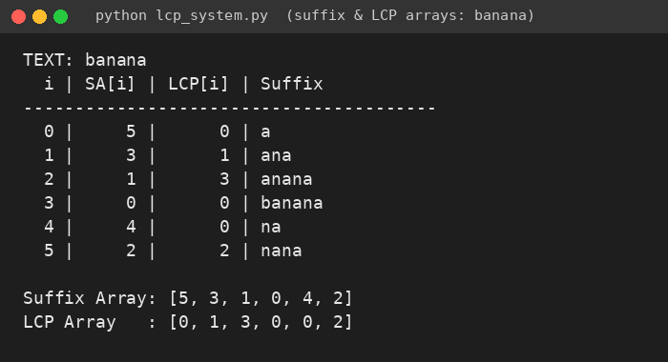
Figure 1: Suffix array and LCP array visualization for "banana"
Figure 2 shows the substring-related queries: pattern occurrences, longest repeated substring, number of distinct substrings and the LCP of two arbitrary suffixes.
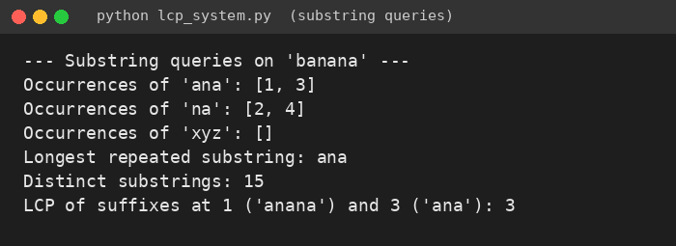
Figure 2: Substring query output
Figure 3 shows a second test string, "mississippi", whose longest repeated substring "issi" (LCP = 4) appears at positions 1 and 4.
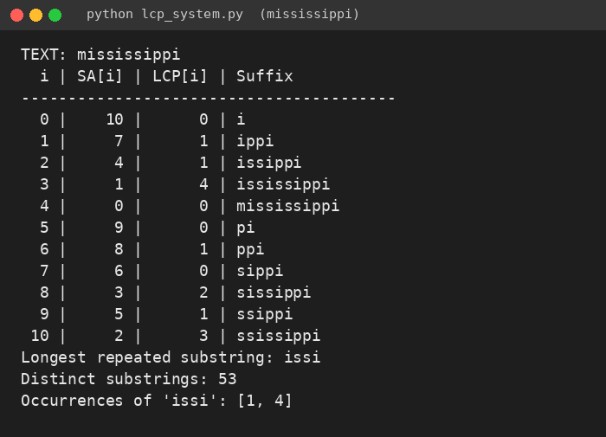
Figure 3: Suffix array and LCP array for "mississippi"
2. Execution-Time Comparison
Both methods were run on the same suffix arrays and their outputs were verified to be identical (Match = True in every row). Times are in milliseconds on the development machine and will vary slightly between runs.
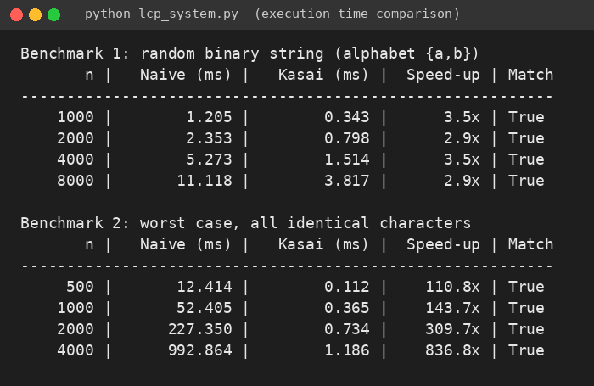
Figure 4: Console output of the timing benchmarks
Benchmark 1 – random binary strings
n | Naïve (ms) | Kasai (ms) | Speed-up
1000 | 1.205 | 0.343 | 3.5×
2000 | 2.353 | 0.798 | 2.9×
4000 | 5.273 | 1.514 | 3.5×
8000 | 11.118 | 3.817 | 2.9×

Benchmark 2 – worst case (all identical characters)
n | Naïve (ms) | Kasai (ms) | Speed-up
500 | 12.414 | 0.112 | 110.8×
1000 | 52.405 | 0.365 | 143.7×
2000 | 227.350 | 0.734 | 309.7×
4000 | 992.864 | 1.186 | 836.8×

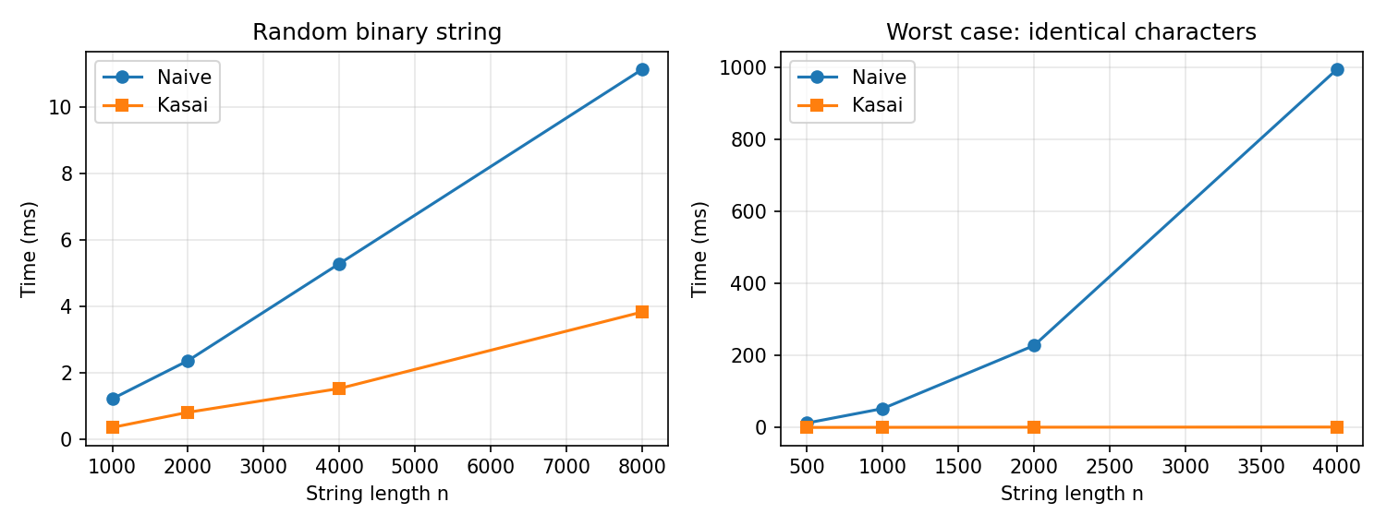
Figure 5: Naïve vs Kasai execution time
3. Observations and Conclusion
• Correctness: Kasai’s algorithm produced the same LCP array as the naïve method in every test.
• Typical input: on random strings adjacent suffixes share only short prefixes, so the naïve method is also fast and the gain is about 3×.
• Worst case: on repetitive input the naïve time grows quadratically (doubling n roughly quadruples the time: 52 ms → 227 ms → 993 ms), while Kasai’s time grows linearly (0.37 ms → 0.73 ms → 1.19 ms), giving a speed-up of more than 800× at n = 4000.
• Usefulness: the suffix array together with the LCP array gives fast substring search, longest-repeated-substring detection and distinct-substring counting, which are the building blocks for compression and text analytics.
The project therefore shows that computing the LCP array with Kasai’s O(n) algorithm is substantially more efficient than the naïve O(n²) method, and that the resulting structure supports a wide range of substring queries.
4. References
• T. Kasai, G. Lee, H. Arimura, S. Arikawa, K. Park, “Linear-time longest-common-prefix computation in suffix arrays and its applications,” CPM 2001.
• U. Manber and G. Myers, “Suffix arrays: a new method for on-line string searches,” SIAM Journal on Computing, 1993.
• T. H. Cormen, C. E. Leiserson, R. L. Rivest, C. Stein, Introduction to Algorithms, MIT Press.

