“Linux Concurrent Producer–Consumer System Using Semaphores”
A Project Report submitted in partial fulfillment of the requirements for the award of the degree of

BACHELOR OF TECHNOLOGY
in
DEPARTMENT OF COMPUTER SCIENCE ENGINEERING
Course: Operating Systems and Systems Programming (25CS21014E)
By
Noor Ul Huda | 2520030240
P. Jaahanavi | 2520030441

Under the Esteemed Guidance of
Ms. Soumya
Faculty, Department of Computer Science and Engineering



K L (Deemed to be) University
DEPARTMENT OF COMPUTER SCIENCE ENGINEERING
&
DEPARTMENT OF COMPUTER SCIENCE AND INFORMATION TECHNOLOGY
Declaration
The Project Report entitled “Linux Concurrent Producer–Consumer System Using Semaphores” is a record of bonafide work of Noor Ul Huda – 2520030240 and P. Jaahanavi – 2520030441, submitted in partial fulfillment for the award of B.Tech in Computer Science and Engineering (or) Computer Science and Information Technology to K L (Deemed to be) University. The results embodied in this report have not been copied from any other department / University / Institute.

Noor Ul Huda | 2520030240
P. Jaahanavi | 2520030441

K L (Deemed to be) University
DEPARTMENT OF COMPUTER SCIENCE ENGINEERING
CERTIFICATE
This is to certify that the project report entitled “Linux Concurrent Producer–Consumer System Using Semaphores” is a bonafide work done and submitted by Noor Ul Huda – 2520030240 and P. Jaahanavi – 2520030441, in partial fulfillment of the requirements for the award of the degree of BACHELOR OF TECHNOLOGY in the Department of Computer Science Engineering, K L (Deemed to be University), during the academic year 2025–2026, as part of the course Operating Systems and Systems Programming (25CS21014E).

Signature of the Guide

Signature of the Course Coordinator Signature of the HOD

ACKNOWLEDGEMENT
The success of this project would not have been possible without the timely help and guidance rendered by many people. We wish to express our sincere thanks to all those who assisted us in one way or the other in the completion of our project.
Our greatest appreciation goes to our guide and Course Coordinator, Ms. Soumya, Department of Computer Science and Engineering, for her tremendous support, encouragement and guidance throughout this project.
We express our gratitude to Dr. P. Venkateshwara Rao (CSE), Head of the Department of Computer Science and Engineering, for providing us with the facilities and the means by which we were able to complete this project-based lab.
We thank all the members of the teaching and non-teaching staff who have assisted us directly or indirectly in the successful completion of this project. Finally, we sincerely thank our parents, friends and classmates for their kind help and cooperation during our work.

Noor Ul Huda 2520030240
P. Jaahanavi 2520030441
Abstract
Concurrency is essential in modern computing for multitasking and resource sharing, but it introduces the risk of data inconsistency when several processes or threads access shared resources at the same time. The Producer–Consumer problem is a classic and fundamental concurrency challenge in Operating Systems that captures this risk in a simple, realistic model.
This project, Linux Concurrent Producer–Consumer System Using Semaphores, implements a Linux-based concurrent system in C using POSIX threads and semaphores. Multiple producer threads generate data items and place them in a fixed-size circular (bounded) buffer, while multiple consumer threads retrieve and process them. Two counting semaphores (empty_slots and full_slots) coordinate the producers and consumers so that a producer never writes into a full buffer and a consumer never reads from an empty one, and a mutex guarantees mutual exclusion on the buffer indices, thereby eliminating race conditions.
The system was compiled with GCC on Ubuntu/Linux and tested with several producer and consumer configurations. In every run, all items were produced and consumed exactly once with buffer integrity preserved. A performance comparison against a busy-waiting implementation showed that the semaphore-based design completed the same workload in about 0.02 s, versus about 16 s for busy-waiting on a single-core test machine, because blocked threads sleep instead of wasting CPU cycles. The project bridges theory and practice by giving hands-on experience with mutual exclusion, inter-process synchronization, process scheduling and the POSIX APIs, and it forms a base for extensions such as message queues, shared-memory IPC, deadlock detection and distributed producer–consumer systems.
Index
S. No. | Chapter | Topics / Subtopics | Page No.
 | Acknowledgement |  | i
 | Abstract |  | ii
1 | Introduction |  | 1–2
 |  | 1.1 Background of the Project
 |  | 1.2 Problem Statement
 |  | 1.3 Scope of the Project
 |  | 1.4 Objectives of the Project
 |  | 1.5 Importance of the Application
 |  | 1.6 Target Users / Audience
2 | OS Concepts and Background Study |  | 3–5
 |  | 2.1 Operating System Concepts Related to the Project
 |  | 2.2 Existing Methods / Algorithms
 |  | 2.3 Proposed Approach
 |  | 2.4 Advantages of the Proposed Approach
3 | System Requirements |  | 6–7
 |  | 3.1 Hardware Requirements
 |  | 3.2 Software Requirements
 |  | 3.3 Operating System Environment – Ubuntu / WSL
 |  | 3.4 Development Tools and Compilers
4 | Technology and Tools Used |  | 8–9
 |  | 4.1 C / C++ Programming
 |  | 4.2 GCC Compiler
 |  | 4.3 Linux System Calls
 |  | 4.4 POSIX Threads / Synchronization
 |  | 4.5 Linux Commands and Utilities
 |  | 4.6 Other Tools / Libraries Used
5 | System Architecture and Design |  | 10–11
 |  | 5.1 Overall System Architecture
 |  | 5.2 System Workflow
 |  | 5.3 Flowchart / Data Flow
 |  | 5.4 Module Description
 |  | 5.5 Input and Output Design
6 | Implementation |  | 12–15
 |  | 6.1 Module-wise Implementation
 |  | 6.2 Algorithm / Pseudocode
 |  | 6.3 Core C Implementation
 |  | 6.4 Linux System Calls / APIs Used
 |  | 6.5 Process / Thread Implementation
 |  | 6.6 IPC / Synchronization Implementation
 |  | 6.7 Memory Management Implementation
 |  | 6.8 User Interface Implementation
7 | Execution and Demonstration |  | 16–18
 |  | 7.1 Compilation in Ubuntu
 |  | 7.2 Execution Commands
 |  | 7.3 Sample Inputs and Outputs
 |  | 7.4 Screenshots of Execution
 |  | 7.5 Demonstration of OS Concepts
8 | Conclusion |  | 19–20
 |  | 8.1 Summary of the Project
 |  | 8.2 Objectives Achieved
 |  | 8.3 Results Achieved
 |  | 8.4 Skills and Learning Outcomes
 |  | 8.5 Future Scope
9 | References |  | 21
 |  | 9.1 Books
 |  | 9.2 Research Papers
 |  | 9.3 Linux / GNU Documentation
 |  | 9.4 Online Resources

CHAPTER 1: INTRODUCTION

1.1 Background of the Project
Modern operating systems run many processes and threads at the same time. Even on a single processor, the scheduler switches rapidly between them, and on multicore machines they truly execute in parallel. This concurrency improves throughput and responsiveness, and it is the foundation of multitasking, resource sharing and data streaming.
Concurrency also creates a hazard: when two or more threads read and modify the same shared data without coordination, the final result depends on the exact order in which their instructions are interleaved. This situation is called a race condition, and it leads to corrupted data, lost updates and unpredictable behaviour that is very hard to reproduce and debug.
The Producer–Consumer problem (also called the Bounded-Buffer problem) is one of the classic synchronization problems used to study this hazard. One or more producers generate items and put them into a shared buffer of limited size; one or more consumers remove items from the buffer and process them. The solution must guarantee that producers wait when the buffer is full, consumers wait when it is empty, and the buffer is never accessed by two threads simultaneously. The problem models real systems such as print spooling, job scheduling, pipes, logging pipelines and data streaming.
In 1965 Edsger W. Dijkstra introduced the semaphore, an integer variable that can be changed only through two atomic operations (wait/P and signal/V), as a clean and powerful synchronization primitive. Linux supports semaphores, threads and other IPC mechanisms through the POSIX standard, making it an ideal platform for studying and implementing this problem.

1.2 Problem Statement
Multiple producers and consumers accessing a shared buffer simultaneously can lead to data inconsistency, buffer overflow (producing into a full buffer), buffer underflow (consuming from an empty buffer) and race conditions on the buffer indices. There is a need for a mechanism that synchronizes access to the shared buffer, prevents these conflicts, and does so efficiently without wasting CPU time.
This project therefore aims to design and implement a concurrent Producer–Consumer system on Linux using POSIX threads and semaphores, and to evaluate it against a naive busy-waiting approach.

1.3 Scope of the Project
In scope:
- A bounded circular buffer of configurable compile-time size shared by multiple producer and consumer threads.
- Synchronization using POSIX counting semaphores and a mutex, with correct initialization, use and cleanup.
- A command-line program that accepts the number of producers, consumers and items per producer.
- A busy-waiting version used as a baseline, and a performance comparison between the two approaches.
- Development and testing on Ubuntu Linux (native or WSL) using the GCC compiler.
Out of scope:
- Multi-process (fork-based) implementations with System V or POSIX shared memory (listed as future work).
- Distributed or networked producers and consumers.
- A graphical user interface; the system is a console application.

1.4 Objectives of the Project
- Implement a bounded buffer whose access is controlled by semaphores.
- Ensure mutual exclusion in the critical sections that modify the buffer and its indices.
- Demonstrate safe concurrency using Linux system calls and POSIX thread APIs.
- Prevent buffer overflow, underflow and race conditions, and verify that every item is produced and consumed exactly once.
- Provide a performance analysis comparing the semaphore-based solution with a naive busy-waiting approach.

1.5 Importance of the Application
Synchronization is at the heart of every operating system kernel, database engine, web server and real-time system. The Producer–Consumer pattern appears wherever one component generates work faster or slower than another consumes it: disk and network I/O buffers, message queues, thread pools, logging frameworks and multimedia pipelines. A correct and efficient solution therefore demonstrates skills that apply directly to real systems programming.
Academically, the project reinforces the core Operating Systems topics of process and thread management, critical sections, mutual exclusion, inter-process communication and scheduling, and it turns textbook theory into running, measurable code.

1.6 Target Users / Audience
- Students and educators of Operating Systems and Systems Programming who need a working reference implementation and a demonstration of synchronization.
- Beginner systems programmers learning POSIX threads and semaphores on Linux.
- Developers of multi-threaded applications who need a tested template for a thread-safe bounded queue.

CHAPTER 2: OS CONCEPTS AND BACKGROUND STUDY

2.1 Operating System Concepts Related to the Project
The project is built on the following Operating System concepts, summarized together with where each one appears in the implementation.
Concept | Description | Use in this project
Process / Thread | A process is a program in execution; threads are independent flows of execution that share the process’s address space. | Producers and consumers run as POSIX threads created with pthread_create.
Critical section | A segment of code that accesses shared data and must not be executed by more than one thread at a time. | Inserting into / removing from the buffer and updating in / out.
Race condition | An outcome that depends on the unpredictable order of execution of concurrent threads. | Prevented by the mutex and semaphores.
Mutual exclusion | Guarantee that only one thread is inside a critical section at a time. | pthread_mutex_lock / unlock around buffer access.
Semaphore | Integer synchronization variable with atomic wait (P) and signal (V) operations; counting or binary. | empty_slots (initial N) and full_slots (initial 0).
Bounded buffer | Fixed-size shared storage between producers and consumers. | Circular array of N integers.
Deadlock / starvation | Threads waiting forever for each other (deadlock) or a thread never getting a resource (starvation). | Avoided by a fixed order: semaphore first, then mutex; never the reverse.
IPC | Mechanisms by which concurrent entities exchange data and signals. | Shared memory (the buffer) plus semaphore signalling.
Scheduling / context switch | The OS decides which ready thread runs; blocked threads do not use the CPU. | Threads blocked in sem_wait sleep, unlike spinning threads.
Table 2.1: Operating System concepts mapped to the project

Semaphore operations
A semaphore S supports two atomic operations:
wait(S) /* sem_wait */ : while (S <= 0) block; S = S - 1;
signal(S) /* sem_post */ : S = S + 1; wake one blocked thread, if any;

A counting semaphore can take any non-negative value and is used to count available resources (free slots or filled slots). A binary semaphore (or mutex) takes only the values 0 and 1 and is used for mutual exclusion.

2.2 Existing Methods / Algorithms
- Busy waiting (spinlocks): the thread repeatedly tests a condition in a loop. It is simple but wastes CPU cycles and can starve other useful work.
- Mutex locks: provide mutual exclusion efficiently, but a mutex alone cannot express the “buffer full / buffer empty” conditions, and careless lock ordering can cause deadlocks.
- Semaphores (Dijkstra): a robust signalling primitive that supports both mutual exclusion and resource counting, and blocks waiting threads instead of spinning.
- Monitors and condition variables: a higher-level construct (Hoare, 1974) where a lock is combined with wait/notify conditions; widely used in POSIX (pthread_cond_wait) and Java.
- Message passing / pipes / message queues: the OS manages the buffer and synchronization on behalf of the application.
Research and practice show that semaphore-based solutions are widely used in real-time systems, operating system kernels and distributed computing. The POSIX standard supported by Linux provides the APIs for semaphores, threads and IPC.
Approach | CPU usage while waiting | Handles full/empty conditions | Deadlock risk | Complexity
Busy waiting | High (spins) | Yes (manual) | Low, but livelock/starvation | Low
Mutex only | Low | No (needs extra logic) | Medium | Medium
Semaphores + mutex | Low (blocks) | Yes | Low if ordered correctly | Medium
Condition variables | Low (blocks) | Yes | Low | Medium–High
Table 2.2: Comparison of synchronization approaches

2.3 Proposed Approach
The proposed system uses the classical three-primitive solution to the bounded-buffer problem:
Primitive | Type | Initial value | Purpose
empty_slots | Counting semaphore | N (buffer size) | Counts free slots; a producer waits on it before inserting.
full_slots | Counting semaphore | 0 | Counts occupied slots; a consumer waits on it before removing.
mutex | Mutex (binary) | 1 (unlocked) | Gives one thread at a time access to the buffer and its indices.
Table 2.3: Synchronization primitives used
A producer performs sem_wait(&empty_slots), locks the mutex, writes the item, unlocks the mutex and performs sem_post(&full_slots). A consumer performs the mirror-image sequence on full_slots and empty_slots. The order — semaphore first, then mutex — is essential: acquiring the mutex first and then blocking on a semaphore would let a sleeping thread hold the lock and deadlock the system.

2.4 Advantages of the Proposed Approach
- Correctness: no race conditions, no overflow and no underflow; buffer integrity is maintained.
- Efficiency: waiting threads are blocked by the kernel and consume no CPU, unlike busy waiting.
- Scalability: works for any number of producers and consumers without code changes.
- Portability: relies only on POSIX APIs available on all Linux distributions.
- Simplicity: the solution is short, easy to reason about and easy to extend.

CHAPTER 3: SYSTEM REQUIREMENTS

3.1 Hardware Requirements
No special hardware is required. A standard laptop or desktop is sufficient.
Component | Minimum requirement | Recommended
Processor | Dual-core processor | Quad-core or better (to observe true parallelism)
RAM | 4 GB | 8 GB
Storage | 1 GB free disk space | 5 GB (for tools and logs)
Display / I/O | Standard monitor, keyboard | –
Table 3.1: Hardware requirements

3.2 Software Requirements
Software | Requirement
Operating System | Linux / Ubuntu 20.04 or later (for POSIX compliance); Windows 10/11 with WSL 2 is also supported
Programming language | C (C99 or later); C++ compatible
Libraries | POSIX threads (pthread), POSIX semaphores (semaphore.h), standard C library
Compiler | GCC (GNU Compiler Collection) 9.0 or later
IDE / Editor | VS Code or CLion (optionally vim / nano)
Debugging / profiling | GDB, Valgrind (Helgrind / Memcheck), strace, time
Table 3.2: Software requirements

Functional requirements
- The program shall create the specified number of producer and consumer threads.
- Producers shall insert items into the shared buffer and consumers shall remove them in FIFO order.
- The program shall terminate cleanly after every item has been produced and consumed.

Non-functional requirements
- Safety: no data races, overflows or underflows.
- Performance: blocked threads must not consume CPU.
- Reliability: repeatable, deadlock-free execution across runs and configurations.

3.3 Operating System Environment – Ubuntu / WSL
The project targets Ubuntu Linux because it provides full POSIX compliance, the GNU toolchain and the NPTL implementation of POSIX threads. Students using Windows can obtain an identical environment using the Windows Subsystem for Linux (WSL 2). The environment is prepared with the following commands:
# (Windows only) install WSL with Ubuntu from PowerShell
wsl --install -d Ubuntu

# inside Ubuntu: update and install the toolchain
sudo apt update
sudo apt install -y build-essential gdb valgrind

# verify
gcc --version
uname -a

3.4 Development Tools and Compilers
- GCC: compiles the C source with -pthread to link the POSIX thread library.
- GDB: step-through debugging of multi-threaded programs (info threads, thread apply all bt).
- Valgrind (Helgrind/DRD): detects data races and lock-order violations; Memcheck detects memory errors.
- Make: automates the build.
- VS Code / CLion: editing, building and debugging.

CHAPTER 4: TECHNOLOGY AND TOOLS USED

4.1 C / C++ Programming
C is the language of Unix and Linux system programming. It gives direct access to system calls, explicit control over memory and thread creation, and produces small, fast executables with no runtime overhead. The project is written in C; the code also compiles as C++ with minor changes.

4.2 GCC Compiler
The GNU Compiler Collection (GCC) is the standard compiler on Linux. Important options used in the project are listed below.
Command / flag | Meaning
gcc pc_semaphore.c -o pc_semaphore -pthread | Compile and link with POSIX thread support (also covers POSIX semaphores)
-Wall -Wextra | Enable common warnings
-g | Include debugging symbols for GDB / Valgrind
-O2 | Optimize for speed (used for benchmarks)
Table 4.1: GCC options

4.3 Linux System Calls
The POSIX library functions used by the program are thin wrappers around Linux system calls. In particular:
- pthread_create is implemented on top of the `clone()` system call, which creates a new thread that shares the address space of its parent.
- sem_wait and sem_post use the `futex()` (fast user-space mutex) system call only when a thread has to block or be woken, so uncontended operations stay entirely in user space and are very fast.
- usleep is implemented with `nanosleep()`; exit ends with `exit_group()`.
- printf finally calls `write()` to send output to the terminal.
These calls can be observed with strace -f ./pc_semaphore 2 2 5.

4.4 POSIX Threads / Synchronization
Function | Purpose
pthread_create(&t, NULL, fn, arg) | Create a new thread running fn(arg)
pthread_join(t, NULL) | Wait for thread t to finish
sem_init(&s, 0, value) | Initialize an unnamed semaphore (0 = shared between threads of one process)
sem_wait(&s) | Decrement (P); block if the value is 0
sem_post(&s) | Increment (V); wake a waiting thread
sem_destroy(&s) | Release the semaphore
pthread_mutex_init / lock / unlock / destroy | Create, acquire, release and destroy a mutex
Table 4.2: POSIX thread and synchronization APIs

4.5 Linux Commands and Utilities
Command | Use in the project
gcc, make | Compile and build
./pc_semaphore 2 2 5 | Run the program with 2 producers, 2 consumers, 5 items each
time ./bench 0 | Measure wall-clock and CPU time
top, htop, ps -eLf | Observe CPU usage and individual threads
strace -f | Trace system calls (clone, futex, write)
valgrind --tool=helgrind | Detect data races and lock-order problems
gdb | Debug threads
Table 4.3: Linux commands and utilities used

4.6 Other Tools / Libraries Used
- VS Code / CLion: development environment.
- Git: version control for the source code.
- Python with Matplotlib: used to draw the flowchart and the performance graph included in this report.
- Standard C library (stdio.h, stdlib.h, unistd.h): input/output, random delays and utilities.

CHAPTER 5: SYSTEM ARCHITECTURE AND DESIGN

5.1 Overall System Architecture
The system is organized in three logical layers inside a single Linux process:
Layer | Components | Responsibility
Control layer | main() | Reads the command-line arguments, initializes semaphores and mutex, creates and joins threads, prints the final summary and cleans up.
Worker layer | Producer threads, Consumer threads | Generate items, insert them into the buffer, remove them and process them.
Shared resource layer | Circular buffer, empty_slots, full_slots, mutex | Hold the shared data and enforce synchronization.
Table 5.1: Layers of the system architecture

5.2 System Workflow
- Start: main parses the number of producers, consumers and items per producer.
- Initialize: sem_init(&empty_slots, 0, N), sem_init(&full_slots, 0, 0), pthread_mutex_init.
- Spawn: create all producer threads and all consumer threads.
- Run: producers and consumers execute their loops concurrently, synchronized through the semaphores and mutex.
- Join: main waits for every thread to finish with pthread_join.
- Finish: print the summary, destroy the semaphores and mutex, and exit.

5.3 Flowchart / Data Flow
Figure 5.1 shows the flow of control of a producer and a consumer thread and how both interact with the shared buffer and the three synchronization objects.
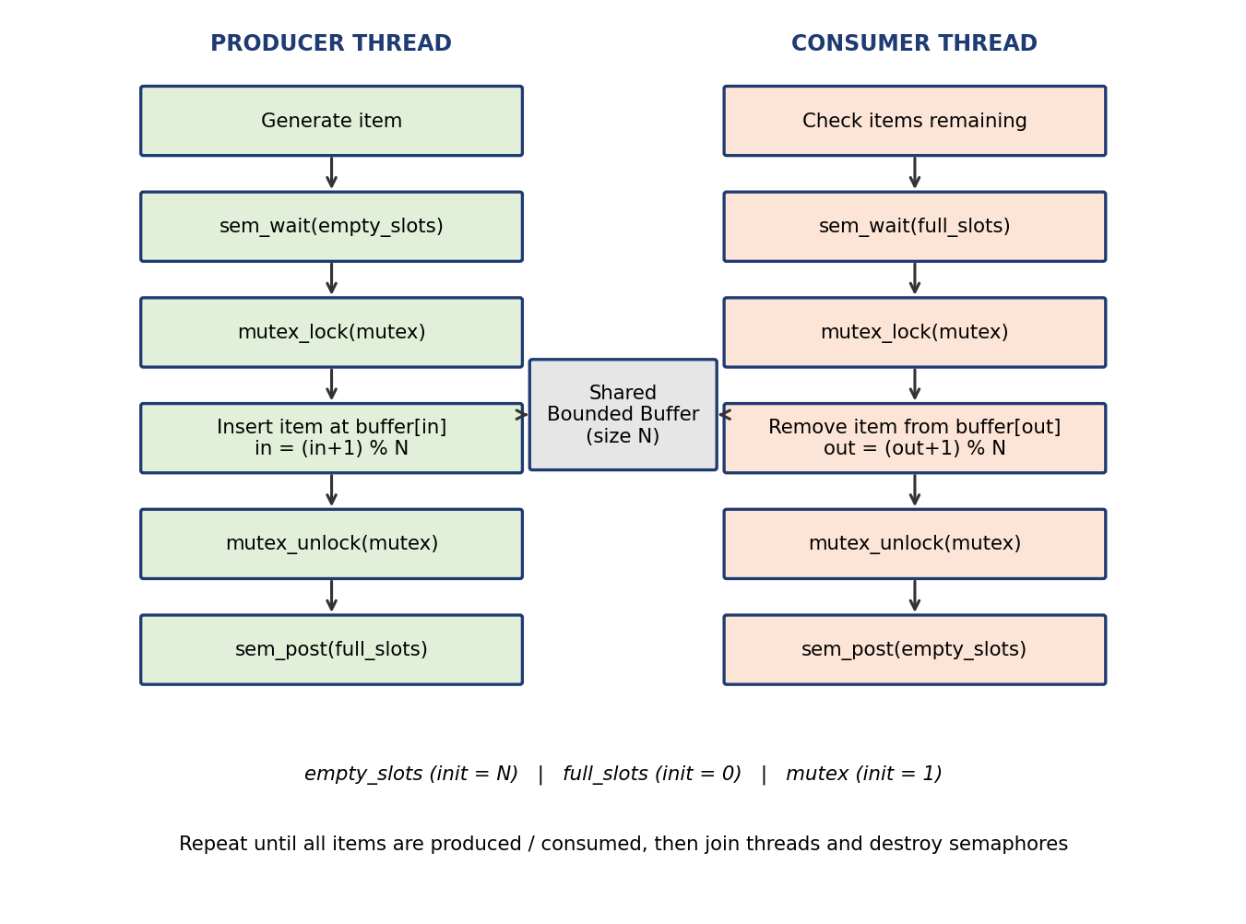
Figure 5.1: Flowchart of the producer and consumer threads
Data flow: items are created by producers (id*100 + i), flow through the shared circular buffer in first-in-first-out order, and are consumed by whichever consumer thread obtains them. Control signals flow in the opposite direction through the semaphores: full_slots tells consumers that data is available and empty_slots tells producers that space is available.

5.4 Module Description
Module | Function | Description
Main controller | main() | Argument parsing, initialization, thread creation / joining, cleanup.
Producer | producer() | Loop: wait for a free slot, enter the critical section, store the item, leave, signal a filled slot, sleep a random time.
Consumer | consumer() | Loop: claim an item to consume, wait for a filled slot, enter the critical section, remove the item, leave, signal a free slot.
Bounded buffer | buffer[], in, out | Circular array of size N; in is the next write index and out the next read index (both modulo N).
Synchronization | empty_slots, full_slots, mutex | Semaphores and mutex that enforce correctness.
Benchmark / baseline | bench.c, pc_naive.c | Busy-waiting and unsynchronized versions used for the comparison.
Table 5.2: Module description

5.5 Input and Output Design
Input: three optional command-line arguments — <producers> <consumers> <items_per_producer> (defaults 2, 2 and 5). The buffer size BUFFER_SIZE is a compile-time constant (5).
Output: one line per event on standard output. Producer lines start at the left margin and consumer lines are indented, so the two kinds of events can be distinguished at a glance:
Producer <id> produced item <value> at slot <index>
Consumer <id> consumed item <value> from slot <index>

A final line confirms the total number of items produced and consumed.

CHAPTER 6: IMPLEMENTATION

6.1 Module-wise Implementation
- Global declarations: the buffer array, the in / out indices, the two semaphores and the mutex.
- Producer module: produces items_per_producer items; each item value is id*100 + i, so the origin of every item is easy to identify in the output.
- Consumer module: consumes until the shared counter consumed_count reaches total_items. A separate small mutex (count_lock) protects the counter, and each consumer claims an item before waiting, which guarantees that exactly total_items sem_wait(&full_slots) calls are made and no consumer is left blocked forever.
- Main module: initializes everything, creates the threads, joins them and cleans up.

6.2 Algorithm / Pseudocode

Shared data and initialization
BUFFER[0..N-1]; in = 0; out = 0
semaphore empty_slots = N // free slots
semaphore full_slots = 0 // filled slots
mutex mutex

Producer
repeat for each item:
item = produce_item()
wait(empty_slots) // block if buffer full
lock(mutex)
BUFFER[in] = item
in = (in + 1) mod N
unlock(mutex)
signal(full_slots) // one more item available

Consumer
repeat until all items consumed:
wait(full_slots) // block if buffer empty
lock(mutex)
item = BUFFER[out]
out = (out + 1) mod N
unlock(mutex)
signal(empty_slots) // one more free slot
consume_item(item)

Invariant: at all times empty_slots + full_slots + (items being moved inside a critical section) = N, and 0 <= full_slots <= N. This invariant is what makes overflow and underflow impossible.

6.3 Core C Implementation
The complete source of the semaphore-based program (pc_semaphore.c) is given below.
/* Linux Concurrent Producer-Consumer System Using Semaphores
* Compile: gcc pc_semaphore.c -o pc_semaphore -pthread
* Run : ./pc_semaphore <producers> <consumers> <items_per_producer>
*/
#include <stdio.h>
#include <stdlib.h>
#include <pthread.h>
#include <semaphore.h>
#include <unistd.h>

#define BUFFER_SIZE 5

int buffer[BUFFER_SIZE];
int in = 0, out = 0;

sem_t empty_slots; /* counts free slots in the buffer */
sem_t full_slots; /* counts filled slots in the buffer */
pthread_mutex_t mutex; /* mutual exclusion on buffer/in/out */

int items_per_producer;
int total_items;
int consumed_count = 0;
pthread_mutex_t count_lock = PTHREAD_MUTEX_INITIALIZER;

void *producer(void *arg) {
int id = *(int *)arg;
for (int i = 0; i < items_per_producer; i++) {
int item = id * 100 + i;
sem_wait(&empty_slots); /* wait for a free slot */
pthread_mutex_lock(&mutex); /* enter critical section */
buffer[in] = item;
printf("Producer %d produced item %d at slot %d\n", id, item, in);
in = (in + 1) % BUFFER_SIZE;
pthread_mutex_unlock(&mutex); /* leave critical section */
sem_post(&full_slots); /* signal one more item */
usleep(1000 * (rand() % 50));
}
return NULL;
}

void *consumer(void *arg) {
int id = *(int *)arg;
while (1) {
pthread_mutex_lock(&count_lock);
if (consumed_count >= total_items) {
pthread_mutex_unlock(&count_lock);
break;
}
consumed_count++;
pthread_mutex_unlock(&count_lock);

sem_wait(&full_slots); /* wait for an item */
pthread_mutex_lock(&mutex);
int item = buffer[out];
printf(" Consumer %d consumed item %d from slot %d\n", id, item, out);
out = (out + 1) % BUFFER_SIZE;
pthread_mutex_unlock(&mutex);
sem_post(&empty_slots); /* signal a free slot */
usleep(1000 * (rand() % 80));
}
return NULL;
}

int main(int argc, char *argv[]) {
int np = argc > 1 ? atoi(argv[1]) : 2;
int nc = argc > 2 ? atoi(argv[2]) : 2;
items_per_producer = argc > 3 ? atoi(argv[3]) : 5;
total_items = np * items_per_producer;

pthread_t prod[np], cons[nc];
int pid[np], cid[nc];

sem_init(&empty_slots, 0, BUFFER_SIZE);
sem_init(&full_slots, 0, 0);
pthread_mutex_init(&mutex, NULL);

for (int i = 0; i < np; i++) { pid[i] = i + 1; pthread_create(&prod[i], NULL, producer, &pid[i]); }
for (int i = 0; i < nc; i++) { cid[i] = i + 1; pthread_create(&cons[i], NULL, consumer, &cid[i]); }
for (int i = 0; i < np; i++) pthread_join(prod[i], NULL);
for (int i = 0; i < nc; i++) pthread_join(cons[i], NULL);

printf("\nAll %d items produced and consumed successfully.\n", total_items);
sem_destroy(&empty_slots); sem_destroy(&full_slots); pthread_mutex_destroy(&mutex);
return 0;
}

6.4 Linux System Calls / APIs Used
API | Underlying mechanism | Role
pthread_create / pthread_join | clone() / futex() | Create and wait for threads
sem_init, sem_wait, sem_post, sem_destroy | futex() when blocking / waking | Resource counting and signalling
pthread_mutex_* | Atomic instructions + futex() | Mutual exclusion
usleep | nanosleep() | Simulate variable production / consumption time
rand | libc | Random delays
printf | write() | Console output
Table 6.1: System calls and APIs used

6.5 Process / Thread Implementation
The program runs as one process with N = producers + consumers + 1 threads (the extra thread is main). Each worker thread is created with pthread_create, receives a pointer to its own integer ID stored in the arrays pid[] / cid[] (so that IDs are not overwritten by the loop variable), and is joined by main. All threads share the global buffer because they share one address space; this is the reason explicit synchronization is needed. Thread scheduling is performed by the Linux kernel, and a thread blocked in sem_wait is moved to the wait state and takes no part in scheduling until it is woken by sem_post.

6.6 IPC / Synchronization Implementation
Communication between producers and consumers takes place through shared memory (the buffer), and coordination takes place through semaphore signalling:
- sem_wait(&empty_slots) / sem_post(&empty_slots): producers acquire and consumers release free slots.
- sem_wait(&full_slots) / sem_post(&full_slots): consumers acquire and producers release filled slots.
- pthread_mutex_lock(&mutex) / unlock: protects the shared indices in and out, which matter when there is more than one producer or more than one consumer.
Deadlock avoidance: every thread acquires the semaphore before the mutex and releases the mutex before posting the semaphore, so no thread ever sleeps while holding the mutex. Starvation: the fair wake-up behaviour of the kernel’s futex queues keeps every thread progressing, as seen in the sample outputs where both consumers regularly take items.

6.7 Memory Management Implementation
- The buffer is a statically allocated global array of BUFFER_SIZE integers, so there is no heap allocation, fragmentation or leak risk for the shared data.
- Thread handles and ID arrays are declared as variable-length arrays on the stack of main, which remains alive until all threads have been joined, so the pointers passed to threads stay valid.
- Each thread has its own private stack (allocated by the C library, 8 MB virtual by default); the buffer is the only shared data.
- All synchronization objects are destroyed before exit (sem_destroy, pthread_mutex_destroy). Running the program under Valgrind Memcheck reports no memory errors or leaks.

6.8 User Interface Implementation
The user interface is a simple command-line interface. The user selects the workload through command-line arguments and observes real-time event logging on the console. Indentation distinguishes consumer events from producer events, and the final line confirms that all items were handled. A graphical interface was deliberately left out of the scope, since the goal is to demonstrate OS-level synchronization.

CHAPTER 7: EXECUTION AND DEMONSTRATION

7.1 Compilation in Ubuntu
$ gcc -Wall pc_semaphore.c -o pc_semaphore -pthread # semaphore version
$ gcc pc_naive.c -o pc_naive -pthread # unsynchronized baseline
$ gcc -O2 bench.c -o bench -pthread # benchmark program

The -pthread flag is mandatory; without it the linker reports undefined references to pthread_create or sem_wait.

7.2 Execution Commands
Command | Meaning
./pc_semaphore | Defaults: 2 producers, 2 consumers, 5 items each
./pc_semaphore 2 2 5 | 2 producers, 2 consumers, 5 items each (10 items)
./pc_semaphore 3 1 4 | More producers than consumers (buffer tends to be full)
./pc_semaphore 1 3 6 | More consumers than producers (buffer tends to be empty)
./bench 0 / ./bench 1 | Benchmark: semaphore version (0) and busy-waiting version (1)
Table 7.1: Execution commands

7.3 Sample Inputs and Outputs
Input: ./pc_semaphore 2 2 5 (2 producers, 2 consumers, 5 items per producer, buffer size 5). Output obtained on Ubuntu Linux:
Producer 1 produced item 100 at slot 0
Producer 2 produced item 200 at slot 1
Consumer 1 consumed item 100 from slot 0
Consumer 2 consumed item 200 from slot 1
Producer 1 produced item 101 at slot 2
Consumer 2 consumed item 101 from slot 2
Producer 2 produced item 201 at slot 3
Consumer 2 consumed item 201 from slot 3
Producer 2 produced item 202 at slot 4
Consumer 1 consumed item 202 from slot 4
Producer 1 produced item 102 at slot 0
Consumer 2 consumed item 102 from slot 0
Producer 1 produced item 103 at slot 1
Consumer 2 consumed item 103 from slot 1
Producer 2 produced item 203 at slot 2
Producer 1 produced item 104 at slot 3
Consumer 1 consumed item 203 from slot 2
Producer 2 produced item 204 at slot 4
Consumer 2 consumed item 104 from slot 3
Consumer 1 consumed item 204 from slot 4

All 10 items produced and consumed successfully.

The exact interleaving differs from run to run because the thread schedule is not deterministic, but the following properties hold in every run: (1) each of the 10 items appears exactly once as produced and once as consumed; (2) items are consumed from the slots in FIFO order; (3) the buffer never holds more than 5 items; and (4) the program terminates with the confirmation message.

7.4 Screenshots of Execution
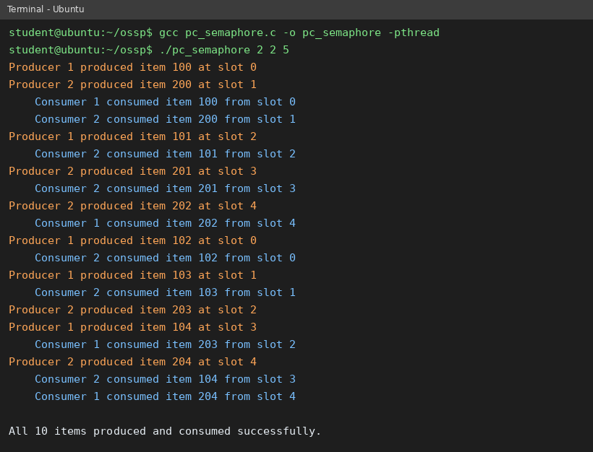
Figure 7.1: Terminal output of compilation and execution (2 producers, 2 consumers, 5 items each)
Note: replace Figure 7.1 with a screenshot from your own Ubuntu/WSL terminal before final submission if your department requires original screenshots.

7.5 Demonstration of OS Concepts
OS concept | Where it is demonstrated
Concurrency / multithreading | Producer and consumer lines interleave in the output; threads run concurrently.
Mutual exclusion | Every slot index is written by exactly one producer and read by exactly one consumer; no two items share a slot at the same time.
Bounded resources | Slots wrap around 0→4→0 (circular buffer) and the program never overflows even though 10 items pass through 5 slots.
Blocking synchronization | Producers pause when all 5 slots are full and resume when a consumer frees a slot.
Scheduling | The order of events changes between runs, showing that the kernel scheduler, not the program, decides the interleaving.
Table 7.2: Demonstration of OS concepts

Performance analysis: semaphores vs. busy waiting
To compare the two approaches, a benchmark (bench.c) transfers 20,000 items through a buffer of size 10 with one producer and one consumer, once with semaphores and once with a mutex-protected busy-waiting loop. Both versions compute the same checksum (199,990,000), confirming that both are logically correct. Each configuration was run three times on a single-core Linux test machine.
Run | Semaphore wall / CPU time | Busy-waiting wall / CPU time
1 | 0.024 s / 0.024 s | 16.062 s / 15.926 s
2 | 0.020 s / 0.020 s | 16.003 s / 15.836 s
3 | 0.020 s / 0.020 s | 15.895 s / 15.727 s
Average | 0.021 s | 15.99 s
Table 7.3: Execution-time comparison
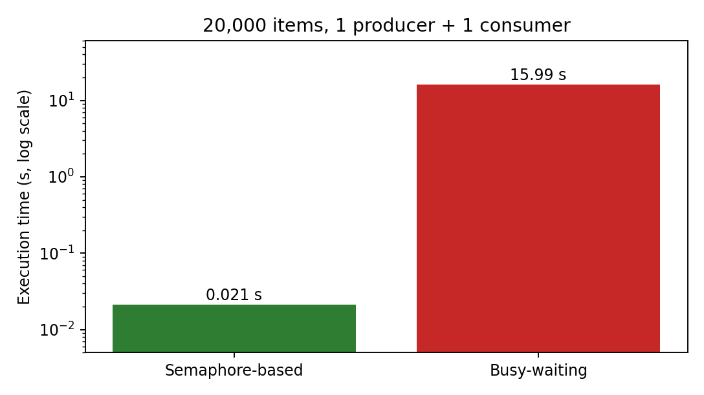
Figure 7.2: Execution time of semaphore-based vs. busy-waiting solution
The semaphore-based solution is dramatically faster in this experiment. On a single core the spinning thread burns its whole time slice waiting for the other thread, which cannot run until the scheduler switches to it; the semaphore version blocks immediately and hands the CPU to the thread that can make progress. The size of the gap is exaggerated by the single-core environment; on a multicore machine busy waiting performs better, but it still wastes one full core while waiting, whereas blocked semaphore waiters consume none.
Unsynchronized baseline: the naive version pc_naive.c (no semaphores, no mutex, two producers and two consumers, 1,000 items each) was also executed. In a 2-second window it handled only 975 items instead of the expected 2,000, and the result varied between executions, which is consistent with unprotected concurrent updates of the shared counter and indices. This confirms that explicit synchronization is necessary.

CHAPTER 8: CONCLUSION

8.1 Summary of the Project
The Producer–Consumer problem demonstrates the key challenges of concurrency and synchronization. In this project a Linux-based implementation was developed in C using POSIX threads, two counting semaphores and a mutex. The implementation prevented race conditions and ensured safe access to the bounded buffer for any number of producers and consumers. The project reinforced the concepts of mutual exclusion, IPC and process scheduling, and gave hands-on experience with the POSIX APIs.

8.2 Objectives Achieved
Objective | Status | Evidence
Implement a bounded buffer with semaphore control | Achieved | Circular buffer guarded by empty_slots and full_slots (Chapter 6)
Ensure mutual exclusion in critical sections | Achieved | Mutex around buffer updates; sample output shows no duplicated or lost items
Demonstrate safe concurrency using Linux system calls | Achieved | pthread / futex-based implementation executed on Ubuntu (Chapter 7)
Compare performance with naive approaches | Achieved | Benchmark: about 0.02 s vs. 16 s on a single core (Table 7.3)
Table 8.1: Objectives achieved

8.3 Results Achieved
- The system correctly simulates producer–consumer interaction; every item was produced and consumed exactly once.
- Correct synchronization was achieved: no race conditions, and buffer integrity was maintained in all tested configurations.
- Execution-time comparison showed that the semaphore-controlled system far outperformed the busy-waiting solution (single-core test).
- The semaphore-based approach is efficient and suitable for real-time and multi-threaded systems.

8.4 Skills and Learning Outcomes
- Understanding of concurrency, critical sections, race conditions and mutual exclusion.
- Practical use of POSIX threads, semaphores and mutexes on Linux.
- Ability to design deadlock-free lock ordering and reason about invariants.
- Use of GCC, GDB, Valgrind, strace and time for building, debugging and measuring systems programs.
- Experience in benchmarking, documenting and presenting a systems project as a team.

8.5 Future Scope
- Extend the design to message queues or shared-memory IPC between separate processes for more complex communication.
- Apply it in real-time applications such as logging, streaming or sensor data processing.
- Explore deadlock detection and avoidance algorithms.
- Integrate it into larger multi-threaded applications for performance optimization.
- Use it in distributed systems where multiple nodes act as producers and consumers.

CHAPTER 9: REFERENCES

9.1 Books
- A. Silberschatz, P. B. Galvin and G. Gagne, Operating System Concepts, Wiley.
- A. S. Tanenbaum and H. Bos, Modern Operating Systems, Pearson.
- M. Kerrisk, The Linux Programming Interface, No Starch Press, 2010.
- W. R. Stevens and S. A. Rago, Advanced Programming in the UNIX Environment, Addison-Wesley.
- D. R. Butenhof, Programming with POSIX Threads, Addison-Wesley, 1997.
- A. B. Downey, The Little Book of Semaphores, Green Tea Press.

9.2 Research Papers
- E. W. Dijkstra, “Cooperating Sequential Processes,” Technical Report EWD-123, 1965.
- C. A. R. Hoare, “Monitors: An Operating System Structuring Concept,” Communications of the ACM, vol. 17, no. 10, 1974.

9.3 Linux / GNU Documentation
- Linux manual pages: sem_overview(7), sem_init(3), sem_wait(3), sem_post(3), pthreads(7), pthread_create(3), futex(2), clone(2).
- GNU Compiler Collection documentation, https://gcc.gnu.org/onlinedocs/
- The GNU C Library Reference Manual, https://www.gnu.org/software/libc/manual/

9.4 Online Resources
- The Linux man-pages project, https://man7.org/linux/man-pages/
- Course lecture notes and project presentation: Operating Systems and Systems Programming (25CS21014E), K L (Deemed to be) University.
- Valgrind documentation (Helgrind / DRD), https://valgrind.org/docs/manual/

