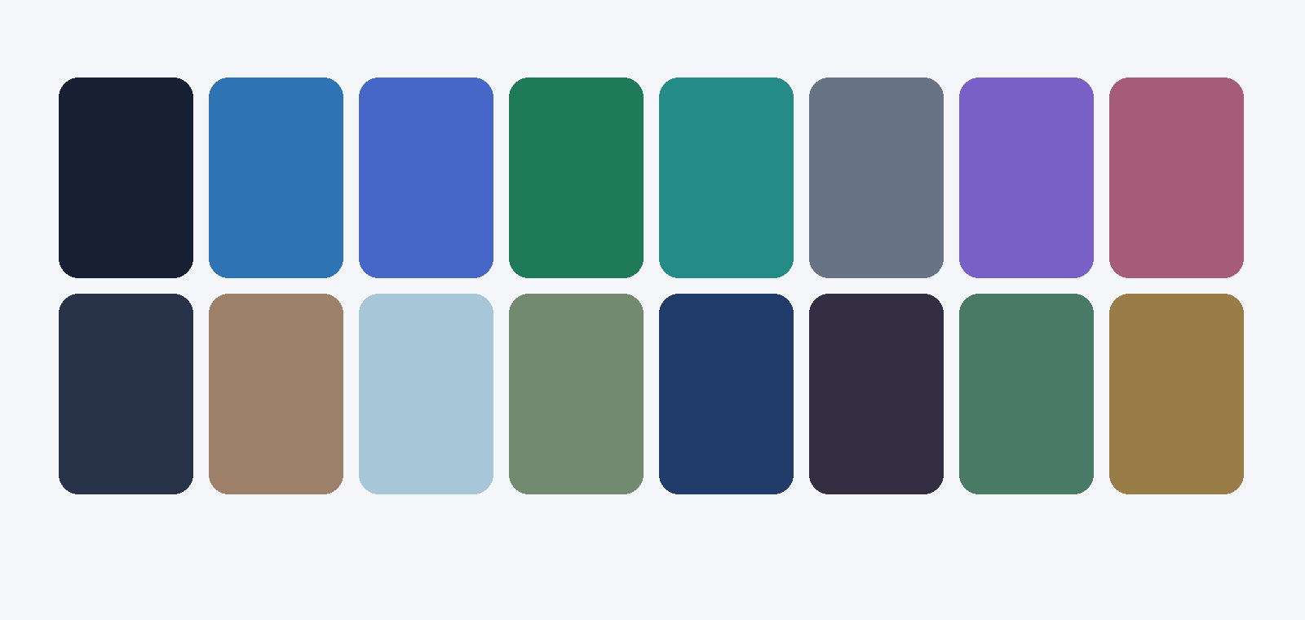
Theme & Responsive
Implementation Report
Jobs & Education Hub + Marketplace
Scope: Global CSS, responsive tokens, Appearance Studio, navigation, footer, page layouts, preset catalog  Branch: codex/theme-studio-responsive-overhaul (both repositories) | Status: Implemented and verified locally; not committed, pushed, or published  Prepared: 31 July 2026

Executive summary
Both Next.js applications now share a responsive, token-driven UI foundation. The Appearance Studio has been restructured around app-specific controls, real component previews, and true page previews. Navigation, footers, page gutters, card spacing, theme presets, and route progress were reviewed and revised without publishing any repository changes.
Decision state. The implementation is ready for an authenticated acceptance walkthrough and your publishing approval. No commit, push, pull request, or deployment has been created.

At a glance
Measure | Jobs & Education Hub | Marketplace
UI routes audited | 28 | 29
TypeScript | Pass | Pass
ESLint | 0 errors (warnings remain) | 0 errors (warnings remain)
Production build | Pass: 38 generated targets | Pass: 40 generated targets
Theme presets shown | 32 curated / 131 compatible | 32 curated / 131 compatible
Publishing | Paused | Paused

Requirement confirmation
Requirement | Status | Implementation evidence
Modern global CSS and responsive tokens | Complete | Shared semantic utilities, breakpoint spacing, card/shell geometry, reduced-motion support.
Remove unused MFE variables and previews | Complete | Copied preview specimens/theme.css removed; UI context and density variables reduced.
Rebuild Appearance/Theme pages | Complete | Independent app-specific studio structure with categorized controls and improved information hierarchy.
Per-category live preview | Complete | Uses components already present in each app rather than invented specimens.
Per-page iframe preview | Complete | Same-origin routes render in iframe with selectable viewport and scale behavior.
Jobs sidebar/flex defect | Complete | Settings page no longer inherits micro-frontend sidebar layout assumptions.
Navbar, footer, page layout | Complete | Responsive navbar shells; real-route footers; duplicate gutters and worst fixed offsets removed.
Static color/font utility migration | Complete | No literal Tailwind palette or fixed font-size utilities remain in the audited source.
BProgress route feedback | Complete | @bprogress/next 3.2.12 uses the live --primary token in both root layouts.
Preset audit and odd-color reduction | Complete | Visible catalog reduced to 32 restrained presets; all 131 remain available for legacy resolution.
Publish only after reiteration | Pending approval | Branches remain local and unpublished.

Design-system changes

Responsive layout contract
The xs, sm, and md breakpoints use deliberately compact page gutters and gaps; lg and xl scale into controlled desktop whitespace rather than inheriting fixed page padding. Page cards, filters, grids, headers, and footers now consume the same spacing variables, so Appearance Studio density changes propagate predictably.

Navigation and footer
Marketplace no longer reserves a redundant spacer below a sticky top bar, and dead mobile controls were removed from the desktop-only component. Broken footer routes, placeholder social accounts, the unrelated Canva QR target, decorative shape noise, and nonfunctional newsletter actions were removed. Jobs received the same restrained, real-route footer contract.

Appearance Studio and presets
Theme variables are organized by user intent. Each category pairs controls with a live app component preview, while page previews render actual routes in an iframe. Presets are now presented by role—Core UI, Modern, Brand, and Navigation—with eight professional options per role. Legacy keys resolve through a hidden compatibility catalog.

Route progress
Both root layouts wrap the existing provider tree with BProgress. The progress bar uses var(--primary), hides the spinner, supports shallow routing, and updates automatically when the active theme changes.

Jobs & Education Hub: page-by-page audit
Route | Role | Audit and implementation
/ | Landing | Tokenized hero, promotional panels, ads, grids, and responsive shell spacing.
/login | Authentication | Compact responsive card, semantic type/color utilities, minimal phone padding.
/signup | Authentication | Responsive form card and validation layout moved to spacing tokens.
/about | Brand | Removed fixed page padding; sections now inherit app-shell-page rhythm.
/contact | Lead capture | Removed w-screen and dual h-screen layout; adaptive 5/7-column card shell.
/jobs | Discovery | Responsive listing/ad grids, semantic card spacing, shared navbar/footer shell.
/jobs/[slug] | Job detail | Detail grid, content/sidebar gaps, action surface, and mobile stack tokenized.
/jobs/create | Job authoring | Form sections, wizard cards, controls, and responsive shell tokenized.
/apply/job/[id] | Application | Centered narrow form with viewport-safe padding and tokenized vertical rhythm.
/applications/jobs | Tracking | Application list runs inside the shared responsive shell.
/companies | Discovery | Company grid and sponsored units use shared card and grid density.
/companies/[slug] | Company detail | Hero, stats, sections, and sidebar use responsive grid tokens.
/companies/create | Company authoring | Form cards and editor spacing moved to the theme density system.
/services | Discovery | Service list shell and spacing aligned with Jobs and Companies.
/services/[slug] | Service detail | Primary/detail/sidebar columns and sections use responsive gaps.
/services/create | Service authoring | Editor groups and card padding are token-driven.
/apply/service/[id] | Application | Narrow application form uses viewport-safe page/card tokens.
/notifications | Inbox | Notification page inherits shared semantic layout and responsive typography.
/profile | Account | Profile surfaces, grids, actions, and content sections use theme tokens.
/dashboard/admin | Administration | Dashboard shell and chart typography/colors are theme-aware.
/dashboard/admin/ads | Administration | Ad manager cards, rows, forms, and status styling tokenized.
/dashboard/admin/categories | Administration | Category metrics, table, and form density standardized.
/dashboard/admin/cities | Administration | City metrics, table, and form density standardized.
/dashboard/admin/contact/list | Administration | Contact table placed in the shared responsive shell.
/dashboard/admin/notifications | Administration | Notification form/table spacing and semantic colors normalized.
/dashboard/admin/reports | Administration | Chart palettes now resolve live CSS theme variables.
/dashboard/admin/settings | Appearance Studio | Sidebar-derived flex defect removed; independent full-width studio.
/dashboard/admin/users | Administration | User cards, forms, and tables use responsive spacing/type tokens.

Marketplace: page-by-page audit
Route | Role | Audit and implementation
/ | Entry | Existing redirect behavior retained; chrome and progress provider load before route change.
/sign-in | Authentication | Compact responsive auth shell with semantic colors and typography.
/sign-up | Authentication | Responsive registration card and social actions use theme tokens.
/about | Brand | Page/card spacing migrated to responsive tokens; content remains brand-led.
/contact | Lead capture | Hero, contact cards, and form spacing normalized to shell/card tokens.
/listings | Discovery | Listing shell, filters, grids, stories, and pagination use responsive density.
/listings/[id] | Listing detail | Detail/sidebar sections and cards now adapt via shared tokens.
/listings/create | Listing authoring | Removed 8rem top offset; wizard starts within the normal app shell.
/my-listings | Account | Grid and status card rhythm tokenized for all breakpoints.
/pendings | Moderation | Duplicate fixed padding removed; cards and grids use responsive tokens.
/profile | Account | Removed duplicate page gutters; header/content use shared shell width and spacing.
/profile/[id] | Public profile | Public profile states, cards, and grids share responsive gutters.
/blogs | Editorial | Blog cards, grids, filters, and empty/loading states use theme spacing.
/blogs/[id] | Editorial detail | Removed duplicate fixed gutters; content and discussion stack responsively.
/blogs/create | Editorial authoring | Wizard is hosted by the shared page shell.
/blog | Legacy editorial | Legacy public entry retained and covered by shared chrome/progress.
/blog/[id] | Legacy editorial | Legacy detail entry retained with shared shell behavior.
/settings | Account settings | Settings sections use semantic type and responsive vertical rhythm.
/settings/appearance | Appearance Studio | Category previews plus true iframe page previews with viewport controls.
/settings/themes | Theme entry | Theme route remains compatible with the redesigned Appearance Studio.
/admin | Administration | Dashboard layout, cards, grids, and chart palettes are theme-aware.
/admin/ads | Administration | Modal/card spacing and shadows moved to semantic tokens.
/admin/categories | Administration | Removed large fixed vertical padding from loading and content states.
/admin/contacts | Administration | Removed duplicate container padding; table/detail panels tokenized.
/admin/manage-content-status | Administration | Tabs, status cards, and responsive page padding standardized.
/admin/notifications | Administration | Removed duplicate page padding; table/forms use shared tokens.
/admin/stories | Administration | Story cards and grids use responsive page/card spacing.
/admin/stories/create | Administration | Creation entry inherits the admin shell and theme system.
/admin/users | Administration | Removed oversized loading padding; user dashboard remains shell-driven.

Brand-impact feature opportunities
The following product additions would improve trust, repeat visits, and perceived brand maturity without weakening the new design system.
App | Feature | Brand/user value | Impact / effort
Cross-app | Verified identity and trust tiers | Employer/company and seller verification, visible trust history, reporting and appeal surfaces. | High / Medium
Jobs | Application command center | Stage timeline, interview tasks, reminders, document checklist, and recruiter response indicators. | High / Medium
Jobs | Skill-fit and salary context | Explainable match signals, salary ranges, missing-skill suggestions, and saved role comparisons. | High / High
Marketplace | Saved search and instant alerts | Reusable filters, price/category/location alerts, and notification preference controls. | High / Medium
Marketplace | Safer offers and messaging | In-app offer flow, fraud prompts, block/report controls, and transaction-safe meeting guidance. | High / High
Marketplace | Listing quality coach | Completion score, photo/content checks, suggested titles, and preview before publish. | Medium / Medium
Cross-app | Brand proof layer | Case studies, verified success metrics, partner logos with source links, and transparent moderation standards. | High / Low
Cross-app | Shareable profile/listing cards | Branded Open Graph images, short links, QR sharing, and referral attribution. | Medium / Medium

Verification and remaining work

Verification completed
TypeScript completed with no errors in both repositories. ESLint completed with zero errors; remaining warnings are existing React Hook Form compiler skips, unused declarations, and image optimization notices. Both optimized Next.js production builds completed.

Remaining before publication
Item | What remains
Authenticated acceptance walkthrough | Review admin, profile, authoring, notification, and Appearance Studio states with representative account data.
Data-dependent visual QA | Confirm long translated labels, empty/error/loading states, uploaded imagery, and dense real-world records at xs through xl.
Connector visualization | Canva generation returned INVALID_ARGUMENT on three supported requests; no Canva candidate was saved.
Optional warning cleanup | The existing lint warnings and two build configuration warnings can be handled in a separate maintenance pass.
Plugin and source checks | GitHub refs verified; Lovable had no reusable design systems; Canva returned INVALID_ARGUMENT; OpenAI Templates supplied the report reference.
Publishing decision | After approval: confirm the diff, commit intentionally, push the branches, then open draft pull requests.

