## HU Extension Assignment 10 E63 Big Data Analytics

### Handed out: 11/03/2017 Due by 9:30AM EST on Saturday, 11/11/2017

You are welcome to implement TensorFlow problems in this problem set in any of supported languages.

**Problem 1.** Install newest release of TensorFlow 1.4 on the operating system of your choice. Use installation instructions on <https://www.tensorflow.org> site and instructions on <https://github.com/tensorflow/tensorflow>. If you know what you are doing install TensorFlow for GPU. Otherwise, install TensorFlow for CPU. Use attach Jupyter notebook: 0_test_install.ipynb to demonstrate that TensorFlow is properly installed. Please document all installation steps including the version of Python you are using. (15%)

**Installing Tensorflow**

|  |
| --- |
| swaite@Rmt-mac-swaite:/usr/local/lib/python2.7/site-packages|  ⇒ brew unlink python && brew link python  ----------------------------------------------------------------  **Had an issue with installing and upgrading python for tensorflow. Probably an issue with my computer.**  error: [Errno 13] Permission denied: '/usr/local/lib/python2.7/site-packages/pkg_resources/__init__.py'  Warning: The post-install step did not complete successfully  **FIX**  swaite@Rmt-mac-swaite:/usr/local/bin|  ⇒ sudo chown -R `whoami` /usr/local/lib/python2.7/site-packages/  ---------------------------------------------------------------  swaite@Rmt-mac-swaite:/Library/Frameworks|  ⇒ sudo easy_install --upgrade pip  swaite@Rmt-mac-swaite:/Library/Frameworks|  ⇒ sudo easy_install --upgrade six  swaite@Rmt-mac-swaite:/Library/Frameworks|  ⇒ sudo pip install --upgrade <https://storage.googleapis.com/tensorflow/mac/cpu/tensorflow-1.4.0-py2-none-any.whl>  swaite@Rmt-mac-swaite:/Library/Frameworks|  ⇒ sudo pip install --upgrade protobuf  swaite@Rmt-mac-swaite:/Library/Frameworks|  ⇒ sudo pip install google |

**Running TensorFlow**

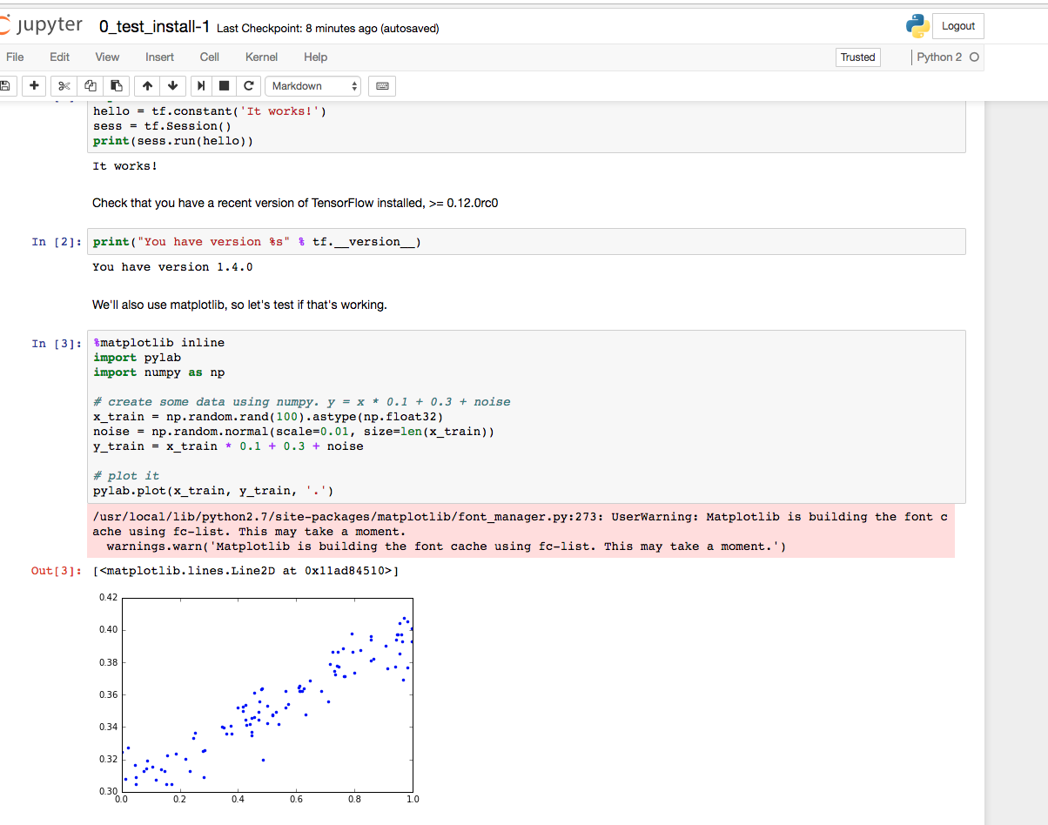

**Problem 2.** Construct a simple neural network (a network of logistic units) which will implement (X1 XOR X2) AND X3 function. Choose weights (-s) of all dendritic inputs and bias inputs. Demonstrate that your network works by presenting the truth table. Present your network by a simple graph. You can produce the graph in any way convenient including pan and paper**.** (25%)

|  |
| --- |
| (X1 XOR X2) AND X3  = |

slide 35 & 36

|  |
| --- |
| First step is to decompose the implementation in AND OR and NOT logical gates, as reflected below:  (X1 XOR X2) AND X3 = ((X1 AND NOT X2) OR (NOT X1 AND X2)) AND X3  (A1(2) OR A2(2)) AND X3 = A1(3) AND A2(3) = H0(X) |

This expression is described in he below neural network graph:



This neural network produces the below truth table:

|  |  |  |  |  |  |  |  |  |
| --- | --- | --- | --- | --- | --- | --- | --- | --- |
| **x1** | **x2** | **X3** | **a1(2)** | **a2(2)** | **a3(2)** | **a1(3)** | **a2(3)** | **h0(x)** |
| 0 | 0 | 0 | 0 | 0 | 0 | 0 | 0 | **0** |
| 0 | 0 | 1 | 0 | 0 | 1 | 0 | 1 | **0** |
| 0 | 1 | 0 | 1 | 0 | 0 | 1 | 0 | **0** |
| 1 | 0 | 0 | 0 | 1 | 0 | 1 | 0 | **0** |
| 0 | 1 | 1 | 1 | 0 | 1 | 1 | 1 | **1** |
| 1 | 1 | 0 | 0 | 0 | 0 | 0 | 0 | **0** |
| 1 | 0 | 1 | 0 | 1 | 1 | 1 | 1 | **1** |
| 1 | 1 | 1 | 0 | 0 | 1 | 0 | 1 | **0** |

**Problem 3.** Determine the value of number e = 2.7183… to 6 decimal places using Taylor expansion. Export the TensorBoard graph of your process. Perform similar calculation using expression for e as . Again export the TensorBoard graph of you process. Provide working code for both approaches.

(25%)

* http://iamtrask.github.io/2015/07/12/basic-python-network/
* <https://medium.com/technology-invention-and-more/how-to-build-a-simple-neural-network-in-9-lines-of-python-code-cc8f23647ca1>

**Problem 4.** When I tried running code on page 63 on my notes for lecture 10, the resulting TensorBoard graph was not entirely identical with the graph on page 64. Please fix the code on page 63 in order to produce the graph identical to the graph on page 64.

(15%)

**CODE**

|  |
| --- |
| import tensorflow as tf  with tf.name_scope("Scope_A"):  a = tf.add(1, 2, name="A_add")  b = tf.multiply(a, 3, name="A_mul")  with tf.name_scope("Scope_B"):  c = tf.add(4, 5, name="B_add")  d = tf.multiply(c, 6, name="B_mul")  with tf.name_scope("Output"):  e = tf.add(b, d, name="output")    writer = tf.summary.FileWriter('logs',graph=tf.get_default_graph())  writer.close() |

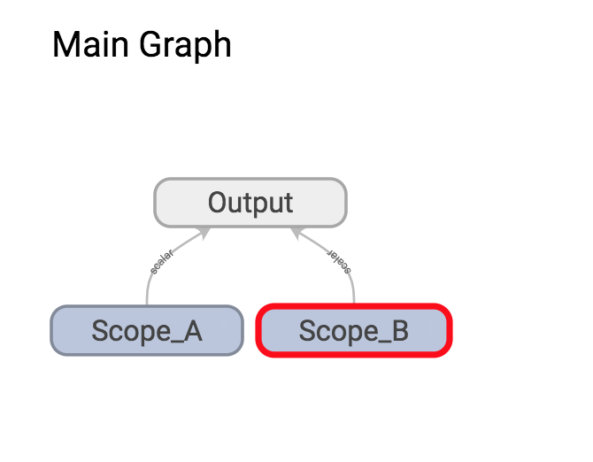

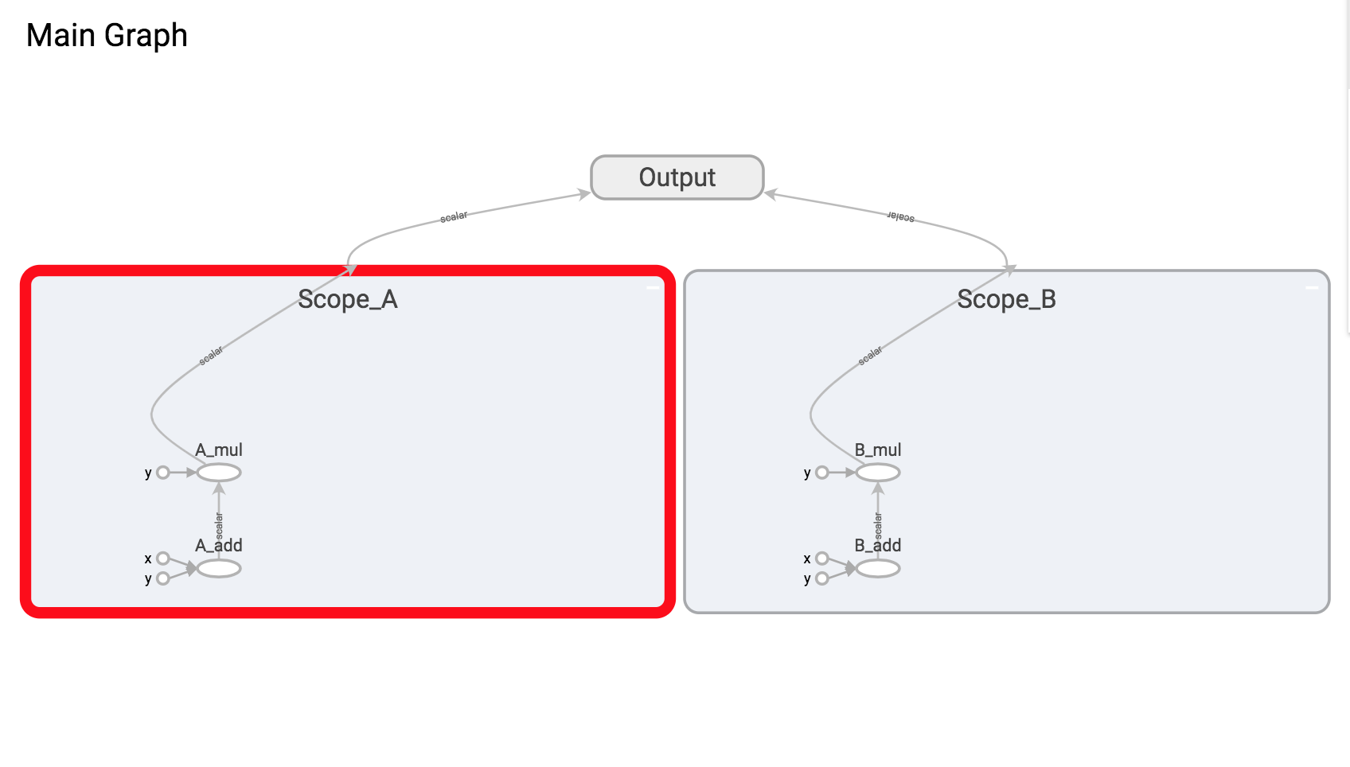

**Problem 5.** Please examine attached Jupyter notebook 2_linear_regression.ipynb. As you are running its cells, the notebook will complain about non-existent API calls. This notebook was written in an earlier version of TensorFlow API and some calls changed their names. Fix all code by replacing older calls with calls in TF 1.5. Uncomment all optional (print) lines.

**CODE CAN BE FOUND IN PROBLEM-5.IPYNB**

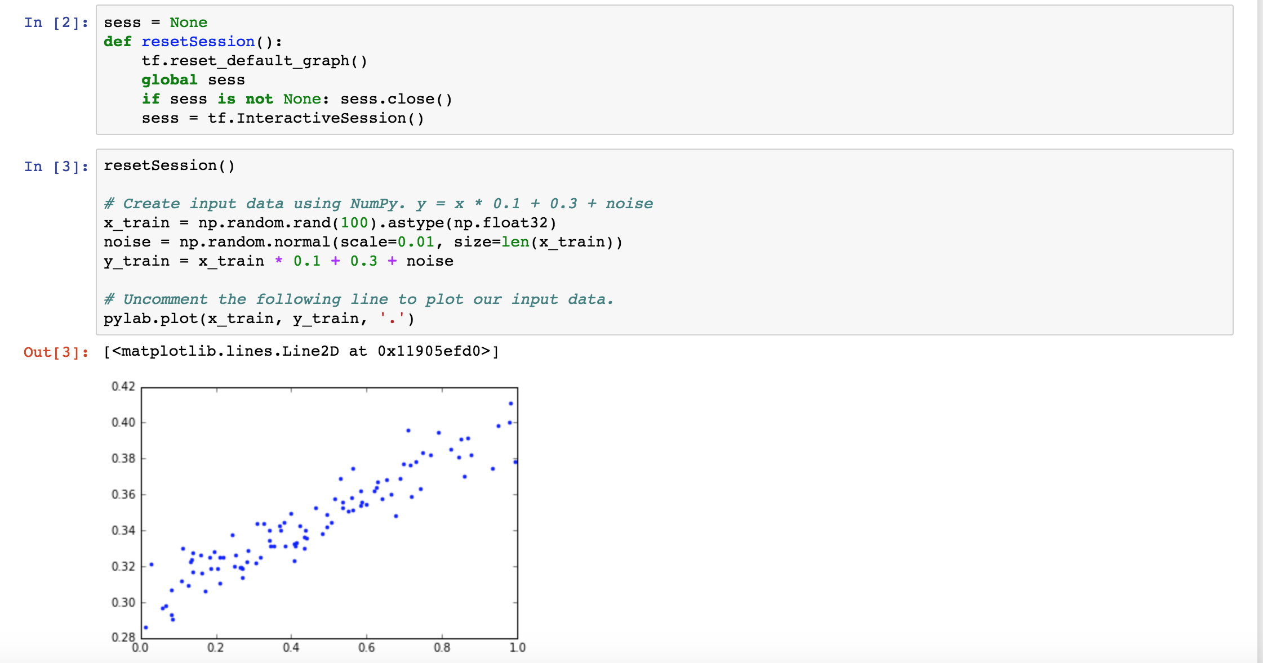

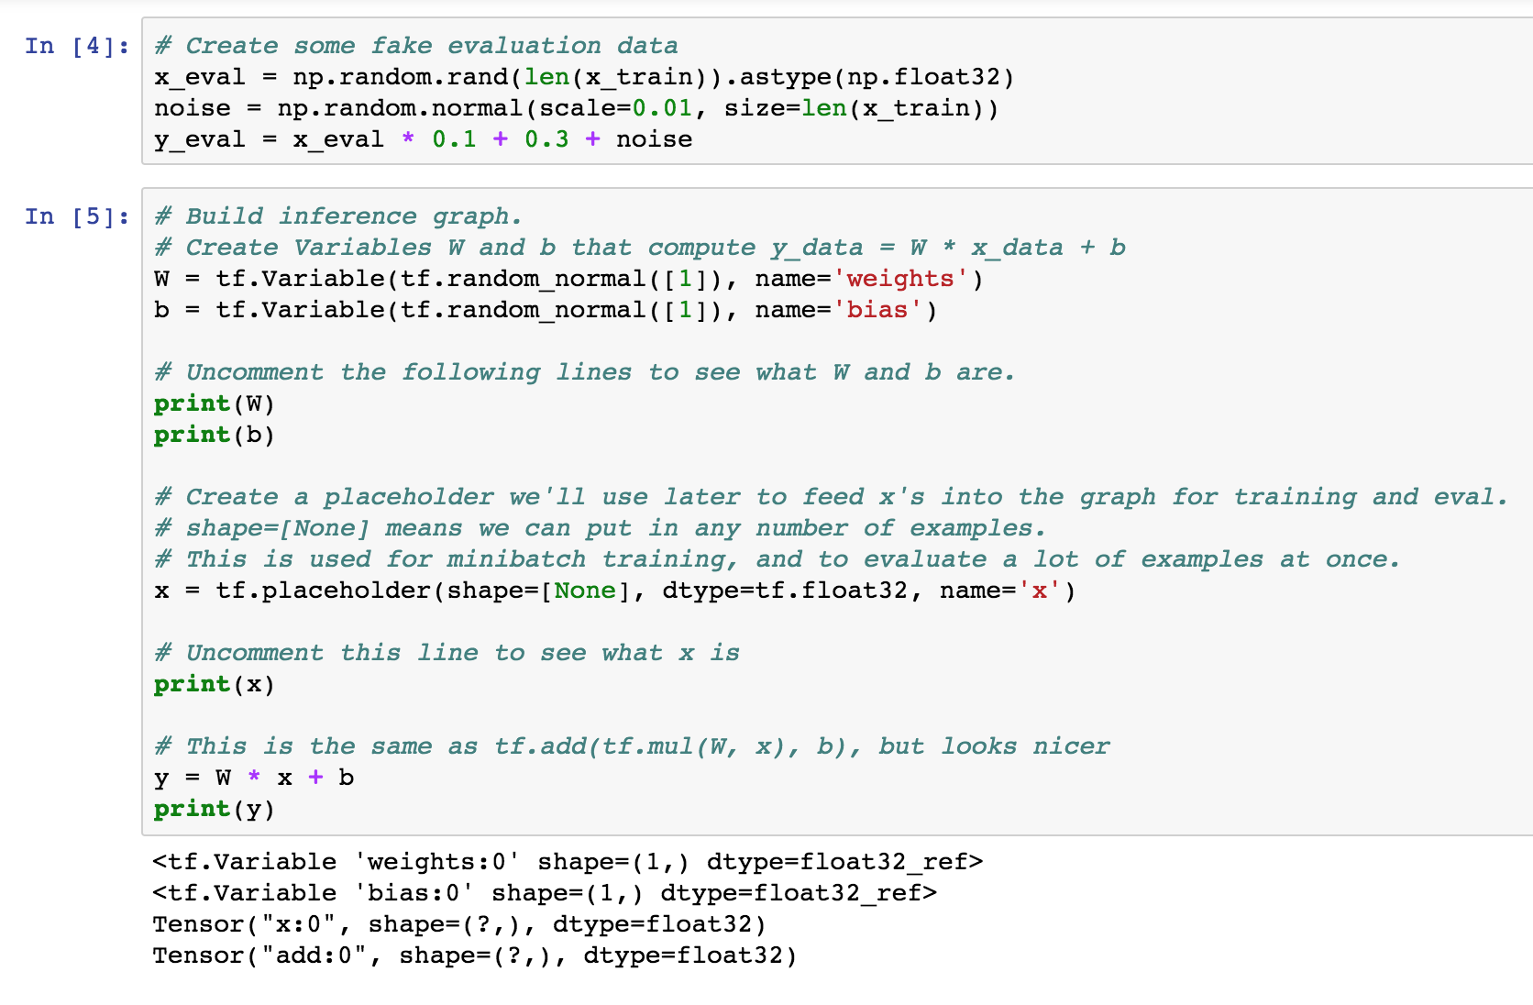

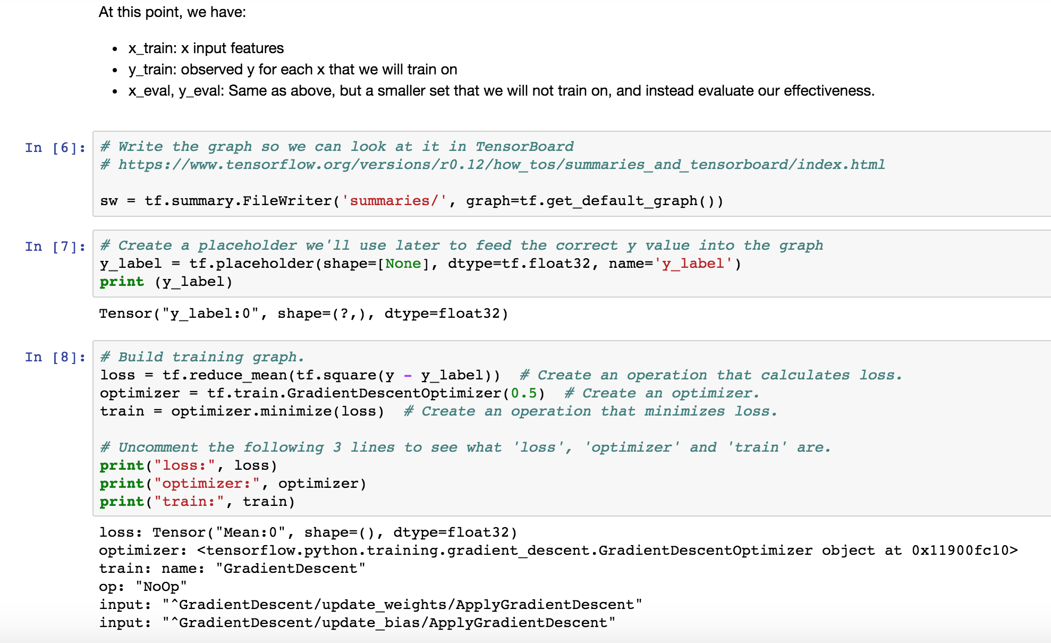

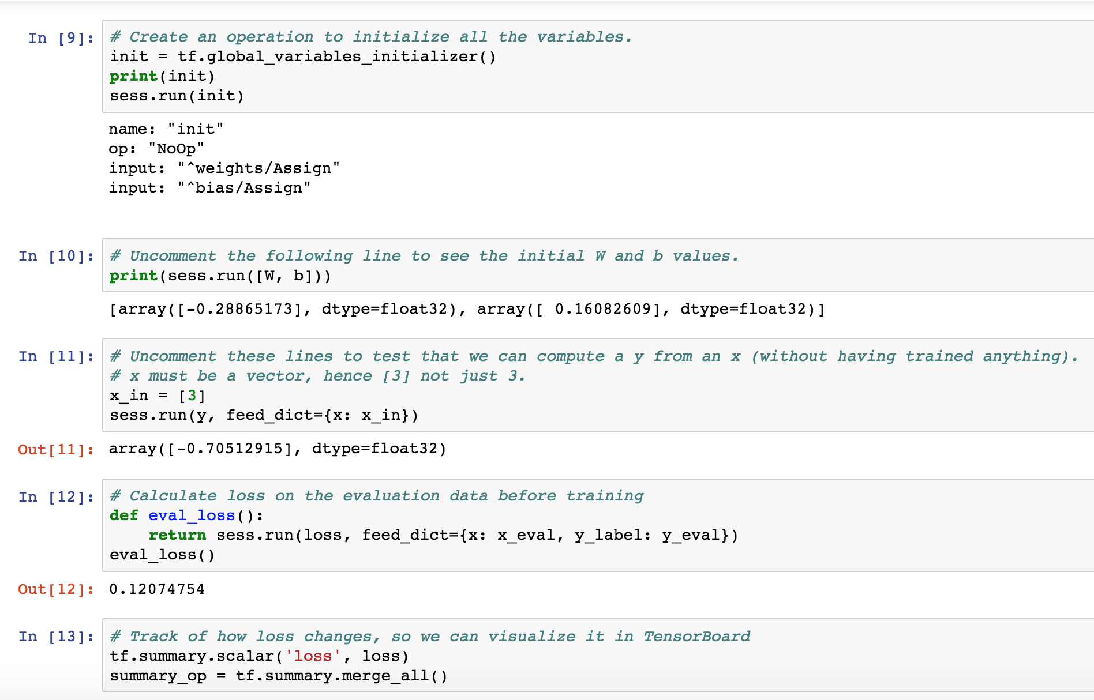

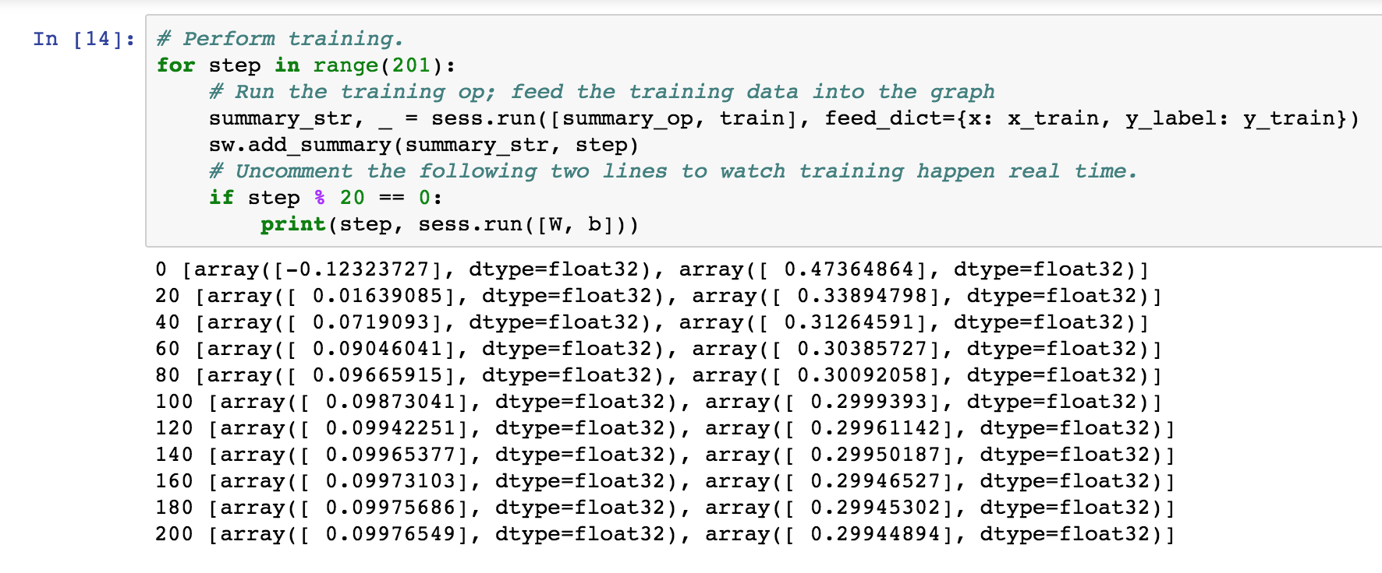

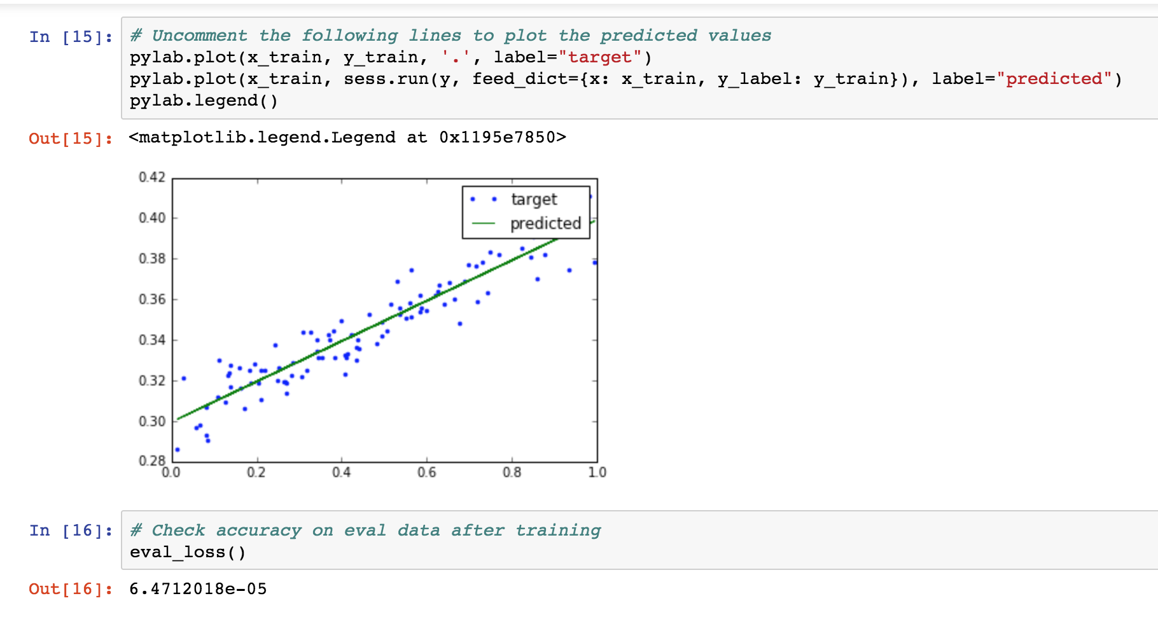

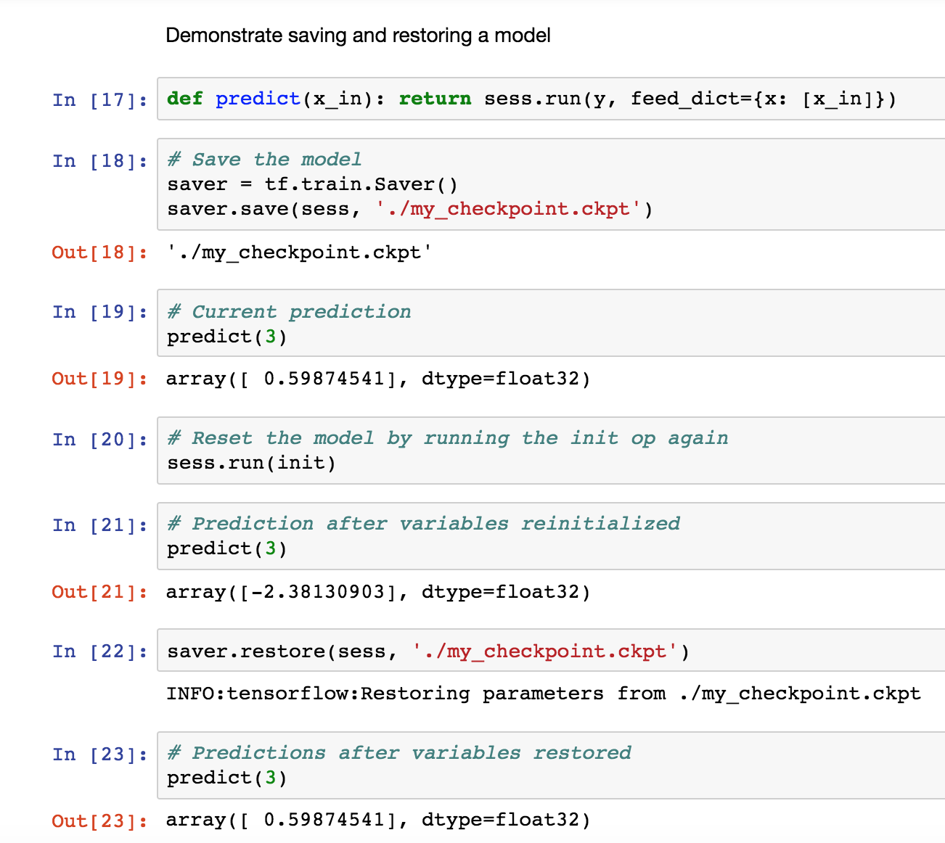

**Provide a copy of this notebook with all intermediate results and the image of TensorFlow graph as captured by the TensorBoard.**

**(20%)**

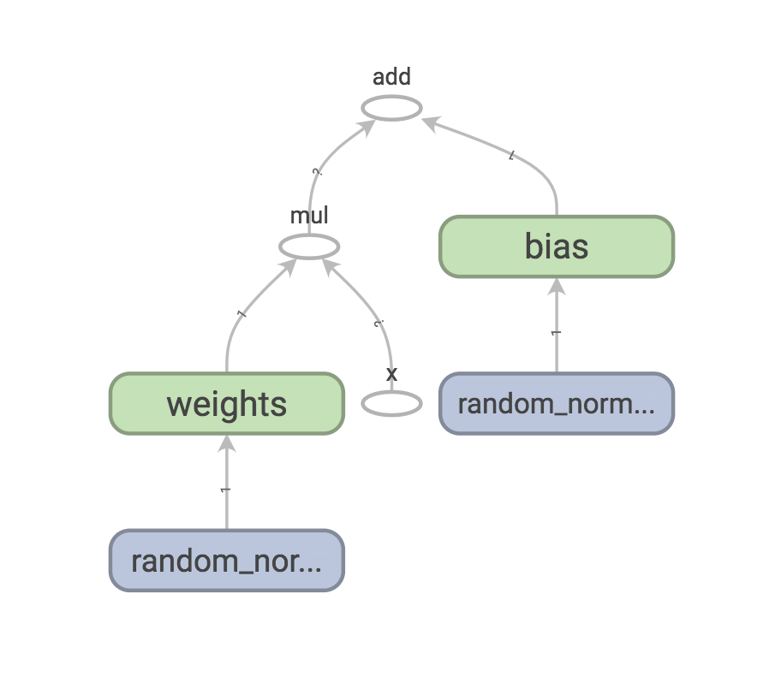

Please, describe every step of your work and present all intermediate and final results in a Word document. Please, copy past text version of all essential command and snippets of results into the Word document with explanations of the purpose of those commands. We cannot retype text that is in JPG images. Please, always submit a separate copy of the original, working scripts and/or class files you used. Sometimes we need to run your code and retyping is too costly. Please include in your MS Word document only relevant portions of the console output or output files. Sometime either console output or the result file is too long and including it into the MS Word document makes that document too hard to read. PLEASE DO NOT EMBED files into your MS Word document. For issues and comments visit the class Discussion Board.