## HU Extension Assignment 06 E63 Big Data Analytics

### Handed out: 10/06/2017 Due by 4:00 PM EST, 10/14/2017

In your solution, please leave the text of every problem as presented here. Add your solution below the problem statement. It is important for us and we will take points if you ignore this request. Please make sure that you provide numeric or textual results of your calculations. If there are no results, we will treat the problem as not addressed. Just providing some code without results will give you 0 point.

**Problem 1) Lecture notes contain script network-count.py in both Spark Streaming API and Spark Structured Streaming API. Use Linux nc (NetCat) utility to demonstrate that scripts work. Run both scripts on your own VM with Spark 2.2 installation. Cloudera VM with Spark 1.6 does not have Spark Structured Streaming API.**

**(20%)**

**Spark Streaming API – network-count.py**

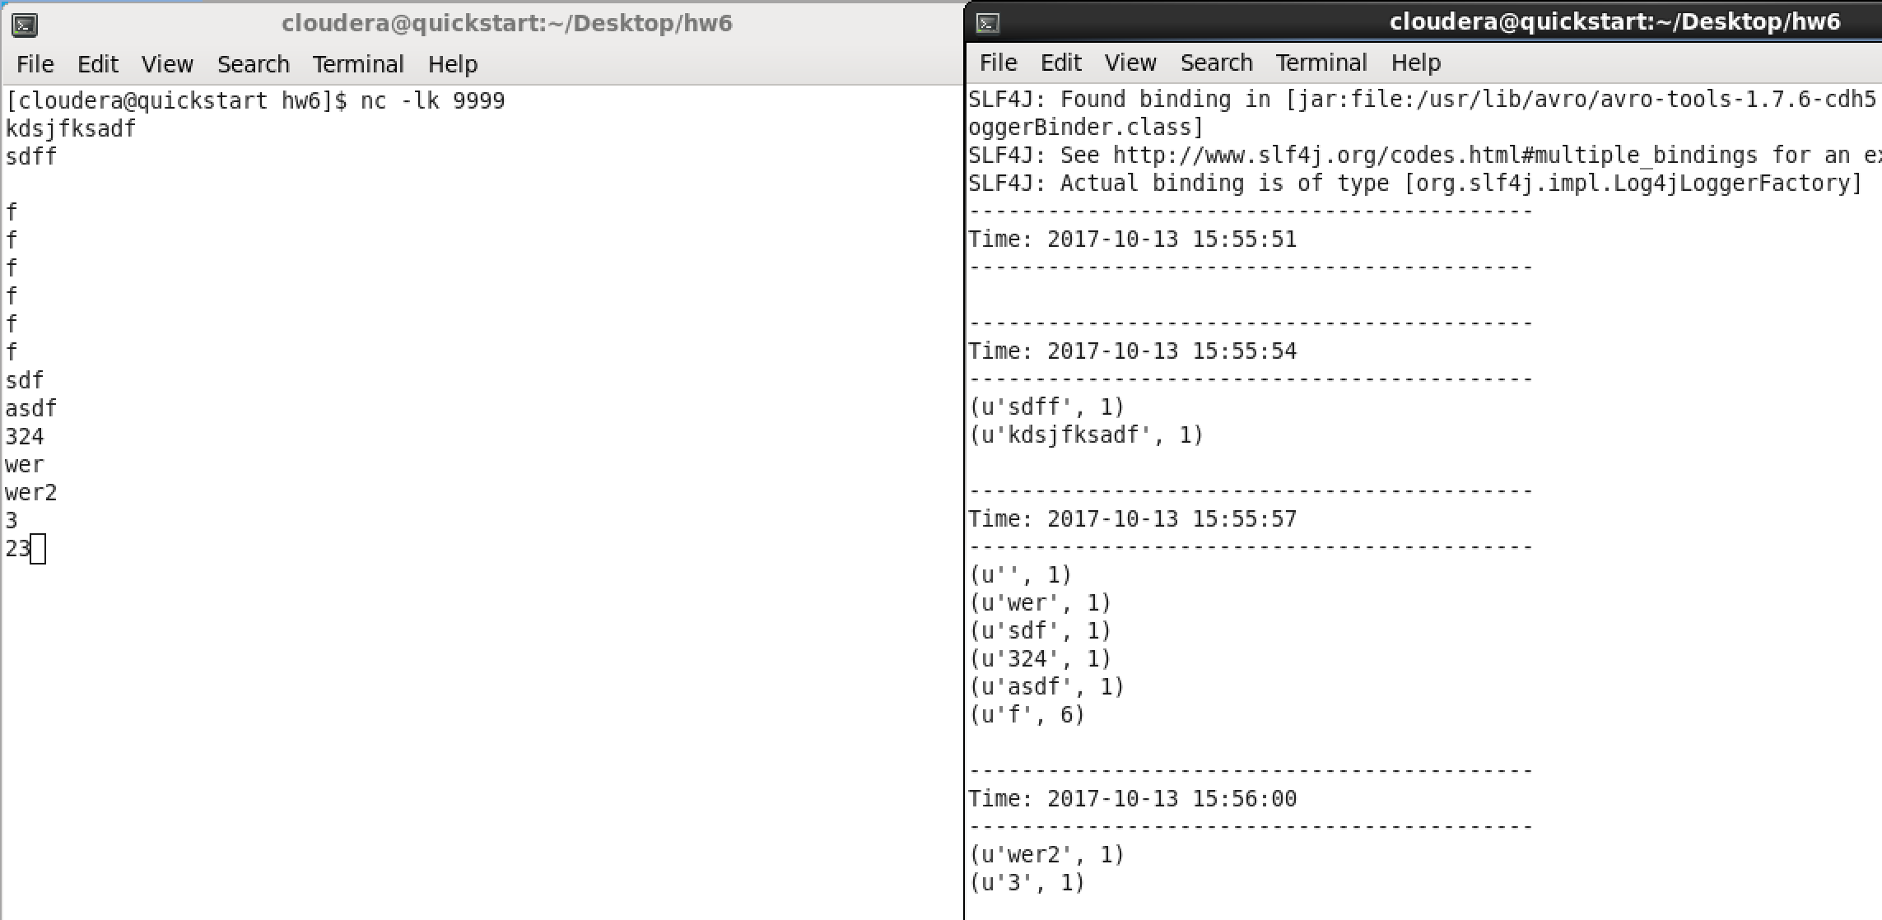

**Spark Streaming API network-count-structured.py**

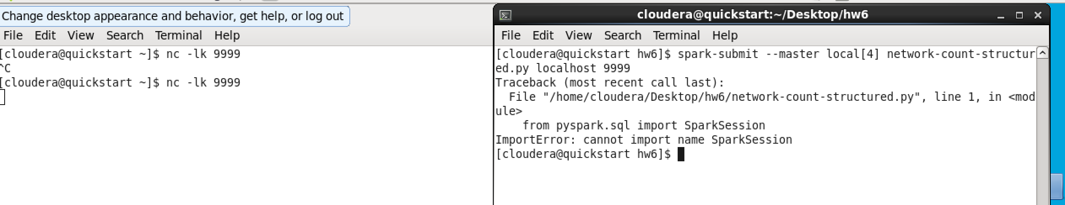

**Note to TA:** Had issues with starting up **network-count-structured.py** due to not having Spark 2 installed. I know that Spark Session isn’t apart of Spark 1.6. I tried to update to Spark 2 VIA a *yum install,* which is what cloudera’s website suggested, but it installed 1.6 again. Moved on to the next problem to try to finish the other hw problems.

**Problem 2) Expand provide orders.tar.gz file. Also, download shell scripts splitAndSend.original.sh and splitAndSend.sh and the Python script count-buys.py. First run splitAndSend.original.sh and count-buys.py. Record the failure mode of count-buys.py. Simply read the error message produced and tell us what is happening. Then run script splitAndSend.sh and Python program count-buys.py and tell us what the results are. In both cases show use contents of your HDFS directories input, output and staging. The second script splitAndSend.sh is supposed to reduce or eliminate the race condition. You might want to rename HDFS directory output from the first run in order to preserve it’s content. In both cases, show the partial contents of your HDFS directories input, output and staging. In the second run, locate an output file named part-00000 that is not empty and show its content to us. Run these experiments on Cloudera VM. You need HDFS for these programs to run.**

**(30%)**

**count-buys.py Error**

|  |
| --- |
| Traceback (most recent call last):  File "/home/cloudera/Desktop/hw6/count-buys.py", line 27, in <module>  ssc.awaitTermination()  File "/usr/lib/spark/python/lib/pyspark.zip/pyspark/streaming/context.py", line 289, in awaitTermination  File "/usr/lib/spark/python/lib/py4j-0.9-src.zip/py4j/java_gateway.py", line 813, in __call__  File "/usr/lib/spark/python/lib/py4j-0.9-src.zip/py4j/protocol.py", line 308, in get_return_value  py4j.protocol.Py4JJavaError: An error occurred while calling o19.awaitTermination.  : org.apache.spark.SparkException: An exception was raised by Python:  Traceback (most recent call last):  File "/usr/lib/spark/python/lib/pyspark.zip/pyspark/streaming/util.py", line 65, in call  r = self.func(t, *rdds)  File "/usr/lib/spark/python/lib/pyspark.zip/pyspark/streaming/dstream.py", line 260, in saveAsTextFile  rdd.saveAsTextFile(path)  File "/usr/lib/spark/python/lib/pyspark.zip/pyspark/rdd.py", line 1506, in saveAsTextFile  keyed._jrdd.map(self.ctx._jvm.BytesToString()).saveAsTextFile(path)  File "/usr/lib/spark/python/lib/py4j-0.9-src.zip/py4j/java_gateway.py", line 813, in __call__  answer, self.gateway_client, self.target_id, self.name)  File "/usr/lib/spark/python/lib/py4j-0.9-src.zip/py4j/protocol.py", line 308, in get_return_value  format(target_id, ".", name), value)  Py4JJavaError: An error occurred while calling o164.saveAsTextFile.  : org.apache.spark.SparkException: Job aborted due to stage failure: Task 1 in stage 9.0 failed 1 times, most recent failure: Lost task 1.0 in stage 9.0 (TID 18, localhost, executor driver): java.io.FileNotFoundException: File does not exist: /user/cloudera/input/chunkae._COPYING_ |

**splitAndSend.original.sh**

**hadoop fs -ls /user/cloudera/input/**

|  |
| --- |
| **[cloudera@quickstart hw6]$ hadoop fs -ls /user/cloudera/input/**  **Found 50 items**  -rw-r--r-- 1 cloudera cloudera 437626 2017-10-13 18:52 /user/cloudera/input/chunkaa  -rw-r--r-- 1 cloudera cloudera 448647 2017-10-13 18:52 /user/cloudera/input/chunkab  -rw-r--r-- 1 cloudera cloudera 448605 2017-10-13 18:52 /user/cloudera/input/chunkac  -rw-r--r-- 1 cloudera cloudera 448794 2017-10-13 18:52 /user/cloudera/input/chunkad  -rw-r--r-- 1 cloudera cloudera 448624 2017-10-13 18:52 /user/cloudera/input/chunkae  -rw-r--r-- 1 cloudera cloudera 448553 2017-10-13 18:52 /user/cloudera/input/chunkaf  -rw-r--r-- 1 cloudera cloudera 448436 2017-10-13 18:52 /user/cloudera/input/chunkag  -rw-r--r-- 1 cloudera cloudera 448679 2017-10-13 18:52 /user/cloudera/input/chunkah  -rw-r--r-- 1 cloudera cloudera 448424 2017-10-13 18:52 /user/cloudera/input/chunkai  -rw-r--r-- 1 cloudera cloudera 448564 2017-10-13 18:53 /user/cloudera/input/chunkaj  -rw-r--r-- 1 cloudera cloudera 458595 2017-10-13 18:53 /user/cloudera/input/chunkak  -rw-r--r-- 1 cloudera cloudera 458580 2017-10-13 18:53 /user/cloudera/input/chunkal  -rw-r--r-- 1 cloudera cloudera 458605 2017-10-13 18:53 /user/cloudera/input/chunkam  -rw-r--r-- 1 cloudera cloudera 458630 2017-10-13 18:53 /user/cloudera/input/chunkan  -rw-r--r-- 1 cloudera cloudera 458663 2017-10-13 18:53 /user/cloudera/input/chunkao  -rw-r--r-- 1 cloudera cloudera 458540 2017-10-13 18:53 /user/cloudera/input/chunkap  -rw-r--r-- 1 cloudera cloudera 458533 2017-10-13 18:53 /user/cloudera/input/chunkaq  -rw-r--r-- 1 cloudera cloudera 458403 2017-10-13 18:53 /user/cloudera/input/chunkar  -rw-r--r-- 1 cloudera cloudera 458470 2017-10-13 18:54 /user/cloudera/input/chunkas  -rw-r--r-- 1 cloudera cloudera 458584 2017-10-13 18:54 /user/cloudera/input/chunkat  -rw-r--r-- 1 cloudera cloudera 458333 2017-10-13 18:54 /user/cloudera/input/chunkau  -rw-r--r-- 1 cloudera cloudera 458600 2017-10-13 18:54 /user/cloudera/input/chunkav  -rw-r--r-- 1 cloudera cloudera 458732 2017-10-13 18:54 /user/cloudera/input/chunkaw  -rw-r--r-- 1 cloudera cloudera 458559 2017-10-13 18:54 /user/cloudera/input/chunkax  -rw-r--r-- 1 cloudera cloudera 458654 2017-10-13 18:54 /user/cloudera/input/chunkay  -rw-r--r-- 1 cloudera cloudera 458533 2017-10-13 18:54 /user/cloudera/input/chunkaz  -rw-r--r-- 1 cloudera cloudera 458535 2017-10-13 18:54 /user/cloudera/input/chunkba  -rw-r--r-- 1 cloudera cloudera 458700 2017-10-13 18:54 /user/cloudera/input/chunkbb  -rw-r--r-- 1 cloudera cloudera 458509 2017-10-13 18:55 /user/cloudera/input/chunkbc  -rw-r--r-- 1 cloudera cloudera 458488 2017-10-13 18:55 /user/cloudera/input/chunkbd  -rw-r--r-- 1 cloudera cloudera 458527 2017-10-13 18:55 /user/cloudera/input/chunkbe  -rw-r--r-- 1 cloudera cloudera 458662 2017-10-13 18:55 /user/cloudera/input/chunkbf  -rw-r--r-- 1 cloudera cloudera 458618 2017-10-13 18:55 /user/cloudera/input/chunkbg  -rw-r--r-- 1 cloudera cloudera 458673 2017-10-13 18:55 /user/cloudera/input/chunkbh  -rw-r--r-- 1 cloudera cloudera 458431 2017-10-13 18:55 /user/cloudera/input/chunkbi  -rw-r--r-- 1 cloudera cloudera 458464 2017-10-13 18:55 /user/cloudera/input/chunkbj  -rw-r--r-- 1 cloudera cloudera 458450 2017-10-13 18:55 /user/cloudera/input/chunkbk  -rw-r--r-- 1 cloudera cloudera 458536 2017-10-13 18:56 /user/cloudera/input/chunkbl  -rw-r--r-- 1 cloudera cloudera 458412 2017-10-13 18:56 /user/cloudera/input/chunkbm  -rw-r--r-- 1 cloudera cloudera 458712 2017-10-13 18:56 /user/cloudera/input/chunkbn  -rw-r--r-- 1 cloudera cloudera 458586 2017-10-13 18:56 /user/cloudera/input/chunkbo  -rw-r--r-- 1 cloudera cloudera 458501 2017-10-13 18:56 /user/cloudera/input/chunkbp  -rw-r--r-- 1 cloudera cloudera 458569 2017-10-13 18:56 /user/cloudera/input/chunkbq  -rw-r--r-- 1 cloudera cloudera 458459 2017-10-13 18:56 /user/cloudera/input/chunkbr  -rw-r--r-- 1 cloudera cloudera 458737 2017-10-13 18:56 /user/cloudera/input/chunkbs  -rw-r--r-- 1 cloudera cloudera 458556 2017-10-13 18:56 /user/cloudera/input/chunkbt  -rw-r--r-- 1 cloudera cloudera 458358 2017-10-13 18:57 /user/cloudera/input/chunkbu  -rw-r--r-- 1 cloudera cloudera 458570 2017-10-13 18:57 /user/cloudera/input/chunkbv  -rw-r--r-- 1 cloudera cloudera 458639 2017-10-13 18:57 /user/cloudera/input/chunkbw  -rw-r--r-- 1 cloudera cloudera 458503 2017-10-13 18:57 /user/cloudera/input/chunkbx |

**splitAndSend.original.sh**

**hadoop fs -ls /user/cloudera/output/**

|  |
| --- |
| **[cloudera@quickstart hw6]$ hadoop fs -ls /user/cloudera/output/**  **Found 4 items**  drwxr-xr-x - cloudera cloudera 0 2017-10-13 18:52 /user/cloudera/output/output-1507945923000.txt  drwxr-xr-x - cloudera cloudera 0 2017-10-13 18:52 /user/cloudera/output/output-1507945932000.txt  drwxr-xr-x - cloudera cloudera 0 2017-10-13 18:52 /user/cloudera/output/output-1507945941000.txt  drwxr-xr-x - cloudera cloudera 0 2017-10-13 18:52 /user/cloudera/output/output-1507945950000.txt |

**splitAndSend.original.sh**

**hadoop fs -ls /user/cloudera/staging/**

|  |
| --- |
| **[cloudera@quickstart hw6]$ hadoop fs -ls /user/cloudera/staging/** |

**splitAndSend.sh**

**hadoop fs -ls /user/cloudera/input/**

|  |
| --- |
| **[cloudera@quickstart hw6]$ hadoop fs -ls /user/cloudera/input**  **Found 50 items**  -rw-r--r-- 1 cloudera cloudera 437626 2017-10-13 19:58 /user/cloudera/input/chunkaa  -rw-r--r-- 1 cloudera cloudera 448647 2017-10-13 19:58 /user/cloudera/input/chunkab  -rw-r--r-- 1 cloudera cloudera 448605 2017-10-13 19:58 /user/cloudera/input/chunkac  -rw-r--r-- 1 cloudera cloudera 448794 2017-10-13 19:58 /user/cloudera/input/chunkad  -rw-r--r-- 1 cloudera cloudera 448624 2017-10-13 19:58 /user/cloudera/input/chunkae  -rw-r--r-- 1 cloudera cloudera 448553 2017-10-13 19:58 /user/cloudera/input/chunkaf  -rw-r--r-- 1 cloudera cloudera 448436 2017-10-13 19:59 /user/cloudera/input/chunkag  -rw-r--r-- 1 cloudera cloudera 448679 2017-10-13 19:59 /user/cloudera/input/chunkah  -rw-r--r-- 1 cloudera cloudera 448424 2017-10-13 19:59 /user/cloudera/input/chunkai  -rw-r--r-- 1 cloudera cloudera 448564 2017-10-13 19:59 /user/cloudera/input/chunkaj  -rw-r--r-- 1 cloudera cloudera 458595 2017-10-13 19:59 /user/cloudera/input/chunkak  -rw-r--r-- 1 cloudera cloudera 458580 2017-10-13 19:59 /user/cloudera/input/chunkal  -rw-r--r-- 1 cloudera cloudera 458605 2017-10-13 19:59 /user/cloudera/input/chunkam  -rw-r--r-- 1 cloudera cloudera 458630 2017-10-13 20:00 /user/cloudera/input/chunkan  -rw-r--r-- 1 cloudera cloudera 458663 2017-10-13 20:00 /user/cloudera/input/chunkao  -rw-r--r-- 1 cloudera cloudera 458540 2017-10-13 20:00 /user/cloudera/input/chunkap  -rw-r--r-- 1 cloudera cloudera 458533 2017-10-13 20:00 /user/cloudera/input/chunkaq  -rw-r--r-- 1 cloudera cloudera 458403 2017-10-13 20:00 /user/cloudera/input/chunkar  -rw-r--r-- 1 cloudera cloudera 458470 2017-10-13 20:00 /user/cloudera/input/chunkas  -rw-r--r-- 1 cloudera cloudera 458584 2017-10-13 20:01 /user/cloudera/input/chunkat  -rw-r--r-- 1 cloudera cloudera 458333 2017-10-13 20:01 /user/cloudera/input/chunkau  -rw-r--r-- 1 cloudera cloudera 458600 2017-10-13 20:01 /user/cloudera/input/chunkav  -rw-r--r-- 1 cloudera cloudera 458732 2017-10-13 20:01 /user/cloudera/input/chunkaw  -rw-r--r-- 1 cloudera cloudera 458559 2017-10-13 20:01 /user/cloudera/input/chunkax  -rw-r--r-- 1 cloudera cloudera 458654 2017-10-13 20:01 /user/cloudera/input/chunkay  -rw-r--r-- 1 cloudera cloudera 458533 2017-10-13 20:02 /user/cloudera/input/chunkaz  -rw-r--r-- 1 cloudera cloudera 458535 2017-10-13 20:02 /user/cloudera/input/chunkba  -rw-r--r-- 1 cloudera cloudera 458700 2017-10-13 20:02 /user/cloudera/input/chunkbb  -rw-r--r-- 1 cloudera cloudera 458509 2017-10-13 20:02 /user/cloudera/input/chunkbc  -rw-r--r-- 1 cloudera cloudera 458488 2017-10-13 20:02 /user/cloudera/input/chunkbd  -rw-r--r-- 1 cloudera cloudera 458527 2017-10-13 20:02 /user/cloudera/input/chunkbe  -rw-r--r-- 1 cloudera cloudera 458662 2017-10-13 20:03 /user/cloudera/input/chunkbf  -rw-r--r-- 1 cloudera cloudera 458618 2017-10-13 20:03 /user/cloudera/input/chunkbg  -rw-r--r-- 1 cloudera cloudera 458673 2017-10-13 20:03 /user/cloudera/input/chunkbh  -rw-r--r-- 1 cloudera cloudera 458431 2017-10-13 20:03 /user/cloudera/input/chunkbi  -rw-r--r-- 1 cloudera cloudera 458464 2017-10-13 20:03 /user/cloudera/input/chunkbj  -rw-r--r-- 1 cloudera cloudera 458450 2017-10-13 20:03 /user/cloudera/input/chunkbk  -rw-r--r-- 1 cloudera cloudera 458536 2017-10-13 20:04 /user/cloudera/input/chunkbl  -rw-r--r-- 1 cloudera cloudera 458412 2017-10-13 20:04 /user/cloudera/input/chunkbm  -rw-r--r-- 1 cloudera cloudera 458712 2017-10-13 20:04 /user/cloudera/input/chunkbn  -rw-r--r-- 1 cloudera cloudera 458586 2017-10-13 20:04 /user/cloudera/input/chunkbo  -rw-r--r-- 1 cloudera cloudera 458501 2017-10-13 20:04 /user/cloudera/input/chunkbp  -rw-r--r-- 1 cloudera cloudera 458569 2017-10-13 20:04 /user/cloudera/input/chunkbq  -rw-r--r-- 1 cloudera cloudera 458459 2017-10-13 20:05 /user/cloudera/input/chunkbr  -rw-r--r-- 1 cloudera cloudera 458737 2017-10-13 20:05 /user/cloudera/input/chunkbs  -rw-r--r-- 1 cloudera cloudera 458556 2017-10-13 20:05 /user/cloudera/input/chunkbt  -rw-r--r-- 1 cloudera cloudera 458358 2017-10-13 20:05 /user/cloudera/input/chunkbu  -rw-r--r-- 1 cloudera cloudera 458570 2017-10-13 20:05 /user/cloudera/input/chunkbv  -rw-r--r-- 1 cloudera cloudera 458639 2017-10-13 20:05 /user/cloudera/input/chunkbw  -rw-r--r-- 1 cloudera cloudera 458503 2017-10-13 20:06 /user/cloudera/input/chunkbx |

**splitAndSend.sh**

**hadoop fs -ls /user/cloudera/output/**

|  |
| --- |
| **[[cloudera@quickstart hw6]$ hadoop fs -ls /user/cloudera/output**  **Found 55 items**  **drwxr-xr-x - cloudera cloudera 0 2017-10-13 20:25 /user/cloudera/output/output-1507951539000.txt**  **drwxr-xr-x - cloudera cloudera 0 2017-10-13 20:25 /user/cloudera/output/output-1507951548000.txt**  **drwxr-xr-x - cloudera cloudera 0 2017-10-13 20:25 /user/cloudera/output/output-1507951557000.txt**  **drwxr-xr-x - cloudera cloudera 0 2017-10-13 20:26 /user/cloudera/output/output-1507951566000.txt**  **drwxr-xr-x - cloudera cloudera 0 2017-10-13 20:26 /user/cloudera/output/output-1507951575000.txt**  **drwxr-xr-x - cloudera cloudera 0 2017-10-13 20:26 /user/cloudera/output/output-1507951584000.txt**  **drwxr-xr-x - cloudera cloudera 0 2017-10-13 20:26 /user/cloudera/output/output-1507951593000.txt**  **drwxr-xr-x - cloudera cloudera 0 2017-10-13 20:26 /user/cloudera/output/output-1507951602000.txt**  **drwxr-xr-x - cloudera cloudera 0 2017-10-13 20:26 /user/cloudera/output/output-1507951611000.txt**  **drwxr-xr-x - cloudera cloudera 0 2017-10-13 20:27 /user/cloudera/output/output-1507951620000.txt**  **drwxr-xr-x - cloudera cloudera 0 2017-10-13 20:27 /user/cloudera/output/output-1507951629000.txt**  **drwxr-xr-x - cloudera cloudera 0 2017-10-13 20:27 /user/cloudera/output/output-1507951638000.txt**  **drwxr-xr-x - cloudera cloudera 0 2017-10-13 20:27 /user/cloudera/output/output-1507951647000.txt**  **drwxr-xr-x - cloudera cloudera 0 2017-10-13 20:27 /user/cloudera/output/output-1507951656000.txt**  **drwxr-xr-x - cloudera cloudera 0 2017-10-13 20:27 /user/cloudera/output/output-1507951665000.txt**  **drwxr-xr-x - cloudera cloudera 0 2017-10-13 20:27 /user/cloudera/output/output-1507951674000.txt**  **drwxr-xr-x - cloudera cloudera 0 2017-10-13 20:28 /user/cloudera/output/output-1507951683000.txt** |

**splitAndSend.sh**

**hadoop fs -ls /user/cloudera/staging/**

|  |
| --- |
| **[cloudera@quickstart hw6]$ hadoop fs -ls /user/cloudera/staging** |

**In the second run, locate an output file named part-00000 that is not empty and show its content to us.**

|  |
| --- |
| [cloudera@quickstart hw6]$ hadoop fs -cat /user/cloudera/output/output-1507955193000.txt/part-00000 (False, 3940L) (True, 4050L) |

**Problem 3). In the second run of the previous problem you will notice that many of part-00000 files in your output directory are empty. Could you explain why.**

**(10%)**

There simply was nothing ordered during that timeframe that part-0000 was written, so nothing will be recorded, and thus the file is empty.

**Problem 4) Could you rewrite count-buys.sh in Spark Structured Streaming API. If you do that change script splitAndSend.sh to move generated chunks from the local files system directory staging to local file system directory input. Run this experiment on your VM with Spark 2.2.**

**(20%)**

|  |
| --- |
| Yes, by passing the local as a third argument to splitAndSend.sh it will write to the local file system and not HDFS.  I ran out of time to finish, but I understand using [file:///](NULL) to get data in **count-buys.sh** and **splitAndSend.sh** to work locally instead of hdfs:///. |

**Problem 5) Examine provided Python program stateful_wordcount.py. Make it work as is. If there are errors on the code, fix them. Modify the code so that it outputs the number of words starting with letters a and b. Demonstrate that modified program work. You should provide several both positive and negative examples.**

**(20%)**

**Make it work as is. If there are errors on the code, fix them.**

|  |
| --- |
| **[cloudera@quickstart hw6]$ nc -lk 9999**  asdasd  asd  112312  3  123  12  1  212  1  212  12  1  21  2  12  13  123  12  31  23  123  sd  c  xcs  dc  sd  sd  sd  sd |

**stateful_wordcount.py**

|  |
| --- |
| -------------------------------------------  Time: 2017-10-14 10:37:09  -------------------------------------------  -------------------------------------------  Time: 2017-10-14 10:37:10  -------------------------------------------  (u'112312', 1)  (u'c', 1)  (u'212', 2)  (u'31', 1)  (u'13', 1)  (u'asdasd', 1)  (u'1', 3)  (u'3', 1)  (u'12', 4)  (u'21', 1)  ...  -------------------------------------------  Time: 2017-10-14 10:37:11  -------------------------------------------  (u'112312', 1)  (u'c', 1)  (u'212', 2)  (u'31', 1)  (u'13', 1)  (u'asdasd', 1)  (u'1', 3)  (u'3', 1)  (u'12', 4)  (u'21', 1)  ...  -------------------------------------------  Time: 2017-10-14 10:37:12  -------------------------------------------  (u'112312', 1)  (u'c', 1)  (u'212', 2)  (u'31', 1)  (u'13', 1)  (u'asdasd', 1)  (u'1', 3)  (u'3', 1)  (u'12', 4)  (u'21', 1)  ...  -------------------------------------------  Time: 2017-10-14 10:37:13  -------------------------------------------  (u'112312', 1)  (u'c', 1)  (u'212', 2)  (u'31', 1)  (u'13', 1)  (u'asdasd', 1)  (u'1', 3)  (u'3', 1)  (u'12', 4)  (u'21', 1)  ...  -------------------------------------------  Time: 2017-10-14 10:37:14  -------------------------------------------  (u'112312', 1)  (u'c', 1)  (u'212', 2)  (u'31', 1)  (u'13', 1)  (u'asdasd', 1)  (u'1', 3)  (u'3', 1)  (u'12', 4)  (u'21', 1)  ...  -------------------------------------------  Time: 2017-10-14 10:37:15  -------------------------------------------  (u'112312', 1)  (u'c', 1)  (u'212', 2)  (u'31', 1)  (u'13', 1)  (u'asdasd', 1)  (u'1', 3)  (u'3', 1)  (u'12', 4)  (u'21', 1)  ... |

**Modify the code so that it outputs the number of words starting with letters a and b. Demonstrate that modified program work. You should provide several both positive and negative examples.**

**CODE CHANGE**

|  |
| --- |
| running_counts = lines.flatMap(lambda line: line.split(" "))\  .filter(lambda word: word.lower().startswith(('a','b')))\  .map(lambda word: (word, 1))\  .updateStateByKey(updateFunc) |



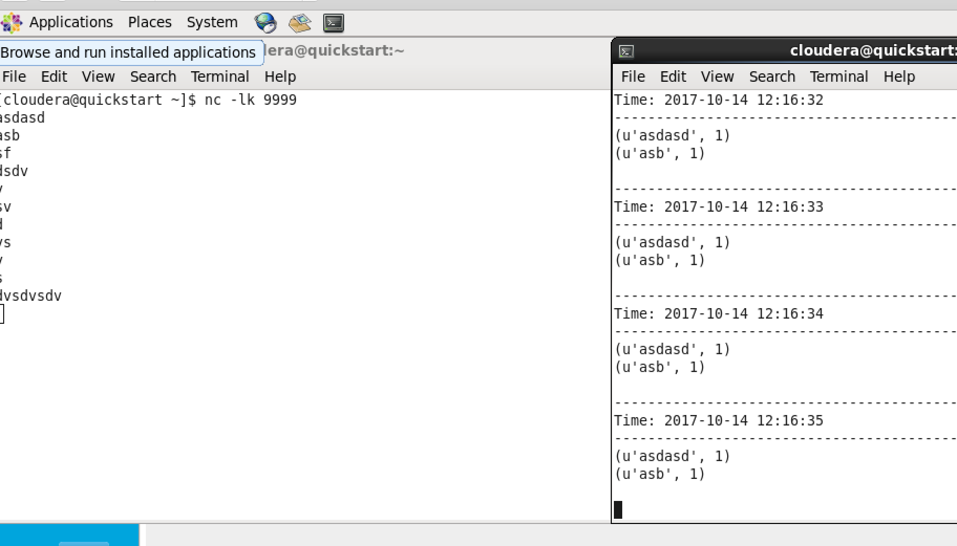

You are welcome to implement your solution in any language of your choice.

You are welcome to follow any other instructions and use any other programming or scripting language to accomplish the above goals.

Please, describe every step of your work and present all intermediate and final results in a Word document. Please, copy past text version of all essential command and snippets of results into the Word document. We cannot retype text that is in JPG images. Please, always submit a separate copy of the original, working scripts and/or class files you used as separate files. Sometimes we need to run your code and retyping is too costly. Please include in your MS Word document only relevant portions of the console output or output files. Sometime either console output or the result file is too long and including it into the MS Word document makes that document too hard to read. PLEASE DO NOT EMBED files into your MS Word document. Please, submit to the class drop box. For issues and comments visit the class Discussion Board. You are not obliged to use Java or Eclipse. You are welcome to use any language and any IDE of your choice.