**RESUME**

# NAGALA NOOTHAN

Email: [noothannagala7@gmail.com](mailto:noothannagala7@gmail.com)

Ph: +91 9391177132

OBJECTIVE

I'm passionate about coding and continuously learning new technologies. Looking for an opportunity to grow in the field of software development where I can apply my skills in real-world projects and contribute to innovative solutions.

# EDUCATION

Diploma in Computer Engineering

Andhra Polytechnic (Expected 2026)

Secondary School Certificate (SSC)

ZPH School, Vadacheepurupalli

Completed: 2023

# TECHNICAL SKILLS

**Programming Languages:**

C, Java, Python

**Web Development:**

Frontend: HTML, CSS, JavaScript, jQuery

Backend: PHP

Database:SQL, MongoDB

**Tools & Software:**

VS Code, MS Office, Tinker-CAD, Adobe Photoshop

**3D & Embedded Systems:**

Tinkercad, Arduino IDE

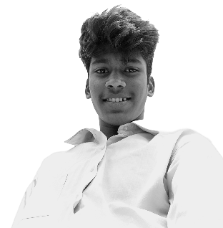

# PROJECTS

1. **Personal Portfolio Website**

Built with HTML, CSS, JavaScript. Responsive design showcasing skills, projects, and resume

1. **Animate Website**

Built with HTML, CSS, JavaScript. A platform to watch web series and anime.

1. **4-Axis Robot Arm**

CAD model created using Tinker-cad for automation simulation. Printed parts using 3D printer and controlled the robot using Arduino.

# WORKSHOPS & EVENTS

3D Printing & CAD Design Workshop

Participated in a college-level tech event demonstrating 3D modeling and printing.

# PERSONAL STRENGTHS

* Quick Learner & Adaptive
* Passionate about Technology
* Team Player with Leadership Skills

# DECLARATION

I hereby declare that the above information is true to the best of my knowledge and belief.

Signature : N.Noothan