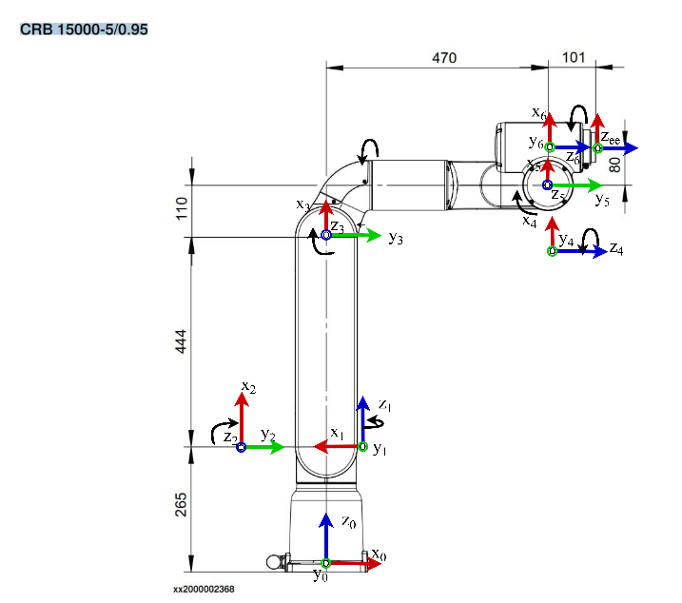
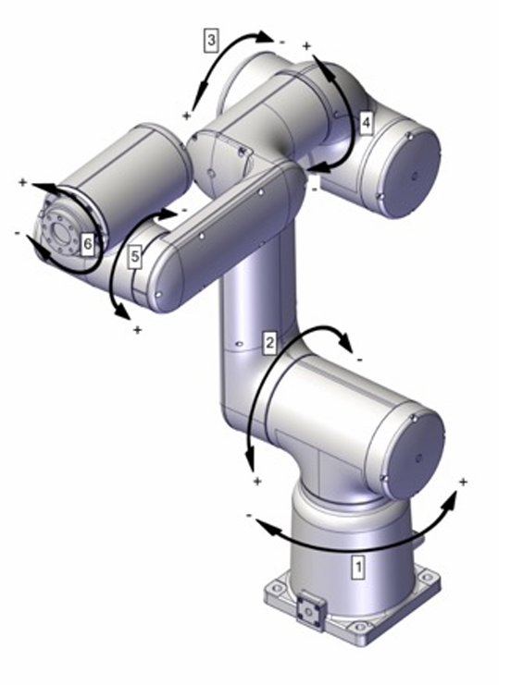
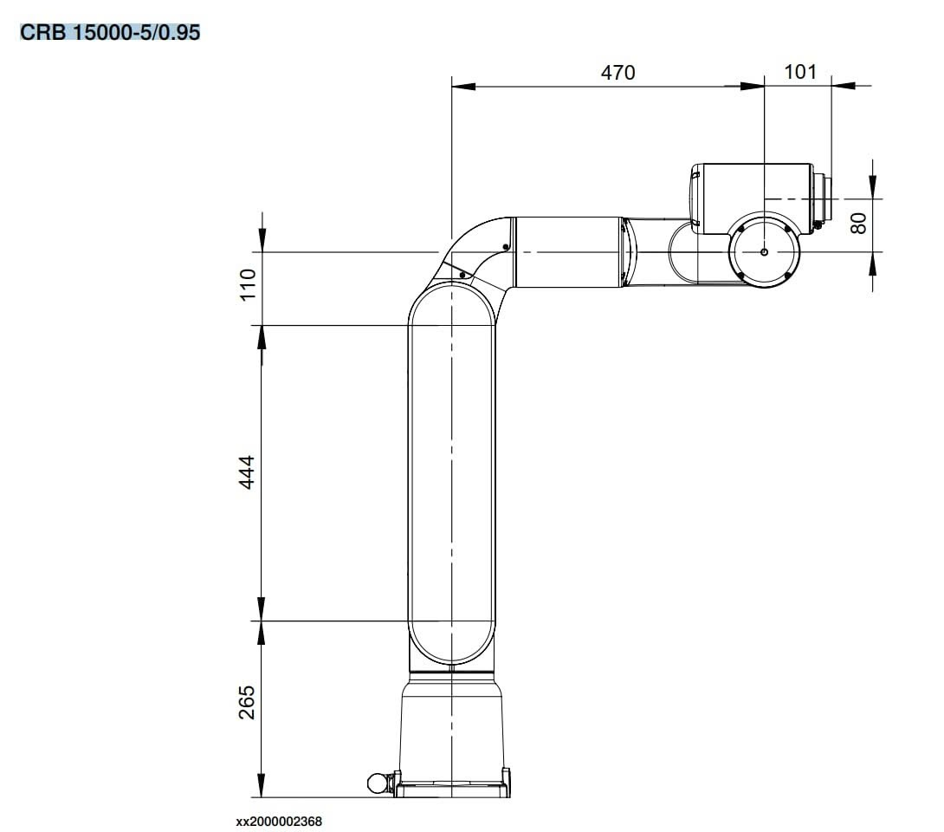
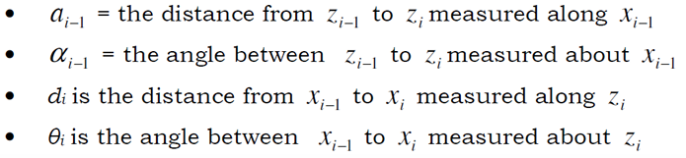
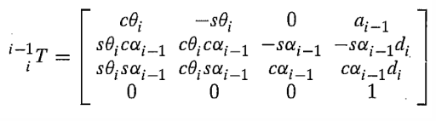
i | $$a_{i-1}$$ | $$α_{i-1}$$ | $$d_{i}$$ | $$θ_{i}$$
1 | 0 | 0 | 0.265 | 180+q₁
2 | 0 | 90 | 0 | 90+q₂
3 | 0.444 | 0 | 0 | q₃
4 | 0.110 | -90 | 0.47 | q₄
5 | 0 | 90 | 0 | q₅
6 | 0.08 | -90 | 0 | q₆
ee | 0 | 0 | 0.101 | 0

