Mendel90 Kit Instructions

The build is broken down into sub assemblies that can be worked on sequentially by one person, or in parallel if there is more than one person building. For this reason each assembly begins on a new page so the instructions can be separated.

All the diagrams can be viewed in openSCAD allowing real time zooming, rotating and panning to get the best view.

15/11/12 14:06:15 First release of this manual.
25/11/12 23:42:38 Made Z cable 100mm longer. Added advice about temperatures.
Table of Contents
Mendel90 Kit Instructions 1
1 General Build Tips 5
Tools Required 5
Recommended 5
Consumables 5
2 Frame Assembly 6
Vitamins 6
Printed parts 6
Assembly 7
3 Bed Fan Assembly 9
Vitamins 9
Printed part 9
Assembly 9
4 X Idler Assembly 10
Vitamins 10
Printed 10
Assembly 11
5 X Motor Assembly 12
Vitamins 12
Printed parts 12
Assembly 13
6 Z Motor Assemblies 16
Vitamins 16
Printed parts 16
Assembly 17
7 Z Axis Assembly 19
Vitamins 19
Printed partsSub-assemblies 19
Assembly 20
8 Y idler assembly 22
Vitamins 22
Printed parts 22
Assembly 22
9 Y motor assembly 23
Vitamins 23
Printed parts 23
Assembly 23
10 Y Carriage Assembly 24
Vitamins 24
Printed parts 24
Assembly 25
11 Y Heatshield Assembly 26
Vitamins 26
Assembly 26
12 Print bed assembly 28
Vitamins 28
Sub-assemblies 28
Bed Wiring 29
Assembly 31
13 Y Axis Assembly 32
Vitamins 32
Printed parts 32
Sub-assemblies 32
Assembly 33
14 X Carriage Fan Assembly 35
Vitamins 35
Printed parts 35
Assembly 35
15 X Carriage Assembly 36
Vitamins 36
Printed parts 36
Assembly 37
16 Hot end assembly 38
Vitamins 38
Assembly 38
17 Extruder Motor Assembly 39
Vitamins 39
Printed parts 39
Assembly 40
18 Extruder Assembly 41
Vitamins 41
Printed parts 41
Sub-assemblies 41
Assembly 42
19 X Axis Assembly 44
Vitamins 44
Sub-assemblies 44
Assembly 45
20 Spool holder assembly 47
Vitamins 47
Printed parts 47
Assembly 48
21 PSU assembly 49
Vitamins 49
Printed parts 49
Wiring 50
Summary 51
Assembly 52
22 Electronics Assembly 53
Vitamins 53
Printed Parts 53
Assembly 53
23 Software 57
Marlin Firmware 57
Arduino IDE 57
Pronterface 57
24 Testing 58
Jumpers 58
Power up 58
Limit switches 58
Motors 58
Heaters 59
Fan 59
25 Calibration 60
Bed Levelling 60
Extruder Calibration 61
Z Home Point 61
First Print 62
26 Operating Instructions 64
Changing filament 64
Removal 64
Insertion 64
Different types of filament 64
Cleaning the hobbed bolt 65

General Build Tips
- X is left / right. Y is backwards / forwards. Z is up / down.
- Bar lengths: The longest and shortest bars are the Y bars. Of the two pairs left, the longer ones are the X axis and the shorter two the Z axis.
- The longer belt is for X and the shorter one is for Y.
- De-grease the rods and black screws that come with packing grease.
- All screws have a plain washer where they meet the plastic, to spread the load and prevent the plastic being chewed up by the rotation of the screw head. Most fixings have a captive Nyloc nut to prevent them vibrating loose. It is very important that the nut is fully seated in the nut trap while the screw is inserted. They are quite a tight fit, so sometimes it is necessary to pull or push them in with a long screw. The two M3 x 45mm screws in the kit are handy for this.
- The bar clamps should not be over tightened, i.e. do not close the gap fully or the parts will break. The Y and Z bars only need a light clamping force because the only force trying to slide them is the bearing friction. The X idler clamps need to withstand the belt tension so need to be reasonably tight but at the motor end the bars butt up against the motor housing.
- Washers tend to have a smooth side and a side with a burr from being stamped out. Make sure the smooth side faces bearings and belts.
- Ribbon clamp notation is <number of wires>_<hole size>. There are three lengths: the short ones are 14 way for the X axis, the medium ones are 20 way for the Z axis and the long ones are 26 way for the bed. An N suffix denotes with nut traps. B denotes no slot.

Tools Required
- Spanners: 5mm, 5.5mm, 7mm & 13mm.
- Allen keys: 1.5mm, 2.5mm, 3mm & 6mm.
- PZ 1 Pozidriv screw driver.
- Small flat blade and small Pozidriv screw driver (for Melzi screw terminals).
- Vice (to close IDC D type connector).
- Wire cutters.
- Wire strippers.
- Soldering iron.
- Digital calipers

Recommended
- Multi-meter with thermcouple attachment
- Dial gauge
- Wire brush

Consumables
- Oil, lithium grease, glass cleaner, lint free wipes.

Frame Assembly

Vitamins
36 M4 cap screw x 16mm
2 Dibond sheet 166mm x 384mm x 3mm
1 Dibond sheet 465mm x 384mm x 3mm
1 Dibond sheet 465mm x 419mm x 3mm
36 Nyloc nut M4
2 AL square tube 12.7 x 12.7 x 1.63 x 400mm
38 Washer M4 x 9mm x 0.8mm
10 Ziptie 100mm min length

Printed parts
10 fixing_block.stl | 1 ribbon_clamp_20_44N.stl
1 ribbon_clamp_26_44N.stl | 4 tube_cap.stl

Assembly

- Remove the protective film from the Dibond panels. They all have a matt side and a shiny side. The shiny side is up on the base, forward on the gantry and outside on the stays.
- Insert M4 nyloc nuts into each of the three nut traps in the fixing blocks (a small pair of snipe nose pliers is useful for pressing them home).
- Using a 3mm Allen key: attach three fixing blocks to the left and right stays with two M4 x 16mm screws each, noting that they go on the matt side that faces inwards. Stand the sheet on its edge on a flat surface and slide the block down to be flush with the edge before tightening the screws.
- Fit the remaining four fixing blocks along the bottom of the back of the gantry in the same way.
- Fix the stays to the back of the gantry using one screw in each fixing block. Note the shiny sides face outwards and the one with the fan hole is on the left hand side looking from the front.
- Attach the two aluminium square tubes to the underside (matt side) of the front of the base by placing a washer in the end of the tube, passing a screw up through the large hole in the underside of the tube, through the washer, through the base and into a washer and nyloc on the top.

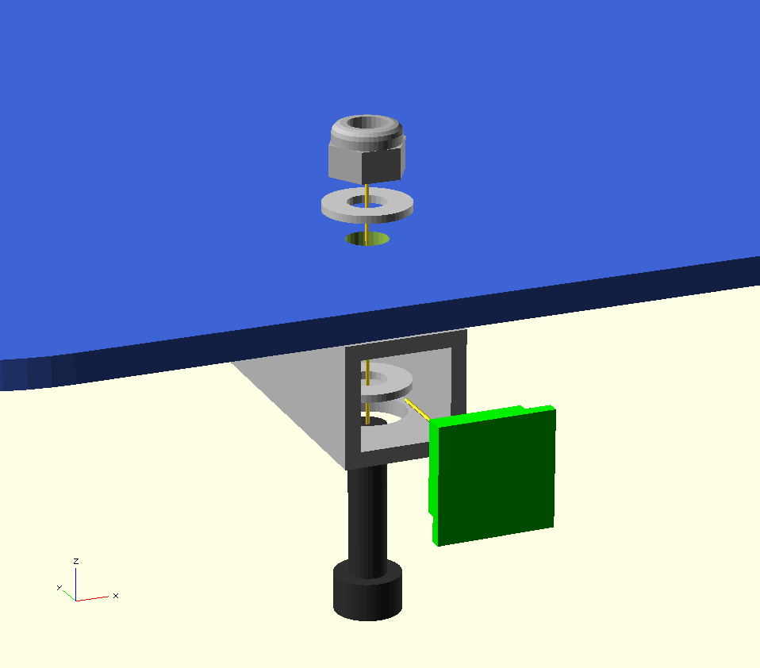
- Screw the gantry to the base using six screws from below. Note that the rear two screws go through the aluminium tubes in the same way as at the front. Align the stays with the back edge before tightening.
- Fit the four end caps to the tubes.
- Loosely insert 5 pairs of zip ties into the pairs of small holes in the gantry and base.
- Loosely attach the two ribbon clamps. The longer one goes at the back of the base for the bed wires. The shorter one goes at the top of the gantry for the X axis cable.

Bed Fan Assembly
The bed fan is optional. It speeds up the cool down period when the parts are finished. It is not included in the kit but the hole is cut out so you may add it later if you wish. In the meantime just fit the fan guard.

Vitamins
4 M4 cap screw x 16mm  1 Fan 80mm x 38mm (not included) | 4 Nyloc nut M4  4 Washer M4 x 9mm x 0.8mm

Printed part
1 fan_guard.stl
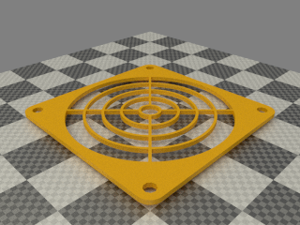

Assembly
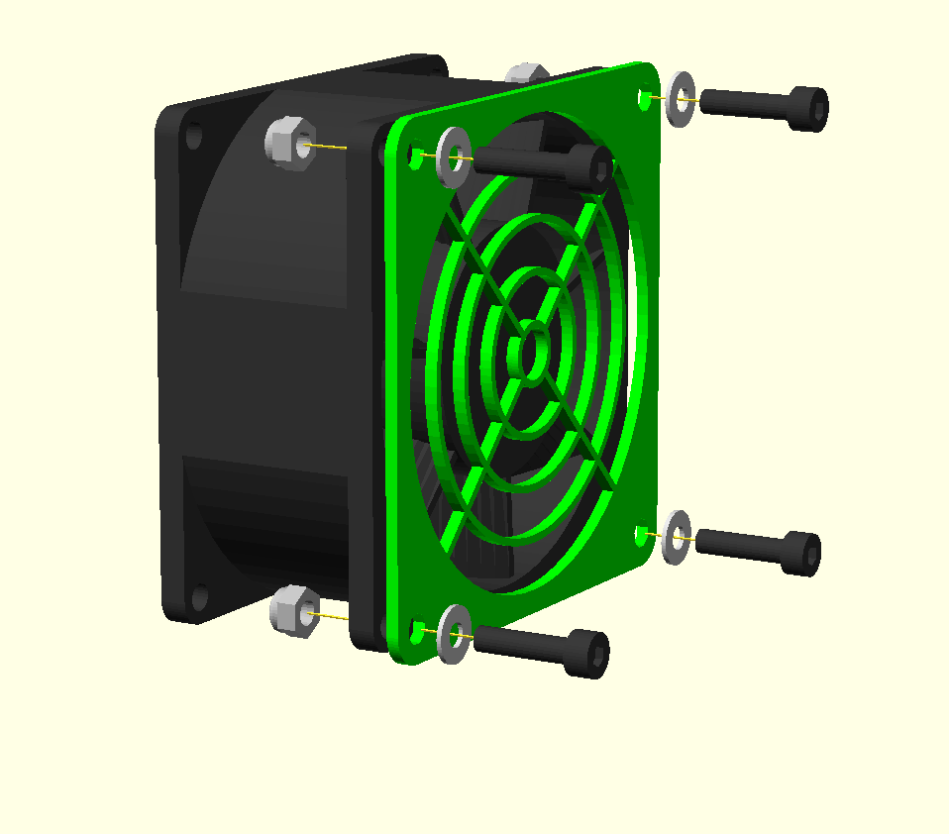
Make sure the fan is blowing inwards. This is usually indicated by an arrow on the frame and is often the side with the label.
The four screws pass through a plain washer, the fan guard, the left stay, the fan (if fitted) and finally a nyloc nut. There isn't a washer behind the fan because fan frames tend not to have room for one.

X Idler Assembly

Vitamins
2 Ball bearing 624 4mm x 13mm x 5mm  1 M4 cap screw x 45mm  2 M3 hex screw x 16mm  2 LM8UU linear bearing  2 Nyloc nut M3 | 1 Nyloc nut M4  2 Washer M3 x 7mm x 0.5mm  2 Washer M4 x 9mm x 0.8mm  2 Washer M5 x 20mm x 1.4mm

Printed
1 x_idler_bracket.stl
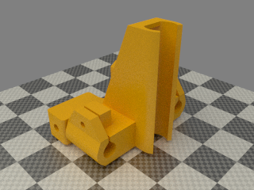

Assembly
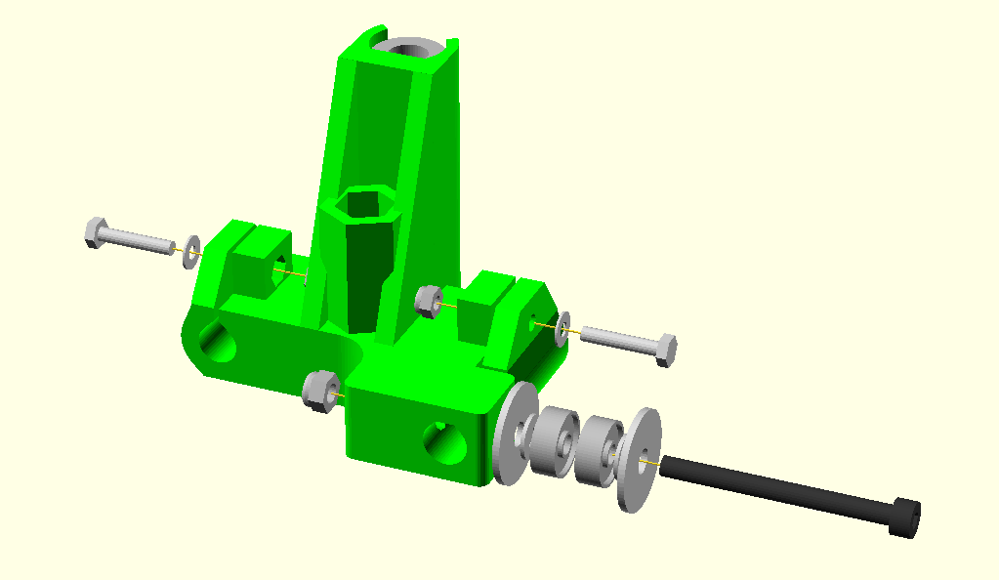
- Insert the two linear bearings by pushing the end which is towards the middle in first. Then slide it up against the divider in the middle before pushing in the other end. Insert a rod to check they are aligned well.
- Insert all the nyloc nuts into their nut traps. It can be easier to pull the M3 nuts for the bar clamps into their hard-to-reach traps using one of the longer screws from elsewhere in the design.
- Make the washer and bearing kebab on the long M4 bolt that forms the idler axle, but leave it loose to allow the X bars to be inserted later.

X Motor Assembly

Vitamins
4 M3 cap screw x 16mm  2 M3 cap screw x 20mm  1 15 way D IDC socket  1 M3 grub screw x 3mm (pre-fitted to pulley)  4 M3 hex screw x 16mm  2 LM8UU linear bearing  1 NEMA17 x 47.5mm stepper motor  8 Nyloc nut M3  2 Nitrile O-ring 2.5mm x 1.6mm  1 Polypropylene strip 401mm x 18mm x 0.5mm | 1 Polypropylene strip 457mm x 25mm x 0.5mm  3 M3 pan screw x 8mm  4 No2 pan wood screw x 13mm  1 T5 pulley 10 teeth  1 Ribbon cable 20 way 1220mm  1 Microswitch  4 Heatshrink sleeving ID 2.4mm x 15mm  4 Washer M2.5 x 5.9mm x 0.5mm  13 Washer M3 x 7mm x 0.5mm  3 Star washer M3 x 0.5mm

Printed parts
1 d_shell.stl | 1 d_shell_lid.stl | 1 ribbon_clamp_14_33.stl  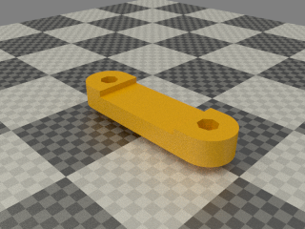
1 ribbon_clamp_14_33NB.stl | 1 ribbon_clamp_20_33.stl  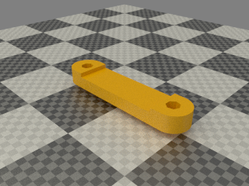 | 1 x_motor_bracket.stl  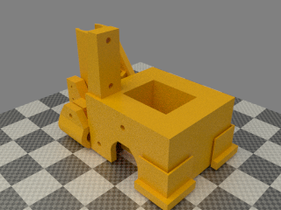

Assembly
- Insert the linear bearings and bar clamp screws as described above for the X idler assembly. Also insert the four nyloc nuts for the ribbon clamps and the remaining two in the ribbon_clamp_14_33NB.
- Fit the pulley to the motor shaft ensuring the grub screw locates on the flat of the shaft. Put it as far down the shaft as possible without it rubbing to motor body.
- Fit the motor with the wires pointing upwards and threaded through the big hole in the top of the bracket. Crop them so they are just long enough to be attached to the ribbon cable and then tucked back into the bracket. Retain the surplus wire for connecting limit switches and the bed thermistor.
- Secure the motor with M3 x 8mm pan screws, star washers and plain washers.
- The next task is attaching the 20 way ribbon cable. Peel back the first two wires at the red edge and the last four wires at the opposite edge. Insert the remaining fourteen wires into the first fourteen pins of the D type socket. i.e. pin 3 of the cable mates with pin 1 of the socket. Pin 8 of the socket is unused. See the photo below: -

Pin 1 is top left in this photo, the unused pin 8 is at the bottom left.
- Close the socket using a vice to make the IDC connections. Clip the strain relief clip on the back but do not pass the cable through it (strain relief is provided by the printed parts but the clip is needed to lock the connector closed).
- Insert into the d_shell in the orientation shown below.

- Secure the connector by screwing on the d_shell_lid with two No2 x 16mm pan screws with M2.5 washers.
- Clamp down the cable with the long thin polypropylene strip underneath it using the ribbon_clamp_14_33NB, M3x16 cap screws and M3 washers (from the back).
- Complete the D connector by adding M3 x 20mm retaining screws and washers and then secure them in place with the rubber O rings.
- Peel back the 6 loose wires along the length of the polypropylene strip until just past the end furthest from the connector. Then clamp the 14 way cable and strip in the ribbon clamp on the top of the X motor bracket with the red edge at the top. Form the cable and strip into a loop as shown in the diagram above before tightening the clamp fully. This is necessary because the cable needs to be a bit longer than the strip to go round the outside of the curve.
- Pass the full 20 way part of the cable through the ribbon clamp in the rear of the motor bracket and clamp it with the second polypropylene strip on top.
- Add loops of sticky tape (not provided) to fasten the middle of each cable to the middle of its cable strip.
- Pass the first two loose wires through the large hole in the top of the motor bracket and out through the small hole for the limit switch. Solder the switch on (use the two outer pins) and then mount it with two No2 x 13mm pan wood screws with M2.5 washers. N.B. The micro switch must be oriented with the button towards the bottom.
- Solder the remaining four lose wires to the motor wires using the heat shrink sleeving to cover the joins and then tuck them into the top motor bracket. Use the following connection scheme: -
Ribbon wire 17 | X motor red
Ribbon wire 18 | X motor blue
Ribbon wire 19 | X motor green
Ribbon wire 20 | X motor black

Z Motor Assemblies

Vitamins
2 M3 cap screw x 16mm
8 M3 cap screw x 20mm
4 M4 cap screw x 16mm
2 NEMA17 x 47.5mm stepper motor
10 Nyloc nut M3
4 Nyloc nut M4
8 M3 pan screw x 8mm
2 PVC aquarium Tubing OD 6mm ID 4mm x 16mm
18 Washer M3 x 7mm x 0.5mm
4 Washer M4 x 9mm x 0.8mm
8 Star washer M3 x 0.5mm

Printed parts
1 z_motor_bracket_lhs.stl  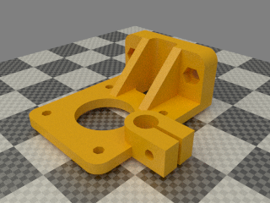 | 1 z_motor_bracket_rhs.stl  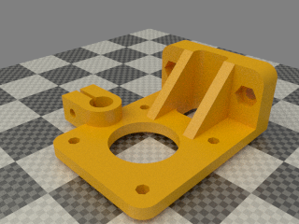
4 z_coupling.stl
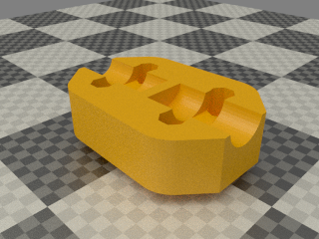

Assembly
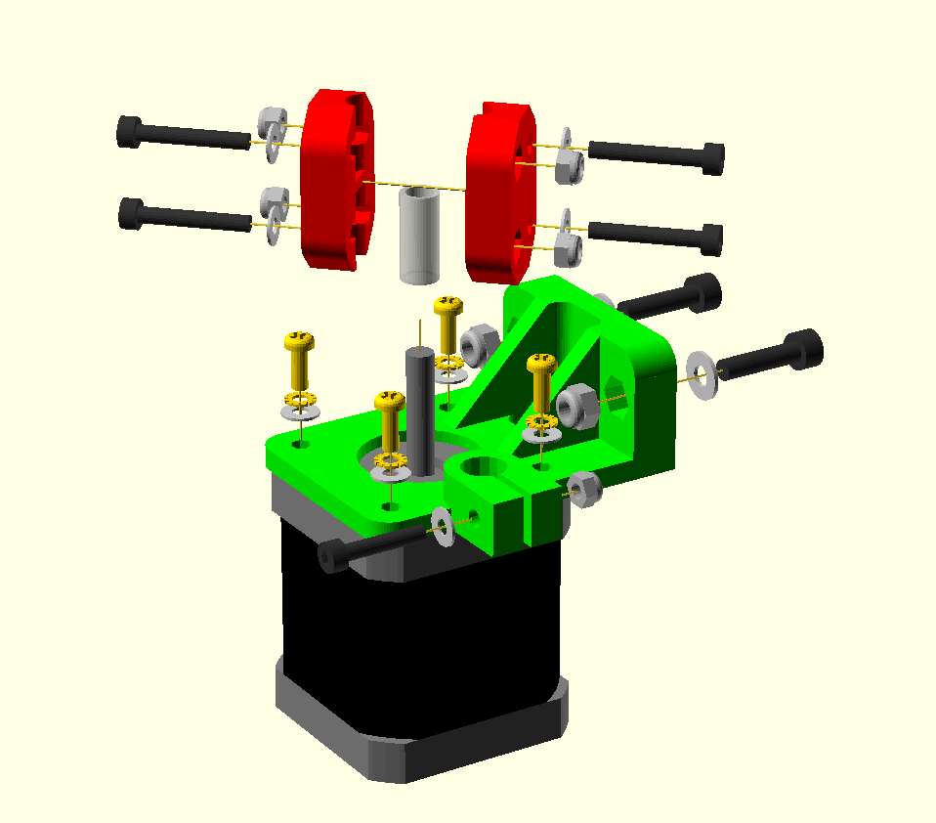
- Fit all the nyloc nuts into their nut traps.
- Fit the M3 x 20mm cap screws to the bar clamps with plain washers.
- Attach the motor with the wires exiting towards the back using four M3 x 8mm pan screws, star washers and plain washers.
- Degrease the motor shafts before fitting the plastic tubing but be careful not to degrease the bearings. It will be a tight fit. Stretching it by opening a pair of pliers inside can help, as can warming it.
- Make sure the metal shaft of the motor protrudes slightly beyond the end of the tubing.
- Join the two halves of the couplings together using four M3 x 20mm cap screws and plain washers.
- Fit the coupling loosely over the tubing for now.
- Twist the motor wires in pairs and feed them through the hole in the gantry. Red / blue are one pair and green / black the other pair. The quickest way to twist them is by using an electric drill. Tie a knot in the far end and put it in the chuck.
- Attach the motor assemblies to the gantry using M4 x 16mm cap screws. Note that the motors rest on the base and the bar clamps face inwards.
- Route the left motor's wires through the mouse hole under the gantry, the rise up the outside of the left stay, pass through the lower hole in the left stay, a cable tie, across the back of the gantry, another cable tie and a slot in the right stay to get to the electronic bay.
- The right hand motor's wires pass through a round hole near the bottom of the gantry to get to the electronics bay.

Z Axis Assembly

Vitamins
2 M3 cap screw x 16mm  4 M4 cap screw x 16mm  2 Brass nut M6  2 Nyloc nut M3  4 Nyloc nut M4  2 No2 pan wood screw x 13mm | 2 Smooth rod 8mm x 336mm  1 Microswitch  2 Threaded rod M6 x 271mm  2 Washer M2.5 x 5.9mm x 0.5mm  2 Washer M3 x 7mm x 0.5mm  4 Washer M4 x 9mm x 0.8mm

Printed partsSub-assemblies
1 x_motor_assembly | 1 x_idler_assembly  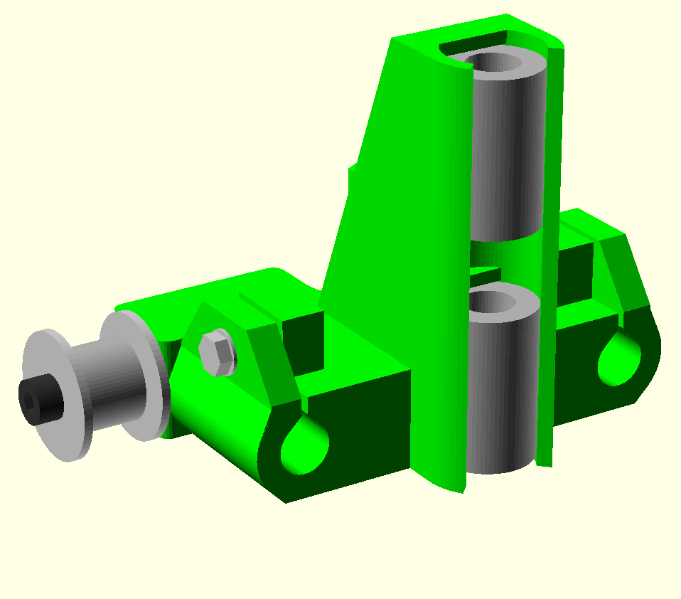 | 2 z_motor_assemblies  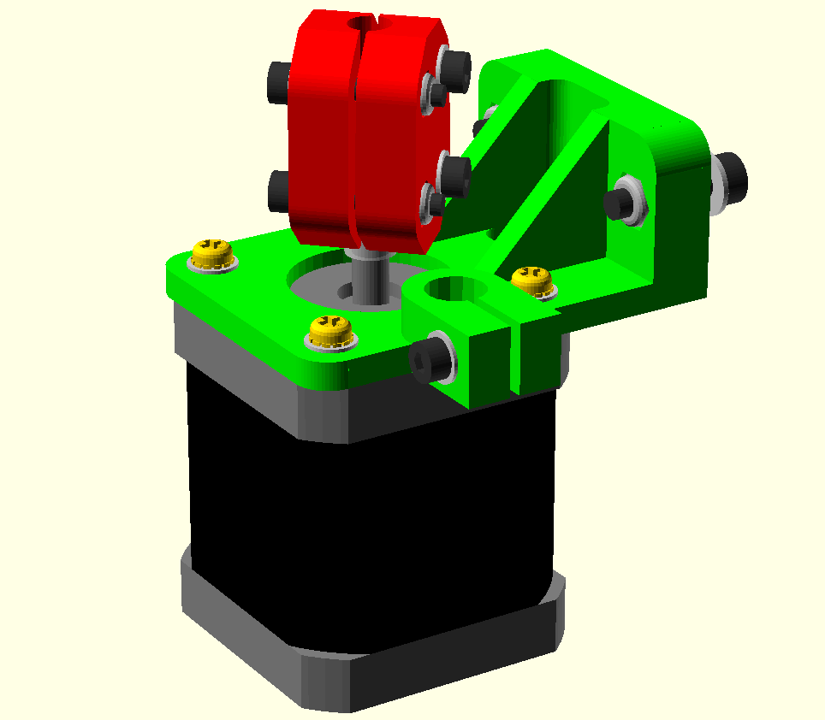

Assembly

- Insert the M3 nyloc nuts into the nut traps inside the bar clamps and M4 nylocs into their base.
- Fit M3 x 16mm cap screws and washers to the bar clamps.
- Attach the bar clamps to the top of the gantry using M4 x 16mm cap screws, note that the one with small screw holes for the limit switch goes on the left and they both face the same way. Leave the screws loose.
- Solder a pair of twisted blue wires (use the excess cut from the X motor) to the outer two pins of the microswitch.
- Fit the micro switch to the left hand bar clamp using No2 x 15mm pan head wood screws. N.B. The button should be towards the front of the machine.
- Thread the limit switch wires though the hole below the left hand bar clamp and route it along the top of the gantry in the holes and cable ties above the ones used for the motor wires.
- Fit the Z bars, inserting them through the X ends. Tighten the left hand bar clamp but leave the right hand one loose.
- Thread the M6 brass nuts onto the bottom of the lead screws about 50mm of the way up.
- Screw the Z screw pointers on the bottom just high enough to clear the couplings.
- Push each X end to the top and insert the lead screw from underneath far enough the allow the bottom end to go into the top of the couplings.
- Orient the couplings so that the flat on the motor shaft is facing towards the gap rather than the plastic. Tighten the couplings enough to grip the lead screws at the top and roughly parallel at the bottom. Don't close the couplings completely, the designed gap is 1mm when closed.
- Clamp the 20 way ribbon cable and its cable strip with the ribbon clamp at the top of the gantry and pass the remainder of the cable through the slot above it.

Y idler assembly

Vitamins
2 Ball bearing 624 4mm x 13mm x 5mm  1 M4 cap screw x 16mm  1 M4 cap screw x 30mm | 2 Nyloc nut M4  5 Washer M4 x 9mm x 0.8mm  2 Washer M5 x 20mm x 1.4mm

Printed parts
1 y_idler_bracket.stl
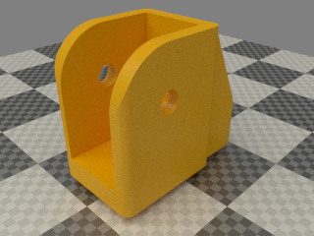

Assembly

Assemble as shown, easiest done on its side with the long axle screw pointing upwards and slowly inserted as the washers and bearings are added.

Y motor assembly

Vitamins
4 M4 cap screw x 16mm  1 M3 grub screw x 3mm  1 NEMA17 x 47.5mm stepper motor  4 Nyloc nut M4  4 M3 pan screw x 8mm | 1 T5 pulley 10 teeth  4 Washer M3 x 7mm x 0.5mm  4 Washer M4 x 9mm x 0.8mm  4 Star washer M3 x 0.5mm

Printed parts
1 y_motor_bracket.stl
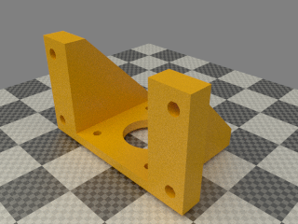

Assembly

Assemble as shown above. Fit the pulley as far down the shaft was possible without rubbing.

Y Carriage Assembly

Vitamins
14 M3 cap screw x 16mm  2 M3 cap screw x 20mm  1 Dibond sheet 216mm x 216mm x 3mm  3 LM8UU linear bearing | 16 Nyloc nut M3  16 Washer M3 x 7mm x 0.5mm  3 Ziptie 100mm min length

Printed parts
1 ribbon_clamp_26_33.stl  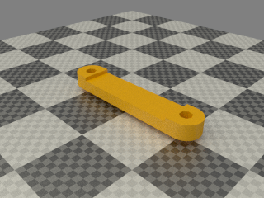 | 1 ribbon_clamp_26_33N.stl  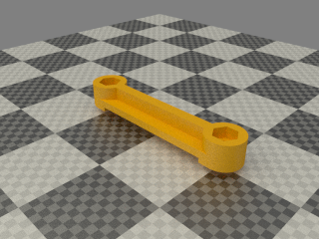 | 2 y_bearing_mount.stl  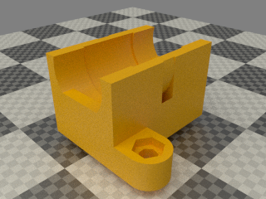
1 y_bearing_mount_switch.stl  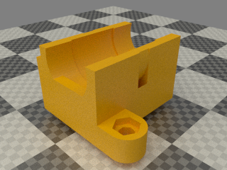 | 1 y_belt_anchor.stl  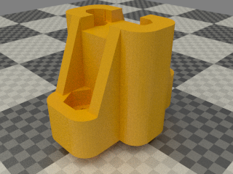 | 1 y_belt_anchor_toothed.stl  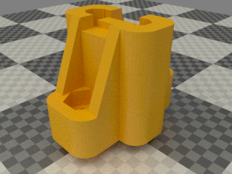
1 y_belt_clip.stl  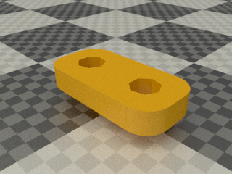 | 1 y_belt_clip_toothed.stl  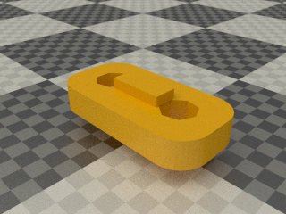

Assembly

This view is from the bottom of the bed which is the matt side of the Dibond. Except for the cable clamps, the nuts go on the bottom and the screw heads and washers on top . The cable clamps have the heads on the bottom to avoid a clash with the Y idler.
- Insert M3 nyloc nuts into all of the nut traps, including those in the top of the belt anchors. A long M3 screw can be used to pull them up to the top.
- Tie the bearings into the holders with the zip ties, and screw the holders to the carriage using M3 x 16mm screws and washers. Note that one of the bearing holders has a tab to trigger the limit switch. That goes on the right hand side (left on picture) with the tab facing forwards (that is, furthest away from the ribbon clamp) .
- Align the two bearings on the left (right on the picture) by inserting a rod and lining up the tabs with the edge of the board before tightening the screws. Leave the third bearing loose.
- Fit the belt clamps loosely to retain the nuts using M3 x 16mm screws and washers, then fit the anchors to the carriage using M3 x 16mm screw and washers. Note that the anchor with the tooth goes at the back and the belt clamp with the tooth at the front.
- Fit two wide ribbon clamps to the holes at the back of the board using M3 x 20mm screws and washers.

Y Heatshield Assembly
The heatshield prevents heat radiating downwards from the bed heating the Y carriage, which can make it warp due to the top surface expanding more than the bottom. 6mm corrugated cardboard is used as a cheap and effective insulator and aluminium foil tape on top reflects heat back towards the bed. It isn't needed for printing PLA and isn't included in the kit. If you want to print ABS it can be added later as it just slides under the bed and is taped in place.

Vitamins
1 Corrugated cardboard 192mm x 216mm x 6mm (cut it from the box of the kit).
5 Aluminium foil tape 50mm x 226mm x 0.05mm

Assembly

Start by printing a paper template from the pdf drawing y_heatshield.pdf. Cut out the outline with scissors or a craft knife. Place the template over the cardboard and cut round with a straight edge and craft knife. Cut through the holes.

Apply the tape strips with some overlap. Turn it foil side down and trim round with a knife.

Print bed assembly

Vitamins
4 19mm bulldog clip  1 PCB bed 214mm x 214mm  4 M3 cap screw x 10mm  1 Glass sheet 214mm x 202mm x 2mm  4 Hex male / female pillar M3 x 20mm  1 Polypropylene strip 271mm x 33mm x 0.5mm  1 Ribbon cable 26 way 381mm | 2 Heatshrink sleeving ID 1.6mm x 15mm  2 Heatshrink sleeving ID 2.4mm x 15mm  2 Heatshrink sleeving ID 6.4mm x 30mm  1 Epcos B57861S104F40 100K 1% thermistor (pre-fitted)  4 Washer M3 x 7mm x 0.5mm  1 Black wire 32/0.2 length 635mm  1 Red wire 32/0.2 length 620mm

Sub-assemblies
1 y_carriage_assembly

Bed Wiring
The thermistor comes pre-glued to the bed with J-B Weld, which is a high temperature thermally conductive epoxy.
- Separate all the 26 ways of the ribbon cable and strip about 10mm of insulation.
- Twist the first 12 wires together, leave two for the thermistor and then twist the last 12 together. It is easier to twist bunches of three together and then twist four of those bunches to get all 12 to meet.
- Solder the two groups of 12 wires to the PCB so that they lead off towards the middle, as shown below. Be careful not to get solder down the holes in the PCB as that will prevent the glass from lying flat. Ensure the red wire is the one on the right.

- Put the 1.6mm heat shrink on the middle two wires and solder them to the thermistor. Shrink the sleeving with a heat gun or place it over the soldering iron very close but not touching.

- Separate, strip and bunch the other end of the cable in the same way and solder the red and black 32/0.2 wires as shown below and then sleeve with the 6.4mm heat shrink.

- Use red and black wires trimmed from the X motor for the thermistor wiring. Twist them before soldering and sleeve with the 2.4mm sleeving. Observe the polarity above for minimum crosstalk with the heater. Cut them 100mm longer than the black heater wire.

Assembly

- Screw the pillars into the Y carriage. The Dibond has been tapped M3 but don't over tighten as it is quite soft. Note that the rear two pillars have a washer under them. The front two are initially spaced the same distance by using a washer as a temporary shim. They can then be adjusted up or down slightly to level the bed relative to the nozzle.
- The bed is installed with the cable at the back. It initially leads off forwards and then loops back on itself under the top ribbon clamp. It then doubles back under the Y carriage through the lower cable clip.
- Screw the bed to the top of the pillars with the M3 x 10 cap screws (no washers).
- Pull the ribbon cable tight enough so that the loop under the bed does not touch the bed and clamp it together with the polypropylene strip (closest to the clamp).
Install the clips and the glass after the carriage has been mounted on the machine.

Y Axis Assembly

Vitamins
1 Belt T5 x 6mm x 670mm (PU & Kevlar)  4 M3 cap screw x 16mm  8 M4 cap screw x 16mm  4 Nyloc nut M3  8 Nyloc nut M4  2 No2 pan wood screw x 13mm | 1 Smooth rod 8mm x 270mm  1 Smooth rod 8mm x 417mm  1 Microswitch  2 Washer M2.5 x 5.9mm x 0.5mm  4 Washer M3 x 7mm x 0.5mm  8 Washer M4 x 9mm x 0.8mm

Printed parts
3 y_bar_clamp.stl  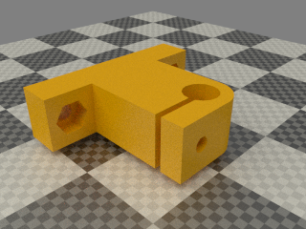 | 1 y_bar_clamp_switch.stl  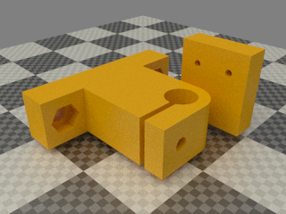

Sub-assemblies
1 print_bed_assembly | 1 y_idler_assembly | 1 y_motor_assembly

Assembly

- Insert the captive nyloc M3 nuts and M3 x 16mm cap screws in each of the Y bar clamps.
- Loosely fit the two left hand Y bar clamps to the base. Orient them so the rod is towards the outside of the machine.
- Twist together some green wire trimmed from the X motor and solder to the outer two pins of the microswitch. Screw it to the y_bar_clamp_switch with No2 pan wood screws and M2.5 washers with the button towards the top and the wires exiting towards the back of the machine.
- Fit the right hand Y bar clamps to the base but leave the screws loose.
- Thread the limit switch wires down the hole in the base close to the limit switch and run it through the nearest cable tie, along the underside of the base through a second cable tie, up through the hole in the base and then through the adjacent mouse hole in the right stay.
- Thread the Y motor wires through the hole in the base and then screw the Y motor bracket in place. Run the wires in the cable ties and holes parallel to the limit switch wires.
- Clamp the Y belt (the shorter of the two) in the front belt anchor with the teeth facing away from the carriage. The end of the belt should project 7.5mm, i.e. two teeth and the gap between them.
- Put a half twist in the belt and the thread it through the Y idler assembly with the smooth side against the bearings and then clamp it in the rear clamp with the teeth facing the carriage. Again leave two teeth projecting from the anchor.
- Slide the Y bars through the bar clamps and the carriage bearings. Tighten the clamps to grip the bars lightly but do not over-tighten them. Slide the carriage up and down to align the right hand bearing and bar clamps. Tighten the bearing first and then move it to each end and tighten the clamps.
- Put the belt over the motor pulley and fasten the idler assembly to the base with enough tension on the belt to play a low note when plucked. Ensure the belt runs in the middle of the idler without touching the washers each side by adjusting the angle of the idler.
- Clamp the bed's ribbon cable and polypropylene strip to the base with the ribbon clamp. The wires turn right and go through the cable ties and under the mouse holes in the right hand stay. The heater wires go through the rear tie and the larger hole.

X Carriage Fan Assembly

Vitamins
4 M4 cap screw x 30mm  1 Fan 60mm x 15mm | 4 Nyloc nut M4  4 Washer M4 x 9mm x 0.8mm

Printed parts
1 x_carriage_fan_bracket.stl | 1 x_carriage_fan_duct.stl

Assembly
- Assemble as shown below with the fan label downwards and the wires exiting nearest the leftmost screw in the picture.

X Carriage Assembly

Vitamins
2 M3 cap screw x 10mm  1 M3 cap screw x 20mm  2 M3 cap screw x 25mm  3 LM8UU linear bearing  1 Nut M3 | 4 Nyloc nut M3  4 Washer M3 x 7mm x 0.5mm  3 Ziptie 100mm min length  1 Belt T5 x 6mm x 865mm (PU & Kevlar)

Printed parts
1 x_belt_clamp.stl  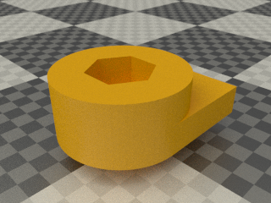 | 1 x_belt_grip.stl  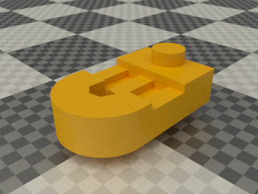
1 x_belt_tensioner.stl  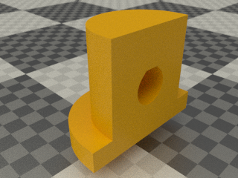 | 1 x_carriage.stl

Assembly

- Insert the linear bearings and secure each one with a zip tie.
- Put M3 nyloc nuts in the four nut traps.
- Add the two M3 x 10mm screws and washers for the fan mount but leave loose.
- Attach the X belt (longer of the two) to the left side x_belt_clamp (RHS in the picture) with the teeth facing upwards (downwards in the picture) and two teeth projecting from the clamp. Clamp with the M3 x 20mm cap screw and washer.
- Insert the M3 captive plain nut and M3 x 25mm cap screw for the belt tensioner and put the tensioning piece on the end of the screw with the flange towards the carriage.
- Put one half twist in the belt and feed it though the slot below the right hand clamp (LHS in the picture) with the teeth facing downwards (upwards in the picture). The twist direction should be such that the vertical stretch in the middle has the teeth facing inwards (to avoid them catching on the fan).
- Double back the belt over the tensioner and clamp it with the x_belt_grip and an M3 x 25mm cap screw and washer with two teeth projecting.

Hot end assembly

Vitamins
1 JHead MK5 hot end  1 UB5C 5R6F 5R6 3W vitreous enamel resistor  1 Epcos B57560G104F 100K 1% thermistor  2 PTFE sleeving OD 1.2mm ID 0.71mm x 62mm  2 Heatshrink sleeving ID 1.6mm x 15mm | 2 PTFE sleeving OD 2.6mm ID 2mm x 45mm  2 Heatshrink sleeving ID 2.4mm x 15mm  1 Heatshrink sleeving ID 6.4mm x 60mm  2 Red wire 16/0.2 length 170mm  1 Ziptie 100mm min length

Assembly
The hot end is pre-assembled and installed in the Wades block. The resistor and thermistor are cemented in with exhaust putty. The heater is then run for a few hours below 100˚C to bake out the water content of the cement without causing blisting due to steam bubbles. This is necessary because the wet cement will be sligtly conductive and effect the sensitive thermistor inputs.
Note that the soldered joints on the resistor leads are inside the PTFE sleeving rather than the heatshrink as they get too hot for the normal black heatshrink material.
Surplus green wire from the motors is used for the thermistor leads.

Extruder Motor Assembly

Vitamins
2 M3 cap screw x 45mm  1 15 way D PCB mount plug (on PCB)  1 M3 grub screw x 6mm  1 NEMA17 x 47.5mm stepper motor  3 Nut M3 | 1 Extruder connection PCB  2 No2 pan wood screw x 13mm  4 3 way terminal block (on PCB)  2 Washer M2.5 x 5.9mm x 0.5mm  2 Washer M3 x 7mm x 0.5mm

Printed parts
1 d_motor_bracket.stl  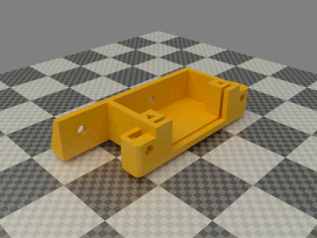 | 1 d_motor_bracket_lid.stl  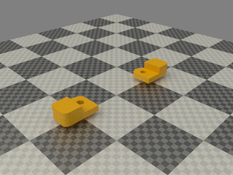 | 1 wades_small_gear.stl  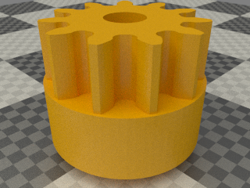

Assembly
Note that the wires exit the motor on the bottom edge (right in the picture).
- Remove two of the motor's screws and replace them with the longer M3 x 45mm screws and washers that fasten the d_motor_bracket to the motor.
- Insert the PCB and the two M3 nuts in the nut traps and then screw down the lid pieces (which hold connector and the nuts in place) using No2 x 15mm pan wood screws and M2.5 washers.
- Fit the gear to the motor leaving only a small gap. The grub screw needs to be tight to avoid working loose but not too tight it or it will crack the plastic gear.
- Cut the motor wires short and connect them to the terminals as follows: -
Terminal PCB Label | Motor Wire
MK | Black
MG | Green
MB | Blue
MR | Red

Extruder Assembly

Vitamins
3 Ball bearing 608 8mm x 22mm x 7mm  3 M3 hex screw x 10mm  2 M4 hex screw x 20mm  2 M4 hex screw x 50mm  1 M8 hex screw x 60mm, hobbed at 25  2 Nut M4 | 2 Nut M8  1 Smooth rod 8mm x 22mm  2 Spring 7mm OD, 1mm gauge x 10mm long  3 Washer M3 x 7mm x 0.5mm  3 Star washer M3 x 0.5mm  1 Star washer M8 x 1.6mm

Printed parts
1 wades_block.stl | 1 wades_gear_spacer.stl  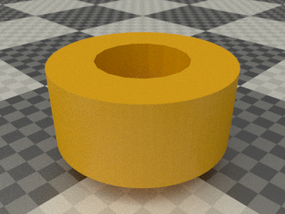
1 wades_idler_block.stl  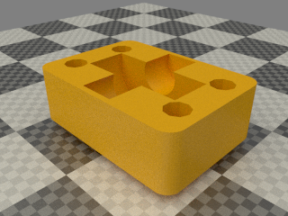 | 1 wades_big_gear.stl  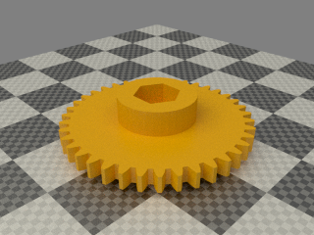

Sub-assemblies
1 extruder_motor_assembly | 1 hot_end_assembly

Assembly
Press fit the bearings into the extruder with a vice or pull them in using the M8 bolt and a nut. They are a tight fit to ensure there is no movement during reversals which would wear away the plastic.
- Insert the two M4 nuts into the slots in the bearing block, one from above and one from below (not visible in the picture).
- Push the idler axle through the bearing and snap it into the idler block.
- Place one of the M4 x 20mm bolts through the hole in the base of the block underneath the motor.
- Loosely attach the motor with three M3 x 10mm hex head screws trapping the M4 bolt in place.
- Push the M8 hobbed bolt through the large gear and make sure it is fully seated.
- Add the spacer to the bolt and put it through the bearing block. Secure with an M8 nut finger tight. Add the M8 star washer and second nut to lock it in place. Finger tight is generally enough to stop it shaking loose.
- Put the springs on the M4 x 50mm hex screws and thread them through the idler block into the bearing housing and into the trapped nuts. Tighten them until the end of the screw is flush with the back of the bearing housing.
- Slide the motor up to engage the gears and rotate them to ensure they don't bind or have too much backlash. Lock the motor in position by tightening the screws.
- Push some filament into the extruder hard against hobbed bolt whilst turning the large gear to pull it in. Some force on the filament is needed initially to open the idler but once you see it open the filament can be fed by just turning the gear.
This is the way the extruder is loaded. Normally one would wind it in by hand until it hits some resistance, then heat the extruder and feed it with the motor. In this case just wind it up and down and check the gears don't bind. The spring force pushes the bolt a little further back in the bearings, so you might need to slacken off the motor a bit.
- Attach the red heater wires to the terminals marked H.
- Attach the green thermistor wires to the terminals marked T.

X Axis Assembly

Vitamins
2 Smooth rod 8mm x 381mm | 2 Wingnut M4

Sub-assemblies
1 extruder_assembly | 1 x_carriage_assembly | 1 x_carriage_fan_assembly

Assembly

- Put the X ends at the bottom of the Z axis.
- Make sure the X bars are completely free of grease or the clamps won't grip.
- Remove the idler's axle bolt.
- Slide the X bars through the idler bracket, the X carriage and into the motor bracket as far as they will go.
- Tighten the X bar clamps while the axis is at the bottom. Don't over tighten them, i.e. don't close the gap entirely, just enough until you feel it grips the bar solidly.
- Move the axis to the top and then tighten the top right Z bar clamp.
- Put the belt round the motor pulley and then re-attach the idler axle with the belt around the idler.
- Tension the belt enough to play a low note when plucked.
- Run the carriage up and down a few times and check that the belt does not rub on the idler washers. If it does then shim one side of the penny washer where it rests against the plastic with a few layers of paper until it runs true.
- Attach the extruder with the M4 wing nuts. If the right hand wing nut stops in a position where it sticks out beyond the carriage start again with the hex head in a different one of the six possible positions.
- Slide the fan assembly's bracket onto the M3 screws on the front of the carriage and tighten them.
- Cut off the plug and screw the wires into the terminals marked F+ (red) and F-(black). Cut the yellow wire (tacho signal) short as it is not used.
- Mate the D type connectors and screw the captive M3 screws in the shell into the captive M3 nuts in the d_motor_bracket.

Spool holder assembly
The spool holder will hold a 300 x 85mm spool commonly used by filament suppliers for 2.3kg reels. The spool is not included in the kit.

Vitamins
4 Ball bearing 608 8mm x 22mm x 7mm  2 M4 cap screw x 16mm  4 M8 cap screw x 30mm  1 Foam sponge 20mm x 20mm x 20mm  2 Nyloc nut M4  4 Nyloc nut M8 | 1 PLA sample 0.3mm 20mm  1 PTFE tubing OD 4.6mm ID 3.84mm x 750mm  2 Washer M4 x 9mm x 0.8mm  8 Washer M8 x 17mm x 1.6mm  4 Washer M8 x 30mm x 1.5mm

Printed parts
1 dust_filter.stl | 1 feed_tube_connector.stl
2 spool_bracket_female.stl | 2 spool_bracket_male.stl

Assembly
The male and female halves of the brackets press fit together. They are supplied fitted to make them more robust while being shipped.
- Insert the two M4 nyloc nuts into the nut traps in the male brackets.
- Screw the bearings to the brackets using the sequence of washers shown above.
- Cut a slit half way through the foam cleaning sponge and squash it into the box in the dust filter with the slot aligned with the holes for the filament.
- Clip the dust filter in the middle of one of the brackets, note the orientation.
- Thread the PTFE tube through the cylinder at the top of the dust filter and wrap some 12mm wide sticky tape around the end to increase the diameter to about 6mm. Pull it back into the cylinder where it should be retained by the lip at the top end.
- Slide the dust cap over the other end of the PTFE tube and add tape as above to secure it.
- Fit the brackets to the inside of the frame stays and secure with the M4 x 16mm cap screws and washers. The one with the dust filter and feed tube goes on the left.

PSU assembly

Vitamins
1 THS15 Aluminium clad resistor 10R  1 THS15 Aluminium clad resistor 4R7  1 PSU e.g. ALPINE500  4 M4 cap screw x 16mm  1 IEC mains lead  4 Nyloc nut M2.5  4 Nyloc nut M4  4 M2.5 pan screw x 12mm  2 6-32 pan screw x 9.5mm | 1 Heatshrink sleeving ID 10mm x 15mm  3 Heatshrink sleeving ID 2.4mm x 15mm  5 Heatshrink sleeving ID 3.2mm x 15mm  2 Heatshrink sleeving ID 6.4mm x 15mm  4 Washer M2.5 x 5.9mm x 0.5mm  6 Washer M4 x 9mm x 0.8mm  2 Star washer M4 x 0.8mm  2 Ziptie 100mm min length

Printed parts
1 atx_long_bracket.stl | 1 atx_short_bracket.stl

Wiring

- Cut one of the black wires to a length of 240mm and one of the red wires to 280mm, strip them, add 15mm of 3.2mm heatshrink and solder to the 10R (gold in the kit) dummy load resistor.
- Cut another black wire and the green wire to 230mm, strip them, twist together, sleeve with 15mm of 3.2mm sleeving and solder to one end of the 4R7 resistor.
- Cut the brown sense wire and one orange wires to 220mm, strip them, twist together, sleeve with 15mm of 3.2mm sleeving and solder to the other end of the 4R7 resistor.
- Cut the remaining six red wires short (~50mm), strip, twist together and solder. Cover the end with 15mm of 6.4mm heatshrink.
- Cut the remaining three orange wires short, strip, twist together and solder. Sleeve with 15mm of 3.2mm heatshrink.
- Cut each of the purple, blue and grey wires short and sleeve them individually with 15mm of 2.4mm heatshrink.
- Cut the six yellow wires to a length of 190mm, strip 15mm, twist and solder them together, cut off the point and sleeve with 15mm of 6.4mm heatshrink leaving enough wire protruding to fit the terminal block on the Melzi terminal.
- Cut the 12 remaining black wires to a length of 210mm, strip 15mm, twist and solder them together, cut off the point and sleeve with 15mm of 10mm heatshrink, leaving just enough wire protruding to fit the terminal block on the Melzi. It will just fit if you don't add too much solder.
The reason for using all 12 wires is that the heater and motor currents cause a small voltage drop in the ground connection. Because it is connected to the mains earth inside the PSU the ground of the Melzi will be a little above earth potential. That causes current to flow in the USB lead to the PC and can disrupt the communication. Keeping the ground resistance as low as possible reduces the problem. It also maximises the voltage at the bed.
- Put a cable tie round the black and yellow bundles plus all the short one.
- Put a second cable tie on the six wires going to the resistors, see the picture above.

Summary
Colour | Wires | Length | Sleeving | Function
Black | 12 | 210mm | 10mm | GND
Yellow | 6 | 190mm | 6.4mm | +12V
Red | 1 | 280mm | 3.2mm | 5V dummy load
Black | 1 | 240mm | 3.2mm | 5V dummy load return
Orange + Brown | 2 | 220mm | 3.2mm | 3.3V dummy load / 3.3V sense
Black + Green | 2 | 230mm | 3.2mm | 3.3V dummy load return / PSU ON
Red | 6 | ~50mm | 6.4mm | 5V - unused
Orange | 3 | ~50mm | 3.2mm | 3.3V - unused
Blue | 1 | ~50mm | 2.4mm | -12V - unused
Purple | 1 | ~50mm | 2.4mm | 5V standby - unused
Grey | 1 | ~50mm | 2.4mm | Power good - unused

Assembly

- Put four M4 nyloc nuts in the nut traps of the two brackets.
- Screw the brackets to the frame with M4 x 16mm cap screws and washers.
- Run the wires from the right Z motor, the Y motor and the bed up the corner between the gantry and the right stay before fitting the PSU between the brackets.
- Secure the PSU with two 6-32 x 9.5mm pan screws, M4 star washers and M4 plain washers.
- Screw the resistors to the frame using four M2.5 x 12mm pan screws, M2.5mm washers and M2.5mm nyloc nuts.

Electronics Assembly

Vitamins
4 M3 cap screw x 16mm  1 Electronics e.g. Melzi  4 Nyloc nut M3  1 Micro SD card | 1 Micro SD to USB adapter  2 Heatshrink sleeving ID 2.4mm x 15mm  1 USB A to Mini B lead  8 Washer M3 x 7mm x 0.5mm

Printed Parts
4 pcb_spacer.stl

Assembly
N.B. The Melzi is the most expensive part of the machine and can easily be damaged if the wiring is incorrect. Please double check before connecting the power. It is supplied loaded with Marlin firmware configured for the Mendel90, has the stepper motor current pots pre-set to 0.5V, which gives 1.2A and has had a full functional test on a jig with motors, limit switches and dummy loads for the heaters and fans. The thermistor inputs have been tested using a known resistance.
Use static precautions when handling.
Screw the Melzi to the frame above the PSU with the four M3 x 16mm cap screws, spacers and M3 nuts with plain washers both sides. The side of the Melzi with the terminals goes towards the gantry.
Before connecting each pair of wires check the resistance with a multi-meter : -
- Thermistors should measure roughly 100KΩ at room temperature.
- The extruder heater should measure about 5.8Ω.
- The bed heater should measure ~1.2Ω .
- There should be no connection between the heaters and the thermistors.
- The limit switches should be a short circuit and open when they are pressed.
- The motors should be about 1.9Ω between red and blue and between green and black but no connection between red and black.
The wires all terminate at screw terminals on the Melzi board. The terminals are labelled on the edge of the PCB. Connect the wires following the first two columns of the table below. Give each wire a tug after screwing down the terminal to make sure it has grabbed the wire. A loose wire can cause a spark which can damage the Melzi.
Note that there are no connections to FAN+ on the Melzi and pin 5 of the ribbon cable.
Melzi Connector | Wire | Signal | D connector pin
ETEMP GND | Ribbon 4 | Extruder thermistor GND | Pin 9
ETEMP SIGNAL | Ribbon 3 | Extruder thermistor signal | Pin 1
BTEMP GND | Red | Bed thermistor GND
BTEMP SIGNAL | Black | Bed thermistor signal
ZSTOP GND | Blue | Z limit switch GND
ZSTOP SIGNAL | Blue | Z limit switch signal
YSTOP GND | Green | Y limit switch GND
YSTOP SIGNAL | Green | Y limit switch signal
XSTOP GND | Ribbon 2 | X limit switch GND
XSTOP SIGNAL | Ribbon 1 (red) | X limit switch signal
FAN - | Ribbon 12 | Fan drive | Pin 13
FAN + |  | Fan 12V
HOTEND - | Ribbon 9, 10, 11 | Extruder heater drive | Pin 4, 5, 12
HOTEND+ | Ribbon 6, 7, 8 | Extruder heater +12V | Pin 3, 10, 11
HOTBED- | Thick black | Bed heater drive
HOTBED+ | Thick red | Bed heater + 12V
POWER GND | PSU Black | PSU GND
POWER + 12V | PSU Yellow | PSU + 12V
E-MOTOR | Ribbon 13 | Extruder motor red | Pin 6
E-MOTOR | Ribbon 14 | Extruder motor blue | Pin 14
E-MOTOR | Ribbon 15 | Extruder motor green | Pin 7
E-MOTOR | Ribbon 16 | Extruder motor black | Pin 15
Z-MOTOR | Z motor 1 red | Z motor red
Z-MOTOR | Z motor 2 blue | Z motor blue
Z-MOTOR | Z motor 1 green | Z motor green
Z-MOTOR | Z motor 2 black | Z motor black
Y-MOTOR | Y motor red | Y motor red
Y-MOTOR | Y motor blue | Y motor blue
Y-MOTOR | Y motor green | Y motor green
Y-MOTOR | Y motor black | Y motor black
X-MOTOR | Ribbon 17 | X motor red
X-MOTOR | Ribbon 18 | X motor blue
X-MOTOR | Ribbon 19 | X motor green
X-MOTOR | Ribbon 20 | X motor black

The Z motors are wired in series, so connect red and green of the first motor and blue and black of the second motor to the Melzi, connect blue on the first motor to red on the second motor and sleeve the joint with 2.4mm x 15mm heatshrink. Connect black of the first motor to green on the second and sleeve with heatshrink.
For reference the ribbon cable has the following pin out: -
Wire number | Signal | D type connector pin
1 (red) | X limit signal
2 | X limit GND
3 | Thermistor signal | Pin 1
4 | Thermistor GND | Pin 9
5 | Probe (not currently used) | Pin 2
6 | Heater +12V | Pin 10
7 | Heater +12V | Pin 3
8 | Heater +12V | Pin 11
9 | Heater - | Pin 4
10 | Heater - | Pin 12
11 | Heater - | Pin 5
12 | Fan - | Pin 13
13 | Extruder motor red | Pin 6
14 | Extruder motor blue | Pin 14
15 | Extruder motor green | Pin 7
16 | Extruder motor black | Pin 15
17 | X motor red
18 | X motor blue
19 | X motor green
20 | X motor black
The photo below shows a wired up machine.
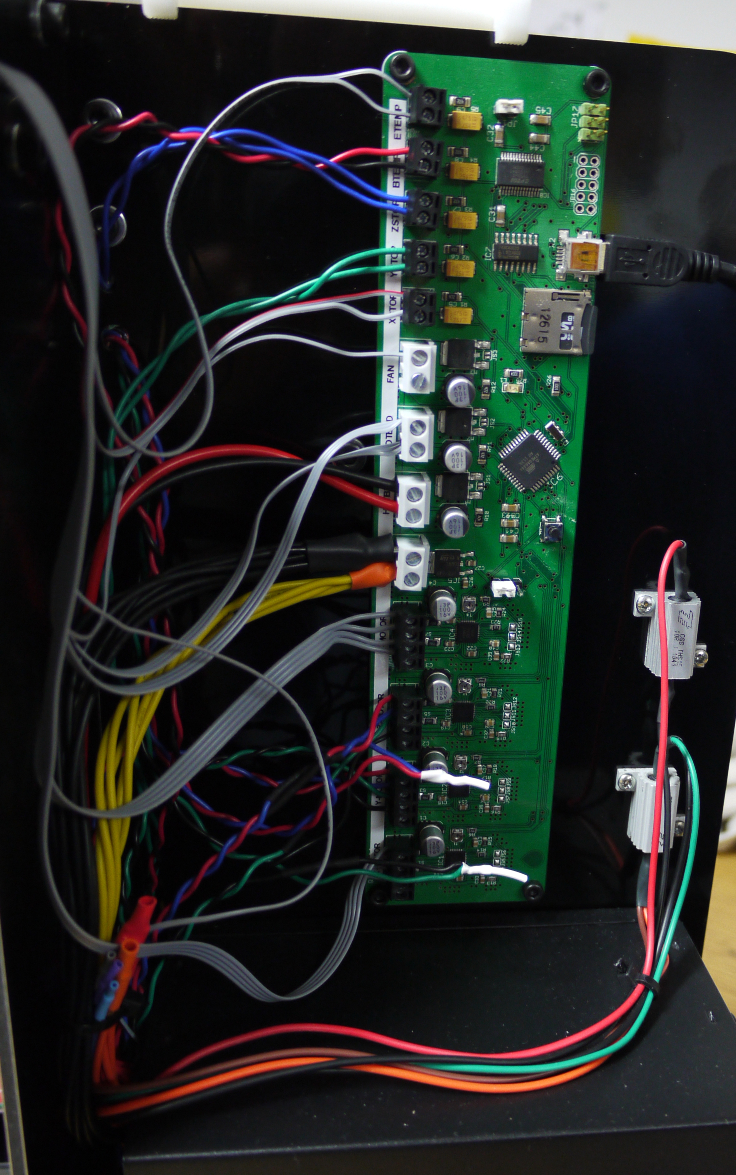

Software
The micro SD card with the kit comes preloaded with software to operate the machine on Windows (Linux versions of all the tools are avialable online). After this has been copied to your PC the card can be wiped and used to run the machine. Running G code from the card gives more consistent results than sending it over USB. Loading G code onto the card via the Melzi is quite slow so a USB SD card reader is included in the kit to allow it to be loaded directly from the PC.
The following softwares are included: -

Marlin Firmware
This is the source code for the firmware that is pre-loaded on the Melzi. It is Nophead's fork and is also available on GitHub https://github.com/nophead/Marlin. The pre-installed version is sufficient to test the machine but calibration involves tweaking the Z axis home position and the hobbed bolt diameter.

Arduino IDE
This is used to compile and load the firmware and is located in theWindows\arduino-1.0.1folder. Once copied to your PC it can be run simply by clicking on arduino.exe, no istallation is needed. It is as downloaded from http://arduino.cc/en/Main/Software with just the addition of the hardware\Melzi folder.

When started it opens an empty sketch. Use the File/Open menu to open Marlin\Marlin\Marlin.ino. Click on the configuration.h tab and make your changes to Z_HOME_POS, E_STEPS_PER_MM and possibly change the baud rate. Everything else should work as is.

When you are directed below to update the firmware do the following: -
- Ensure the auto reset jumper at the top of the Melzi is fitted.
- Use the Tools / Board menu option to set the board to “Melzi W/ ATmega1284p 16mHz”.
- Use the Tools / Serial Port option to select the correct USB port.
- Press the play button.
- Wait for ”Done uploading” to appear.
- Save your changes with the save button.

Pronterface
This is a simple host application used to control the printer downloaded from http://koti.kapsi.fi/~kliment/printrun/ .
Again it needs no installation. Simply copy the files and run Windows\printrun-win-Mar2012-slic3r\dist\pronterface.exe. To configure it for the Mendel90 build volume and origin plus get some handy buttons for bed levelling copy printrunconf.ini over the one it creates when first run. This is located in C:\Documents and Settings\Username on WinXP and C:\Users\Username on Win7.

Testing

Jumpers
Make sure the auto reset jumper is installed at the top of the Melzi. This is required for loading firmware but has to be removed for stand alone operation from the SD card. The power jumper in the middle of the board should be set to VREG to power the Melzi from the PSU. The USB position can be useful for loading firmware before the board is installed but the 5V at the end of a USB cable is a lot less accurate and more noisy then the regulator output.

Power up
Double check the 12V supply to the board is the right way round, plug in the mains and switch on the PSU. The PSU fan should run. Connect the USB lead to a PC and a USB connection should appear. On Windows, the PC will need a USB FTDI driver for the serial port to appear. This can be found in the Arduino drivers folder. The board comes with Marlin installed configured for 250kB. Note that non-standard baud rates have problems on some versions of Linux, so you may have to configure the firmware for 115.2kB and reinstall the firmware.
Open pronterface, set the baud rate and serial port and press “Connect”. After a few seconds the following should be displayed.
Connecting...
start
Printer is now online.
echo:Marlin: 1.0.0 RC2
echo: Last Updated: 2012-07-27 | Author: nophead
echo: Free Memory: 12982 PlannerBufferBytes: 1232
echo:Using Default settings:
echo:SD card ok

Limit switches
Check that the limit switches are working with M119. When no switches are triggered they should all read low:
x_min:L y_min:L z_min:L
ok
Check that manually triggering each switch causes the corresponding input to change from L to H while the switch is held down. Also check that each axis is able to hit its limit switch. For X the extruder wing nut can get in the way. If this is the case simply rotate the hex head bolt in its socket. The Z axis must be reasonably level side to side so that the right hand side doesn't hit the top of the axis before the left side hits the limit switch. The microswitches must be mounted in the correct orientation for the button to strike its intended target (X towards the bottom, Y towards the top, Z towards the front).

Motors
Put some oil on the Z lead screws and lithium grease on the extruder gears. ABS gears will run continously for months with grease but wear out quickly when run dry.
Move all of the axes manually to somewhere near the centre. Then check that all the axes move in the right direction by using the jog buttons in Proterface. Click on the “10” ring in the +X quadrant and check that the carriage moves 10mm towards the left, away from the limit switch. Then click the “10” ring in the -X quadrant and check it moves back towards the switch. Since the limit switches have been verified to be working and the motor is running in the right direction it is now safe to home by pressing the X home button (house icon with an X). Repeat the procedure for the Y axis. +Y moves the bed backwards away from the switch and -Y forwards towards the switch
Note that both the X and Y axes are backwards by normal conventions when viewed from the front of the machine. Because the Z limit switch is at the top the +Z button should move the Z axis upwards towards its limit switch and -Z should move it back downwards.
When all the axes have been homed successfully enter G1X0Y0Z100F30000 to centre them. It should then be possible to use the “100” ring to move the X and Y axes to their extremes. The firmware soft limits should prevent them hitting the end.
Check the the extruder feeds forwards when the “Extrude” is pressed and backwards when the “Reverse” button is pressed.. Marlin may prevent you from doing 'cold extrusion'; you can override this with command M302. Make sure you don't have any filament loaded during this test.

Heaters
Tick the “Monitor Printer” to show the temperature graph. The figures under the “Check Temp” button should show the hot end (T) and the bed (B) to be around room temperature.
Set the “Heater:” target temperature to 220˚C and press the “Set” button. The temperature of the hot end should rise and settle at 220˚C. If you have a thermocouple probe you can insert it inside the hot end and verify the temperature at this stage (before the barrel is filled with plastic). To do this you will need to remove the idler and stiffen the thermocouple wire by sleeving it with about 150mm of PTFE tubing with an outside diameter less than 3mm.
Pressing the blue “Off” button should cause the temperature to slowly fall back to room temperature again.
Repeat the same procedure with the bed heater by setting it to 60˚C.

Fan
Type M106 to turn the fan on and M107 to turn it off.
This completes the testing.

Calibration

Bed Levelling
The best way to level the bed relative to the nozzle is to use a dial gauge mounted in place of the extruder using this clamp. If you don't have a dial gauge you can roll a spare piece of smooth rod or slide some paper or film under the nozzle and feel when it is just touching.

The two pillars at the back of the bed have a washer under them to ensure the front can be made both higher or lower than the back. Those pillars are tightened and not adjusted. Front - back adjustment is achieved by adjusting the two pillars at the front. Left - right adjustment is done by turning the Z lead screws. Ideally there would be only one mounting point at the front as only three points are needed to mount a stiff sheet like glass. Having four makes the adjustment more tedious as they tend to bend the sheet and interact with each other.
Start by sliding a washer under the front pillars to set them to the same height as the back. Move the gauge or nozzle to the middle of the back of the bed. Note that level on the gauge, or nudge the Z axis to just touch your feeler. This is the level that we want the whole bed to be at.
Move to the back left corner and adjust the left lead screw to get the same level as the middle. Move to back right and adjust the back right lead screw. Moving the gauge all the way across the back should now read the same height.
Now move to each of the front corners in turn and turn the pillar until the height is correct. Lock them in place by tightening the top screws through the bed.
The whole bed should now be level but usually you need to repeat the procedure a few times due to the interaction of the four points.

Extruder Calibration
The E steps per mm should be adjusted so that when commanded to extrude 100mm it actually feeds 100mm. This is done by placing a mark (a piece of tape for instance) on the filament 120mm above the extruder and telling it to feed 100mm at say 60mm/min. Then measure the distance to the mark to work out how much it actually extruded. It depends on the diameter of the bolt hobbing and how far the plastic is pressed into it, i.e. how soft it is and the spring tension. Harder plastics will feed faster.
Multiply the E_STEPS_PER_MM in the firmware by 100 / actual extrusion and reload it.
You also need to make sure the slicer knows what volume of plastic it actually gets for a 1mm increment, and that depends on the diameter of your filament. Measure the diameter using digital callipers and then input that figure into the slicing software. The Faberdashery sample provided will be very close to 2.85mm.

Z Home Point
When using a top Z limit switch you set the height of the machine in the firmware and thereby define "0" as "touching the bed" without having to actually crash the head into the bed.
Once the bed is levelled home Z, and then nudge it down to meet an object of known height placed on the bed. A smooth rod is ideal as you can roll it backwards and forwards nudging the nozzle up and down and feel when it just touching.
When the nozzle is just touching your feeler object, take the Z value with M114. Subtract the height of the object from that and then subtract the result from the Z_HOME_POS in the firmware.
For example, if it thinks it is at 7 when it is actually 8 then Z_HOME_POS is too small by 1mm.
Update the firmware and download it. The position should then be accurate when the machine is cold. To get it spot on start printing an object (see next section) and stop it after it has done the outline. Cool the outline and measure its thickness in a few places and take the average. If it is say 0.32mm but the object was sliced with 0.3mm layers then it is too high by 0.02mm so increase the Z_HOME_POS by that amount.
When the Z home point has been set rotate the two Z screw pointers so that they point directly at the Z bars. One can now see if the lead screws get out of sync.

First Print
- Clean the glass bed to remove any finger marks.
- The SDCard also contained a G code file: android_export.gcode. This should print well assuming your filament is close to the 2.86mm that it was sliced for. Open it with the File / Open menu option of Pronterface and then press the SD button and select SD Upload. Alternatively copy it onto the SD card with the USB adapter and give it an uppercase name, 8 characters or less, and a .G suffix.
- Make sure the “Monitor Printer” button is not ticked as that can affect print quality.
- Press the SD button, select SD print and then select the file. The machine should home and then place the nozzle on the bed preventing it from oozing while it warms up, print an outline and then print the object.
- Wait for the glass to cool and the object should then be easy to remove. It should look like this: -

The object was sliced with Skeinforge (downloaded from http://fabmetheus.crsndoo.com/), which was also on the SD card in the Skienforge50 folder and the settings used to slice it are in the .skeinforge folder.
Running skienforge requires Python 2.7 to be installed and then run skeinforge50\skeinforge_application\skeinforge.py.

Operating Instructions

Changing filament
Do not to let the extruder run out of filament. If it does it will lose grip as soon as it gets past the hobbed bolt, making it difficult to remove as you cannot simply rewind it. You would have to remove the idler screws and grab the end with snipe nose pliers and pull it out while hot.

Removal
To change to a new reel of filament heat the extruder to normal operating temperature then rewind 100mm at ~120mm/min. When the bit that has been molten gets to the hobbed bolt there will come a point where it is too thin or soft to be gripped. At this point pull it with enough hand tension to stop it from slipping and keep up the tension until it is all the way out. Do not stop rewinding it when it is part way out. This can cause soft filament to expand into the entrance of the J-Head (which is bigger than the filament path) and jam there as it freezes.
If you are switching between a strong colour and a weaker one it can take a long time to flush through all the pigment. To minimise this you can remove PLA at 80˚C (which is above its glass transition temperature but below its melting point). As it is therefore not a liquid but a rubbery solid, it will pull out in one piece leaving very little behind. It does stretch a lot though, so you need to rewind about 150mm to get it all out. The same trick can by done with ABS at 150˚C.
Do not leave the extruder hot without filament as the plastic residue inside will oxidise and become baked on to the inside of the melt chamber. Switch off the heater if you are not going to reload it immediately.

Insertion
To insert the new filament press the “Motors off” button, push the filament into the extruder while turning the big gear by hand. It is important to apply enough force to get the filament to open the idler without it slipping against the hobbed bolt. If the bolt slips against the plastic its teeth can get clogged.

Different types of filament
Please note different filaments require different temperatures. Not only does the type of plastic, but even the colour, makes a big difference. The village green PLA from Faberdashery that is supplied with the kit is happy at 220˚C but other colours vary. The pigments change how viscosity varies with temperature. Here are some recommended temperatures for other colours of PLA: -
Fire Engine Red | 200˚C
Butter cream | 220˚C
Artyic white | 240˚C
Lapis blue | 250˚C

Failure to use an appropriate temperature may cause the extruder to become blocked. When trying a new filament for the first time turn the extruder motor off and try feeding it by hand turning the big gear. If the temperature is too low it will be very stiff to turn. If it is too high it will drip out the nozzle like syrup rather than forming a solid filament. Other signs of it being too hot are discolouration or smoke. Don't select a temperature higher than 250˚C as it will damage the hot end.

Cleaning the hobbed bolt
In normal use the hobbed bolt does not need cleaning. If the filament starts slipping for any reason, such as not enough spring tension, or the nozzle is blocked then its teeth can become clogged with plastic. It will then not give consistent grip until it is cleaned.
- Remove the filament by the method described above.
- Lower the Z axis so the extruder is below the gantry.
- Undo the M8 nuts and remove the big gear and the hobbed bolt.
- Clean the bolt with a wire brush.
- Reassemble and reload the filament.

