**2110233 Com Eng Math Lab - (1/2022) Take Home Quiz**

Submission: (1) pdf file and (2) three audio files before 23:59, 27 October 2022

1. (20 points) Download three different animal sounds from

* <https://mixkit.co/free-sound-effects/animals/> or
* <https://drive.google.com/drive/folders/1Yf5rG3MvCO04uFxEJErU0oYpmAmQ9U3G?usp=sharing> or
* anywhere or you can collect it yourself

use DFT to visualize and analyze the spectrums of each audio. You should compare the spectrums on the same scale. Each audio should be less than 5 seconds.

* 1. Display Fourier Spectrum for each animal sound

|  |
| --- |

* 1. Analyze the spectrum for each animal sound

| baboon.mp3 has a maximum magnitude at 171.21 hz  bark.mp3 has a maximum magnitude at 511.42 hz, 2149.96hz  bear-roar.mp3 has a maximum magnitude at 21697.82 hz |
| --- |

* 1. Put your code here or explain how you compare or analyze the spectrum (You can use any tools and library, just explain in this section).

| magnitude = np.abs(np.fft.fft(signal))  frequency=np.linspace(0,22050,len(magnitude))  plt.plot (frequency,magnitude)  plt.title(title)  plt.savefig(title+'.png)  # Use np.fft.fft to obtain the fft spectrum and plot the graph between fft spectrum and frequencies. |
| --- |

Note:

-If you use python, you can use “scipy.io.wavfile.read” for reading WAV file,

see <https://docs.scipy.org/doc/scipy/reference/generated/scipy.io.wavfile.read.html>

-for reading mp3 file, see <https://librosa.org/doc/main/generated/librosa.load.html>

1. (20 points) Moving Average

Given that your student ID: 6xxxxx*xx*21, assign 7th and 8th to  and , respectively. If is zero, replace by the value of 5. Calculate -day moving average of “GOOGL” stock price (close) using Fourier transform where , e.g., Student ID is 623018*68*21, . Download “googl_close.csv” file for “GOOGL” stock price (close) using

| !wget https://drive.google.com/uc?id=1i5MiyFxVU4uiu6MJ_aSSeCtnEXkfv0wc -O googl_close.csv |
| --- |

| import pandas as pd  df = pd.read_csv("googl_close.csv", parse_dates=['Date'])  df.head() |
| --- |

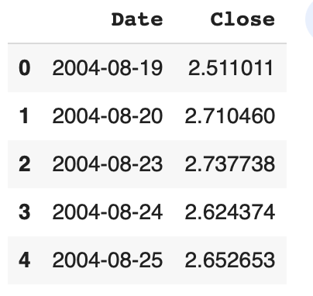

* 1. Student ID and

| Student ID =6330261921 |
| --- |

The output is the average values of the input over -day

* 1. Plot log-magnitude plots for -day moving average filter ( vs. )

|  |
| --- |

* 1. Plot the sequence of the original stock quotes (GOOGL – CLOSE)

|  |
| --- |

* 1. Plot the output,

|  |
| --- |

* 1. Explain how you calculate 2.1) and 2.4) in frequency domain or put your code here

| start = -np.pi  stop = np.pi+0.001  h = []  while (start < stop):  h.append(1/(N*2+1) * np.sin(start*(N*2+1)/2) / np.sin(start/2))  start += 0.001  H = np.array(h)  plt.plot(np.arange(-np.pi, np.pi+0.001, 0.001),  20*np.log(np.abs(H))/np.log(10))  x = scipy.fft.fftshift(scipy.fft.fft(np.array(df['Close'])))  Y = scipy.fft.ifft(H[((H.shape[0]-x.shape[0])//2):(-(H.shape[0]-x.shape[0])//2)] * x)  plt.plot(df['Date'],np.abs(Y)) |
| --- |