**REDUCING THE NUMBERS OF SIZE OF ELECTRICAL POWER PLANTS USING PREFERRED NUMBERS**

By Yanto Sidik Pratiknyo

Indonesia Open University

yantosp2013@gmail.com

**ABSTRACT**

*Variations of size of electrical power plant in Indonesia are very high, due to the maximizing of primary source of energy such water fall, gas, solar etc. On the other side, the reducing of utilization of the power plant is developed. The conclusion can be drawn that maximizing power plant in the design is not necessarily important. Therefore, the standardization of size of power plant should be developed. In case of sample from 135 electrical power plants in Jawa with 48 sizes, it will be analyzed. Applying the range calculation, frequency distribution and preferred numbers, the size of electrical power plant can be reduced between 8 to 10 sizes or only about 25%.*

*Keyword: power plant, standardization, preferred numbers.*

**1. RESEARCH QUESTIONS**

The high variation in the electrical policy and implementation can reduce the efficiency and effectiveness in operation and development. Types of electrical rate to the consumer in Indonesia are about 30 difference prices. Sample from electrical power plants in Jawa, consist of 135 plants, and surprisingly has 46 sizes range form 0.5 MW to 661 MW, because of tailor made by maximizing the primary energy as sources.

This papers focus on the electrical power plants in analyzing. The table of sample of power plants in Jawa as in the table 1: Electrical Power

Table 1: Samples of Electrical Power In Jawa



Source analyzed from: <https://id.wikipedia.org/wiki/Daftar_pembangkit_listrik_di_Indonesia>

**2. LITERATURE STUDIES**

Literature review or study will be analyzed using proposition.

Proposition 1

The design of electrical power plant is based on the maximum of primary energy source, such hydro, gas, solar, etc.

To extract maximum energy from the water flow, the design focus of the hydro-power was on the turbine of the plant that consists of a unique blade shape of turbine bucket (1). Design of the micro hydro turbine schemes for electricity must be up to the predetermined water for the river, otherwise generator to be ceased (2). Geographical steering of new construction generation plants extension should be located in the nearest consumption, otherwise, the cost will be increased (3). Following the Rankine cycle, in the steam power plant, system begins with the feed water being dropped from condenser and sent to the boiler by the feed pump (4).

Proposition 2

In the other side, the effort to reduce of the using of the power plant must be maximal.

The hybrid system decrease fifty percent of the energy against using gas turbine solely (5). It can be stated that the power generated from the EGS (enhanced geothermal systems) and the lowest possible temperature at which CO2 can be reduce by preheater in adding a second cycle as the thermal energy recovered from reservoir (6). It can be summarized that current knowledge in the flexible operation of hydroelectric powers was increasing and causing potential adverse effects (7).

Proposition 3

Interval of the data can be overlaped or not overlaped

It can be found in the fuzzy logic, that interval of member of set can be overlap, so everything is, or is allowed to be, to be partial, i.e., a matter of degree, imprecise (approximate0, granular (linguistic) and perception based. In simple words, the theorem cited that the highest degree of separation of two convex fuzzy can be achieved with a hyper plane (8). In the statistical series of range R with N items is involved in a computation, the optimal class interval may be estimated from the formula C=- R /(1 + 3.322 logN) (9)

Proposition 4

Interval of the data can be unbalance or unproportional in term of linearity, in mathematically or conventionally.

In order to minimize unnecessary variations in sizes, proffered numbers as very important. The range of the data is covered by minimum number of size. And will be benefit for producer and user. (10). With the standardize number of size in discrete, the efficiency can be improved. Charles Renard proposed a set of preferred numbers. His system was adopted in 1952 as international standard ISO 3. Renard's system divides the interval from 1 to 10 into 5, 10, 20, or 40 steps, leading to the R5, R10, R20 and R40 scales, respectively. The factor between two consecutive numbers in a Renard series is approximately constant that are the 5th, 10th, 20th, or 40th root of 10 (approximately 1.58, 1.26, 1.12, and 1.06, respectively), which leads to a geometric sequence. This way, the maximum relative error is minimized if an arbitrary number is replaced by the nearest Renard number multiplied by the appropriate power of 10.

Renard series are R5, R10, R20, R40 and R80. For example, R5 means five standard sizes between 1 and 10 which are given as below:

100/5 = 1.00  
101/5 = 1.584… ~ 1.60  
102/5 = 2.511… ~ 2.50  
103/5 = 3.981… ~ 4.00  
104/5 = 6.309… ~ 6.30  
105/5 = 10 (It is not included in the preferred numbers)

In industrial design, preferred numbers are standard guidelines for choosing exact product dimensions. Product developers should choose numbers of lengths, distances, diameters, volumes, and other characteristic quantities. While these choices are constrained by considerations of functionality, usability, compatibility, safety or cost, there usually remains considerable in the choice for many dimensions. In practice, preferred numbers are applied in audio frequencies, computer engineering, paper documents, envelopes, and drawing pens, photography, retail packaging, currency etc.

The most convenient class intervals are 1, 2, 5, 10, 20, etc., so that in practice the formula for the theoretical class interval may be used as a means of choosing among these convenient ones. In the currency of dollars, the intervals are 1, 2, 5, 10, 20, 50, 100.

**3. ANALYZIS**

Samples of the research are 135 power plants in Jawa with 48 types of size. Calculation for comparative study are using frequency distribution, class interval, and preferred numbers.

The preferred numbers van be applied for the controllable production in order to increase the productivity.

Applying samples of Java electrical power plant, comparative analysis can be depicted as follow.

* Using the Sturges (1926), statistical series of range R with N items is, the optimal class interval (C) may be estimated from the formula

N = 135 power plants

x1 (smallest) = 0,5 MW

x2 (highest) = 661 MW

R (range) = x2-x1 = 661-0,5= 660,5 MW

C =- R /(1 + 3.322 logN)

C = 660,5 / (1 + 3,322 log 135)

C= 81.77572776 round up = 82

Number of class = 660,5/ 81.77572776 = 8.076968779 round down 8

The optimal size according to the range formula due to rounding to be 10, that bourder every interval as follow

Below 0.5, 05-82.5, 82.5-164.5, 164.5-246.5, 246.5-328.5, 328.5-410.5, 410.5-492.5, 492.5- 574.5, 574.5-656.5, 656.5-738.5 or up

The implementasi to the calculation in case of samples in Jawa can be seen in the tabel 2:

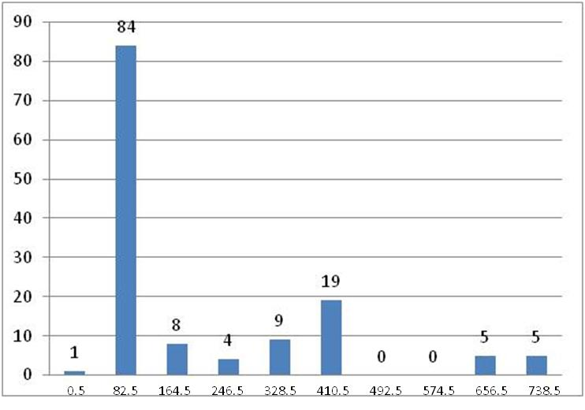

Figure 1; Range of power plant

* Using the high frequency, with 4 times occurred minimum, the numbers as follow

2.48, 5.12, 6.4, 25, 126, 315, 400, 661.

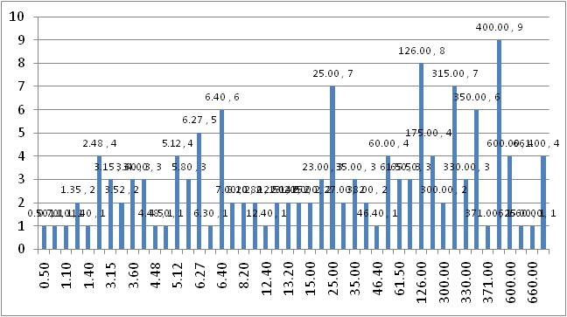

Figure 2: Frequency of Power Plant

* Using preferred numbers of dollar currency denominators

1, 2, 5, 10, 20, 50, 100, 200, 500, 1000

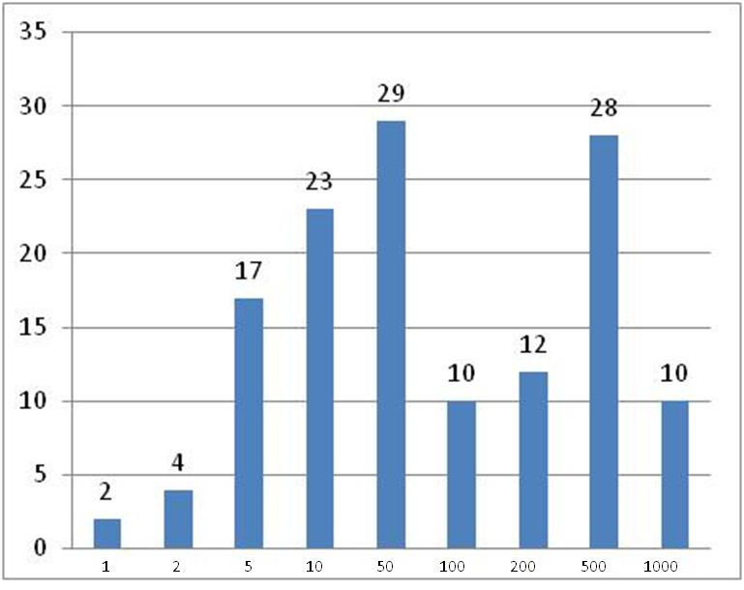

Figure 3: Preference numbers

From the three analyzes, the number of clusters range about 8 to 10. This reduces the original product from 46 types of the electrical power plants.

**4. CONCLUSION**

From the samples of 135 electrical power plants in Jawa with 48 number of sizes, it can be reduced to 8-10 numbers, that applying the range of calculation, frequency distribution and preferred numbers, the size of electrical power plant can be reduced between 8 to 10 sizes or 25% from exisitng number of sizes. Variations of size of electrical power plant in Indonesia are very high, due to the maximizing of primary source of energy such water fall, gas, solar etc. On the contrary, the reducing of utilization of the power plant is developed. Maximizing power plant in the development is not necessarily important. Therefore, the standardization of size of power plant should be applied.

**LITERATURES**

1. Khudhiri, Nasr Al. Dol, Sharul Sham. Khan, Mohammad S.( 2018). Design of Hydro-power Plant for Energy Generation for a Mid-size Farm with Insufficient Water Distribution Networks, <https://www.researchgate.net/publication/325912074> . ISSN: 2249 – 8958, Volume-2, Issue-5, p3
2. Bilal Abdullah, Nasir (2013), Design of Micro - Hydro - Electric Power Station, International Journal of Engineering and Advanced Technology (IJEAT)
3. Eickea, Anselm. Khannaa, Tarun. and Hirtha, (2019). Locational investment signals in electricity markets: How to steer the sitting of new generation capacity? Leibniz-Informations zentrum Wirtschaft, Leibniz Information Centre for Economics, Version 2019-10-31.
4. Wu,Xiao. Shen, Jiong. Li1, Yiguo and Lee, Kwang Y. (2015). Steam power plant configuration, design, and control, John Wiley & Sons, Ltd.
5. Modukpe, G. and Ndubisi S. N, (2019), Design of a Hybrid Solar/Gas Turbine Power System for Beta Glass Plc, Delta Plant, CiiT International Journal of Automation and Autonomous System, Vol 11, No 1, January.
6. Mohan, Arun Ram. Turaga, Uday. Shembekar, Vishakha, Elsworth, Derek. Pisupati, Sarma V. (2013). Utilization of carbon dioxide from coal-based power plants as a heat transfer fluid for electricity generation in enhanced geothermal systems (EGS). Energy 57, p 505.
7. Nesbitt, M, March (2017), P. Flexible Operation of Hydropower Plants, Electric Power Research Institute, May
8. Sturges, Herbert A (1926). The Choice of a Class IntervalAuthor:.Reviewed work(s): Source: Journal of the American Statistical Association, Vol. 21, No. 153 (Mar., 1926), pp. 65-66 Published by: American Statistical Association Stable URL: http://www.jstor.org/stable/2965501 .Accessed: 06/04/2012 02:17
9. Zadeh Lotfi A (1965). Fuzzy Logic Systems: Origin, Concepts and Trends, Information and Control 8, 338-353 Computer Science Division Department of EECSUC Berkeley, November
10. Taguchi, Genichi (1986), Introduction To Quality Engineering, Asia Productivity Organization.
11. <https://en.wikipedia.org/wiki/Preferred_number> accessed 6.14am, 3/23/2020.
12. <http://www.mesubjects.net/standardization-and-prefered-numbers/>
13. <https://en.wikipedia.org/wiki/Charles_Renard>
14. <https://id.wikipedia.org/wiki/Tarif_dasar_listrik>
15. <https://id.wikipedia.org/wiki/Daftar_pembangkit_listrik_di_Indonesia>