Antimicrobial Use Survey - New Figures

Table of Contents

## Read Data

## Demographics

Q2 - Year of Graduation from a College of Veterinary Medicine Q3 License to Practice Q4 Current Food Animal Practice Situation Q5 Organization Membership Q6 Food Animal Species Serving Practice

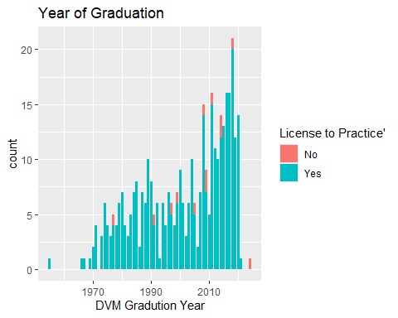

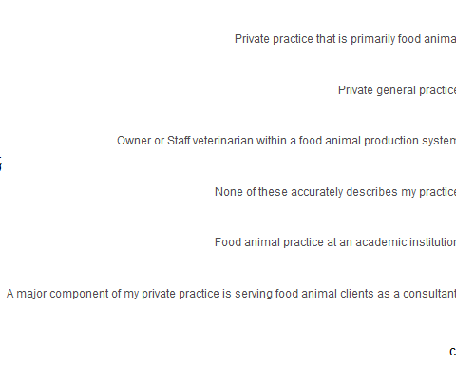

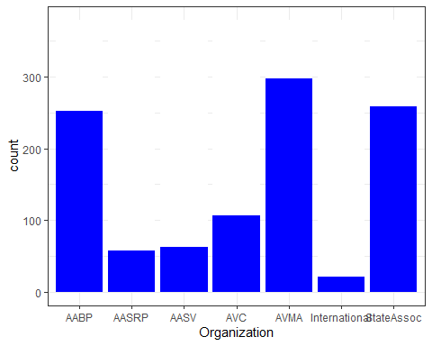

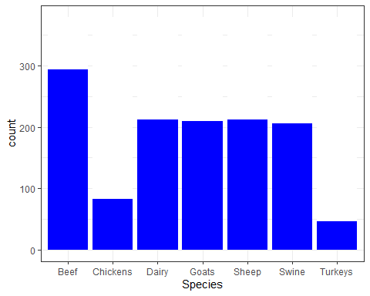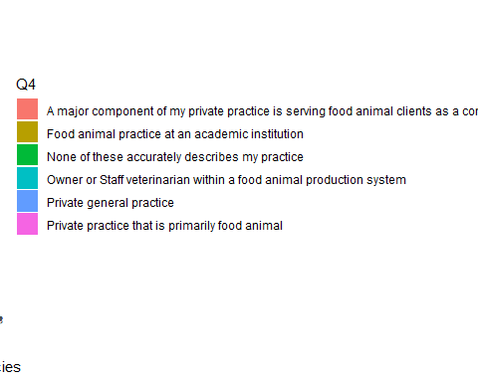

## Question 7 - what matters

Inputs that Contribute to Decisions in Selecting a Food Animal Antimicrobial Regimen

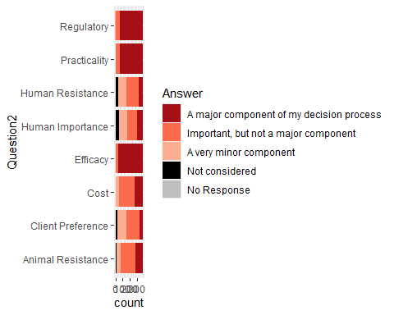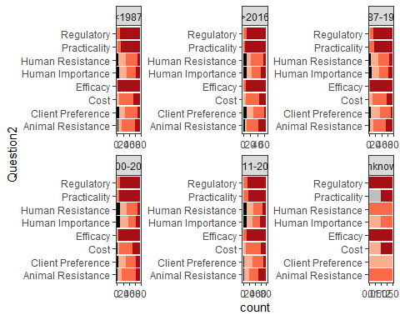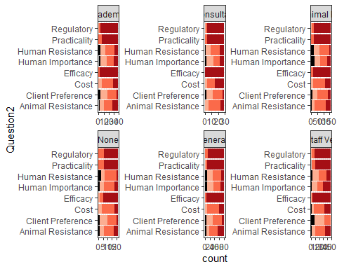

## Question 8

What did we miss?

##   
## VERY IMPORTANT - volume of dosage & duration of treatment - very important when range doctoring vs \x93feedlot\x94 treating\r\nVERY IMPORTANT - source & prior risk factors (high risk vs native non exposed to outside cattle)   
## 1   
## Options available. There aren\x92t many unless you do significant ELDU or are willing to accept off label residue risk. For lactating dairy cattle in a large scale commercial herds where decision making is largely lay staff, there really are only 2 options that can be considered (ampicillin or certiorari?   
## 1   
## While it doesn\x92t really impact the way that I make decisions, I think route/frequency of administration should be considered. For instance, some producers may not be able to give excede behind the ear. And I do not use excenel or naxel due to frequency of administration.   
## 1   
## 1. Availability - can you obtain enough quantity of product to treat a large population within a reasonable period of time   
## 1   
## Animal Welfare considerations, accuracy of dosage and likelihood of proper administration by client all are very important considerations   
## 1   
## As of lately, availability of some drugs has been within the parameters for which drug to chose.   
## 1   
## Availability   
## 1   
## Availability - major component   
## 1   
## Availability - what I already have on the truck, or what I can get easily from my regular supplier   
## 1   
## Availability (i.e. on backorder, requiring selection of another drug): Major component   
## 1   
## Availability in my country - A major component of my decision process   
## 1   
## Availability of antibiotic, (ie Polyflex or other IMI often go on backorder).   
## 1   
## Availability of approved products. When metaphylactic antimicrobial medications are not available, it is a major concern regarding protocol development and also acquiring higher risk classification livestock.   
## 1   
## Availability of medications--Major consideration (especially this last year)\r\nRoute of administration--Important   
## 1   
## Availability!   
## 1   
## Availabiltiy of antimicrobial - is it on hand or would have to be acquired? How long until can use?   
## 1   
## Chuteside and rather being able to catch again or not. If not, what product can be used in a dart gun if they need multiple doses.   
## 1   
## Class of cattle   
## 1   
## Client preference is to ensure proper duration and dosing is followed.   
## 1   
## Clinical state of disease. Major Component.   
## 1   
## Current availability   
## 1   
## Current availability of formulations that are able to be administered by the producer (e.g. oxytetracycline is currently unavailable in our region, do we have an alternative that can be administered by the producer?)   
## 1   
## Current resistance in the flock. Alternatives to ABX use   
## 1   
## Drug availability/ drug shortages, backorders, etc   
## 1   
## Duration of activity after a single dose. A major component.   
## 1   
## Ease and safety of administration. Eg. Excede in a down cow.   
## 1   
## Ease of administration for condition being treated and animal location, example would chute or pasture.   
## 1   
## Ease of administration, animal weight and dosing which correlates with cost (I'm not going to use 6cc/100 lb resflor on a 1200 lb steer. Major importance   
## 1   
## Ease of implementation, availability of product, and chances of fully executing the therapeutic regimen.   
## 1   
## Ease of use/administration for full dosing   
## 1   
## Efficacy against likely pathogen   
## 1   
## Experience of what will work best in the scenario presented, depending on dispersal of the antimicrobial in the body and suspected infectious agent.   
## 1   
## Historical record of antibiotic use and success in the production situation.   
## 1   
## human safety in handling the drug   
## 1   
## I assume that the 'practically applied' question incorporates, route of administration, safety to the administrator (ie. Micotil), type of administration (RDS vs. chute), proposed time to slaughter, etc.   
## 1   
## I do a lot of nutritional management and often need a product that is cost effective, easy to use, that will not decrease intake, and is effective.   
## 1   
## I interpreted the Cost question to mean cost effective. Cost/cwt and cost effective are two entirely different questions and will limit the value of this question as you won't know how the respondent interpreted the question. Question should probably be reworded.   
## 1   
## I serve an area heavily skewed towards companion large animals, frequently have owners wanting to utilize any and all treatments for sick patient regardless of drug restrictions (Am developing an ELDU waiver for owners who want prohibited therapy anyway) and that factor often, not always, trumps above factors.   
## 1   
## I tend not to consider human importance/microbial resistance in humans because I think the FDA has already done that by limiting the use and approval of certain antimicrobials in food animals. I tend not to use antimicrobials that are not approved for use in certain food animals and I tend not to use them for unapproved purposes/dosages/durations.   
## 1   
## In client preference other than cost - the main factors considered are duration of efficacy, need to repeat, and viscosity/dose volume due to many rented pastures (limited working facilities) and high remote drug delivery use   
## 1   
## IN my case in beef cattle intended for feedlot we are asked not to use draxxin because that is their first choice   
## 1   
## Inventory available at the farm.   
## 1   
## Inventory management/usual expiration date   
## 1   
## Is the antibiotic effective for the problem? What does the results attest to and what does your experience tell you.   
## 1   
## Length of effective treatment with one dose and the need to repeat treatment. This goes along with the "ability for the regime..." but is more specific. This is a key factor for me.   
## 1   
## Length of time the drug holds therapeutic blood levels in treated animal. ie. not having to re-treat at short intervals and get the animal into restraint and stress it.   
## 1   
## Majority of antimicrobial selection decisions are based on availability or replacements and need to curtail milk sold due to processor restrictions. Many cows are culled, rather than treated.   
## 1   
## Manufacturers reputation and research quality. An important component.   
## 1   
## May go along with practicality....example can it fit into a dart for dosing with a dart gun. In my part of the world lots of cows and calves get treated for pinkeye with a dart gun. Not many products with fit into the dart for a proper dose. They may also not flow out of the dart   
## 1   
## milk and meat withholding time   
## 1   
## Most of my decisions are made by what is labeled for poultry. We are very limited in available antimicrobials, so we don't have many options to choose from.   
## 1   
## nice to have drug sensitivities to give us a direction   
## 1   
## no   
## 1   
## No   
## 3   
## No Response   
## 294   
## None   
## 1   
## Not so much missed as a comment on the potential to select for resistance and FDA or WHO classifications, currently considered as minor components of decision-making because of the high theoretical aspect and low actual supporting clinical data in cattle practice for the situations I deal with.   
## 1   
## or, not using at all and addressing issues through management.   
## 1   
## Organic or NAE status - most important. Effect of cumulative treatments on brand antimicrobial reduction goal - somewhat important   
## 1   
## Owner compliance   
## 1   
## Owner compliance and ability to medicate at appropriate intervals   
## 1   
## past responce on individual farms. I deal mostly with cow/calf and use culture and sensitivity from necropsy.   
## 1   
## Past success with using the antimicrobial in similar situations. Availability (supply chain disruptions) of the antimicrobial. Flock morbidity and mortality. Solubility of the antimicrobial in specific water sources (factors such and pH and mineral content).   
## 1   
## PK relationship to PD ... ability to impact the pathogen at the interface between the treatment timing and pathogenesis of the disease.   
## 1   
## Potential drug interactions - synergies or toxicities. Medication availability   
## 1   
## Previously used antibiotics to treat the same animal (ie a re-treated animal)   
## 1   
## Product availability. Depending on what is available, may have to utilize a second or third choice antibiotic to help animals until additional product can be ordered and received my the site. Farms and production systems try to have some inventory on hand, but there are times where product has to be ordered and overnighted and a antibiotic needs to be administered until product arrives when experiencing a severe disease issue.   
## 1   
## Rarely, I will consider (i.e. doubt) the capacity of the producer/owner to follow up with observation, communication, and further treatment, leading to a decision of "let's do antibiotics as well just in case"   
## 1   
## Relative cost of the animal.   
## 1   
## Selecting for resistance is difficult to assess. It is a major concern but hard to know impact on this with individual decisions outside of appropriate drug/pathogen selection and proper dosage. Efficacy, safety and cost are top concerns.   
## 1   
## Selection is based on treatment response data correlated with disease severity indicated by lung auscultation scores.   
## 1   
## Severity of disease and the ability for non-antimicrobial products/management to impact the outcome in combination or alone.   
## 1   
## Sometimes it is the only efficacious option due to availability of antibiotic and susceptiblity   
## 1   
## source or site of infection; organ or body system affected   
## 1   
## Special storage conditions required - a minor component\r\nEase of preparation and administration (syringability, reconstitution required, special administration location, etc) - important\r\nPotential hazards of accidental human injection - major component\r\n   
## 1   
## Specific site efficacy and confidence in product.   
## 1   
## Support from companies producing the medication.   
## 1   
## The practicality is huge, especially in cow calf practice. Almost always have to choose something long acting.   
## 1   
## Time of year and how busy the producers are doing fieldwork. Cold temps means no Nuflor   
## 1   
## Treatment for the owner rather than the patient, some what important   
## 1   
## Volume of drug that is approved for that treatment (ie Draxxin vs Nuflor)   
## 1   
## We have very few options in poultry and specifically Turkeys. So not a lot of thought required to be honest   
## 1   
## Withdrawal time, especially for milk.   
## 1   
## Age of animal and what\x92s legal for that age   
## 1

## Question 9

Q9 Extent of Antimicrobial Susceptibility Testing BEFORE Antibiotic Treatment Q10 Extent of Antimicrobial Susceptibility Testing AFTER ENCOUNTERING A PERCEIVED LACK OF TREATMENT EFFICACY Q11 Extent of Antimicrobial Susceptibility Testing to Routinely Monitor Antimicrobial Susceptibility of Pathogens Which Cause Disease in Your Client’s Herd or Flocks ## Q12 Extent of Antimicrobial Susceptibility Testing to Routinely Monitor Antimnicrobial Susceptibility of Potential Foodborne Pathogens in Your Client’s Herd or Flocks

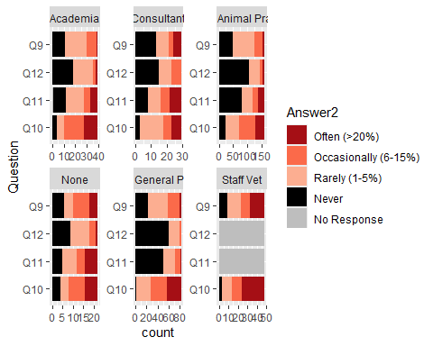

## Question 13, 14

Q13 Monitor Antimicrobial Susceptibility of Pathogens Which Cause Disease (Y/N) (Staff Vets Only) Q14 Monitor Antimicrobial Susceptibility of Zoonotic Pathogens (Y/N) (Staff Vets Only)

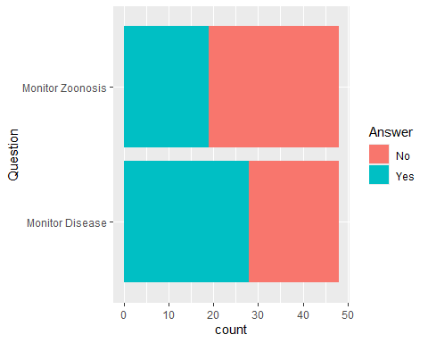

## Question 15

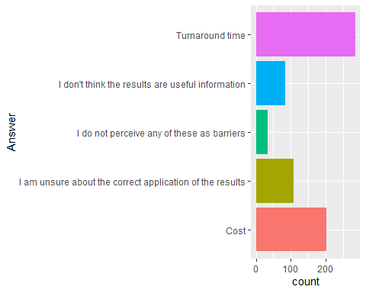 ## Question 16

Free text response . . .

## Question 17

Level of Confidence in Knowledge Related to Antimicrobial Use Areas

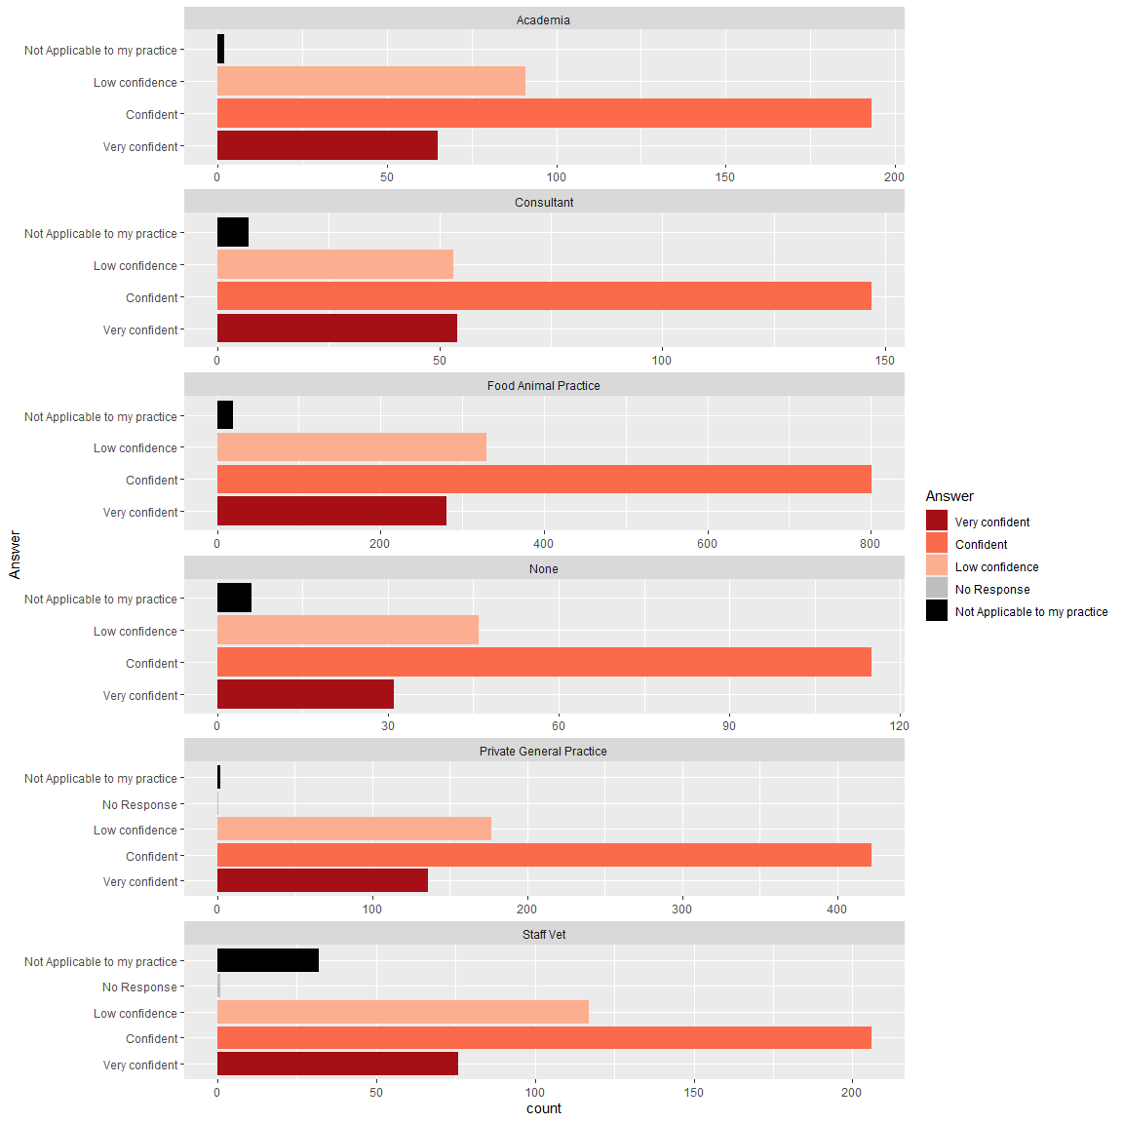

## Question 18

Interest in Certificate Program

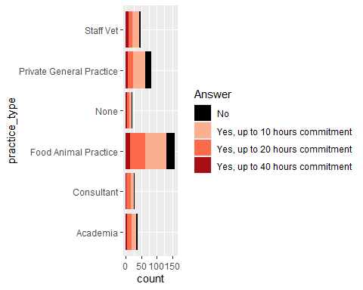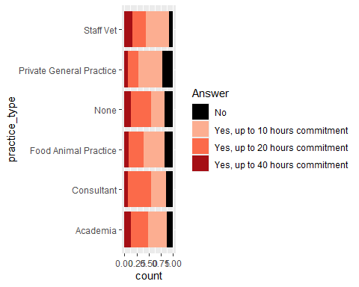

## Question 19, 20

Concern About AMR as Problem for Antimicrobial Efficacy in Treatment, Prevention, and Control of Livestock Diseases

Concern About AMR in Livestock to Treat Bacterial Infections in Humans

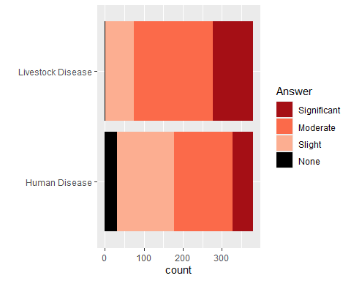

## <ggproto object: Class FacetWrap, Facet, gg>  
## compute_layout: function  
## draw_back: function  
## draw_front: function  
## draw_labels: function  
## draw_panels: function  
## finish_data: function  
## init_scales: function  
## map_data: function  
## params: list  
## setup_data: function  
## setup_params: function  
## shrink: TRUE  
## train_scales: function  
## vars: function  
## super: <ggproto object: Class FacetWrap, Facet, gg>

## Question 21 to 23

Client with good working relation requests antimicrobial for prevention and control of disease. How willing are you to take the risk of not authorizing continued use?

Client with good working relation requests antimicrobial for prevention and control of disease. Risk percieved to relationship if signifcant spike in morbidity or mortality.

New client requests antimicrobial for prevention and control of disease. Risk percieved to relationship if significant spike in morbidity or mortality.

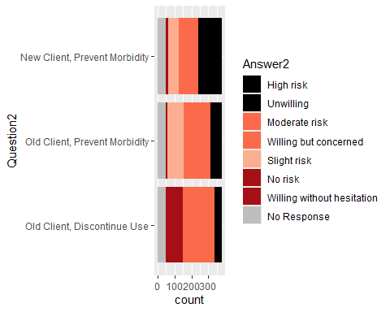

## Question 24, 25

Q24 For what proportion of your food animal clients do you periodically review data which includes:

Q25 For which of the following categories do you routinely review data from the flocks or herds under your care?

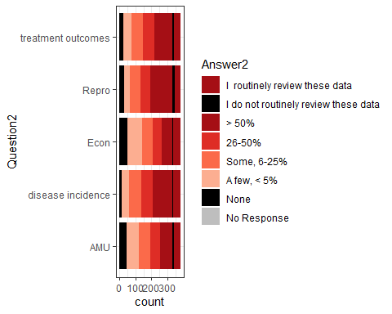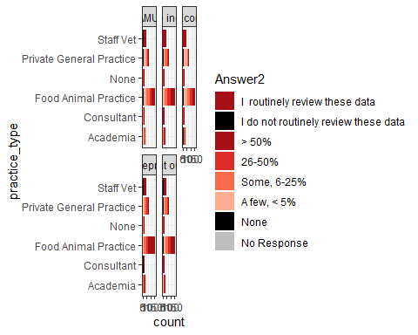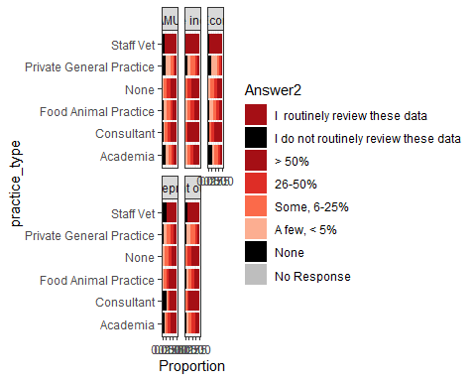 ## Question 26

Q26 Given that adequate data tools were available and you were appropriately compensated, would you be willing to begin or expand routine analysis of disease incidence, antimicrobial use, and treatment outcome data with your clients? (Y/N)

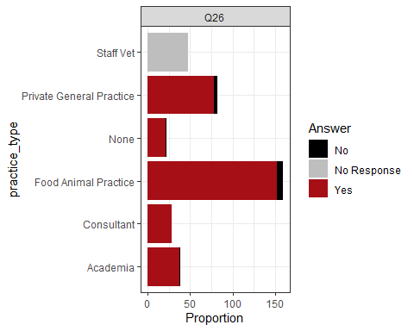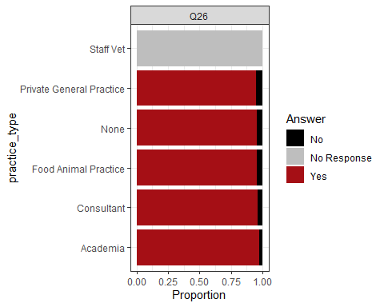 ## Question 27

Q27 Considering the clients for which you do not review data related to disease incidence, antimicrobial use, or treatment outcome, which of these barriers do you perceive as contributing to this lack of interaction for at least some clients?

Q28 If you do not review data related to disease incidence, antimicrobial use, or treatment outcome within the herds or flocks under your care, which of these barriers do you perceive as contributing to this lack of review?

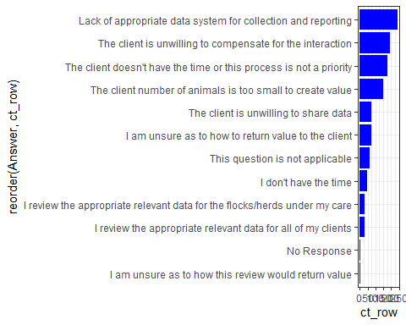

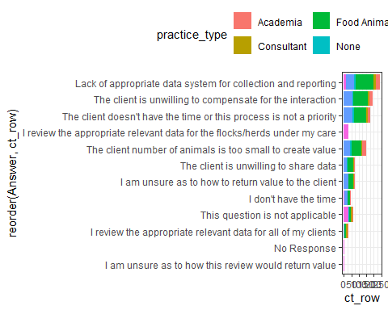

## Question 31

Q31 Would you find value in having a confidential report comparing your antimicrobial use and prescribing practices to an aggregate of antimicrobial use data from other veterinarians in a similar practice situation?

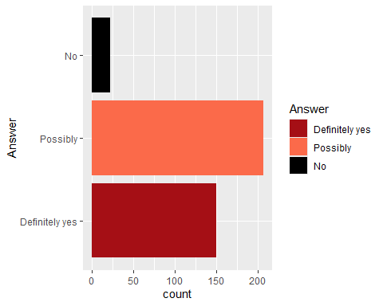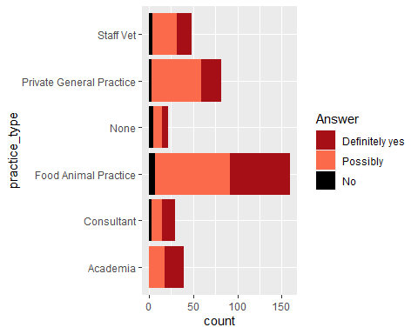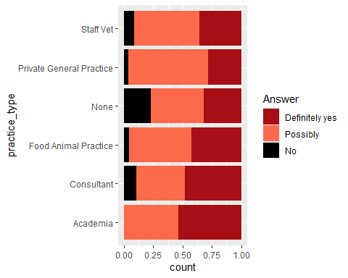 ## Q32 Guidance Documents



## Question 33

Q33 How many times a year do you find yourself in need of additional information to support an antimicrobial use or prescribing decision for food animals?

## Question 34

Q34 In the last year, which of the following resources have you utilized for information to support an antimicrobial use or prescribing decision?