Table of Contents
Title............................................................................................................. ii
Table of Contents ....................................................................................... iii
I. Introduction .............................................................................................. 1
1. 1 Theoretical background ................................................................ 3
1. 2 Statement of the problem ................................................................
1. 3 Significance of the study…………………………………………
1. 4 Research question(s) (enumerate please)........................................
1. 5 Research hypothesis/hypotheses ... .................................................
1. 6 Definition of key terms ...................................................................
1. 7 Limitations ......................................................................................
1.8 Delimitation ……………………………………………………...
II. Review of the Related Literature ..............................................................
III. Methodology ...........................................................................................
3. 1 Participants/Source material (for translation proposals).……….
3. 2 Instrumentation……………………………………………………
3. 3 Procedure (itemize please) ………………………………………
3. 4 Design……………………………………………

1. Chapter 1: Introduction
1.1 Introduction
Since the recent epidemic, when frequent school breaks due to the virus made direct learning
difficult, e-learning has become a widely used method. There were various e-learning
platforms offered by educational institutions even before the epidemic. Although many
educational institutions have had success implementing e-learning, the need for more
cutting-edge learning environments has never subsided. An adaptive e-learning system is the
newest. One of the areas of e-learning research that is now quite active is adaptive
learning. It aims to give pupils the opportunity to learn intelligently by adapting the system's
behavior to their individual learning styles and personality traits.
The use of online learning platforms has grown recently.
An e-learning environment is considered adaptive if it is capable of: monitoring the activities
of its users; interpreting these on the basis of domain-specific models; inferring user
requirements and preferences out of the interpreted activities, appropriately
representing these in associated models; and, finally, action upon the available knowledge
on its users and the subject matter at hand, to dynamically facilitate the learning process[1].
In traditional e-learning systems the implementation of learning environment follows a “one-size-fits-all” approach, whereby all students receive the same content in the same way with no consideration of learners particular needs. Adaptive e-learning systems are proposed to solve this problem. It is aimed to adapt to each individual by presenting learning materials dynamically depending on characteristics and learn style of the student .The purpose of adaptive e-Learning is to provide students a suitable content at the right time, in other words the system should determine the knowledge level and organize content automatically for each student
There are several forms of adaptation, namely: adaptation based on user modeling, or those that use learning objectives to provide the learner with an education that fit with his profile [1]. So-called personalized Educational Hypermedia Systems are systems that use a methodology based on the objectives, preferences and knowledge of each, while adapting to their necessities [2]. In this way, a student in an adaptive educational model will be attribute a content that suit to his expertise on the theme. Making personalized learning a big step towards improving online learning outcomes
This study is aimed to develop an ontology-based adaptive learning system. An ontology is defined as ‘a formal, explicit specification of a shared conceptualization’ for a specific domain [3]. It is used as a mechanism for knowledge representation of any application. Typically any ontology consists of concepts, definitions, and formal axioms relating them together. It enable to support more accurate searches, and to empower more advanced information services by deriving new concepts automatically from interontology relationships. This is very much applicable to represent educational content and delivery where based on the conceptual relationships among learning content can be organized into a knowledge structure using ontology technology [4]. Ontology is useful to provide personalized learning content to infer learning elements appropriate to each learner’s characteristics from both a domain ontology and user model ontology [1]. In an ontology-based E-learning system, ontology is used to model the two main components of an adaptive E-learning system which are the learner model and the learning content
model. Learner model is the core component of an adaptive E learning system since it represents the learner’s characteristics according to which the personalization of recommendation can be done. Among the characteristics that can be represented
in a learner model there are the knowledge and skills, the cognitive and meta- cognitive features, and the learning style.
The proposed model consists of three main ontologies: educational content ontology, adaptation ontology and the learner ontologies (see Figure 1). The aim is to provide a more precise, individualized learning service appropriate to the characteristics of each student, it uses a user diagnostic module that deduces and analyzes students’ characteristics such as level of understanding, learning styles, preferences, learning history, and learning context. Then, the system dynamically builds personalized learning content for a particular student based on the inferred characteristics.

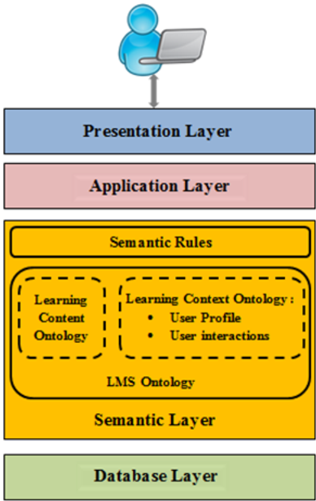
Figure(1): Higher level of proposed ontologies

1. 1 Theoretical background

- Ontology-based recommender system for e-learning
Ontology is a formal explicit description of concepts in adomain. The main components of an ontology are concepts,relations, instances and axioms. A concept represents a set or class of entities or ’things’ within a domain. Relations describe the interactions between concepts or a concept’s properties. Instances are the ’things’ represented by a concept. Finally, axioms are used to constrain values for classes or
instances. An ontology and its individual instances of classes construct a knowledge
base. Ontologies are typically encoded using ontology languages, such as the Web
Ontology Language (OWL), Resource Description Framework (RDF),DARPA
Agent Markup Language (DAML) and Ontology Inference Layer (OIL) [7].
Ontologies are frequently utilized in many fields and for a variety of reasons. An ontology can be utilized in the field of recommender systems to match users with their preferences. Most knowledge-based recommender systems in the e-learning space employ ontologies to represent knowledge about learners and learning materials. Ontology is employed in this situation to match learners' preferences for learning resources.
Numerous studies have shown improved learning resource recommendation
efficiency when using ontologies to represent knowledge in e-learning recommender
systems. For instance, [8] advocated the use of a semantic web-based adaptive
learning framework called (PALO) to give students access to personalized learning
resources. Based on various learning methods and knowledge levels, OWL ontology
and SWRL rules are combined to represent learning objects and learner profiles. [9]
equally suggested an E-Learning system that creates learner profiles, categorizes
learners based on those profiles, makes personalized content recommendations, and
adapts content based on assessment results. The learner ontology and the course
ontology were used to model the learner profile and learning content.

- Learner Profile
The learner profile is a collection of details about the learner, including their cognitive abilities and knowledge. learning preferences, cognitive processes, and metacognitive skills information and the learner's interactions with the system. These details are retrievable statically using surveys, or dynamically by examining the actions of while interacting with the system, the learner. The knowledge learner profile data are utilized to create a learner model. There are numerous standards for modeling profiles that a suggestion was made to improve the compatibility of learners' information and enable communication between educational institutions systems, like the Learner Information Package for the LMS, the FOAF (Friend), PAPI Learner (Public and Private Information), The Jean Daubias Model and Of A Friend.
In recent years, several researchers have tended to use ontologies to represent the learner profile. Resource Description Framework-based semantic retrieval for learner profiles was proposed by authors in [10]. (RDF). Authors suggested an ontological approach for the description of learner profiles and learning styles in [11] so that they could be easily used for customized E-learning while also allowing for more flexibility and reusability.

III. RELATED WORKS

Ontologies have been employed by numerous scholars in the field of e-learning to represent knowledge. For e-learning, authors in [12] created a framework for a semantic recommender system in which learning items are stored and categorized and semantic recommendations based on ontology are generated. Using an ontology-based hybrid knowledge-based recommender system, authors of [13] suggested learning activities for MOOC participants. To model and represent the knowledge about the domain model, learners, and learning activities, the authors employed ontologies. The authors of [14] created an ontology to connect several dimensions of learning styles. As a result, the learner's attributes and learning style are related using the ontology. To explain the semantic relationships between the objects in [15], writers employed an ontology.

- The proposed ontology-based recommender system for e-learning

Our suggested recommender system is ontology-based. two primary steps, the first of which seeks to determine the Using machine learning, determine a learner's learning preferences following the Felder and Silverman Learning algorithms style Model, after which the chosen LS will be utilized in the learning content ontology with learner profile ontology to make it easier for them to match and to find the most a suitable learning material that should be suggested to the student. We will outline our suggested solution in the subsections that follow. a method to automatically determine learning preferences, followed by We'll talk about the two suggested ontologies, the similarity between them

1) Automatic learning style recognition
1. What exactly is a learning style (LS)?
A learner's chosen technique of perceiving, processing, visualizing, and comprehending the learning content is represented by their preferred learning style, which is a crucial component of their learner profile. Every learner has a unique learning style that is influenced by their personality and the environment. While some students prefer theoretical materials, others prefer practical and experimental materials. Some students like to study in groups, while others feel more productive working alone. To improve learning, it is necessary to take into account the preferences of different learners.
There are numerous definitions of learning style in the literature. [20] referred to learning preferences as the Cognitive, practical, and psychological actions that work as largely consistent markers of how students view, engage with, and react to the learning environment. LS are "a complex way, and circumstances under which, learners most efficiently and most successfully see, process, retain, and recall what they are trying to learn," according to [21].
c) The Learning Styles Model proposed by Felder and Silverman
A learning styles model categorizes and summarizes a learner's diverse learning preferences into several dimensions.
There are numerous learning style models in the literature, including [22][23]. We used the Felder and Silverman model as our foundation for our study.
The FSLSM is the most popular and most suited to be implemented in adaptive e-learning systems, according to earlier research [24][23]. The FSLSM has four dimensions: active/reflective, sensing/intuitive, visual/verbal input, and sequential/global understanding. Each dimension has two opposing learning style preferences. One learning style preference from each dimension is combined to create a learning style, yielding 16 learning styles combinations (LSCs): (A,S,Vi,G), (A,S,Vi,Seq), (R,S,Vi,G), (A,S,Ve,Seq), (A,S,Ve,G), (R,S,Ve,Seq) (R,S,Ve,G),By using the learning material, active learners can better absorb the knowledge. reflective students prefer to first contemplate the study material in silence. Active Additionally, students choose group study, while the reflective Learners favor doing their own thing. learning preferences are classes that cover information from the real world. They typically are by engaging in practical (laboratory) activity, students become are better at memorizing information than intuition. Those who are intuitive learners dislike materials with a lot of memorization of simple math problems, and they like the ones utilizing mathematical formulas and abstractions. They might be more inventive and grabbing than sensors. novel notion. The preference of visual learners is to see information. through the use of visual aids like photos,

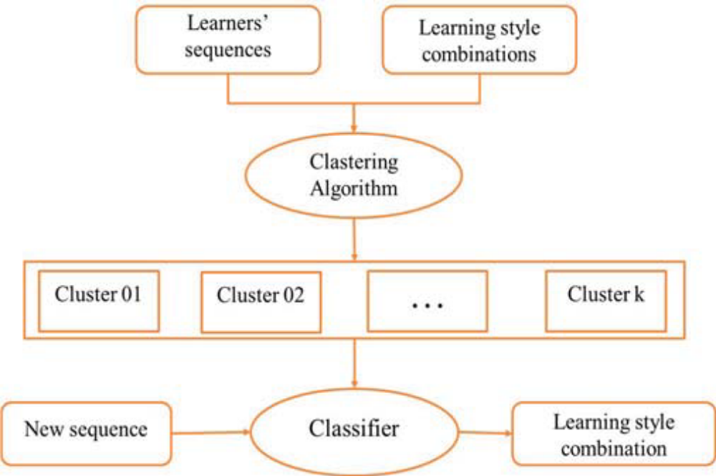

Fig. 1. Our proposed approach to predict LS automatically

The first phase seeks to extract from the web log file the learner's prior interactions with the E-learning system. The past interactions between those learners will then be preprocessed. in order to limit information to what is absolutely necessary build a learning sequence. The sequence for each student is consisting of the set, learner ID, session ID, and learner ID of educational resources that a student accesses during a session To determine the learner's learning style combination, we previously came up with the idea of matching each learning resource with its appropriate learning style preference based on FSLSM (LSC). The learning resources that the learner accessed during the learning process make up the learner's sequences, therefore in order to identify the LSC of each sequence, we must ascertain the preferred learning styles that each learning resource alludes to.
Based on the Index of Learning Styles Questionnaire1, Table 1 shows our proposed matching.

learning style  preferences | Learning resources
Active | Video, Demonstration, Exercise, assignment,  Practical material, Image, chart
Reflective | Video, PPT, PDF, Announcement, References
Sensing | Video, PDF, Example, Practical materia
Intuitive | Video, PPT, PDF, Forum, Topic List, References
Visual | Video, Image, Chart
Verbal | Video, PDF, Announcement
Sequential | Exercises, Assignement, References, sequential
Demo | Exercises, Assignement, References, image

TABLE I. LEARNING RESOURCES AS PER FSLSM

A clustering technique can be used to divide the learners' sequences into sixteen clusters, each of which corresponds to a particular combination of learning styles, after the learning materials have been mapped to the relevant learning style preferences.
The learner's sequences were labeled with LSCs in the first step of our generic approach, which tries to consider the outcome as a training data set. With the help of this trained data set, a classification algorithm will be taught, and a model will be created that will allow LSC to be predicted for new or leaner sequences.
Having established the learner's and their own learning preferences, Combined with the learning material, this learning method will be employed as a data characteristic that complies with the learning's ontology for learners topic ontology. The descriptions of the two ontologies are provided in the subsequent section.
2) Building the ontologies for the learner and the learning materials
The essential elements of a knowledge-based recommender system for online learning have been proposed as two ontologies in this work. Both the learner profile ontology and the learning content ontology fall under this category. The learner profile can be matched with the learning content using those two ontologies, and the learner's needs can be met by choosing the learning material. We created the two ontologies in this work using the Protege tool, and we joined them using the SPAQL query language to provide customised recommendations.
(a) The Learning Content Ontology
It is quite beneficial to use ontology in a knowledge recommender system for e-learning since it enables a structured description of learning items and the relationships among them. Since learning objects are exclusively text-based, the traditional representation of the content, which is focused on the usage of keywords, cannot take into account the requirements and context of the pupils. It is necessary to adopt an ontology-based representation of the contents to overcome these constraints since it will make it possible to tailor access to the contents to the needs and situations of the learners. Eight core classes, including Subject, Topic, Course, LearningResource, LearningStyle; Type, Format, and Author, make up the Learning Content Ontology that we have suggested in this study.
They are shown in Figure 2.

Fig. 2. The main classes of the LC’O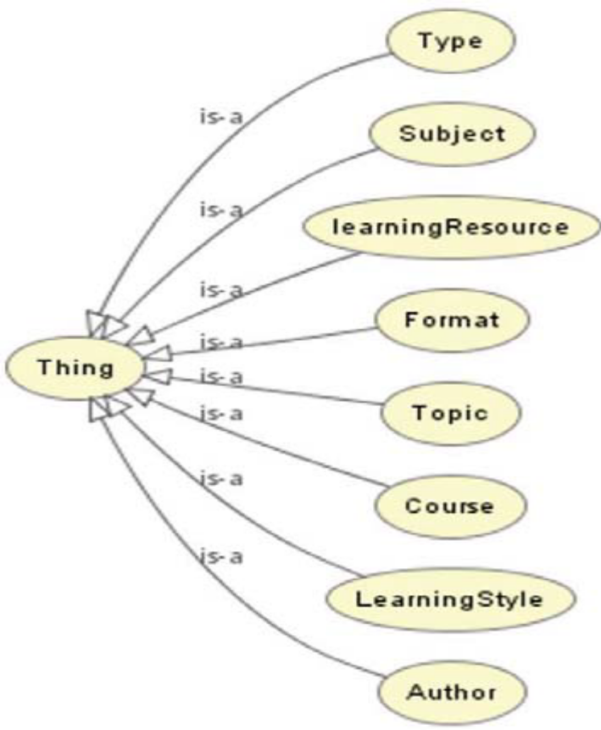

The has Topic connection allows the Subject class to be connected to numerous topics. A subject's unique Subject Name and a description of its goals and objectives serve to define it as well.
The class Topic represents the speciality that needs to be learned; a Topic is identified by its data-type attribute TopicName. Additionally, it refers to the collection of subjects, courses, and resources that make up a topic using the object-type characteristics BelongsTo, Hascourse, and Described By.
The course to be learned is represented by the class Course. This class can be associated to one Topic using the IsCouseOf relation and is identified by the data-type field CouseName. The object-type property Described By can be used to describe it in a variety of resources.
The individual who creates is referred to by the class Author.
The hasTopic connection allows the Subject class to be connected to numerous topics. Additionally, a certain subject is specified by Subject Name and a Goals and Objectives Description objectives.

the speciality to be learned is represented by the class topic; this class identifies a data type by using the data-type property TopicName. Topic. The object-type characteristics are also utilized: BelongsTo, Described and Hascourse Using the group of subjects as a reference,
the courses and materials that make up a topic.
The course to be learned is represented by the class Course. This The data-type property CouseName identifies a class, and can have an IsCouseOf relation to another Topic. Also
Using the object-type, numerous resources can describe it. DescribedBy is a property.
The individual who creates is referred to by the class Author.
The title, language, location, description, and difficultylevel data-type parameters are stored by the LearningResource class. Additionally, it includes the object-type properties:
These relationships connect it to the classes Subject, (Topic and courses*), author, LearningStyle, Format, and type, respectively. IncludedIn, Describes, createdBy, HasLearningStyle, HasFormat, and Hastype.
Learning Profile Ontology (LP'O)
An ontology for learner profiles is developed to represent the details and preferences of a learner.
The Learner, LearningLevel, Preferences, and LearningStyle classes make up this ontology. Learners' first and last names, addresses, and email addresses are kept in the learner class. Additionally, it has characteristics for a username and a password that can be used to access data.
HasPreferences, hasLearningLevel, and have LearningStyle are the three relations that the Learner class has. The learner profile is matched with the learning content using these relations, which are the main object-data attributes, and the appropriate learning resource is chosen based on the learner's needs.
3) Aligning the learner profile ontology with the ontology of the learning materials
A learner is required to complete a form while attempting to register for the first time in the system. His desired language, his preferred course, and his degree of knowledge are all listed on this form. The method we've described in our earlier research can be used to automatically detect the learning type. [3][4][5][6].
The Learner Profile ontology contains those details about the learner. The appropriate learner profile ontology must be mapped to the learning content ontology in order to modify how learners access content; for example, the learner's learning style will be linked to the learning resource's learning style attribute.

so that the student can obtain educational materials that suit his preferred method of learning. In order to give the learner a learning resource that describes the course that interests him or her, the learner's preferred language will also be mapped to the learning resource's language property, along with the learner's learning level and difficulty level. Additionally, the object property "Describes" of the class learningResource will be mapped with the "CourseName" property of the class Preferences.
To assist learners in finding pertinent content, the suggested ontology-based approach leverages a semantic presentation of learning resources. When a learner searches for content, the system only shows him learning resources whose semantic content corresponds to the data in his profile's ontology.

- 2 Statement of the problem
The advancement in information technology and communication (ICT) has a major effect in all kinds of businesses. Almost all activities such as industry, entertainment, health management and education is affected accordingly. In terms of education, ICT is offering greater opportunities to revolutionalising the learning process that adopts the same learning activities that give no attention to learner differences. The learning process has to be personalized. According to Laroussi[5], personalization is the next step in the evolution of eLearning environments. For this reason the Adaptive learning has to be the common practice in the form of personalization systems that guide the student’s learning process. Moreover, the urgency of adopting Adaptive learning has also attributed to managing the learning process during global pandemics such as COVID-19. In the current pandemic, the traditional face to face learning
has been interrupted many times and still subject to be halted anytime. Therefore, a
distance adaptive learning would play a major role in facilitating a tailored distance
learning that needs less parents intervention.
- 3 Significance of the study

Adaptive learning respects students' past knowledge, meets their learning needs, and closes comprehension gaps for them. Adaptive learning prevents "teaching to the middle," which ignores advanced or lagging pupils, by requiring students to demonstrate mastery before going on. Instructors may measure curriculum performance, identify students who need help, and improve learning outcomes while doing so. System metrics enable intervention before specific students are at risk of dropping out or failing, and instructors can have a deeper understanding of the subject areas in which students are having difficulty. In this sense, the instructor's function shifts from that of content provider to that of learning facilitator. Adaptive learning for the institution enables the delivery of tailored learning at scale, leading to higher levels of academic success for more students in a cost-efficient manner, while reducing cheating because the content and assessments can vary for each student

- 4 Research question(s) (enumerate please)
In this thesis, the following research questions were looked into:
1. Which learning style model should be utilized in AEHS, and how may

can learning styles be identified?

The first step in facilitating adaptability is choosing a solid taxonomy of

learning modalities The majority of the educational systems created so far rely on just one learning method.

a fashion model like those put out by (Felder and Silverman, 1988), (Honey and

(Biggs, 1987), Mumford, 2000, or (Witkin, 1962). We favor the application of a unified

a model of learning style that combines traits from other models proposed in the

literature.

The conventional approach to learning type diagnosis is asking the pupils to

take out a special psychological survey. In this thesis, we suggest an

the implicit modeling approach, which

2. How can an AEHS implement adaptation in line with various learning styles?
There is a tremendous amount of material available in current e-learning systems.

greater than what could be presented by conventional educational methods, for sure. While

Despite this availability being a benefit, there is a risk that it might become

a much for the students to handle. Therefore, it is very crucial to filter the

content to protect learners from cognitive overload. Additionally, it is crucial.

to determine the most effective way to present this material and the order (the navigation type).

In this thesis, we attempt to pinpoint the adaptation technologies that will most effectively

define the appropriate adaption guidelines for students with various learning preferences.

3. How can we create an adaptive educational system based on learning styles and how effective is it?

Using the approaches and procedures suggested for modeling and adaptation, we

created and put in place an e-learning platform called WELSA (Web-based

Learning style-adaptive educational system, which consists of various

functionalities:

• an updated course player with learner tracking features for the students

an element of adaptability

• a tool for analysis that reveals pupils' preferred methods of learning

• a course editor for the instructors to assist them in creating courses in the necessary

format.

We had to respond to a number of inquiries, including: What is the best approach to represent

a model of domain, learner, and adaptation? What is the connection between each person?

disparities and the system's adaptive capabilities? What standards are

In 2006, Brown et al. started a doubt-casting campaign "Is it true that we can use learning styles in adaptive web-based educational systems?

should?" This thesis will demonstrate that the answer is unquestionably "yes."

- 5 Research hypothesis/hypotheses

- 6 Definition of key terms
What Is Online Learning?
We describe e-learning as education that is provided on a digital platform that is designed to facilitate learning, such as a desktop computer, laptop computer, tablet, or smart phone. The types of e-learning that this book examines contain the following characteristics:
• Stores and/or transmits teachings in electronic form on servers on the Internet or intranet, local internal or external memory, external drives, or the cloud.
• Contains information that is pertinent to the learning objective.
• Delivers material using media elements like text and images.
• Promotes learning by utilizing instructional techniques like examples, practice, and feedback.
• Can be either instructor-led (synchronous e-learning) or made for independent study at your own pace (asynchronous e-learning).
• Can include both synchronous and asynchronous learner collaboration, such as in breakout rooms or online

Personalized e-Learning According to each learner's unique needs and preferences, distinct learning sequences can be created for them using personalization in e-learning, a technology that is related to education (Devediü, 2006). Different approaches have been used by researchers to personalize the e-learning environment. For instance, PERSO uses Case Based Reasoning (CBR) to suggest courses to learners based on their level and preferred media (Chorfi and Jemni, 2003). A geology tailored hyper book was created using tools for creating customised hyper books, such as Metalinks, taking the learner's level of knowledge, media preferences, and learning objectives into consideration (Murray, 2003). In order to create tailored course plans based on learners' objectives and knowledge level, course planning technologies like PASER have been employed.

ADAPTIVITY IN E-LEARNING SYSTEMS
Systems that alter their behavior and output in response to various user traits or qualities, such as preferences, personality, emotion, and abilities, are referred to as adaptive systems or user-adaptive systems. "The technology element of joint human-machine systems that can adjust their behavior to meet the changing needs of their users, typically without explicit instructions from their users" is how adaptive systems are defined (Feigh, Dorneich, & Hayes, 2012, p. 1008). According to Jameson, an adaptive system is "an interactive system that changes its behavior to different users on the basis of user model acquisition and application procedures that entail learning, inference, or decision-making in some way" (Jameson, 2009, p. 106). There are many examples of adaptive systems. In the field of Human-Computer Interaction (HCI), adaptivity entails
The use of adaptive technology is possible across a wide range of industries, including e-commerce, e-health, and e-learning. For instance, the AEADS system in the e-commerce industry distributes advertisements based on the preferences and actions of a specific user (Qaffas, Cristea, & Mead, 2018). Another application domain is adaptivity used in user interfaces. The CHAIN method uses adaptive support and assistance as part of a user interface to help people complete tasks (Akiki, 2018).
A crucial aspect of contemporary e-learning systems is adaptability (Rodrigues et al., 2019). Adaptivity aids student learning by suggesting effective study techniques, providing pertinent instructional materials, and directing students' movement through the content (Brusilovsky, 1996). An important educational aspect is always personalized, adaptive learning depending on knowledge level, interests, and learning style (Xie et al., 2019). Researchers face difficulties when trying to develop effective e-learning systems because of the variety of factors at play, including student characteristics, the difficulty of matching learning materials and their sequences to particular characteristics, and the requirement that such systems adhere to reliable instructional models.

3. Ontology
In a certain area, ontology is the clear formal specification of concepts and their relationships (Gruber, 1993). It provides explanations of fundamental terms and the connections between them in that field, as well as a common vocabulary for scholars to use while exchanging information in that field. For a wide range of applications, including knowledge-based systems, information exchange, the semantic web, and application integration, ontology is becoming more and more crucial. Domain specialists can share and annotate material in their fields using standard ontologies that have been developed for a variety of subjects.

Ontology is viewed as a very effective method of supporting educational technology systems (Mizoguchi and Bourdeau, 2000; Aroyo et al., 2002). the expanding significance of the semantic web
Theory of Learning Styles
One of the individual variations that has a significant impact on learning is learning style. The term "learning style" refers to everything that makes a person unique when they are learning, including their preferred method of approaching a subject and the learning techniques they use to complete it. Several meanings have been provided, including:
• According to Beshuizen and Stoutjesdijk (1999), "some students have a tendency to embrace a certain learning technique independent of the precise requirements of the learning task."
• "the combination of typical cognitive, affective, and psychological variables that serve as reasonably stable markers of how a learner perceives, engages with, and responds to the learning environment" (Keefe, 1979)
• "A person's preferred method of information organization and presentation" (Riding and Rayner, 1998)
• "How learners perceive, process, store, and recall learning attempts" (James and Gardner, 1995)
• "distinctive behaviors that provide indications as to how a person's mind functions and serve as indicators of how a person learns from and adapts to his surroundings" (Gregorc, 1979)
• "a gestalt of internal and external operations resulting from the neurobiology, psychology, and development of the individual, and reflected in learner behavior" (Keefe and Ferrell, 1990).
As we can see, the literature has given learning style a variety of meanings. According to Jonassen and Grabowski (1993), learning styles can be thought of as applied cognitive styles that are one level removed from pure processing ability. Instead of referring to actual ability, skill, or processing tendency, learning styles typically refer to learners' preferences for how they prefer to process information.

(Riding and Rayner, 1998) claim that the fundamental components of a person's own psychology that are formed and ordered by a person's

Affect, action, and knowledge are components of cognitive style, and therefore

The manner in which a person constructs a generalized theory reflects psychological process.

approach to education. the development of a combination of learning techniques

Contribute to a person's learning style with cognitive style (Papanikolaou et al.,

2006).

1. 7 Limitations

1.4 Aim of the Research
The aim of the study is to develop an Ontology-based learning environment that supports adaptive learning. This is actualized by the use of Ontological representation of the different elements of the learning process. This includes user ontology, context ontology, learning material and the supporting environment.

1.5 Objectives of the Research
This objective is divided into the following minor objectives:
- Designing customized Ontologies that acts as the underling structure of the proposed Adaptive learning environment.
- The development of a prototypical tool that realizes the proposed Adaptive learning environment.
- The design of an evaluation framework of the proposed environment.

1.8 Delimitation
Because of the `different characteristics of learners such as age and maturity, the learners cognitive capabilities vary accordingly. For this reason the Ontological details of the proposed Ontologies is tailored to the context of Libyan Basic education stage

1.8 Structure of the dissertation
This dissertation is prepared with the critical focus on each chapter in order to present different sections objectively. The dissertation is divided in six distinct chapters. The chapter one is introduction as presented above. The introduction chapter provides with the background of the research problem followed by the problem statement.
This chapter further outlines the different research questions, aim, and objectives of the research. It has presented the scope of the research along with its significance in order to demonstrate the nature of contributions that will be achieved upon the completion of this dissertation. The second chapter is the literature review that will undertake review of the literature pertaining to the e-learning in higher education instructions of Libya.
The third chapter of this dissertation focuses on the defining the methodology. The data collected from the methodology used will be presented in the fourth chapter of data analysis. The discussion of the findings will take place in the fifth chapter of discussion. The sixth chapter will conclude the dissertation and provide with the strategic recommendations that will contain the theoretical framework for the adoption of an adaptive e-learning in the basic education institutions of Libya.
1.9 Summary
This chapter presented the introductory overview of the dissertation indicating the primary problem statement of the dissertation, followed by the research questions, objectives and the aim along with the scope. The research’s significance has been presented and the structure of the entire dissertation has been elaborated..
The following chapter is the second chapter of dissertation presenting the literature review pertaining to an adaptive e learning , history and the adoption of an adaptive e-learning. The focus remains on assessing the use, influence and initiatives of an adaptive e-learning and ICT along with their challenges that are experienced in an ongoing basis.

