GDRsimulationStats

Nora Bull

18 11 2021

# Willow statistics simulation

## Function to calculate and save p-values for simulated GDR

GDRsim_pval_calcSave <- function(GDRnull_file, pvalSaveFile) {  
   
 "  
 Input:  
 GDRnull_file: path to file with random GDR values   
 Format: CSV  
   
 pval_save_file: desired filepath to store values  
 Format: CSV  
 "  
   
 # Read data  
 GDRnull_data <- read.csv(GDRnull_file)  
 col = colnames(GDRnull_data)  
 data = unlist(strsplit(col, '_'))  
 G = gsub("G", "", data[1])  
 perm = gsub("P", "", data[2])  
 GDR = as.double(gsub("GDR", "", data[3]))  
 uniq_pvals = length(unique(GDRnull_data[,1]))  
   
 # Create empirical cumulative distribution function (ecdf)  
 P = ecdf(GDRnull_data[,1])  
   
 # Calculate p value for GDR  
 p_val = P(GDR)  
  
 # Save p val to file  
 #GDR <- as.character(GDR)  
 cat(c(G, perm, GDR, uniq_pvals, p_val), file = pvalSaveFile, sep = ",", append = TRUE)  
 cat('\n', file = pvalSaveFile, append=TRUE)  
}

# Run p-value calculation

# Create file to save p-values:  
save_file <- "C:/Users/norab/Master/thesis_data/simulation/simNull_pvals_24.11.21.csv"  
file.create(save_file)

## [1] TRUE

cat(c("group_size,permutations,GDR,n_uniq_pvals,pval\n"), file = save_file, append=TRUE)  
  
# Create list of files to process (each containing random GDRs for one simulated GDR values)  
simNull_files <- list.files(path="C:/Users/norab/Master/thesis_data/simulation/simData/", full.names=TRUE, recursive=FALSE)  
  
# Apply GDRsim_pval_calcSave function to all simNull_files  
run <- sapply(simNull_files, GDRsim_pval_calcSave, save_file)

# Multiple testing correction

# Read data  
all_data <- read.csv(save_file, sep=",")  
  
# adjust  
all_data$pval_adj_holm <- p.adjust(all_data$pval)  
all_data$pval_adj_bonferroni <- p.adjust(all_data$pval, method = "bonferroni")  
all_data$hommel <- p.adjust(all_data$pval, method = "hommel")  
  
# Save  
save_to <- 'C:/Users/norab/Master/thesis_data/simulation/simNull_alldata_24.11.21.csv'  
write.csv(all_data, save_to, row.names = FALSE)

# Plot CDF for four simulated instances

Retrieve ecdf and p_val for 4 files:

The 4 scenarios of simulated GDR value distributions are plotted: G = number of group samples P = number of permuted samples

1. Low G, low P
2. Low G, high P
3. High G, low P
4. High G, low P

Low = ~20 % permuted samples High = ~80 % permuted samples

## Function to plot ecdf and

ecdf_pval <- function(GDRnullFile, title) {  
   
 # Read data  
 GDRnullData <- read.csv(GDRnullFile)  
 col = colnames(GDRnullData)  
 data = unlist(strsplit(col, '_'))  
 G = gsub("G", "", data[1])  
 perm = gsub("P", "", data[2])  
 GDR = as.double(gsub("GDR", "", data[3]))  
   
 # Make ecfd  
 P = ecdf(GDRnullData[,1])  
 # calc p-value  
 p_val = P(GDR)  
   
 # Plot  
 title = paste0("simGDR: ", title)  
 plot(P, main = title, xlim=c(0,1), ylab="Probability", xlab="GDR")   
   
 abline(v=GDR, col="red", lwd = 2, lty = 2)  
 abline(h=p_val, col="purple", lwd = 2, lty = 2)  
 GDRlab = paste("GDR = ",round(GDR, 2))  
 p_valLab = paste("p-val = ", p_val)  
 legend(x=0, y=1,c(GDRlab, p_valLab), col=c("red", "purple"), lty=2, cex=0.8)  
   
 print(p_val)  
 return(GDR)}

## Plot

# Files to plot  
randSimG20_P4 <- "C:/Users/norab/Master/thesis_data/simulation/simData/randSimG20_P4.csv"  
randSimG20_P16 <- "C:/Users/norab/Master/thesis_data/simulation/simData/randSimG20_P16.csv"  
randSimG190_P38 <- "C:/Users/norab/Master/thesis_data/simulation/simData/randSimG190_P38.csv"  
randSimG190_P152 <- "C:/Users/norab/Master/thesis_data/simulation/simData/randSimG190_P152.csv"  
  
# Plot  
ecdf_pval(randSimG20_P4, title = "G20 / P4")

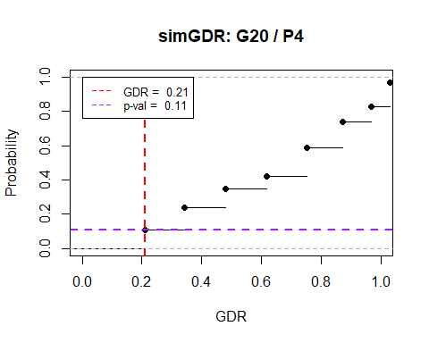

## [1] 0.11

## [1] 0.2105263

ecdf_pval(randSimG20_P16, title = "G20 / P16")

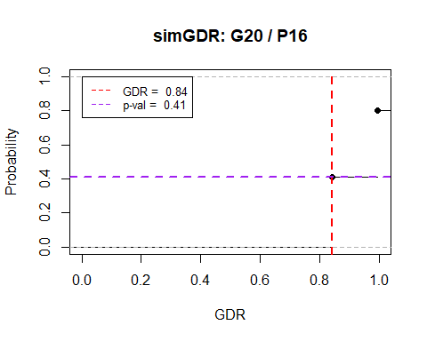

## [1] 0.41

## [1] 0.8421053

ecdf_pval(randSimG190_P38, title = "G190 / P38")

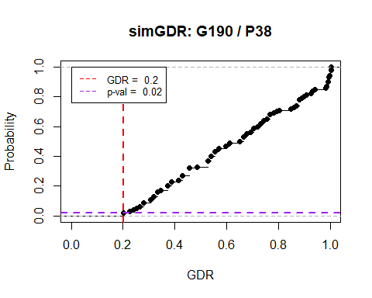

## [1] 0.02

## [1] 0.2010582

ecdf_pval(randSimG190_P152, title = "G190 / P152")

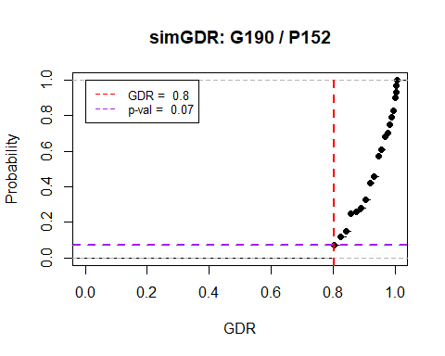

## [1] 0.07

## [1] 0.8042328