Norwegian aid to Ethiopia
This country snapshot report provides a statistical overview of Norwegian development aid (ODA) to Ethiopia.

1. International aid to Ethiopia
In 2023, Norway was the 10th largest donor of bilateral aid to Ethiopia among members countries of the OECD Development Assistance Committee (DAC). These figures represent the most recent available international data by recipient country.
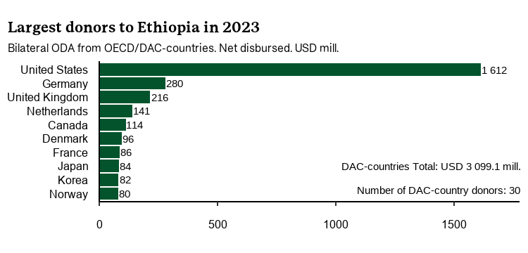

2. Norwegian aid to Ethiopia
In 2024, Norway disbursed NOK 673,1 million in bilatearl aid to Ethiopia through both bilateral and multilateral channels. In addition, Kenya received an estimated share of Norway’s core support to multilateral organisations, but such figures for 2023 are not yet available.
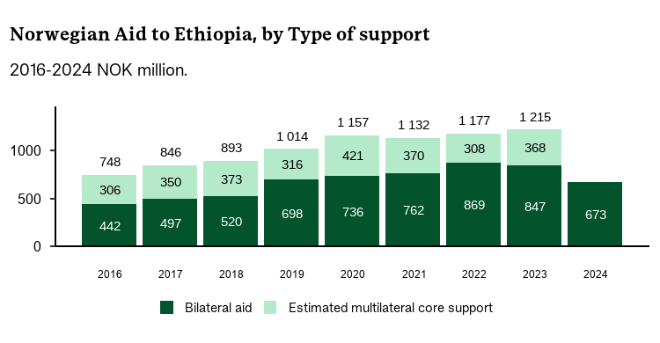

2.1 Norwegian bilateral aid in 2024
In 2024, most of most of Norway’s bilateral aid to Ethiopia was targeting Production sectors and trade (NOK 200,5 mill), Environment and energy (NOK 138,6 mill) and Education (NOK 117,4 mill).
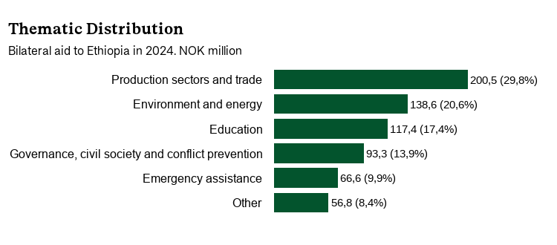
In 2024, most of Norway’s bilateral aid to Ethiopia was channeled through Multilateral organisations (NOK 229,0 mill), Norwegian non-governmental organisations (NOK 207,3 mill) and Public sector in recipient country (NOK 99,7 mill).
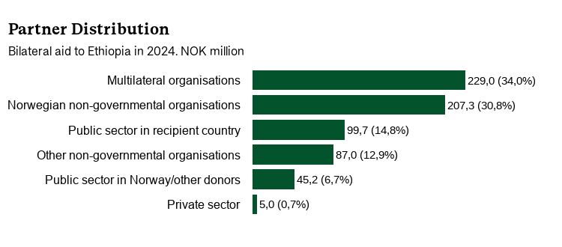
most of for bilateral aid to Ethiopia in 2024 were Other (NOK 191,2 mill), Ethiopia Ministry of Finance and Economic Development (NOK 100,1 mill) and World Bank (NOK 94,0 mill).
Agreement Partners, bilateral aid to Ethiopia in 2024
Agreement partner | NOK mill
Ethiopia Ministry of Finance and Economic Development | 100,1
World Bank | 94,0
Utviklingsfondet | 61,3
UNICEF - United Nations Children's Fund | 47,8
Kirkens Nødhjelp | 44,6
UNDP - UN Development Programme | 38,0
Farm Africa | 27,7
Flyktninghjelpen | 24,9
Digni | 22,0
UNOCHA - UN Office of Co-ordination of Humanitarian Affairs | 21,5
Other | 191,2
Total | 673,1

2.2 Estimated Norwegian multilateral core support to Ethiopia
According to OECD estimates (imputed multilateral ODA to countries), Ethiopia received NOK 368,3 million of Norwegian core support to multilateral organisations in 2023.
The table below shows the distribution of this estimated core support by multilateral organisation in 2023. most of were GAVI - Global Alliance for Vaccines and Immunization (NOK 107,6 mill), IDA - International Development Association (NOK 91,2 mill) and CERF - Central Emergency Response Fund (NOK 32,9 mill).
Agreement Partners, estimated multilateral core support to Ethiopia in 2023
Agreement partner | NOK mill
GAVI - Global Alliance for Vaccines and Immunization | 107,6
IDA - International Development Association | 91,2
CERF - Central Emergency Response Fund | 32,9
AFDF - African Development Fund | 20,8
WFP - World Food Programme | 19,1
GFATM - Global Fund to Fight AIDS, Tuberculosis and Malaria | 18,1
UNICEF - United Nations Children's Fund | 16,6
UNHCR - UN Office of the UN High Commissioner for Refugees | 15,1
UNDP - UN Development Programme | 13,1
GCF - Green Climate Fund | 10,8
Other | 23,1
Total | 368,3

This country snapshot report was generated on 03. 08. 2025 from the Country Snapshot portal. For questions, please contact Norad’s Seksjon for Statistics and Analysis.

Aidresults.no provides detailed statistics on Norwegian bilateral aid to Ethiopia.
Estimated multilateral core support from Norway to Ethiopia has been calculated by the OECD Development Co-operation Directorate (DCD). These estimates, referred to as imputed multilateral ODA to countries are based on how multilateral organisations allocate their core resources across recipient countries. Note that aid provided through regional and global programmes beyond multilateral core contributions is not included.
Due to OECD rounding of values, there may be small discrepancies between the total estimated amount of multilateral core support to Ethiopia in this table and the the figure shown in the table on the first page.
The table does not include imputed multilateral core support to Ethiopia for all multilateral organisations receiving core support from Norway. However, the estimates include organisations that account for approximately 90 percent of total core contributions from DAC countries to multilateral organisations.

