DOCUMENTATION

ASSIGNMENT ASSIGNMENT_NUMBER_3

STUDENT NAME: Gîrda Nora Marcela
GROUP: 30424

CONTENTS

1. Assignment Objective 3
2. Problem Analysis, Modeling, Scenarios, Use Cases 3
3. Design 3
4. Implementation 3
5. Results 3
6. Conclusions 3
7. Bibliography 3

Assignment Objective

Main Objective

To develop an order management system that allows users to manage clients, products, and orders, including their creation, update, deletion, and viewing.
Sub-objectives
Sub-objective | Section
Implement client management (add, edit, delete, view clients) | Implementation
Implement product management (add, edit, delete, view products) | Implementation
Implement order management (create, edit, delete, view orders) | Implementation
Integrate a graphical user interface (GUI) for managing clients, products, and orders | Implementation
Ensure database connectivity and data persistence for clients, products, and orders | Implementation
Generate and display bills for orders | Implementation
Analyze and model the system using UML diagrams and use case descriptions | Design
Define and use appropriate data structures and algorithms | Design
Test the system functionality and validate results | Results
Draw conclusions and suggest future developments | Conclusions

Problem Analysis, Modeling, Scenarios, Use Cases
Functional Requirements:
The system shall allow the user to add, edit, delete, and view clients.
The system shall allow the user to add, edit, delete, and view products.
The system shall allow the user to create, edit, delete, and view orders.
The system shall generate and display bills for orders.
The system shall ensure data persistence using a database.

3. Use Cases
USE CASE-> Diagram
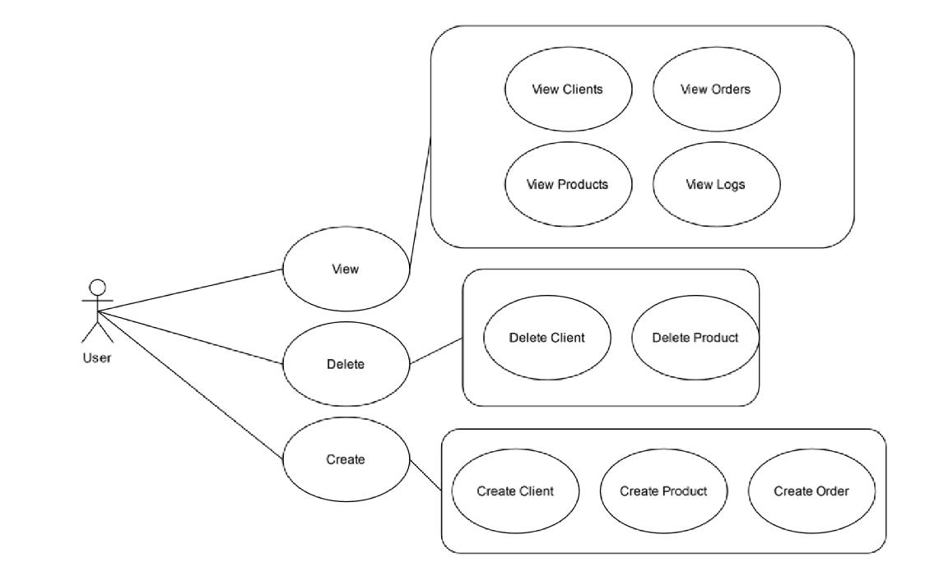
Use Case Descriptions:
Use Case: Manage Clients
Add Client
- User enters client details.
- System saves client details in the database.
Edit Client
- User selects a client and modifies details.
- System updates client details in the database.
Delete Client
- User selects a client to delete.
- System removes the client and associated orders from the database.
View Clients
- User requests to view all clients.
- System retrieves and displays all clients.
Use Case: Manage Products
Add Product
- User enters product details.
- System saves product details in the database.
Edit Product
- User selects a product and modifies details.
- System updates product details in the database.
Delete Product
- User selects a product to delete.
- System removes the product from the database.
View Products
- User requests to view all products.
- System retrieves and displays all products.
Use Case: Manage Orders
Create Order
- User selects a client and products.
- System saves the order details and reduces product stock.
Edit Order
- User selects an order and modifies details.
- System updates the order details in the database.
Delete Order
- User selects an order to delete.
- System removes the order and updates product stock.
View Orders
- User requests to view all orders.
- System retrieves and displays all orders.

Design

The application follows a well-structured layered architecture, including a presentation layer, a business logic layer, a data access layer, and a model layer.

The presentation layer consists of GUI classes responsible for interacting with the user. These classes, such as InitGUI, ClientManagementWindow, ProductManagementWindow, OrderManagementWindow, BillViewWindow, and TableView, provide a user-friendly interface for displaying data and capturing user input, ensuring a seamless user experience.

The model layer contains data models representing the core entities of the application, such as Bill, Client, Product, OrderData, and OrderItem. Each class in this layer encapsulates the properties and behaviors of the corresponding entity.

The data access layer (DAO) is responsible for database interactions. It includes Data Access Objects (DAOs) like ClientDAO, OrderDataDAO, OrderItemDAO, and ProductDAO, which provide CRUD operations for each entity.

The business logic layer contains service classes such as ClientService, OrderDataService, OrderItemService, and ProductService. These classes handle the core operations and business rules, coordinating between the model layer and the data access layer.

The application demonstrates several key OOP design principles, including encapsulation, the single responsibility principle (SRP), separation of concerns, and abstraction. Each class has a single responsibility, making the code easier to maintain and extend. Encapsulation is implemented effectively, with classes encapsulating their data and providing public methods for access and modification. The separation of concerns ensures clear delineation of functionality between layers, enhancing maintainability and scalability. Overall, the application is designed to be modular, maintainable, and extensible, adhering to best practices in software engineering and object-oriented design.
OOP Design
Classes: Client, Product, OrderData, OrderItem, Bill
Service Classes: ClientService, ProductService, OrderDataService, OrderItemService
Data Access Classes: ClientDAO, ProductDAO, OrderDataDAO, OrderItemDAO
Presentation Classes: InitGUI, ClientManagementWindow, ProductManagementWindow, OrderManagementWindow, BillViewWindow, TableView

CLASS DIAGRAM:
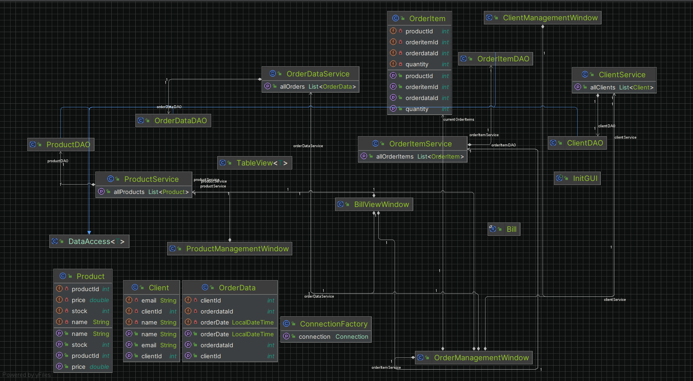

PACKAGE DIAGRAM:
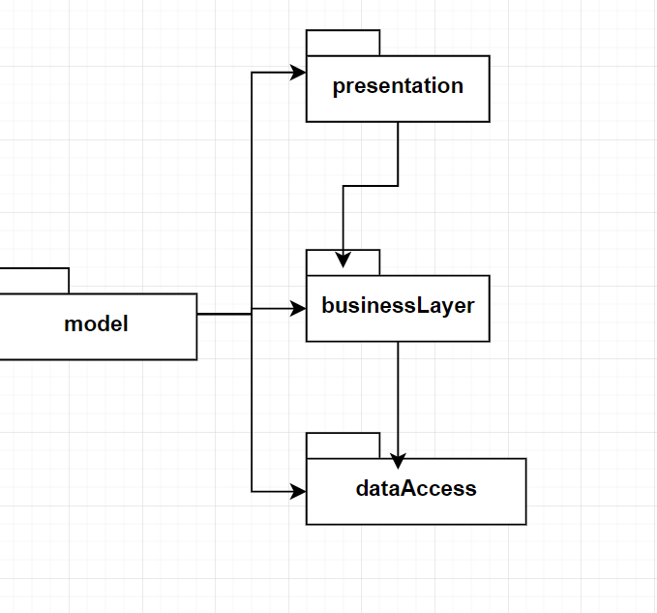

Data Structures
List: Used to store collections of clients, products, orders, and order items.
Record (Bill): Represents a bill with order details.
Defined Interfaces and Algorithms
Data Access Methods: CRUD operations (Create, Read, Update, Delete) for clients, products, orders, and order items.
Order Processing Algorithm: Manages product stock updates and order item addition during order creation.

Implementation
Classes Description
Client
- Fields: clientId, name, email
- Methods: getters and setters
- Product
- Fields: productId, name, price, stock
- Methods: getters and setters
OrderData
- Fields: orderdataId, clientId, orderDate
- Methods: getters and setters
OrderItem
- Fields: orderitemId, orderdataId, productId, quantity
- Methods: getters and setters
Bill
- Fields: orderId, clientId, clientName, totalAmount (record)
- Important Methods
ClientService
- addClient(Client client): Adds a new client.
- updateClient(Client client, int id): Updates a client.
- deleteClient(int id): Deletes a client.
- getAllClients(): Retrieves all clients.
- getClientById(int id): Retrieves a client by ID.
- deleteClientWithOrder(int clientId): Deletes a client and associated orders.
ProductService
- addProduct(Product product): Adds a new product.
- updateProduct(Product product, int id): Updates a product.
- deleteProduct(int id): Deletes a product.
- getAllProducts(): Retrieves all products.
- getProductById(int id): Retrieves a product by ID.
OrderDataService
- addOrderData(OrderData orderData): Adds a new order.
- updateOrderData(OrderData orderData, int id): Updates an order.
- deleteOrderData(int id): Deletes an order.
- getAllOrders(): Retrieves all orders.
- getOrderById(int id): Retrieves an order by ID.
- deleteOrderDataWithItems(int orderId): Deletes an order and associated items.
OrderItemService
- addOrderItem(OrderItem orderItem): Adds a new order item.
- updateOrderItem(OrderItem orderItem, int id): Updates an order item.
- deleteOrderItem(int id): Deletes an order item.
- getAllOrderItems(): Retrieves all order items.
- getOrderItemById(int id): Retrieves an order item by ID.
- deleteOrderItemsByOrderId(int orderId): Deletes order items by order ID.
Graphical User Interface (GUI)
- ClientManagementWindow: Manages client-related operations.
- ProductManagementWindow: Manages product-related operations.
- OrderManagementWindow: Manages order-related operations.
- BillViewWindow: Displays bills for orders.
- InitGUI: Main application window with navigation to different management windows.

Conclusions

Conclusions

Successfully implemented an order management system with client, product, and order management functionalities.Integrated a user-friendly graphical user interface for easy interaction.Ensured data persistence and consistency through robust database operations.

Lessons Learned

Gained deeper understanding of object-oriented programming and design principles.Improved skills in GUI development using Java Swing.Enhanced knowledge of database connectivity and data persistence.

Future Developments

Implement advanced search and filter options for clients, products, and orders.Add user authentication and role-based access control.Integrate reporting features for sales and inventory management.Enhance the GUI with modern frameworks like JavaFX for better user experience

Bibliography
https://dsrl.eu/courses/pt/

