Sprint Report Document

**Hire Me (وظفني)**

**Sprint -3- Report**

|  |  |  |
| --- | --- | --- |
| # | Student Name | ID |
| 1 | Kholoud Alaqeely | 435200055 |
| 2 | Leena Abuaish | 435200914 |
| 3 | Rahaf Almozaini | 435200445 |
| 4 | Lama Almansour | 435200549 |

Section No.: 47406

Team No.: 2

*Sprint start :12 \11\2017*

*Completion date: 22\11\2017*

Table of Contents

Sprint Review 3

Work completed/not completed 3

Explanation for the uncompleted User Story 3

Sprint Retrospective 4

Actions to stop doing 4

Actions to start doing 4

Actions to keep doing 4

Metrics 5

Sprint Burndown 5

List of Tables

Table 1:Work completed/not completed 3

List of Figures

Figure 1:Sprint#2 Burndown Chart 5

# Sprint Review

## Work completed/not completed

|  |  |
| --- | --- |
| **User Story** | **Completion** |
| As a candidate user of hire me application, I would like to view the organizations in categories, so that I can browse the organizations easily. | Completed |
| As a candidate user of hire me application, I would like to be able to add my profile (CV), so that I can be able to apply for a position. | Completed |
| As a candidate user of hire me application, I would like to be able to edit my profile (CV), so that I can have an updated profile (CV). | Completed |
| As a candidate user of hire me application, I would like to be able to add a specific organization to my favorite list, so that I can view it later. | Not completed |
| As a candidate user of hire me application, I would like to view the organizations information, so that I can find the information I need. | Completed |

Table 1:Work completed/not completed

## Explanation for the uncompleted User Story

As you can see in table 1, that one of the stories were not completed. We couldn’t complete the story because of the time and some problems that we faced during the implementation. Some of these problems were:

After we started implementing the user story we realized that we need to do the view Org. information by the candidate first so we can do the favorite list user story. The problem was that the view Org. story was not planned for this sprint. Therefore, we had to plan it in this sprint and do it so we can do the favorite list story. And that took more time than expected. The other problem that we faced that when we click the “add to favorite” button the system will crash with no clear reason.

# Sprint Retrospective

Actions to stop doing

1. Updating Ice scrum regularly while working only not daily.
2. Planning user stories that depend on each other in the same sprint.

## Actions to start doing

1. While planning the sprint we should not plan more than we can handle.
2. Take in consideration the relation between the user stories and the dependency between them.

## Actions to keep doing

1. Planning what to work on before the start of each lab.
2. Work distribution between team members.
3. Respecting deadlines and submitting work on time.
4. Holding meetings at 12:00 pm instead of 7:00 am.
5. Scheduling meetings with TeamViewer since we don’t have enough time to meet face-to-face at the university.
6. Breakdown the task to smaller tasks that can be done in 1 hour.
7. Write more specific tasks.
8. Use previous sprints estimations and the actual time spent as a reference in the next sprints.
9. Try to keep the burndown chart under the median line.
10. Learn how to work under pressure.
11. Holding more meetings.
12. Updating Ice scrum daily.
13. While planning the sprint, we should take in consideration our other obligations with the other courses and how much are we occupied in that period of time.

# Metrics

## Sprint Burndown

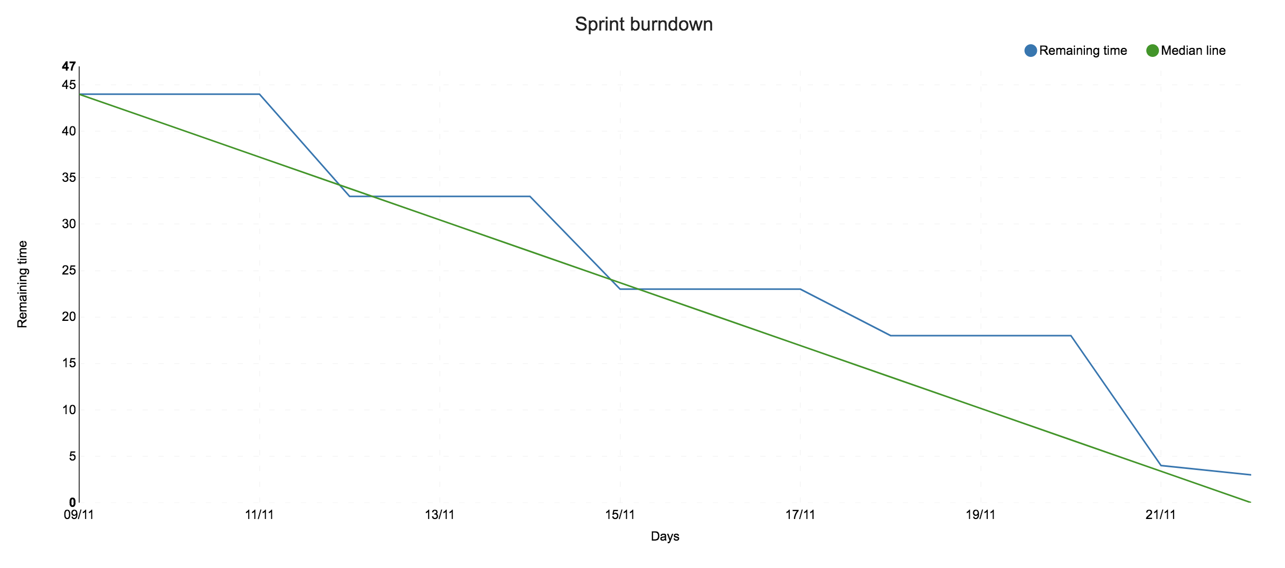

Figure :Sprint#3 Burndown Chart