**King Saud University**

**College of Computer and Information Sciences**

**Department of Information Systems**

**IS230: Introduction to Database Systems**

2nd Semester 1437-1438 H

**

**Helth Care**

**Phase # 2**

|  |  |  |  |
| --- | --- | --- | --- |
| **ID** | **NAME** | **SN** | **Section #** |
| **Group Number : 1** | | | |
| *435200123* | *Reema al-swailam* | *1* | *47851* |
| *435202497* | *Haifa alabduljabbar* | *2* | *47851* |
| *435201094* | *Norah alkhunifer* | *3* | *47851* |
| *435200467* | *Ghaliah Almutiari* | *4* | *47851* |
| *435201808* | *Alzahra alhowaish* | *5* | *46442* |
| *435201908* | *Raghad Alsaleh* | *6* | *47851* |
| *435202506* | *Riyam Alshalan* | *7* | *47851* |

**Supervised By:**  **Monirah Alajlan**

Second Semester 1437-1438

Spring 2017

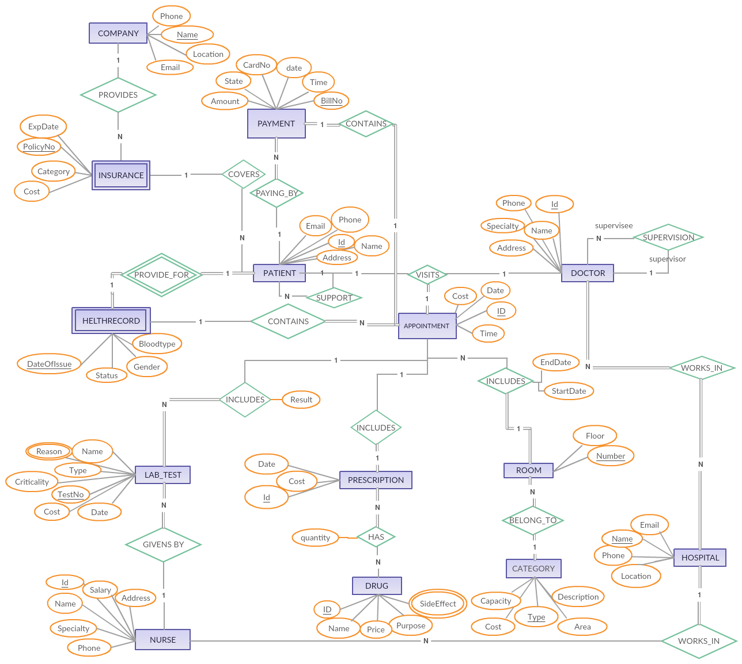**ER diagram :**

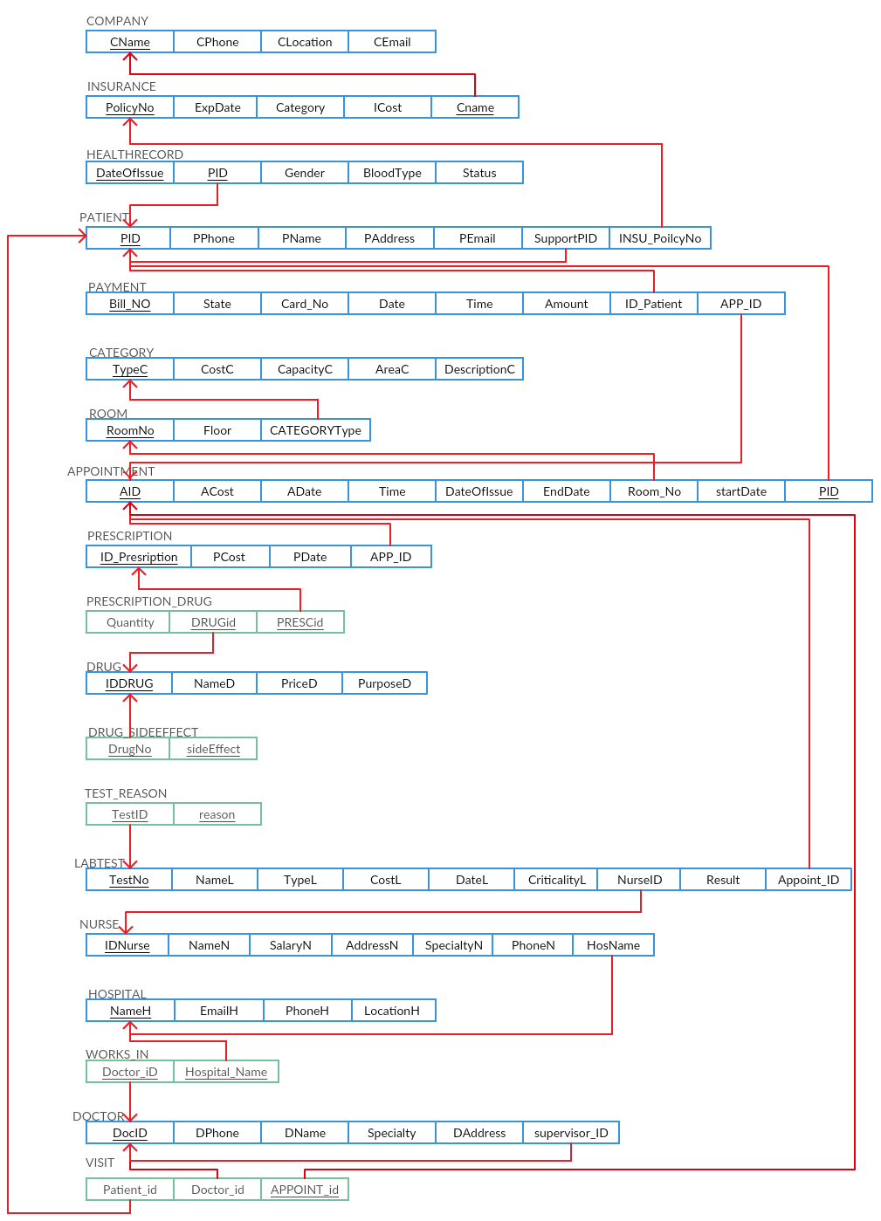**Mapping :**

**Data dictionary 1 :**

|  |  |  |
| --- | --- | --- |
| **Entity Name** | **Description** | **Aliases** |
| NURSE | This entity Describe each nurse information include (id, name, salary, address, Specialty, phone and the hospital name ) of the nurse . | Employ  Worker |

|  |  |  |  |  |
| --- | --- | --- | --- | --- |
| **Multiplicity** | **Entity Name** | **Relationship** | **Multiplicity** | **Entity Name** |
| N | LAB_TEST | “GIVENS BY” | 1 | NURSE |
| 1 | HOSPITAL | “WORKS_IN” | N | NURSE |

|  |  |  |  |  |  |  |  |  |  |  |
| --- | --- | --- | --- | --- | --- | --- | --- | --- | --- | --- |
| Entity Name | Attribute | Description | Data Type | length | nulls | Multi-valued | Default-value | Range | FK | PK |
| NURSE | IDNurse | A unique 9-digit identifier assigned to each nurse | Integer (int) | 9 | No | No | - | - | No | YES |
| NURSE | NameN | The nurse legal full name. | Varchar | 255 | No | No | - | - | No | No |
| NURSE | SalaryN | The nurse salary | Float | 4 | No | No | 2000 | 2000-5000 | No | No |
| NURSE | AddressN | The full Address of nurse home or apartment | Text | 255 | No | No | - | - | No | No |
| NURSE | SpecialtyN | The Specialty of the nurse | Text | 255 | No | No | - | - | No | No |
| NURSE | PhoneN | The mobile or landline phone number that can be used to contact an nurse | Varchar | 14 | No | No | - | - | No | No |
| NURSE | HosName | The full name of the hospital that the nurse work in . | Varchar | 44 | No | No | - | - | YES | No |

**Data dictionary 2 :**

|  |  |  |
| --- | --- | --- |
| **Entity Name** | **Description** | **Aliases** |
| PAYMENT | This entity describe each PAYMENT information include (BillNo , Amount , state , CardNo , Date and Time ) of the payment | Bill |

|  |  |  |  |  |
| --- | --- | --- | --- | --- |
| **Entity Name** | **Multiplicity** | **Relation** | **Entity Name** | **Multiplicity** |
| PAYMENT | 1 | “CONTAIN” | APPOINTMENT | 1 |
| PAYMENT | N | “PAYING_BY" | PATIENT | 1 |

|  |  |  |  |  |  |  |  |  |  |  |
| --- | --- | --- | --- | --- | --- | --- | --- | --- | --- | --- |
| Entity Name | Attribute | Description | Data  Type | length | null | Multi-value | Default-value | Range | FK | PK |
| PAYMENT | Bill_NO | bill number for each patient | Integer (int) | 8 | No | No | - | - | No | Yes |
| PAYMENT | Amount | Total payment amount | float | 5 | No | No | - | - | No | No |
| PAYMENT | state | the patient payment was done or not | Varchar | 7 | No | No | - | pay / pay not | No | No |
| PAYMENT | Card_NO | Bank Card Number | Integer (int) | 16 | No | No | - | - | No | No |
| PAYMENT | Date | The date of patient paid | Date | 10 | No | No | Current_date | - | No | No |
| PAYMENT | Time | The time of patient paid | Time | 8 | No | No | Current_time | - | No | No |
| PAYMENT | ID_patient | ID number of the patient | Integer (int) | 9 | No | No | - | - | Yes | No |
| PAYMENT | APP_ID | ID number of the Appointment | Integer (int) | 9 | No | No | - | - | Yes | No |