**King Saud University**

**College of Computer and Information Sciences**

**Department of Information Systems**

**IS230: Introduction to Database Systems**

2nd Semester 1437-1438 H

**



**Phase # 1**

|  |  |  |  |
| --- | --- | --- | --- |
| **ID** | **NAME** | **SN** | **Section #** |
| **Group Number :** | | | |
| *435200123* | *Reema al-swailam* | *1* | *47851* |
| *435202497* | *Haifa alabduljabbar* | *2* | *47851* |
| *435201094* | *Norah alkhunifer* | *3* | *47851* |
| *435200467* | *Ghaliah Almutiari* | *4* | *47851* |
| *435201808* | *Alzahra alhowaish* | *5* | *46442* |
| *435201908* | *Raghad Alsaleh* | *6* | *47851* |
| *435202506* | *Riyam Alshalan* | *7* | *47851* |

**Supervised By:**  *Nourah AlQahtani*

Second Semester 1437-1438

2017

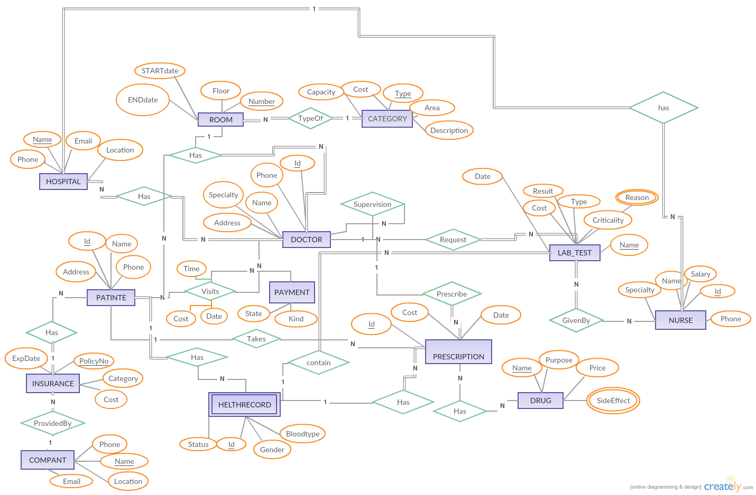

Assume one nurse work on only one hospital .

Assume that insurance include hole family .

Assume the doctor have only one patient in same date and same time .

Assume The doctor prescribe prescription for each patient .

Assume The hospital is only one building .

Assume The room number is unique in same hospital .