**King Saud University**

**College of Computer and Information Sciences**

**Department of Information Systems**

**IS230: Introduction to Database Systems**

2nd Semester 1437-1438 H

**

**Helth Care**

**Phase # 2**

|  |  |  |  |
| --- | --- | --- | --- |
| **ID** | **NAME** | **SN** | **Section #** |
| **Group Number : 1** | | | |
| *435200123* | *Reema al-swailam* | *1* | *47851* |
| *435202497* | *Haifa alabduljabbar* | *2* | *47851* |
| *435201094* | *Norah alkhunifer* | *3* | *47851* |
| *435200467* | *Ghaliah Almutiari* | *4* | *47851* |
| *435201808* | *Alzahra alhowaish* | *5* | *46442* |
| *435201908* | *Raghad Alsaleh* | *6* | *47851* |
| *435202506* | *Riyam Alshalan* | *7* | *47851* |

**Supervised By:**  **Monirah Alajlan**

Second Semester 1437-1438

Spring 2016 ***.***

**DB tables creation commands:**

CREATE TABLE "CATEGORY"

( "TYPEC" VARCHAR2(10) NOT NULL ENABLE,

"COSTC" NUMBER(5,2) NOT NULL ENABLE,

"CAPACITYC" NUMBER(*,0) NOT NULL ENABLE,

"AREAC" VARCHAR2(10),

"DESCRIPTIONC" VARCHAR2(255),

PRIMARY KEY ("TYPEC")

USING INDEX ENABLE

)

;

CREATE TABLE "HOSPITAL"

( "NAMEH" VARCHAR2(15) NOT NULL ENABLE,

"EMAILH" VARCHAR2(25) NOT NULL ENABLE,

"PHONEH" NUMBER(*,0) NOT NULL ENABLE,

"LOCATIONH" VARCHAR2(30) NOT NULL ENABLE,

PRIMARY KEY ("NAMEH")

USING INDEX ENABLE,

)

;

CREATE TABLE "LABTEST"

( "TESTNO" NUMBER(*,0) NOT NULL ENABLE,

"NAMEL" VARCHAR2(15) NOT NULL ENABLE,

"TYPEL" VARCHAR2(15) NOT NULL ENABLE,

"COSTL" NUMBER(7,2) NOT NULL ENABLE,

"DATEL" DATE,

"CRITICALITYL" VARCHAR2(255) NOT NULL ENABLE,

"NURSEID" NUMBER(*,0) NOT NULL ENABLE,

PRIMARY KEY ("TESTNO")

USING INDEX ENABLE

)

;

CREATE TABLE "NURSE"

( "IDNURSE" NUMBER(*,0) NOT NULL ENABLE,

"NAMEN" VARCHAR2(15) NOT NULL ENABLE,

"SALARYN" NUMBER(10,2),

"ADDRESSN" VARCHAR2(30),

"SPECIALTYN" VARCHAR2(30) NOT NULL ENABLE,

"PHONEN" NUMBER(*,0),

"HOSNAME" VARCHAR2(15) NOT NULL ENABLE,

PRIMARY KEY ("IDNURSE")

USING INDEX ENABLE,

)

;

CREATE TABLE "ROOM"

( "ROOMNO" NUMBER(*,0) NOT NULL ENABLE,

"FLOOR" NUMBER(*,0) NOT NULL ENABLE,

"CATEGORYTYPE" VARCHAR2(20),

PRIMARY KEY ("ROOMNO")

USING INDEX ENABLE

)

;

ALTER TABLE "NURSE" ADD FOREIGN KEY ("HOSNAME")

REFERENCES "HOSPITAL" ("NAMEH") ENABLE

;

ALTER TABLE "LABTEST" ADD FOREIGN KEY ("NURSEID")

REFERENCES "NURSE" ("IDNURSE") ENABLE

;

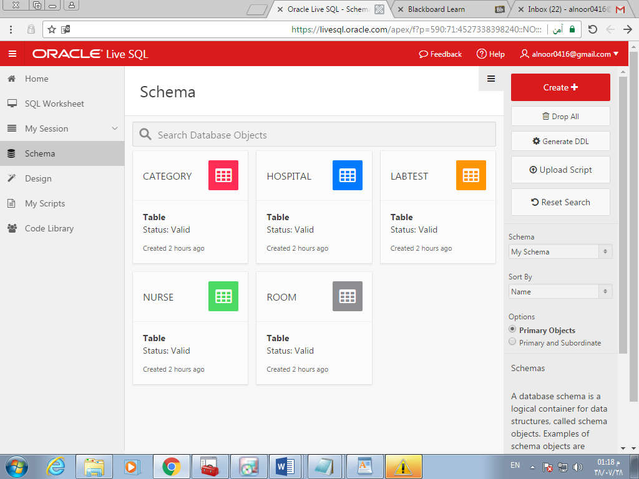

**Data insertion commands:**

**HOSPITAL:**

INSERT INTO hospital (NameH, EmailH, PhoneH, LocationH) VALUES ('King Abdulaziz', 'abdulaziz@hospital.com', 114309279, '1st turki street ');

INSERT INTO hospital (NameH, EmailH, PhoneH, LocationH) VALUES ('King Fahad', 'fahad@hospital.com', 114538239, 'olaya street ');

INSERT INTO hospital (NameH, EmailH, PhoneH, LocationH) VALUES ('King Faisal', 'fisal@hospital.com', 114645367, 'takhasusi street ');

INSERT INTO hospital (NameH, EmailH, PhoneH, LocationH) VALUES ('King Saud', 'saud@hospital.com', 11768729, 'king abdullah street ');

INSERT INTO hospital (NameH, EmailH, PhoneH, LocationH) VALUES ('King Sultan', 'sultan@hospital.com', 114532879, 'naser ahmad street ');

**category:**

INSERT INTO category (TypeC, CostC, CapacityC, AreaC, DescriptionC) VALUES ('executiveA', '900.99', 1, '10m^2', 'has one bed and tow sofa ,one private bathroom ');

INSERT INTO category (TypeC, CostC, CapacityC, AreaC, DescriptionC) VALUES ('shared A', '150.00', 4, '15m^2', 'has one bed and one chair ,one shared bathroom ');

INSERT INTO category (TypeC, CostC, CapacityC, AreaC, DescriptionC) VALUES ('shared B', '100.00', 6, '15m^2', 'has one bed and one chair ,one shared bathroom ');

INSERT INTO category (TypeC, CostC, CapacityC, AreaC, DescriptionC) VALUES ('standard A', '500.58', 1, '5m^2', 'has one bed and one sofa ,one private bathroom ');

INSERT INTO category (TypeC, CostC, CapacityC, AreaC, DescriptionC) VALUES ('standard B', '440.00', 1, '3m^2', 'has one beds and tow chairs ,one private bathroom ');

**LABTEST:**

INSERT INTO LABTEST (TestNo, NameL, TypeL, CostL, DateL, CriticalityL, NurseID) VALUES (1, 'food Allergy', 'Allergy', 500.57, TO_DATE('2017-04-30','YYYY-MM-DD'), 'non-urgent', 456120439);

INSERT INTO LABTEST (TestNo, NameL, TypeL, CostL, DateL, CriticalityL, NurseID) VALUES (2, 'foot Arthritis', 'Arthritis', 640.99, TO_DATE('2017-05-19','YYYY-MM-DD') , 'urgent', 456128721);

INSERT INTO LABTEST (TestNo, NameL, TypeL, CostL, DateL, CriticalityL, NurseID) VALUES (3, 'Rare Diseases', 'Autoimmune Dise', 900.99, TO_DATE('2017-06-17','YYYY-MM-DD') , 'non-urgent', 456129382);

INSERT INTO LABTEST (TestNo, NameL, TypeL, CostL, DateL, CriticalityL, NurseID) VALUES (4, 'Anemia', 'Blood and Blood', 100.00,TO_DATE('2017-04-29','YYYY-MM-DD') , 'urgent', 456123789);

INSERT INTO LABTEST (TestNo, NameL, TypeL, CostL, DateL, CriticalityL, NurseID) VALUES (5, 'Breast cancer', 'Cancer Tests', 140.88, TO_DATE('2017-04-27','YYYY-MM-DD'), 'urgent', 456128721);

**nurse:**

INSERT INTO nurse (IDNurse, NameN, SalaryN, AddressN, SpecialtyN, PhoneN, HosName) VALUES (456120439, 'sama tamer', '5000.00', 'olaya', 'Cardiac', 559826345, 'King Fahad);

INSERT INTO nurse (IDNurse, NameN, SalaryN, AddressN, SpecialtyN, PhoneN, HosName) VALUES (456123239, 'Nourah turki', '5000.00', 'umhamam', 'Advanced practice registered', 559873498, 'King Fahad');

INSERT INTO nurse (IDNurse, NameN, SalaryN, AddressN, SpecialtyN, PhoneN, HosName) VALUES (456123789, 'Razan mohamad', '8000.00', 'olaya', 'accouchement', 550362718, 'King Saud');

INSERT INTO nurse (IDNurse, NameN, SalaryN, AddressN, SpecialtyN, PhoneN, HosName) VALUES (456128721, 'sumaia omar', '6000.00', 'raboa', 'Geriatric', 551234987, 'King Abdulaziz');

INSERT INTO nurse (IDNurse, NameN, SalaryN, AddressN, SpecialtyN, PhoneN, HosName) VALUES (456129382, 'tala ahmad', '7000.00', 'fisaliah', 'Critical care', 550092745, 'King Sultan');

**room:**

INSERT INTO room (RoomNo, Floor, CATEGORYType) VALUES (201, 2, 'executiveA');

INSERT INTO room (RoomNo, Floor, CATEGORYType) VALUES (212, 2, 'executiveA');

INSERT INTO room (RoomNo, Floor, CATEGORYType) VALUES(301, 3, 'shared A');

INSERT INTO room (RoomNo, Floor, CATEGORYType) VALUES (505, 5, 'shared B');

INSERT INTO room (RoomNo, Floor, CATEGORYType) VALUES (511, 5, 'standard A');

*Ex:*

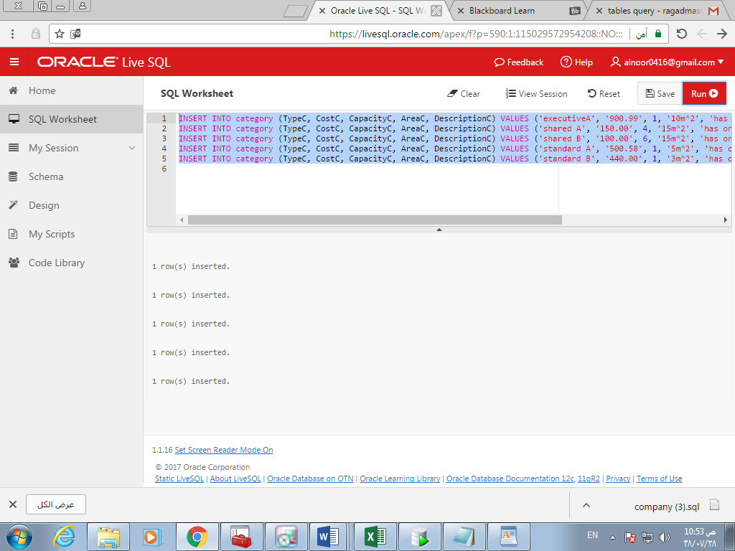**Data Queries commands and outputs:**

1. *A nested query.*

SELECT SUM(CostL) FROM LABTEST ;

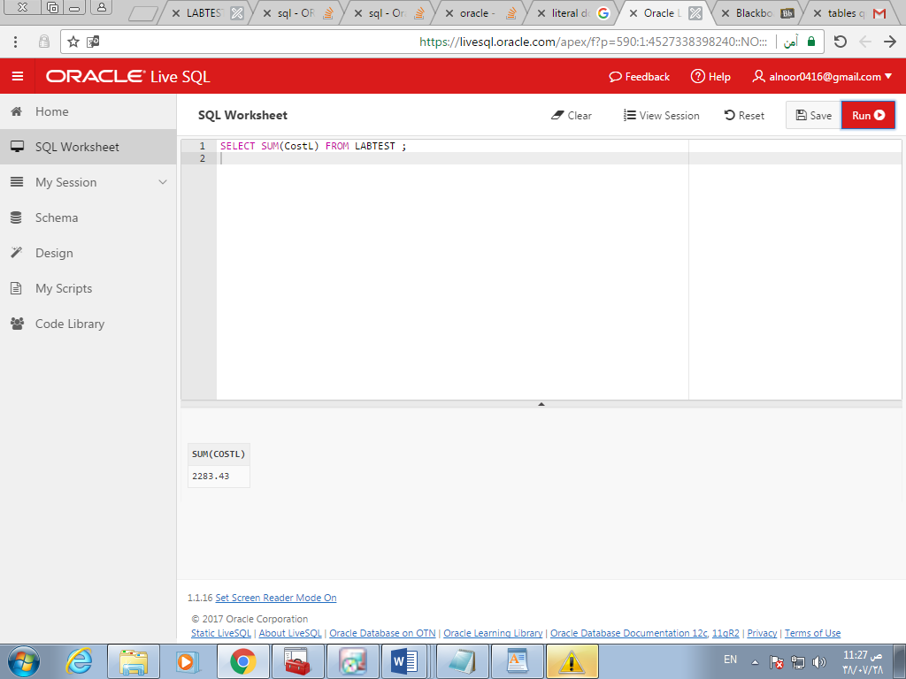

1. *A query with aggregation function.*

SELECT *

FROM NURSE

WHERE IDNurse IN (SELECT IDNurse

FROM NURSE

WHERE SalaryN > 4500) ;

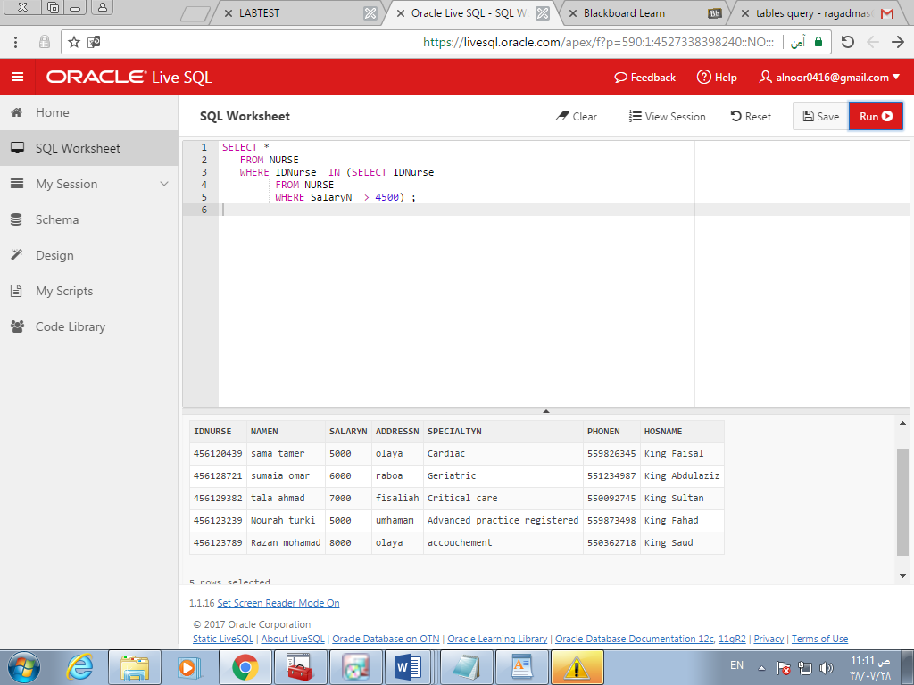

1. *A query that requires grouping.*

SELECT HosName, COUNT(IDNurse)

FROM NURSE

GROUP BY HosName;

1. *A query that requires ordering.*

SELECT *

FROM NURSE

ORDER BY NameN;

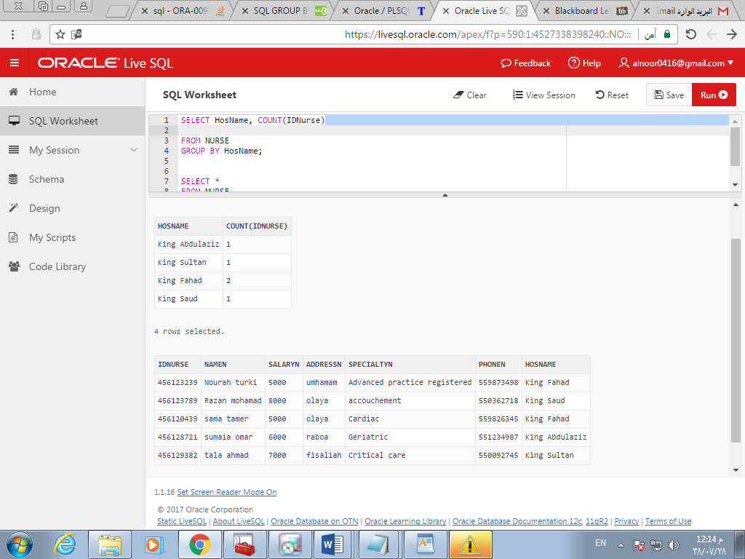

*"screen shot for query 3 and 4"*

1. *A query that requires joining tables.*

SELECT NameH,NameN

FROM NURSE

RIGHT OUTER JOIN HOSPITAL ON

NURSE.HosName = HOSPITAL.NameH ;

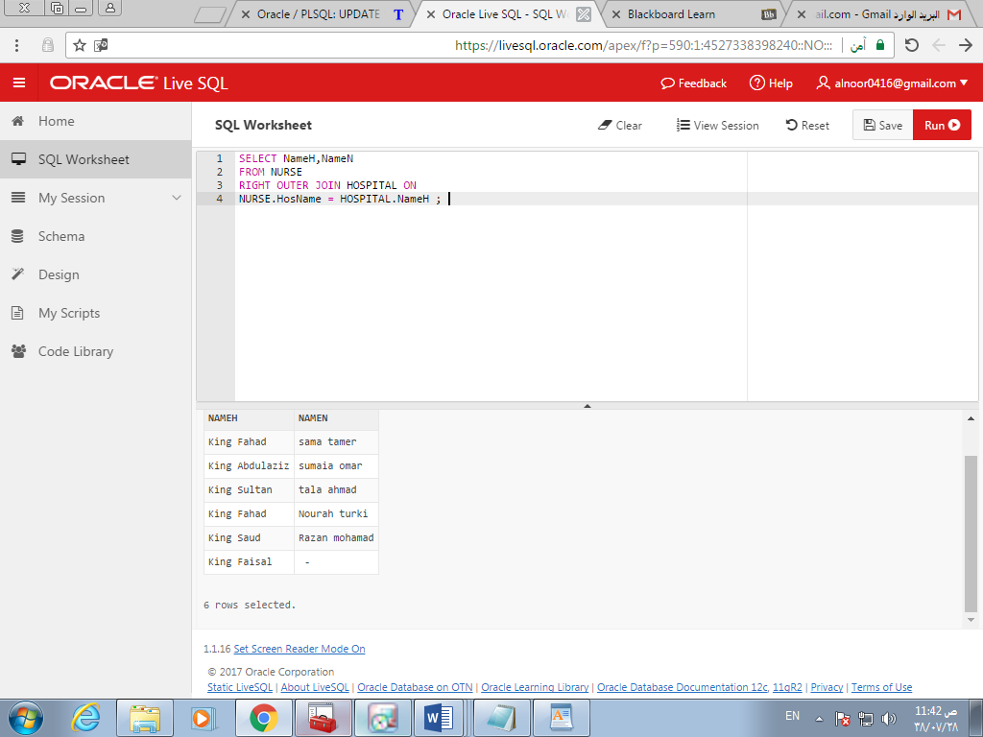

1. *A query that requires joining tables by using RIGHT OUTER JOIN.*

SELECT NameN nurse , NameL LABTEST

FROM nurse ,LABTEST

WHERE nurse.IDNurse = LABTEST.NurseID ;

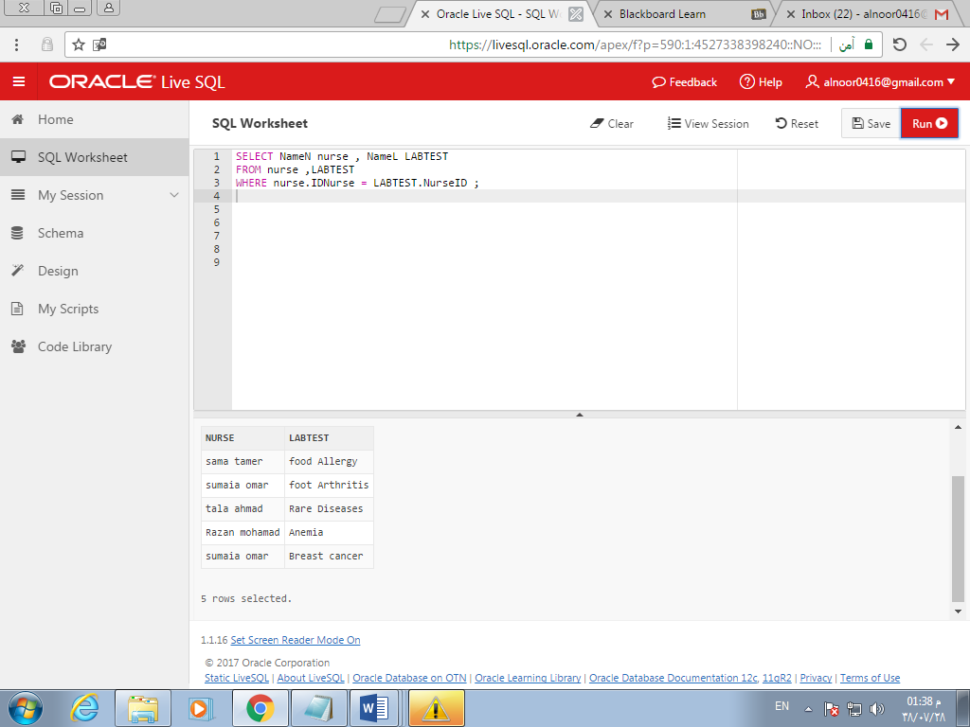

1. *A query that requires joining tables by using LEFT OUTER JOIN.*

SELECT * FROM NURSE

LEFT OUTER JOIN HOSPITAL ON NURSE.HosName = HOSPITAL.NAMEH

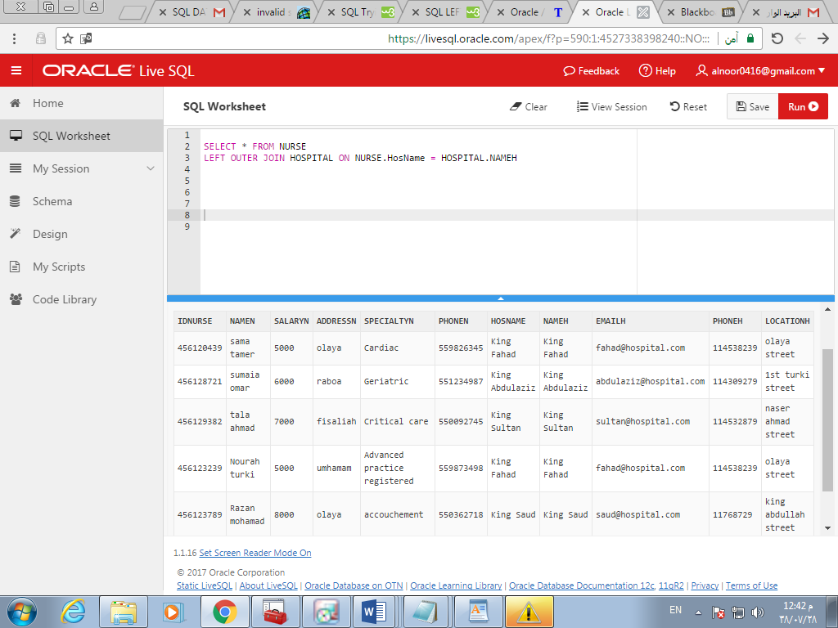

1. *A query that requires either union or intersection.*

SELECT IDNURSE, NAMEN FROM NURSE UNION SELECT TESTNO ,NAMEL FROM LABTEST

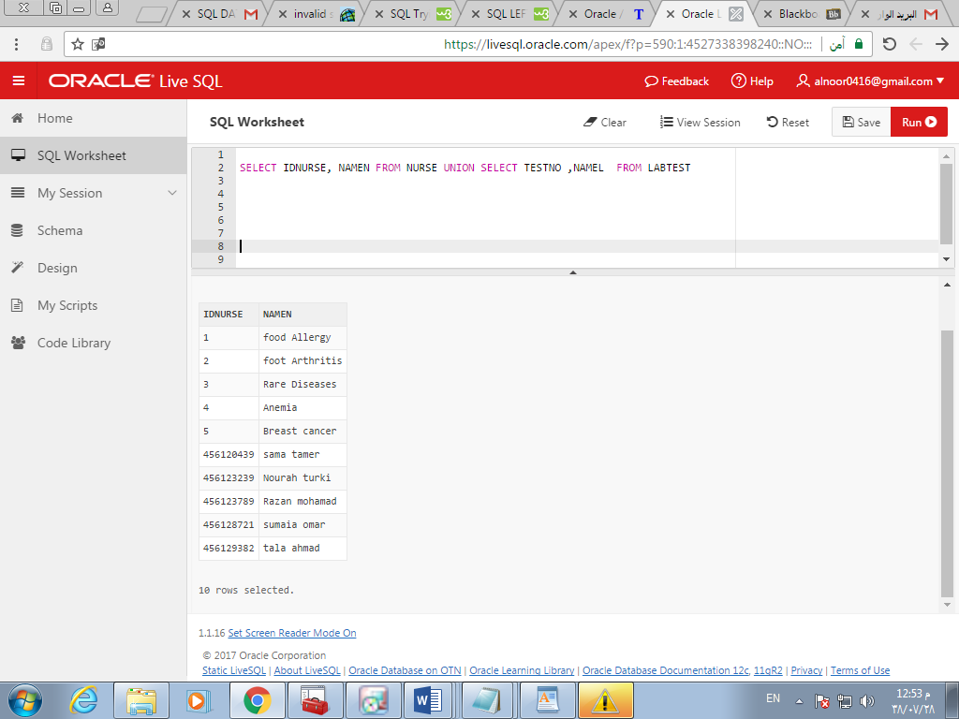

1. *An update query.*

UPDATE HOSPITAL

SET LocationH= 'altaawin'

WHERE NameH='King Faisal';

UPDATE NURSE

SET SalaryN = SalaryN + 470

WHERE IDNurse =456120439;

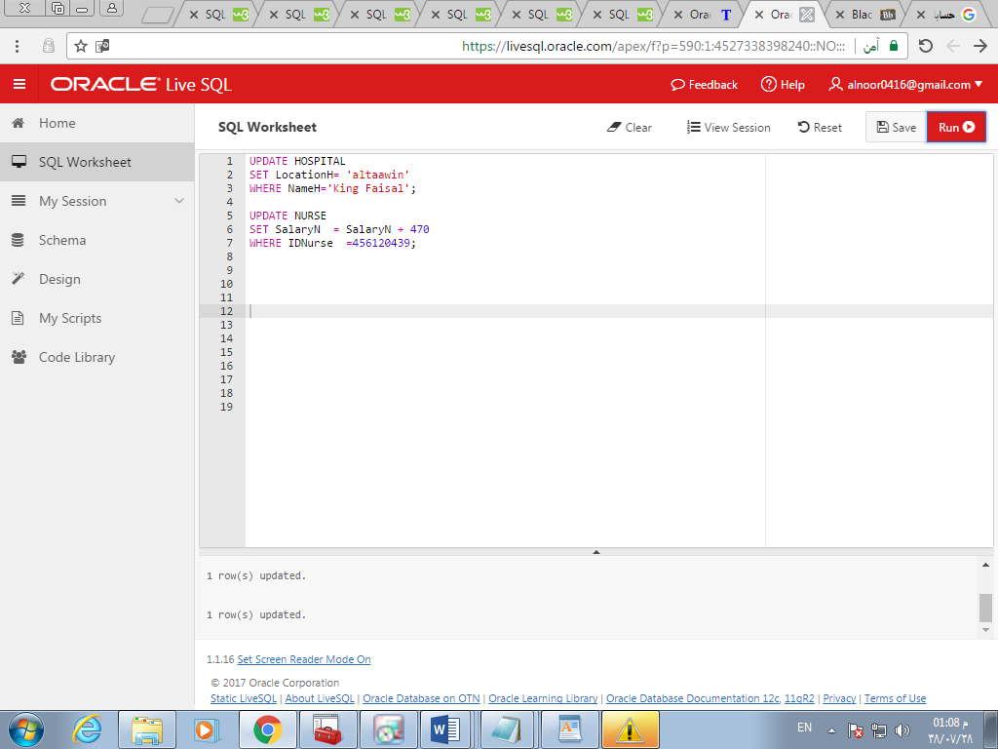

1. *A query that defines a trigger on your database (must be meaningful).*

ALTER TABLE NURSE ADD CONSTRAINT salary_rang

CHECK( salaryN>=2000);

ALTER TABLE HOSPITAL

ADD CONSTRAINT Serve_all_places UNIQUE (LocationH);

