1.

# AWS vs Azure vs Google Cloud: Establishment

## Amazon Web Services

Amazon Web Services is a subsidiary of amazon.com, which provides an on-demand Cloud Computing platform to individuals, companies, and governments on a paid-subscription basis.

Amazon Web Services is the oldest and the most experienced player in the cloud market. As one of the oldest cloud providers, it has established a bigger user base, as well as bigger trust and reliability factors.

AWS was publicly launched in 2006 with service offerings such as Elastic Compute Cloud (EC2), Simple Storage

Service (Amazon S3), etc. By 2009, Elastic Block Store (EBS) was made public, and services such as Amazon

CloudFront, Content delivery network (CDN), and more formally joined the AWS Cloud Computing Service offerings.

## Microsoft Azure

Microsoft Azure, initially called Azure, was launched in 2010 with the intent to provide a competent Cloud

Computing platform for businesses. Azure was renamed as ‘Microsoft Azure’ in 2014, though the name ‘Azure’ is still commonly used. Since its inception, Microsoft Azure has shown great progress among its competitors.

## Google Cloud Platform

Google Cloud Platform (GCP), which is offered by Google, is a suite of Cloud Computing services that runs on the same infrastructure that Google uses internally for its end-user products such as Google Search engine, YouTube, and more.

Google Cloud Platform began its journey in 2011, and in less than a decade it has managed to create a good presence in the cloud industry. The initial intent of Google Cloud was to strengthen Google’s own products such as Google Search engine and YouTube. But now, they have also introduced their enterprise services so that anyone can use Google Cloud Platform which shares the same infrastructure as that of Google Search or YouTube.

# AWS vs Azure vs Google Cloud: Availability Zones

It has been already established that AWS was the earliest in the cloud domain which means that they have had more time to establish and expand their network. So, AWS is hosting in multiple locations worldwide. Azure and GCP are also hosting in multiple locations worldwide, but the difference occurs in the number of their respective availability zones.

**AWS** has 66 availability zones with 12 more on the way.

**Azure** has 54 regions worldwide and is available in 140 countries all around the world.

**Google Cloud Platform** has been made available in 20 regions around the world with 3 more on their way.

Moving on with this Azure vs AWS vs Google Cloud blog, let’s look into the market shares and growth rate of each of these cloud providers.

# AWS vs Azure vs Google Cloud: Market Shares and Growth Rate

According to the reported quarterly earnings for 2021, Microsoft’s Azure cloud revenue has been observed to, once again, outperform both AWS and Google Cloud combined.

In spite of the Goliath-like stature of Amazon’s AWS, Microsoft’s Azure cloud outperformed its competitors with its US$17.7 billion (50% revenue growth over the previous quarter) in commercial-cloud revenue as per the fiscal earnings report. While Amazon’s AWS reported US$13.5 billion in cloud business revenue for the quarter (revenue grew 32% in the quarter), Google Cloud had a modest US$4.05 billion.

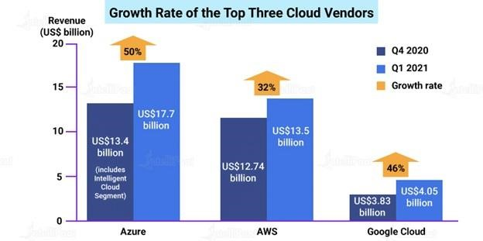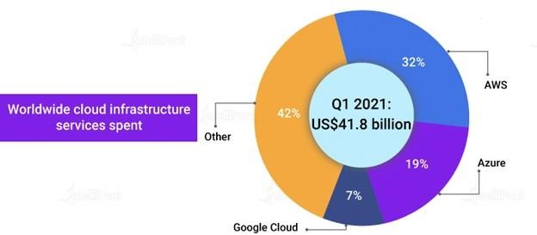

**AWS vs Azure vs Google Cloud: Who Uses Them?**

Since **AWS** is the oldest player in the cloud market, it comparatively has a bigger community support and user base. Therefore, AWS has more high-profile and well-known customers like Netflix, Airbnb, Unilever, BMW, Samsung, MI, Zynga, etc.

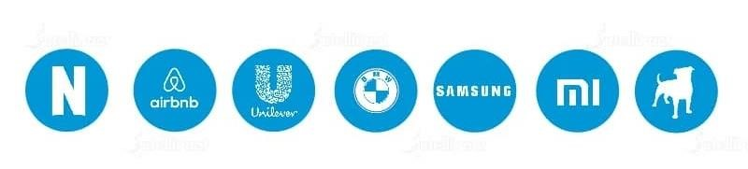

**Azure** is also gaining its share of high-profile customers with time. As of now, Azure has almost 80 percent of Fortune 500 companies as its customers. Some of its major customers are Johnson Controls, Polycom, Fujifilm, HP, Honeywell, Apple, etc.



**Google**, on the other hand, shares the same infrastructure as that of Google Search and YouTube and, as a result, many high-end companies have put their faith in Google Cloud. Major clients of Google Cloud are HSBC, PayPal, 20th Century Fox, Bloomberg, Dominos, and more.



# AWS vs Azure vs Google Cloud: Services

Now, you will see what all these three cloud giants have to offer in terms of services with the added advantage of five years of a head start, AWS computing services are by far the most evolved and functionally rich.

AWS offers around 200+ services, whereas Azure offers up to 100+ services. Google Cloud, on the other hand, is catching up with Azure and AWS offering around 60+ services.

Service offerings from AWS, Azure, and GCP that come under the domains of compute, database, storage, and networking are mapped below:

## Compute Services

|  |  |  |  |
| --- | --- | --- | --- |
| Services | AWS | Azure | GCP |
| IaaS | Amazon Elastic Compute Cloud | Virtual Machines | Google Compute Engine |
| PaaS | AWS Elastic Beanstalk | App Service and Cloud Services | Google App Engine |
| Containers | Amazon Elastic Compute Cloud Container Service | Azure Kubernetes Service  (AKS) | Google Kubernetes Engine |
| Serverless Functions | AWS Lambda | Azure Functions | Google Cloud Functions |

## Database Services

|  |  |  |  |
| --- | --- | --- | --- |
| Services | AWS | AZURE | GCP |
| RDBMS | Amazon Relational Database | SQL Database | Google Cloud Database |
| NoSQL: Key– Value | Amazon DynamoDB | Table Storage | Google Cloud Storage, Google Cloud BigTable |
| NoSQL: Indexed | Amazon SimpleDB | Azure Cosmos DB | Google Cloud Datastore |

## Storage Services

|  |  |  |  |
| --- | --- | --- | --- |
| Services | AWS | Azure | GCP |
| Object Storage | Amazon Simple Storage Services | Blob Storage | Google Cloud Storage |
| Virtual Server Disks | Amazon Elastic Block Store | Managed Disks | Google Compute Engine Persistent Disks |
| Cold Storage | Amazon Glacier | Azure Archive Blob Storage | Google Cloud Storage Nearline |
| File Storage | Amazon Elastic File System | Azure File Storage | ZFS/Avere |

## Networking Services

|  |  |  |  |
| --- | --- | --- | --- |
| Services | AWS | Azure | GCP |
| Virtual Network | Amazon Virtual Private  Cloud (VPC) | Virtual Networks (VNets) | Virtual Private Cloud |
| Elastic Load  Balancer | Elastic Load Balancer | Load Balancer | Google Cloud Load  Balancing |
| Peering | Direct Connect | ExpressRoute | Google Cloud Interconnect |
| DNS | Amazon Route 53 | Azure DNS | Google Cloud DNS |

## AWS vs Azure vs Google Cloud: Key Cloud Tools

Currently, there is too much competition among the three cloud providers. In accordance with the latest trends and customer demands, all three providers have begun to offer these services and are likely to expand them in the future.

## AWS Key Tools

Artificial Intelligence and Machine learning

From its list of diversified AI-oriented services, AWS offers DeepLens, an AI-powered camera for developing and deploying machine learning algorithms to use them for optical character recognition and image or object recognition. AWS has announced an open-source deep learning library called Gluon, which can be utilized by developers and non-developers to quickly build neural networks without any knowledge of AI.

SageMaker to Serverless

AWS has a long list of services in the areas of machine learning and AI. AWS’s list of services also includes

SageMaker, which is used to train and deploy machine learning models. It also has the Lex conversational interface that powers Alexa services, Greengrass IoT messaging service, and Lambda serverless computing service.

## Azure Key Tools

Cognitive Services

Heavily investing in the fields of machine learning and AI, Microsoft offers machine learning and a bot service on

Azure. Apart from this, it also has cognitive services that include Bing Web Search API, Text Analytics API, Face API, Computer Vision API, and Custom Vision Service. Furthermore, for IoT, Microsoft has several management and analytics services, and its serverless computing service is known as Functions.

## Supporting MSFT Software

Azure has several tools that help in supporting on-premises Microsoft software. Azure Backup is a service that links Windows Server Backup, in Windows Server 2012 R2, and Windows Server 2016. Visual Studio Team Services hosts Visual Studio projects on Azure.

## Google Cloud Key Tools

IoT to Serverless

Out of all the advanced technologies, Google Cloud has offerings in APIs for natural language, speech, translation, and more. In addition to these offerings, it offers IoT and serverless services but beta previews.

## Big On AI

Google Cloud is currently the leader in AI development. The credit of which goes to TensorFlow, an open-source software library for building machine learning applications. TensorFlow is highly popular among developers.

|  |  |  |  |
| --- | --- | --- | --- |
| Vendor | AL/ML | IoT | Serverless |
| AWS | •Comprehend  •Lex  •Polly  •Rekognition  •Machine Learning  •Translate  •Transcribe  •DeepLens  •Deep Learning AMIs  •SageMaker  •Apache MXNet on AWS  •TensorFlow on AWS | •IoT Core  •FreeRTOS  •Greengrass  •IoT 1-Click  •IoT Analytics  •IoT Button  •IoT Device Defender  •IoT Device Management | •Lambda  •Serverless Application Repository |
| Azure | •Machine Learning  •Azure Bot Service  •Cognitive Services | •IoT Hub  •IoT Edge  •Stream Analytics  •Time Series Insights | •Funcations |
| GCP | •Cloud Machine Learning  Engine  •Dialogflow Enterprise  Edition  •Cloud Natural Language  •Cloud Speech API  •Cloud Translation API  •Cloud Video Intelligence  •Cloud Job Discovery (Private Beta) | •Cloud IoT Core (Beta) | •Cloud Functions (Beta) |

## AWS vs Azure vs Google Cloud: Hybrid and Multi Cloud Options

All three vendors are not yet significantly into hybrid and multi cloud offerings, but offer different tools to give customers more flexibility.

# AWS Hybrid and Multi Cloud

AWS Snowball

AWS Snowcone

AWS Outposts

AWS Local Zones

VMware Cloud on AWS AWS Wavelength

Amazon ECS Anywhere

Amazon EKS Anywhere

# Azure Hybrid And Multi Cloud

Azure Arc

Azure Backup

Azure Active Directory

Azure Security Centre

Azure Blob Storage

Azure Stack

Azure Centinel

# Google Cloud Hybrid and Multi Cloud

Anthos

Traffic Director

Looker

Cloud Build

Operations

Cloud Run for Anthos.

# AWS vs Azure vs Google Cloud: Pricing

Following is a comparison among the pricing models of AWS, Azure, and GCP on the basis of the machine type that they offer:

|  |  |  |  |
| --- | --- | --- | --- |
| Machine Type | AWS | Azure | GCP |
| Smallest Instance | In the case of AWS, a very basic instance that includes 2 virtual CPUs and 8 GB of  RAM will cost you around US$69 per month. | For the same type of instance, i.e., an instance with 2 vCPUs and 8 GB of  RAM, in Azure, will cost you around US$70/month. | Compared to AWS, GCP will provide you the most  basic instance, containing 2  virtual CPUs and 8 GB of  RAM at a 25 percent cheaper rate. So, it will cost you around US$52/month |
| Largest Instance | The largest instance offered by AWS that includes 3.84 TB  of RAM and 128 vCPUs will cost you around US$3.97/hour. | The largest instance offered by Azure includes 3.89 TB of  RAM and 128 vCPUs. It costs around US$6.79/hour. | GCP takes the lead here with its largest instance that includes 3.75 TB of  RAM and 160 vCPUs. It will cost you around US$5.32/hour. |

Another point to note here is that AWS recently started offering pay-per-minute billing. Azure already offers payper-minute billing, while Google Cloud offers pay-per-second billing models which let users save way more than using AWS or Azure. Google also offers various discounts to help customers save up to 50 percent in some cases when compared to AWS. According to Gartner, ‘Google offers deep discounts and exceptionally flexible contracts to try to win projects from customers.’

**AWS vs Azure vs Google Cloud: Pros and Cons**

# AWS : Pros and Cons

It is no brainer that AWS is the biggest player in the cloud computing industry, covering the total market share of about 33 percent. One of the obvious reasons for this popularity is the 200+ managed services offered by AWS and the ease with which they can be used.

In addition to this, there are several other advantages that make AWS a prime market player. It has a massive scope of operations and a comprehensive network of worldwide data centers. With its ease of providing scalability and holistic security to its users, AWS has become the most mature and enterprise-ready provider.

Besides having these advantages, AWS has a drawback in its pricing strategy. While organizations find AWS to be the most suitable cloud service provider, they are often perplexed about its pricing strategy. Even after constantly reducing its prices, many enterprises find it difficult to understand AWS’s cost structure and to manage those costs effectively while running high volume workloads on the service.

# Microsoft Azure: Pros and Cons

Microsoft entered the cloud market by taking its on-premise services, such as Windows Server, Office, SQL Server, Sharepoint, and others, to the cloud. This helps Microsoft to curve out its competitors as Azure is integrated with other applications that are popularly used by a majority of organizations. In addition, Micorosoft also gives significant discounts to its customers on service contracts.

Some of the areas where Microsoft falls short is the maintenance required for the platform and the high expertise needed to use Azure. However, the ample advantages of the platform often outweigh its disadvantages, and organizations trust Azure for their on-cloud requirements.

# Google Cloud: Pros and Cons

Google Cloud that comes along with Google Workspace is a strong competitor when it comes to offering cloud services. It started its offerings in containers since Google developed the Kubernetes standard that is now offered by AWS and Azure. Specializing in high compute offerings, such as big data, analytics, and machine learning, Google cloud offers considerable scaling and load balancing capabilities.

While Google Cloud has certain advantages, it also has a few drawbacks. Google does not have a traditional relationship with organizational customers. However, it is quickly expanding its offerings and footprint of global data centers. In the future, we can expect Google Cloud to be a tougher competitor to Amazon and Azure.

**AWS vs Azure vs Google Cloud: What is Best for Us?**

Now, let’s wrap up this Azure vs AWS vs Google Cloud blog and look at the most significant pros and cons of these three cloud giants. So which cloud provider would be claimed the winner for all the factors that have been discussed above?

Establishment: With a head start of 5 years, the winner here is AWS.

Availability zones: With a greater number of regions and availability zones, the winner here is AWS.

Market shares: With around one-third of market shares in its name, the winner here is AWS.

Growth rate: Having a growth rate of almost 100 percent, the winner is GCP.

Who uses them: With various high-end customers using all three cloud platforms, it’s a tie!

Services:

When it comes to the number of services, the winner is AWS.

Regarding the integration with open-source and on-premise systems, such as MS tools, that are mostly used in almost all organizations, the winner is Azure.

Pricing Models: With more customer-friendly pricing models and discount models, the winner here is Google Cloud. 2. Creation of Google Cloud Platform and creating a new project

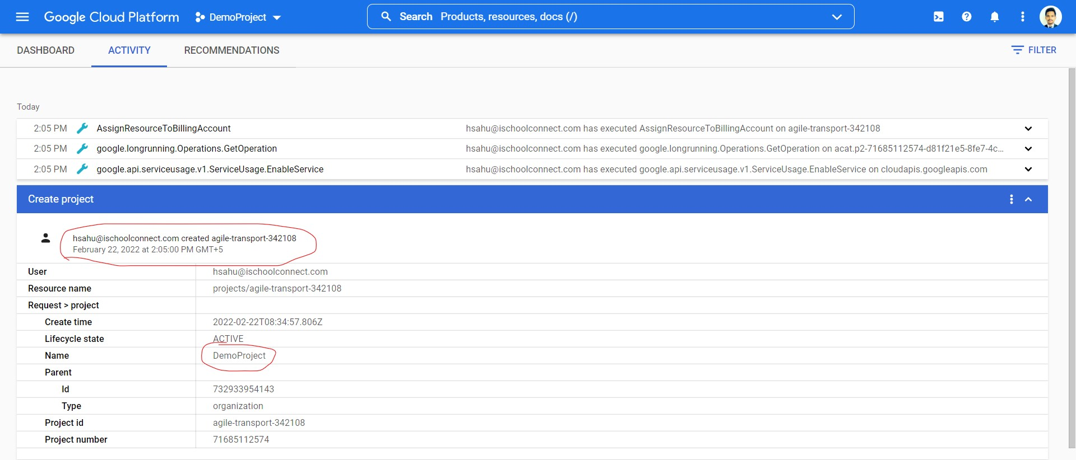

Getting start with the cloud shell and executing some commands:

$gcloud init

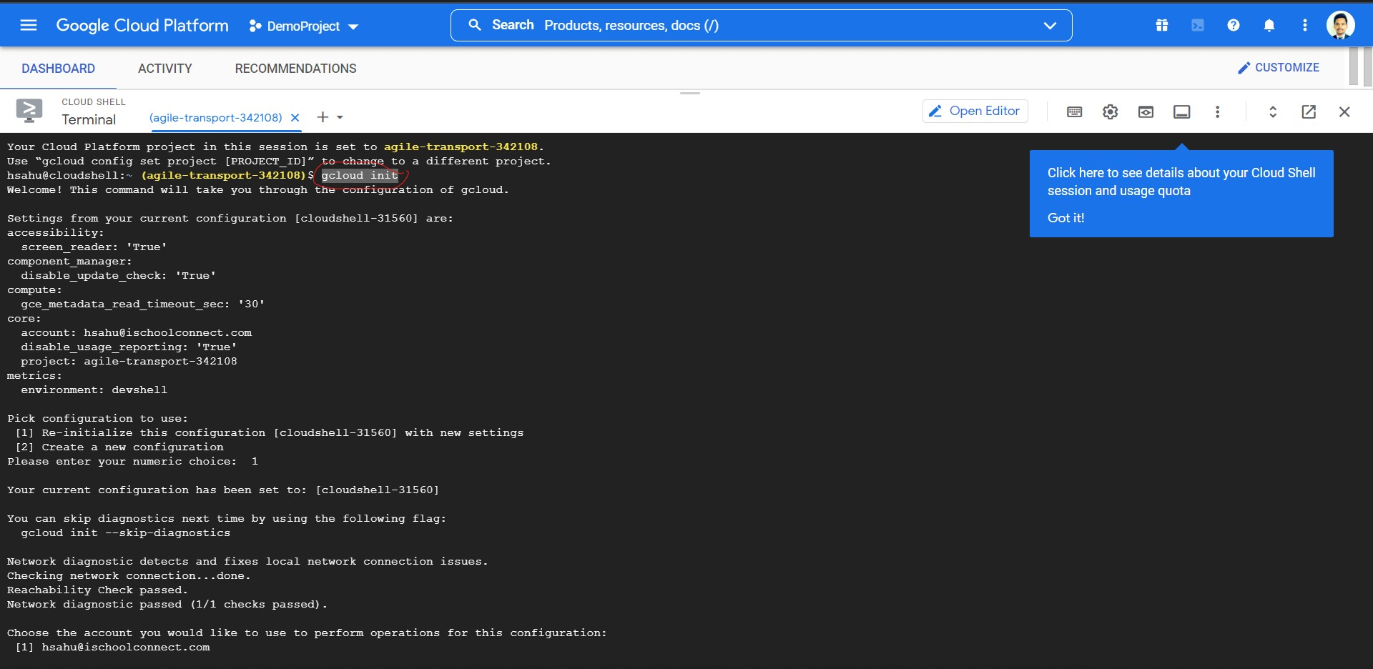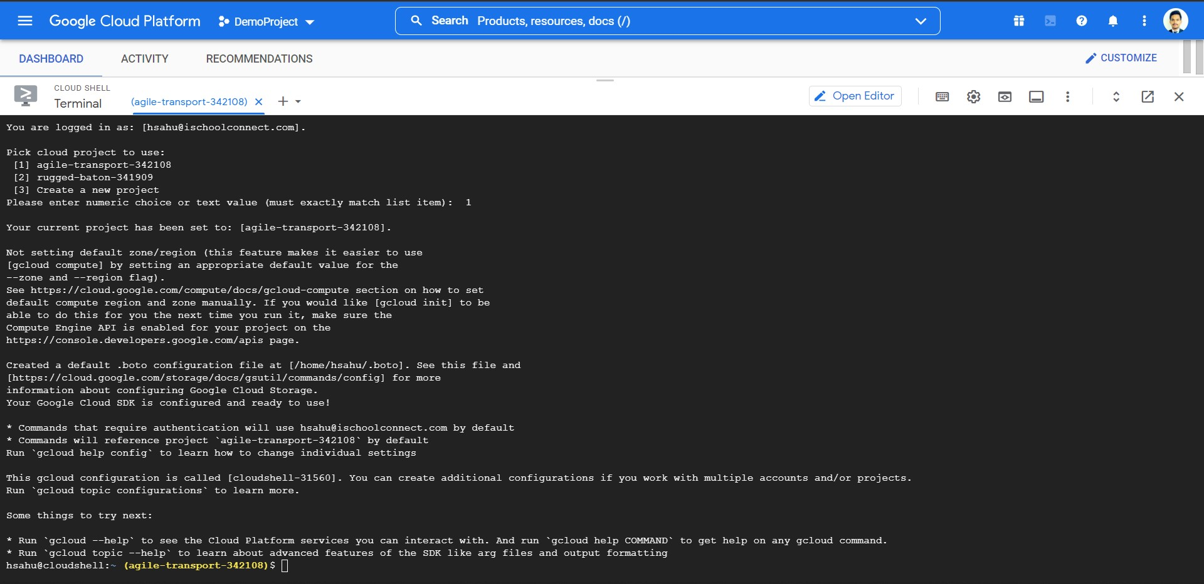

$gcloud version

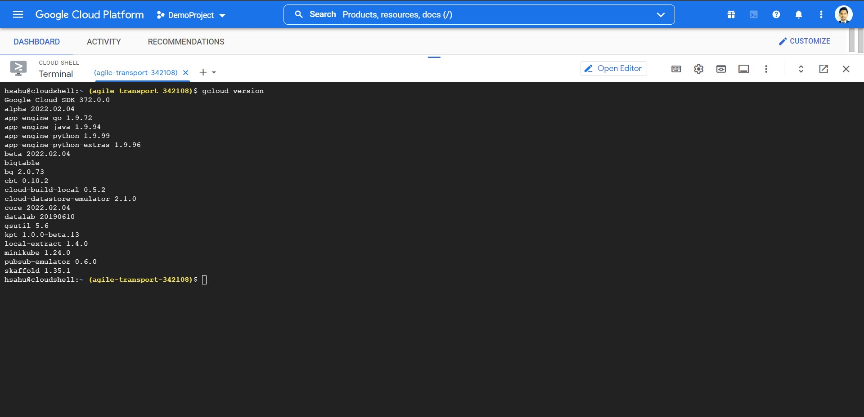

$gcloud info

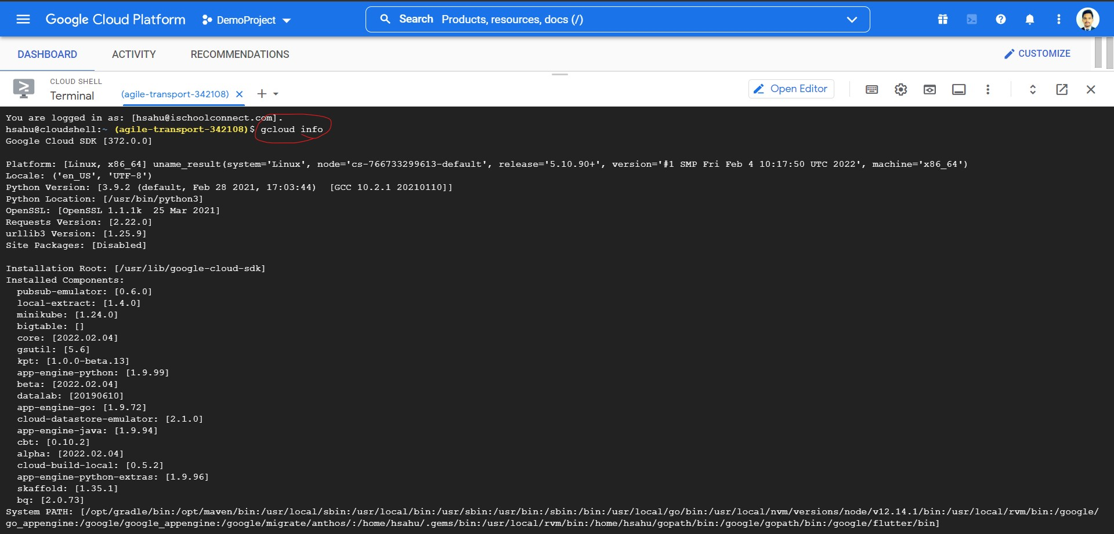

$gcloud auth login

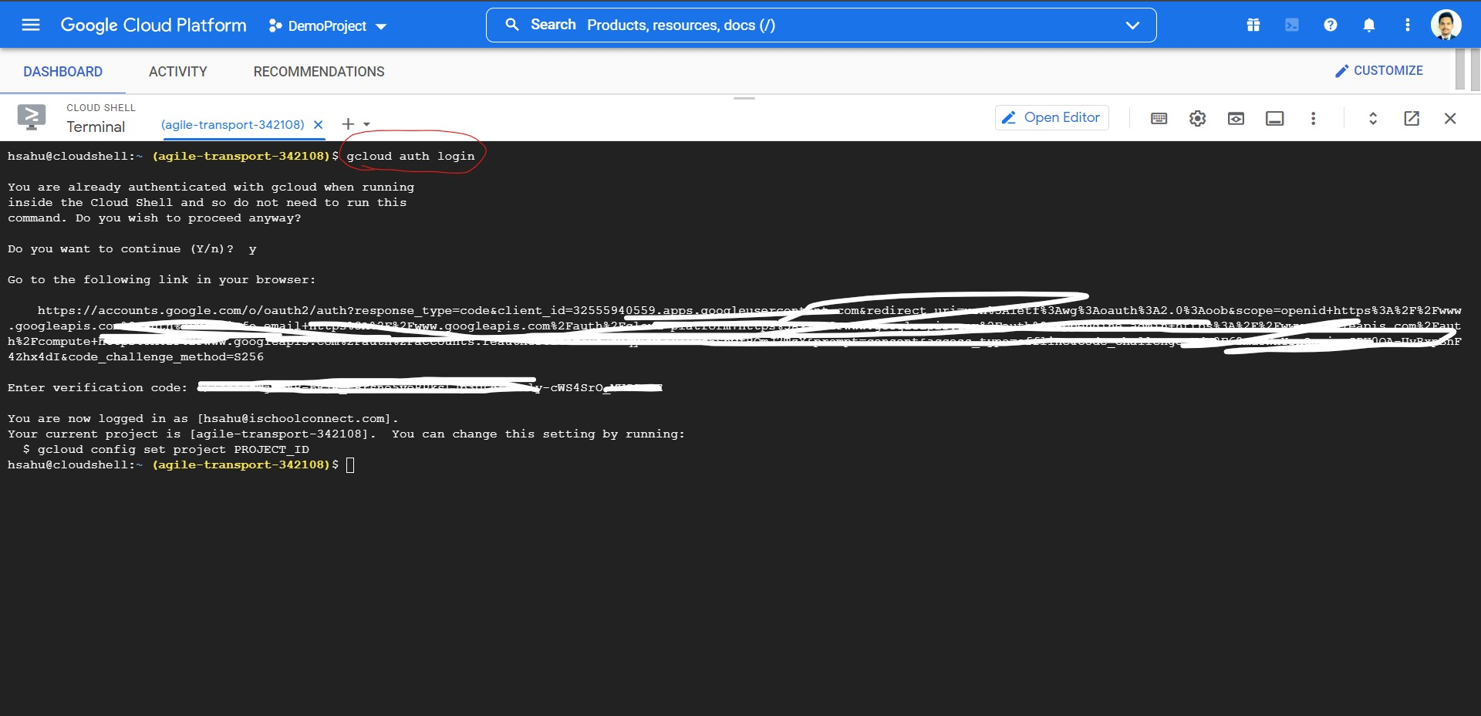

So finally I have installed CLOUD SDK in my local PC and now we try to authanticate and use cloud sdk $gcloud init

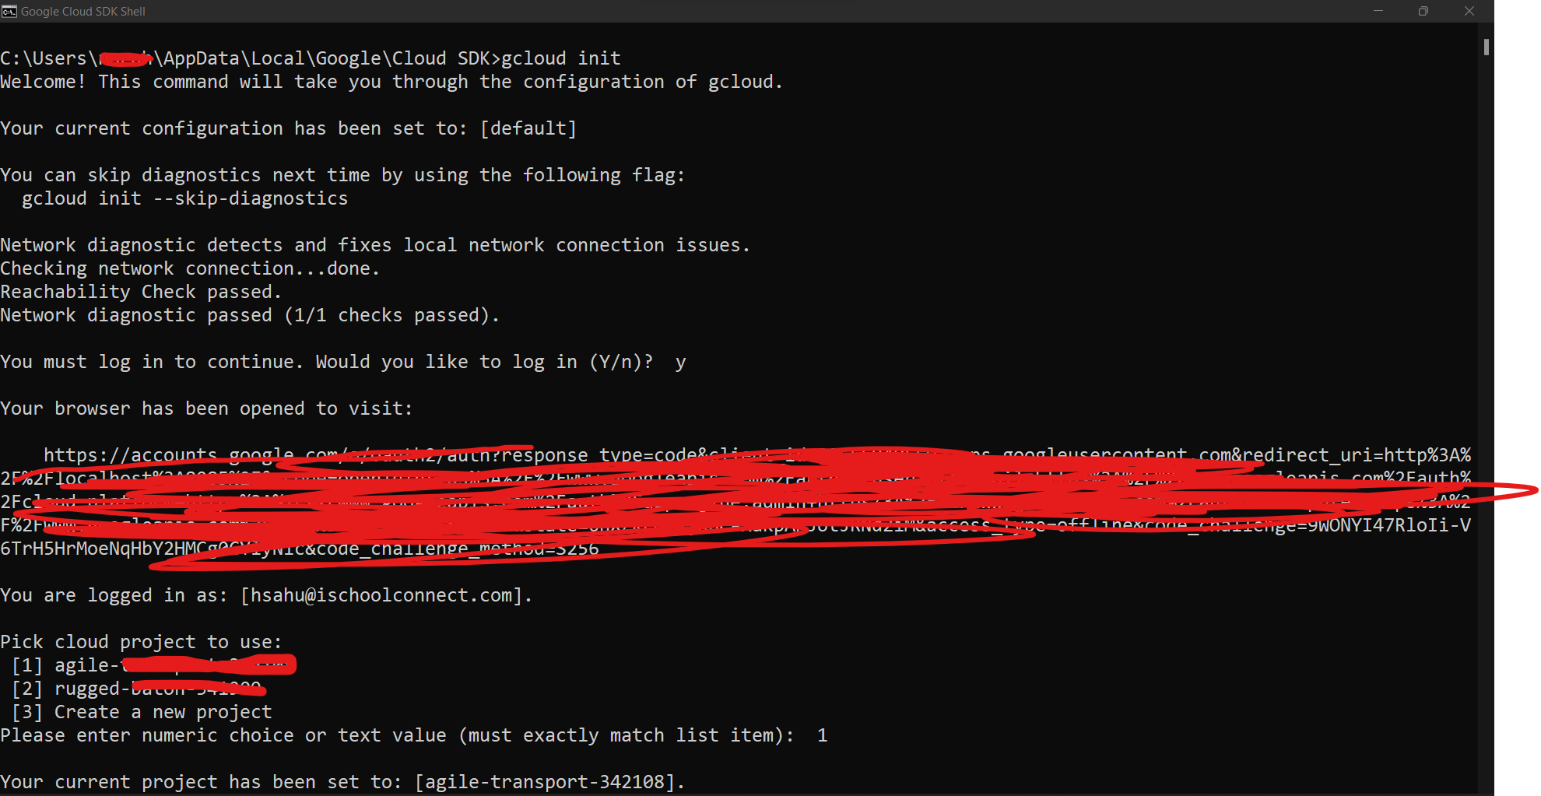

PTO