1. Delete all VPC networks, delete all fire walls, create a Virtual Machine, tell what happens?

So, lets login to our google cloud platform and look for default VPC and Firewall and delete them.

First choose VPC Network from the menu and same for Firewalls.

Note: - if you are first time visiting VPC Network and VPC section then you should enable Compute Engine API.

Then we have list of VPC that exist and as we have new account then there should a default VPC exist

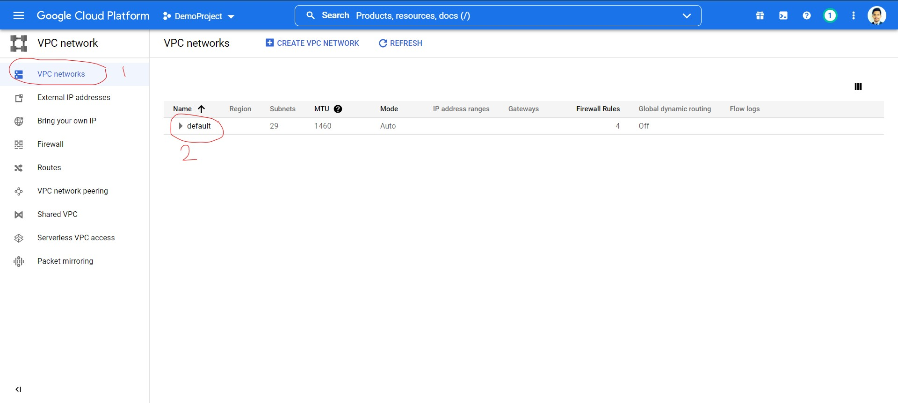

Then we must select the Default VPC and need to delete it according to our TASK

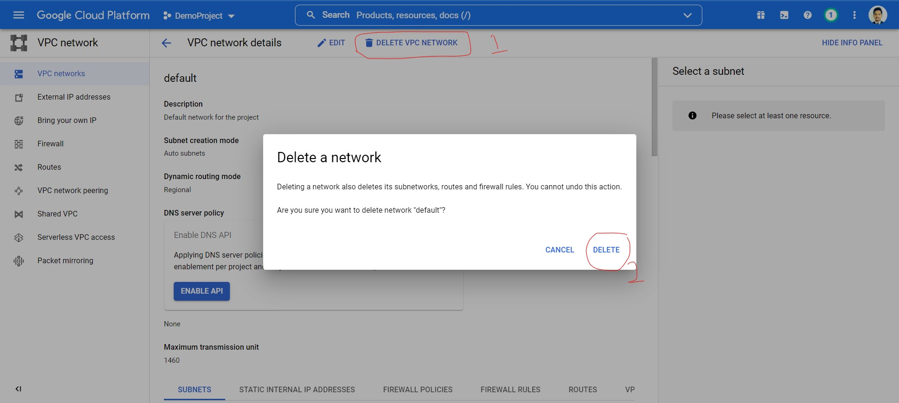

As we see all the VPC is deleted

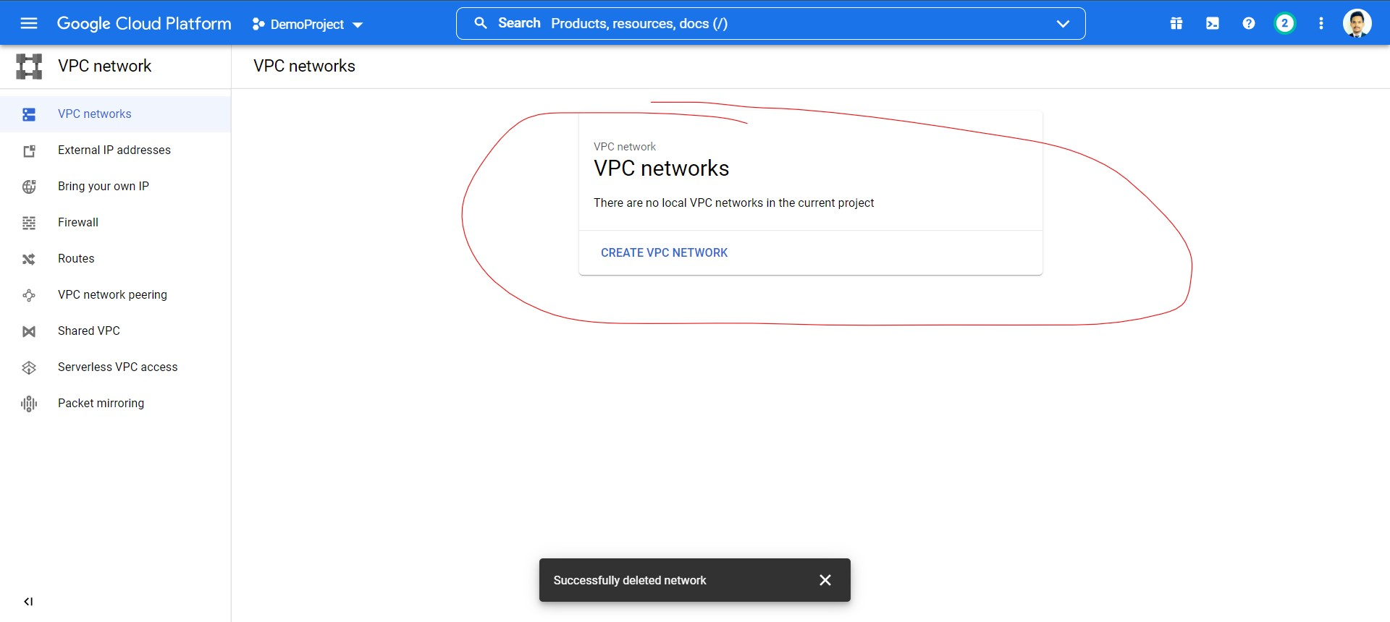

Now we move to repeat same things for the firewall and delete the existing or default firewall rule

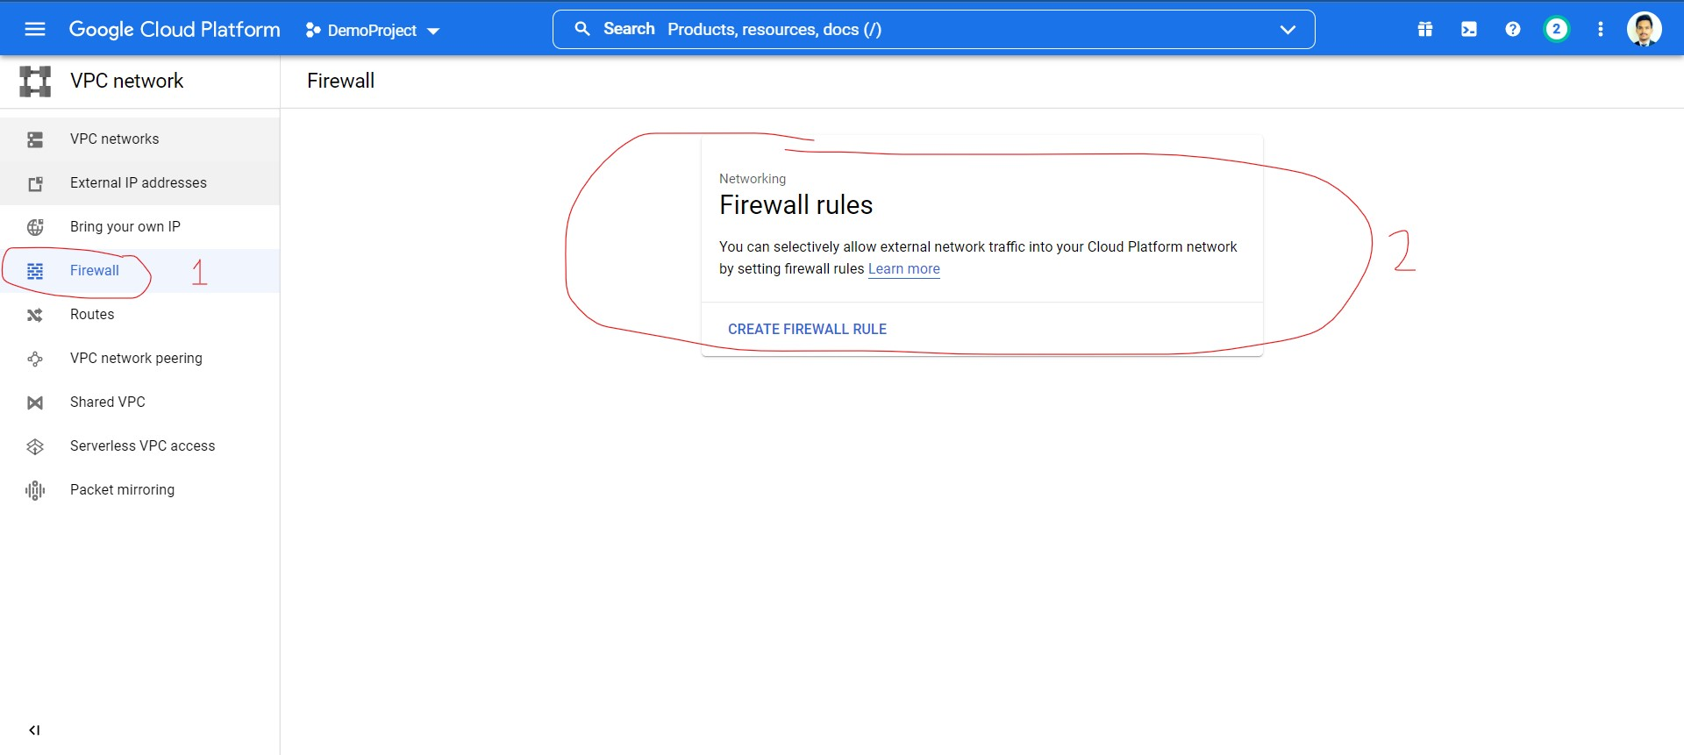

Now we have to move to Compute engine through Menu and need to create virtual machine and have to look is we are able to create the virtual machine or not so lets go-

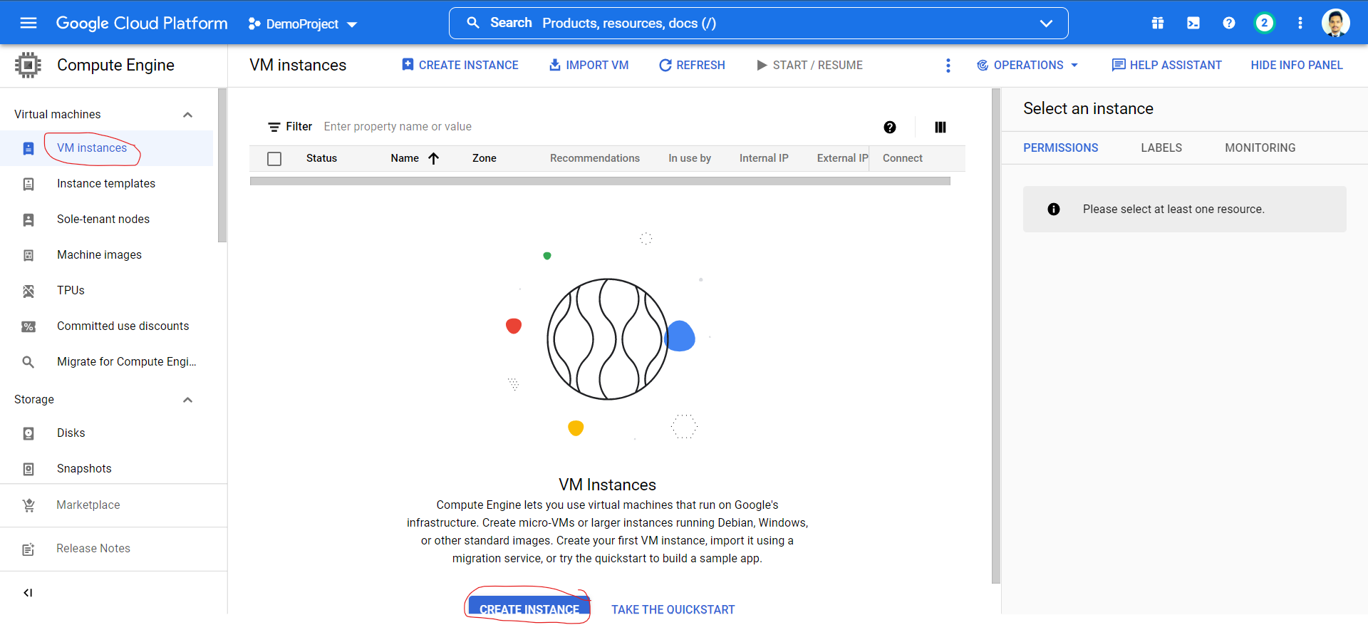

And now start to create a virtual machine with some default configuration-

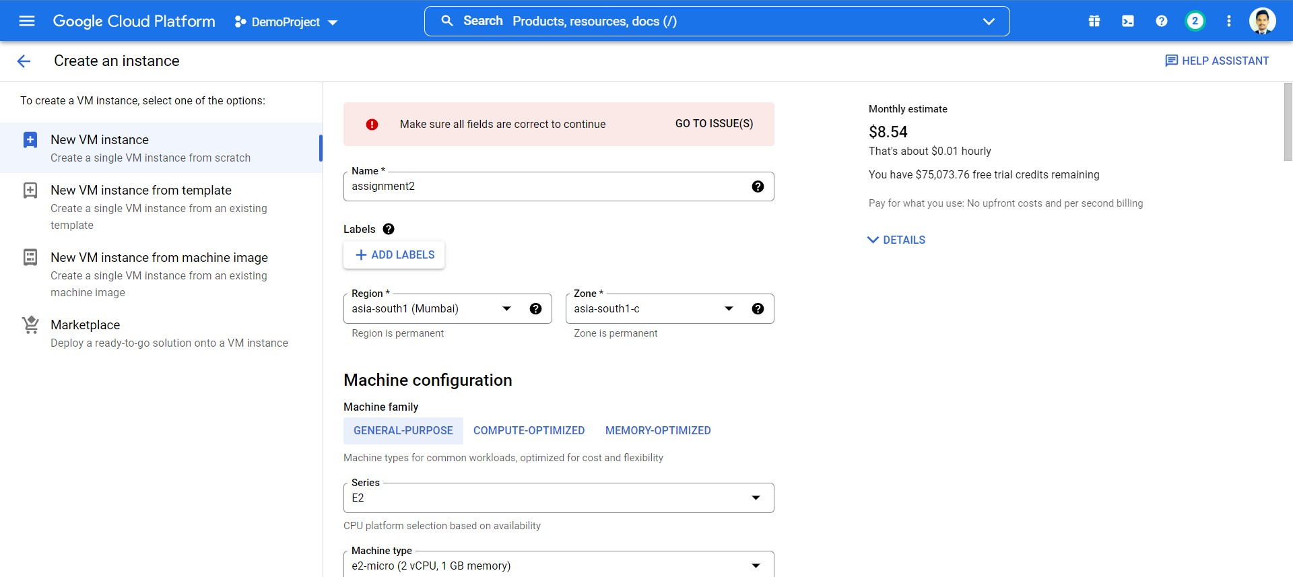

as aspect we are getting an error due to unbeatability of network and subnetwork field that is required to run a vm and accessible.

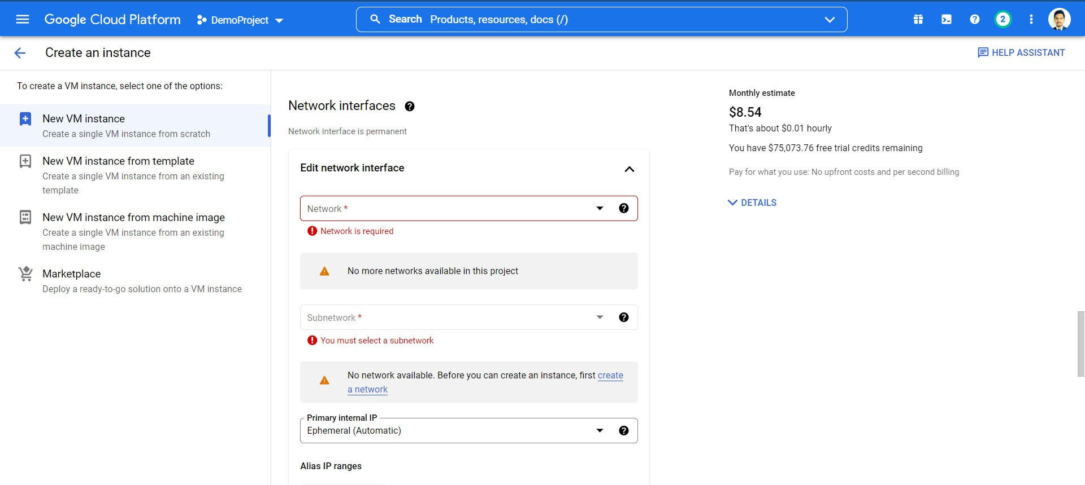

And this is because we have delete a defule VPC that is responsible to provide Netword and subnetwork details.

Remidation – to solve given problem we need to create a virtual private cloud with default or spacific confrigution. It is not necessary to add firewall rules to it because firewall rules is only for the security perpose.