1. Create scenario according to the diagram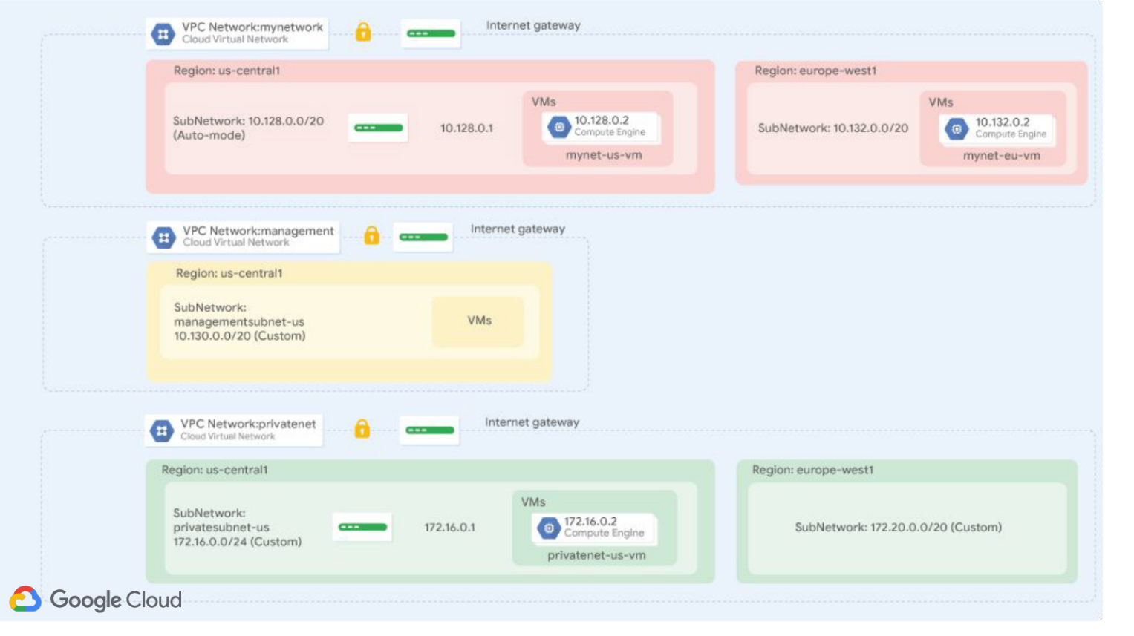

So, let’s get started with creating 1st and 2nd VPC and name of VPC is “mynetwork” and “networkmanagement” respectively.

So I just create 2 VPC with some default confrigations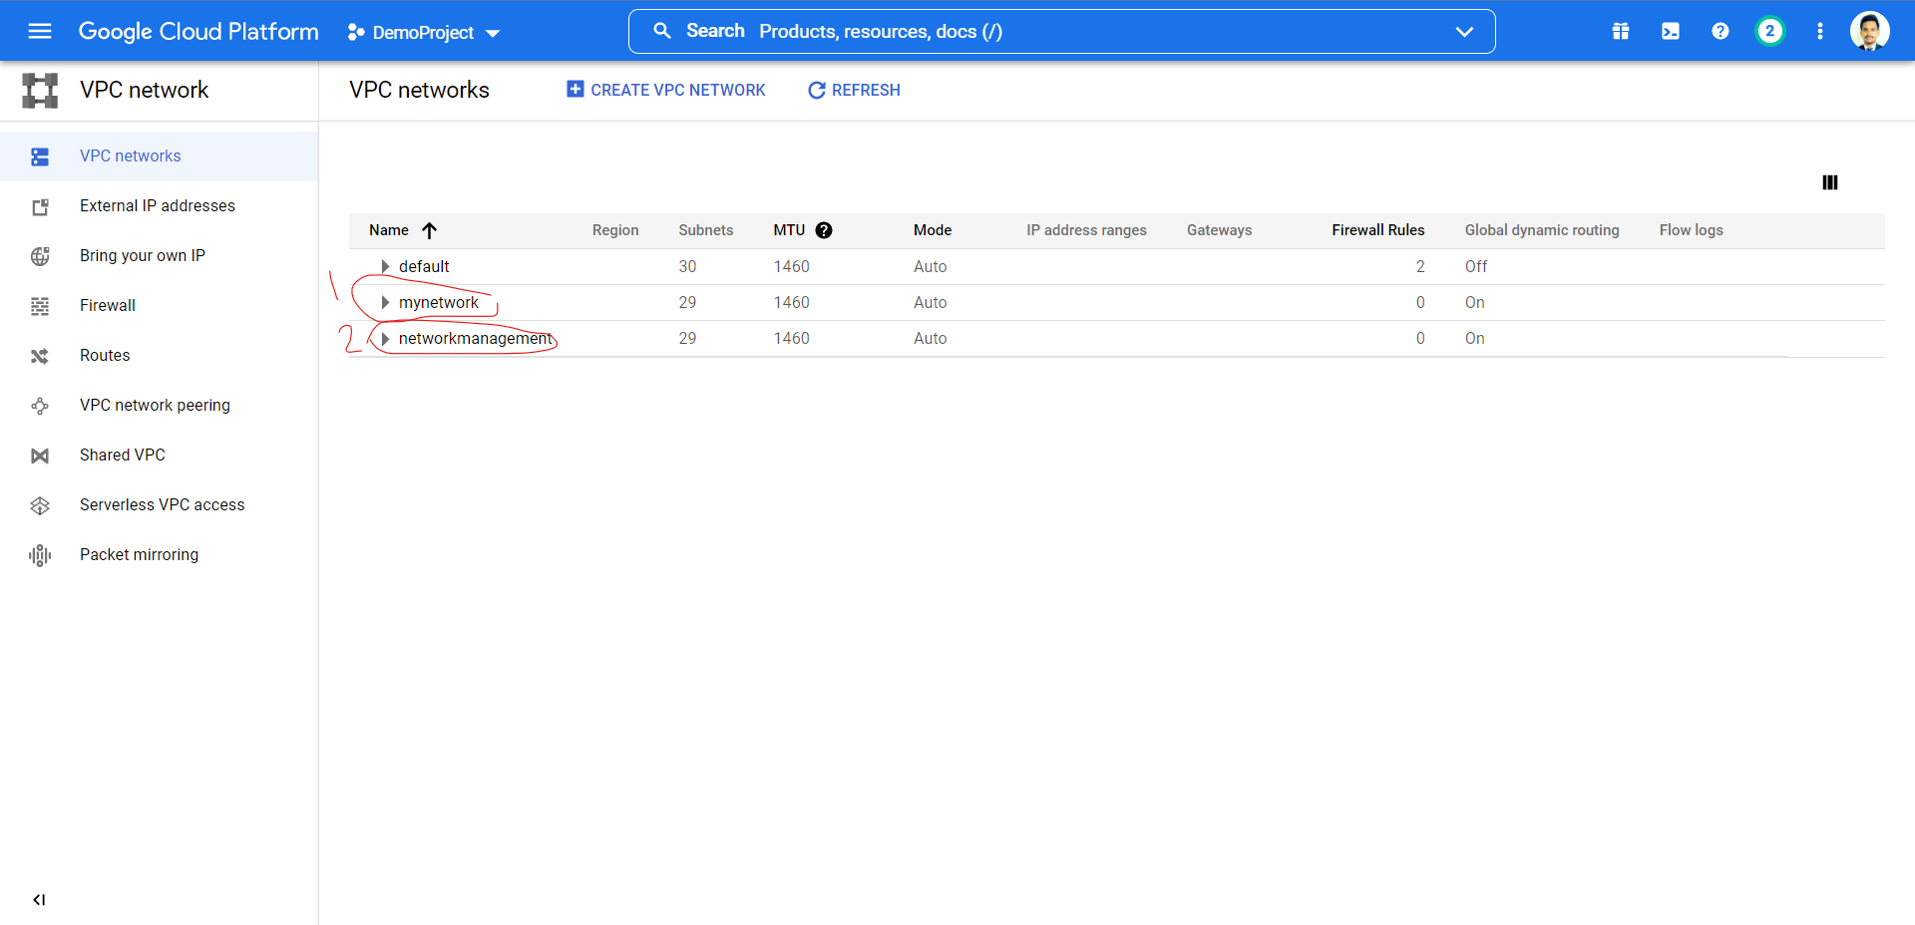

Now time to go to compute engine and create 2 VM instances for “mynetwork” VPC and 1 VM instance for “networkmanagement” VPC and we can select particular VPC in networking Configuration. So, lets do for “mynetwork” first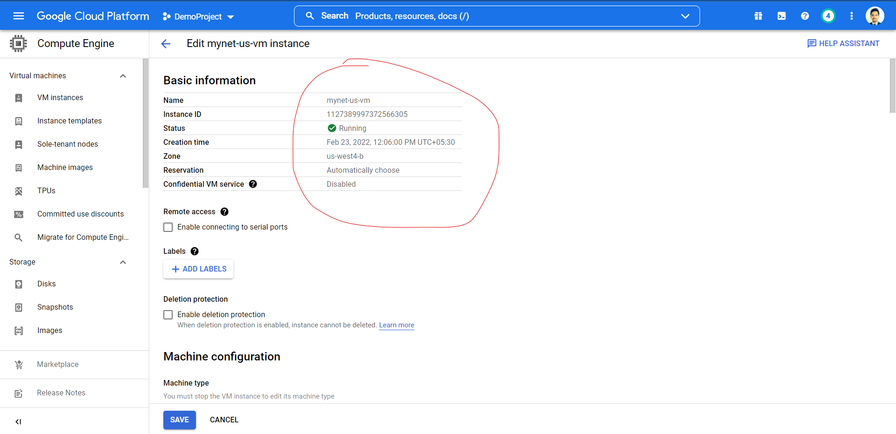

Similarly, we do for 2nd VM on same network that is “mynetwork”. Finally we have both VM in “mynetwork” is UP and RUNNING. 

