**Auth Rest**

**POST /auth/login**

• **Positive Scenarios:**

* Login with valid credentials (email and password).

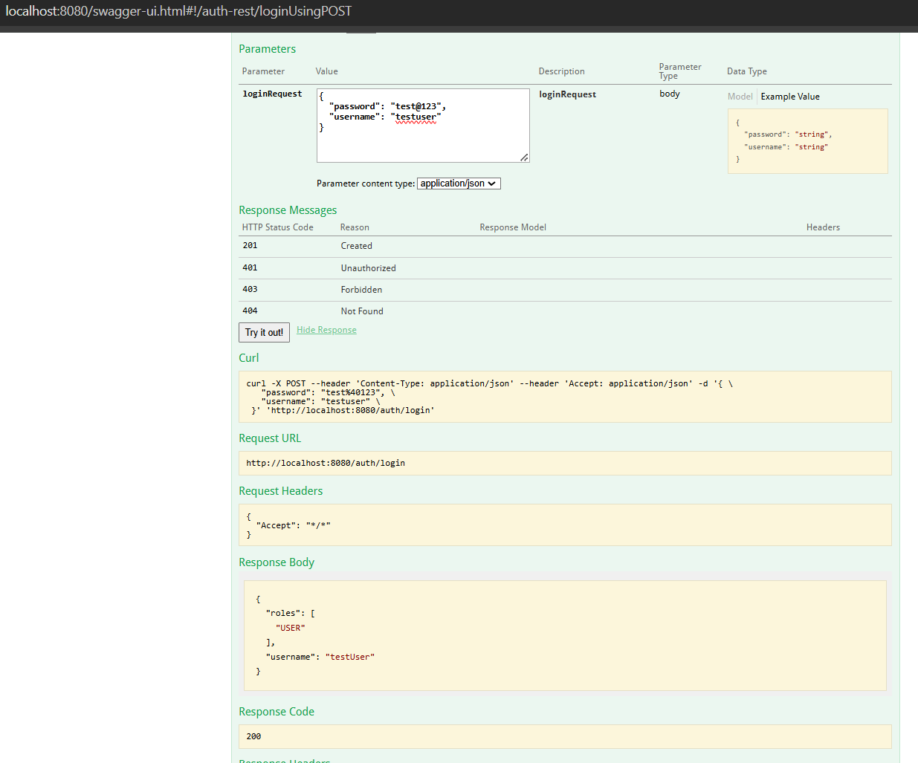

* Login with valid admin credentials.

• **Negative Scenarios:**

* Login with an invalid password.

**Car Rest**

**POST /car**

* **Positive Scenarios:**
  + Create a car with valid data for all fields.

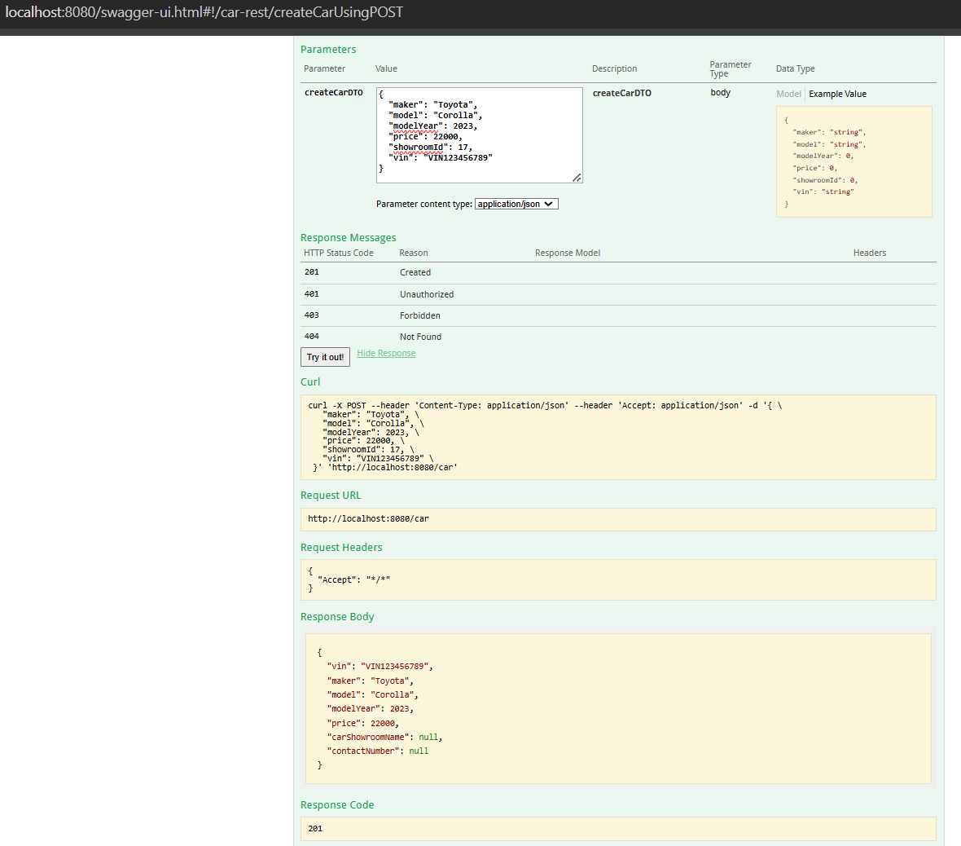

* **Negative Scenarios:**
  + Attempt to create a car with duplicate VIN.

* + Attempt to create a car with missing required fields (e.g., VIN, maker).

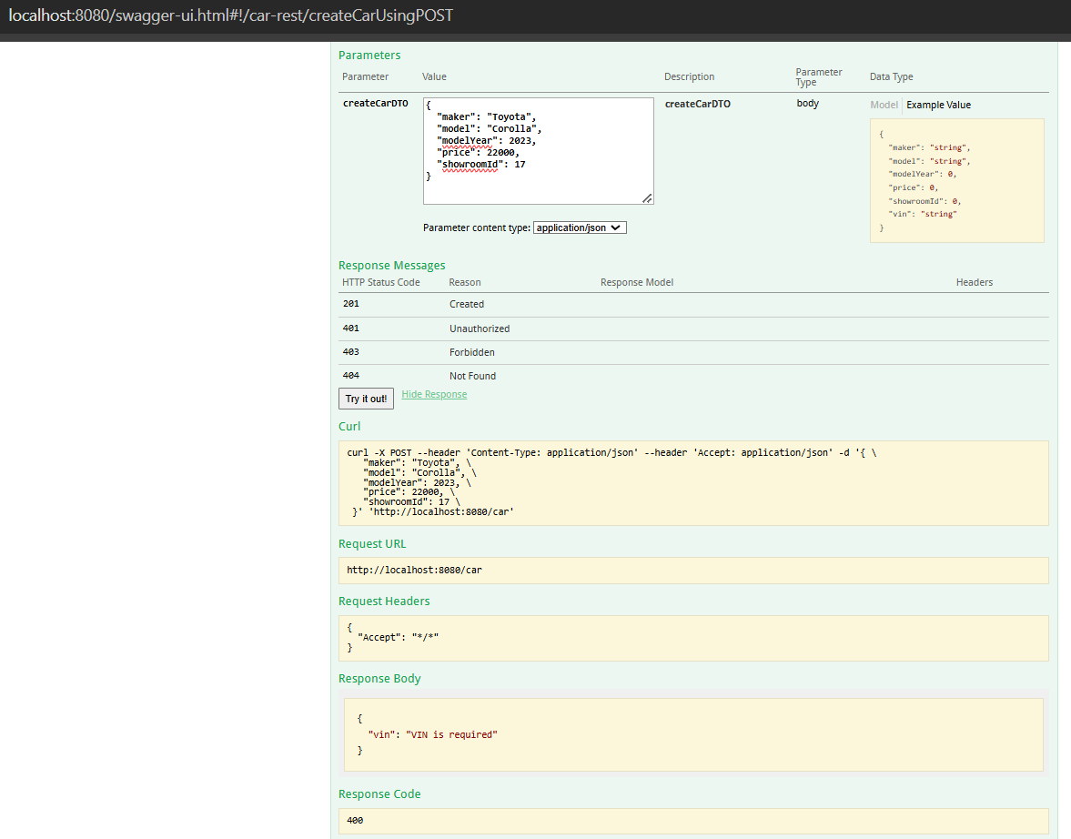

* + Attempt to create a car with an invalid price (e.g., negative value).

**GET /car/cars**

* **Positive Scenarios:**
  + Retrieve all cars

* + Retrieve paginated data with valid page and size parameters.

* **Negative Scenarios:**
  + Provide invalid pagination parameters (e.g., negative page/size).

**GET /car/showroom-cars**

* **Positive Scenarios:**
  + Retrieve cars for a specific showroom by showroom ID.

* + Use valid filters (e.g., maker, model, year).

* **Negative Scenarios:**
  + Retrieve cars for a non-existent showroom ID.

* + Provide invalid filter parameters (e.g., invalid maker name).

**Car Showroom Rest**

**POST /car-showrooms**

* **Positive Scenarios:**
  + Create a showroom with valid data for all fields.

* + Create a showroom with optional fields left blank.

* **Negative Scenarios:**
* Attempt to create a showroom with a duplicate commercial_registration_number.  
  A screenshot of a computer

  Description automatically generated
* Attempt to create a showroom with missing required fields (e.g., name, contact number).  
  A screenshot of a computer

  Description automatically generated
  + Attempt to create a showroom with invalid data (e.g., too long name).

**GET /car-showrooms/all**

* **Positive Scenarios:**
  + Retrieve all showrooms

* + Retrieve paginated showrooms with valid page and size parameters.

* + Use valid search queries.

* **Negative Scenarios:**
  + Provide invalid pagination parameters (e.g., negative page/size).

**DELETE /car-showrooms/{id}**

* **Positive Scenarios:**
  + Delete an existing showroom by valid ID.

* **Negative Scenarios:**
  + Attempt to delete a non-existent showroom.

**GET /car-showrooms/{id}**

* **Positive Scenarios:**
  + Retrieve details of an existing showroom by valid ID.

* **Negative Scenarios:**
  + Attempt to retrieve details of a non-existent showroom.

* + Try to access a deleted showroom

**PUT /car-showrooms/{id}**

* **Positive Scenarios:**
  + Update an existing showroom with valid data.

* **Negative Scenarios:**
  + Attempt to update a non-existent showroom.

