**EXPERIMENT -02**

**AIM- Installation of Kali Linux**

Kali is an operating system based on Debian that is used by security experts called penetration testers to test the security of hardened systems. Kali comes with an extensive list of tools that you can use to test how secure your server is, ranging from testing anti-virus software to social engineering attacks and malware. This operating system is for intermediate to advance users and while it does come with the Gnome Desktop Environment, most of its features will require you to be proficient in the use of the terminal. Don’t let that scare you, the terminal is often easier and quicker than graphical user interfaces.

**Let’s get started; Install Kali Linux 2021.1:**

**Step 1: Create a USB installer**

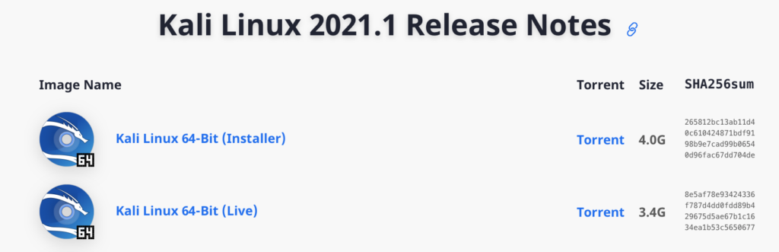

First thing is first, you are going to need to boot into a USB installer to start the installation process. This involves two parts; first, download a copy of Kali Linux 2021.1 from their [Official Website](https://www.kali.org/downloads/). There are two versions of the ISO, one is an installer, the other is for the live version of kali. Choose the one labelled installer.

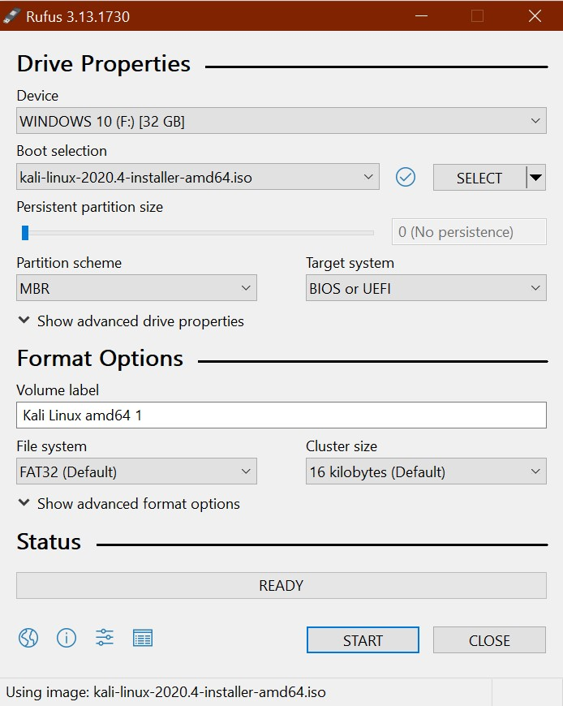

Then download [Rufus](https://rufus.ie/) which is the tool you will need to create your USB installer with a few simple clicks. [Click here](https://github.com/pbatard/rufus/releases/download/v3.13/rufus-3.13.exe) to download version 3.13 of Rufus or go to [Rufus.ie](https://rufus.ie/) and download the latest version.

***Step 2: Boot to the USB drive***

Make sure your recently created USB installer is plugged into the computer you would like to install Kali Linux 2021.1 into then power it on and as it boots continuously tap either the F10 or F12 (depends on your computer) function key on your keyboard to enter the boot menu then choose your USB drive to boot into.

***Step 3: Start the installation***

The Kali USB installer unlike many Linux distro’s does not come with a version of the operating system already installed on the USB drive called “live USB”. If you would like to run Kali as a live USB you will need to create a bootable USB from the live ISO available on the Kali Downloads page.

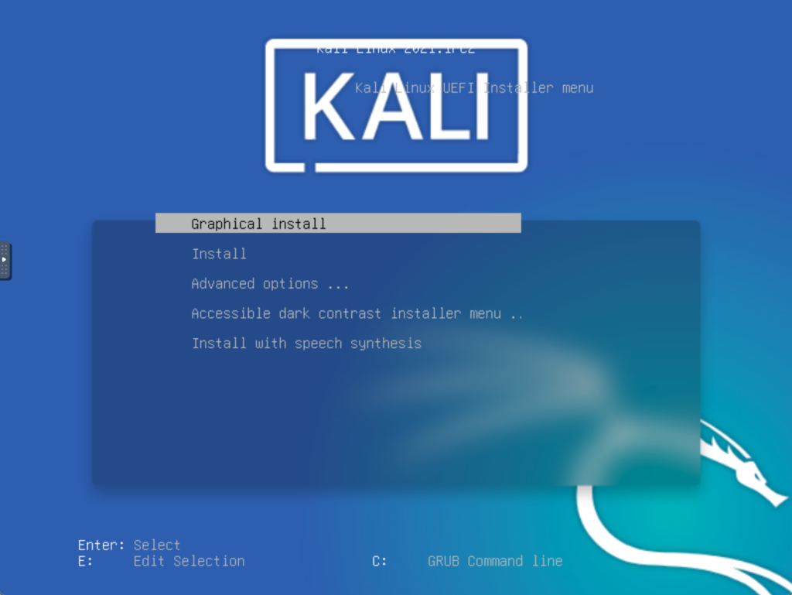

You can choose “Graphical install” to get started; If you run into any problems then select the regular “Install” option.

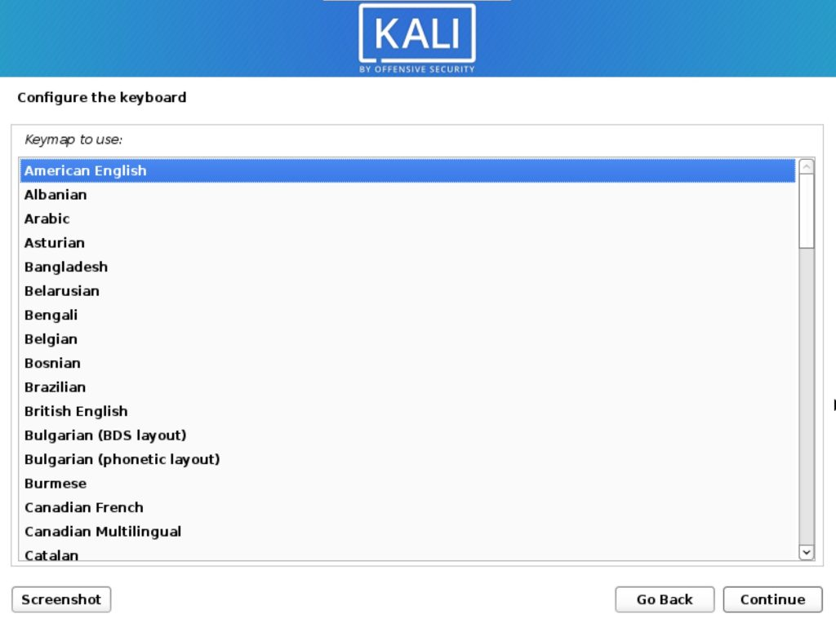

Next, pick your desired language and click continue. Then choose your location before you continue; then choose your keyboard layout and go through any other options you are prompted with.

***Step 4: Choose some options***

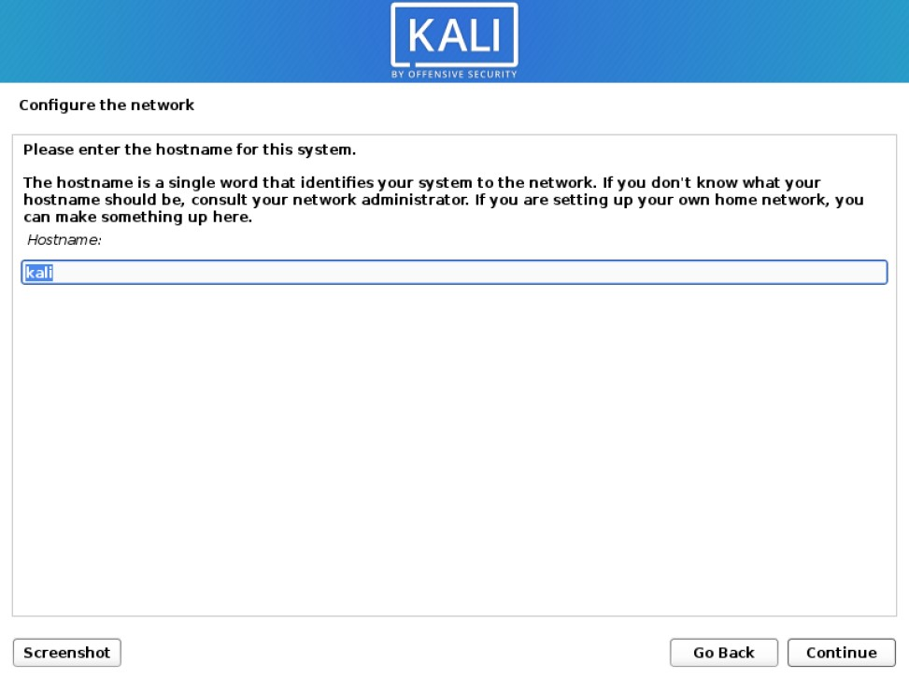

Enter your desired hostname then move on to the next option; a hostname is what identified your computer to the network you connect to.

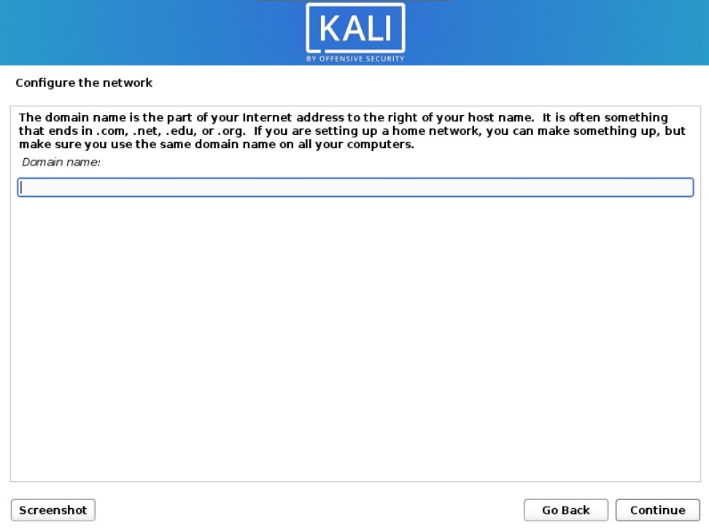

Enter a domain name here if you would like to or leave it blank if you do not have one;

Since Kali 2020.1 you are required to create a Non-Root user which will serve as the default user instead of the traditional root from versions of Kali prior to 2020.1. After installation, if you prefer to use Root you can activate it and set a password if that is the direction you would like to go.

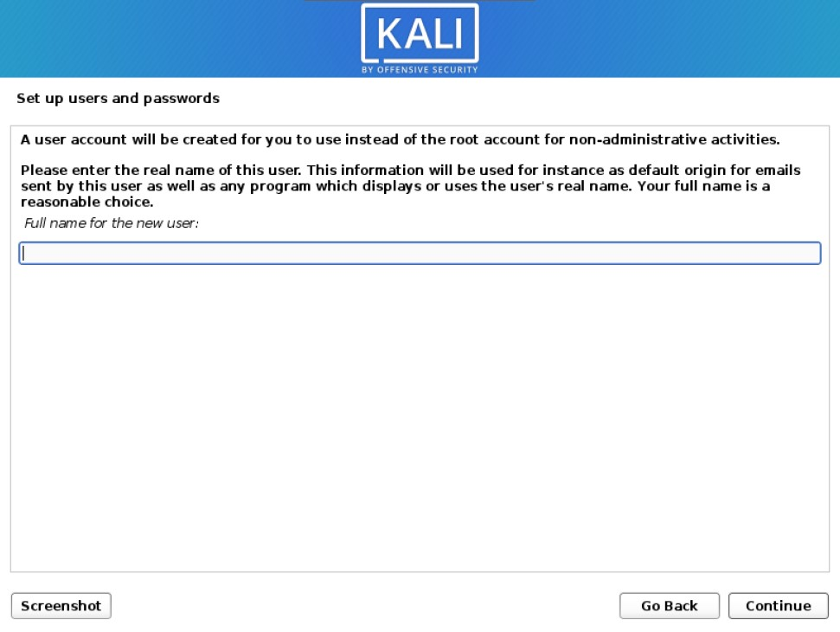

For now enter your desired name, followed by a username, and finally a password.

***Step 5: Partition the Drive***

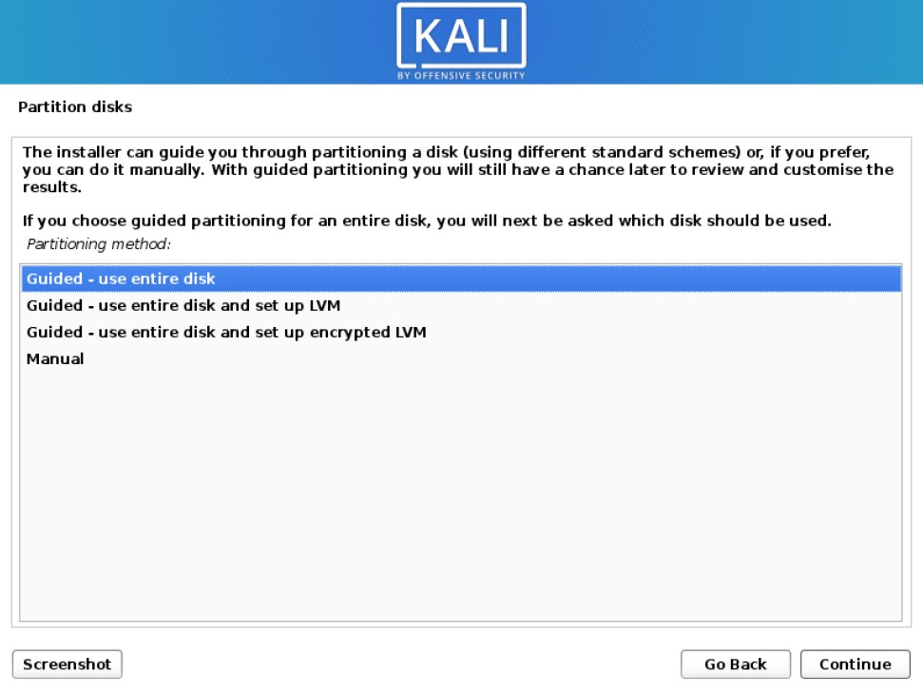

Here you may choose partition options and you may choose to enable and configure whole disk encryption or LVM (logical volume management) or customize your partitions to your own liking. For most people, the default options are probably going to be just fine. Click continue then follow the onscreen instructions to confirm the partition you have chosen.

***Step 6: Finalize the Installation***

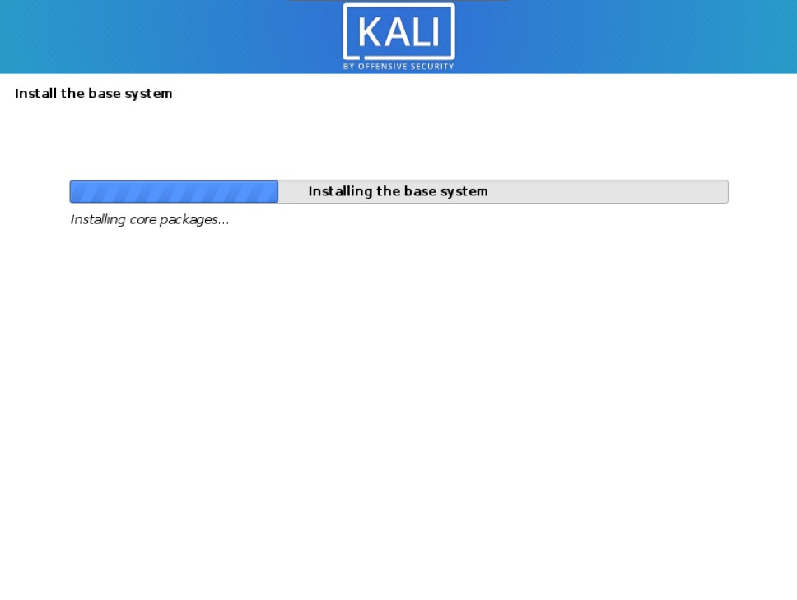

Your installation has begun now, note that this will take several minutes depending on how fast your system is.

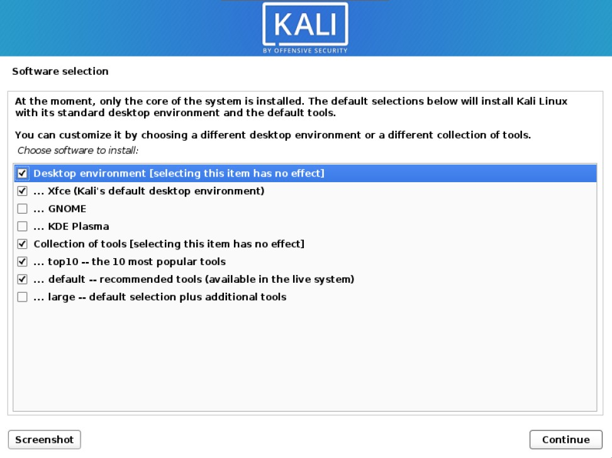

You will be prompted with some software options, which include desktop environments, and what tools you would like to install. Do note that you can install these tools later should you change your mind. Or find that you require more tools than you originally had chosen at installation. XFCE is Kali’s default desktop environment, but you can choose GNOME or KDE plasma if you prefer.

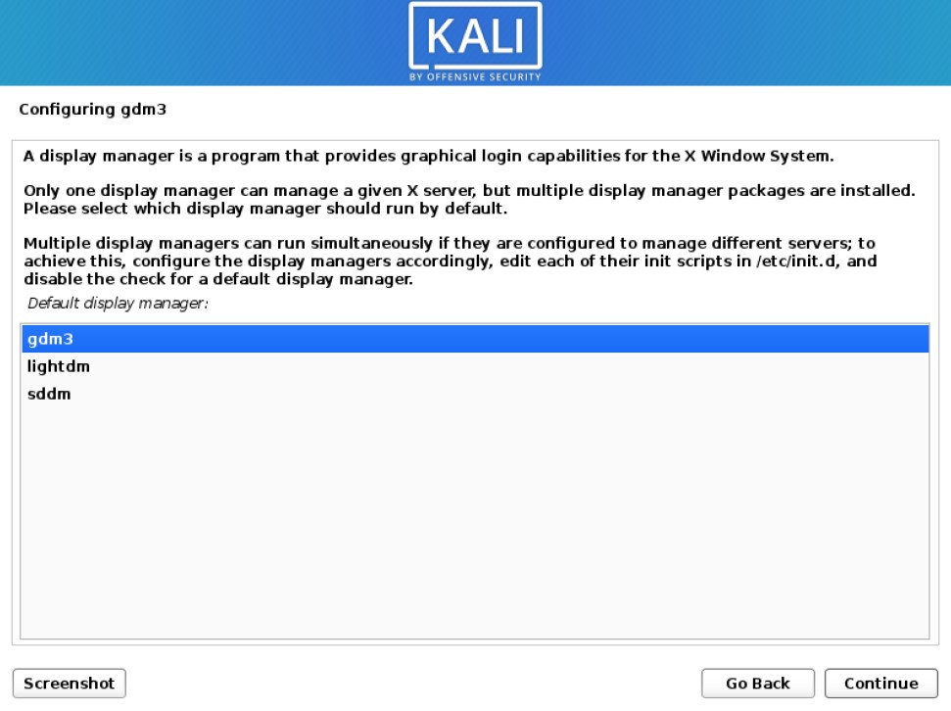

Shortly after you may be prompted to choose a display manager. This may occur if you have chosen to install more than one desktop environment. Select whichever display manager you like best and click continue.

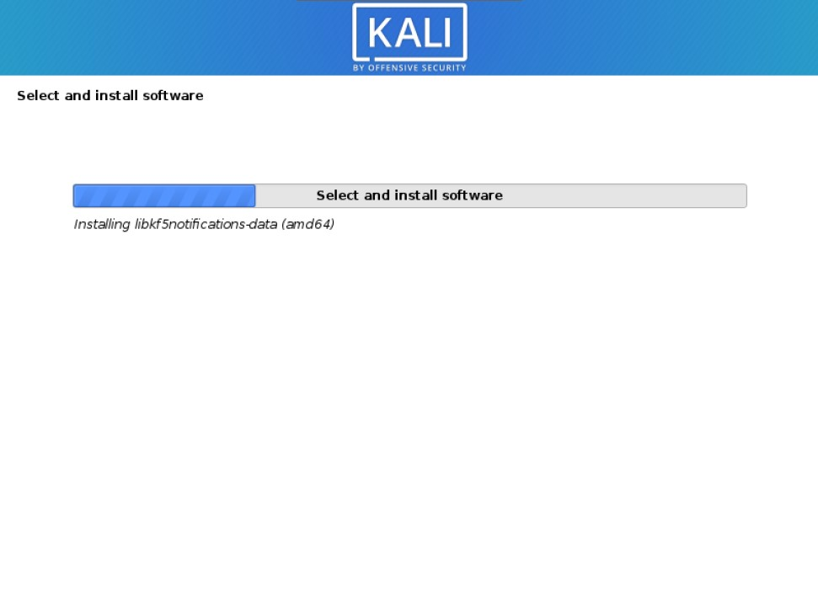

The installation will then continue; this should take a few more minutes depending on how fast your system is. When your installation is complete you will be prompted to restart your system. Click continue and in no time you will be greeted with a login prompt.

#### **Welcome to your Desktop;**

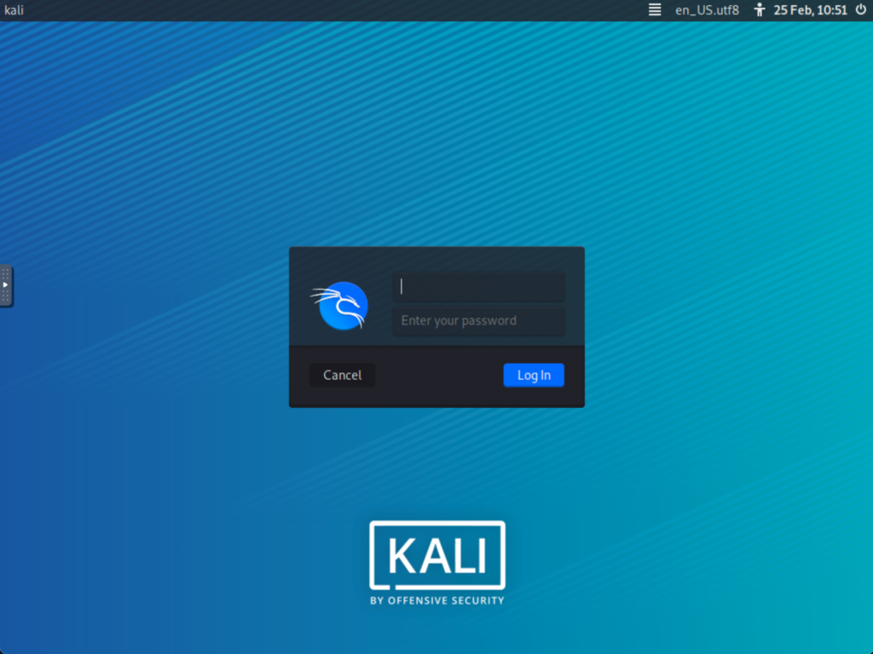

Your installation does not immediately boot up, it does require that you first key in a username and password. Use the username and password you set earlier during setup;

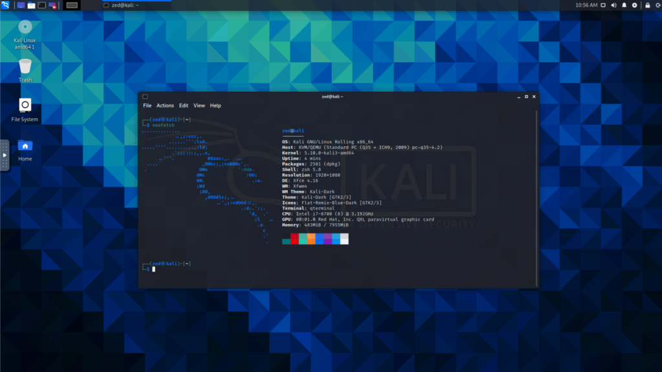

Now that you have installed Kali Linux you can log in. Next, you will be greeted by the desktop environment that you have chosen during installation.