2025

Project Graduation

Be Ready

Name : Reem Farghaly Mongy Amen Ahmed Ibrahim
Under supervisor: Mahmoud Rehan
Year:2025

1.Splash Screen

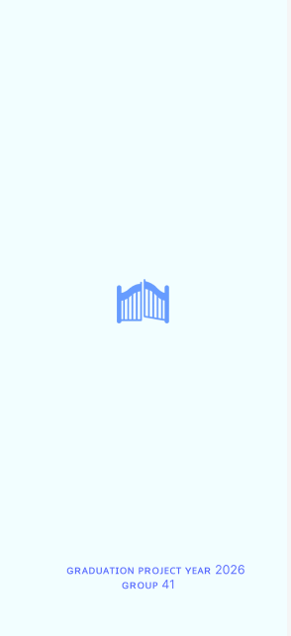

File : native_splash.yaml :-

flutter_native_splash:
color: "#F2FEFF"
image: assets/image/gate.png
fullscreen: true

android_12:
color: "#F2FEFF"
image: assets/image/gate.png
branding: assets/image/branding (1).png

file:pubspec.yaml:-
dependencies:
flutter:
sdk: flutter
flutter_native_splash: ^2.4.7

2.Intro Screen:-

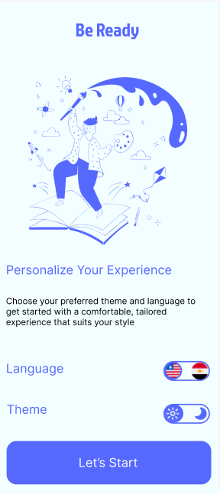

file:pubspec.yaml:-
dependencies:
flutter:
sdk: flutter
provider: ^6.1.5+1
animated_toggle_switch: ^0.8.5
icons_plus: ^5.0.0
shared_preferences: ^2.5.3
flutter_localizations:
sdk: flutter
intl: any
File : Intro :-
import 'package:be_ready/core/flag_switch.dart';
import 'package:be_ready/design/AppColor.dart';
import 'package:be_ready/design/AppImage.dart';
import 'package:be_ready/l10n/app_localizations.dart';
import 'package:be_ready/routes.dart';
import 'package:flutter/material.dart';
import '../../core/Theme_switch.dart';
class Intro extends StatelessWidget {
const Intro({super.key});

@override
Widget build(BuildContext context) {
return Scaffold(
appBar: AppBar(title: const Text("Be Ready")),
body: Container(
padding: EdgeInsets.all(16),
child: Column(
crossAxisAlignment: CrossAxisAlignment.stretch,
children: [
Image.asset(AppImage.theme),
SizedBox(height: 30),
Text(
AppLocalizations.of(context)!.intro_screen_tittel,
style: Theme.of(context).textTheme.bodyMedium,
),
SizedBox(height: 30),
Text(
AppLocalizations.of(context)!.intro_screen_suptittel,
style: Theme.of(context).textTheme.bodySmall,
),
SizedBox(height: 20),
Row(
mainAxisAlignment: MainAxisAlignment.spaceBetween,
children: [
Text(
AppLocalizations.of(context)!.language,
style: Theme.of(context)
.textTheme
.bodyMedium
?.copyWith(fontWeight: FontWeight.w500),
),
LanguageSwitcher(),
],
),
SizedBox(height: 20),
Row(
mainAxisAlignment: MainAxisAlignment.spaceBetween,
children: [
Text(
AppLocalizations.of(context)!.theme,
style: Theme.of(context)
.textTheme
.bodyMedium
?.copyWith(fontWeight: FontWeight.w500),
),
ThemeSwitcher(),
],
),
SizedBox(height: 30),
ElevatedButton(
onPressed: () {
Navigator.pushReplacementNamed(
context,
AppRoutes.onBoardingScreen.name,
);
},
child: Text(
AppLocalizations.of(context)!.letsStart,
style: Theme.of(context)
.textTheme
.bodyMedium!
.copyWith(color: AppColor.white),
),
),
],
),
),
);
}
}

file : languageSwitcher :-
import 'package:animated_toggle_switch/animated_toggle_switch.dart';
import 'package:be_ready/Provider/languageProvider.dart';
import 'package:be_ready/design/AppColor.dart';
import 'package:flutter/material.dart';
import 'package:icons_plus/icons_plus.dart';
import 'package:provider/provider.dart';

class LanguageSwitcher extends StatefulWidget {
@override
State<LanguageSwitcher> createState() => _LanguageSwitcherState();
}

class _LanguageSwitcherState extends State<LanguageSwitcher> {
@override
Widget build(BuildContext context) {
LanguageProvider languageProvider = Provider.of<LanguageProvider>(context);

return AnimatedToggleSwitch<Locale>.rolling(
current: languageProvider.getSelectedLocale(),
values: languageProvider.getSupportedLocales(),
onChanged: (item) {
setState(() {
languageProvider.changeLocale(item);
});
},
iconBuilder: (value, foreground) {
if (value == Locale('en')) {
return Flag(
Flags.united_states_of_america,
size: 24,
);
} else {
return Flag(
Flags.egypt,
size: 24,
);
}
},
style: ToggleStyle(
indicatorColor: AppColor.royalBlue,
backgroundColor: Colors.transparent,
borderColor: AppColor.royalBlue,
),
);
}
}

file : languageProvider:-
import 'package:be_ready/cach/appSharedPreferences.dart';
import 'package:flutter/cupertino.dart';
import 'package:flutter/material.dart';

class LanguageProvider extends ChangeNotifier {
Locale _locale = Locale("en");
get getLanguage => _locale;

set setLanguage(Locale mode) { _locale = mode;
notifyListeners();
}
bool get isArabic => (_locale == Locale("ar"));

AppSharedPreferences appSettingsPreferences = AppSharedPreferences.getInstance();
LanguageProvider() {
_locale = appSettingsPreferences.getCurrentLocale();
}
List<Locale> getSupportedLocales() {
return [
Locale("en"),
Locale("ar"),
];
}
Locale getSelectedLocale() {
return _locale;
}
void changeLocale(Locale newLang) {
_locale = newLang;
appSettingsPreferences.saveLocale(_locale);
notifyListeners();
}
}
file:ShierdPrefrences:-
import 'package:flutter/material.dart';
import 'package:shared_preferences/shared_preferences.dart';

class AppSharedPreferences {
static late SharedPreferences _sharedPreferences;
static const themeKey = "theme";
static const light = "light";
static const dark = "dark";

AppSharedPreferences._();

static AppSharedPreferences? _app_shared_preferences = null;
static Future<void> init() async {
if (_app_shared_preferences == null) {
_app_shared_preferences = AppSharedPreferences._();
await _app_shared_preferences?._initSharedPreferences();
}
}
Future<void> saveTheme(ThemeMode mode) async {
var ThemeName = mode == ThemeMode.light ? light : dark;
await _sharedPreferences.setString(themeKey, ThemeName);
}
ThemeMode getCurrentTheme() {
var ThemeName = _sharedPreferences.getString(themeKey);
return ThemeName == dark ? ThemeMode.dark : ThemeMode.light;
}

static AppSharedPreferences getInstance() {
if (_app_shared_preferences == null) {
throw Exception(
"make sure you call init before using getInstance",
);
}
return _app_shared_preferences!;
}
Future<void> _initSharedPreferences() async {
_sharedPreferences = await SharedPreferences.getInstance();
}
Future<void> saveLocale(Locale locale) async {
await _sharedPreferences.setString("locale", locale.languageCode);
}
Locale getCurrentLocale() {
var langCode = _sharedPreferences.getString("locale");
return langCode == null ? Locale("en") : Locale.fromSubtags(languageCode:langCode);
}
}

file: ThemeSwitch:-
import 'package:animated_toggle_switch/animated_toggle_switch.dart';
import 'package:be_ready/Provider/ThemeProvider.dart';
import 'package:be_ready/design/AppColor.dart';
import 'package:flutter/material.dart';
import 'package:icons_plus/icons_plus.dart';
import 'package:provider/provider.dart';

class ThemeSwitcher extends StatefulWidget {
ThemeSwitcher();

@override
State<ThemeSwitcher> createState() => _ThemeSwitcherState();
}

class _ThemeSwitcherState extends State<ThemeSwitcher> {
@override
Widget build(BuildContext context) {
ThemeProvider provider = Provider.of<ThemeProvider>(context);

return SizedBox(
width: 80,
height: 40,
child: AnimatedToggleSwitch<ThemeMode>.rolling(
current: provider.getSelectedThemeMode(),
values: provider.getModes(),
onChanged: (newThemeMode) {
setState(() {
provider.changeTheme(newThemeMode);
});
},
iconBuilder: (value, foreground) {
if (value == ThemeMode.light) {
return Icon(EvaIcons.sun, size: 24);
} else {
return Icon(EvaIcons.moon, size: 24);
}
},
style: ToggleStyle(
indicatorColor: AppColor.royalBlue,
backgroundColor: Colors.transparent,
borderColor: AppColor.royalBlue,
),
),
);
}
}
file : ThemeProvider:-
import 'package:be_ready/cach/appSharedPreferences.dart';
import 'package:flutter/cupertino.dart';
import 'package:flutter/material.dart';

class ThemeProvider extends ChangeNotifier {
ThemeMode _themeMode = ThemeMode.system;

get getTheme => _themeMode;

set setTheme(ThemeMode mode) {
_themeMode = mode;
notifyListeners();
}

bool get isDarkMode => (_themeMode == ThemeMode.dark);

AppSharedPreferences appSettingsPreferences = AppSharedPreferences.getInstance();

ThemeProvider() {
_themeMode = appSettingsPreferences.getCurrentTheme();
}

List<ThemeMode> getModes() {
return [
ThemeMode.light,
ThemeMode.dark,
];
}

ThemeMode getSelectedThemeMode() {
return _themeMode;
}
void changeTheme(ThemeMode newTheme) {
_themeMode = newTheme;
appSettingsPreferences.saveTheme(_themeMode);
notifyListeners();
}
}
3.OnBording Screen :-
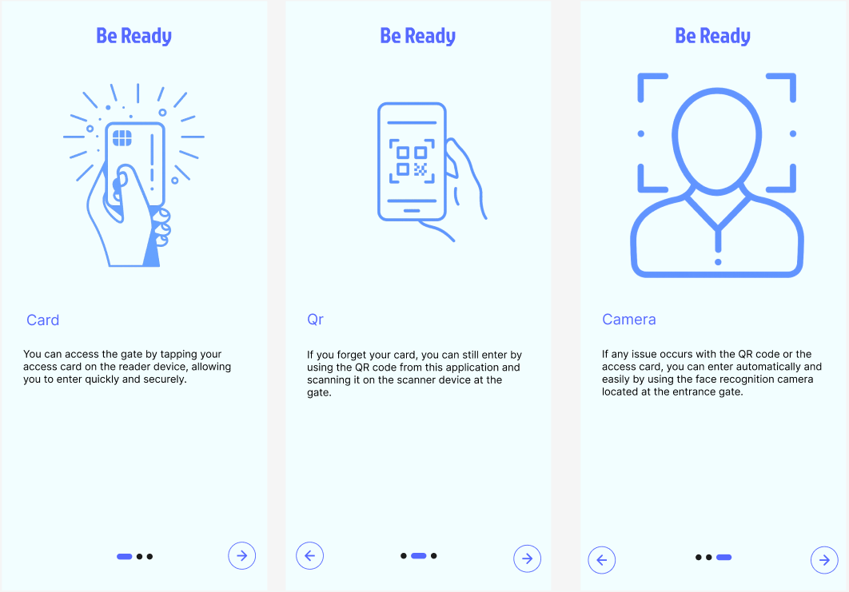

File:pubspec.yaml:-
smooth_page_indicator: ^1.2.1
file: onboarding:-
import 'package:be_ready/design/AppColor.dart';
import 'package:be_ready/design/AppImage.dart';
import 'package:be_ready/l10n/app_localizations.dart';
import 'package:be_ready/routes.dart';
import 'package:flutter/material.dart';
import 'package:smooth_page_indicator/smooth_page_indicator.dart';

class onBoardingPage extends StatefulWidget {
onBoardingPage({super.key});

@override
State<onBoardingPage> createState() => _onBoardingPageState();
}

class _onBoardingPageState extends State<onBoardingPage> {
final List<String> images = [AppImage.card, AppImage.qr, AppImage.camera];

late final List<String> title;
late final List<String> text;

int currentPage = 0;
final PageController controller = PageController();

@override
void didChangeDependencies() {
super.didChangeDependencies();
title = [
AppLocalizations.of(context)!.onBoarding_screen_tittel_1,
AppLocalizations.of(context)!.onBoarding_screen_tittel_2,
AppLocalizations.of(context)!.onBoarding_screen_tittel_3
];

text = [
AppLocalizations.of(context)!.onBoarding_screen_text_1,
AppLocalizations.of(context)!.onBoarding_screen_text_2,
AppLocalizations.of(context)!.onBoarding_screen_text_3
];
}

@override
Widget build(BuildContext context) {
return Container(
padding: EdgeInsets.symmetric(horizontal: 16, vertical: 16),
child: Column(
children: [
Expanded(
child: PageView.builder(
controller: controller,
itemCount: images.length,
onPageChanged: (index) {
setState(() {
currentPage = index;
});
},
itemBuilder: (context, index) {
return Padding(
padding: const EdgeInsets.all(16.0),
child: Column(
crossAxisAlignment: CrossAxisAlignment.start,
children: [
Image.asset(images[index]),
const SizedBox(height: 50),
Text(
title[index],
style: Theme.of(context).textTheme.bodyMedium,
textAlign: TextAlign.start,
),
const SizedBox(height: 40),
Text(
text[index],
style: Theme.of(context).textTheme.bodySmall,
textAlign: TextAlign.start,
),
],
),
);
},
),
),
Padding(
padding: EdgeInsets.all(20),
child: Row(
mainAxisAlignment: MainAxisAlignment.spaceBetween,
children: [
Container(
decoration: BoxDecoration(
shape: BoxShape.circle,
border: Border.all(color: AppColor.royalBlue, width: 2),
),
child: currentPage > 0
? IconButton(
onPressed: () {
if (currentPage > 0) {
controller.previousPage(
duration: Duration(milliseconds: 300),
curve: Curves.easeInOut,
);
}
},
icon: Icon(Icons.arrow_back, color: AppColor.royalBlue),
)
: SizedBox(),
),
SmoothPageIndicator(
controller: controller,
count: images.length,
effect: ExpandingDotsEffect(
activeDotColor: AppColor.royalBlue,
dotHeight: 8,
dotWidth: 8,
),
),
Container(
decoration: BoxDecoration(
shape: BoxShape.circle,
border: Border.all(color: AppColor.royalBlue, width: 2),
),
child: IconButton(
onPressed: () {
if (currentPage < images.length - 1) {
controller.nextPage(
duration: Duration(milliseconds: 300),
curve: Curves.easeInOut,
);
} else {
Navigator.pushReplacementNamed(
context,
AppRoutes.logIn.name,
);
}
},
icon: const Icon(Icons.arrow_forward, color: AppColor.royalBlue),
),
),
],
),
),
],
),
);
}
}
file: onboarding screen:-
import 'package:flutter/material.dart';
import 'onBoardingPage.dart';

class OnBoarding extends StatelessWidget {
const OnBoarding({super.key});

@override
Widget build(BuildContext context) {
return Scaffold(
appBar: AppBar(
title: const Text("Be Ready"),
),
body: onBoardingPage(),
);
}
}

4. Login & Regist screen:-
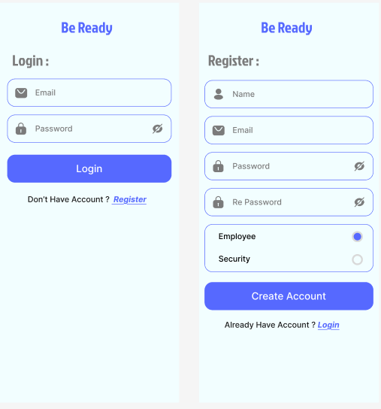

File: textFeild:-
import 'package:be_ready/design/AppColor.dart';
import 'package:flutter/material.dart';
import 'package:google_fonts/google_fonts.dart';

class AppFormField extends StatefulWidget {
AppFormField({
required this.label,
required this.icon,
this.keyboardType = TextInputType.text,
this.isPassword = false,
super.key,
});

String label;
IconData icon;
TextInputType keyboardType;
bool isPassword;

@override
State<AppFormField> createState() => _AppFormFieldState();
}

class _AppFormFieldState extends State<AppFormField> {
bool isTextVisible = true;

@override
Widget build(BuildContext context) {
return TextField(
style: GoogleFonts.inter(
color: AppColor.black,
fontSize: 18,
fontWeight: FontWeight.w500,
),
obscureText: widget.isPassword ? isTextVisible : false,
keyboardType: widget.keyboardType,
decoration: InputDecoration(
labelText: widget.label,
prefixIcon: Icon(widget.icon),
suffixIcon: widget.isPassword
? InkWell(
onTap: () {
setState(() {
isTextVisible = !isTextVisible;
});
},
child: Icon(
isTextVisible ? Icons.visibility_off : Icons.visibility,
),
)
: null,
),
);
}
}
file:usedText:-
import 'package:be_ready/design/AppColor.dart';
import 'package:be_ready/routes.dart';
import 'package:flutter/material.dart';

class UsedText extends StatelessWidget {
UsedText({
required this.text1,
required this.text2,
required this.AppRoutes,
super.key,
});

String text1;
String text2;
String AppRoutes;

@override
Widget build(BuildContext context) {
return Row(
mainAxisAlignment: MainAxisAlignment.center,
children: [
Center(
child: Text(
text1,
style: Theme.of(context).textTheme.titleMedium,
),
),
Center(
child: TextButton(
onPressed: () {
Navigator.pushReplacementNamed(context, AppRoutes);
},
child: Text(
text2,
style: Theme.of(context).textTheme.bodyMedium,
),
),
),
],
);
}
}
file:login screen:
import 'package:be_ready/Ui/customWidget/UsedText.dart';
import 'package:be_ready/Ui/customWidget/textFeild.dart';
import 'package:be_ready/design/AppColor.dart';
import 'package:be_ready/l10n/app_localizations.dart';
import 'package:be_ready/routes.dart';
import 'package:flutter/material.dart';

class LogIn extends StatelessWidget {
const LogIn({super.key});

@override
Widget build(BuildContext context) {
return Scaffold(
appBar: AppBar(title: const Text("Be Ready")),
body: Container(
padding: EdgeInsets.symmetric(horizontal: 16, vertical: 16),
child: Column(
crossAxisAlignment: CrossAxisAlignment.stretch,
children: [
Text(
AppLocalizations.of(context)!.login,
style: Theme.of(context)
.textTheme
.bodyLarge!
.copyWith(color: AppColor.gray),
),
SizedBox(height: 10),
AppFormField(
label: AppLocalizations.of(context)!.email,
icon: Icons.email,
keyboardType: TextInputType.emailAddress,
),
SizedBox(height: 10),
AppFormField(
label: AppLocalizations.of(context)!.password,
icon: Icons.lock,
keyboardType: TextInputType.text,
isPassword: true,
),
SizedBox(height: 10),
ElevatedButton(
onPressed: () {
Navigator.pushReplacementNamed(
context,
AppRoutes.securityScreen.name,
);
},
child: Text(
AppLocalizations.of(context)!.login,
style: Theme.of(context)
.textTheme
.bodyMedium!
.copyWith(color: AppColor.white),
),
),
SizedBox(height: 10),
UsedText(
text1: AppLocalizations.of(context)!.don_t_have_an_account,
text2: AppLocalizations.of(context)!.register,
AppRoutes: AppRoutes.register.name,
),
],
),
),
);
}
}
file:register screen:-
import 'package:be_ready/Ui/customWidget/UsedText.dart';
import 'package:be_ready/Ui/customWidget/textFeild.dart';
import 'package:be_ready/Ui/registerScreen/Radio_role.dart';
import 'package:be_ready/design/AppColor.dart';
import 'package:be_ready/l10n/app_localizations.dart';
import 'package:be_ready/routes.dart';
import 'package:flutter/material.dart';

class Register extends StatelessWidget {
const Register({super.key});

@override
Widget build(BuildContext context) {
return Scaffold(
appBar: AppBar(title: const Text("Be Ready")),
body: SingleChildScrollView(
child: Container(
padding: EdgeInsets.symmetric(horizontal: 16, vertical: 16),
child: Column(
crossAxisAlignment: CrossAxisAlignment.stretch,
children: [
Text(
AppLocalizations.of(context)!.register_screen_tittel,
style: Theme.of(context)
.textTheme
.bodyLarge!
.copyWith(color: AppColor.gray),
),
SizedBox(height: 10),
AppFormField(
label: AppLocalizations.of(context)!.name,
icon: Icons.person,
keyboardType: TextInputType.name,
),
SizedBox(height: 10),
AppFormField(
label: AppLocalizations.of(context)!.email,
icon: Icons.email,
keyboardType: TextInputType.emailAddress,
),
SizedBox(height: 10),
AppFormField(
label: AppLocalizations.of(context)!.password,
icon: Icons.lock,
keyboardType: TextInputType.text,
isPassword: true,
),
SizedBox(height: 10),
AppFormField(
label: AppLocalizations.of(context)!.password,
icon: Icons.lock,
keyboardType: TextInputType.text,
),
SizedBox(height: 10),
RadioRole(),
SizedBox(height: 10),
UsedText(
text1: AppLocalizations.of(context)!.already_have_an_account,
text2: AppLocalizations.of(context)!.login,
AppRoutes: AppRoutes.logIn.name,
),
],
),
),
),
);
}
}

file:radio role :-
import 'package:be_ready/design/AppColor.dart';
import 'package:be_ready/l10n/app_localizations.dart';
import 'package:be_ready/routes.dart';
import 'package:flutter/material.dart';

enum SingingCharacter { employee, security }

class RadioRole extends StatefulWidget {
const RadioRole({super.key});

@override
State<RadioRole> createState() => _RadioRoleState();
}

class _RadioRoleState extends State<RadioRole> {
SingingCharacter? _character = SingingCharacter.employee;

@override
Widget build(BuildContext context) {
return Column(
crossAxisAlignment: CrossAxisAlignment.stretch,
children: [
ClipRRect(
child: Container(
decoration: BoxDecoration(
color: Colors.transparent,
borderRadius: BorderRadius.circular(16),
border: Border.all(color: AppColor.royalBlue, width: 2),
),
child: Column(
children: <Widget>[
ListTile(
title: Text(
AppLocalizations.of(context)!.employee,
style: Theme.of(context).textTheme.titleSmall,
),
trailing: Radio<SingingCharacter>(
activeColor: AppColor.royalBlue,
value: SingingCharacter.employee,
groupValue: _character,
onChanged: (value) {
setState(() {
_character = value;
});
},
),
),
ListTile(
title: Text(
AppLocalizations.of(context)!.security,
style: Theme.of(context).textTheme.titleSmall,
),
trailing: Radio<SingingCharacter>(
activeColor: AppColor.royalBlue,
value: SingingCharacter.security,
groupValue: _character,
onChanged: (value) {
setState(() {
_character = value;
});
},
),
),
const SizedBox(height: 16),
],
),
),
),
const SizedBox(height: 16),
ElevatedButton(
onPressed: () {
if (_character == SingingCharacter.security) {
Navigator.pushReplacementNamed(
context,
AppRoutes.securityScreen.name,
);
} else {
Navigator.pushReplacementNamed(
context,
AppRoutes.employeeScreen.name,
);
}
},
child: Text(
AppLocalizations.of(context)!.createAccount,
style: Theme.of(context)
.textTheme
.bodyMedium!
.copyWith(color: AppColor.white),
),
),
],
);
}
}

5.security&employee screen :-
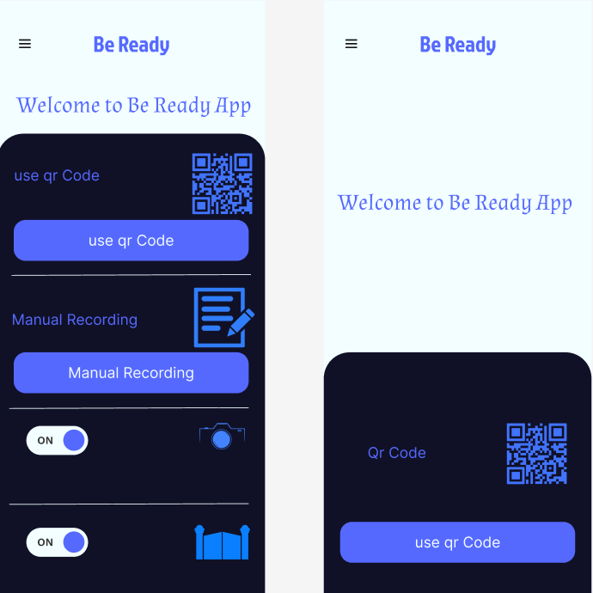

File : security screen:-
import 'package:be_ready/Ui/customWidget/toggle%20Switch.dart';
import 'package:be_ready/design/AppImage.dart';
import 'package:be_ready/routes.dart';
import 'package:be_ready/widget/CustomScaffold.dart';
import 'package:flutter/material.dart';
import 'package:provider/provider.dart';
import '../../Provider/ThemeProvider.dart';
import '../../design/AppColor.dart';
import '../../l10n/app_localizations.dart';

class securityScreen extends StatelessWidget {
const securityScreen({super.key});

@override
Widget build(BuildContext context) {
final themeProvider = Provider.of<ThemeProvider>(context);
return CustomScaffold(
title: "be ready ",
icons: null,
route: null,
body: Column(
mainAxisAlignment: MainAxisAlignment.spaceBetween,
children: [
SizedBox(height: 10),
Text(
AppLocalizations.of(context)!.welcome,
style: Theme.of(context).textTheme.titleLarge!.copyWith(
color: AppColor.royalBlue,
fontWeight: FontWeight.bold,
),
textAlign: TextAlign.center,
),
Align(
alignment: Alignment.bottomCenter,
child: Container(
padding: EdgeInsets.all(25),
decoration: BoxDecoration(
borderRadius: BorderRadius.circular(40),
color: themeProvider.isDarkMode
? AppColor.softBlue
: AppColor.darkBackground,
),
child: Column(
crossAxisAlignment: CrossAxisAlignment.stretch,
mainAxisSize: MainAxisSize.min,
children: [
Row(
mainAxisAlignment: MainAxisAlignment.spaceBetween,
children: [
Text(
AppLocalizations.of(context)!.qr_code,
style: Theme.of(context)
.textTheme
.bodyMedium!
.copyWith(color: AppColor.royalBlue),
),
Container(
height: 100,
width: 100,
color: Colors.transparent,
child: Image.asset(AppImage.qrCode),
),
],
),
SizedBox(height: 10),
ElevatedButton(
onPressed: () {
Navigator.pushNamed(context, AppRoutes.qrScreen.name);
},
style: ElevatedButton.styleFrom(
shape: RoundedRectangleBorder(
borderRadius: BorderRadius.circular(16),
),
backgroundColor: AppColor.royalBlue,
),
child: Text(
AppLocalizations.of(context)!.get_qr_code,
style: Theme.of(context)
.textTheme
.bodyMedium!
.copyWith(color: AppColor.softBlue),
),
),
SizedBox(height: 10),
Divider(
color: themeProvider.isDarkMode
? AppColor.royalBlue
: AppColor.softBlue,
),
SizedBox(height: 10),
Row(
mainAxisAlignment: MainAxisAlignment.spaceBetween,
children: [
Text(
AppLocalizations.of(context)!.manual_recording,
style: Theme.of(context)
.textTheme
.bodyMedium!
.copyWith(color: AppColor.royalBlue),
),
Container(
height: 100,
width: 100,
color: Colors.transparent,
child: Image.asset(AppImage.Manual_recording),
),
],
),
SizedBox(height: 10),
ElevatedButton(
onPressed: () {
Navigator.pushNamed(
context,
AppRoutes.manualRecording.name,
);
},
style: ElevatedButton.styleFrom(
shape: RoundedRectangleBorder(
borderRadius: BorderRadius.circular(16),
),
backgroundColor: AppColor.royalBlue,
),
child: Text(
AppLocalizations.of(context)!.manual_recording,
style: Theme.of(context)
.textTheme
.bodyMedium!
.copyWith(color: AppColor.softBlue),
),
),
SizedBox(height: 10),
Divider(
color: themeProvider.isDarkMode
? AppColor.royalBlue
: AppColor.softBlue,
),
SizedBox(height: 10),
Row(
mainAxisAlignment: MainAxisAlignment.spaceBetween,
children: [
ToggleSwitch(),
Container(
height: 100,
width: 100,
color: Colors.transparent,
child: Image.asset(AppImage.camera2),
),
],
),
SizedBox(height: 10),
Divider(
color: themeProvider.isDarkMode
? AppColor.royalBlue
: AppColor.softBlue,
),
SizedBox(height: 10),
Row(
mainAxisAlignment: MainAxisAlignment.spaceBetween,
children: [
ToggleSwitch(),
Container(
height: 100,
width: 100,
color: Colors.transparent,
child: Image.asset(AppImage.gate),
),
],
),
SizedBox(height: 10),
],
),
),
),
],
),
);
}
}
file:toggle switch:-
import 'package:be_ready/Provider/ThemeProvider.dart';
import 'package:be_ready/design/AppColor.dart';
import 'package:flutter/material.dart';
import 'package:provider/provider.dart';

class ToggleSwitch extends StatefulWidget {
const ToggleSwitch({super.key});

@override
_ToggleSwitchState createState() => _ToggleSwitchState();
}

class _ToggleSwitchState extends State<ToggleSwitch>
with SingleTickerProviderStateMixin {

bool isChecked = false;
final Duration _duration = const Duration(milliseconds: 370);

late Animation<Alignment> _animation;
late AnimationController _animationController;
@override
void initState() {
super.initState();
_animationController = AnimationController(
vsync: this,
duration: _duration,
);
_animation = AlignmentTween(
begin: Alignment.centerLeft,
end: Alignment.centerRight,
).animate(
CurvedAnimation(
parent: _animationController,
curve: Curves.bounceOut,
reverseCurve: Curves.bounceIn,
),
);
}

@override
void dispose() {
_animationController.dispose();
super.dispose();
}

@override
Widget build(BuildContext context) {
final themeProvider = Provider.of<ThemeProvider>(context);
return AnimatedBuilder(
animation: _animationController,
builder: (context, child) {
return GestureDetector(
onTap: () {
setState(() {
if (_animationController.isCompleted) {
_animationController.reverse();
} else {
_animationController.forward();
}
isChecked = !isChecked;
});
},
child: Container(
width: 100,
height: 50,
padding: const EdgeInsets.symmetric(vertical: 6),
decoration: BoxDecoration(
color: isChecked ? AppColor.royalBlue : AppColor.softBlue,
borderRadius: BorderRadius.circular(40),
boxShadow: [
BoxShadow(
color: AppColor.royalBlue.withOpacity(0.6),
blurRadius: 12,
offset: const Offset(0, 8),
)
],
),
child: Stack(
children: <Widget>[
Align(
alignment: Alignment.centerLeft,
child: Padding(
padding: const EdgeInsets.only(left: 12.0),
child: Text(
"OFF",
style: TextStyle(
color: isChecked ? AppColor.softBlue : AppColor.royalBlue,
fontWeight: FontWeight.bold,
fontSize: 15,
),
),
),
),
Align(
alignment: Alignment.centerRight,
child: Padding(
padding: const EdgeInsets.only(right: 12.0),
child: Text(
"ON",
style: TextStyle(
color: isChecked ? AppColor.softBlue : AppColor.royalBlue,
fontWeight: FontWeight.bold,
fontSize: 15,
),
),
),
),
Align(
alignment: _animation.value,
child: Container(
width: 50,
height: 50,
decoration: BoxDecoration(
shape: BoxShape.circle,
color: isChecked ? AppColor.softBlue : AppColor.royalBlue,
),
),
),
],
),
),
);
},
);
}
}
file:employee screen:-
import 'package:be_ready/Provider/ThemeProvider.dart';
import 'package:be_ready/design/AppColor.dart';
import 'package:be_ready/design/AppImage.dart';
import 'package:be_ready/l10n/app_localizations.dart';
import 'package:be_ready/routes.dart';
import 'package:be_ready/widget/CustomScaffold.dart';
import 'package:flutter/material.dart';
import 'package:provider/provider.dart';

class Employee extends StatelessWidget {
const Employee({super.key});

@override
Widget build(BuildContext context) {
final themeProvider = Provider.of<ThemeProvider>(context);
return CustomScaffold(
title: "be ready ",
icons: null,
route: null,
body: Column(
mainAxisAlignment: MainAxisAlignment.spaceBetween,
children: [
SizedBox(height: 10),
Text(
AppLocalizations.of(context)!.welcome,
style: Theme.of(context).textTheme.titleLarge!.copyWith(
color: AppColor.royalBlue,
fontWeight: FontWeight.bold,
),
textAlign: TextAlign.center,
),
Align(
alignment: Alignment.bottomCenter,
child: Container(
padding: EdgeInsets.all(25),
decoration: BoxDecoration(
borderRadius: BorderRadius.circular(40),
color: themeProvider.isDarkMode
? AppColor.softBlue
: AppColor.darkBackground,
),
child: Column(
crossAxisAlignment: CrossAxisAlignment.stretch,
mainAxisSize: MainAxisSize.min,
children: [
Row(
mainAxisAlignment: MainAxisAlignment.spaceBetween,
children: [
Text(
AppLocalizations.of(context)!.qr_code,
style: Theme.of(context)
.textTheme
.bodyMedium!
.copyWith(color: AppColor.royalBlue),
),
Container(
height: 100,
width: 100,
color: Colors.transparent,
child: Image.asset(AppImage.qrCode),
),
],
),
SizedBox(height: 30),
ElevatedButton(
onPressed: () {
Navigator.pushNamed(context, AppRoutes.qrScreen.name);
},
style: ElevatedButton.styleFrom(
shape: RoundedRectangleBorder(
borderRadius: BorderRadius.circular(16),
),
backgroundColor: AppColor.royalBlue,
),
child: Text(
AppLocalizations.of(context)!.get_qr_code,
style: Theme.of(context)
.textTheme
.bodyMedium!
.copyWith(color: AppColor.softBlue),
),
),
SizedBox(height: 40),
],
),
),
),
],
),
);
}
}
file: customScaffold :-
import 'package:be_ready/Provider/ThemeProvider.dart';
import 'package:be_ready/design/AppColor.dart';
import 'package:be_ready/design/AppImage.dart';
import 'package:be_ready/l10n/app_localizations.dart';
import 'package:be_ready/routes.dart';
import 'package:flutter/material.dart';
import 'package:provider/provider.dart';
import '../Provider/languageProvider.dart';

class CustomScaffold extends StatelessWidget {
const CustomScaffold({
super.key,
required this.title,
required this.body,
this.icons,
this.route,
});

final String title;
final Icon? icons;
final Widget body;
final String? route;

@override
Widget build(BuildContext context) {
final themeProvider = Provider.of<ThemeProvider>(context);

return Scaffold(
appBar: AppBar(
title: Row(
mainAxisAlignment: MainAxisAlignment.spaceBetween,
children: [
Expanded(
child: Center(
child: Text(
title,
style: TextStyle(color: AppColor.royalBlue),
),
),
),
icons == null
? SizedBox()
: IconButton(
onPressed: () {
if (route != null) {
Navigator.pushReplacementNamed(context, route!);
} else {
Navigator.pop(context);
}
},
icon: icons!,
)
],
),
),
drawer: Drawer(
backgroundColor: themeProvider.isDarkMode
? AppColor.darkBackground
: AppColor.softBlue,
child: Column(
children: [
DrawerHeader(
decoration: BoxDecoration(
color: themeProvider.isDarkMode
? AppColor.royalBlue
: AppColor.darkBackground,
),
child: Center(
child: Text(
"Be Ready",
style: Theme.of(context).textTheme.bodyLarge!.copyWith(
color: AppColor.softBlue,
),
),
),
),
GestureDetector(
child: ListTile(
title: Text(
AppLocalizations.of(context)!.log_out,
style: Theme.of(context).textTheme.bodyMedium,
),
leading: Icon(
Icons.logout,
color: themeProvider.isDarkMode
? AppColor.softBlue
: AppColor.royalBlue,
),
onTap: () => Navigator.pushReplacementNamed(
context,
AppRoutes.onBoardingScreen.name,
),
),
),
Divider(),
GestureDetector(
onTap: () {
themeProvider.setTheme = themeProvider.isDarkMode
? ThemeMode.light
: ThemeMode.dark;
},
child: ListTile(
title: Text(
themeProvider.isDarkMode
? AppLocalizations.of(context)!.dark
: AppLocalizations.of(context)!.light,
style: Theme.of(context).textTheme.bodyMedium,
),
leading: Icon(
themeProvider.isDarkMode ? Icons.dark_mode : Icons.light_mode,
color: themeProvider.isDarkMode
? AppColor.softBlue
: AppColor.royalBlue,
),
),
),
Divider(),
GestureDetector(
onTap: () {
final lang = Provider.of<LanguageProvider>(
context,
listen: false,
);

lang.changeLocale(
lang.isArabic ? const Locale("en") : const Locale("ar"),
);
},
child: ListTile(
title: Text(
AppLocalizations.of(context)!.change_language,
style: Theme.of(context).textTheme.bodyMedium,
),
leading: Image.asset(
Provider.of<LanguageProvider>(context).isArabic
? AppImage.EG
: AppImage.LR,
),
),
),
Divider(),
],
),
),
body: body,
);
}
}

file: image:-
import 'package:flutter/animation.dart';

abstract class AppColor {
static const Color softBlue = Color(0xFFF2FEFF);
static const Color royalBlue = Color(0xFF5669FF);
static const Color darkBackground = Color(0xFF101127);
static const Color gray = Color(0xFF7B7B7B);
static const Color black = Color(0xFF000000);
static const Color white = Color(0xFFFFFFFF);
}
file: color :-
import 'package:flutter/animation.dart';

abstract class AppColor {
static const Color softBlue = Color(0xFFF2FEFF);
static const Color royalBlue = Color(0xFF5669FF);
static const Color darkBackground = Color(0xFF101127);
static const Color gray = Color(0xFF7B7B7B);
static const Color black = Color(0xFF000000);
static const Color white = Color(0xFFFFFFFF);
}
file: theme:-
import 'package:flutter/material.dart';
import 'package:google_fonts/google_fonts.dart';
import 'AppColor.dart';

abstract class AppTheme {
static var lightTheme = ThemeData(
scaffoldBackgroundColor: AppColor.softBlue,
textTheme: TextTheme(
bodyLarge: GoogleFonts.jockeyOne(
color: AppColor.royalBlue,
fontSize: 36,
fontWeight: FontWeight.w700,
),
bodyMedium: GoogleFonts.inter(
color: AppColor.royalBlue,
fontSize: 20,
fontWeight: FontWeight.w500,
),
bodySmall: GoogleFonts.inter(
color: AppColor.black,
fontSize: 16,
fontWeight: FontWeight.w400,
),
titleLarge: GoogleFonts.almendra(
color: AppColor.royalBlue,
fontSize: 36,
fontWeight: FontWeight.w400,
),
titleSmall: GoogleFonts.inter(
color: AppColor.gray,
fontSize: 16,
fontWeight: FontWeight.w400,
),
titleMedium: GoogleFonts.inter(
color: AppColor.black,
fontSize: 20,
fontWeight: FontWeight.w500,
),
),
appBarTheme: AppBarTheme(
backgroundColor: AppColor.softBlue,
titleTextStyle: GoogleFonts.jockeyOne(
color: AppColor.royalBlue,
fontSize: 36,
fontWeight: FontWeight.bold,
),
centerTitle: true,
),
iconTheme: IconThemeData(color: AppColor.white, weight: 22),
elevatedButtonTheme: ElevatedButtonThemeData(
style: ElevatedButton.styleFrom(
backgroundColor: AppColor.royalBlue,
shape: RoundedRectangleBorder(borderRadius: BorderRadius.circular(16)),
padding: EdgeInsets.symmetric(vertical: 16),
textStyle: TextStyle(
fontSize: 20,
fontWeight: FontWeight.w400,
color: AppColor.white,
),
),
),
inputDecorationTheme: InputDecorationTheme(
floatingLabelBehavior: FloatingLabelBehavior.auto,
focusedBorder: OutlineInputBorder(
borderRadius: BorderRadius.circular(16.0),
borderSide: BorderSide(color: AppColor.royalBlue, width: 2),
),
enabledBorder: OutlineInputBorder(
borderRadius: BorderRadius.circular(16.0),
borderSide: BorderSide(color: AppColor.royalBlue, width: 2),
),
border: OutlineInputBorder(
borderRadius: BorderRadius.circular(16.0),
borderSide: BorderSide(color: AppColor.royalBlue, width: 2),
),
labelStyle: GoogleFonts.inter(
color: AppColor.gray,
fontSize: 16,
fontWeight: FontWeight.w400,
),
hintStyle: GoogleFonts.inter(
color: AppColor.gray,
fontSize: 20,
fontWeight: FontWeight.w400,
),
suffixStyle: TextStyle(
color: AppColor.black,
fontSize: 16,
fontWeight: FontWeight.w400,
),
focusColor: AppColor.black,
prefixIconColor: AppColor.gray,
contentPadding: EdgeInsets.all(16),
),
);

static var darkTheme = ThemeData(
appBarTheme: AppBarTheme(
backgroundColor: AppColor.darkBackground,
surfaceTintColor: Colors.transparent,
titleTextStyle: GoogleFonts.jockeyOne(
color: AppColor.royalBlue,
fontSize: 36,
fontWeight: FontWeight.bold,
),
centerTitle: true,
),
elevatedButtonTheme: ElevatedButtonThemeData(
style: ElevatedButton.styleFrom(
shape: RoundedRectangleBorder(
borderRadius: BorderRadius.circular(16),
),
padding: EdgeInsets.symmetric(horizontal: 16, vertical: 20),
backgroundColor: AppColor.royalBlue,
textStyle: TextStyle(
color: Colors.white,
fontSize: 20,
fontWeight: FontWeight.w500,
),
),
),
colorScheme: ColorScheme.light(primary: Colors.white),
iconButtonTheme: IconButtonThemeData(
style: IconButton.styleFrom(foregroundColor: Colors.white),
),
textTheme: TextTheme(
titleLarge: GoogleFonts.almendra(
color: AppColor.softBlue,
fontSize: 36,
fontWeight: FontWeight.w400,
),
bodyLarge: GoogleFonts.jockeyOne(
color: AppColor.royalBlue,
fontSize: 36,
fontWeight: FontWeight.w400,
),
bodyMedium: GoogleFonts.inter(
color: AppColor.royalBlue,
fontSize: 20,
fontWeight: FontWeight.w700,
),
bodySmall: GoogleFonts.inter(
color: Colors.white,
fontSize: 16,
fontWeight: FontWeight.w500,
),
titleMedium: GoogleFonts.inter(
color: AppColor.white,
fontSize: 20,
fontWeight: FontWeight.w500,
),
),
iconTheme: IconThemeData(color: Colors.white),
inputDecorationTheme: InputDecorationTheme(
iconColor: Colors.white,
floatingLabelBehavior: FloatingLabelBehavior.auto,
enabledBorder: OutlineInputBorder(
borderRadius: BorderRadius.circular(16),
borderSide: BorderSide(color: AppColor.royalBlue, width: 1),
),
border: OutlineInputBorder(
borderRadius: BorderRadius.circular(16),
borderSide: BorderSide(color: AppColor.royalBlue, width: 1),
),
focusedBorder: OutlineInputBorder(
borderRadius: BorderRadius.circular(16)
borderSide: BorderSide(color: AppColor.royalBlue, width: 1),
),
labelStyle: GoogleFonts.inter(
color: Colors.white,
fontSize: 16,
fontWeight: FontWeight.w500,
),
hintStyle: GoogleFonts.inter(
color: Colors.white,
fontSize: 16,
fontWeight: FontWeight.w500
),
contentPadding: EdgeInsets.all(16),
),
scaffoldBackgroundColor: AppColor.darkBackground,
);
}

