Name: Norania Tariq
Student ID: 25915886
AI and Data Science Group 1

Assignment : Mouse Click Game-Ice hockey

My game is the ice hockey concept. I started by creating all the important classes needed for the game, like keeper, pucks, and goal. So far, I’ve only created one enemy object. The classes store images and positions for each object, alongside a constructor that sets the values to the objects. I have used the display method in most classes to draw the objects on the screen which are then used in main class and displayed inside the void draw method, which is repeated 60 times per second.
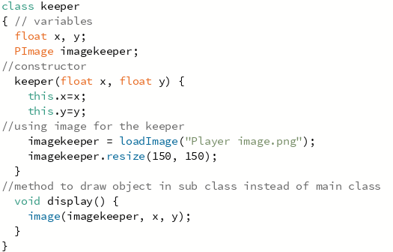
All the classes have similar code like above to display and position the image, except the main class which has setup for background image and draw function to display all objects on the screen.
Then, I added the void move function to my pucks class so they aim and move towards the goal and added Boolean collision for pucks and goal so they disappear when hit the goal, which will decrease the score. Boolean is a as true or false to control what to display or remove something after a time. I have also added the mouseMoved for the keeper to move with the mouse, and mouseClicked for the keeper and pucks collision, so they vanish by keeper when they’re clicked with Boolean. I have also added the second enemy which are red coloured pucks. I used array for both type of enemies to display more than 1. The second enemy appears later as the game is running like said in the requirements.
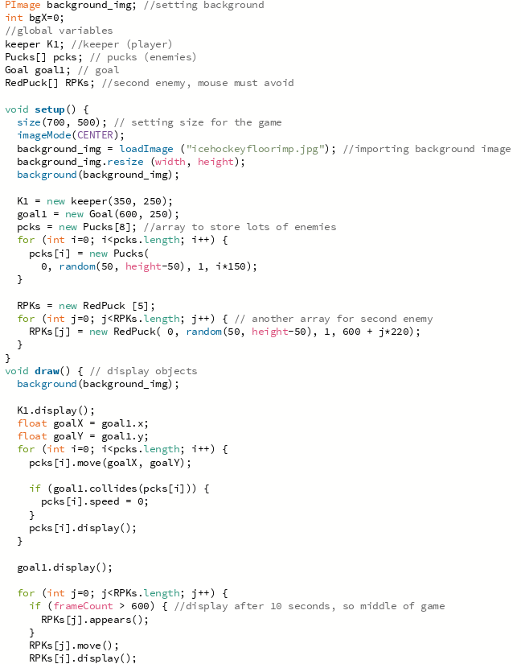
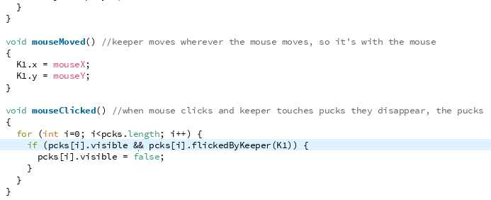
I have increased the speed of red pucks, so the game gets complicated by watching out for the pucks, because when keeper touches the red puck, the game ends, I used the Boolean method to make the game over screen. I have changed the black pucks, from just black circle to using 4 images of puck with shine on different corners to animate it into spinning. I used the image counter for the images to animate it.
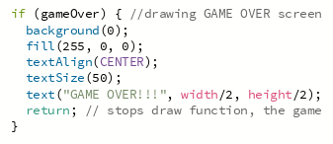
Final coding parts that I did was a collision between the black pucks and the goal which aim towards the goal, so when they hit it, they decrease the score by -5 and disappear. I also added the score in my game so when pucks are hit by keeper they increase the score by 5, and if pucks hit goal, then decreased. However, I struggled with the decreasing part because score was decreased if pucks hit the center of goal only, and disappear, but not on the sides of goal inside it. I fixed that by increasing the distance in Boolean collision for goal and pucks, because it was set to 20 only so I increased to 60, which does make pucks disappear a bit before reaching the goal.
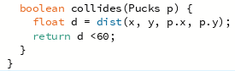
I have also added an explosion in another class that appears when keeper hits puck and scores. It’s an animated grey explosion for ice, so it’s visible that uses 3 images, same animating method as the spinning pucks. I created superclass Enemy for redpucks and Pucks classes to inherit from. Which is then also used for polymorphism, but they’re both changed into ArrayList then array, so it’s easier to remove/add pucks. So, most of the main class code is refactored in the above screenshot, to readable code. Polymorphism was used for the 2 types of pucks because they’re both enemies. They’re both controlled in same way even though they have different purposes. I could not do the file handling part because I was struggling to understand how to store a high score. I just have score in my game.
