**Phone:**

+998 93 688 19 99

**email:**

otkirgadoyev24@gmail.com

**Languages**

**Uzbek– native**

**Russian – intermediate**

**English – intermediate**

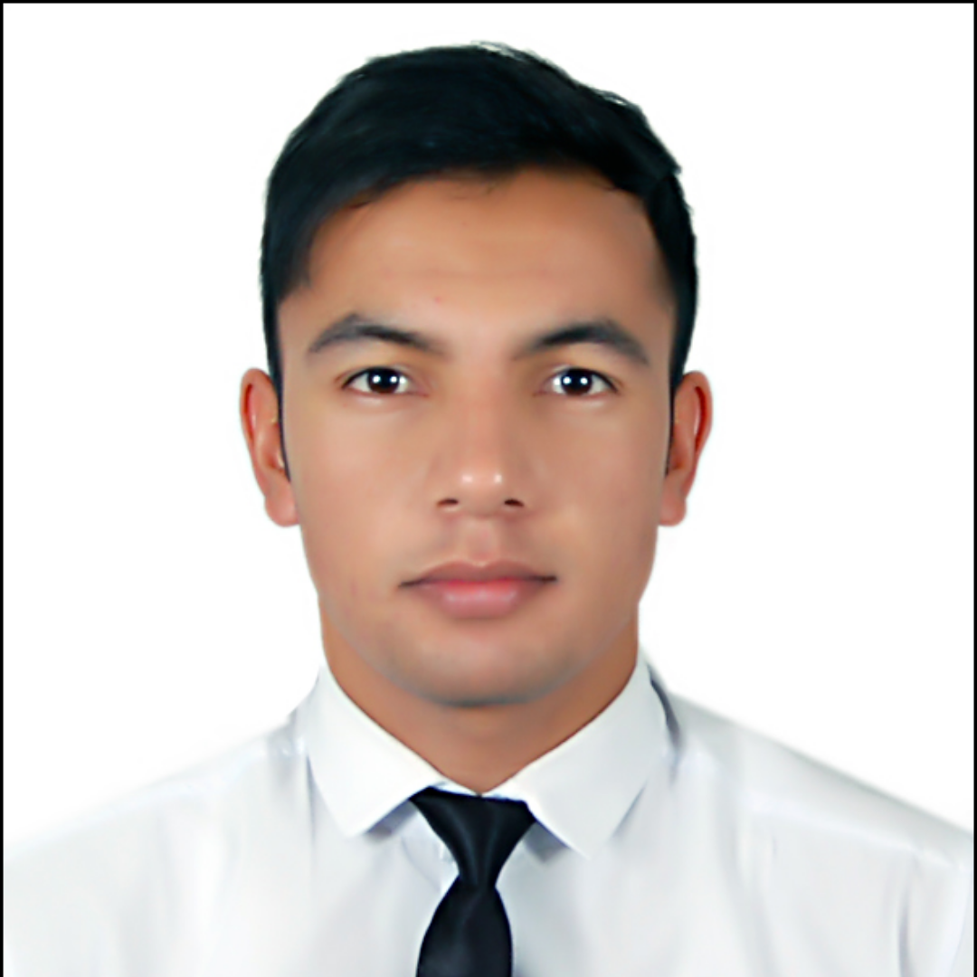

**Education**

(2018-2022)  
**Bachelor** :**Tashkent University of Information Technologies**

**Programming languages**

Web dasturlash : **Front end(HTML , CSS , BootStrap ,**

**JavaScript)**

**Back end(Python,Django, Telegram Bot)**

Interests

|  |
| --- |
| * **Project Management** * **Robotechnics** * **AI(Artificial Intelligence)** |

–