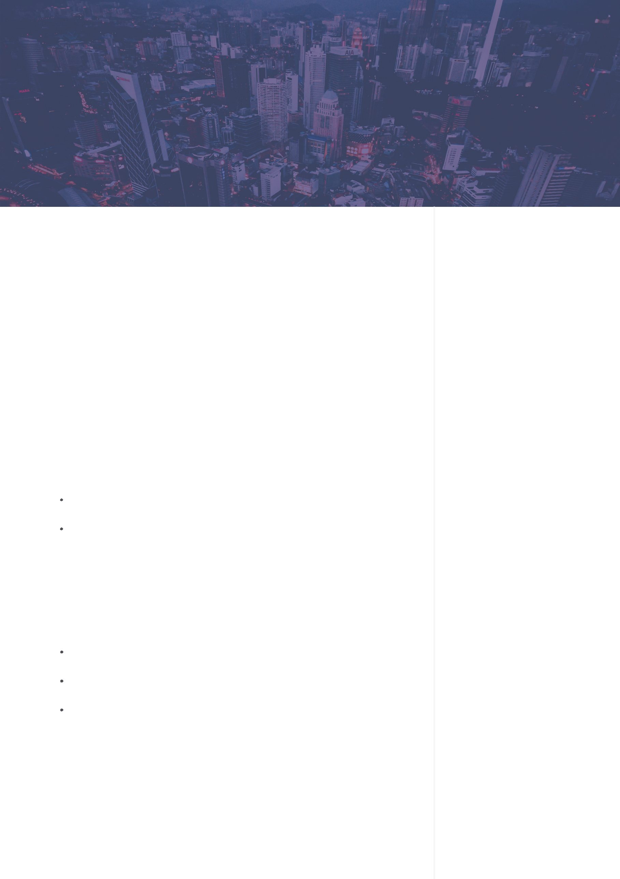

Web Developer

your.name@gmail.com | (XXX) XXX-XXXX | 142 Your Address Blvd, City Name, CA XXXXX

[Today’s Date]

[Hiring Manager’s Name]

[341 Company Address]

[Company City, State xxxxx

[(xxx) xxx-xxxx]

[hiring.manager@gmail.com]

Dear [Mr./Mrs./Ms.] [Manager’s Name],

I’m writing to you regarding [COMPANY NAME]’s Web Developer opening, which I discovered on Indeed. I’ve been working as a Web Developer at Grooming Technologies for more than 9 years now, and during that time I’ve revamped web security applications, designed and developed a user-friendly website, and trained over 50 staff members in internal web functions. I’m interested in working for [COMPANY NAME] because I want to further my own knowledge and interest in web development, and I believe I’ll be able to offer new ideas to help [COMPANY NAME] reach and surpass the primary objectives mentioned in its job ad.

My core duties at Grooming Technologies included designing user interfaces, testing and debugging websites, and training staff. Additionally, my work revamping our security applications diminished hacker attacks from 2.3% to 0.02%. I also redesigned our website—increasing visitor clicks by 37% and customer purchases by 20%. Prior to this position, I worked at Focus Solutions as a Web Developer where I assisted in developing a user-friendly website that increased sales revenue by 40%.

This professional experience has helped me improve my skills in leadership, allowed me to gain mastery over necessary development tools, and provided me with extensive knowledge of how to design a user friendly, secure website. I believe my skill set will benefit [COMPANY NAME], which has the clear potential to increase online revenue and expand its audience.

I’m looking forward to discussing the position and my qualifications with you in more detail soon. I feel confident that I fulfill the requirements for the Web Developer position. You can contact me at (123) 456-7890, or by email at [abcwebtech@gmail.com](mailto:abcwebtech@gmail.com). If I have not heard from you in a week, I will reach out to you again. Thank you for your time and consideration.

Sincerely,

Name

Dear Job Seeker,

PLEASE note that you *must* install the font files to make this cover letter template work perfectly. It’s very simple to do – **just follow the instructions in the “Read Me” file in the Zip file you downloaded this template from.**

If you’re struggling to write your cover letter, **don’t worry.** You’re in good company – everyone struggles with it. For a high quality cover letter that will land you employment, we recommend [consulting the certified experts at Resume Writer Direct](https://resumewriterdirect.com/cover-letter/?utm_source=CL_Word_Doc&utm_medium=RWD_Link&utm_campaign=RG_Downloads). (Yep, they can also help you with your resume!)

Or, here’s some other content that might help you finish your cover letter.

* [Cover Letter Builder](https://resumegenius.com/cover-letter-builder?utm_source=CL_Word_Doc&utm_medium=Cover_Letter_Builder_Link&utm_campaign=RG_Downloads)
* [How to Write a Cover Letter](https://resumegenius.com/cover-letters-the-how-to-guide?utm_source=CL_Word_Doc&utm_medium=Cover_Letter_Guide_Link&utm_campaign=RG_Downloads)
* [Cover Letter Examples by Industry](https://resumegenius.com/cover-letter-examples?utm_source=CL_Word_Doc&utm_medium=Cover_Letter_Examples_Link&utm_campaign=RG_Downloads)

Oh, and by the way, **you’re also going to need a resume.**

* [Free Resume Builder](https://resumegenius.com/?utm_source=CL_Word_Doc&utm_medium=Resume_Builder_Link&utm_campaign=RG_Downloads)
* [How to Write a Resume](https://resumegenius.com/how-to-write-a-resume?utm_source=CL_Word_Doc&utm_medium=How_to_Write_Resume_Link&utm_campaign=RG_Downloads)
* [Resume Samples by Industry](https://resumegenius.com/resume-samples?utm_source=CL_Word_Doc&utm_medium=Resume_Samples_Link&utm_campaign=RG_Downloads)