# Table of Contents

Contents

Table of Contents 1

Working with restaurant dataset 2

Creating Spark session 2

Read restaurant_csv dataset 2

Applying Geocode UDF 3

Applying Geohash 3

Working with Weather dataset 4

Reading Weather dataset and applying geohash UDF 4

Deleting duplicated rows 5

Saving weather cleaned dataset 5

Joining Restaurant and Weather Datasets 6

Cleaning joined dataset from Nulls and Drop Duplicates 6

Saving datasets. 7

Testing 7

# Working with restaurant dataset

Install Spark locally using one of the methods described [here](https://spark.apache.org/downloads.html) or in Docker.

## Creating Spark session

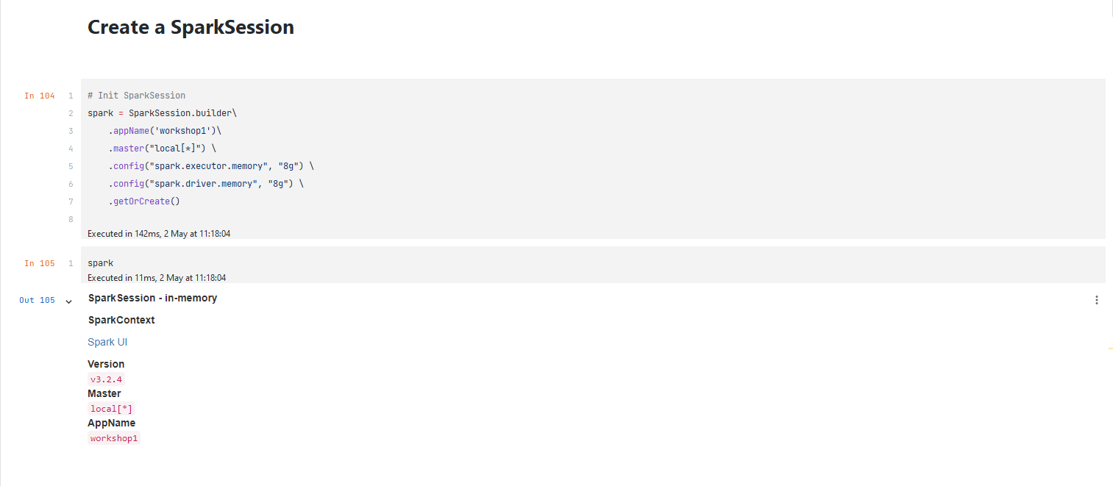

## Read restaurant_csv dataset

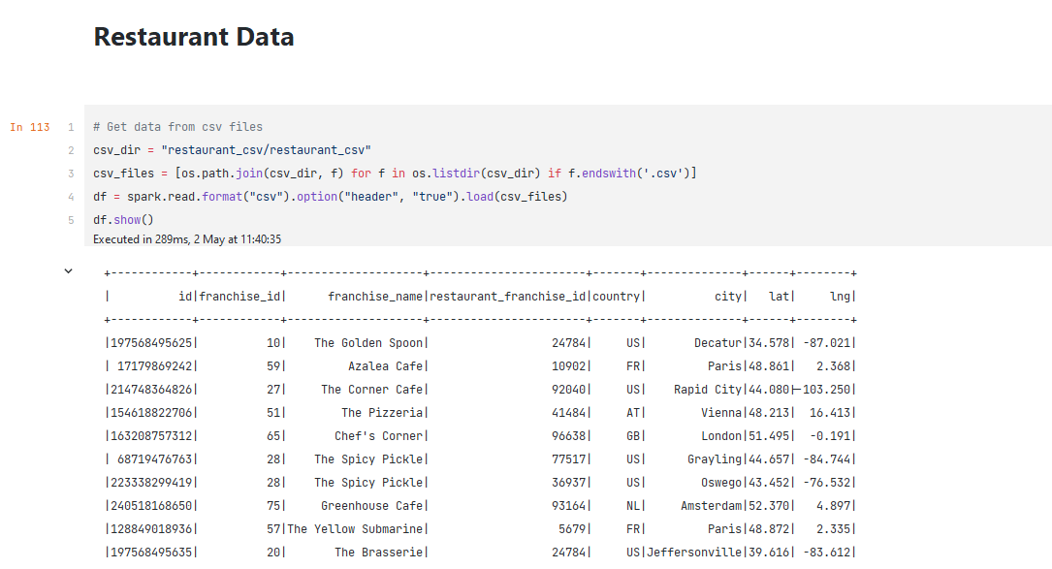

## Applying Geocode UDF

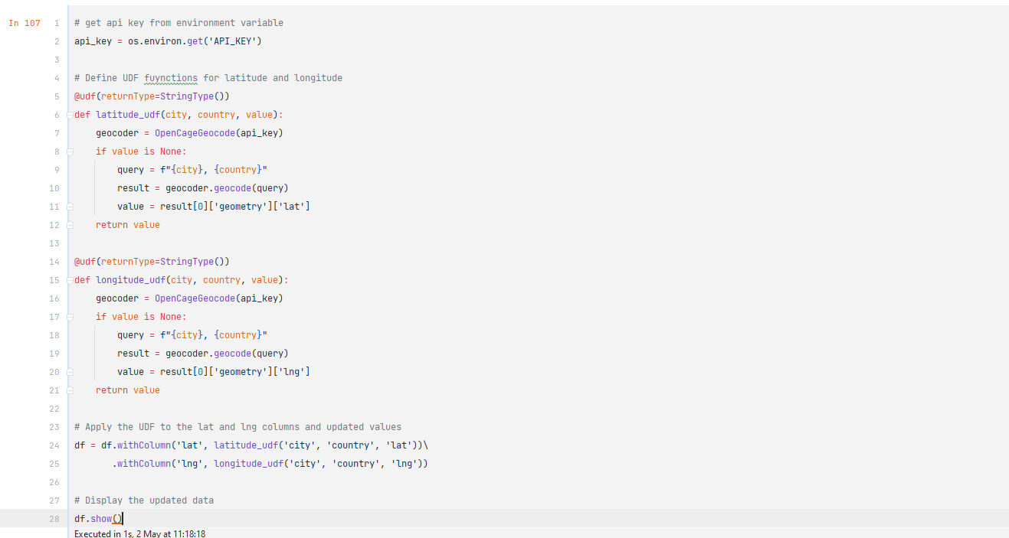

## Applying Geohash

I also created geohash UDF in order to hash my geocode. Saved it as parquest file as “restaurant”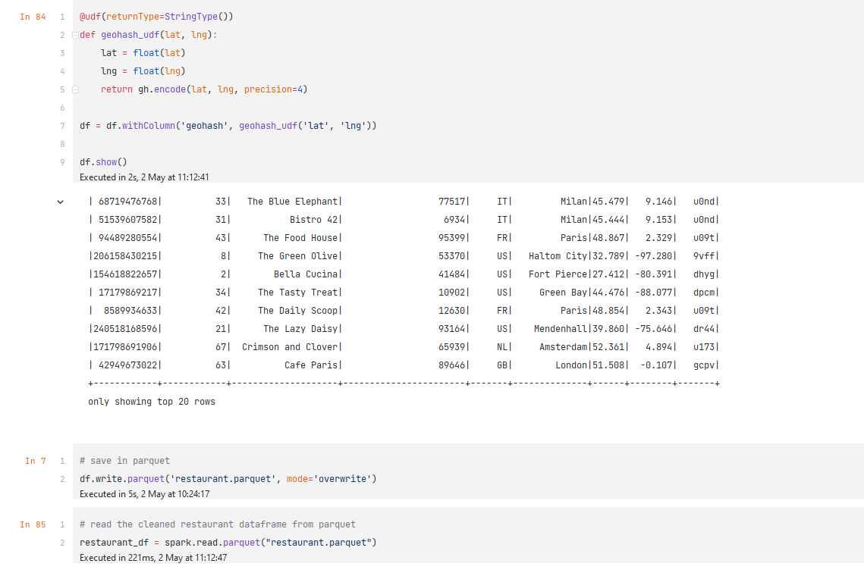

# Working with Weather dataset

## Reading Weather dataset and applying geohash UDF

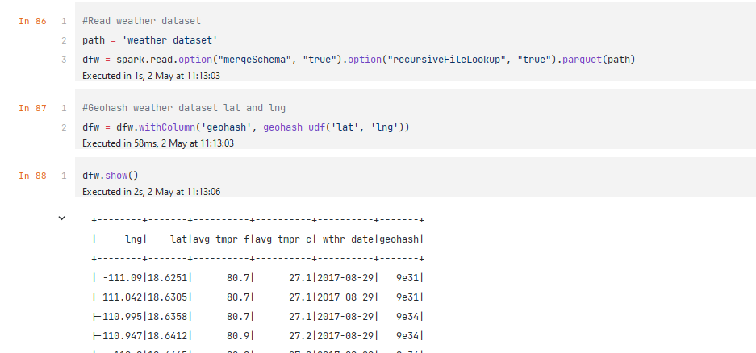

## Deleting duplicated rows

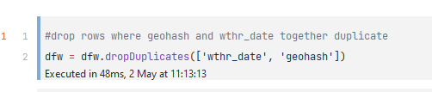

## Saving weather cleaned dataset

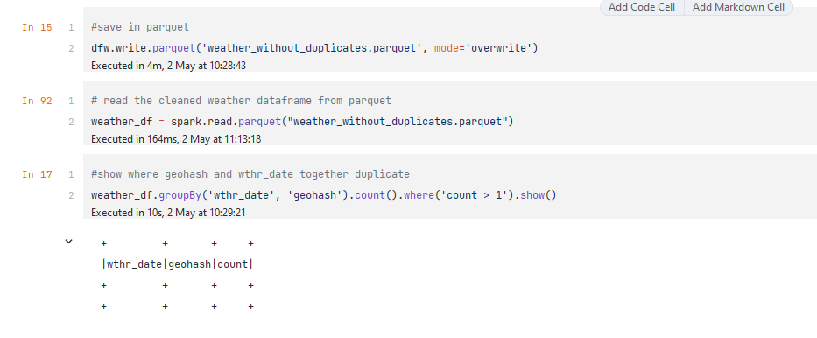Save dataset then read it again to decrease computing time

# Joining Restaurant and Weather Datasets

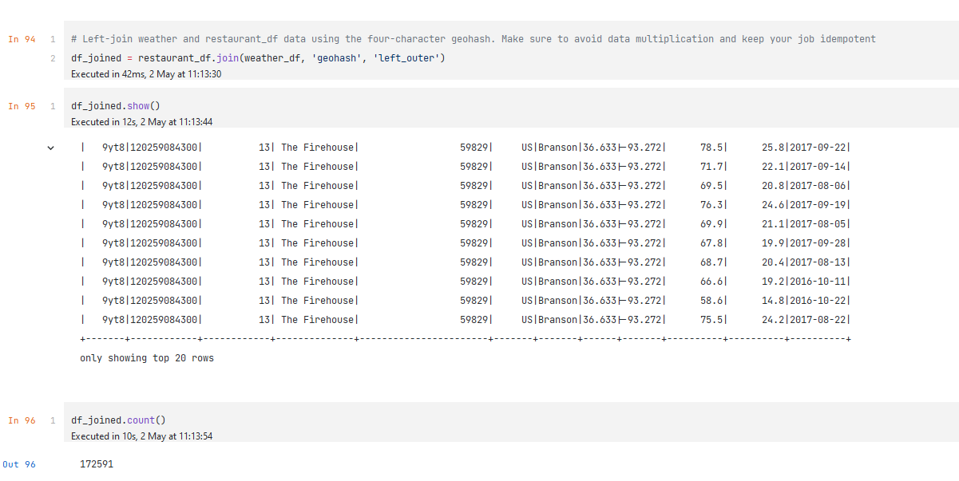

## Cleaning joined dataset from Nulls and Drop Duplicates

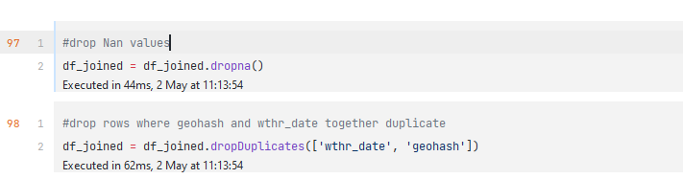

## Saving datasets.

Saved dataset using partitioning by “city” column

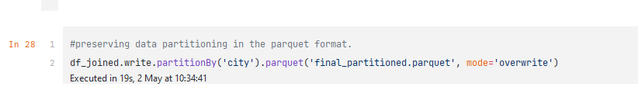

# Testing

I unit test in order to check following UDFs: latitude_udf, longitude_udf, geohash_udf.

Unit test results with positive result:

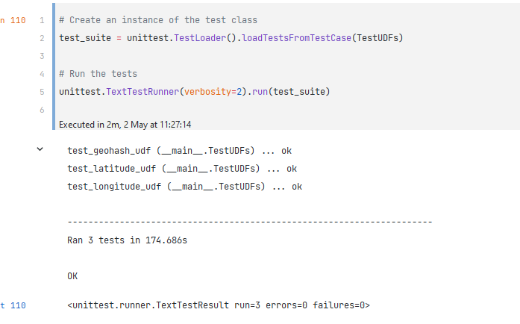

Unit test results with some negative result:

