Defining and using metrics to evaluate the QoS of Web Services invoked from a Workflow engine
Marcela Daniele¹, Paola Martellotto¹, Daniel Riesco², German Montejano², Narayan Debnath³

¹ Universidad Nacional de Río Cuarto, Facultad de Ciencias Exactas, Físico-Químicas y Naturales, Departamento de Computación, Ruta 36 Km 601 CP X5804BYA, Río Cuarto, Córdoba, Argentina,
{paola, marcela}@dc.exa.unrc.edu.ar
² Universidad Nacional de San Luis, Facultad de Ciencias Exactas, Físicas y Naturales, Departamento de Informática, Ejército de los Andes 950 - D5700HHW - San Luis – Argentina, {driesco,gmonte}@unsl.edu.ar
³ Winona State University, Department of Computer Science, MN 55987 – USA
ndebnath@winona.edu

Abstract. The automation of business processes or workflows in organizations produces a significant cost reduction, improved efficiencies, fewer opportunities to make mistakes, and better quality control, which benefits all organizations. At present, the automation of business processes through Workflow Management Systems (WMS) has become a main target for growth and development of organizations. In order to optimize the invocation of applications from a WMS a proposal is made using Web Services. A web service is an open and self-described component that supports rapid composition of distributed applications. Its main advantage is that it allows applications to be more modular and decoupled, facilitating their reuse in different platforms or programming languages. In the context of WMS, the main advantages are the possibility of external applications to be distributed on the network and that it is transparent to WMS. With the increasing number of web services that provide similar functionalities, it is important to put more emphasis on finding the best web service that meets the needs of the applicant, including both their functional and non-functional requirements. Non-functional descriptions of the service forces the applicant to specify, at run time, the quality attributes that can influence the choice of a web service offered by a supplier. In this sense, it is essential to use metrics to evaluate the quality characteristics of web services (QoS), to filter out web services discovered, and obtain the most suitable one. The dynamic behavior of web services regarding the emergence of new web services and constant changes in existing ones requires an ongoing evaluation process, which allows collecting information on web services as well as assessing the adequate quality of this service as requested by the user of WMS. In this work the authors attempt to define and use metrics to evaluate quality attributes of Web services as part of its invocation from a WMS.
Keywords. Workflow, Interface of Invoked Applications, Quality Metrics, QoS, Web Services.
- Introduction
A business process consists of a set of logically related tasks that are executed with the intention of obtaining a result of particular business, which includes both human resources and material resources with the aim of producing a profit for the organization. Modelling business processes allows viewing tasks, activities and flows, and the various organizational units that are affected by the process. The engineering of business processes is defined as the fundamental layout and design of business processes to achieve an improvement in performance measurements such as cost, service quality and speed.
The description and automation of business processes is performed through the Workflow Management System (WfMS). The WfMS provides integrated tools to automate business processes, enabling organizations to standardize and streamline repetitive tasks, and monitor their progress, eliminating routines where it is easy to make mistakes.
The Workflow Management Coalition (WfMC) [1] standardized the automation of business processes. The Workflow Reference Model, developed by the WfMC defines a generic framework for building WfMS, allowing interoperability between them and other applications involved. This model defines five interfaces that allow communication of Workflow applications at different levels. One of them is Invoked Applications Interface [2], which allows the invocation of external applications. The WfMC specifies a set of WAPIs (Workflow Application Programming Interfaces) for managing workflows. These WAPIs define the roles of interfaces and APIs calls to a third-generation language, forcing out information about the application and its invocation in development time. Many WfMS know in advance the applications to use, but there are systems where different applications that provide the same service may be required by the WfMS engine. One possible solution is to use Web Services to specify the Invoked Applications Interface, in order to optimize workflow communication with external applications.
Web services essentially provide a standard means of communication between different software applications, offering the ability to access different services on a unified and interoperable way over the Internet. Web services are registered through the protocol called UDDI (Universal Description, Discovery and Integration) [4] to be located and used by applications. This protocol has some shortcomings while selecting a service. One of these problems is given by the fact that it does not take into account the quality of web services, which refer to the ability of the service to respond to the invocations and implement them in line with the expectations of the supplier and customer. Various quality factors that reflect the client's expectations, including availability, connectivity and high response, become keys to maintain a competitive and viable business. Another of the disadvantages of UDDI protocol is the difficulty of establishing a correspondence between the requirements of the requester and the many Web services specifications currently available that provide similar functionality, but have different syntactic description.
To achieve the goal of optimizing workflow communication with external applications, sections [5] and [6] propose the specification of this interface with web services [3] and apply the technique of Graph Transformation Rules [7] to facilitate dynamic selection of web services, incorporating in this selection the analysis of the characteristics of their quality (QoS) [8].
The specification of the invoked application interface with web services allows transparent distribution of external applications, and thus the WfMS engine can invoke the application without the need to know its exact location. This provides the important benefit that applications can change their location on the network without involving any change in their invocation.
Also, with the addition of QoS to the description of web services, it becomes possible to assess their quality, filter the list of all the services discovered and get the services that best meet the needs of the applicant.
UDDI, the protocol currently used to register and locate Web services on the network, requires a specific description of the application or service that needs to be invoked (somehow trying to describe its semantics), and therefore the query results are limited by the keywords in the search and not entirely reliable.
The application of graph transformation rules can achieve a more precise semantic specification of web service, and establish a correspondence between user requirements and available web services, and the Workflow Engine can choose at the time of invocation. The formalization of the specification as a graph with attributes, allows one correspondence with web services available on the network that conforms to the morphism defined, making the Workflow behave internally in a distributed way. It also facilitates the incorporation of new services, and the invocation is not limited to a specific application, as defined in development time.
An interesting aspect is to determine precisely how the workflow engine makes the contrasting process and finally invokes the web service that best suits the workflow user's requirements. In relation to the QoS, the workflow engine should monitor and record these features internally obtained for the purpose of using this information when selecting a service from a list of all candidate web services.
In this regard, the stated objective is to define and use metrics to evaluate quality attributes during the process of matching the web services offered by vendors and requested by workflow users.
The selection of a Web service requires filtering mechanisms that have discovered services and get the most appropriate one. In this sense, it is essential to use metrics to evaluate the quality characteristics (QoS) of Web services, which due to constantly emerging new services or changes in existing ones, requires that this activity is performed using methods and tools. In [9], the quality estimation model is shown using standard evaluation criteria (ISO / IEC 9126), applied to the specific case of web services as a tool for estimating the quality of these products in a specific way. In [10], there is a proposal of a framework that establishes a contract for the invocation of web services considering the QoS, and from such authors, interesting ideas were obtained for the proposals included in this paper.
This chapter is organized as follows: Section 2 presents the functional specification of Invoked Applications Interface with web services. Section 3 deals with non-functional specification of this interface and includes a description of the desirable quality features in web services. Section 4 details the process of invoking external applications to a workflow, using graph transformation rules for dynamic selection of services. Section 5 describes the metrics used to evaluate the quality attributes of Web services. Finally, the conclusions and references are submitted.
- Functional Specification of the Invoked Applications Interface with Web Services
Generally, in the WfMS, the user requires the use of external applications to perform their tasks, for example, applications that allow using e-mail services, fax, managing their documents, or other user's own applications. The Invoked Application Interface defined by the WfMC allows the WfMS engine to invoke these applications. This interface requires knowledge of application information to be invoked in time of development. While many WFMS applications that will be required are known a-priori, there are also many cases where multiple applications providing the same service may be required by the engine. Even if a specific application must be invoked, it would be useful to reference it in its exact location. In order to allow the WFMS engine to invoke an external application without knowing its location, we describe a solution using web services.
A Web service is an open and self-described component that supports the composition of distributed applications. Its main benefit is that it allows applications to be more modular and decoupled, facilitating their reuse in different platforms or programming languages. Therefore, Web services essentially provide a standard means of communication between different software applications.
WSDL is the specification language used to define web services. It allows providing information about the location of the service and its interface. With this information the user knows how to interact with the service. WSDL provides all this information through XML elements. The two elements () defined in the abstract interface are:
- types: it provides the definition of the data types used to describe the messages exchanged.
- Interface: it describes the sequence of messages that the service sends or receives.
The two elements that are defined in the concrete implementation are:
- binding: it defines specific implementation details of the service.
- service: it is used to associate a binding with the URL that is hosting the service.
The types element defines the input information needed by the WfMS engine to invoke an application. The information is as follows:
- Application Type: on the one hand, it refers to applications related to specific WFMS. For example, in the case of a system that implements the software development process OpenUP/Basic, Java applications that generate code from a design diagram, cost estimate, total duration of a software project, effort, planning tasks, etc. On the other hand, it can also refer to non-specific applications of the WFMS such as office applications like word processors, email clients or spreadsheets.
- WFMS Information: It contains information relevant to the WFMS engine, giving the possibility to identify the relationship between the application and the process instance that requires the application, the specific work item and possible ways of invoking the application (create, update, read-only, print, etc.).
- Parameters: They store information relevant to the application, for example, the name of a file, the identifier of a record, etc.
- Additional Requirements: They store relevant information about the specific characteristics of the application that is being sought, for example, the operating system, geographic location or the specific name of the application (in case the user wants to invoke a concrete application).
As a result of innovation, the WFMS engine returns the name and location of the chosen application. It may happen that the application can not be invoked (which can not be started, which is not defined, which is busy, etc.); this should be reported to the requester. Thus the web service to invoke an application must define the input information, output data and possible errors in the invocation. As an example, Figure 1 shows the specification of the element types of WSDL document that defines a web service invoking an external application. The specification is completed with the other elements mentioned above (interface, binding, service).

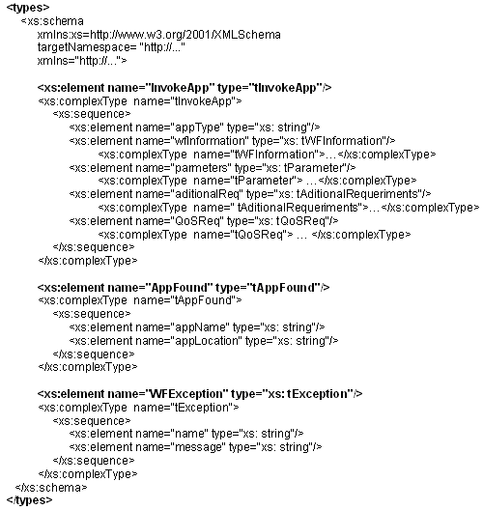
Fig. 1. Functional Specification of the web service.
- Non-Functional Specification of the Invoked Applications Interface with Web Services
The description of a web service has two main components: their functional and non-functional ones [Papazoglou08]. The functional description is a syntactic description that focuses on its functional aspects, detailing the operational characteristics that define the general behavior of a Web service, i.e., defining details of how the service is invoked, location, etc. This description, described in the section above, focuses on the details of the syntax of messages and on how to configure the network protocols to send such messages.
An important requirement for SOA-based applications is to operate reliably and deliver consistent service to a variety of levels. Therefore, the requirements of a web service should not focus only on its functional properties, but also on describing the environment that hosts it, i.e., to describe non-functional capabilities or QoS of the service. Each service can offer various options for non-functional characteristics based on the technical requirements resulting from the demand for availability, performance and scalability, security and privacy policies, etc., which must all be described. On the other hand, the increasing number of web services that provide similar functionality also reveals that it is important to put more emphasis on finding the best web service that meets the needs of the requester.
The non-functional description defines the QoS of the service, such as cost of service, performance metrics, response time, security attributes, authorization, authentication, transactional integrity, reliability, scalability and availability. Non-functional descriptions of the service forces the requester to specify, at run time, the quality attributes that can influence the choice of a web service offered by a supplier. Thus, the specification of the QoS features offered by a Web service becomes a high priority for both the supplier and its customers.
  - Quality Characteristics of Web Services
The quality characteristics of a Web service refer to the ability of the service to respond to the invocations and implement them in accordance with the expectations of the supplier and customer [8]. Various quality factors that reflect the client's expectations, including availability, connectivity, and high response, become key to maintaining a competitive and viable business because they can have a serious impact on the provision of web services. Thus, the QoS features are an important criterion to determine the usability and usefulness of services, which influences their popularity and are a major point of differentiation between the suppliers of those web services.
Considering the quality characteristics of a Web service is a critical and significant challenge due to the dynamic and unpredictable nature of the Internet. Applications with very different characteristics and requirements compete for all resources on the web. Changes in traffic patterns, critical business transactions in terms of security, and the effects of infrastructure failure, create the need to standardize the QoS of a Web service. Often, unresolved QoS features cause critical transactional applications to suffer unacceptable levels of performance degradation.
Traditionally, QoS is measured by the extent to which applications, systems, networks and other Internet technology support the availability of services to a required level of performance, at all input and output conditions. While traditional QoS metrics are applicable, the specific characteristics of web services environments seek to achieve higher availability of applications and increase the complexity in terms of access and service management.
In the context of Web services, QoS can be viewed as the ability to provide security on a set of quantitative characteristics, specifically related to non-functional aspects of services. These characteristics are a necessary requirement for understanding the underlying performance of the service so that other applications and services can invoke and run them as part of their business process.
The assessment of software quality is usually a difficult process to coordinate, because it requires the involvement of actors outside the organization to be evaluated and its members, guiding the assessment according to their needs. In particular, this assessment used in advanced technologies such as Web services become a challenge.
In [9], the authors define QoS as a set of qualitative and quantitative characteristics of a distributed multimedia system, which are necessary to achieve the required functionality in an application. In this sense, the QoS determines the usability and usefulness of the service, influencing its popularity. With the wide spreading of the WS, the QoS has become a significant factor in determining the success a service provider can achieve over others [11]. Measuring QoS in the Internet is a critical and significant challenge due to the dynamic and unpredictable nature of the Web. The QoS covers a range of techniques to harmonize the needs of that required by the service provided, based on available network resources. The QoS of a service accounts for the quality requirements necessary to achieve the functionality expected from it. This defines a way to incorporate some quality characteristics of web services that will later be considered for selecting the most appropriate web service. Table 1 shows the key elements that are considered to support QoS in web services environment. In particular, taking into account the characteristics related to the runtime service.

Table 1. Quality Characteristics of Web Services.
Quality Characteristic | Definition
Performance | Speed to complete a service requirement is measured in terms of throughput, response time, latency, execution time and transaction time.
Performance | Throughput | Number of web service requests served within a period of time
Performance | Response time | Expected time between the moment when a request is sent and a response is received
Performance | Latency | Time between a request for a service to start up and the requirement to be addressed.
Performance | Execution Time | Is the time required by a web service to process the sequence of activities
Performance | Transaction Time | It represents the time that elapses while the web service is completing a transaction
Availability | Probability of the web service to be available
Reliability | Ability of a service to operate correctly and consistently and to provide the same quality despite the flaws in the system or network
Robustness | Degree to which a service reacts properly to abnormal situations, such as invalid, incomplete or conflicting entries

The incorporation of the quality characteristics of Web services offers significant benefits for both users and suppliers. On one hand, users can express their needs and use the web service that best suits them, and on the other hand, service suppliers can publish their capacities of better services through the definition of quality characteristics.
  - Non-functional Specification of the Web Services
Figure 2 shows the non-functional specification of Web service to invoke external applications within the WfMS. Quality characteristics are defined as a new element in the types section of WSDL document.

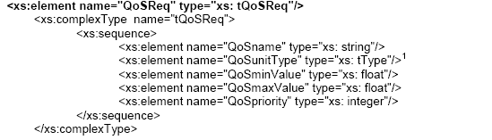Fig. 2. Non-functional specification of the web service.

tType represents an enumerated data type specifying the possible measurement units of QoS of the service (numeric, milliseconds, percentage, etc.).
Figure 3 illustrates an example of WSDL specification of the Availability required for the web service to invoke an application. The minimum and maximum values indicate that the probability that the web service is available should be between 95% and 99%. The web service user defines medium priority for this quality characteristic.
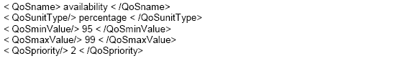 Fig. 3. Specification of the Availability Quality Characteristic.
By incorporating the description of the quality characteristics of web services, these may be taken into account when making the correspondence between user requirements and available web services, as discussed in the following section.
- The Process of Invoking External Applications with Graph Transformation Rules
Currently Web services are registered through the protocol UDDI [4] to be located and used by applications. This protocol requires the syntactic description of the application or service to be invoked and if more than one program offers the same service, which service will be invoked must be defined at development time.
To allow the WfMS engine to select the most suitable application among several that semantically behave the same but have different syntactic description, it is proposed to optimize the selection of services using Graph Transformation Rules, and incorporating the attributes of quality automatic selection. The Graph Transformation Rules allow providing a more precise semantic specification of a Web service, and establishing a correspondence between user requirements and available web services, thereby facilitating their automatic discovery at runtime. In this specification, a web service with more precise semantic, the user can also describe the attributes of quality, to incorporate non-functional aspects of web service selection that best meets user requirements of WfMS.
Figure 4 presents the proposed scheme for web service invocation using Graph Transformation Rules, presented initially in [6]. This figure shows the web services offered by suppliers through UDDI, web services required in the invocation of external applications, correspondence by the workflow engine and web service selection will eventually be invoked.
The workflow engine considers two important elements to make the contrasting process among the services offered and the required application:
- History of Previous Runs: the workflow engine performs the invocation of web services, monitors their quality attributes and records in the history of previous executions. This record contains information that serves the workflow engine to know what the applications were used in the past, and under the same conditions, which were chosen to be invoked. This information includes the name of the application, type, location, operating system, date and quality characteristics timely monitored.
- Quality Characteristics of the WfMS engine itself: the WfMS engine has a record of minimum quality characteristics required to invoke an application. This registration is in addition to the quality characteristics required by the applicant, as specified in its precondition. Its aim is to enable the analysis of those features that were not explicitly required by the applicant, based on the minimum requirements of the WFMS engine that have been predefined by the user.

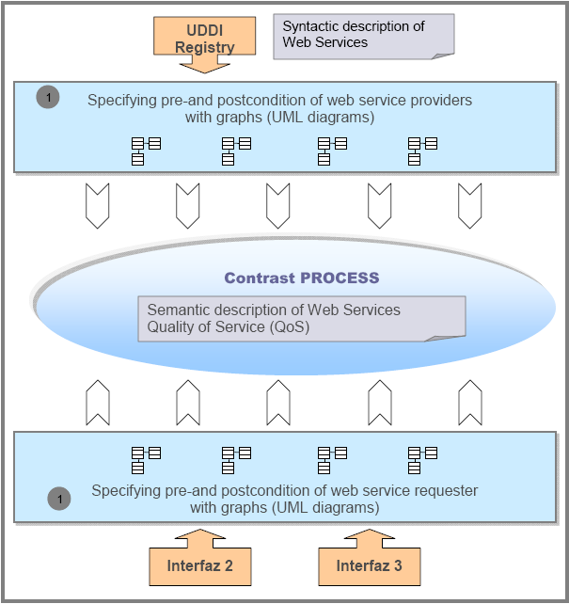
Fig. 4. General scheme for the selection of web services.

In the proposed scheme, the main component of the WfMS engine, which acts as an agent for service discovery, is based on functional requirements and quality characteristics specified by the user and the minimum requirements set by the engine itself. Thus, the engine provides a ranking of Web services available and chooses the most appropriate one. It is also responsible for collecting and processing information from web services offered by suppliers, and keeping it updated as the calls are made. To perform the mapping and final selection, the engine performs the following steps:
- Specifying pre- and post-condition of the requester and the pre and post-conditions of web service suppliers. The pre and post-condition of the requester containing the functional requirements, such as application type, parameters and additional requirements, and non-functional requirements, refer to the quality attributes of the web service. The pre and post-conditions of web service suppliers contain information that is available from the UDDI registry, referring mainly to the functional characteristics of the Web service.
- Realization the contrasting process at the semantic level. The workflow engine searches the UDDI registry of all Web services that correspond to the functional requirements of the requester and obtains a preliminary list of web services. During this contrasting process the workflow engine uses graph transformation technique to analyze the correspondence of services (Fig. 5).
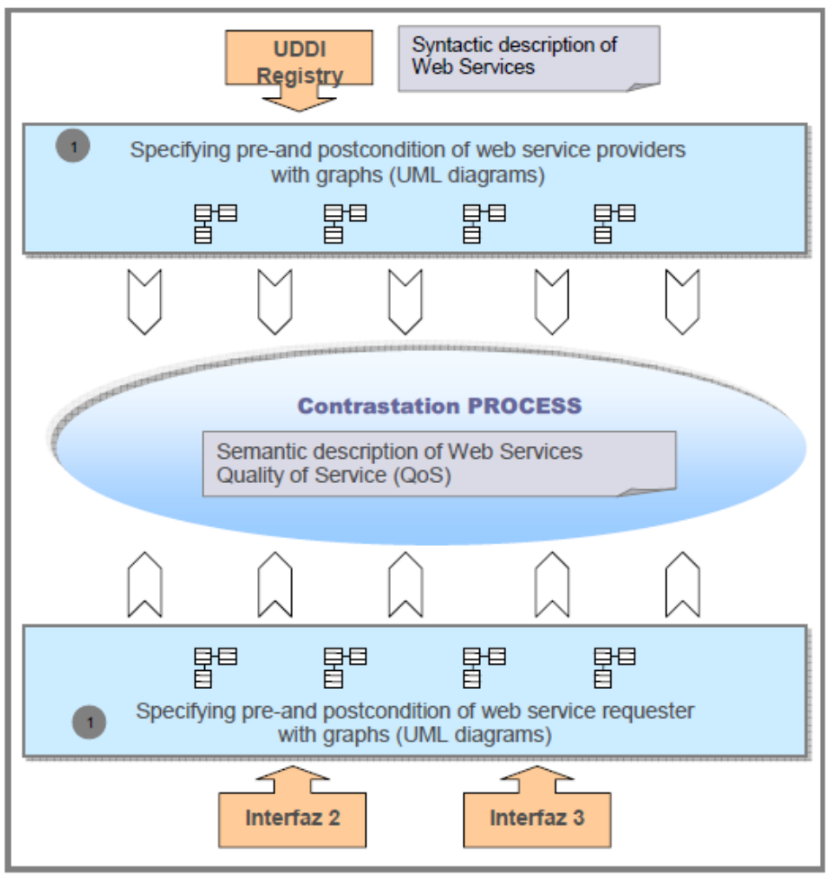Fig. 5. The Contrasting Process in details.

- Realization the contrasting process at the QoS level. To analyze non-functional features, the workflow engine considers non-functional requirements of the requester. In addition, for features not explicitly specified by the requester, the workflow engine consults its own record of quality characteristics.
For the quality characteristics of web services offered, the workflow engine considers:
  - If the Web service has previously been invoked, the workflow engine searches the history of previous executions and checks according to information stored therein.
  - If the Web service has not been invoked before, it analyzes the characteristics during the verification process. It applies metrics for evaluating quality attributes.
When the contrasting process is performed at the QoS level, it is a filter of the preliminary list of candidate web services and gets the web service that best suits the requirements of the requester. If more than one Web service meets the characteristics demanded by the requirements, the workflow engine will apply some additional criteria to choose one of them (For example: the first in the list, or last, etc.) (Fig. 5).
- Finally, the workflow engine invokes the selected web service and stores the execution in the history of previous executions.
- Metrics for evaluate the QoS of a Web Service
As stated in the previous section, during the contrasting process of web services, when considering a service that was not invoked previously, its quality characteristics are assessed by applying the metrics to be defined in this section.
Taking into consideration the quality characteristics related to the performance of web services, described in Table 1 of Section 3: performance, response time, latency, execution time and transaction time, availability, reliability and robustness.
First, we define a measurement unit depending on the characteristic being evaluated. A weight is assigned to each measurement unit, which is based on a defined scale, shown in section 5.1. Then a function is defined, called F, which simply adds the numerical weights obtained for each feature, and gives a total value for each service evaluated. The definition of the weights of the measurement unit and the function F, is given in section 5.2.
Based on these results, the WFMS engine orders and compares services, selecting the service that could get more value according to the weight of its quality characteristics. The engine assumes that the service of greater weight is satisfying further the quality characteristics desired by the requester.
Moreover, considering that each quality characteristic can be measured by its weight and priority, then, an extended function is defined, called Fp, which considers both variables. It is introduced in Section 5.3.
5.1 Defining the weight assignment considering the Measurement Unit
The Measurement Units used are:
- Time Unit: measurement unit that can assign a value in milliseconds, seconds, minutes or hours, depending on the evaluated characteristics.
- Percentage: this unit displays a numeric value between 0 and 100, which is taken from a representative sample, and depends on the assessed property.
Table 2 shows the measurement unit used to measure and evaluate the quality characteristics considered in this work. In addition, this table shows the definition of an identifier for each QoS.

Table 2. Measurement Units for the QoS of the Web Services.
QoS | Measurement Unit | Identifier/Value
Performance | Time Unit | P
Response Time | Time Unit | RT
Latency | Time Unit | L
Execution Time | Time Unit | ET
Transaction Time | Time Unit | TT
Availability | Percentage | A
Reliability | Percentage | R
Robustness | Percentage | Rs

For example, in the case of quality characteristic Availability, a sample consisting of 20 executions of the web service (EWS) is considered, 16 of which result successful. It determines the percentage of service availability (PA), considering the number of times that the web service is available (NTA).

An algorithm is defined to calculate the value of NTA, whereas for each execution it takes into account if the service is available, then the value of NTA is changed for NTA = NTA + 1. The availability percentage PA is calculated as follows:

PA = (NTA / EWS) * 100. | ()

For de Availability the value of PA is:

PA = (16 / 20) * 100 = 80

Each identifier of the QoS assumes the value that is assigned according to the scale given to each measurement unit as shown in section 5.2. Function F sums weights or values for each quality characteristic of the web service measured. This function F is evaluated by the WFMS engine during the contrasting process and is defined as:

F = P + RT + L + ET + TT + A + R + Rs. | (2)

With this information, the workflow engine compares the web services found and measured to select the one service that has achieved the highest score.
5.2 Defining of Weights according to Measurement Unit

To assign a weight to measurement units of Time Unit and Percentage, a scale is defined with the following possible values [0, 0.25, 0.5, 0.75, 1], and each measurement unit is assigned a weight according to that scale. As was indicated in Table 2, the QoS Performance (P), Response Time (RT), Latency (L) Execution Time (ET) and Transaction Time (TT) are evaluated considering the measurement unit Time Unit.
Table 3 shows the values to be assigned to each of these characteristics, considering that the time units can be microseconds, milliseconds, seconds, among others. Then, depending on the quality characteristic involved and the service that is to be evaluated, it will be necessary to define the maximum and minimum time, and intermediate times for each desirable QoS. This definition allows changing these settings as needed.

Table 3. Value assigned to quality characteristics evaluated with Time Units.
Measurement Unit Time | Value by scale
T_{max}: maximum time for the evaluated QoS | 0
T_{maxm}: defined as T_{max} > T_{maxm} > T_{med} | 0.25
T_{med}: medium time defined by  T_{med} = (T_{min} + T_{max}) / 2 | 0.5
T_{minm}: defined as T_{med} > T_{minm} > T_{min} | 0.75
T_{min}: minimum time for the evaluated QoS | 1

The Availability (A), the Reliability (R) and the Robustness (Rs) characteristics are measured in percentage and their value is obtained from Table 4.

Table 4. Value assigned to quality characteristics evaluated with Percentage.
D= Measurement Percent | Value by scale
0 | 0
Between 0.01 % y 25 % | 0.25
Between 25.01 % y 75 % | 0.5
between 75.01 % y 99.99 % | 0.75
100 | 1

For the availability, the value obtained would be 0.75.
5.3 Assigning priorities to the quality characteristics
Table 5 shows the priority values determined by the user requesting a service, and assumed by the considered QoS. This should be configured on the Invoked Applications Interface of the WFMS.

Table 5. Value assigned to the QoS according to priority.
Priority | Value by scale
Low | 1
Medium | 2
High | 3

Then the function with priorities (Fp) assigned for each QoS is defined in 3.

Fp = P*Pp + RT*RTp + L*Lp + ET*ETp + TT*TTp + A*Ap + R*Rp + Rs*Rsp | (3)

For the WFMS engine to have the necessary information to obtain the value of Fp, the user must determine and report the priority of each desired characteristic, and this will be reflected in the non-functional specification of the web service request, given in section 3.2. Figure 3 provides an example of specifying the characteristic Availability, with priority requirement means, in which the value assigned according to Table 5 will be 2.
- CONCLUSIONS
The automation of business processes or workflows in organizations has produced significant cost saving, increased efficiency, fewer opportunities to make mistakes, and better quality control and benefits all organizations. At present, the automation of business processes has become a main target for the growth and development of organizations. The use of web services as part of the interface of the WFMS Invoked Applications provides important benefits such as application-transparent distribution outside the workflow, i.e., the workflow engine can invoke applications without knowing its exact location, with the important benefit of such applications that it could change its location on the network without involving any change in its invocation from the workflow that uses it.
With respect to quality characteristics of web services, which currently have a client who wants to access a service who is not only interested in the functional aspects of the service, but in its quality characteristics, i.e., all non-functional attributes that can have a high impact on quality of service offered by a supplier. Thus, the incorporation of non-functional requirements in the definition of web service is vital when you want to select the most appropriate web service that meets all user requirements.
Moreover, as there are multiple web services in UDDI registry that provides similar functionality, quality characteristics are used to search much more sophisticated customer needs. With the addition of these characteristics to the description of a Web service it is possible to assess its quality, filter the list of all discovered services and run the application that best fits the needs of the applicant. The main advantage of this integration is that it is not necessary to modify the current web service model defined by the UDDI protocol.
Using metrics to evaluate the quality characteristics of Web services available on the net, the goal is to capture the relevant information regarding the functionality of the service and the evaluation of the quality for the request in certain contexts and offered by suppliers.
The metrics allow the workflow engine to monitor the quality attributes, since in the list of candidates some web services appear that had not been previously invoked, and therefore, they are not stored in the history of previous runs, or simply when need to update the stored values.
Another important benefit is given by the use of graph transformation rules, which allows the results of the consultations on the UDDI protocol not to be limited by the keywords defined at design time, encouraging the dynamic selection of web services.
References
- Workflow Management Coalition. The Workflow Reference Model. WfMC-TC00-1003. http://www.wfmc.org/standards/referencemodel.htm. Último acceso Mayo 2008.
- Workflow Management Coalition. Programming Interface 2&3 Specification. WfMC-TC-1009.V2.0. http://www.wfmc.org/standards/publicdocuments.htm. Últ. acceso Mayo 2008.
- World Wide Web Consortium. Web Service Architecture. http://www.w3.org/TR/ws-arch/. Último acceso Mayo 2008.
- OASIS. UDDI Version 3.0.2. http://uddi.org/pubs/uddi_v3.htm. Últ. acceso Mayo 2008.
- Daniele Marcela, Martellotto Paola, Riesco Daniel. Mejorando la Invocación de Aplicaciones desde un Workflow: Un caso de estudio. XXXV Conferencia Latinoamericana de Informática - XXXV CLEI. Universidad Federal de Pelotas. Pelotas, Brasil. 22 al 25 de Septiembre de 2009. Páginas 550 pp. ISBN 978-987-24611-0-2.
- Martellotto Paola, Daniele Marcela , Riesco Daniel. Invocación de Aplicaciones desde el Workflow con Servicios Web considerando sus Requerimientos No Funcionales. 38th Argentine Conference on Informatics – JAIIO 2009. 10th Argentine Symposium on Software Engineering – ASSE 2009. 24 al 28 de Octubre de 2009. Mar del Plata – Argentina. Páginas 160-165. ISSN 1850-2776.
- Baresi L., Heckel R. Tutorial Introduction to Graph Transformation: A Software Engineering Perspective. First International Conference on Graph Transformation. Spain. v. 2505, pp. 402-429. (ICGT 2002). 2002.
- Papazoglou M., Web Services: Principles and Technology. Ed. Pearson Education Limited, Prentice Hall, First Edition. 2008.
- María Pérez, Luis E. Mendoza, Anna C. Grimán. Modelo para estimación de la calidad de un Web Service. Universidad Simón Bolívar, Departamento de Procesos y Sistemas, LISI, 2006.
- Marco Comuzzi and Barbara Pernici. A Framework for QoS-Based Web service Contracting. In ACM Transactions on web, Vol. 3(3), June 2009.
- Mani, A. y Nagarajan, A. Understanding Quality of service for Web Services, (2002). http://www-106.ibm.com/developerworks/webservices/library/ws-quality.html

