Remote sensing analysis of agricultural transformation in Italy
  - Italy land cover from 1992 to 2022 and a Bologna satellite pilot
Remote sensing workstream
Revision 2 for team review
28 October 2026

Purpose and scope
This technical contribution documents national, regional and province-level mapped cropland change in Italy between 1992 and 2022. Seven selected years support a panel for subsequent modeling. A separate Bologna optical and radar pilot demonstrates recent vegetation and surface monitoring. A probability sample has been prepared for independent reference labelling; measured accuracy is not yet available.
The analysis distinguishes mapped changes, their interpretation and the evidence still needed for validation. Provincial crop identification and causal attribution require separate agricultural, climatic and socioeconomic evidence.
Component | Coverage | Status
National land cover | Italy 20 regions and 110 provinces across seven selected years | Snapshot and interval tables completed
Optical pilot | Bologna June 2019 to 2025 and April to September 2025 | Pilot summaries completed
Radar pilot | Bologna April to September 2025 | Single orbit summaries completed
Crop specific and causal modeling | Italy provinces and regions | Further modeling and independent validation required

Plain language glossary
NDVI measures the contrast between near infrared and red light and helps describe vegetation greenness. Backscatter is the radar signal returned to the satellite. A mask selects the pixels included in a calculation. A mosaic is a pixel containing a mixture of land cover types. Net change equals gains minus losses. Validation checks a result against independent evidence.

1 Executive summary
Using cropland classes 10, 11, 12 and 20, the mapped area decreased from 140,149.3 km² in 1992 to 139,192.1 km² in 2022. The net change was -957.3 km², or -0.68 percent. These are areas of classified pixels within a common boundary mask, not official agricultural census estimates. Across the seven snapshots, strict mapped cropland is highest in 2002 at approximately 141,283.4 km², followed by decreases through 2022. This is a descriptive map pattern (C3S, 2019; ISTAT, 2026).
Measure | Result
Mapped gross loss | 4,252.4 km²
Mapped gross gain | 3,295.1 km²
Loss mapped as urban at the second endpoint | 3,081.3 km²
Largest regional net decreases | Lombardia and Veneto
Largest regional net increases | Sardegna and Toscana
For the fixed WorldCover 2021 cropland mask in the Bologna pilot, June 2025 NDVI was 0.4585. The June 2019 to 2024 average was 0.5375; the difference was -0.0790 NDVI units. June 2025 was the lowest June value in this seven year pilot series.
A lower NDVI can reflect crop timing, harvesting, irrigation, crop changes, weather or residual image problems. This result alone does not demonstrate drought, reduced yields or declining farm profitability. Radar changes likewise require interpretation with field and weather information.

Recommended use by the team
The modeling workstream can use the province and regional totals as descriptive land cover evidence. The statistics workstream should align agricultural definitions and years before comparison. Policy interpretation should retain alternative explanations until independently supported. Figures should display their geographic scope and uncertainty.

2 Data and geographic scope
Source | Data used | Purpose
ESA CCI and Copernicus land cover | 1992 1997 2002 2007 2012 v2.0.7cds and 2017 2022 v2.1.1 nominal 300 m | Long term land cover endpoints
ISTAT administrative boundaries | 20 regions and 110 province-level units at 1 January 2026 | Common mask for both endpoints
Sentinel 2 surface reflectance | COPERNICUS/S2_SR_HARMONIZED | Recent vegetation index pilot
ESA WorldCover | 2021 v200 cropland class 40 at 10 m | Fixed pilot cropland reference
Sentinel 1 GRD | IW VV and VH descending relative orbit 95 | Recent radar pilot
The national land cover downloads cover 35 to 48 degrees north and 6 to 19 degrees east. Neighboring countries were removed with the ISTAT regional polygons. Both land cover rasters share a 4680 by 4680 latitude and longitude grid, approximately 1 divided by 360 degree spacing. Official 2026 ISTAT province polygons were also rasterized on exactly the same grid; province and region masks have no coverage disagreements (ISTAT, 2026).
The Bologna area is a rectangle from 11.2 to 11.5 degrees east and 44.4 to 44.6 degrees north. It is a pilot area near Bologna, not the administrative province. It includes urban land and hills; the cropland statistics use a separate fixed mask.

Why the datasets cover different periods
Historical land cover is now summarized for 1992, 1997, 2002, 2007, 2012, 2017 and 2022. These seven snapshots support panel construction, while annual timing between snapshots remains unobserved. Sentinel 1 and Sentinel 2 cannot provide 1992 observations. A historical NDVI series would require a separate Landsat workflow, harmonization and validation.
The two land cover versions belong to the same product family and processing chain, but differences in observing systems and classification uncertainty still affect change estimates. A class change is a mapped transition requiring verification, rather than a direct field observation of conversion. The 1992 mirror data were checked pixel by pixel against the original CDS subset before intermediate archive data were incorporated; all 21,902,400 cells matched. The four added years through 2012 use v2.0.7cds and 2017 uses v2.1.1 (C3S, 2019; Microsoft, n.d.).

3 National land cover method
First, read lccs_class from each NetCDF file and confirm that latitude and longitude coordinates match exactly. Preserve categorical values and do not smooth or interpolate class codes.
Second, transform the ISTAT 2026 regional and province polygons from their supplied CRS to geographic coordinates and assign each grid cell by its center. Apply those same boundaries to every year. This holds geography constant and does not reconstruct historical administrative boundaries (ISTAT, 2026).
Third, calculate the WGS84 ellipsoidal area of a cell for each latitude row and sum these areas. Nominal 300 m pixels do not all represent the same ground area on a latitude and longitude grid.
Fourth, define the principal cropland group as classes 10, 11, 12 and 20. A loss is cropland in 1992 and another valid class in 2022; a gain is the reverse. Stable cropland remains in the group at both endpoints.
Fifth, summarize all seven snapshots and the six consecutive intervals by ISTAT region and province code. Repeat all three class definitions. Verify grid identity, a common valid footprint, province to region to national reconciliation, and gain minus loss equals net change. These accounting checks pass; they are not independent classification validation.
Definition | 1992 km² | 2022 km² | Net km²
Principal classes 10 11 12 20 | 140,149.3 | 139,192.1 | -957.3
Principal plus mosaic class 30 | 150,566.4 | 149,420.3 | −1,146.1
Principal plus mosaic classes 30 and 40 | 163,592.6 | 160,497.0 | −3,095.6
Class 30 is a cropland dominant mosaic; class 40 is a natural vegetation dominant mosaic. Counting an entire mosaic pixel as cultivated land would overstate cultivated area. The final row describes the footprint of a mixed landscape, not a pure cropland estimate.
The common valid pixel footprint covers approximately 301,441.2 km². All cells assigned to Italy have a valid class in both dates. Pixel center assignment produces a boundary approximation, so this footprint need not equal the official polygon area.

4 National and regional findings
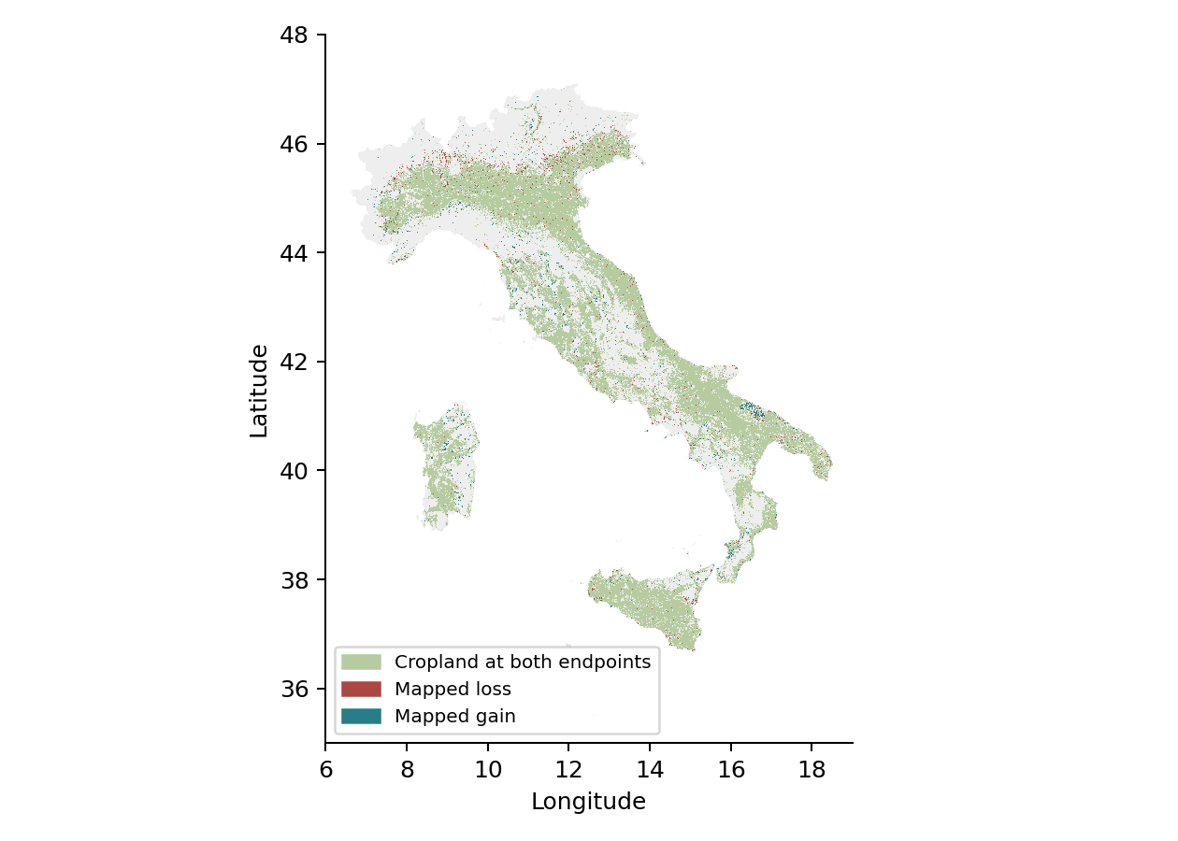
Figure 1. Mapped cropland persistence, loss and gain between 1992 and 2022. Display is reduced for readability; areas were calculated on the original grid. Gray indicates other land within the common Italy mask. Source: ESA CCI and C3S land cover with ISTAT boundaries.
Loss and gain occur simultaneously. The national net decline therefore hides substantial spatial turnover. The largest mapped destination of principal cropland loss is urban class 190, approximately 3,081.3 km². Classification and boundary uncertainty prevent treating this number as a validated estimate of development on farmland.
Lombardia and Veneto show the largest regional net decreases under the principal definition. Sardegna and Toscana show the largest net increases. Regional ranking and magnitude can change when mosaic classes are included; the national direction remains negative under all three tested definitions.

5 Sentinel 2 vegetation pilot
For each monthly interval, surface reflectance image records were filtered to the Bologna rectangle. Scene classification values 0, 1, 3, 8, 9, 10 and 11 were excluded. NDVI was calculated for each image as near infrared B8 minus red B4, divided by their sum. Monthly values are the pixelwise median of image NDVI, followed by a spatial mean over eligible cropland.
The principal optical summary requires at least three retained image records per pixel; records are not necessarily unique acquisition dates. The Bologna pilot retrospectively applies a fixed WorldCover 2021 cropland mask to every pilot year, including 2019 and 2020. This pilot-specific choice differs from historical production analysis, which uses the annual CCI/C3S maps. The 10 m export grid is EPSG 32632; scene classification has coarser native resolution than the optical bands (Zanaga et al., 2022; Google, n.d.a).
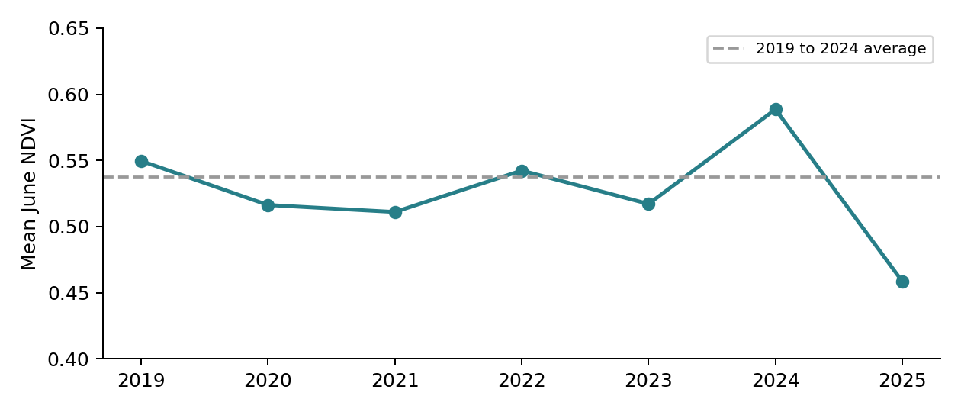
Year | June NDVI | Eligible cropland percent
2019 | 0.5496 | 100.00
2020 | 0.5163 | 99.58
2021 | 0.5110 | 99.77
2022 | 0.5423 | 98.04
2023 | 0.5171 | 100.00
2024 | 0.5886 | 97.22
2025 | 0.4585 | 100.00
Figure 2 and table. Three record filtered June results. Eligible coverage exceeds 97 percent in every June. Removing the three record requirement changes annual June means by at most about 0.00175 NDVI units. Different years can still represent different pixel subsets.

6 Seasonal optical and radar findings
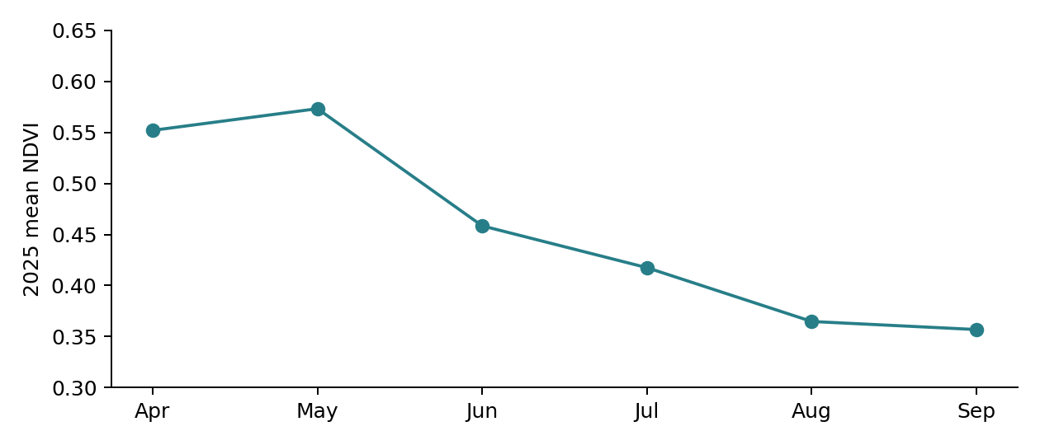
Figure 3. In 2025, pilot mean NDVI rises from April to May and declines through September. This is a seasonal description. Crop development and harvest timing can produce this pattern without indicating permanent land degradation.
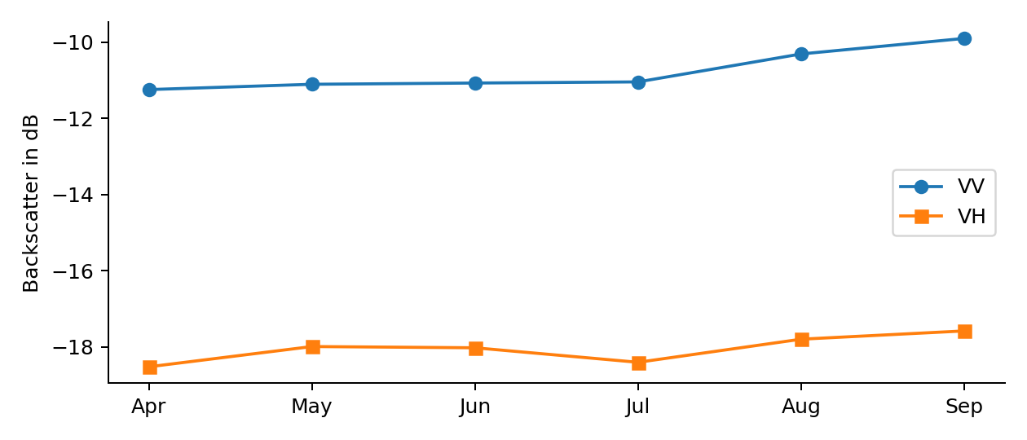
Figure 4. Sentinel 1 descending orbit 95 provides a consistent viewing geometry. Each image is converted from dB to linear power, averaged through time, then spatially averaged over cropland and converted back to dB. Monthly record counts are 6, 8, 7, 8, 7 and 8. All six monthly cropland summaries have complete reported coverage. (Google, n.d.b).
VV becomes less negative by about 1.34 dB between April and September; VH changes by about 0.94 dB. Radar is sensitive to surface moisture, roughness and vegetation structure. These observations are not calibrated soil moisture measurements. Additional speckle filtering, incidence angle screening and terrain normalization were not implemented in this pilot.

7 Work plan and mentoring coordination
The team execution and mentoring window is November 2026 to February 2027, with five mentoring sessions. The allocation below is a proposed sequence within that window; exact dates and session placement require team confirmation. It replaces the earlier one-month work plan. Completed endpoint, province and pilot outputs provide the starting evidence.
No | Proposed period and focus | Review output
1 | November 2026 scope and data definitions | Freeze geography class rules and model inputs
2 | December 2026 seven-year panel review | Review versions grid checks and statistics joins
3 | January 2027 reference interpretation | Review sample labels evidence and disagreements
4 | Late January 2027 model and uncertainty review | Review accuracy results if labels complete and model diagnostics
5 | February 2027 final report and presentation | Review supported claims Harvard references and submission

Model integration and handoff
Use the coded CSV outputs for model joins. Province geography_id is the zero-padded ISTAT COD_PROV; region_id is COD_REG. The companion istat_uts_id documents COD_UTS, which can differ for metropolitan cities. Preserve the 2026 boundary vintage and class definition with each result. Bologna remains a rectangle pilot identifier, not a province-wide estimate.
For a shared table, use fields geography_id, geography_type, period_start, period_end, variable, value, unit, source_product, product_version, class_definition and quality_note. For monthly optical summaries also retain eligible_cropland_percent, minimum_image_records and mask_year.
Satellite preparation and quality records belong to the remote sensing workstream. Modeling integrates features and tests associations; statistics aligns agricultural definitions; policy synthesis evaluates supported explanations; visualization and project coordination manage figures and milestones. Independent labelling roles should be agreed before the reference sample is interpreted.

8 Quality limits and remaining analysis
Issue | Implication and required follow up
Seven selected years | Six consecutive intervals are available; annual timing and shorter fluctuations remain unobserved.
No independent change validation | 265 cells have been sampled for independent interpretation. Accuracy and corrected areas remain unavailable until labelling and adjudication are completed.
Coarse historical classes | The maps cannot identify individual crops or field management. Use agricultural statistics and suitable crop labels.
Uneven seasonal optical coverage | Some April May August and September comparisons have low eligible area. Screen coverage before forming baselines.
Pilot scope and fixed 2021 mask | Results cannot be generalized to Italy or automatically treated as the same active fields every year.
No climate attribution | Link weather and irrigation information and test alternative explanations before naming drought impacts.
A pragmatic 90 percent coverage screen is recommended for seasonal comparisons. It is an analyst choice, not a validated scientific cutoff. All June comparisons pass; several other historical months fail. A mean from a very small clear subset should not be compared unqualified with a near complete month.

What is ready and what remains
Ready for review: seven-year snapshot and interval tables for 110 provinces and 20 regions, the original 1992 to 2022 comparison and three cropland definitions, Bologna pilot exports, and a 265-cell unlabelled validation package. Remaining: independent labelling and observed accuracy, historical NDVI, crop-specific mapping, climate and policy analysis, and final confirmation of mentoring dates.
Five-year snapshots do not isolate a potential version discontinuity between 2015 and 2016; adjacent-year checks remain advisable. No observed accuracy percentage or empirical confidence interval is claimed. Sample-size planning assumptions are not validation results. The national net change remains sensitive to map uncertainty. Corrected areas and uncertainty should be calculated only after independent reference interpretation is complete.

9 Regional and province results
The table below retains the strict regional endpoint summary for reference. Coded companion CSVs provide the same 1992 to 2022 metrics for all 110 provinces, as well as seven-year snapshots and consecutive intervals. All totals use common 2026 geography and geodesic km² areas. Rounding is for display only.
Region | 1992 km² | 2022 km² | Net km²
Abruzzo | 4,369.1 | 4,323.2 | -46.0
Basilicata | 5,827.6 | 5,857.7 | +30.1
Calabria | 6,266.0 | 6,436.4 | +170.3
Campania | 5,751.6 | 5,665.4 | -86.2
Emilia-Romagna | 13,046.5 | 13,017.6 | -28.8
Friuli-Venezia Giulia | 2,996.3 | 2,808.2 | -188.1
Lazio | 8,438.8 | 8,344.8 | -94.1
Liguria | 242.9 | 252.5 | +9.7
Lombardia | 10,531.8 | 9,933.3 | -598.5
Marche | 6,027.8 | 5,973.9 | -54.0
Molise | 2,624.1 | 2,620.0 | -4.2
Piemonte | 9,050.0 | 8,963.2 | -86.8
Puglia | 13,888.1 | 13,847.1 | -40.9
Sardegna | 10,120.1 | 10,425.3 | +305.2
Sicilia | 18,269.5 | 18,092.3 | -177.2
Toscana | 8,196.8 | 8,499.8 | +303.0
Trentino-Alto Adige/Südtirol | 863.4 | 952.2 | +88.8
Umbria | 3,771.8 | 3,820.5 | +48.7
Valle d'Aosta/Vallée d'Aoste | 15.9 | 18.3 | +2.4
Veneto | 9,851.3 | 9,340.4 | -510.9
Province totals reproduce regional and national results. The largest province to regional aggregation difference is below 3 × 10⁻¹⁰ km². The principal national net remains −957.2704 km². Small regions, coastlines and fragmented fields remain sensitive to grid and classification effects; net increase does not identify crop type or production growth.

Intermediate year panel
Seven selected years now provide real observations for panel construction. The 1992 and 2022 CDS endpoints are retained; the five intermediate snapshots use matching CCI/C3S versions from the Microsoft archive. The exact 1992 bridge comparison supports consistency of the data route, while product-version and sensor effects still require investigation (C3S, 2019; Microsoft, n.d.).
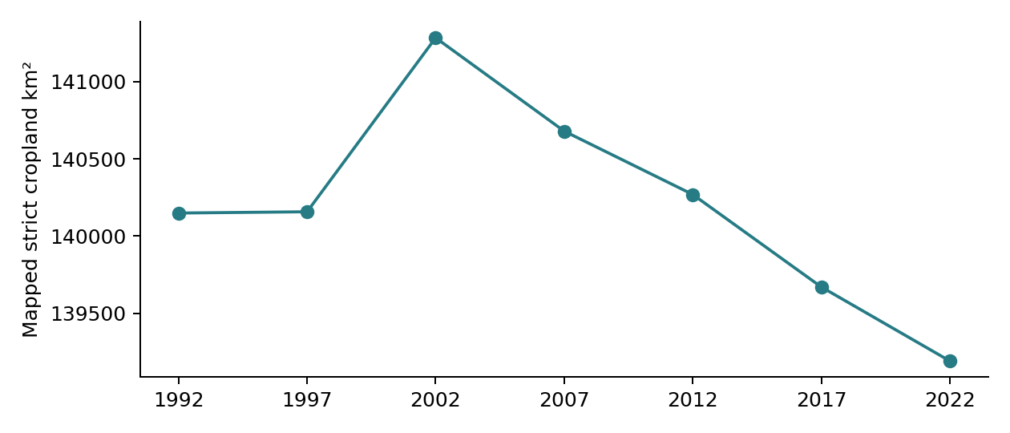
Year | Strict cropland km² | Product version
1992 | 140,149.3 | v2.0.7cds
1997 | 140,157.6 | v2.0.7cds
2002 | 141,283.4 | v2.0.7cds
2007 | 140,679.4 | v2.0.7cds
2012 | 140,269.5 | v2.0.7cds
2017 | 139,671.0 | v2.1.1
2022 | 139,192.1 | v2.1.1
Figure 5 and table. Strict cropland area on the common seven-year footprint. Companion snapshots retain coded geography and metadata; intervals describe persistence, gain, loss and net change. Lines join selected snapshots; intervening annual changes are unobserved. These observations make a panel possible but do not provide agricultural or climate covariates, validate map changes or establish a causal explanation.

Validation design and labelling
A national strict 1992 to 2022 change sample contains 265 cells. Four strata cover stable cropland, mapped gain, mapped loss and stable other land. Stable other land is included so accuracy can refer to the full study area. The response unit is each original cell footprint, rather than its center alone (Olofsson et al., 2014).
Mapped stratum | Area share percent | Sample draws
stable cropland | 45.082 | 76
gain | 1.093 | 50
loss | 1.411 | 50
stable other | 52.414 | 89
The team sample-size function gives a nominal 169 draws under a target overall-accuracy SE of 0.02 and assumed user accuracies 0.90, 0.80, 0.80 and 0.95. Minimum allocation of 50 draws per stratum raises the total to 265. These are planning assumptions, not measured accuracies; actual precision may differ.
Independent draws use probability proportional to geodesic cell area within each stratum, with replacement and seed 20261028. No duplicate cells occurred. Area weights and all draws are retained. The existing area-adjusted estimator is used only after complete independent labels are supplied; finite population correction is not applied. This design supports a national strict endpoint assessment, not a separate accuracy estimate for every province or interval.
The proposed workflow is primary interpretation coordinated by the remote sensing workstream, independent second interpretation of all gain and loss cells plus a reproducible 20 percent of stable cells, and adjudication of disagreements. Reviewer availability and allocation remain to be agreed. Blind cell footprints and a separate coordinator key reduce map-guided interpretation.
For each date, record the reference class, provider, scene or photograph identifier, actual acquisition date, reviewer and confidence. Use appropriate historical evidence; current imagery cannot establish the 1992 class alone. Do not use the assessed map or its derivatives as reference truth. Uncertain cells remain unlabelled for adjudication. The estimator refuses incomplete labels; no observed accuracy or confidence interval is reported at this stage.

10 Sources and reproducibility notes
Harvard references are listed below. The original CDS inputs and pilot documentation were checked on 20 October 2026. Province boundaries were accessed on 27 October 2026; archive metadata and the validation-method reference were checked on 28 October 2026.
Copernicus Climate Change Service (C3S) (2019) Land cover classification gridded maps from 1992 to present derived from satellite observations. Versions 2.0.7cds and 2.1.1. Climate Data Store. doi:10.24381/cds.006f2c9a. Available at: https://cds.climate.copernicus.eu/datasets/satellite-land-cover (Accessed: 20 October 2026; metadata rechecked 28 October 2026).
Google (n.d.a) Harmonized Sentinel 2 MSI Level 2A surface reflectance. Earth Engine Data Catalog. Available at: https://developers.google.com/earth-engine/datasets/catalog/COPERNICUS_S2_SR_HARMONIZED (Accessed: 20 October 2026).
Google (n.d.b) Sentinel 1 algorithms. Google Earth Engine guides. Available at: https://developers.google.com/earth-engine/guides/sentinel1 (Accessed: 20 October 2026).
Istituto Nazionale di Statistica (ISTAT) (2026) Confini delle unità amministrative a fini statistici al 1 gennaio 2026. Non-generalised regional and province boundaries. Available at: https://www.istat.it/storage/cartografia/confini_amministrativi/non_generalizzati/2026/Limiti01012026.zip (Accessed: 27 October 2026).
Microsoft (n.d.) ESA Climate Change Initiative Land Cover Maps. Planetary Computer archive. Available at: https://planetarycomputer.microsoft.com/dataset/group/esa-cci-lc (Accessed: 28 October 2026).
Olofsson, P., Foody, G.M., Herold, M., Stehman, S.V., Woodcock, C.E. and Wulder, M.A. (2014) 'Good practices for estimating area and assessing accuracy of land change', Remote Sensing of Environment, 148, pp. 42–57. doi:10.1016/j.rse.2014.02.015.
Zanaga, D. et al. (2022) ESA WorldCover 10 m 2021 v200. Zenodo. doi:10.5281/zenodo.7254221. Available at: https://developers.google.com/earth-engine/datasets/catalog/ESA_WorldCover_v200 (Accessed: 20 October 2026).

Processing record
The source manifest records exact archive item identifiers, original URLs, versions and access dates. The intermediate-year extraction uses Microsoft Planetary Computer cloud-optimized copies of CCI/C3S class data. The 1992 bridge check is exact. NetCDF source files, intermediate rasters and private credentials are excluded from the review package; processing scripts and checks document their use.
The four original Bologna CSV exports are retained with original names and column schemas. The current pilot findings were not rerun in Earth Engine during this report revision. The validation files contain blank reference fields; no synthetic or guessed reference labels are included.

