# 基础知识：

* <https://www.bilibili.com/video/BV1HJ411a7AN?p=2>
* <https://blog.csdn.net/qq_43680229/article/details/84072607>
* 最权威：参考STM32F4XX官方的参考手册P607~P647

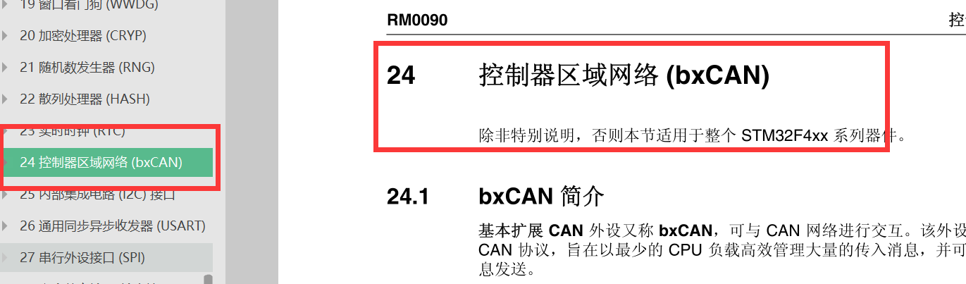

# CAN通信-电机控制：

* <https://blog.csdn.net/ORANGEbb/article/details/111938429>
* <https://blog.csdn.net/qq_50964344/article/details/115875390?utm_medium=distribute.pc_relevant.none-task-blog-2~default~BlogCommendFromMachineLearnPai2~default-2.no_search_link&depth_1-utm_source=distribute.pc_relevant.none-task-blog-2~default~BlogCommendFromMachineLearnPai2~default-2.no_search_link>