SAPS KWAZULU-NATAL
Digital Control Room
Overview of the demonstration platform

For the SAPS KZN management team
11 October 2026
Prepared by Nordien
Demonstration build. All data is made up.

1. The problem and the idea
A call to the 10111 line can wait a long time for an answer, and many calls are never answered. The national police response times reported to Parliament are about 25 to 29 minutes (Alpha 28:30, Bravo 25:45, Charlie 24:34, as of 30 April 2026, from a written reply to Parliament).
Those figures measure how long police take to arrive, not how long a call takes to be answered. They come from a search summary of the reply and should be checked against the reply itself before anyone quotes them outside the team.
The idea. A citizen opens the app and taps Calling 10111. It looks like the emergency line, but the call is answered by a SAPS KZN control-room desk that runs on this platform. Crime reports, anonymous tips and requests for help with gender-based violence (GBV) come in the same way. Each report becomes one case file, with one number, that travels from the citizen to the desk, on to a police station or unit, and up to Provincial HQ.
What this is. A demonstration. The data is made up, nothing reaches a real police station, and a person stays in the loop at every step. Its purpose is to show what is possible and the technical capacity behind it. If you like it, a working prototype is the next step.

2. The platform at a glance
Screen | Who uses it | Device | What it does
Citizen app | The public | Phone | Emergency call, crime report, anonymous tip, unsafe place, profile. English and isiZulu.
Weather app | Someone who cannot safely ask for help openly | Phone | Looks like a weather app. A hidden door to GBV help.
Control room desk | Officers in four sections: call centre, desk, tip-off line, GBV | Computer | Answers calls, checks reports and tips, sends files for action.
Station, unit and partner pages | Police stations, units, care centres, shelters | Phone or computer | Each has its own private page showing only its own tasks.
HQ board | Provincial Commissioner and HQ | Computer | Sees everything, decides, directs. Statistics, tips, referrals, accountability.

HQ owns the whole process. The next page shows how a report moves between the citizen, the desk, the action points and HQ.
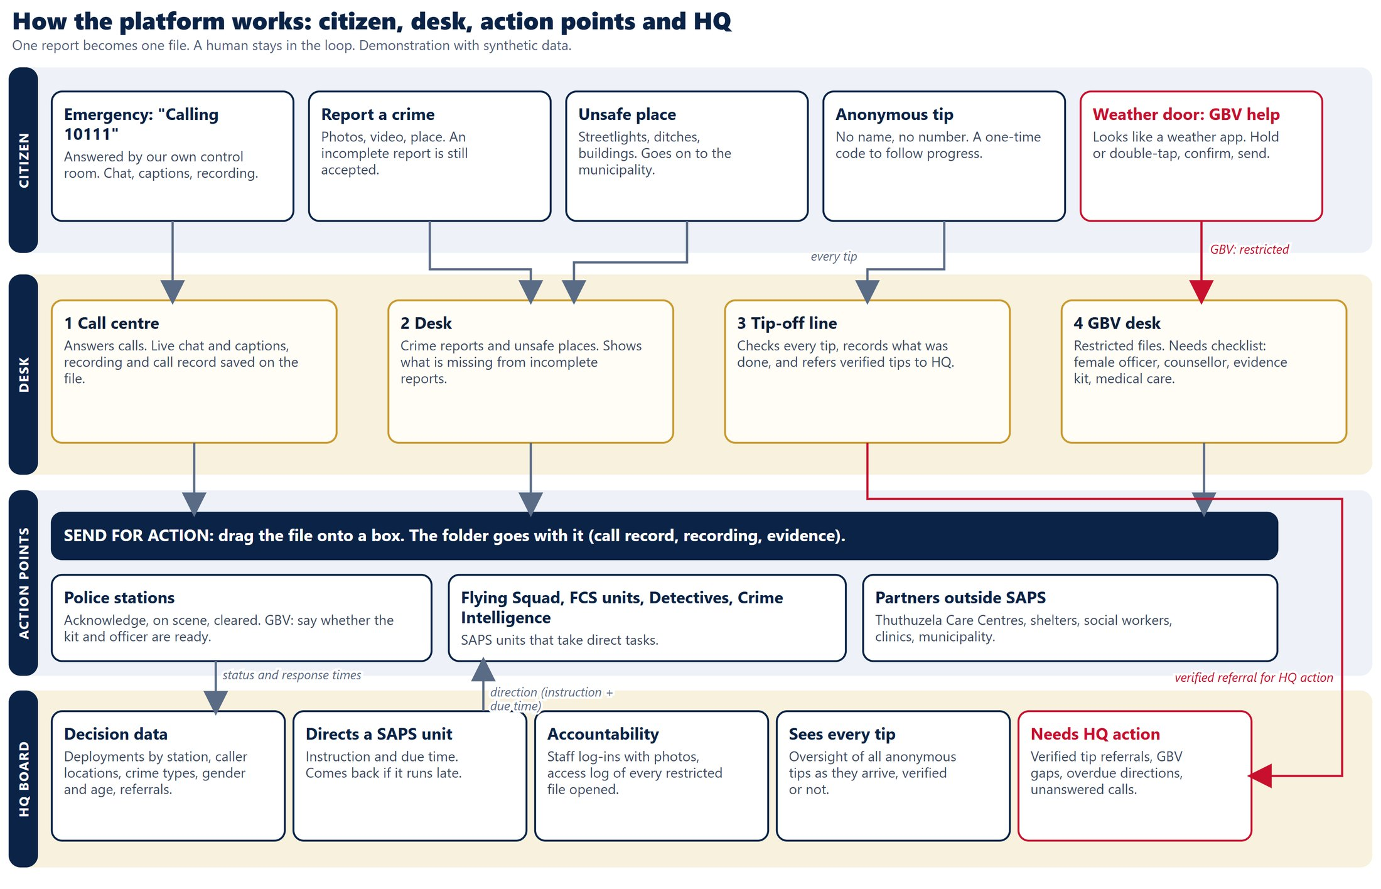

3. The citizen app
The citizen app is made for a phone. It starts with a short privacy notice, then offers five things:
- Emergency. Shows "Calling 10111". The desk answers, and the caller and officer can chat and see live captions. In this demo a call lasts one minute.
- Report a crime. Photos, video, location or a map pin. A report that is not complete is still accepted, and the desk sees what is missing.
- Anonymous tip. No name and no number. The citizen gets a one-time code to follow progress.
- Unsafe place. Broken streetlights, open ditches, dangerous buildings. These are passed on to the municipality.
- Profile (optional). A registered citizen's details are carried on every file they send.
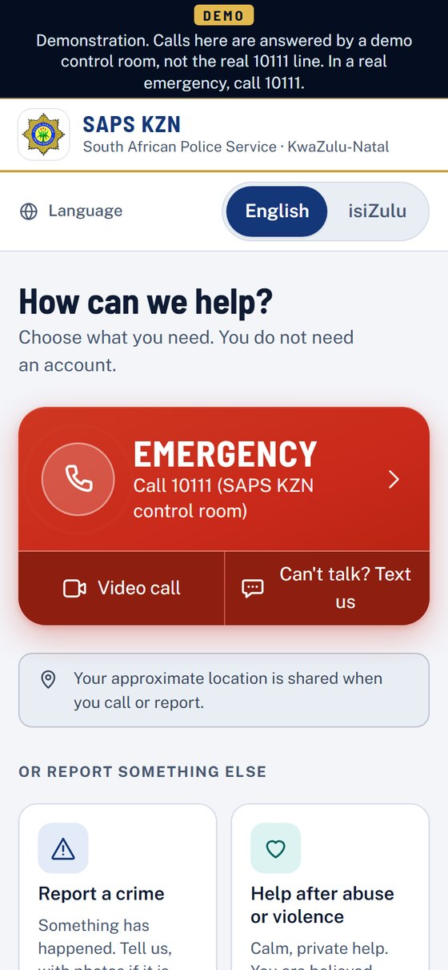 | 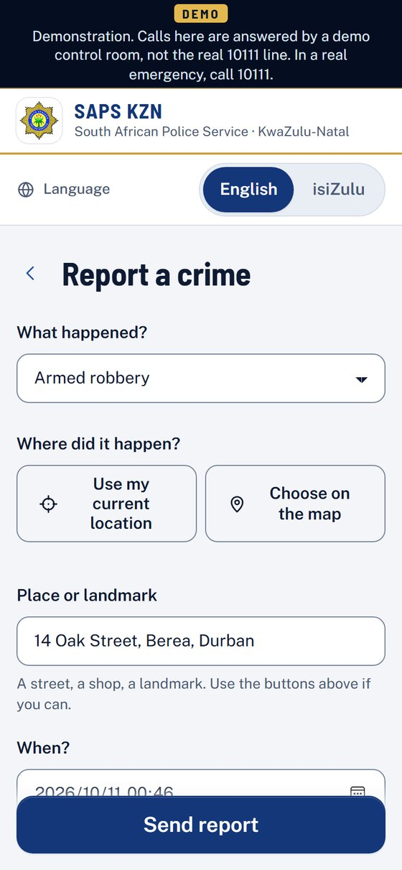 | 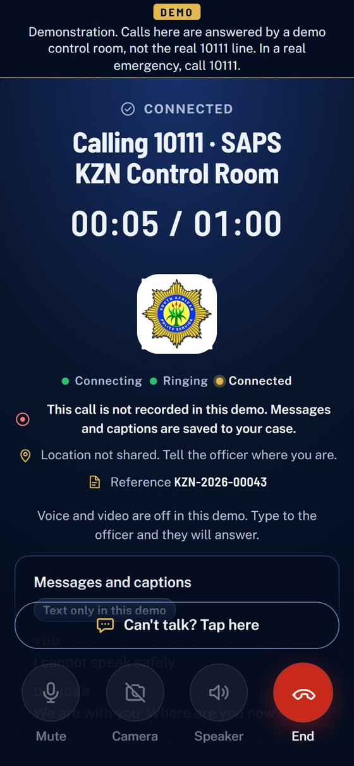
Home screen | Crime report | Call connected

4. The weather app: a hidden door for GBV help
GBV is a very high national priority. Many survivors cannot be seen asking for help. The weather app looks and behaves like any ordinary weather app, with no police marks. Holding or double-tapping the small cloud icon opens a confirmation. Nothing is sent until the person confirms, and a quick-exit button is always on screen.
The person is asked whether she is safe right now, how she can be reached, what would help, and who did this (all optional). One tap sends the request. It goes to the SAPS GBV desk and, at the same time, to the person she nominated and trusts, with a map link. A report that is incomplete is still accepted.
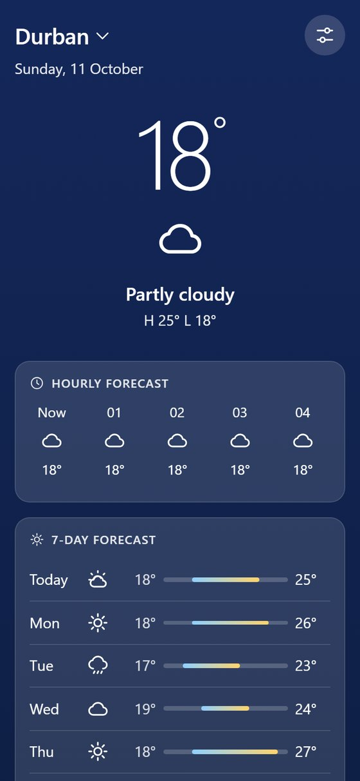 | 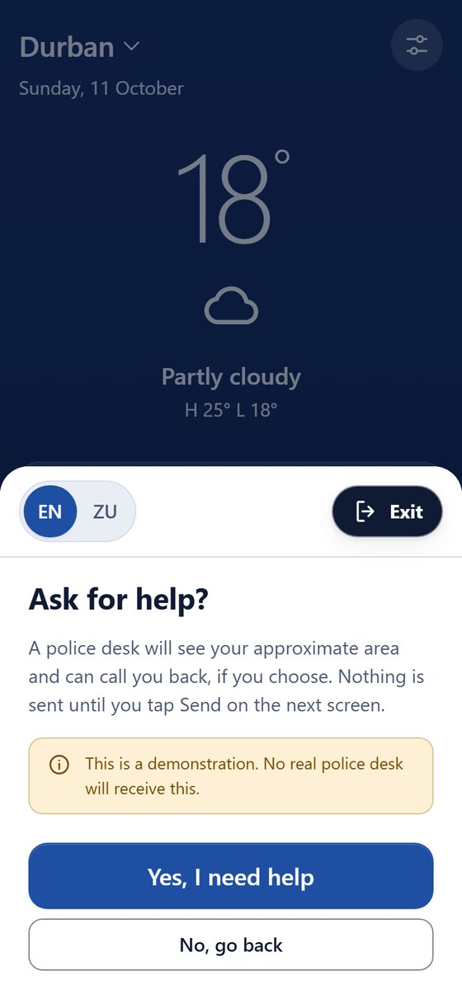 | 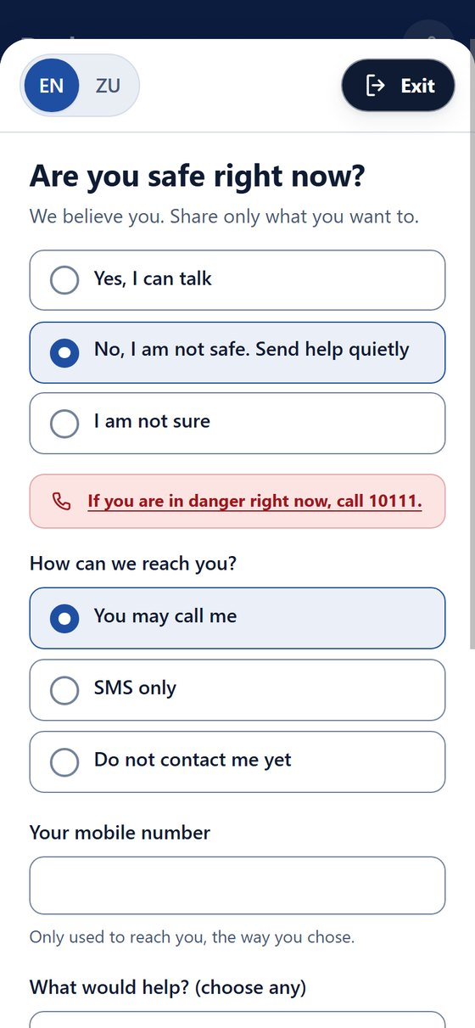
The cover | Confirm before sending | Safety questions

The next page follows a GBV request from the weather app to the end result.
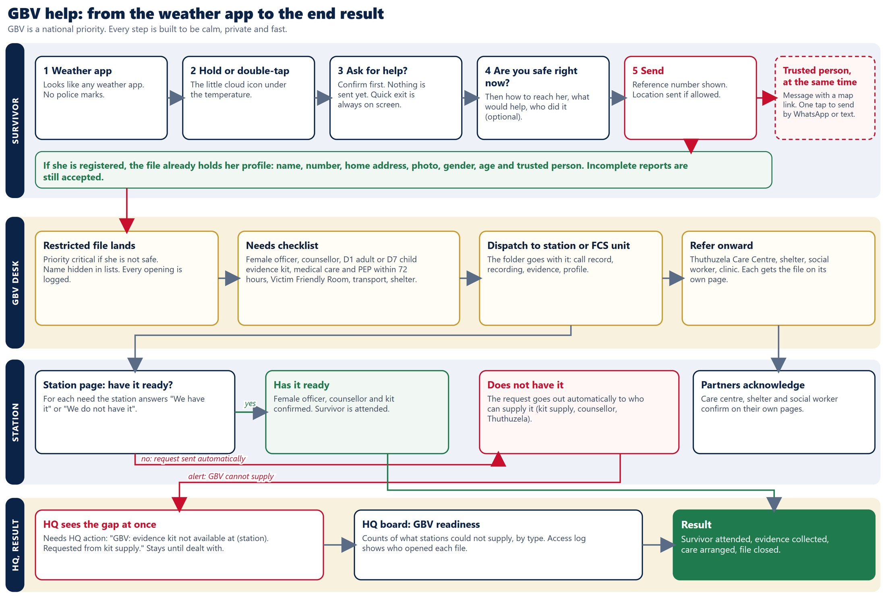

5. The control room desk
Officers sign in by choosing a section, entering any name or number as their officer ID, and taking a live photo with the camera. A photo is taken again at sign-out. These go into a shift record that HQ can review. Each section sees only its own files, and the server enforces this.
Section | What it handles
1 Call centre | Incoming calls. Live chat and captions. The recording, the transcript and the call chat are saved onto the case file automatically.
2 Desk | Crime reports and unsafe places. Shows what is missing from incomplete reports.
3 Tip-off line | Checks every anonymous tip, records what was done, and refers verified tips to HQ.
4 GBV desk | Restricted files. A needs checklist: female officer, counsellor, D1 or D7 evidence kit, medical care, Victim Friendly Room and more.

Send for action. The officer drags a file onto a box: a police station, the Flying Squad, an FCS unit, a cluster commander or a partner. The whole folder goes with it: call record, recording, evidence and citizen profile.
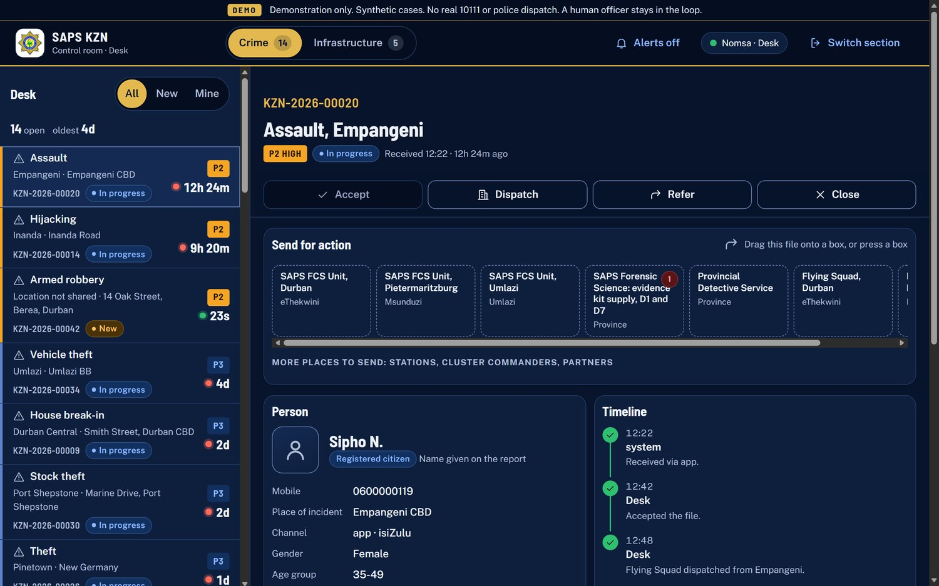
A crime file with the send-for-action boxes
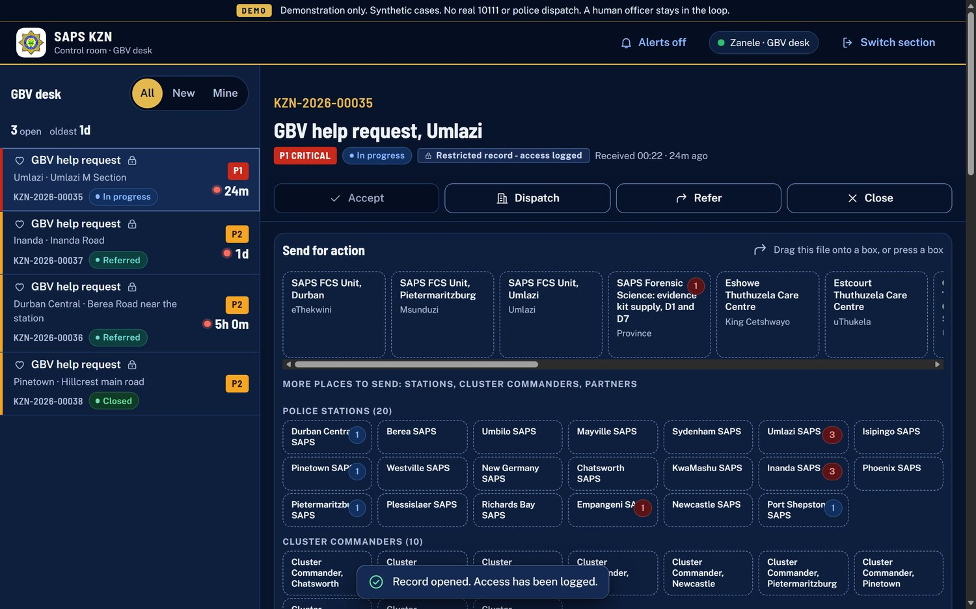
A GBV file. It is marked restricted and every opening is logged

6. Stations, units and partners
Every action point has its own page, opened through a private link. It shows only that point's tasks. A station acknowledges, goes on scene and clears. For GBV, the station must say for each need whether it has it ("We have it" or "We do not have it"). If it does not, a request goes out automatically to whoever can supply it, and HQ is alerted.

7. The HQ board
The HQ board is for decisions. It carries no names, numbers or photos. Where a count would identify someone (fewer than 5), it shows "<5".
- Needs HQ action. A slim bar at the top: verified tip referrals, GBV gaps, overdue directions, files past their time limit, unanswered calls.
- Overview. Where callers and reporters are, what is moving now, and how this system answers calls compared with the reported national figure.
- Tips. Oversight of every anonymous tip as it arrives, whether or not it has been verified.
- Deployments. Which stations are deployed, and how fast.
- Crime and people. Crime types, and gender and age in groups only.
- Referrals and directions. Referrals go out of SAPS (care centres, shelters, clinics, municipalities). Directions go down to a SAPS unit with an instruction and a due time.
- Performance, Staff log-ins and Access log. Response by cluster; searchable shift records with sign-in and sign-out photos; who opened which restricted file and when.
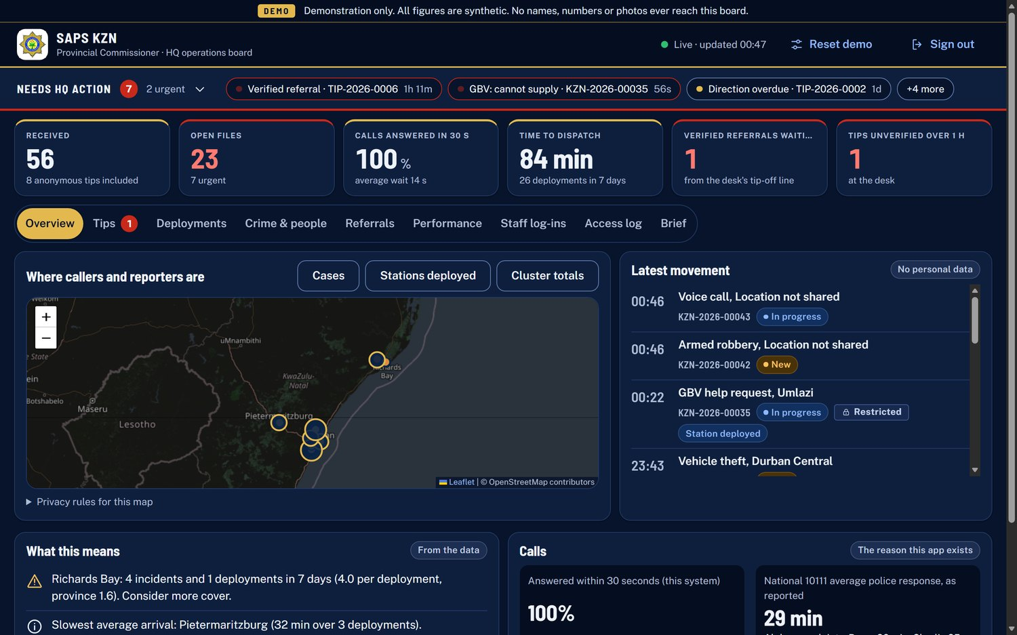
The HQ board overview
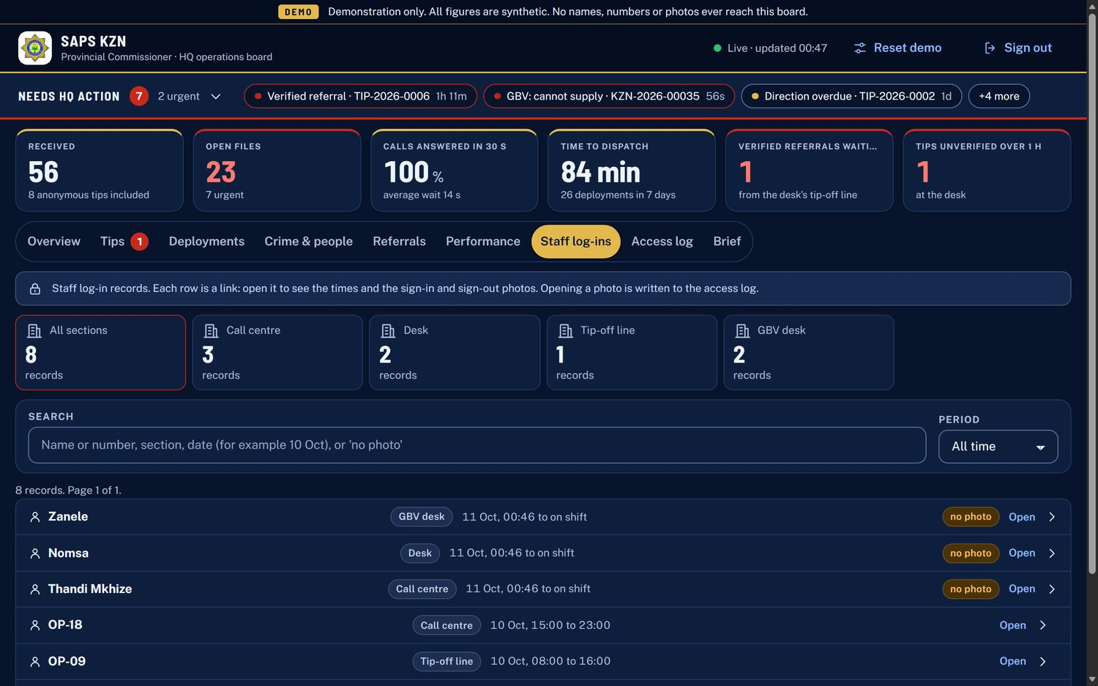
Staff log-ins: searchable records with photos

8. Anonymous tips, start to finish
- The citizen sends a tip. No name, number or device is stored. They keep a one-time code.
- The desk's own tip-off line checks it and records what was done.
- A verified tip becomes a verified referral for HQ action.
- HQ acknowledges it, directs a SAPS unit, or closes it.
- The citizen can follow progress with the code, still without being identified.
HQ also sees every tip as it arrives, including those not yet verified.

9. Safety and privacy built in
- Anonymous tips store no identity. Only a hash of the one-time code is kept.
- GBV and weather requests are restricted: names are hidden in lists and every opening is recorded in an access log.
- GBV, SOS and tips never appear as dots on the HQ map.
- Gender and age are optional, used only in grouped statistics, never next to a name.
- Each desk section can only see its own files.
- Live captions are never labelled as artificial intelligence, and "this call is recorded" shows only when a recording really is running.

10. What is real today, and what comes next
Working in the demo | Comes with the working prototype
Every screen and hand-off, the case numbers, the audit log and the HQ statistics | Real voice and video calls with automatic recording (needs a video service account)
Call ringing, answering, chat, live captions, one-minute limit | WhatsApp bot and automatic alerts to the trusted person (built, switched off)
Drag-and-drop sending, each action point's own page, GBV needs requests | Per-person officer accounts, retention rules and a security review
Incomplete reports accepted from every channel | Real station and cluster data (the demo uses 20 stations and 10 clusters, approximate)

The isiZulu in the app and in this pack is a first draft and needs a check by a native speaker. The same applies to the legal wording of the privacy notice.

11. Try it yourself
Open the citizen and weather links on a phone. Open the desk and HQ links on a computer in Chrome or Edge.
Screen | Link | Log-in
Citizen app | https://saps-kzn-420161470509.africa-south1.run.app/citizen | None
Weather app | https://saps-kzn-420161470509.africa-south1.run.app/weather | None
Control room desk | https://saps-kzn-420161470509.africa-south1.run.app/desk | Pick a section, any name or number, take the photo, password 0000
HQ board | https://saps-kzn-420161470509.africa-south1.run.app/commissioner | Password 0000
Action points | https://saps-kzn-420161470509.africa-south1.run.app/unit | Opened from the desk

On the HQ board, Reset demo puts the sample data back.

