I-SAPS KWAZULU-NATAL
Isikhungo Sokulawula Esiyidijithali
Isifinyezo sohlelo lwesilingo

Eqenjini labaphathi be-SAPS KZN
11 Okthoba 2026
Kulungiswe yi-Nordien
Uhlelo lwesilingo. Yonke idatha yakhelwe.

1. Inkinga nombono
Ikholi eya kulayini we-10111 ingalinda isikhathi eside ingaphenduliwe, futhi amakholi amaningi awaphenduleki nhlobo. Izikhathi zokuphendula zamaphoyisa kuzwelonke ezibikwe ePhalamende zingaba yimizuzu engu-25 kuya kwengu-29 (Alpha 28:30, Bravo 25:45, Charlie 24:34, kusukela zingama-30 kuMbasa 2026, kusukela empendulweni ebhaliwe ePhalamende).
Lezi zibalo zilinganisa ukuthi amaphoyisa athatha isikhathi esingakanani ukufika, hhayi ukuthi ikholi ithatha isikhathi esingakanani ukuphendulwa. Zithathwe esifinyezweni sosesho lwempendulo, futhi kufanele zihlolwe empendulweni uqobo ngaphambi kokuba muntu aziphinde ngaphandle kweqembu.
Umbono. Umsebenzisi uvula uhlelo bese ethinta Ushayela u-10111. Libukeka njengomugqa wezimo eziphuthumayo, kodwa ikholi iphendulwa yihhovisi lokulawula le-SAPS KZN elisebenza kulolu hlelo. Imibiko yobugebengu, amathiphu angaziwa nezicelo zosizo lodlame olusekelwe ebulilini (i-GBV) ziza ngendlela efanayo. Umbiko ngamunye uba ifayela elilodwa, linenombolo eyodwa, elihamba livela kumsebenzisi liye eposini lokuphendula, liye esiteshini noma kuyunithi, bese lifinyelela e-HQ yesifundazwe.
Lokhu yini. Isilingo. Idatha yakhelwe, akukho okufika esiteshini samaphoyisa sangempela, futhi umuntu uhlala esesigabeni ngasinye. Inhloso ukukhombisa okungenzeka kanye namandla obuchwepheshe angemuva kwalo. Uma uthanda, uhlelo olusebenzayo lulandela.

2. Uhlelo ngamafuphi
Isikrini | Ubani ongasisebenzisa | Idivayisi | Senzani
Uhlelo lomsebenzisi | Umphakathi | Ifoni | Ikholi eyingozi, umbiko wobugebengu, ithiphu elingaziwa, indawo engaphephile, iphrofayela. Isingisi nesiZulu.
Uhlelo lwesimo sezulu | Umuntu ongenakucela usizo obala | Ifoni | Lubukeka njengohlelo lwesimo sezulu. Yisango elifihlekile lokufinyelela osizweni lwe-GBV.
Idesk yehhovisi lokulawula | Amaphoyisa ezigabeni ezine: isikhungo samakholi, idesk, umugqa wamathiphu, i-GBV | Ikhompuyutha | Iphendula amakholi, ihlola imibiko namathiphu, ithumela amafayela ukuze kuthathwe isinyathelo.
Amakhasi eziteshi, amayunithi nabalingani | Iziteshi zamaphoyisa, amayunithi, izikhungo zokunakekela, izindawo zokukhosela | Ifoni noma ikhompuyutha | Ngalinye linekhasi lalo eliyimfihlo elibonisa imisebenzi yalo kuphela.
Ibhodi le-HQ | Ikhomishani yesifundazwe ne-HQ | Ikhompuyutha | Ibona konke, ithatha izinqumo, inikeza imiyalo. Izibalo, amathiphu, ukudluliselwa, ukuziphendulela.

I-HQ ingumnikazi wohlelo lonke. Ikhasi elilandelayo libonisa indlela umbiko ohamba ngayo phakathi komsebenzisi, idesk, izindawo zokusebenza ne-HQ.
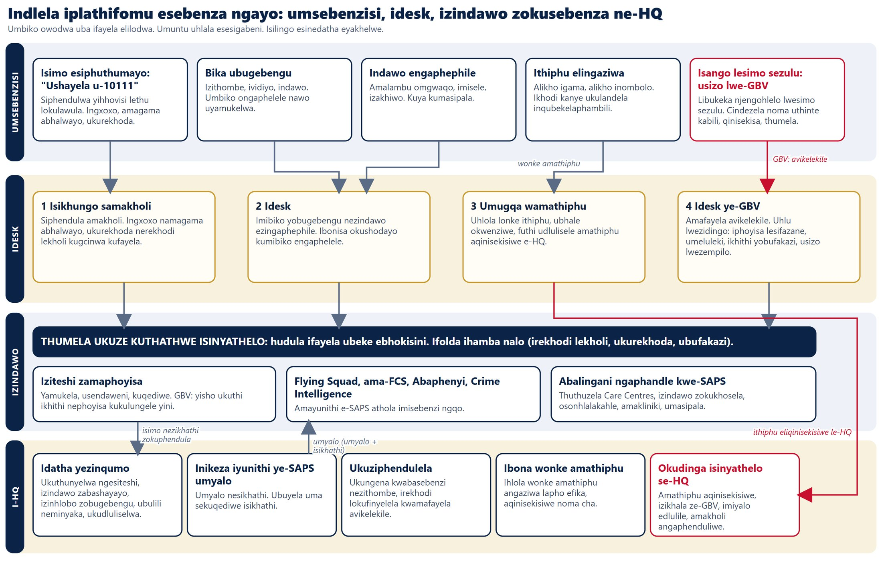

3. Uhlelo lomsebenzisi
Uhlelo lomsebenzisi lwenzelwe ifoni. Luqala ngesaziso esifushane sobumfihlo, bese lunikeza izinto ezinhlanu:
- Isimo esiphuthumayo. Ibonisa "Ushayela u-10111". Idesk iyaphendula, bese umshayi nephoyisa bengaxoxa futhi babone amagama abhalwayo ngqo. Kulesi silingo ikholi ihlala umzuzu owodwa.
- Bika ubugebengu. Izithombe, ividiyo, indawo noma iphinikhodi yemephu. Umbiko ongaphelele nawo uyamukelwa, futhi idesk ibona okushodayo.
- Ithiphu elingaziwa. Alikho igama futhi alikho inombolo. Umsebenzisi uthola ikhodi kanye ukulandela inqubekelaphambili.
- Indawo engaphephile. Amalambu omgwaqo aphukile, imisele evulekile, izakhiwo eziyingozi. Lokhu kudluliselwa kumasipala.
- Iphrofayela (akuphoqelekile). Imininingwane yomsebenzisi obhalisiwe iba kulo lonke ifayela alithumelayo.
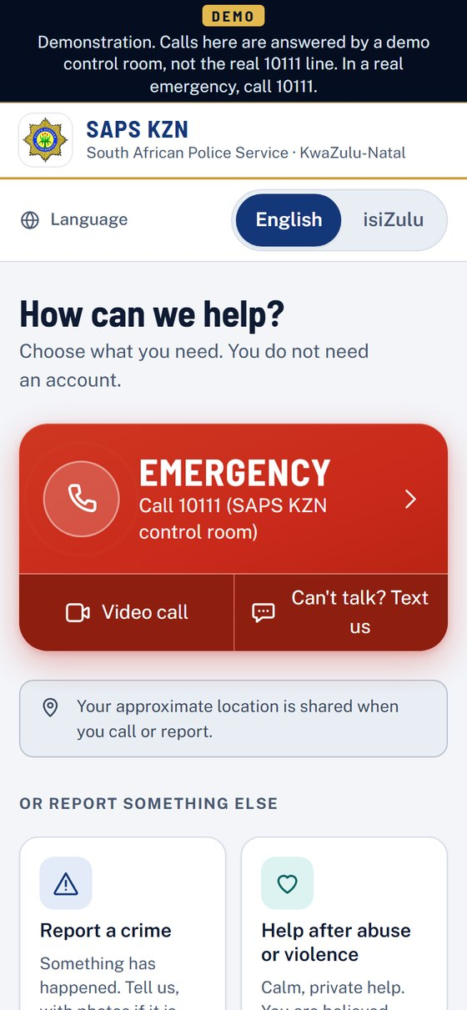 | 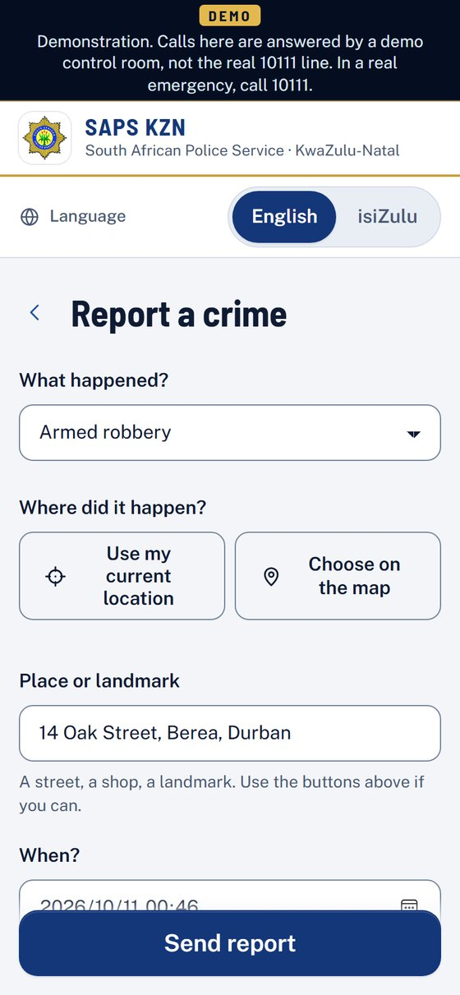 | 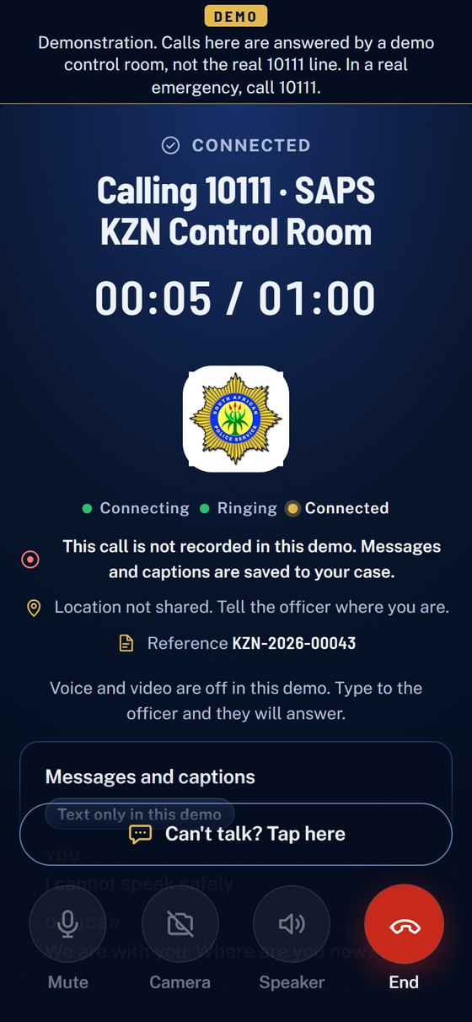
Isikrini sasekhaya | Umbiko wobugebengu | Ikholi ixhumekile

4. Uhlelo lwesimo sezulu: isango elifihlekile losizo lwe-GBV
I-GBV iwumsebenzi obaluleke kakhulu kuzwelonke. Abaningi abasindile abakwazi ukubonwa becela usizo. Uhlelo lwesimo sezulu lubukeka futhi lusebenze njengoba kwenza noma yiluphi uhlelo lwesimo sezulu, lungenazo izimpawu zamaphoyisa. Ukucindezela noma ukuthinta kabili isithonjana sefu esincane kuvula isiqinisekiso. Akukho okuthunyelwayo kuze kuqinisekiswe, futhi inkinobho yokuphuma ngokushesha ihlala ibonakala esikrinini.
Umuntu ubuzwa ukuthi uphephile yini manje, angathintwa kanjani, yini engasiza, nokuthi ubani owenze lokhu (konke akuphoqelekile). Ukuthinta kanye kuthumela isicelo. Siya kudeski ye-GBV ye-SAPS futhi, ngesikhathi esifanayo, kumuntu amnikeze yena ethembekile, kunelinki yemephu. Umbiko ongaphelele nawo uyamukelwa.
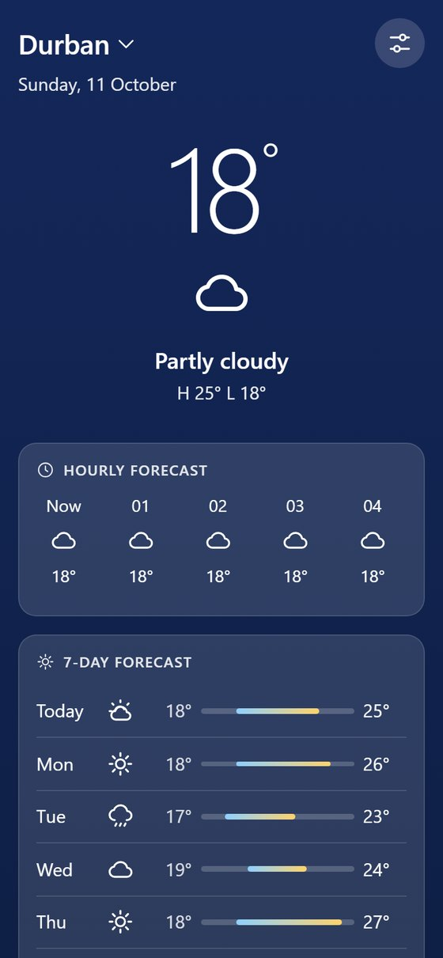 | 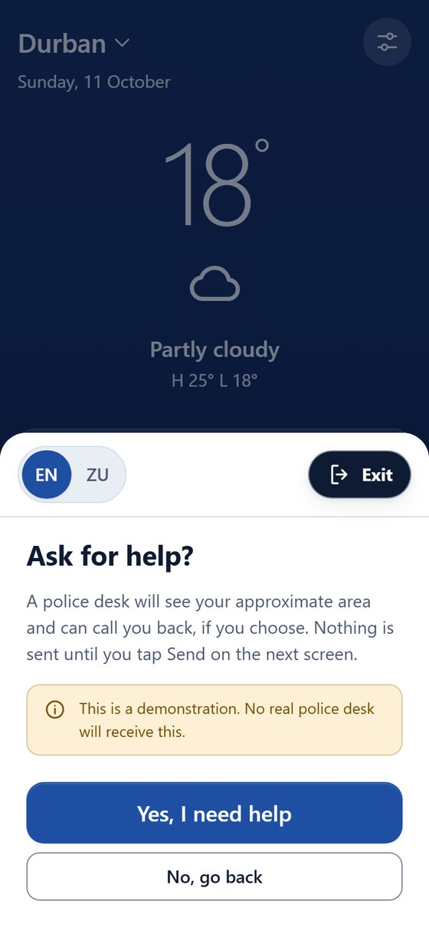 | 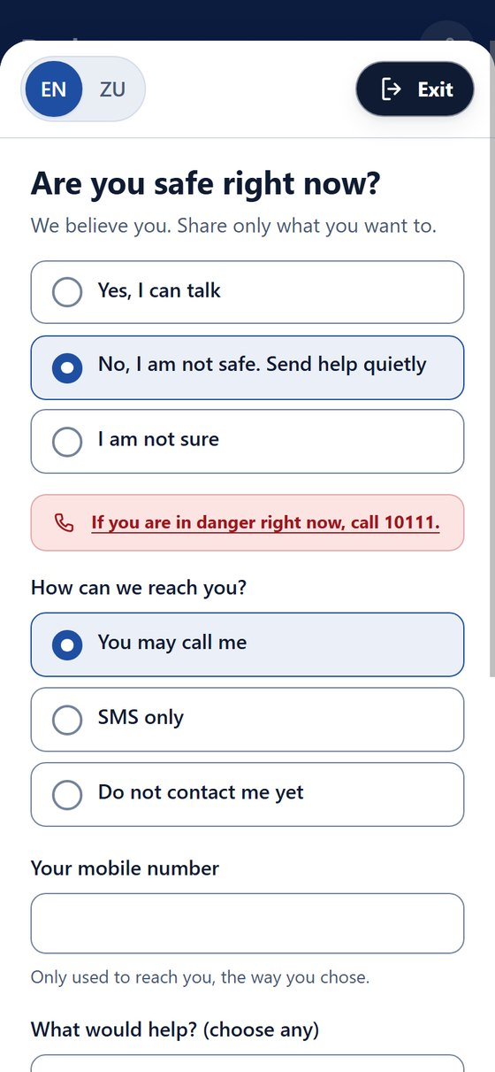
Ikhava | Qinisekisa ngaphambi kokuthumela | Imibuzo yokuphepha

Ikhasi elilandelayo lilandela isicelo se-GBV kusukela ohlelweni lwesimo sezulu kuze kube umphumela.
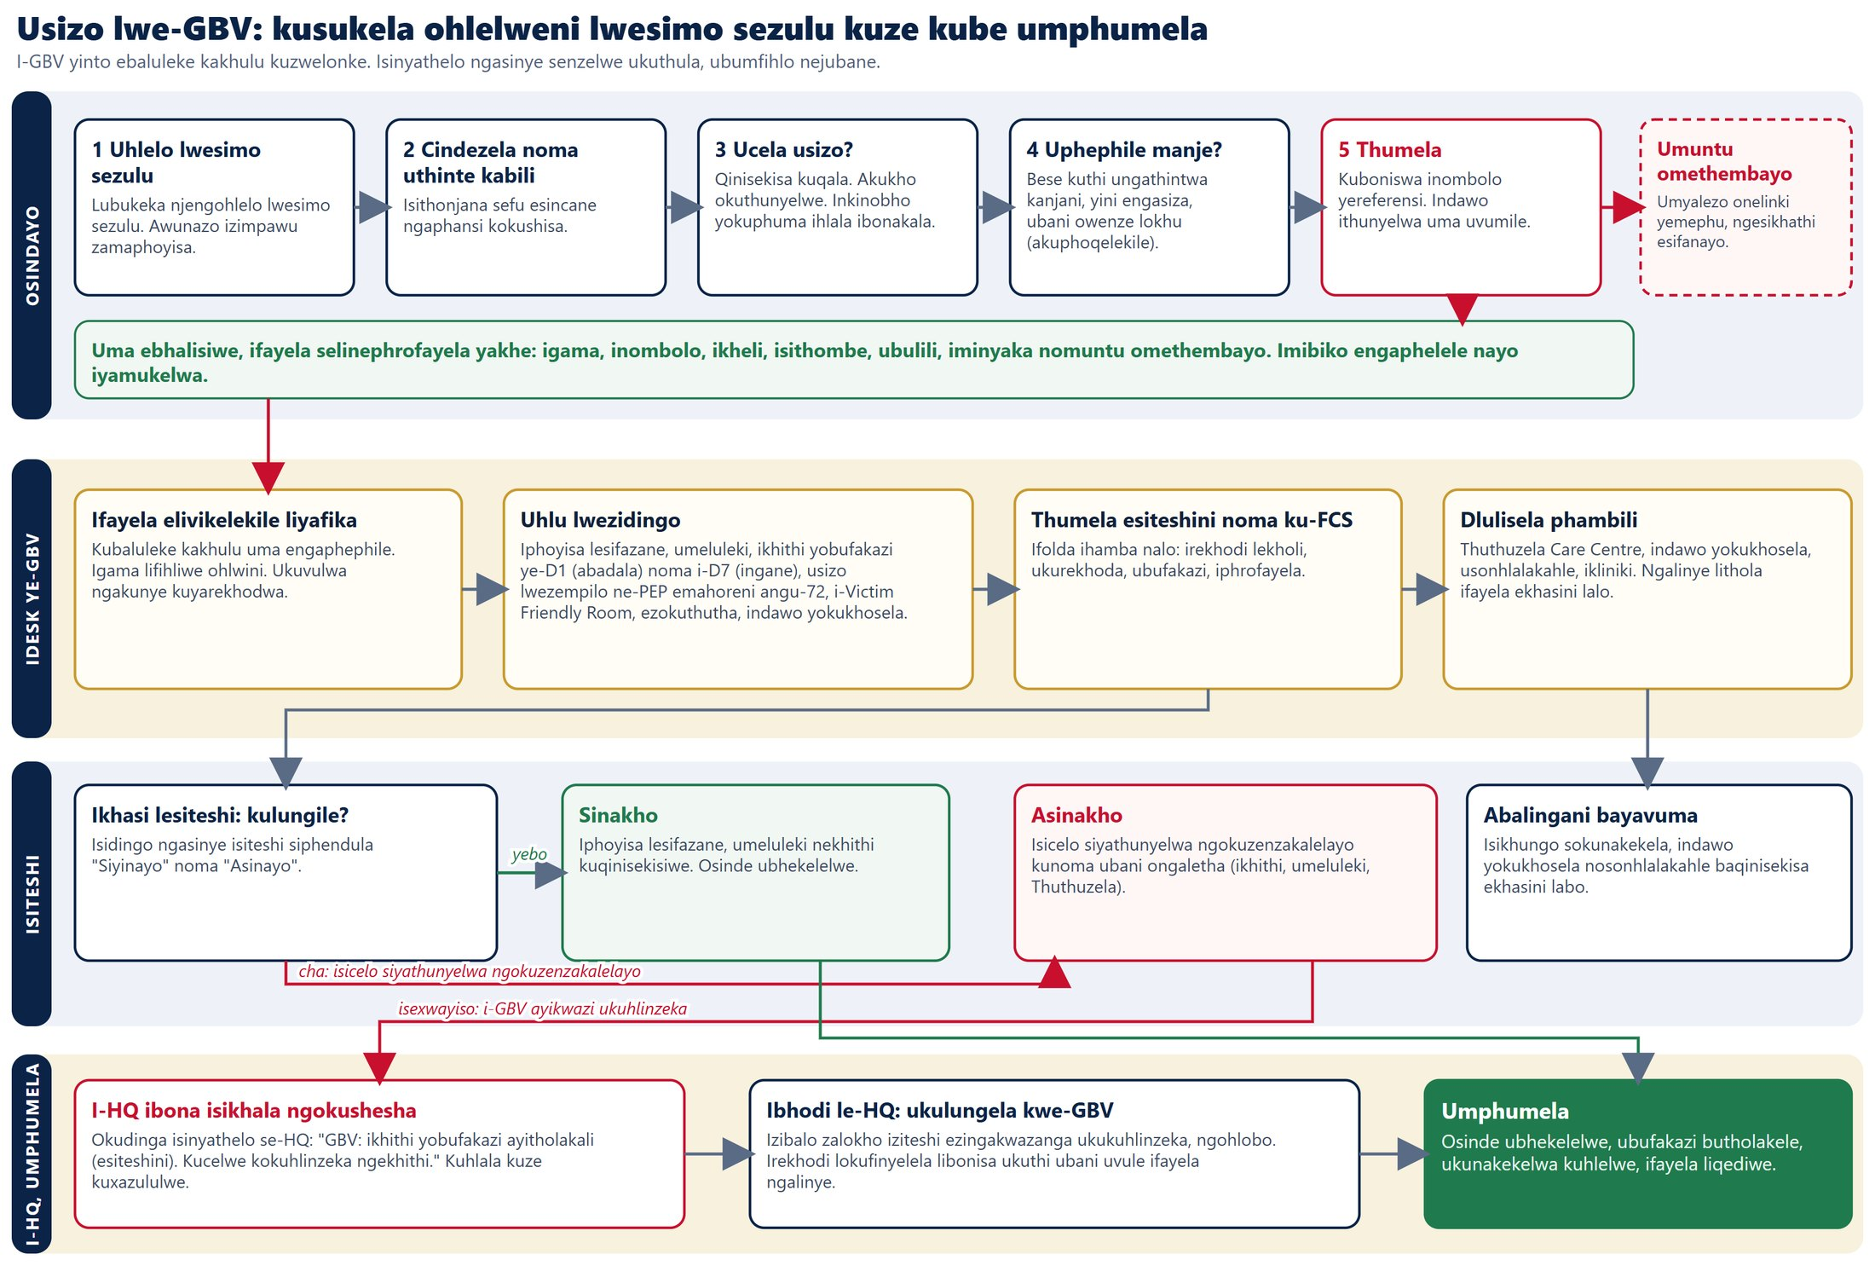

5. Idesk yehhovisi lokulawula
Amaphoyisa angena ngokukhetha isigaba, ngokufaka noma yiliphi igama noma inombolo njengenombolo yephoyisa, nangokuthatha isithombe ngekhamera. Isithombe sithathwa futhi lapho ephuma. Lokhu kuya ohlwini lwamashifti lapho i-HQ ingabuka khona. Isigaba ngasinye sibona amafayela aso kuphela, futhi iseva iyakuphoqelela lokhu.
Isigaba | Sibhekana nani
1 Isikhungo samakholi | Amakholi angenayo. Ingxoxo namagama abhalwayo ngqo. Ukurekhoda, umbhalo wekholi nengxoxo kugcinwa kufayela ngokuzenzakalelayo.
2 Idesk | Imibiko yobugebengu nezindawo ezingaphephile. Ibonisa okushodayo kumibiko engaphelele.
3 Umugqa wamathiphu | Uhlola lonke ithiphu elingaziwa, ubhale okwenziwe, futhi udlulisele amathiphu aqinisekisiwe e-HQ.
4 Idesk ye-GBV | Amafayela avikelekile. Uhlu lwezidingo: iphoyisa lesifazane, umeluleki, ikhithi yobufakazi ye-D1 noma i-D7, usizo lwezempilo, i-Victim Friendly Room nokunye.

Thumela ukuze kuthathwe isinyathelo. Iphoyisa lihudula ifayela lilibeke ebhokisini: isiteshi samaphoyisa, i-Flying Squad, iyunithi ye-FCS, umphathi wesigodi noma umlingani. Yonke ifolda ihamba nalo: irekhodi lekholi, ukurekhoda, ubufakazi neprofayela yomsebenzisi.
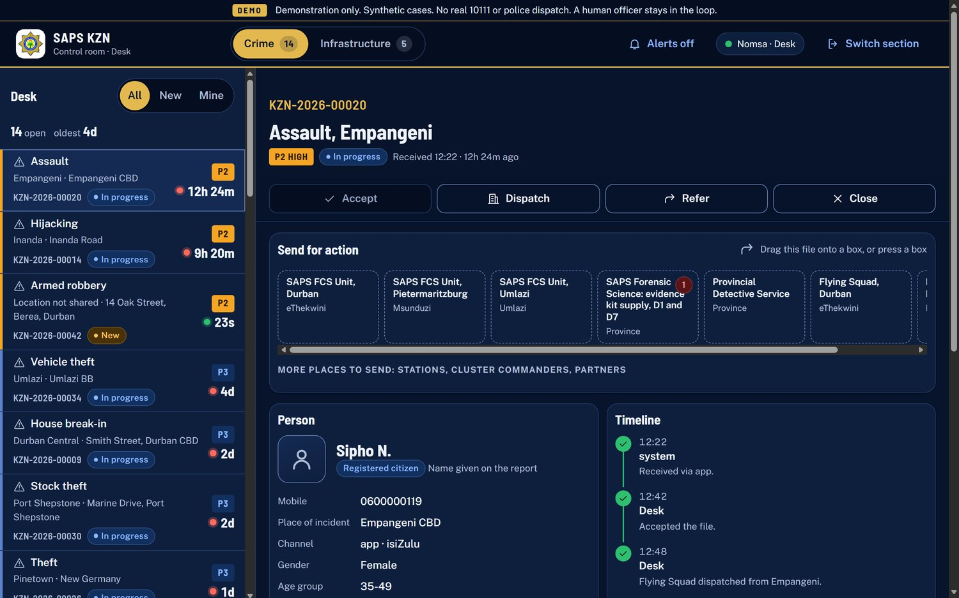
Ifayela lobugebengu elinamabhokisi okuthumela
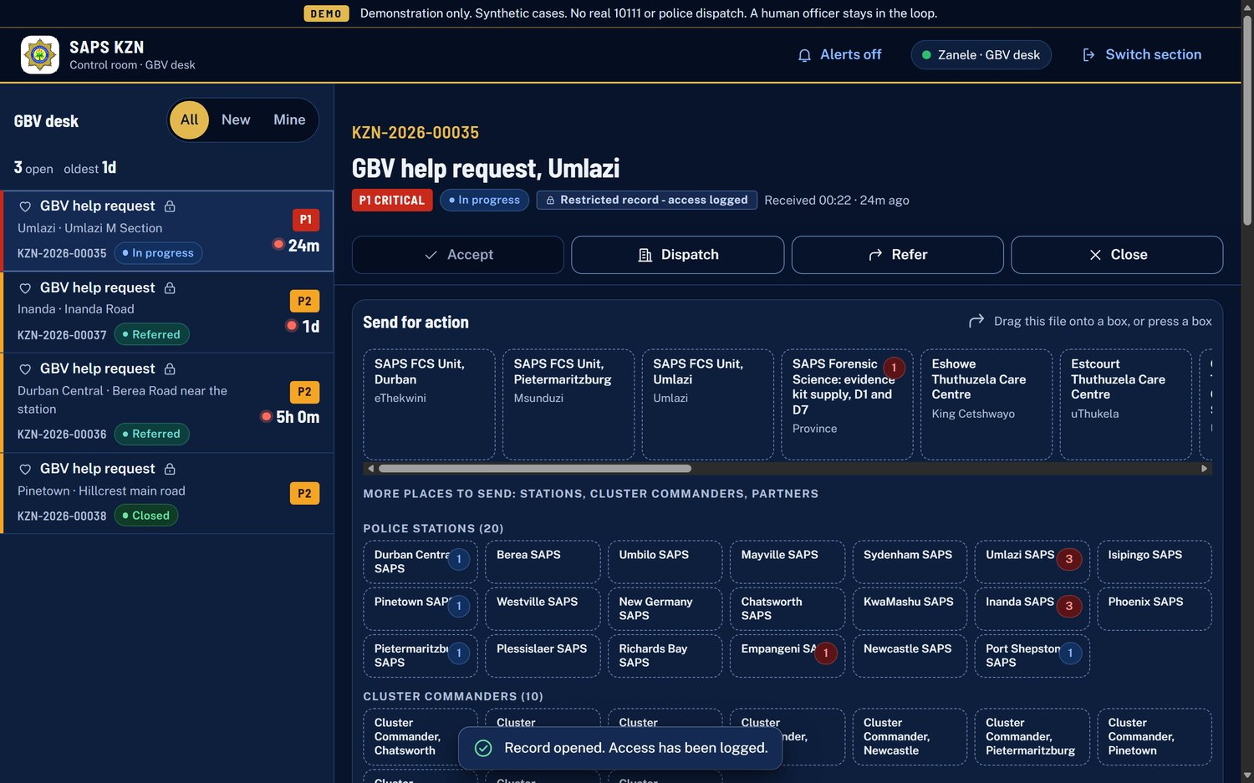
Ifayela le-GBV. Lifakwe uphawu lokuvikelwa futhi ukuvulwa ngakunye kuyarekhodwa

6. Iziteshi, amayunithi nabalingani
Indawo ngayinye yokusebenza inekhasi layo, elivulwa ngelinki eyimfihlo. Libonisa kuphela imisebenzi yaleyo ndawo. Isiteshi siyamukela, siya endaweni bese siqeda. Kwe-GBV, isiteshi kufanele sisho ngesidingo ngasinye ukuthi sinaso yini ("Siyinayo" noma "Asinayo"). Uma singenaso, isicelo siyathunyelwa ngokuzenzakalelayo kunoma ubani ongasihlinzeka, futhi i-HQ iyaxwayiswa.

7. Ibhodi le-HQ
Ibhodi le-HQ lenzelwe izinqumo. Alinawo amagama, izinombolo noma izithombe. Lapho inani lingabonisa umuntu (ngaphansi kuka-5), libonisa "<5".
- Okudinga isinyathelo se-HQ. Ibha encane phezulu: amathiphu aqinisekisiwe, izikhala ze-GBV, imiyalo edlulile, amafayela adlule isikhathi, amakholi angaphenduliwe.
- Ukubuka konke. Lapho kukhona abashayayo nabakhulumayo, okuhambayo manje, nokuthi lolu hlelo luphendula kanjani amakholi uma luqhathaniswa nenani elibikiwe kuzwelonke.
- Amathiphu. Ukuhlola wonke amathiphu angaziwa lapho efika, aqinisekisiwe noma cha.
- Ukuthunyelwa. Iziteshi ezithunyelwe, nokushesha kwazo.
- Ubugebengu nabantu. Izinhlobo zobugebengu, nobulili neminyaka ngamaqembu kuphela.
- Ukudluliselwa nemiyalo. Ukudluliselwa kuya ngaphandle kwe-SAPS (izikhungo zokunakekela, izindawo zokukhosela, amakliniki, omasipala). Imiyalo iya phansi kuyunithi ye-SAPS kunomyalo nesikhathi.
- Ukusebenza, Ukungena kwabasebenzi nerekhodi lokufinyelela. Ukuphendula ngesigodi; amarekhodi amashifti asesesheka anezithombe zokungena nokuphuma; ukuthi ubani uvule yiliphi ifayela elivikelekile nini.
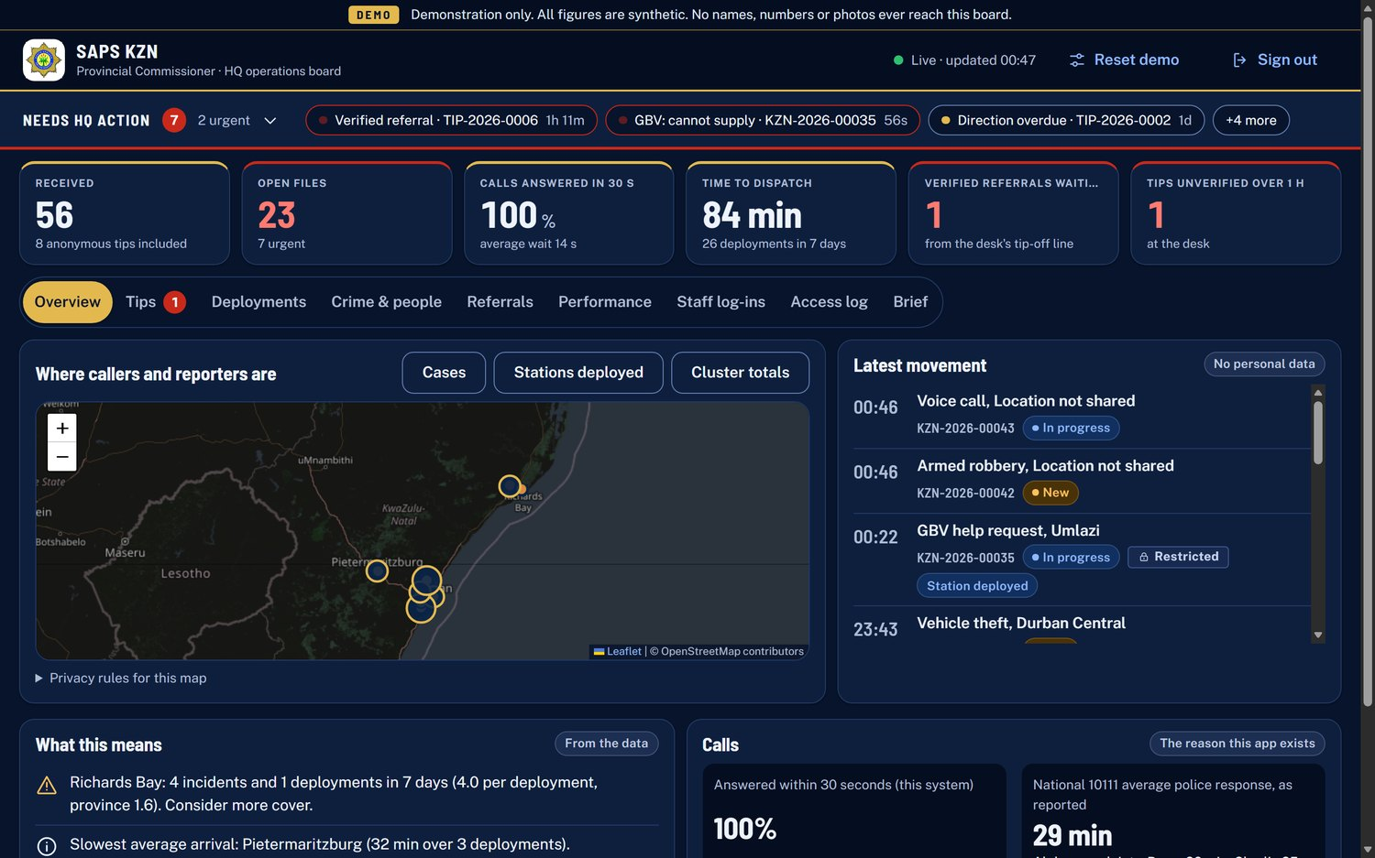
Ukubuka konke kwebhodi le-HQ
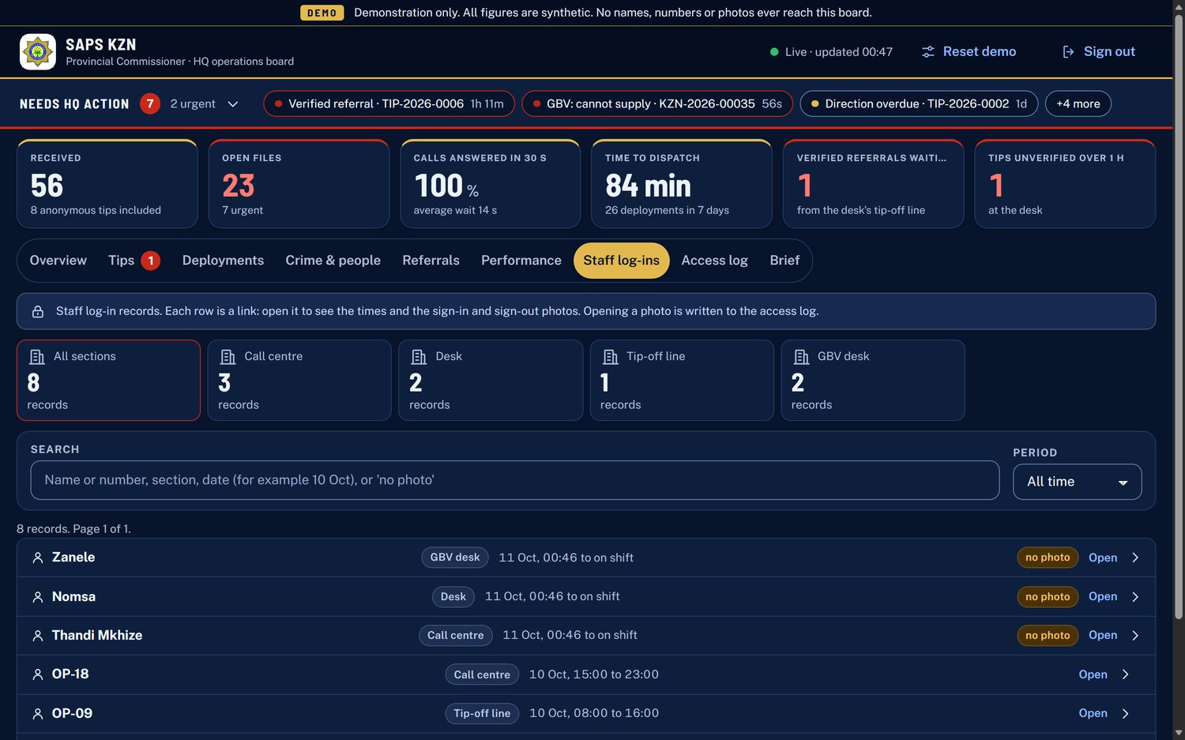
Ukungena kwabasebenzi: amarekhodi asesesheka anezithombe

8. Amathiphu angaziwa, kusukela ekuqaleni kuze kube sekugcineni
- Umsebenzisi uthumela ithiphu. Akugcinwa igama, inombolo noma idivayisi. Ugcina ikhodi kanye.
- Umugqa wamathiphu wedeski uqobo luyalihlola futhi ubhale okwenziwe.
- Ithiphu eliqinisekisiwe liba ithiphu eliqinisekisiwe le-HQ.
- I-HQ iyalamukela, inikeze iyunithi ye-SAPS umyalo, noma ilivale.
- Umsebenzisi angalandela inqubekelaphambili ngekhodi, ngaphandle kokuhlonzwa.
I-HQ ibona futhi wonke amathiphu lapho efika, nalawo angakaqinisekiswa.

9. Ukuphepha nobumfihlo kwakhelwe ngaphakathi
- Amathiphu angaziwa awagcini muntu. Kugcinwa kuphela i-hash yekhodi kanye.
- Izicelo ze-GBV nezesimo sezulu zivikelekile: amagama afihliwe ohlwini futhi ukuvulwa ngakunye kurekhodwa erekhodini lokufinyelela.
- I-GBV, i-SOS namathiphu awabonakali njengamachashaza kumephu ye-HQ.
- Ubulili neminyaka akuphoqelekile, kusetshenziswa ezibalweni zamaqembu kuphela, hhayi eduze kwegama.
- Isigaba ngasinye sedeski sibona amafayela aso kuphela.
- Amagama abhalwayo ngqo awafakwa uphawu lobuhlakani bokwenziwa, futhi "le kholi iyarekhodwa" ibonakala kuphela lapho ukurekhoda kusebenza ngempela.

10. Okusebenza namuhla, nokulandelayo
Kusebenza kusilingo | Kuza nohlelo lokuqala olusebenzayo
Zonke izikrini nokudluliselana, izinombolo zamafayela, irekhodi lokuhlola nezibalo ze-HQ | Amakholi omsindo nevidiyo angempela anokurekhoda okuzenzakalelayo (adinga i-akhawunti yesevisi yevidiyo)
Ukukhala kwekholi, ukuphendula, ingxoxo, amagama abhalwayo ngqo, umkhawulo womzuzu owodwa | I-WhatsApp bot nezexwayiso ezizenzakalelayo kumuntu othembekile (kwakhiwe, kuvaliwe)
Ukuhudula nokubeka, ikhasi lendawo ngayinye, izicelo zezidingo ze-GBV | Ama-akhawunti omuntu ngamunye, imithetho yokugcina amarekhodi nokubuyekezwa kokuphepha
Imibiko engaphelele emukelwa kuzo zonke izindlela | Idatha yangempela yeziteshi nezigodi (isilingo sisebenzisa iziteshi ezingu-20 nezigodi eziyi-10, ngokulinganiselwa)

IsiZulu kuhlelo nakulesi sikhwama siwumbhalo wokuqala futhi sidinga ukuhlolwa yisikhulumi sasemdabini. Okufanayo kuyasebenza ekwakhiweni kwezwi lomthetho lesaziso sobumfihlo.

11. Zama ngokwakho
Vula amalinki omsebenzisi nesimo sezulu efonini. Vula amalinki edeski ne-HQ ekhompuyutheni ku-Chrome noma i-Edge.
Isikrini | Ilinki | Ukungena
Uhlelo lomsebenzisi | https://saps-kzn-420161470509.africa-south1.run.app/citizen | Alukho
Uhlelo lwesimo sezulu | https://saps-kzn-420161470509.africa-south1.run.app/weather | Alukho
Idesk yehhovisi lokulawula | https://saps-kzn-420161470509.africa-south1.run.app/desk | Khetha isigaba, noma yiliphi igama noma inombolo, thatha isithombe, iphasiwedi 0000
Ibhodi le-HQ | https://saps-kzn-420161470509.africa-south1.run.app/commissioner | Iphasiwedi 0000
Izindawo zokusebenza | https://saps-kzn-420161470509.africa-south1.run.app/unit | Zivulwa kudeski

Ebhodini le-HQ, Reset demo ibuyisela idatha yesampula.

