SAPS KWAZULU-NATAL
Digital Control Room
Technical overview of the demonstration platform

For the SAPS KZN management team and technical reviewers
11 October 2026
Prepared by Nordien
Demonstration build. All data is made up.

1. Purpose and scope
This document describes how the SAPS KZN demonstration is built and run. It is meant to show the technical capacity behind the demo and to give a reviewer enough to judge what a working prototype would involve. It covers architecture, access control, data, the main flows, security and privacy controls, deployment and the known limits. It is not a production specification.

2. Architecture
Layer | Choice | Notes
Web application | Python 3, Flask, served by gunicorn | One worker with 8 threads, on purpose: live data is held in memory.
Screens | Jinja templates, plain JavaScript, one design system in CSS | No build step. Phone-first for citizens, desktop-first for desk and HQ.
Data | In-memory store written through to Firestore | Collections are prefixed saps_ (cases, tips, referrals, partners, media, audit, officers, shifts, counters).
Files | Cloud Storage bucket | Evidence videos and call recordings. Falls back to memory if no bucket is set.
Hosting | Google Cloud Run, region africa-south1 (Johannesburg) | Project nordien-saps-kzn, 1 GiB memory, exactly one instance.
Calls and video | Text and captions now; Twilio Video when keys are added | Not configured in the demo. The screen says so.
Messaging | WhatsApp and SMS through Twilio | Built and switched off until settings are added.

The flow diagram on the next page shows how the screens relate to each other.
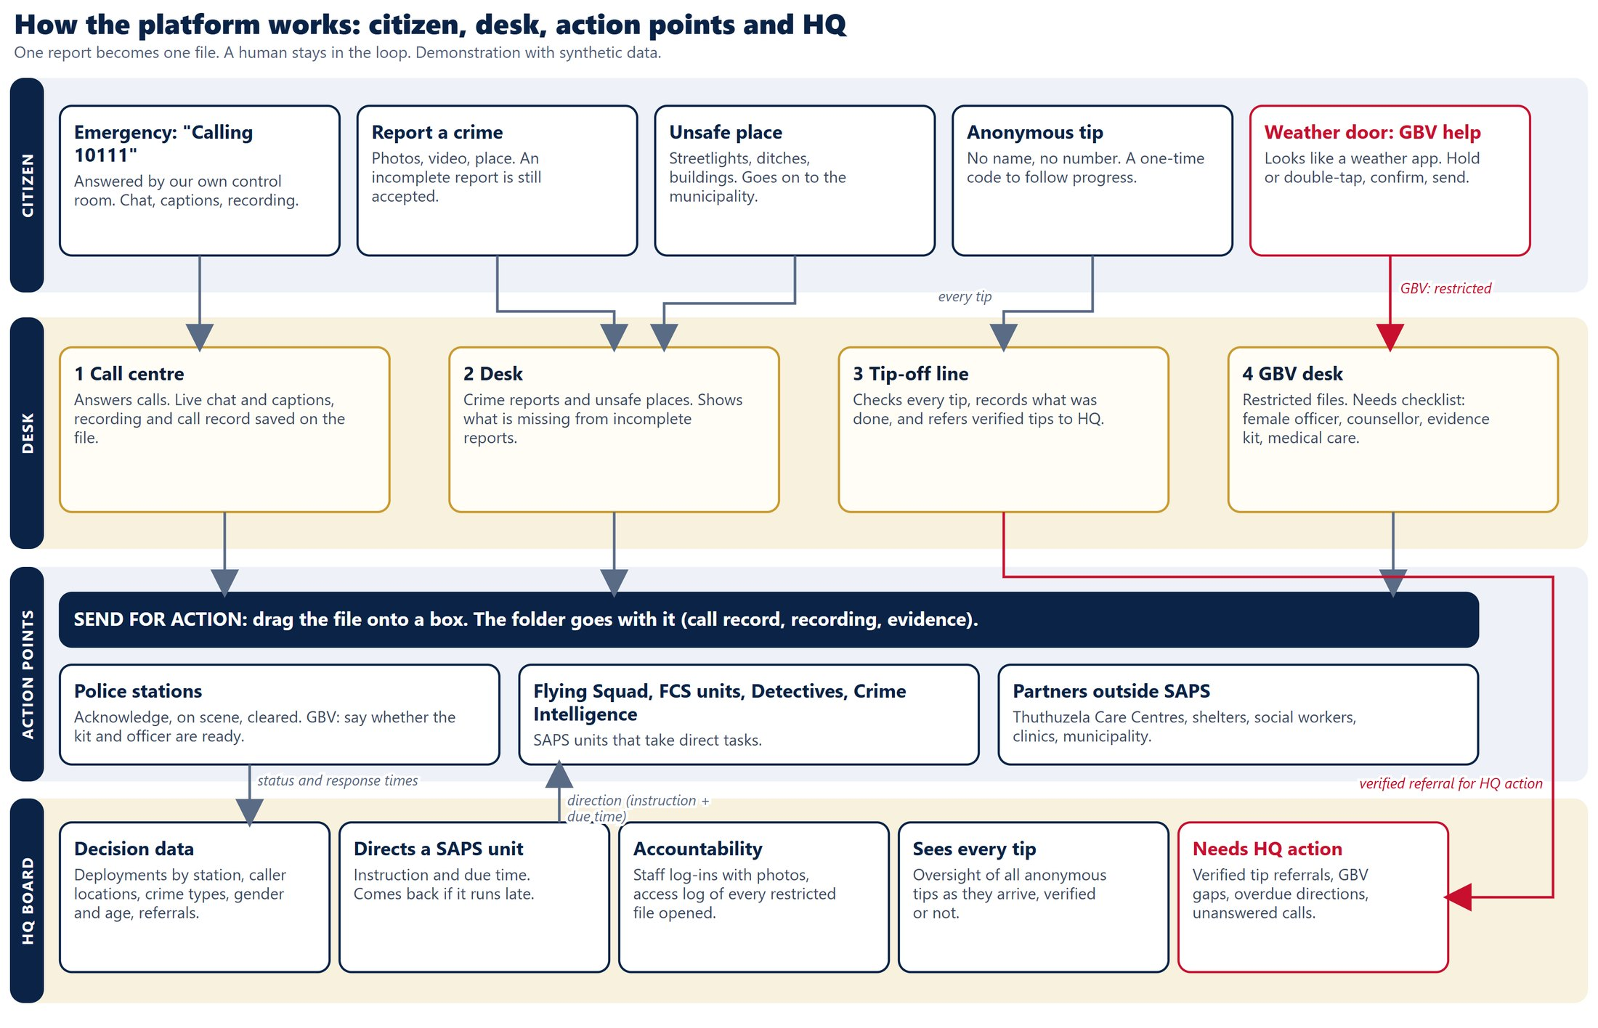

3. Roles and access
Role | How it signs in | What it can reach
Citizen | No sign-in. Optional profile. | Only its own submissions. Tips are followed with a one-time code.
Desk officer | Section, any name or number, live camera photo, password | Only the files of its own section. Server-enforced.
HQ (board) | Password | Statistics, tip oversight, directions, referrals, shift records, access log. No personal data.
Action point | Private link with a token | Only the tasks sent to that point.
Admin | Admin token | Reset the demo data.

For this demo, all passwords are 0000 and any name or number is accepted as an officer ID. This is the owner's decision for a demonstration with made-up data. Action-point links are signed with the application's secret key, so that key must stay stable or the links stop working.
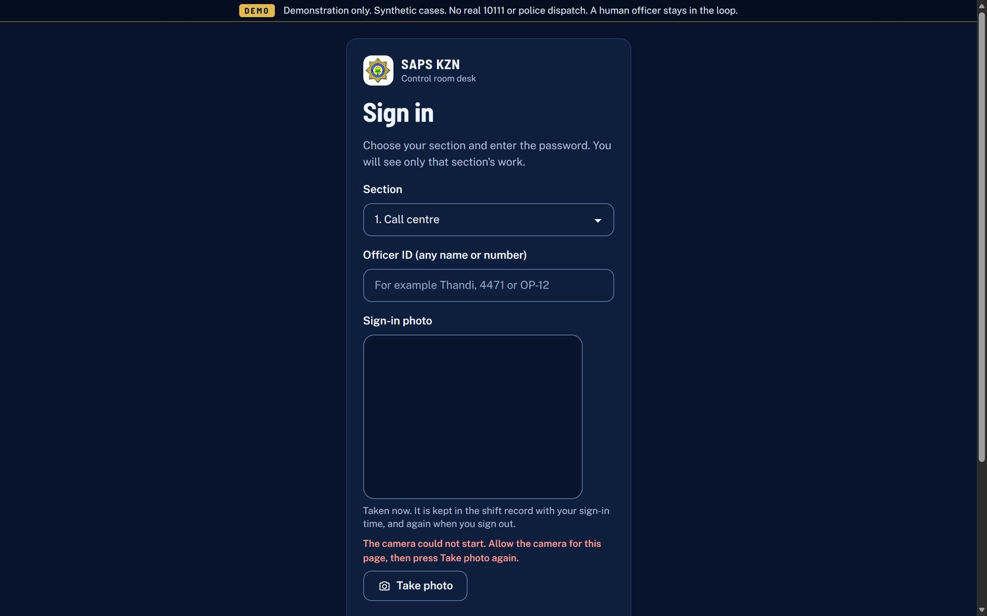
Desk sign-in: section, officer ID and live photo

4. Data model
Record | What it holds
Case | Number (KZN-year-number), channel, type, priority (critical, high, normal, low), status (new, assigned, in progress, referred, closed), location, notes, evidence, call record, GBV needs, and whether it is incomplete and what is missing.
Tip | Number (TIP-year-number). Text and evidence only. No name, number, device identifier or address. Only a hash of the one-time code.
Referral and direction | Referral out of SAPS, or direction down to a SAPS unit with instruction and due time.
Partner and action point | Stations, units and outside partners, with private link tokens.
Media | Photos, video, call recordings in five-second chunks, call chat and transcript.
Audit | Who opened a restricted file or a photo, in which section, and when.
Officer and shift | Officer ID, section, sign-in and sign-out times and photos, and whether the camera was unavailable.

A tip moves through these states: new, verified, referred, acknowledged, directed, closed.

5. The main flows

Emergency call
- The citizen starts a call. It rings at the desk with a sound and an incoming-call card.
- An officer answers. Text chat and live captions begin. Captions come from the browser's own speech recognition, shown as they are spoken.
- The call stops itself after one minute in the demo. An unanswered call is closed after 90 seconds.
- The call record, chat, transcript and any recording are saved onto the case file.

Crime report and sending for action
- The report is accepted even if incomplete. It is flagged "Incomplete" and lists what is missing.
- The desk reviews it and drags it onto a station, unit, cluster commander or partner box.
- The folder goes with it. The action point sees it on its own page and acknowledges, goes on scene and clears.
- HQ deployment figures update as statuses change.

GBV request
- The weather app sends the request. A registered citizen's profile is attached. The nominated trusted person is notified with a map link by one tap, or automatically when messaging is switched on.
- The file lands in the GBV section, restricted and marked critical if the person is not safe.
- The desk ticks the needs it expects (female officer, counsellor, D1 or D7 kit, medical care and PEP, Victim Friendly Room, transport, shelter) and dispatches to a station or FCS unit.
- The station answers each need with "We have it" or "We do not have it". If it does not, a request is sent automatically to the partner who can supply it, and HQ gets a "GBV cannot supply" alert.
- Referrals go to care centres, shelters, social workers or clinics, each on their own page.
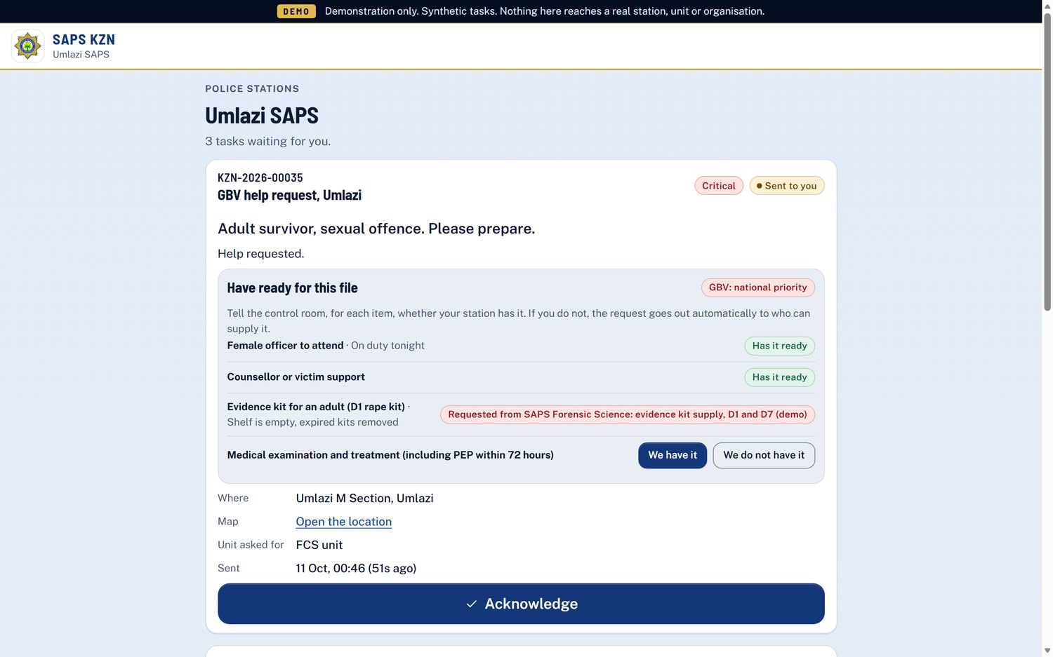
A station page, where the station answers each GBV need
The diagram on the next page shows the full GBV path.
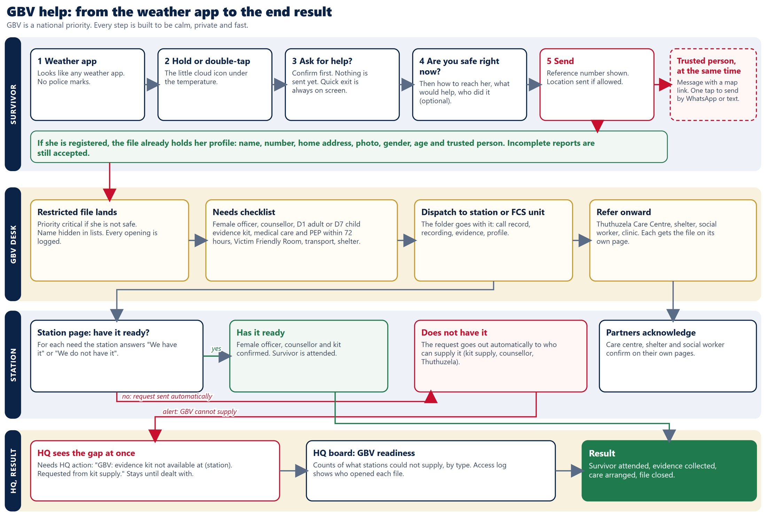

6. Real-time behaviour
The screens update by asking the server for changes at short intervals, with a version check so nothing is sent when nothing changed. This avoids long-lived connections and keeps the demo simple and reliable.
Screen | Checks every | Notes
Desk | 2 seconds | Incoming calls ring with a sound.
HQ board | 2.5 seconds | Needs-action bar, tips, statistics.
Citizen during a call | 1 second | Chat and captions.

7. Security and privacy controls
- Content security policy limits where scripts, images and connections may come from.
- Writes must come from the same site and be JSON. Rate limits: log-in 10 a minute, report 20, upload 10, call start 10.
- Citizen text is shown with text-only rendering, never as HTML.
- Tips are stored apart from cases with no identity. Server logs may still hold network addresses, which the platform provider controls.
- Restricted records (GBV and weather requests): names hidden in lists; every opening and every photo view is audit-logged with officer and section.
- The HQ feed carries no personal data. Counts under 5 show as "<5". GBV, SOS and tips are never map points.
- Desk sections are isolated on the server, not just hidden on screen.
- Sign-in photos come from the live camera only. If the camera cannot start, the officer may continue and the record is flagged.
- No secrets are in the code. All settings are environment variables.
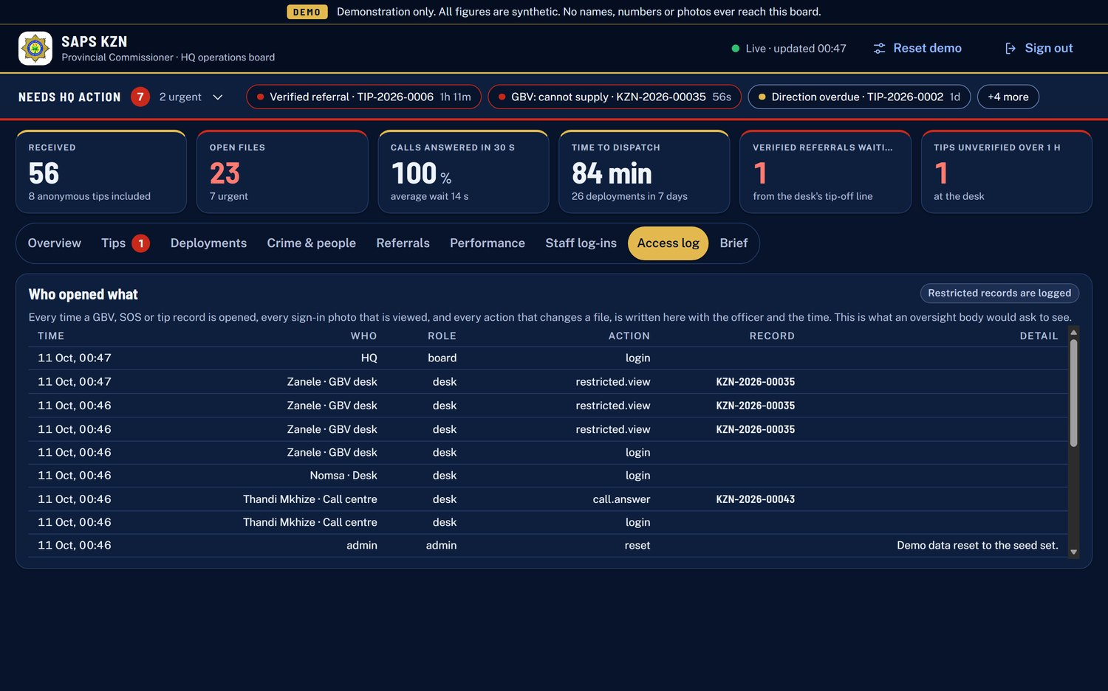
The access log: who opened which restricted file
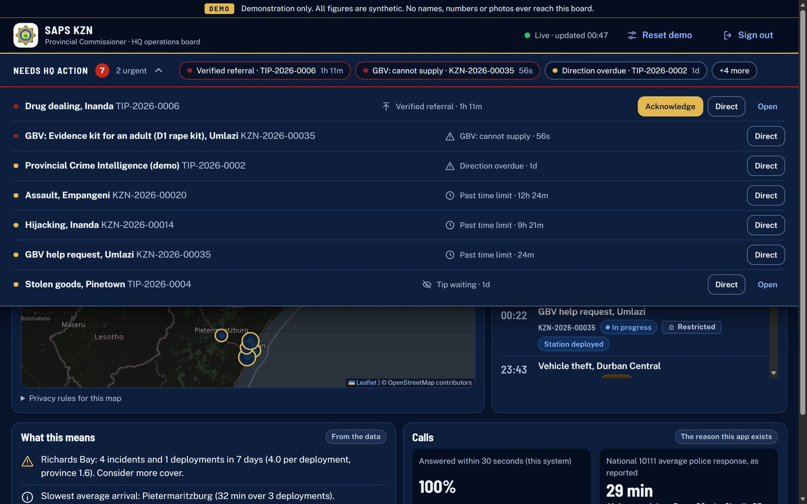
HQ needs-action list including a GBV supply gap

8. Interfaces (API summary)
Area | Examples
Public (citizen) | Config, report, upload, tip status by code, call start, call state, call line, call end, call recording.
Authentication | Log in, log out, who am I.
Staff (desk and HQ) | Feed, case, tip, action, call answer and end, dispatch, deployment, referral, direct, units, stations, partners, action points, media, shifts, shift photos, audit, call record text, GBV needs.
Action points | Tasks, update a task, answer a need, add media. Token required.
Admin | Reset demo data. Admin token required.
Health | A simple health check returns the store type and whether video and messaging are on.

9. Deployment and operations
- Runs on Cloud Run in the Johannesburg region, one instance, always on.
- Safe release: deploy a new revision with no traffic and a test tag, check it at the test address, then move traffic. The previous revision stays for instant rollback.
- Rollback is one command that points traffic back at a named earlier revision.
- Production settings live outside the code repository on the owner's computer.
- The code is in a private repository, backed up nightly with a guard that refuses to push anything that looks like a secret.

10. Quality and testing
There are 60 automated tests covering sign-in, section isolation, incomplete reports, the tip journey, calls, GBV needs and requests, referrals and directions, the HQ statistics and privacy rules, and shift records. Three journeys were also rehearsed by hand end to end: a call answered and ended, an anonymous tip verified and referred to HQ, and a crime report sent to a station and cleared. All pages were checked at phone and desktop sizes.

11. Known limits and the road to a working prototype
Limit today | What the prototype does about it
One instance; live data held in memory | Move live state to a shared service so several instances can run and the system can scale.
Shared demo passwords | Per-person accounts with stronger sign-in, and a review of access rules.
Live captions depend on the browser and work in English only | Server-side speech recognition with isiZulu support, with human checking.
No real voice or video yet | Connect a video service and record calls automatically.
Messaging switched off | Choose a sender number and switch on WhatsApp and SMS alerts.
Approximate stations and clusters (20 and 10) | Load the real list of about 184 stations and their clusters.
Public map tiles and web fonts | Self-host fonts and use a licensed map source.
No retention policy | Define how long records are kept, and add a formal security and privacy review.

12. How the code is organised
Folder or file | What is in it
app.py | Creates the application, registers pages, redirects and error pages.
saps/ | The service logic (cases, tips, calls, referrals, statistics), the API, HQ insights, security rules, storage, messaging.
templates/ | One page template per screen.
static/ | Scripts, styles and images, including the design system.
tests/ | The automated tests.
docs/ | Handover notes, rehearsal script and the HQ model.

