I-SAPS KWAZULU-NATAL
Isikhungo Sokulawula Esiyidijithali
Isifinyezo sobuchwepheshe sohlelo lwesilingo

Eqenjini labaphathi be-SAPS KZN nakubahloli bobuchwepheshe
11 Okthoba 2026
Kulungiswe yi-Nordien
Uhlelo lwesilingo. Yonke idatha yakhelwe.

1. Inhloso nobubanzi
Leli xwebhu lichaza ukuthi isilingo se-SAPS KZN sakhiwe futhi sisetshenziswa kanjani. Lenzelwe ukukhombisa amandla obuchwepheshe angemuva kwesilingo nokunikeza umhloli okwanele ukuthi athole ukuthi uhlelo olusebenzayo lungabandakanya ini. Lihlanganisa ukwakheka, ukulawula ukufinyelela, idatha, ukugeleza okuyinhloko, ukuphepha nobumfihlo, ukuthunyelwa kwohlelo nemikhawulo eyaziwayo. Akuyona incazelo yohlelo lwangempela lokukhiqiza.

2. Ukwakheka
Ungqimba | Ukukhetha | Amanothi
Uhlelo lwewebhu | Python 3, Flask, esetshenziswa yi-gunicorn | Isisebenzi esisodwa esinezintambo eziyi-8, ngenhloso: idatha ephilayo igcinwa kumemori.
Izikrini | Izifanekiso ze-Jinja, i-JavaScript elula, uhlelo olulodwa lwedizayini ku-CSS | Akukho ngxenye yokwakha. Ifoni kuqala kubasebenzisi, ikhompuyutha kuqala kudeski ne-HQ.
Idatha | Isitolo semmemori esibhalwa ngokuqondile ku-Firestore | Izingqikithi zinesiqalo se-saps_ (cases, tips, referrals, partners, media, audit, officers, shifts, counters).
Amafayela | Ibhakede le-Cloud Storage | Amavidiyo obufakazi nokurekhoda kwamakholi. Libuyela kumemori uma kungekho bhakede.
Ukusingatha | Google Cloud Run, isifunda i-africa-south1 (eGoli) | Iphrojekthi nordien-saps-kzn, imemori ye-1 GiB, isikhathi esisodwa kuphela.
Amakholi nevidiyo | Umbhalo namagama abhalwayo manje; i-Twilio Video uma kufakwa izikhiye | Akulungiselelwe kusilingo. Isikrini siyakusho.
Ukuthumela imilayezo | I-WhatsApp ne-SMS nge-Twilio | Kwakhiwe, kuvaliwe kuze kufakwe izilungiselelo.

Umdwebo wokugeleza ekhasini elilandelayo ubonisa ukuthi izikrini zihlobene kanjani.
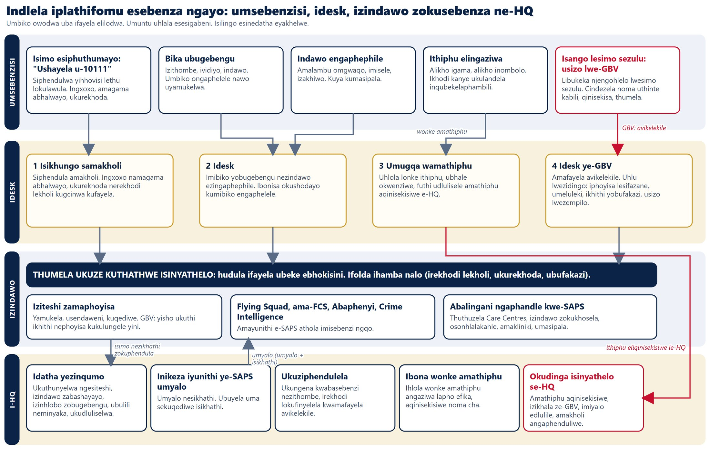

3. Izindima nokufinyelela
Indima | Ingena kanjani | Ingafinyelela kuphi
Umsebenzisi | Akukho ukungena. Iphrofayela ayiphoqelekile. | Okuthunyelwe nguye kuphela. Amathiphu alandelwa ngekhodi kanye.
Iphoyisa ledeski | Isigaba, noma yiliphi igama noma inombolo, isithombe sekhamera, iphasiwedi | Amafayela esigaba salo kuphela. Kuphoqelelwa yiseva.
I-HQ (ibhodi) | Iphasiwedi | Izibalo, ukuhlola amathiphu, imiyalo, ukudluliselwa, amarekhodi amashifti, irekhodi lokufinyelela. Alukho ulwazi lomuntu.
Indawo yokusebenza | Ilinki eyimfihlo enethokheni | Imisebenzi ethunyelwe kuleyo ndawo kuphela.
Umlawuli | Ithokheni yomlawuli | Ukusetha kabusha idatha yesilingo.

Kulesi silingo, wonke amaphasiwedi ngu-0000 futhi noma yiliphi igama noma inombolo liyamukelwa njengenombolo yephoyisa. Lesi isinqumo somnikazi sesilingo esinedatha eyakhelwe. Amalinki ezindawo zokusebenza asayinwa ngesihluthulelo esiyimfihlo sohlelo, ngakho-ke lesi sihluthulelo kufanele sihlale singaguquki noma amalinki ayeke ukusebenza.
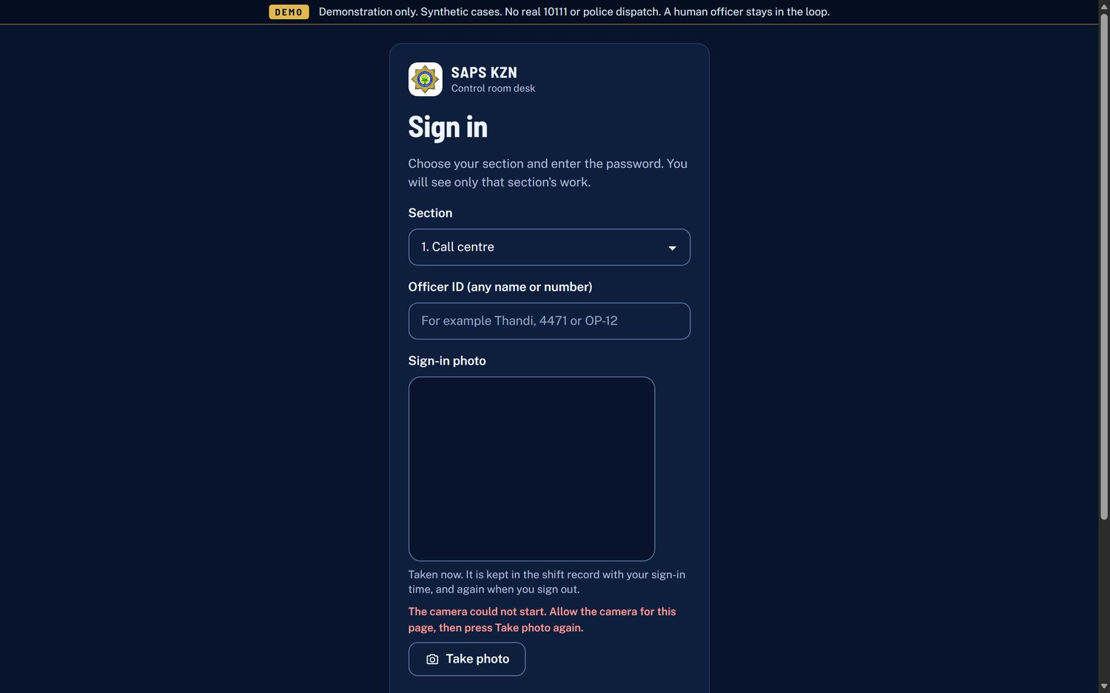
Ukungena kudeski: isigaba, inombolo yephoyisa nesithombe esiphilayo

4. Imodeli yedatha
Irekhodi | Iqukethe ini
Ifayela (case) | Inombolo (KZN-unyaka-inombolo), isiteshi, uhlobo, ukubaluleka (kubaluleke kakhulu, phezulu, evamile, ephansi), isimo (kusha, kunikeziwe, kuyaqhubeka, kudluliselwe, kuvaliwe), indawo, amanothi, ubufakazi, irekhodi lekholi, izidingo ze-GBV, nokuthi liphelele noma cha nokuthi yini eshodayo.
Ithiphu | Inombolo (TIP-unyaka-inombolo). Umbhalo nobufakazi kuphela. Alikho igama, inombolo, isihlonzi sedivayisi noma ikheli. I-hash kuphela yekhodi kanye.
Ukudluliselwa nomyalo | Ukudluliselwa kuya ngaphandle kwe-SAPS, noma umyalo oya phansi kuyunithi ye-SAPS onemiyalo nesikhathi.
Umlingani nendawo yokusebenza | Iziteshi, amayunithi nabalingani bangaphandle, namathokheni amalinki angasese.
Imidiya | Izithombe, ividiyo, ukurekhoda kwamakholi ezingxenyeni zamasekhondi amahlanu, ingxoxo yekholi nombhalo.
Ukuhlola (audit) | Ubani ovule ifayela elivikelekile noma isithombe, esigabeni sini, nini.
Iphoyisa neshifti | Inombolo yephoyisa, isigaba, izikhathi nezithombe zokungena nokuphuma, nokuthi ikhamera ibingatholakali yini.

Ithiphu lidlula kulezi zimo: kusha, liqinisekisiwe, lidluliselwe, lamukelwe, linikeziwe umyalo, livaliwe.

5. Ukugeleza okuyinhloko

Ikholi eyingozi
- Umsebenzisi uqala ikholi. Ikhala kudeski ngomsindo nekhadi lekholi engenayo.
- Iphoyisa liyaphendula. Ingxoxo yombhalo namagama abhalwayo ngqo kuyaqala. Amagama avela ekuqapheleni inkulumo kwebhrawuza uqobo, abonakala njengoba ekhulunywa.
- Ikholi iyazimisa ngemuva komzuzu owodwa kusilingo. Ikholi engaphenduliwe ivalwa ngemuva kwamasekhondi angu-90.
- Irekhodi lekholi, ingxoxo, umbhalo nanoma yikuphi ukurekhoda kugcinwa kufayela.

Umbiko wobugebengu nokuthumela ukuze kuthathwe isinyathelo
- Umbiko uyamukelwa noma ungaphelele. Ufakwa uphawu "Ongaphelele" bese kudwetshwa okushodayo.
- Idesk iyawubuyekeza bese iwuhudulela ebhokisini lesiteshi, leyunithi, lomphathi wesigodi noma lomlingani.
- Ifolda ihamba nawo. Indawo yokusebenza iwubona ekhasini layo bese iyawamukela, iya endaweni futhi iyaqeda.
- Izibalo zokuthunyelwa ze-HQ ziyabuyekezwa njengoba izimo ziguquka.

Isicelo se-GBV
- Uhlelo lwesimo sezulu luthumela isicelo. Iphrofayela yomsebenzisi obhalisiwe iyanamathiselwa. Umuntu othembekile onikeziwe wazisiwa ngelinki yemephu ngokuthinta kanye, noma ngokuzenzakalelayo uma imilayezo ivuliwe.
- Ifayela lifika esigabeni se-GBV, livikelekile futhi lifakwe uphawu lokubaluleka kakhulu uma umuntu engaphephile.
- Idesk ihlola izidingo elindele (iphoyisa lesifazane, umeluleki, ikhithi ye-D1 noma i-D7, usizo lwezempilo ne-PEP, i-Victim Friendly Room, ezokuthutha, indawo yokukhosela) bese ithumela esiteshini noma kuyunithi ye-FCS.
- Isiteshi siphendula isidingo ngasinye ngokuthi "Siyinayo" noma "Asinayo". Uma singenayo, kuthunyelwa ngokuzenzakalelayo isicelo kumlingani ongayihlinzeka, futhi i-HQ ithola isexwayiso "I-GBV ayikwazi ukuhlinzeka".
- Ukudluliselwa kuya ezikhungweni zokunakekela, ezindaweni zokukhosela, kosonhlalakahle noma emakliniki, ngalinye ekhasini lalo.
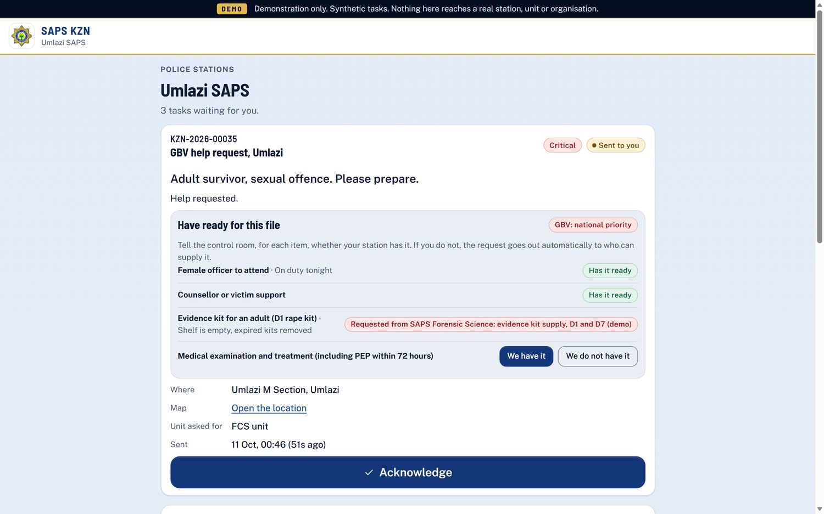
Ikhasi lesiteshi, lapho isiteshi siphendula khona isidingo ngasinye se-GBV
Umdwebo ekhasini elilandelayo ubonisa indlela yonke ye-GBV.
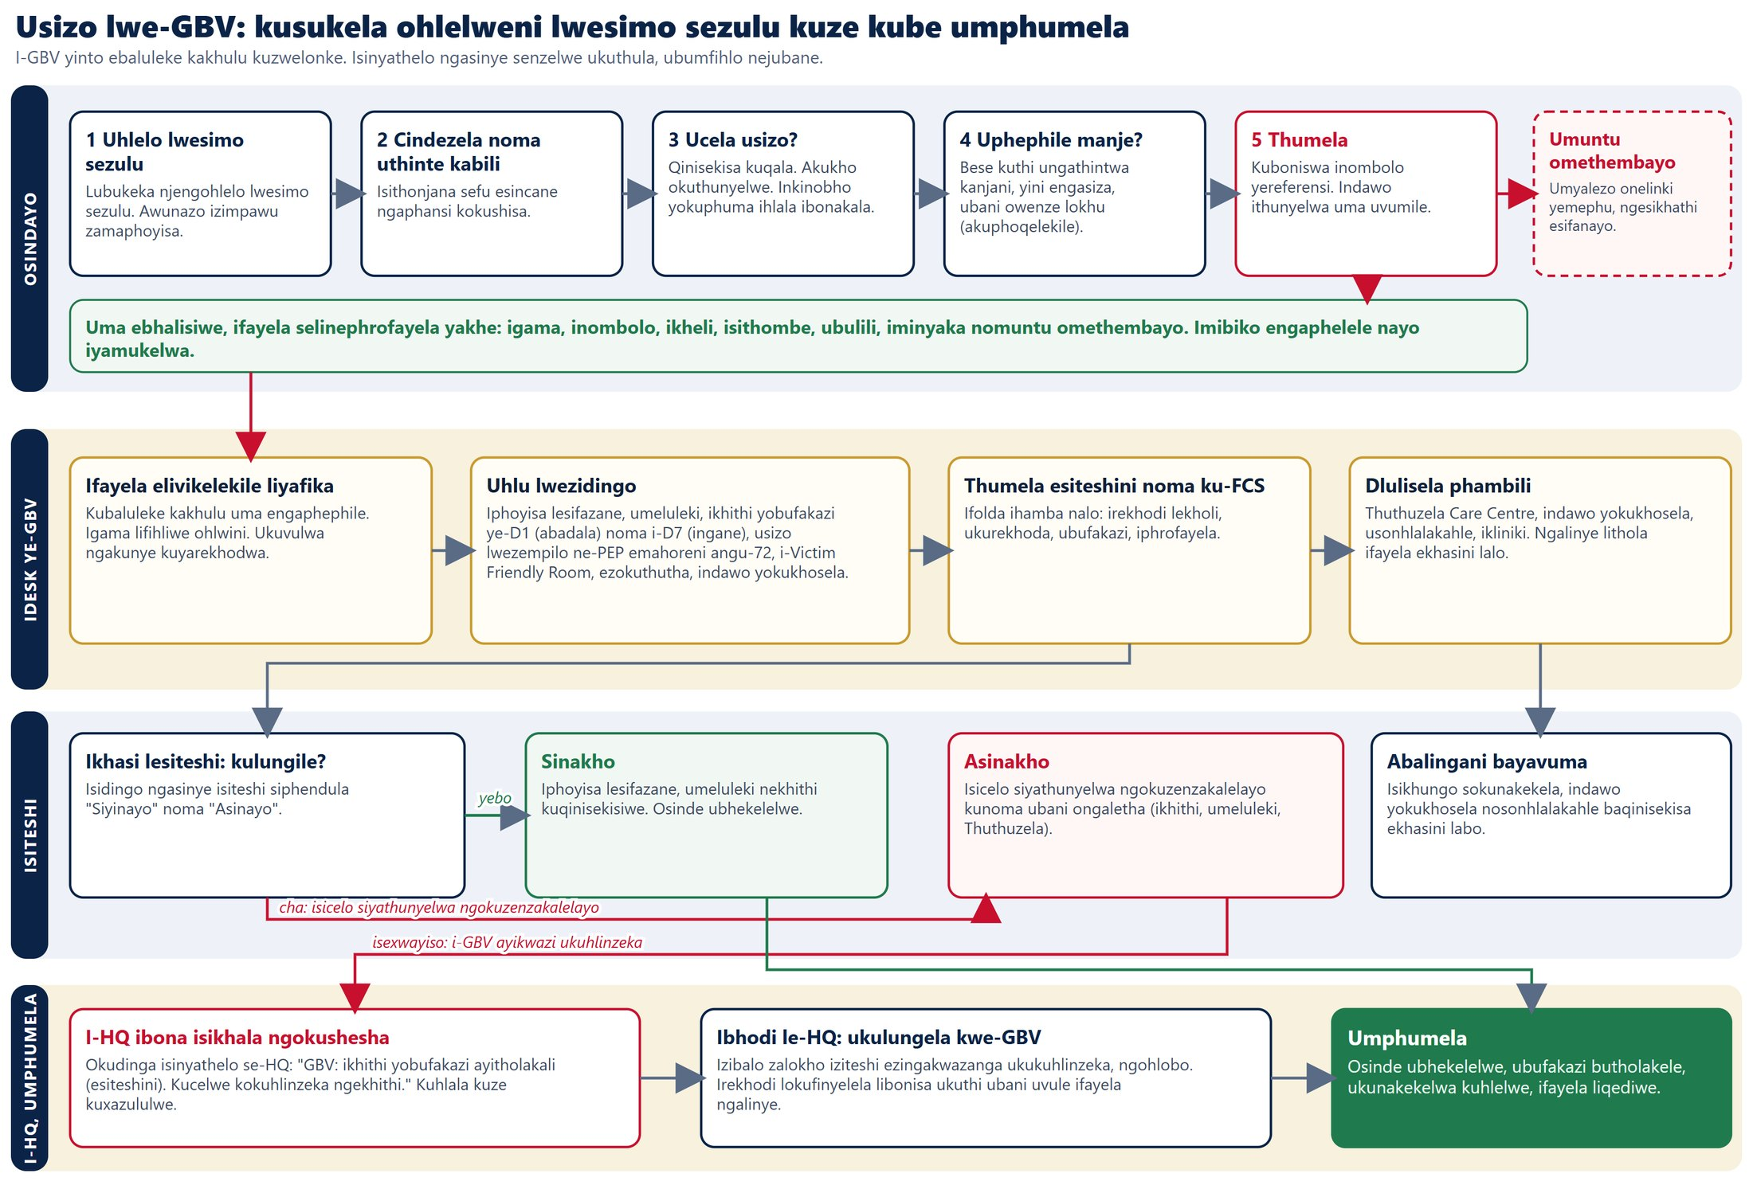

6. Ukusebenza ngesikhathi sangempela
Izikrini ziyabuyekezwa ngokubuza iseva ngezinguquko emaphethelweni amafushane, nokuhlola inguqulo ukuze kungathunyelwa lutho uma kungashintshanga lutho. Lokhu kugwema ukuxhumana okuhlala isikhathi eside futhi kugcina isilingo silula futhi sethembekile.
Isikrini | Sihlola njalo | Amanothi
Idesk | Amasekhondi angu-2 | Amakholi angenayo akhala ngomsindo.
Ibhodi le-HQ | Amasekhondi angu-2.5 | Ibha yezidingo, amathiphu, izibalo.
Umsebenzisi ngesikhathi sekholi | Isekhondi eli-1 | Ingxoxo namagama abhalwayo.

7. Ukulawulwa kokuphepha nobumfihlo
- Inqubomgomo yokuqukethwe ikhawulela lapho amaskripthi, izithombe nokuxhumana kungavela khona.
- Okubhalwayo kufanele kuvele endaweni efanayo futhi kube yi-JSON. Imikhawulo yenani: ukungena ngu-10 ngomzuzu, umbiko ngu-20, ukulayisha ngu-10, ukuqala ikholi ngu-10.
- Umbhalo womsebenzisi ubonisiwe ngokuveza umbhalo kuphela, hhayi njenge-HTML.
- Amathiphu agcinwa ngokwehlukile emafayeleni angenalo ulwazi lomuntu. Amarekhodi eseva asengaba namakheli enethiwekhi, alawulwa umhlinzeki wesikhungo.
- Amarekhodi avikelekile (izicelo ze-GBV nezesimo sezulu): amagama afihliwe ohlwini; ukuvulwa ngakunye nokubuka isithombe ngakunye kurekhodwa erekhodini lokuhlola kunegama lephoyisa nesigaba.
- Isiphakeli se-HQ asinalo ulwazi lomuntu. Izibalo ezingaphansi kuka-5 zibonakala njenge-"<5". I-GBV, i-SOS namathiphu awaze abe amachashaza kumephu.
- Izigaba zedeski zihlukaniswe kuseva, hhayi nje ukufihlwa esikrinini.
- Izithombe zokungena zithathwa ngekhamera ephilayo kuphela. Uma ikhamera ingakwazi ukuqala, iphoyisa lingaqhubeka futhi irekhodi lifakwa uphawu.
- Azikho izimfihlo ekhodini. Zonke izilungiselelo ziyizinguquko zendawo.
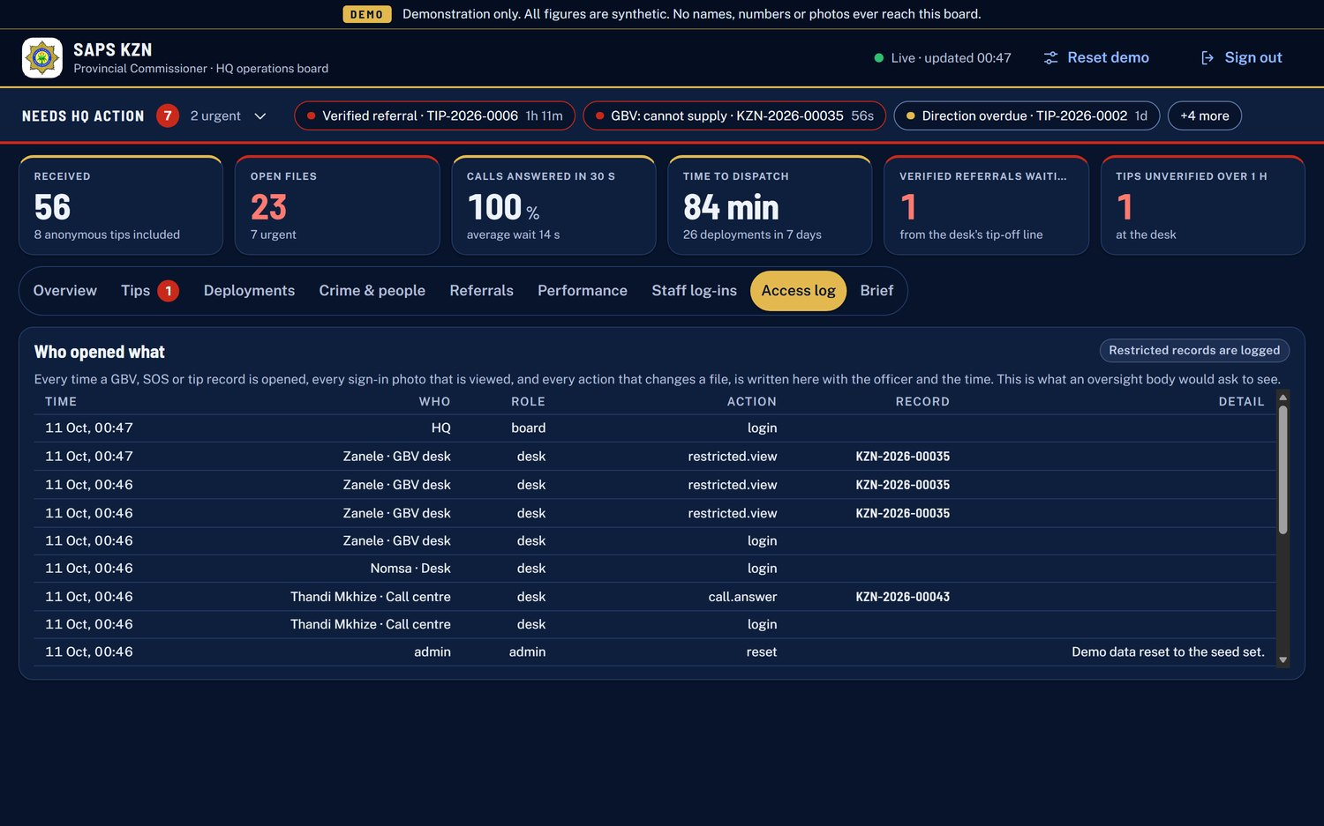
Irekhodi lokufinyelela: ubani ovule yiliphi ifayela elivikelekile
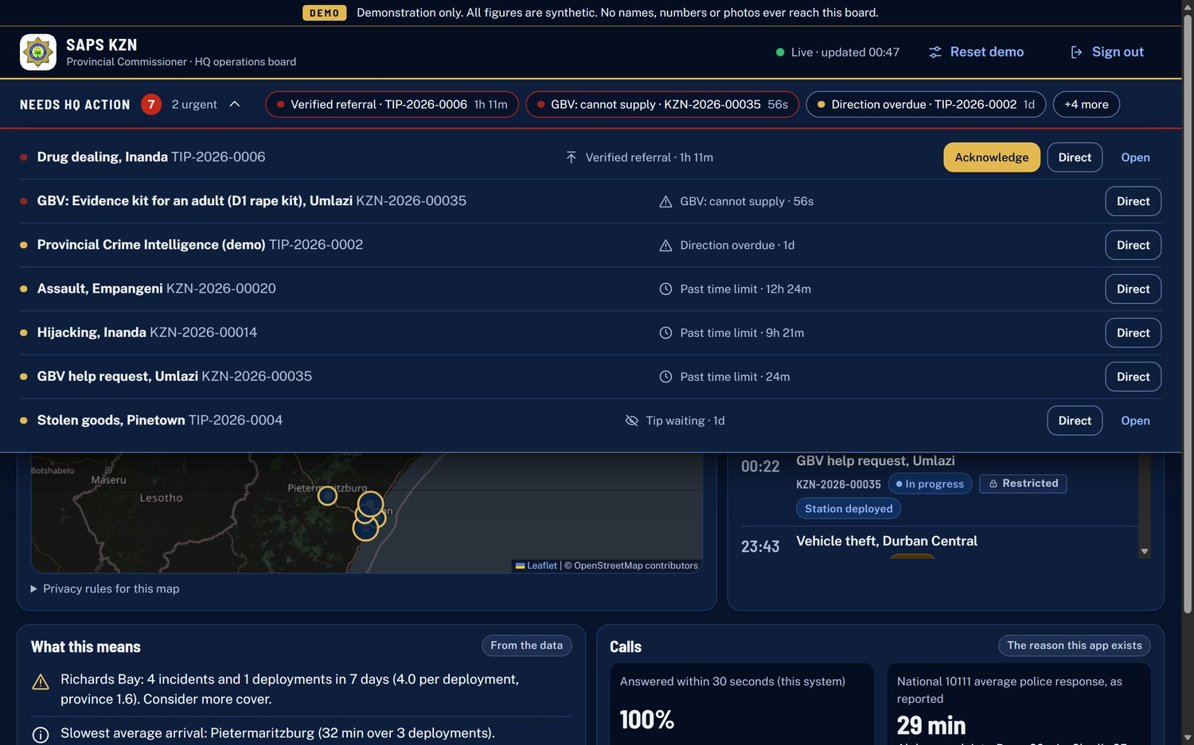
Uhlu lwezidingo ze-HQ oluhlanganisa isikhala sokuhlinzeka se-GBV

8. Izixhumi (isifinyezo se-API)
Indawo | Izibonelo
Okuvulekile (umsebenzisi) | Ukulungiselelwa, umbiko, ukulayisha, isimo sethiphu ngekhodi, ukuqala ikholi, isimo sekholi, umugqa wekholi, ukuphela kwekholi, ukurekhoda kwekholi.
Ukuqinisekisa | Ukungena, ukuphuma, ngubani mina.
Abasebenzi (idesk ne-HQ) | Isiphakeli, ifayela, ithiphu, isinyathelo, ukuphendula nokuqeda ikholi, ukuthumela, ukuthunyelwa, ukudluliselwa, umyalo, amayunithi, iziteshi, abalingani, izindawo zokusebenza, imidiya, amashifti, izithombe zamashifti, ukuhlola, umbhalo wekholi, izidingo ze-GBV.
Izindawo zokusebenza | Imisebenzi, ukubuyekeza umsebenzi, ukuphendula isidingo, ukwengeza imidiya. Ithokheni iyadingeka.
Umlawuli | Ukusetha kabusha idatha yesilingo. Ithokheni yomlawuli iyadingeka.
Impilo | Ukuhlolwa okulula kwempilo kubuyisa uhlobo lwesitolo nokuthi ividiyo nemilayezo kuvuliwe yini.

9. Ukuthunyelwa nokusebenza
- Kusebenza ku-Cloud Run esifundeni sase-Johannesburg, isikhathi esisodwa, njalo kuvuliwe.
- Ukukhishwa okuphephile: thumela inguqulo entsha ngaphandle komphakathi nethegi yokuhlola, uyihlole kwikheli lokuhlola, bese uthuthela umphakathi. Inguqulo yangaphambilini ihlala ukuze kubuyiswe ngokushesha.
- Ukubuyisa kuyimiyalo eyodwa eqondisa umphakathi kuhlelo olungaphambilini olunegama.
- Izilungiselelo zokukhiqiza zihlala ngaphandle komgodi wekhodi ekhompuyutheni yomnikazi.
- Ikhodi ikumgodi oyimfihlo, egcinwa ngobusuku obulandelanayo ngokuqapha okala ukuthumela noma yini ebukeka njengesimfihlo.

10. Ikhwalithi nokuhlolwa
Kunokuhlolwa okuzenzakalelayo okungu-60 okuhlanganisa ukungena, ukuhlukaniswa kwezigaba, imibiko engaphelele, uhambo lwethiphu, amakholi, izidingo nezicelo ze-GBV, ukudluliselwa nemiyalo, izibalo ze-HQ nemithetho yobumfihlo, namarekhodi amashifti. Izindlela ezintathu nazo zazanywe ngesandla kusukela ekuqaleni kuze kube sekugcineni: ikholi ephenduliwe yaphela, ithiphu elingaziwa laqinisekiswa lwadluliselwa e-HQ, nombiko wobugebengu othunyelwe esiteshini waqedwa. Wonke amakhasi ahlolwe ngosayizi bafoni nekhompuyutha.

11. Imikhawulo eyaziwayo nomgwaqo oya ohlelweni olusebenzayo
Umkhawulo namuhla | Okwenziwa uhlelo olusebenzayo
Isikhathi esisodwa; idatha ephilayo igcinwa kumemori | Dlulisela isimo esiphilayo kusevisi eyabelwanayo ukuze izikhathi eziningi zisebenze futhi uhlelo lukwazi ukukhula.
Amaphasiwedi anjalo ahlanganyelwayo esilingweni | Ama-akhawunti omuntu ngamunye anokungena okuqinile, nokubuyekezwa kwemithetho yokufinyelela.
Amagama abhalwayo ngqo axhomeke kubhrawuza futhi asebenza ngesiNgisi kuphela | Ukuqapha inkulumo eseseva enesekelo lesiZulu, nokuhlolwa ngabantu.
Ayikho imisindo nevidiyo yangempela okwamanje | Xhuma isevisi yevidiyo bese urekhoda amakholi ngokuzenzakalelayo.
Imilayezo ivaliwe | Khetha inombolo yomthumeli bese uvula izixwayiso ze-WhatsApp ne-SMS.
Iziteshi nezigodi ezilinganisiwe (20 nezi-10) | Layisha uhlu lwangempela lweziteshi ezingaba ngu-184 nezigodi zazo.
Amathayela emephu nama-font asemakhasini ewebhu avulekile | Zisingathe ama-font futhi usebenzise umthombo wemephu onelayisense.
Ayikho inqubomgomo yokugcina | Cacisa ukuthi amarekhodi agcinwa isikhathi esingakanani, bese wengeza ukubuyekezwa ngokusemthethweni kokuphepha nobumfihlo.

12. Ikhodi ihlelwe kanjani
Ifolda noma ifayela | Okukuyo
app.py | Yakha uhlelo, ibhalisa amakhasi, ukuqondiswa kabusha namakhasi amaphutha.
saps/ | Ingqondo yesevisi (amafayela, amathiphu, amakholi, ukudluliselwa, izibalo), i-API, ukuqonda kwe-HQ, imithetho yokuphepha, isitoreji, imilayezo.
templates/ | Isifanekiso sekhasi esisodwa sesikrini ngasinye.
static/ | Amaskripthi, izitayela nezithombe, okuhlanganisa uhlelo ledizayini.
tests/ | Ukuhlolwa okuzenzakalelayo.
docs/ | Amanothi okudlulisela, umbhalo wokuzilolonga nemodeli ye-HQ.

