COMP40725
Lab Book 2: Learning SQL using The Supplier Parts Database

NB Using the shell provided in XAMPP has to added benefits
- MySQL is automatically in the path meaning that you do not need to change to the insall directory to log on
- The history of your commands is stored and may be accessed by using the “Up Arrow” key

PART 1: Setup the lab and load SupplierPartsDB database

- Create a folder called Lab2 in your COMP40725. You may wish to have this inside a folder that is being synced by Google Drive
- Download the file called Lab_Book_2_supplierParts.sql from Moodle into the Lab2 folder.
- Open the above SQL file in a text editor which provides highlighting to see the list of SQL queries that are contained in the file e.g.
  - Windows: Notepad++ http://notepad-plus-plus.org/download/v6.5.3.html or
  - Mac: TextWrangler http://www.barebones.com/products/textwrangler/download.html
- Load XAPP
- Start your MySQL Server
- Open a shell/ terminal
  - Start the XAMP shell (MySQL will be in your path) or
  - Load a windows shell (MySQL may not be in your path) by pressing “Windows Key” + “R” and then typing “cmd” and then hitting return or
  - In Mac / Linux open a terminal (MySQL may not be in your path)
- Load the database into MySQL using one of the below options (blue indicates prompts):

From the XAMPP shell
- MySQL is in your path and the SQL file is in your present working directory:
# mysql –u root –p
mysql> source Lab_Book_2_supplierParts.sql

- MySQL is in your path and the SQL file is NOT in your present working directory:
# mysql –u root –p
mysql> source D:\GoogleDrive.UCD\COMP40725\ \Lab2\Lab_Book_2_supplierParts.sql
This is the best option

From cmd.exe
- MySQL is in your path and the SQL file is in your present working directory:
c:\xampp\mysql\bin>mysql> mysql –u root –p < Lab_Book_2_supplierParts.sql

- MySQL is in your path and the SQL file is NOT in your present working directory:
c:\xampp\mysql\bin>mysql> mysql –u root –p < D:\GoogleDrive.UCD\COMP40725\ \Lab2\Lab_Book_2_supplierParts.sql

Note: If anything goes wrong with the database (accidental deletion, etc.), you can repeat this step to restore the database to its original state.
  - If the import was successful, you should not see any error messages. To check that the import was successful, make sure you are logged in to mysql and execute
SHOW DATABASES;,
You should see a new database called SupplierPartsDB. If so, execute:
USE SupplierPartsDB;
  - Execute:
SHOW TABLES;
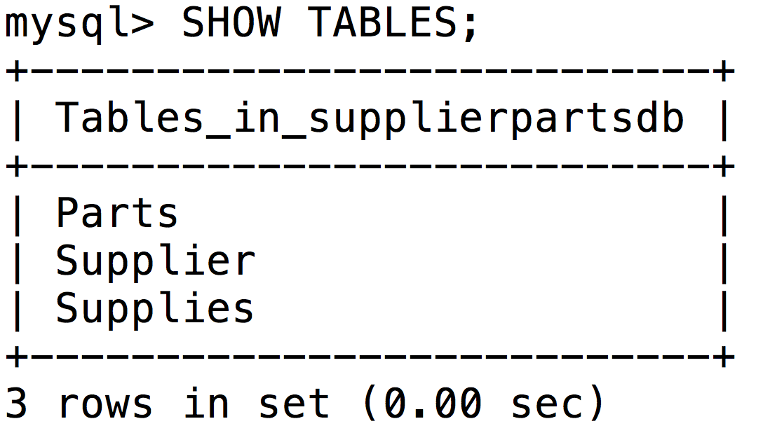
This should return the list of tables called: Supplier, Parts and Supplies. As can be seen above.
Execute the following command for each table to see its structure:
DESCRIBE tablename;

PART 2: Lab Questions

Your submission should be named lab2_studentNumber_firstName_LastName.doc

Open Notepad++ or TextWrangler and create and save an empty file called tmp.sql in your Lab 2. You can write your statements in this file before you execute them to assist you in designing them.

Support for this practical can be found in the following ways
- Lecture Notes.
- Google “MySQL name_of_command” and you will find some examples.
- Demonstrator – you can ask us any question no matter how basic.

For each of the questions below, include a screenshot of your SQL query being executed and the resultant changes to the table (where necessary).

Q1. The SQL CREATE TABLE <tableName> AS… can be used to create a table from an existing table in MySQL. Create a table named ‘SupplierA’ built from the data contained in the Supplier table for supplierNum S1 and S2. You should provide a screenshot of both the CREATE TABLE query and the result of the query: SELECT * FROM SupplierA. Part of the solution is in the slides!

------------------------------------------------------------------------------------------------------------------
1. To provide a basis for comparison, we should show the data contained in the table, Supplier, from which the table, SupplierA, will be built:
SELECT * FROM Supplier;

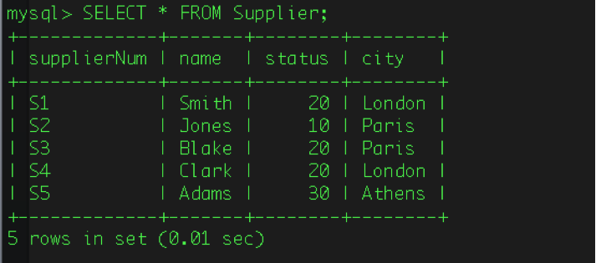

2. Now, let’s create the new custom table using the following query:

CREATE TABLE SupplierA AS SELECT supplierNum, name, status, city
FROM Supplier WHERE supplierNum='S1' OR supplierNum='S2';

3. The result of creating table, SupplierA, using the ‘SELECT’ statement:

SELECT * FROM SupplierA;

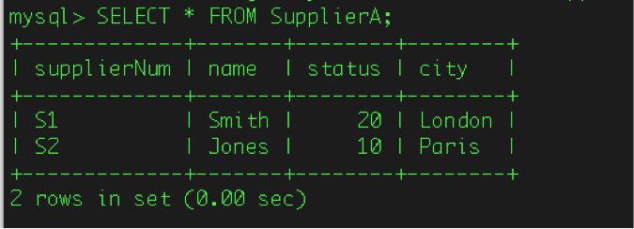

-----------------------------------------------------------------------------------------------------------------
Q2. Update the Supplier table to reflect a change in Supplier_status to the value ‘20’ for all suppliers from Paris. You should provide a screenshot of the update and of a suitable SELECT statement to show the change. Try searching on Google!

1. Let’s view the Supplier table’s data before the change:
SELECT * FROM Supplier;

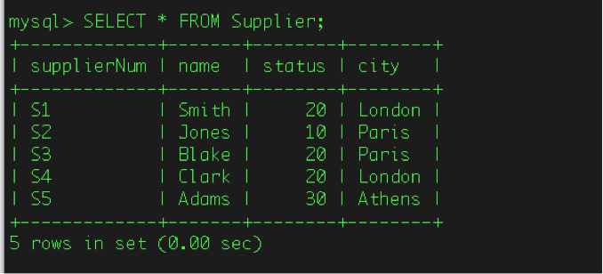

2. Perform update:
UPDATE Supplier SET status=20 WHERE city='Paris';
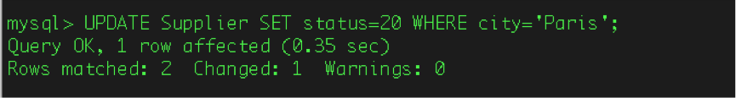

3. Et voila…

SELECT * FROM Supplier;
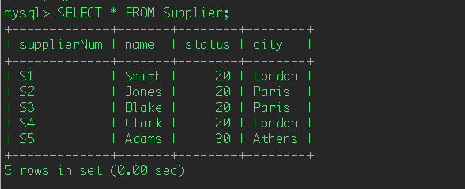

--------------------------------------------------------------------------------------------------------------
Q3. Delete all entries in the Supplies table corresponding to supplierNum S4. You should provide a screenshot of the DELETE statement and of a suitable SELECT statement to show the change.

1. First off, let’s view the relevant entries in the Supplies table to pinpoint what exactly we need to delete:

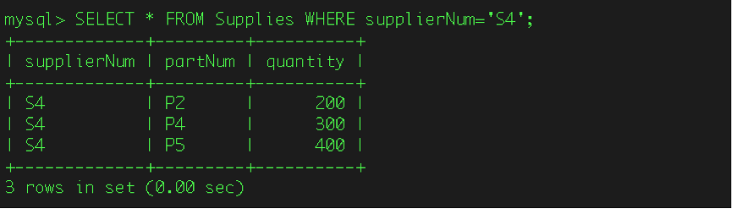
SELECT * FROM Supplies WHERE supplierNum='S4';

2. Now, delete relevant entries using the DELETE statement:

DELETE FROM Supplies WHERE supplierNum='S4';
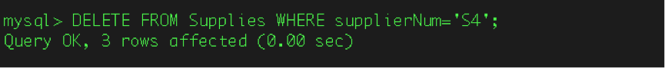

3. Do these entries (for supplierNum ‘S4’) still exist?
SELECT * FROM Supplies WHERE supplierNum='S4';

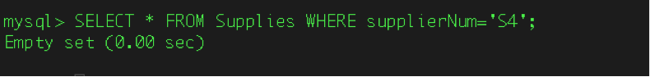

--------------------------------------------------------------------------------------------------------------------
Q4. Insert the following information into the Supplies table:
supplierNum | partNum | quantity
S4 | P2 | 500
S4 | P4 | 100
S4 | P5 | 800

You should provide a screenshot of the INSERT statement and of a suitable SELECT statement to show the change.

1. Let’s try inserting one record of data (the first row) using the following statement-style:
INSERT INTO Supplies VALUES ('S4', 'P2', 500);
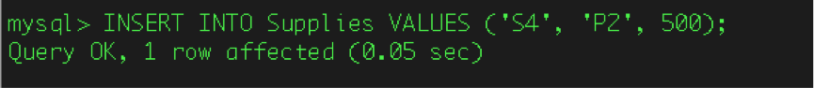

2. Now, checking if this data is now in its new place:
SELECT * FROM Supplies;

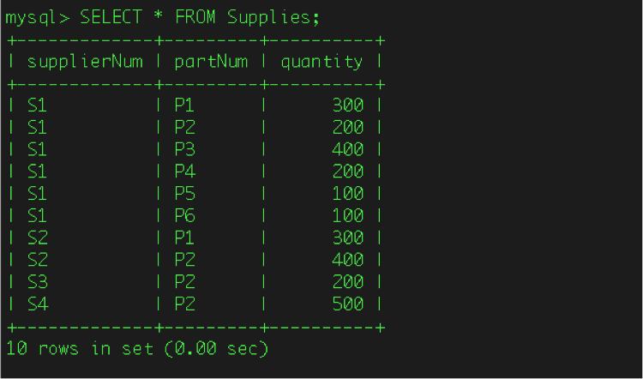

3. For learning purposes, we can achieve data entry of the remaining records using another (similar) syntax:
INSERT INTO Supplies (supplierNum, partNum, quantity) VALUES
('S4', 'P4', 100), ('S4', 'P5', 800);

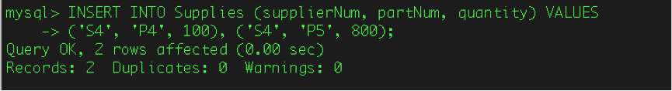

4. Finally, let’s view the table, Supplies again to be sure that the data was entered correctly:
SELECT * FROM Supplies;

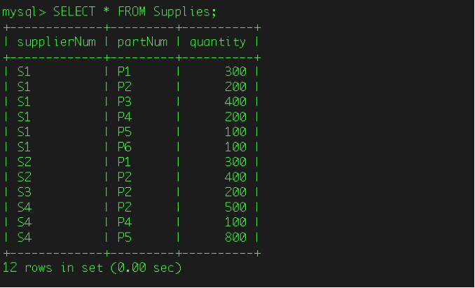

--------------------------------------------------------------------------------------------------------------------

Q5. Show the count of suppliers in each city ordered from highest to lowest.

- We can use the following statement toward this end:

SELECT city, COUNT(city) AS countSuppliers FROM Supplier GROUP BY city DESC;
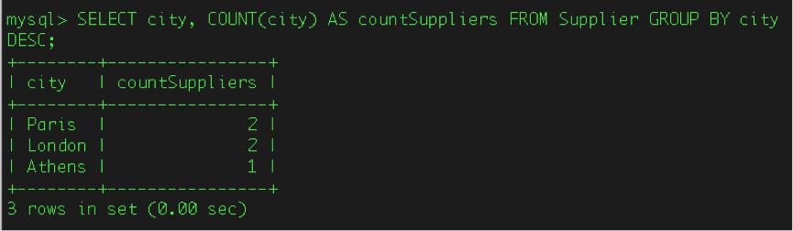

------------------------------------------------------------------------------------------------------------------

Q6. Remove the ‘weight’ attribute from the Parts table.

1. View table prior to making any changes:

SELECT * FROM Parts;
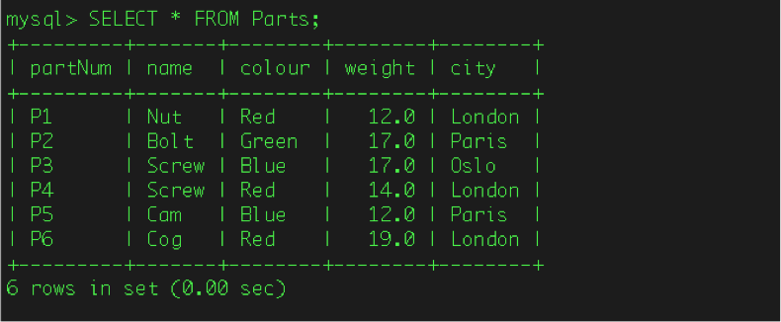

- Perform alteration of table, specifically removing the ‘weight’ attribute:

ALTER TABLE Parts DROP weight;

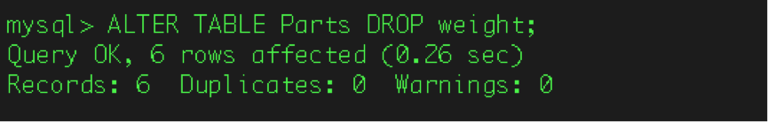

3. We are now left with the Parts table minus its weight column:
SELECT * FROM Parts;

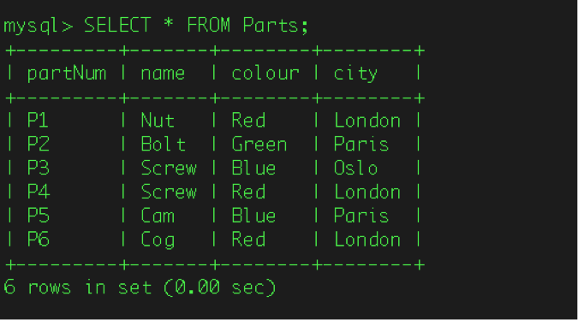

--------------------------------------------------------------------------------------------------------------------
Q7. Show only the name of all the parts in the Parts table except red parts.

- Select all information from the Parts table to begin with:
SELECT * FROM Parts;
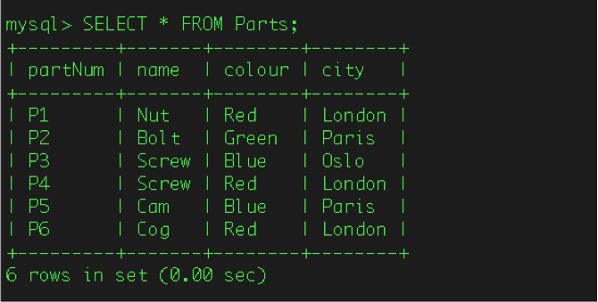

- Now, select only the name of all parts where the name is not ‘red’:

SELECT name FROM Parts WHERE color <> 'red';

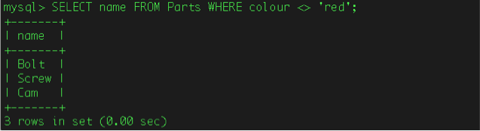

--------------------------------------------------------------------------------------------------------------------
Q8. Show all the parts in the Parts table except those with a quantity of 500 or 800 using a NOT IN condition.

- Use following command to perform this operation:

SELECT Parts.partnum, name, colour, quantity, city FROM Parts, Supplies WHERE
Parts.partNum = Supplies.partNum AND quantity NOT IN (500, 800);

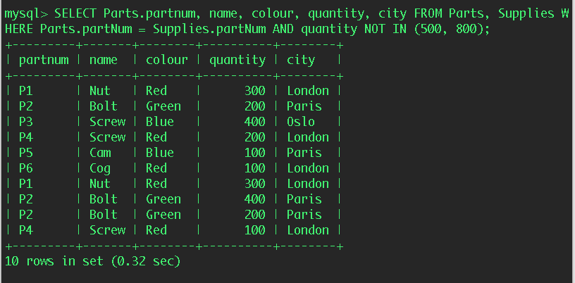

Q9. Show all entries from the Supplies table with their corresponding part names.

1. Providing all existing information from Supplies table, plus parts’ corresponding names;

SELECT supplierNum, Supplies.partNum, name, quantity,
FROM Supplies LEFT OUTER JOIN Parts ON Supplies.partNum=Parts.partNum;

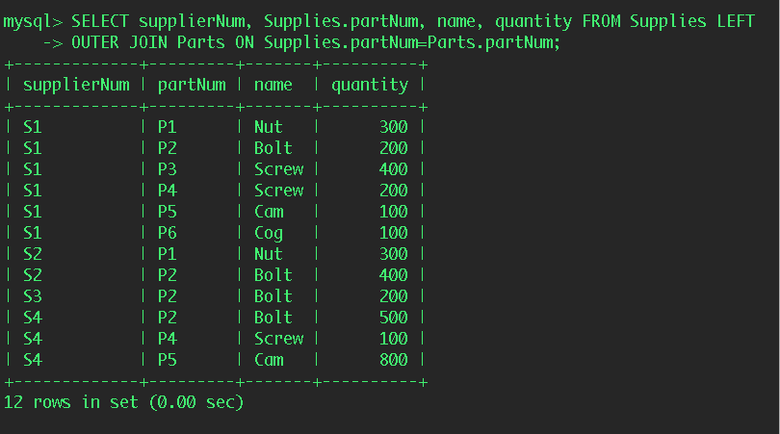

------------------------------------------------------------------------------------------------------------------
Q10. Show the names of all Suppliers that appear more than once in the Supplies table.

- Method 1:

SELECT name, count(Supplies.supplierNum) AS countSuppliers FROM Supplier LEFT
JOIN Supplies ON Supplier.supplierNum=Supplies.supplierNum GROUP BY name
HAVING (countSuppliers) >1;

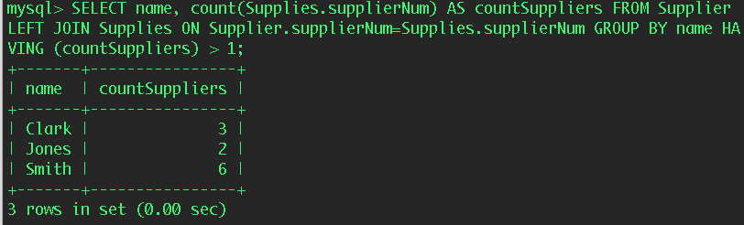

- Method 2 where only names are included:

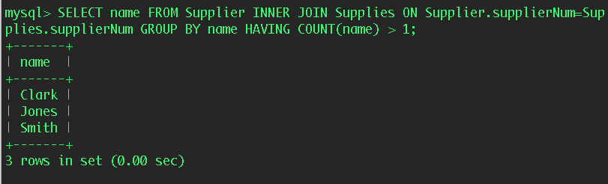
SELECT name FROM Supplier INNER JOIN Supplies ON Supplier.supplierNum=Supplies.supplierNum GROUP BY name HAVING COUNT(name) > 1;

