**SONM (Supercomputing optimized by network mining)**

**(v0.1)**

**www.sonm.io**

Draft 0.20

02.01.2017

Reddit:

BitcoinTalk:

Slack: - нужна организация SONM на гитхаб, слак подключается к гитхабу.

Twitter:

Facebook:

G+ - не нужен

VK:

Whitepaper:

Активность в телеграмм еще нужна

Contents

1.2. Grand vision and core features. 3

1.3. Ecosystem of SONM 8

Why hubs? 10

What are supernodes? 12

1.4. DrugDiscovery@home – world example 13

2.0. Tokens of SONM (workname – Dilatones) 21

Creation of the Token and initial TOKEN account functionalities 22

2.1. Roadmap 24

Faruk (lone star): 24

Mutual help system 25

The Experiment 26

Solaris 26

Interstellarys 28

Future Vision of SONM 28

Singularity 29

What happens when existence end? Что будет когда ничего не будет? 29

2.2. Comparison to similar projects 30

GridCoin,CureCoin and other altcoins. 30

Golem Network 30

2.3. Crowdfunding 30

Details 31

Financial plan 32

2.4. SONM TEAM DESCRIPTION 33

* 1. **Introduction**
  2. **Grand vision and core features.**
* **SONM** will be the first active decentralized platform and network for distributed general purpose computations and creation of a global distributed market for computing power. Combined with flexible tools to aid developers in securely distributing and monetizing their software, **SONM** altogether changes the way computing tasks are organized and executed. By powering decentralized microservices and asynchronous task execution, **SONM** is set to become a key building block for future Internet service providers and software development. And, by substantially lowering the price of computations, complex applications such as CGI rendering, scientific calculation, game servers deployment and machine learning become more accessible to everyone.
* **SONM** will give an opportunity for people worldwide to get additional income, using their computing devices. For many people, especially from developing countries, this may give an opportunity to get out of the poverty and will allow making stable income from renting out even simple general purpose computing devices.
* SONM derives its technology for mining from **BOINC (Berkley Open Infrastructure Network Computing)**, which is a platform for distributed scientific volunteer computing. This platform is used by majority of modern scientific distributed volunteer computing projects and we decided to use its technological principles for supernodes in our decentralized computing network. This will enable us to use validation procedures for cross-checking the results correctness.
* **BOINC (Berkelet Open Infrastructure Network Computing)** platform provides possibility to create servers and distribute computing tasks between miners, which calculate their part of a job and return results to the server, where results are validated and statistics is calculated about each miner impact on the statistics. All statistic and input/output data is open and ready for check. Also BOINC supports clusterization of resources and therefore it is possible to create virtual private machines of any architectures. All of that means, that this platform can provide services, which are currently provided by cloud computing platforms (like Amazon WebServices, GPU clouds for example) and can be applied to any computing task from site hosting to calculation of BigData, and even work as service of Amazon Delta, which means that this project can work as PaaS (Platform-as-a-Service) and IaaS (Infrastructure-as-service). We will use BOINC code as starting point to create decentralized network with supernodes managing computing distribution tasks.

**Choosing the right distributed computing platform**

In choosing of the right computing platform many factors were considered:

* **Common hardware:** The hardware most commonly used for Bitcoin and Altcoin mining was AMD/ATI GPUs. AMD/ATI GPUs outperform Nvidia GPUs, when it comes to SHA256 and Scrypt hashing. DrugDiscovery@home (DDAH) also performs very well on AMD hardware as well as on consumer Nvidia hardware. Basically any hardware should be able to be attached to the computing tasks.

**What are the advantages of using BOINC computing platform?**

* **Easy:** Ease of setup for the general computer user was also evaluated. BOINC software was the most polished software, which represents a simple “download and go” program that runs in the background of a PC with simple setup procedure. Taking into account MIST browser-based wallet from Ethereum network, we expect that no blockchain download will be required for our currency. Therefore we expect our project to solve one of the most irritating issues of blockchain wallets – the time, needed for blockchain download in order to get blockchain currency active.
* **Large user base:** Besides the Bitcoin Network, BOINC is the largest distributed computing platform in the world, harnessing nearly 50 PetaFLOPS of computational power.
* **Strong development team:** BOINC is superior, when it comes to overall production and security, large developmers and users community. BOINC creates secure folder on providers PC, which is used for storage and usage of the data for computing tasks.
* Here goes fragment from Krzysztof about BOINC for P2P.

**Smart-contracts and SONM tokens for renting in/out computing power and disk space**

* Our project creates possibility to convert BOINC statistics into the smart-contract based tokens (created on Ethereum platform), which can be then used as digital currencies for computing power market and other purposes. We are taking out middlemen for computing and storage solutions and therefore we create maximum profits for miners, providing their computing power and we suggest the most efficient solutions in terms of efficiency for Requestors of computing power.
* In order to select a project, one needs to enter server address. In case of our project users will be entering world (hub) addresses or system will be assigning projects themselves according to analysis of devices properties and therefore maximizing miners profits.

***Machine learning and distributed artificial intelligence for network management***

* We expect to use machine-learning algorithms for optimizations of application-task-device combinations. So if the task of Requestors (clients) has best performace on GPU, then it will be assigned to GPU and system will decide itself which of the connected GPUs will provide the maximum efficiency.

***Participants of the system***

* Further we define clients, ordering computing power as **Requestors**. Therefore **Requestors** can submit their tasks through virtual private machines and run any code they want (cause virtualization in this case allow to use ‘save sandbox’). Developers will be able to create and run boinc-compatible projects for calculating Big Data through registration of their software projects in Application Pool.
* Software engineers, scientists and developers specialists can unite into “*worlds*” – hubs of the network, based on our hybrid-boinc platform, where they could run different distributed applications or organize distributed virtual cloud. Each world would have a set of the specialized software (Application Pool) and even can issue own token. For example **DrugDiscovery@home (or DDAH)** - is a world of life sciences and new therapies development, so there is expected no applications connected with data base cluster optimization, UFO’s search or some quantum physics calculations. For those, who are familiar with standard cryptocurrency mining, “worlds” have similar functions with “pools”. Read more in “worlds” section.
* **Application Pool** – is a module for every world, where open source of distributed applications running on this world will be published. With evolution of SONM to full p2p system it will be a framework, where everybody could track what application on in which world and with what bounty is running.
* Providers of resources get cryptocurrency’s tokens (build on Ethereum) for their work from **Requestors**. SONM basically is functioning as a market for computational power.
* **Requestors** will be providing computing tasks to the networks, which then will be distributed among nodes. The nodes are learning to increase their efficiency and will have specializations on certain types of devices and applications. We expect that **providers** and **Requestors** also will connect to groups like software developers through “worlds”, representing separate GRIB (hybrid BOINC) servers. Anybody can organize their own DAO and propose idea of cloning application (for example DrugDiscovery software infrastructure will be dedicated to solving computing problems in the healthcare field on systems level, but anyone, who wants to contribute to fighting diseases is welcome to do so) or developing absolutely new application and crowdfund money to that purpose. Therefore, it is will be complete, wholeness ecosystem with **Requestors, providers(miners).**
* **Providers(miners)** are nodes owners.The most powerful and trustful nodes will become **supernodes** and their owners will be getting additional % from computing incomes for checking results of calculations. Before submitting results to the server, community have to decide what result should be canonical throw consensys. **Supernode**, as a most trustful node decide what result is canonical and **bet** that result. Other nodes must agree with that or not agree, therefore **supernode** have additional income for submitting canonical result and suffer from penalty for wrong canonical result (lie). All other result in a specifiec task just compare with cannonicial result by hub. This mechanism is called **Proof-of-Research.**

Examples of the Use Cases

***Scientific projects:***

As written above, this network could be used to organize useful calculations projects, such as drug development, bioinformatics, social statistics and modeling, aerodynamic calculations, climate predictions, meteors trajectory modelling or other stuff.

***Site hosting:***

**Requestors**, who want to deploy sites on the network, could do it also using our snippets on their sites to collect payments in Dilatones(tokens) or Ether cruptocurrency and automatically pay for hosting. Providers will be providing resourses to the ‘world’ cluster which will work as a ‘cloud’ service at this point.

***Game servers cases:***

There are many MMO games, which are using a different sort of in-game currency. With our technology we are offering solutions, when game servers could be deployed on **SONM**, therefore users could support services working by providing resourses to the world and get some tokens as an in-game currency.

***Neuro-network projects:***

They usually require a massive computational power.

***Rendering video and etc.***

Read more in ‘ecosystem’ section to know much about this.

**Scheme of the network**

**Buyers**

**Providers**

**Worlds**

Fig. 1. Scheme of the network.

* 1. Future vision

**Are you a dreamer?**

Let’s speak frankly, what dreams people have about ‘supercomputers’? If you read something from sci-fi, like Sheckly or Azimov, you can recall that people in some of their stories, dream about computer, which could be able to answer to any their question and solve different and complex economy and life problems. So, we dream about it too. And this is the final goal, which we want to succed in this project.

How that even could be possible? And how google answer your simple question? Or how neural network solve problems?

You could say, that google can’t solve question it is only get you a search results, and neuro-network could by able to solve only small task and it needs to learn first, and you will be absolutely correct, but, in fact, what if we will have neuro-network which will know how to distribute a big job to a different small tasks, calculate power, prices and all other stuff, which we are using in development of our marketplace of computer power? And what if this network will have an closely infinite calculation power? Does it solve the problem?

We think that yes, that network could probably be exactly *the supercomputer*, which could be able to solve almost any human question. Read more in ‘singularity’ (Roadmap section).

* 1. Ecosystem of SONM

SONM business case boils down to the fact that, due to relatively recent technological advances, the market for computing resources can be organized according to entirely new principles. In contrast, the computing market today is dominated by heavyweight players such as Amazon, Google, Microsoft and IBM, who leverage their market power and assets to ensure hefty margins, resulting in inefficiently priced computing services. Luckily, the market is not doomed to function this way forever. With SONM the supply of computing resources is based on contributions of individual and professional providers, combined with an array of dedicated software solutions via SONM Application Pool.

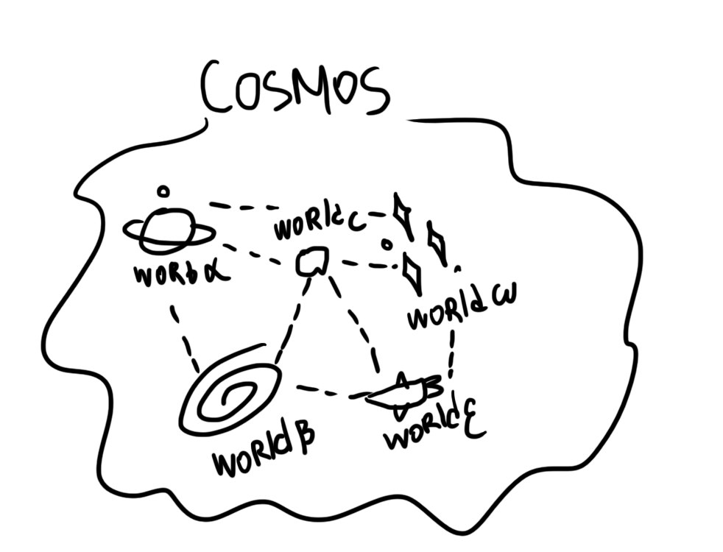

In SONM tree are three main groups of people, participating in computing market – suppliers of computing resources **("providers" or “miners**”), task creators ("**Requestors**") who submit their tasks to be computed by the network, and of course, **worlds owners (servers providers)**.

The “**worlds**” are server nodes, which are implementations of BOINC-servers and organizations of software developers behind them. “Worlds” term is almost an analog for ‘pools’ in standard cryptocurrency’s mining terminology.

SONM offers a system of “**unions**” for users, which is originally based on Ethereum DAO concepts – usually “**providers**” provide their capacity on demand from “**Requestors**”, but, as you know, *useful* calculation has their own price! For example you could decide, that it will be a great demand on processing big databases and you can organize your DAO, crowdfund your idea, develop software for this task and assign it to some world or create your own world and start business as a world that receives computing tasks from Requestors and distributes them among providers.

After organizing your DAO, you can collect the amount of tokens you want to spend on calculations, and, after collecting and selling results – distribute profit between members of DAO. Read more about it in following sections.

Current computing and internet markets are entering the singularity stage. Every day there are created new technologies, protocols, software in all areas – video transfer, rendering, data science, AI, chatbots and etc! One of the missions of SONM systems – is to unite these solutions and make them working together in the most efficient way for our bright future!

Therefore, if some group of people decides to produce useful calculations of any kind – they could buy SONM tokens and run their applications inside of the world, or they can organize a new world.

Our market of calculations will be *not just* market of capacity, but also a market for ***data results***. The prices on the market will be the real spot market prices, calculated in the most efficient ways for the task-oriented computations (taking into account hardware parameters).

“Worlds” – is a name for server hubs in SONM system.

What are worlds?

World is a GRIB (Hybrid BOINC) server of SONM network organized by anyone, who wants to earn on it and make it possible to run through it software of some sort. Creators of the GRIB servers will be able to setup their own % on top of the price, which providers ask from Requestors and/or Requestors suggest to providers. Therefore each GRIB-server will represent a separate market for computing power and all these markets will be united into one global market by the network., usually in some specific field.

Business-model of world

Organizers of world could earn money on small % from deploying custom applications on their platform (while it is not fully p2p network), they could develop and run their own programs, thy could consult and help other members, they could build applications on demand from Requestors or unites or DAO’s. Also it could be any other methods of monetization.

**In brief** world are goal and topic grouped providers of computing tasks for specific types of the applications, created around BOINC-server supporting nodes, which provide services for the Requestors.

Сейчас DrugDiscovery@home занимает 6 страниц – думаю можно сократить до 1, или вообще убрать. Это отвлекает внимание

DrugDiscovery@home – world example

**DrugDiscovery@home** is the first of the “**world”** in SONM system**,** which is building universal infrastructure for life sciences computing and new medical therapies development by integration of the open source software solutions in this field. Each disease therapy development will consist of different software usage for numerous tasks, which will have their own price in SONM tokens.

**Genesis of DrugDiscovery@home**

By Febraury 2016, a group of miners were looking for ways to use their legacy mining hardware for useful purposes, while staying part of the cryptocurrency movement at the same time. This became *modern* DrugDiscovery@home.

DrugDiscovery@home created an asset with a “Proof of Cure” concept to verify contributed computational power, where computing power results in models of high value medical treatments, resulting in reduced number of experiments, required for getting therapies into clinical trials.

Since smart contracts share the Ethereum blockchain, this allows the legacy mining equipment from Altcoin mining to be redirected towards medical research, since the Ethereum miners are already covering the security and hashing rate of the Ethereum blockchain.

**DrugDiscovey@home Mission Statement**

Cheap computing power along with cutting edge modeling algorithms will allow us to produce and sell new biomedical technologies at lower costs than any other research company and we want to make our products affordable and available to everyone.

We will start our research from developing cures to different forms of cancer and anti-aging drugs, but plan to enlarge its scope according to the available resources.

**DrugDiscovery@home workflow**

If you are not scientist – you can not even try to read following:

The currently suggested DrugDiscovery@home workflow integrates together the classic in silico drug development methods, which were widely adopted by biomedical and pharmaceutical industries along with getting the most recent newly developed in silico drug design approaches.

For example, we suggest a workflow for preclinical drug development as a series of programs, acting as filters on each stage. This project funnel is going to start from largest chemical compounds databases (such as virtual spaces) and fastest programs (for example Lipinsky, ADME/Tox, physico-chemical parameters filtering) thus producing initial databases for targeted drug design. Next stage will include datasets enrichment using various docking (including consensus, biotarget-tunned, multiple-conformations) docking software, pharmacophore-based screening and QSAR models.

On the last stages we plan to use the most heavy applications on the remaining datasets, such as molecular dynamics (in screening mode – for ligand-protein complex stability evaluation), molecular dynamics with thermodynamics integration, dynamic pharmacophore models.

Biological targets are selected according to the in silico models of the diseases and pathologies profiles. Metabolic and signaling networks analysis, adjusted to the gene expression level, biostatistics omics data processing can show us the most promising therapy targets and their combinations, including drug-drug synergy and polypharmacology possibilities.

In this regard we expect to collaborate with enterprises, working in this field, as well as to develop our own approaches. Our primary goal in this effort will be to make as much as possible data open to the public and all software resources to be open source as well.

**DrugDiscovery@home Summary**

* DrugDiscovery@home  looks to redirect what some consider to be wasted computational power from alternative cryptocurrencies and spare computing time of different devices (PC, laptops, tablets, smartphones, GPUs, GPGPUs, gadgets and even clusters etc.)  to valuable scientific research.
* DrugDiscovery@home pays for SONM computing facilities by its own token, which is converted to SONM token according to their market values and the corresponding smart contract.
* DrugDiscovery@home takes upon itself and obligation to promise to convert to our token all its incomes from therapies development process, from contract research, from patents selling and licensing.

**DrugDiscovery@home token white paper can be found** here.

**Presentation on DrugDiscovery@home can be found** [here](http://www.drugdiscoveryathome.com/wp-content/uploads/2016/09/DrugDiscovery_at_Home_19_09_2016_long.pdf)**.**

Technology

Возможно не стоит включать этот абзац в целях противодействия угону идеи.

Просто я прочитал уже огромное количество белых листов, и в большинстве случаев там вообще ничего не говориться про технологию, поэтому я наверное сюда все же впишу пару строк, что бы наши вайты чем-то существенным отличались.

Думаю надо почитать вайты аналогичных проектов и сюда вставить диаграмму.

Какую конкретно диаграмму? Ох. Кжиштоф может это сделать?

Here goes the diagram, illustrating technology.

On server-node side there is ‘GRIB’ platform which represent a modified BOINC server. On technological steck is a package of different components like web-server, db server, a several daemons, The Sheulder and Bridges.

Daemons are written on C++ do a lot of different tasks.

There are exist following daemons:

Transitioner – service for proceeding states of sub-tasks. This daemon check condition of task.

Validator – validating results. One task could be proceed through a several units to get a ‘cannonicial’ result. The number about how much parallel sub-tasks must be done to verification is depend by hubs settings.

Assimilator – check complete sub-tasks and procced output data.

File deleter – garbage collector

Feeder – optimization tool for database.

Sheulder – CGI-program which behavior lilke **tracer daemon.** This program is run where clients are connect to GRIB server-node. This program is **distribute tasks between providers.** It can automatically distribute tasks in depend on how much resourses have provider.

Also there is two Bridges in GRIB system. First is a BOINC-Grid bridge, which can allow to compatible BOINC systems and Grid systems to work together, another one is connect with Ethereum smart contract through decentralized app (dapp) build on web3.js.

You can read additional info for BOINC system and how it works here - <http://boinc.berkeley.edu/>

Changelog and differences in BOINC and GRIB system and description about additional feauteres will be able in separate wiki.

Here we need to compare BOINC with

Krzysztof can do it.

On client-node we have a standart BOINC manager written on C#, which represent a program which connect to a specifiec hub and download a required software and input data from it. (software is a specified distributed-calulation application running inside safety wrapper.). Client is do a lot of job to do communication with server nodes.

There is ingoing work to adapting this software to be more suiteable to our providers. With steps to p2p system this program will work similar to a BitTorrent client program – download from tracer (which probably will be implemented to a Smart Contract on Ethereum Blockchain) list of a knowing server-nodes and request info about their running projects, required power, price for tokens and job costs and e.t.c.  
  
It could be automatically programmated to request all info from the network, define what project could effort a maximal profit and run it. That would be implemented to provide a most suite automatical application for automatical mining with automatical switching.

Also there will be work on other functioning of client-node software: Requestors will be able to upload their input data for some program running on the server-node and therefore start a new task. For example if you work on render video – the source video will be input data.

**Supernode**

Before submitting results to the server, community have to decide what result should be canonical throw consensys. **Supernode**, as a most trustful node decide what result is canonical and **bet** that result. Other nodes must agree with that or not agree, therefore **supernode** have additional income for submitting canonical result and suffer from penalty for wrong canonical result (lie). All other result in a specifiec task just compare with cannonicial result by hub.

In technology it will build on the same base as agar.io network , or, probably we will integrate this process into agar.io service, because there is no need to invent bicycle.

You can read more about future development at Roadmap section.

* 1. Dilatones

**Dilaton** is a particle, associated with gravity in string theory and also a theoretical scalar field (analogous to the photon).

The Token account is a core component of SONM and is designed to ensure flexibility and control over the future evolution of the project. Token is created during the crowdfunding period (described in this whitepaper)

The supply of Dilatones will be limited to the pool of tokens created during crowdfunding period.

Dilatone is provided for exchange of the computing power as a smart-contracts based system.

Creation of the Token and initial TOKEN account functionalities

Dilatone is a token on Ethereum platform. Its design follows widely adopted token implementation standards. This makes it easy to manage using existing solutions including Ethereum Wallet.

Maximum number of tokens created during crowdfunding period:

Total – 200 000 000

Crowdfunding – 160 000 000

SONM team – 10 000 000

Ecosytem fund – 30 000 000

Sending 1 ether to a token account will create 100 tokens (expected starting price for 1 token equals 0.01 Ether or 0.1 usd)

No token creation, minting or mining after the crowdfunding period.

Tokens will be transferable once the crowdfunding is successfully completed.

Приведенные выше цифры подразумевают, что максимальный сбор будет 16млн$ (при цене эфира около 10$, при падении потребуется небольшой пересчет).

* 1. Roadmap

In this section we present planned milestones for SONM development. You will find a non-technical description of SONM architecture in this post on our blog, some thoughts about challenges ahead here and of course you can examine the code on GitHub. The successive versions of Cosmos software are split into milestones. This plan should be considered only as preliminary, as SONM is using bleeding-edge technologies, and is itself a very complex project.

Faruk (lone star):

Faruk – mean lone star – that is where we are at the moment with our proof-of-concept. The current version of SONM is only focused on only “DrugDiscovery@home” world, which is project of develops new medicine drugs.

Today we already has modified core of BOINC system, that allow us to run distributed projects and jobs, we have a complete software to a DrugDiscovery@home project, and token distribution system. In fact, we can start first computational market with useful calculations in 2-4 weeks since end crowdfunding, and users can be able to mine medicine drugs and get tokens for that.  
  
But in fact we need to **run some test’s on this stage** to realize the price of flops and set some prime prices to projects. (Because usually flops are not have their own price, price usually set only for specific GPU/an hour- it is rent of hardware, we want to rent capacity, therefore we must to know market price for that.)

The Experiment

Я до сих пор не особо уверен и не особо понимаю – будет ли у нас два токена или один, т.к. это в общем-то зависит от времени проведения ico и скорости разработки, поэтому я не знаю, что здесь написать.

UPD. Пожалуй можно здесь написать о распределении токенов SONM, выделенных специально под проект DrugDiscovery, а по поводу самих токенов DrugDiscovery я думаю лучше написать в каком-нибудь отдельном документе, например статье о DrugDiscovery, которую готовит Андрей. Схему распределения токенов и работы DD тоже лучше написать туда.

We want to bring many great projects in our network, so we will be distribute tokens from our ecosystem fund to a different ‘worlds’ of our ecosystem. DrugDiscovery will get a big amount from this fund as a first world which decided to connect to the network.

1 000 000 tokens will be distributed through work of DrugDiscovery world. This money will help to gather members of calculations and show true power of distributed computing network.

Solaris

In this release we will be focusing on a few things. At first – it will be complete new release of new version of GRIB platform, which we will can use in future as a standart software to organize world. In new version will be present Application Pool of first type – it’s will be framework-module on GRIB based where users could propose their applications for worlds.

Connection between hubs will be developed on this stage too.

Secondary – will be created second world of SONM system – Hyperion.

Hyperion will be world of *cluster* type – it will represent itself like a cluster resources for virtual machines. Any one could join to Hyperion and provide resourses to support cluster as easily as anyone could connect and demand resourses for virtual machine of any type. At this stage we are also see about integration with Storaj or IPFS services.

Most important thing in solarys – standard’s for world making (in software AND organization-architecture system). At first place worlds will be registred in special ethereum smart-contract, and in future it will be just translate info about itself to the network.

Smart contract for world registry will contain fields about addreses of wallets of hub (where will be store funds for distribution among users – protection from fraud.), probably ip address or, more likely DNS record from some decentralized service. Smart contract will not store this data, but translate it to the blockchain in form of *events.* Other users will listen to the events of this contract and will understand, that there is new world appear in the system. ***In the future release it could be substituted by inner messaging system in part of p2p.***

Interstellarys *Market organization*

On this stage there will be *constellations* of world’s. There will be very much different world’s with different applications and rules. It is actually will be more like full p2p system. On this stage we will be focusing on Universal program and network issues. Universal program is:

1. Program for miners, where they could track every job in the network with all meta-data and could quick connect to them.
2. Program for traders – they could estimate info about how much tokens are turn in the system, how much job’s in it, saturation of market, etc.
3. Program for *Requestors* – they can simply submit task for the computation in the network *if this task is standart and software for it already installed on some world.* Requestors can submit *task but not software application –* there still need to run world to do it.

Future Vision of SONM

In the end of development process we see the complete p2p market of calculations and result data’s. Anyone can join to any project in network without necessary to find hub’s and setting software/hardware and earn money on it. On other hand Requestors could request resourses directly from the network and software developers could be easily unite into ‘worlds’(hub’s) or deploy their software on it. You can read more about it in following sections.

Singularity

This is the final stage.

What happens when existence end?

World making would be as simple as possible – like deploy Apache2 web server nowdays. There will be strong standards to developing distributed applications (maybe framework’s too). Submitting and admitting job’s and tasks will be proceeded in a few clicks. Becoming of a new world economy.

Work on automatization job’s processing in distributed applications and Universal program search alhorhymes will collocate with modern AI architectures and neuro-programming allow us to start building and deploying a HUGE AI system on our network. That’s mean that it is not will be standard AI, which will be trapped in the sandbox, but unlimited AI as a part of the system. *Like google search machine*, but smarter, because it could operate with more complex data nether search tasks. (But same idea, yes – adapting search, analyse search data results, understanding *human* question etc). This platform will be running on a big array of computational resourses from all over the globe and it is will be ***REAL*** smart and actually will able to answer to a most complex question of the humankind – What is a purpose of life? What is happening over the event horizont of the black hole? What character of “Game of Thrones” will be killed next? What will happens when existence end?  
Azimov called this thing ‘Multivac’ or ‘Microvac’..or just ‘ac’ – analog computer  
Read more here - <http://lib.ru/FOUNDATION/question.txt>  
p.s. We called it Superintelligence Orchestrated by Network Mining (another meaning for SONM)

* 1. Comparison to similar projects

GridCoin, CureCoin and other altcoins.

1. Our project provides platform for the decentralized network computing.

The best matching analogues of our project are Golem, Elastic network and some other projects, which haven´t yet passed the ICO.

Our key comparison to these projects is that we are using already existing middleware with large supporting community – BOINC (Berkeley Open Infrastructure for Network Computing). This middleware now exists only in the form of server-centralized volunteer distributed computing project.

However, we expect to transfor this technology into decentralized P2P network.

1. Comparison to GridCoin and CureCoin.

There are also some existing cryptocurrency projects such as CureCoin and GridCoin that had involvement in scientific distributed computing, but these run their own separate blockchains. DrugDiscovery decided that advances in Ethereum system, there was no longer compelling need for separate blockchain. A separate blockchain did not contribute anything novel to the project, but rather would require more focus for the developers. They would have to put time and resources into the creation, hash rate, and security of a brand new blockchain and wallet interface. This would take away time and resources from developing uses, applications, economy, and adoption for the coin.

Advantages against Golem Network

1. ***Golem network hasn t yet demonstrated concept proof.*** Golem network does not exist yet, but according to their concept paper this project will be build from zero. On other hand we involve more common and standartised platform which are similar to many ongoing distributed projects, therefore it compatible with many of them. Also, because we are using many opensource adopted components we already have the core, platform and most common feauters of project, and , in fact, we are ahead golem project by at least two years of development.
2. ***Golem range of applications is still limited.*** The currently efficiently tested tasks in Golem are limited to rendering tasks in Blender only.
3. ***Golem has reduced functionality.*** Golem represents only a "peer-to-peer market" for computational resources and not the protocol, which is cryptographically secure and ensures distribution, validation of tasks and proportional correct payment for the computational power.
4. **Validation of the computing results.** Among Golem minuses is vulnerable reputation system, which is discussed here: https://www.reddit.com/r/GolemProject/comments/5iuvdv/what_do_you_think_of_this_critique_from_the/

Elastic project

1. **Elastic project seems to be frozen.**

Elastic Project seems to be somewhat inactive, they have quite many non-active pages, like <http://www.elastic-project.com/how_does_mining_work>

[www.elastic-project.com/safe_running_external_code](http://www.elastic-project.com/safe_running_external_code)

<http://www.elastic-project.com/screenshots>

1. **Elastic project seems to be obscure.** Team is not shown on their web site.
2. Elastic programming language has limitations similar to C - with 64,000 predefined integers (m[0] through m[63999]) and 1000 floats (f[0] through f[999]). While compatibility is good to have remained, such limitation is better to avoid.
   1. Crowdfunding

The crowdfunding of SONM and the corresponding token creation process are organised around smart contracts running on Ethereum. Participants willing to support development of the SONM Project can do so by sending ether to the designated address. By doing so they create Dilatones(DYS) at the rate of 100 DYS per 1 ETH. A participant must send ether to the account after the start of the crowdfunding period (specified as the block number). Crowdfunding ends when the end block is created, or when the amount of ether sent to the account reaches the maximum.

Crowdfunding Summary

|  |  |
| --- | --- |
| DYS created for 1 eth | 100DYS |
| Minimum ether |  |
| Maximim ether | 1 600 000 eth |
| % to SONM team | 5% |
| % to Ecosystem | 15% |
| Approximate date of start (StartBlock) | To be announced |
| Approximate date of end (EndBlock) | To be announced + 3 weeks |
| Maximum number of DYS generated | 200 000 000 |
| of which crowdfunding participants | 160 000 000 |
| of which SONM team and Ecosystem fund | 40 000 000 |

The crowdfunding address will be announced at the crowdfunding start through the following channels:   
 **HERE IT IS SMM CHANNELS – TOPIC,FACEBOOK,TWITTER,SLACK ETC**

**This is for channles**

Details

ICO will be proceed throw native SONM application on a base of smart contract (similar with FirstBlood ico).   
The first hour of sale will be **power hour**. At this time tokens will be aviable at rate of 170 DYS for 1ETH. Then rate will change to 150 DYS for 1 ETH. Every ***day*** rate will decrease linearly until it hits 100 DYS for 1 ETH. The token sale will have a hard cup that, when reached, will immediately disable additional sales. The cup will be measured in Ether and set in the token smart contract to a value approximately equal to $16 million USD based on ETH/USD price at the start of the token sale.

At the end of the sale, the founding team receive 5% of allocation of DYS, subject to a twelve month holding period. These tokens will serve as long-term incentive for founding team. An additional 15% will be allocated to a Ecosystem fund. At the end of ICO, token creation will be closed permanently. Tokens transfer will be restricted for one month after the sale ends.

ICO plan for distributions.

Financial plan

Maximum:

Minimum:

The ether raised during crowdfunding will be used by SONM team in accordance with the roadmap presented above. Crowdfunding code implies that level of project financing might be anything between minimum financing and the maximum financing (cap). The roadmap is a full vision to be completed if the cap is reached.   
  
SONM should be considered an R&D project involving bleeding-edge technologies. The progress we have already made while working on the DrugDiscovery project proves the validity of our general assumptions presented in this whitepaper, but we are also well aware of the huge amount of work ahead. The commitment of SONM team with respect to the technologies presented in this whitepaper is full, but still ultimately depends on the level of success of the crowdfunding.   
  
In the 'minimum financing' scenario, the ultimate deliverable is a working SONM with functionality enabling the creation of a decentralized market for computing power, as well as a rudimentary toolbox for developers to integrate their own software with SONM. In particular, the minimum financing will be sufficient to introduce a basic version of SONM Ecosystem.   
  
  
  
In the ‘maximum financing’ scenario, we are making a commitment to deliver software we describe much faster due parallel development program. Also this could allow us to get an additional focus on ‘singularity’ and AI section.

SONM consists solely of employment costs. We assume that with maximum financing we will be able to finance team of 20 people (most of them developers) for a period of 4 years.   
  
Office and indirect costs includes costs of offices in both Moscow and Warszawa, as well as other indirect, employment-related costs.   
  
Contractors ​covers all third parties we are willing to work with. The number here is high largely because of security audits. Legal and accounting services are also included in this category.   
  
Community animation and expansion activities are strictly related to SONM expansion plan. This includes both communication and marketing efforts to get new communities on board, as well as supporting (financing or co-financing) third party integrations with SONM. Activities here will be mostly requestor-oriented, to ensure that there are a growing number of use cases integrated, with users actively using them on the SONM network. We plan that at least half of this money will go on market to re-buy our tokens and financing our worlds by them.   
  
The Complementary technologies category covers expenditures on external technologies SONM is dependent on. This will most likely take the form of financing original efforts to introduce modifications needed by SONM.   
  
Contingency fund ​is calculated as 10% of the total budget (5% for minimum financing).

ТАБЛИЦА

Таблица того что мы сделаем в каком релизе и при каких денежных средствах.

* 1. SONM TEAM DESCRIPTION

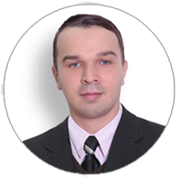  
  
 Andrey Voronkov has wide experience of startups in IT and biomedical fields, working as CEO of Digital BioPharm ltd. And as scientific director of IVAO inc. investment company. He has experience in preclinical drug development using molecular dynamics, docking, virtual chemical spaces processing, usage of BOINC server for distributed computing.

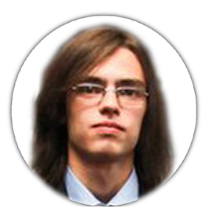

Sergey Ponomarev is experienced with smart-contracts development, Java,C++,C#,php,node.js and Solidity programming. Has a big background in p2p network organization and research projects. Has a very deep knowledge about program architecture and p2p networks.

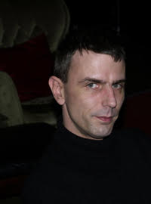Krzysztof Piszczek, lead developer. Krzysztof is software developer and Linux administrator. Since early 90's computer addicted s-f literature fan. As BOINC administrator of few projects Krzysztof is responsible in our organisation for BOINC server maintenance and applications development. Krzysztof is also Radioactive@Home and Universe@Home projects administrator and developer.

Krzysztof Faryna is experienced BOINC administrator, who manages BOINC Poland foundation.

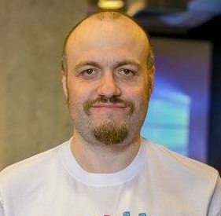

Denis Rysev, marketing and evangelist. Denis has experience of being producer at Nival Network and game designer in Finam. Also participates as delegate (witness) in Golos.ai platform.

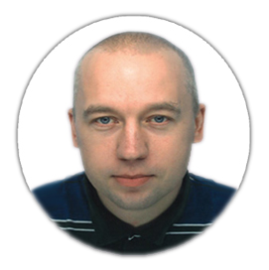

Zaslavskiy Mikhail, PhD is biostatistician, who is one of the winners of Dream Challenge competition from AstraZeneca and one of the top100 kaggle ratings participants.

Vladimir Berishvilli is PhD student at Moscow State University, working in the field of computer-assisted drug design. His fields of expertise are molecular dynamics, docking, QSAR, pharmacophore modeling. Programming skills : Python, Java.

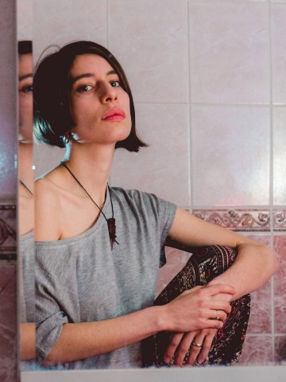 Oxana Lorie. Graphic designer - solves your problems using pictures. And also can do everything that graphic designer has to do and much more.

<https://www.behance.net/Gilleas>