Electronics Project

Using Multisim Program, do the following

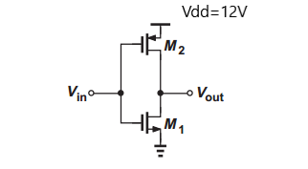

1-The inverter shown in Fig.1 must provide a trip point @5.5 V.

Choose the transistor model from component library then choose the transistor dimensions for NMOS and PMOS.

Verify your analytical solution clearly using the simulation and show transistors operating regions at the trip point.

2- If the inverter drives a load capacitance of 1pF. Choose the transistor dimensions for NMOS and PMOS transistors to achieve TpHL=TpLH=70 fs

Verify your analytical solution using the simulation.

Note:

* You could start a hand analysis with $λ_{n}=λ_{p}=0$, then retuning the dimensions using simulation with real models.
* Use real transistors component in the program to obtain values for the transistor parameters. For ex: as shown in the figures below.

Any copied reports the grade will be zero for the both.

The deadline is 30/5/2022

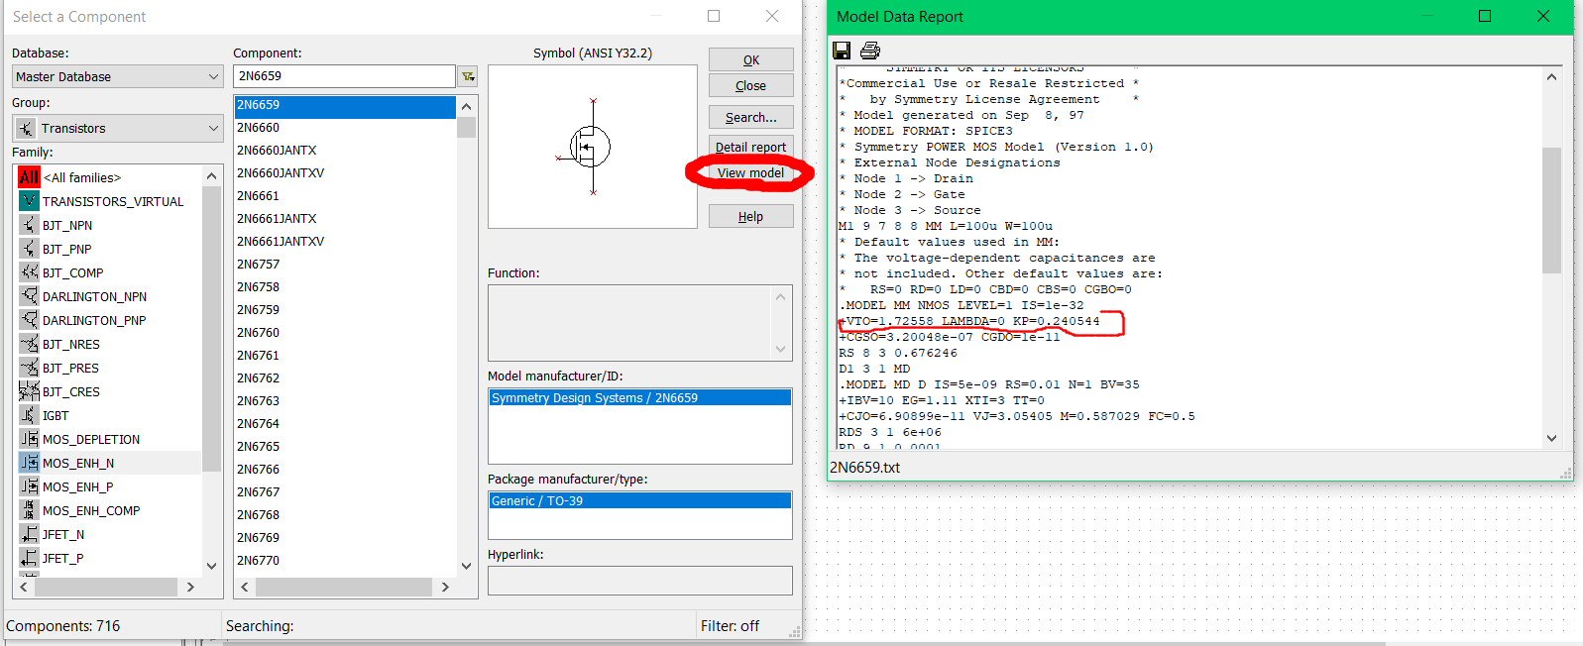

* You could modify the width and length of the used transistor by edit model option.

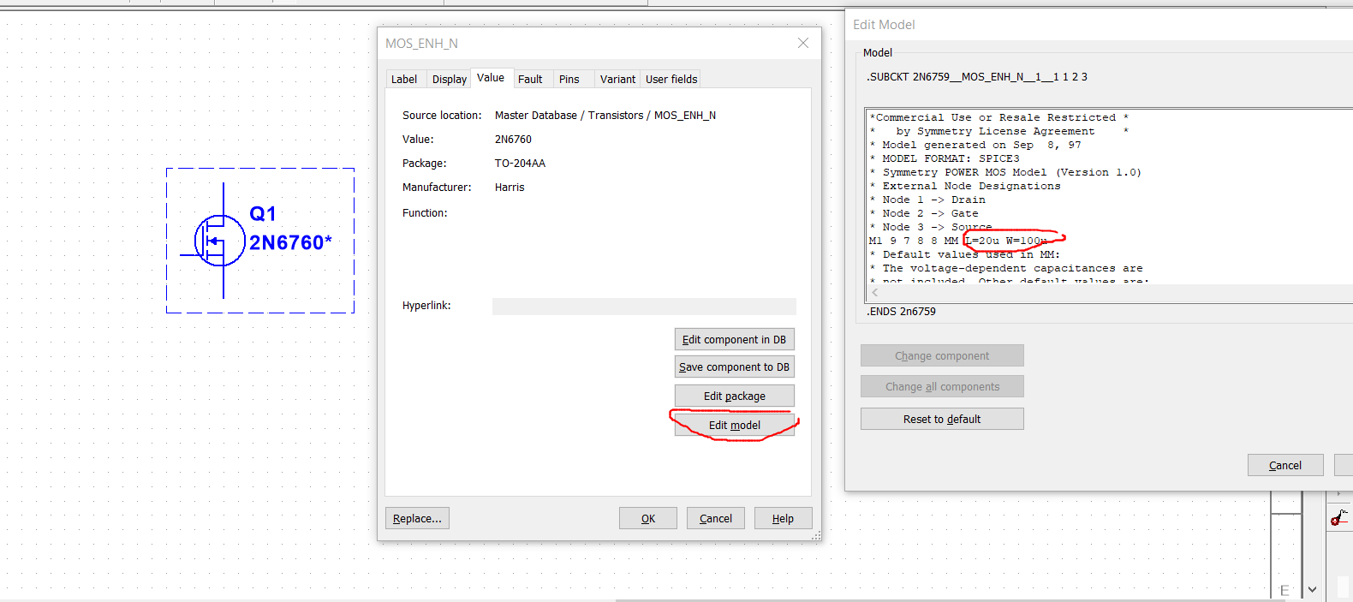

* Make sure of the source and drain connection. where the source of transistor is connected to its bulk.