

**Control Assignment**

**Team : 14**

|  |  |
| --- | --- |
| **Name** | **ID** |
| Menatalh Hossamalden Abdrabo | 9203998 |
| Norhan Reda Abdelwahed Ahmed | 9203639 |
| Hoda Gamal Hamouda Ismail | 9203673 |

**Req 1**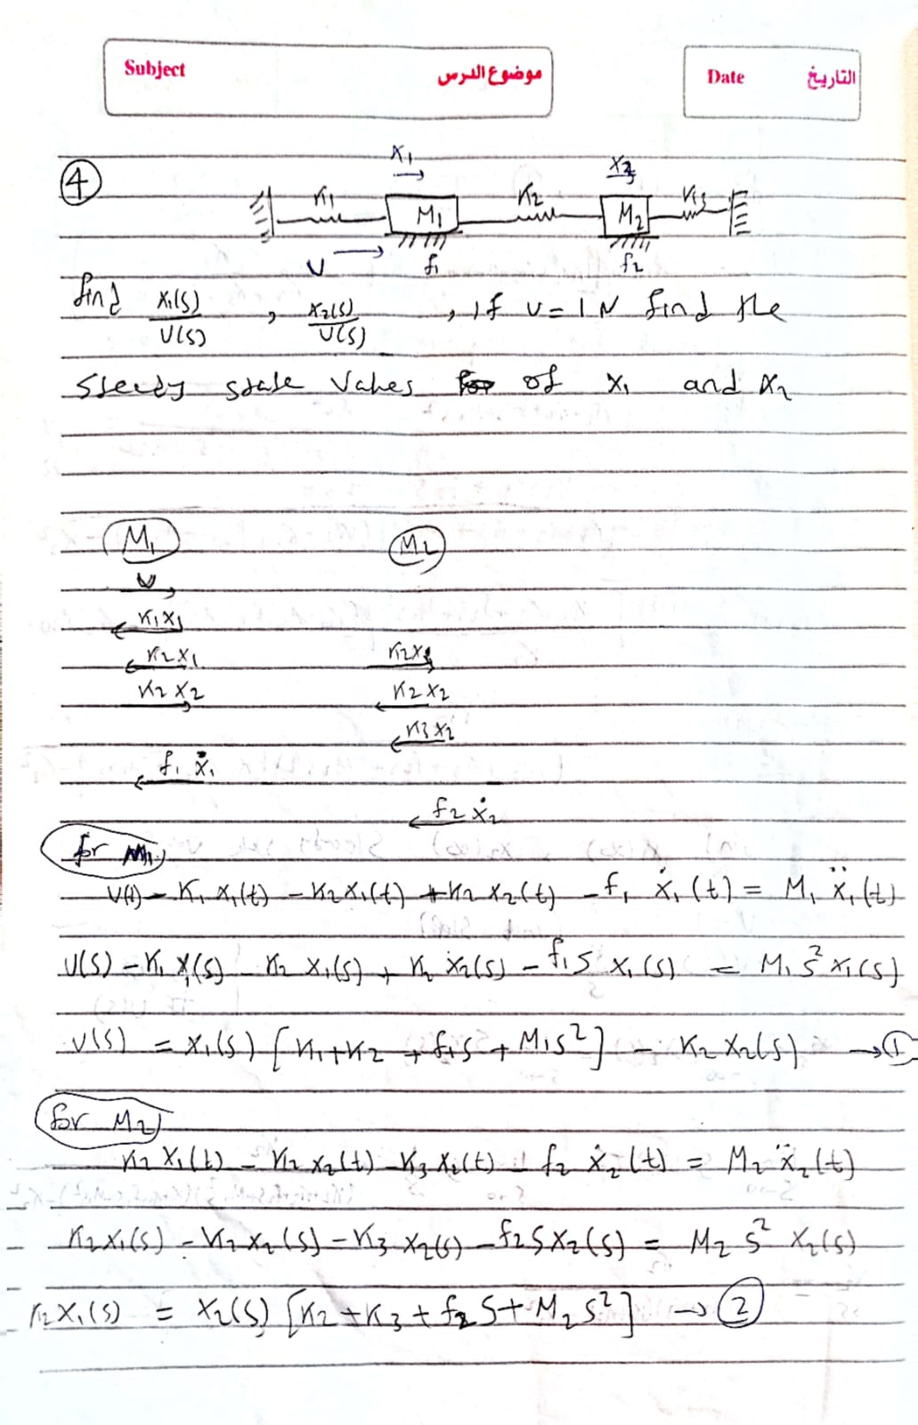

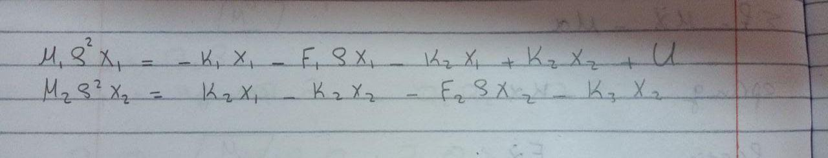

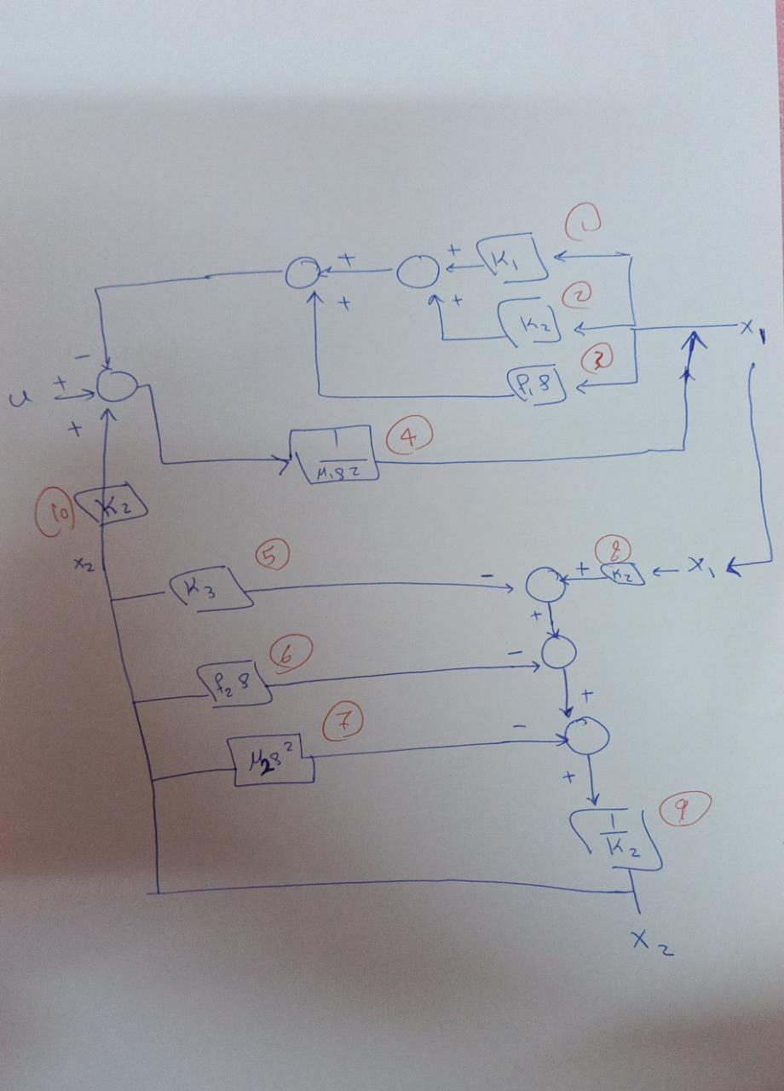**Req 2**

**0.01 s^2 + 0.01 s + 0.0055**

**tf1= ------------------------------------------------------------**

**s^4 + 2 s^3 + 2.1 s^2 + 1.1 s + 0.0525**

**0.005**

**tf2= -----------------------------------------------------------**

**s^4 + 2 s^3 + 2.1 s^2 + 1.1 s + 0.0525**

**Req 3**



To study the stability of the system with the transfer function $\frac{X1}{U}$ and $\frac{X2}{U}$, we analyzed the poles and zeros of the transfer functions. The poles of a transfer function are the values of s that make the transfer function infinite or undefined, while the zeros are the values of s that make the transfer function zero.

Since all the poles in both plots lie in the left half of the S-plane and no zeros in both plots lie in the right half of the S-plane , then the system is stable.

Overall, the stability of the system with the transfer functions: $\frac{X1}{U}$ and $\frac{X2}{U}$ depends on the location of its poles and zeros in the S-plane. If all the poles lie in the left half of the plane and there are no zeros in the right half of the plane, then the system is stable. Otherwise, the system is unstable.

**Req 4**

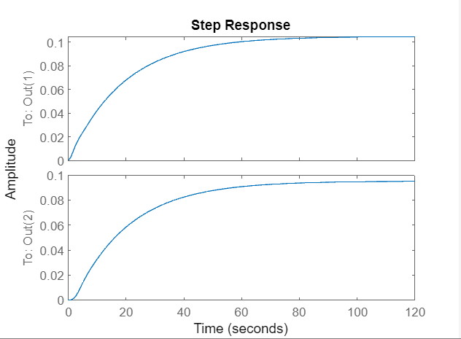

**X1**

rise time= 41.700422956062113

peak time= 1.387141379497528e+02

max peak= 0.104691936202951

Settling time= 74.318449376120768

X2ss= 0.104691936202951

ess= 0.8956

**X2**

rise time= 41.507635562886918

peak time= 1.387141379497528e+02

max peak= 0.095168126679141

Settling time= 76.124819172111145

X2ss= 0.095168126679141

ess= 0.9051

**Req 5**

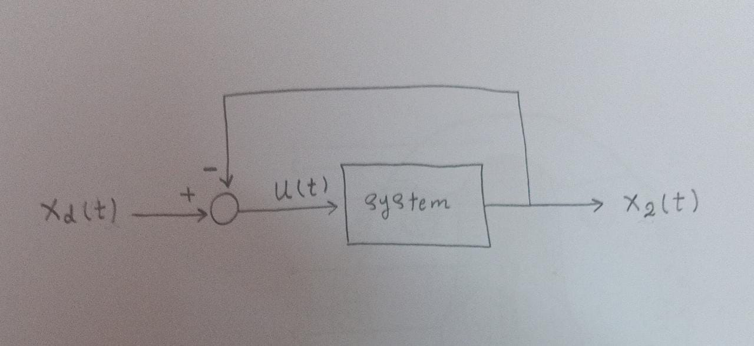

**Req 6**

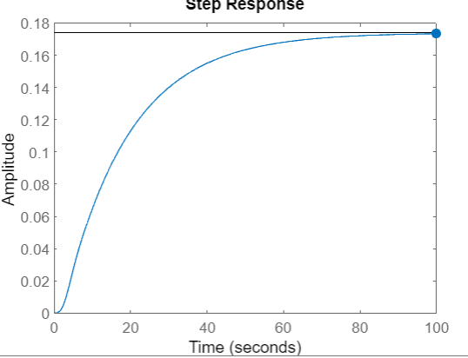

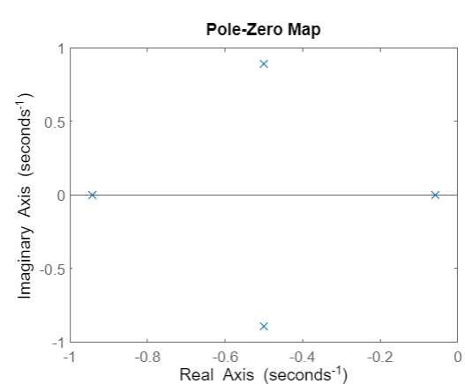

**Req 7**

rise time= 37.467621515312409

peak time= 1.252934896436744e+02

max peak=0.173

Settling time= 68.966829376855586

X2ss= 0.174

ess= 1.826678046342734

**Req 8**

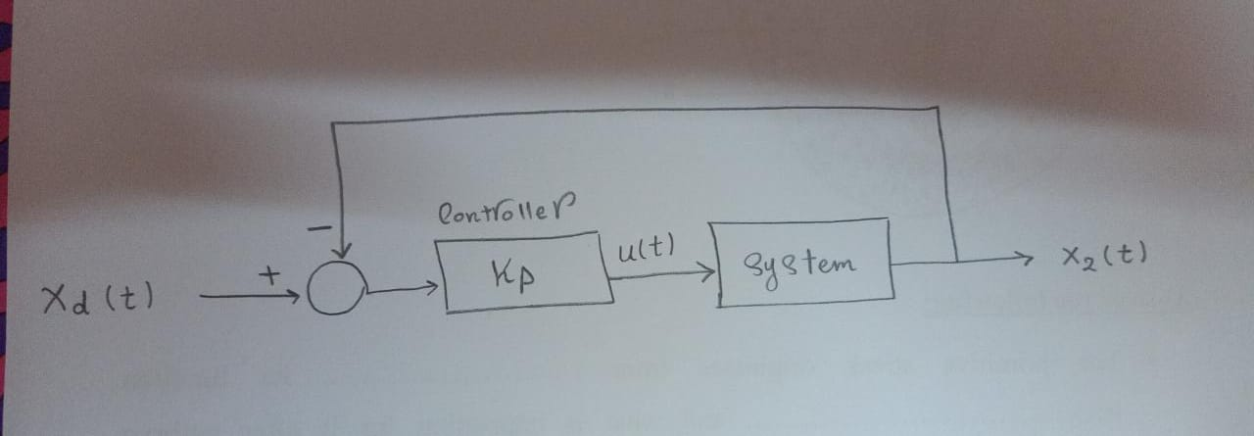

**kp=1**

rise time= 37.467621515312409

peak time= 1.252934896436744e+02

max peak=0.173

Settling time= 68.966829376855586

X2ss= 0.174

ess= 1.8267

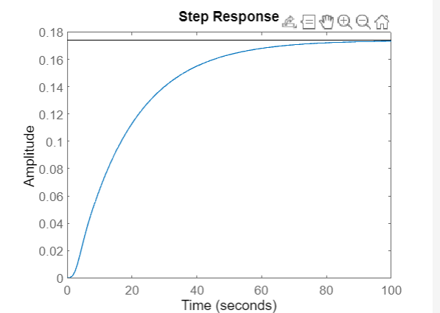

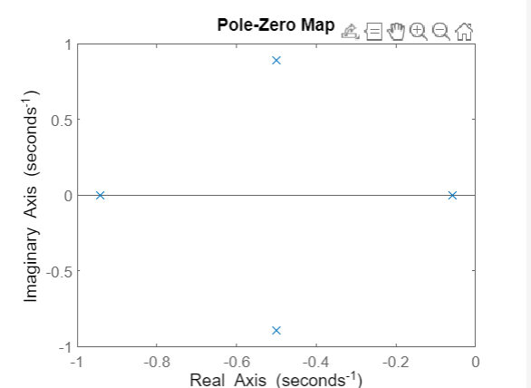

**kp=10**

rise time= 18.846485591043255

peak time= 61.389467388124636

max peak= 0.974

Settling time= 35.781502479245354

X2ss= 0.976

ess= 1.0271

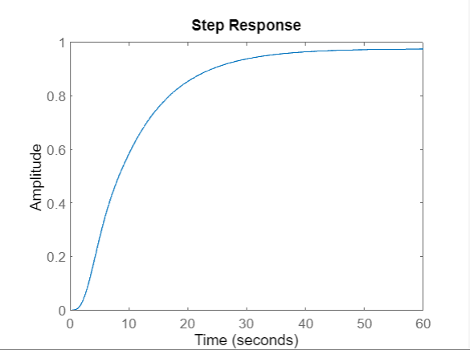

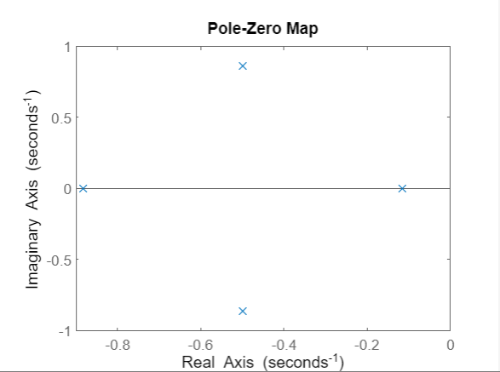

**kp=100**

rise time= 2.2180

peak time= 6.306809980973551

max peak= 2.68

Settling time= 31.014091607682847

X2ss= 1.81

ess= 0.1830

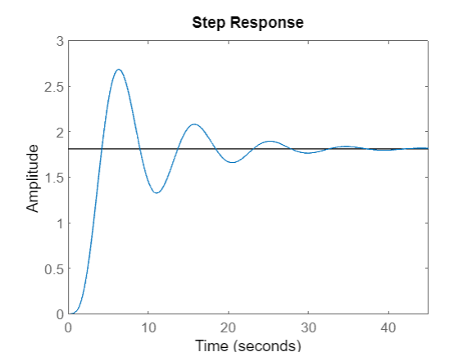

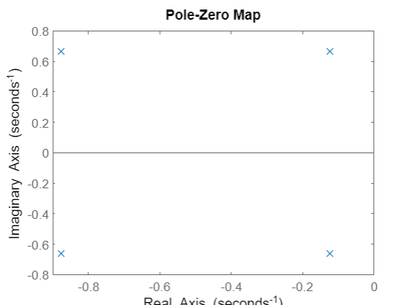

**kp=1000**

rise time= NaN

peak time= Inf

max peak= Inf

Settling time= NaN

X2ss= inf

ess= 1.8001e+12

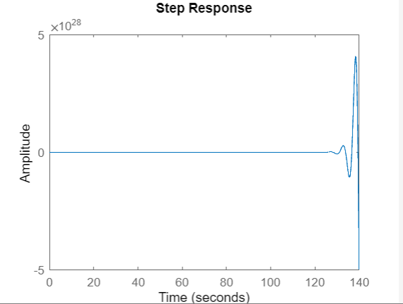

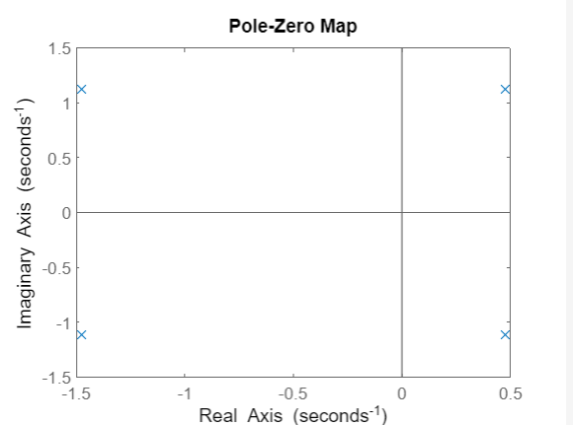

**Comment on Requirement 8 results:**

As Kp increases, we observed the following trends:

1. **Steady-state error (ess):** The steady-state error decreases as Kp increases, which means that the system becomes more accurate in reaching the desired output value, but after a certain point (Kp = 1000) it starts to increase again.
2. **Rise time:** The rise time decreases as Kp increases, indicating that the system reacts faster to changes in the input signal, but after a certain point (Kp = 1000) it becomes NaN.
3. **Settling time:** The settling time decreases initially as Kp increases, but after a certain point (Kp = 1000) it becomes NaN. This is because high gains can introduce oscillations and instability.
4. **Peak time and overshoot:** As Kp increases, the peak time decreases, and the overshoot increases. A high Kp value causes the system to oscillate more and have more overshoot, which may result in instability, but after a certain point (Kp = 1000) peak time starts to increase again.

From the results, we conclude that increasing the proportional controller gain Kp can improve the system’s steady-state error and speed up its response. However, there is a tradeoff between accuracy, speed, and stability. High gains lead to increased overshoot and oscillations.

**Req 9**

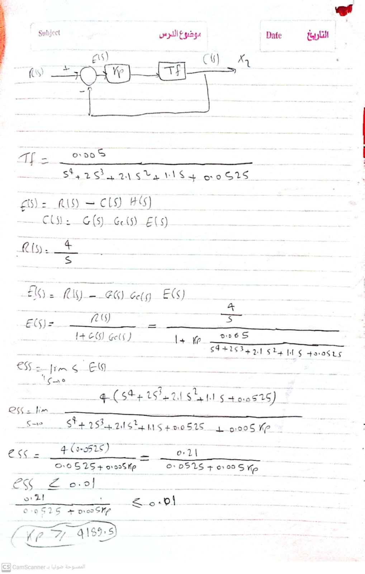**At kp = 4189.5**

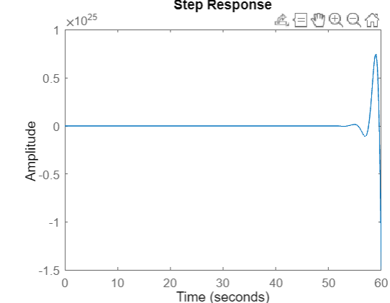

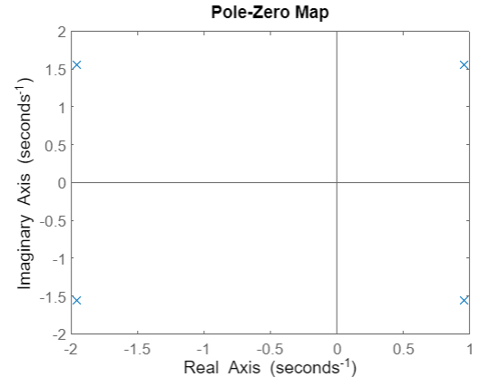

**The system will not be stable so we can’t use only a proportional compensator to achieve the required ess**

**Req10**

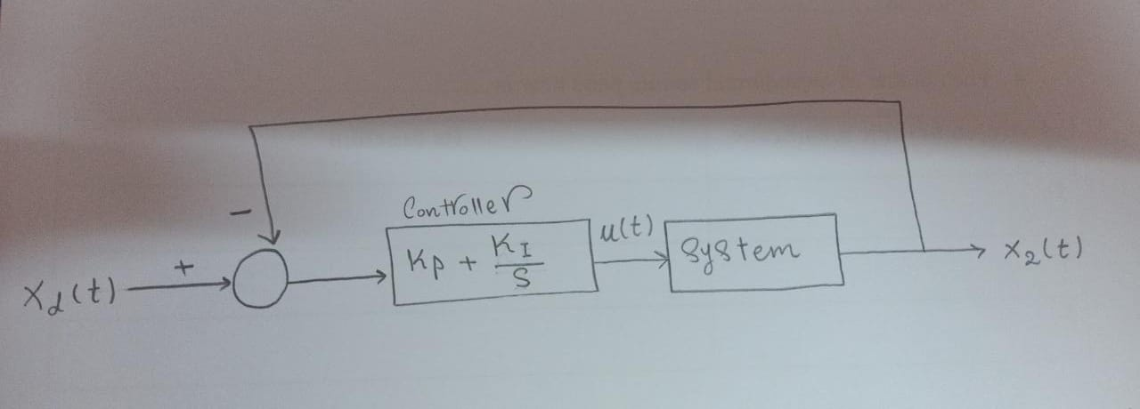

We choose PI controller (Kp + Ki/S) with Kp = 100 & KI = 5

rise time= 2.267588161154840

peak time= 6.524670874962880

max peak= 5.98

Settling time= 32.475805724765706

X2ss= 4

ess= 0.0086 less than 0.01

