1. Destructible.md:
(1) get_max_hp:
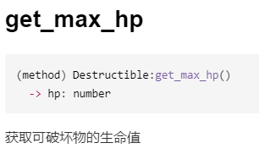
2. Game.md:
